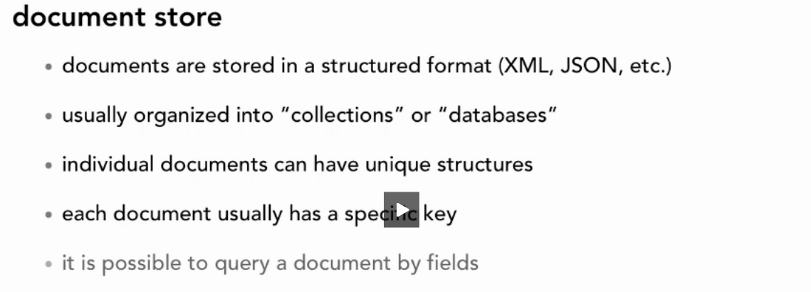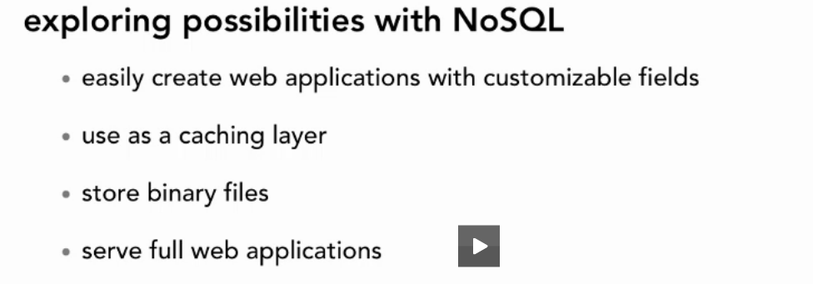

***Notes:***

for No.4 also able to serve saved html/js files in nosqlS\Database and set permission who can see them

cloadbased service is also available if not want to install couchdb locally

stored files are available at c:\programfiles\appche software foundatrion \ couchdb\var\lib\couchdb

**irisCouchDb**

you cant load database in it but able to recreater dabase by your hand

Nosql Database installed without predefined schemas

***Features :***

**List all dbs** : http://127.0.0.1:5984/_all_dbs

**List all Docs :** http://127.0.0.1:5984/restaurant/_all_docs

**List specific Document :** http://127.0.0.1:5984/restaurant/[**specific Doc Hash Code**]

***load temporaryView***

function(doc) {

emit(null, doc); >>> emit(key,value)

emit(doc.name, doc); >>> emit(key,value)

}

then save the view and have access to it by http://127.0.0.1:5984/restaurant/_design/pages/_view/withouthours**[?key="Delivery"]**

**reduce**

refresh the page add code below and checkbox reduce

function(key,values,rereduce)

{

return values.length;

}

*reduce function get called once for each key that map function supplies*

***attachments***

*function(doc) {*

*if(doc._attachments) {*

*var filename;*

*for (var key in doc._attachments) {*

*if (doc._attachments.hasOwnProperty(key) && typeof(key) !== 'function') {*

*filename = key;*

*break;*

*}*

*}*

*emit(doc.name, filename);*

*}*

*}*

***then save it as a view and cxall it by removing( _util till ?)***

***Serving Content :***

***upload your Html content to one of degign Documents***

***security***

*go to configuration and* **set require_valid_user=true and after thnat every oiperation will need valid**

**Nodejs accessibiulity**

**using "cradle" module to have access to CouchDB**

**DB Partitioning**

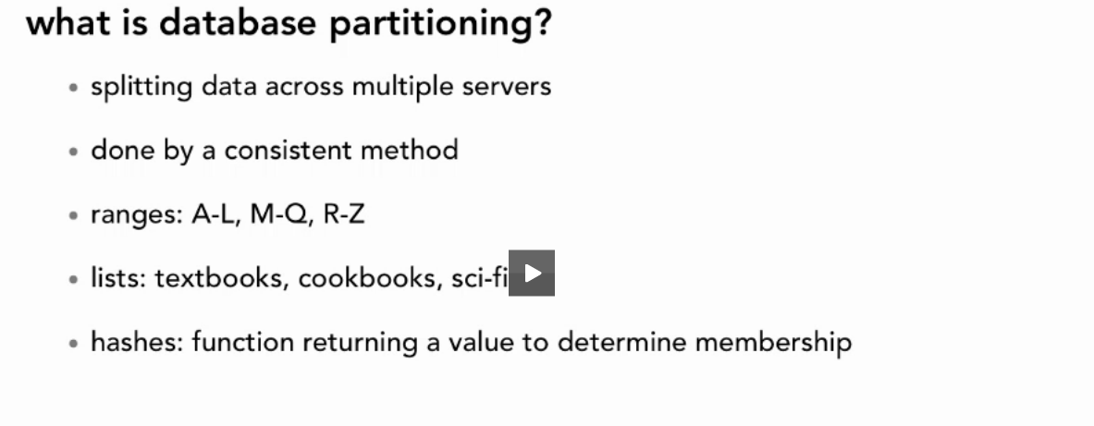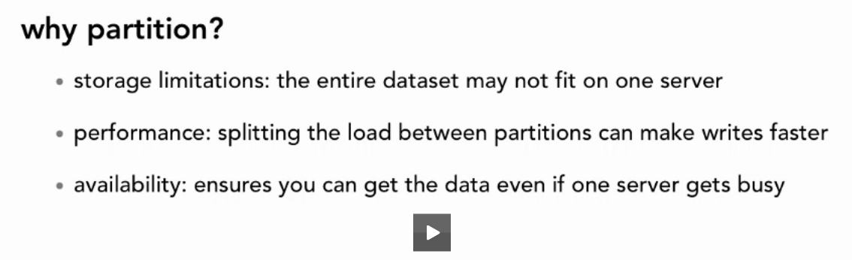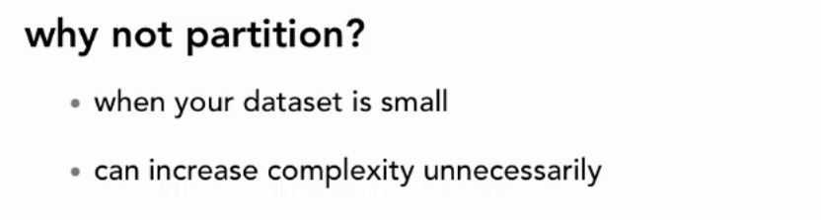

***CAP THEROME***

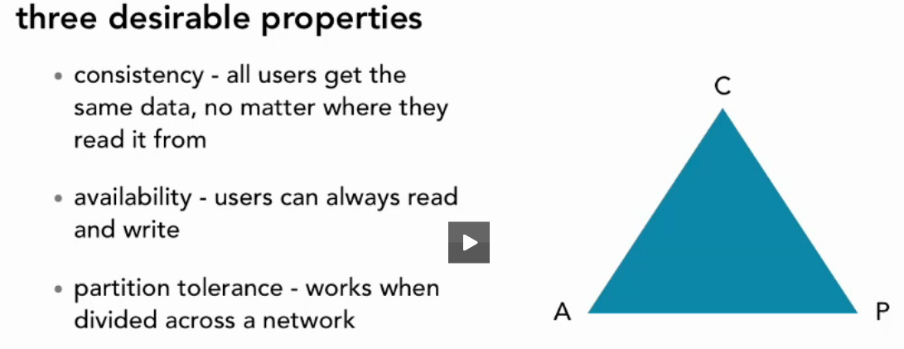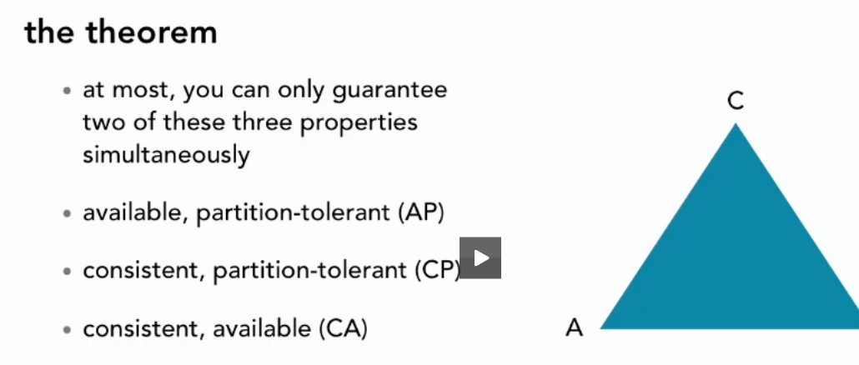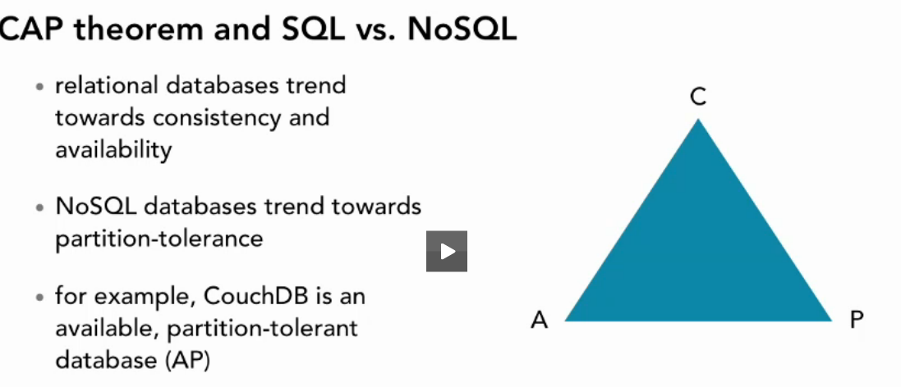

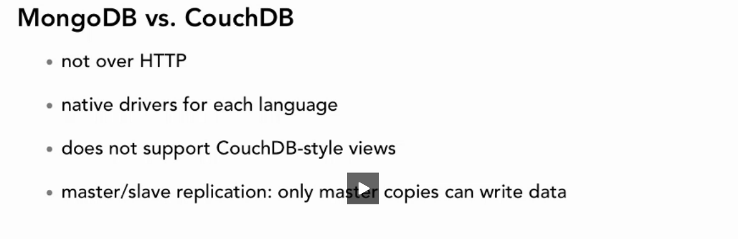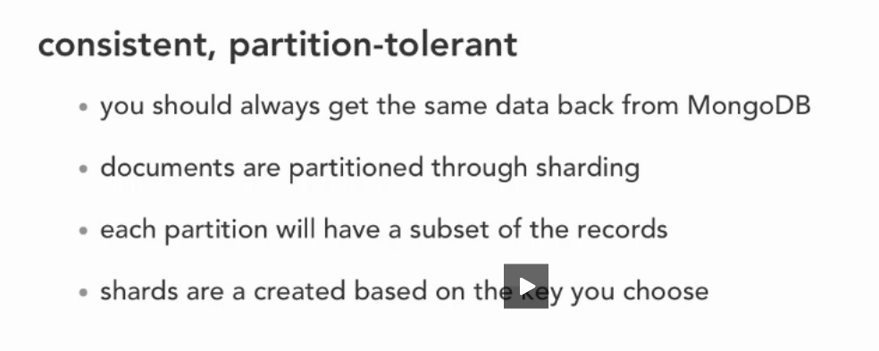

*mongo db is pretty much simmilar to couchdb except the way query, partition and connect*

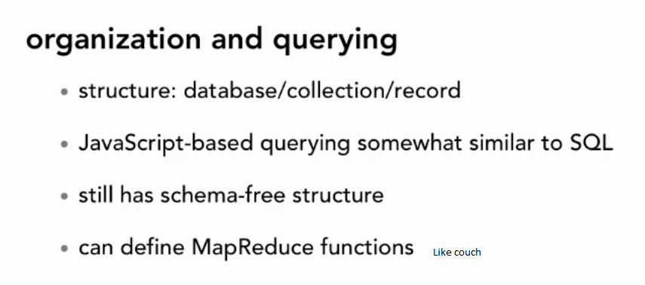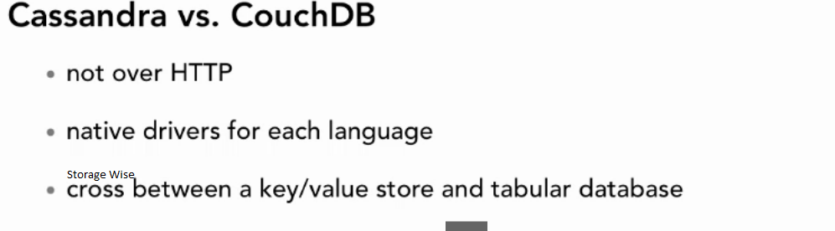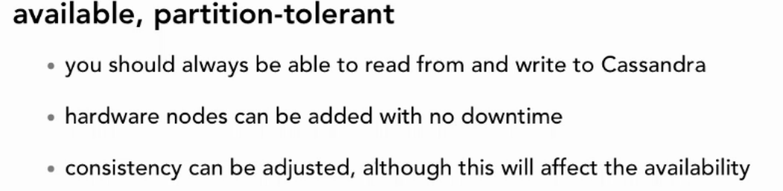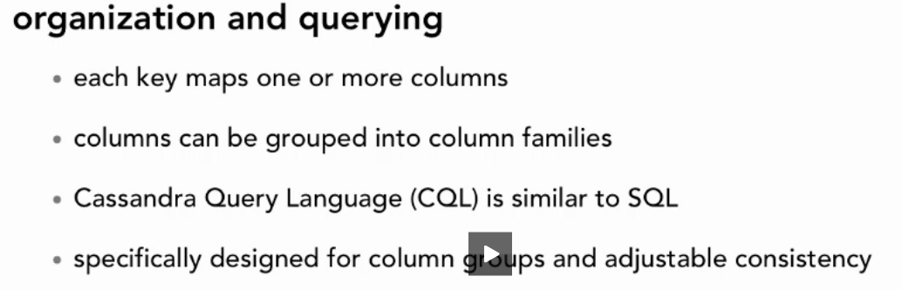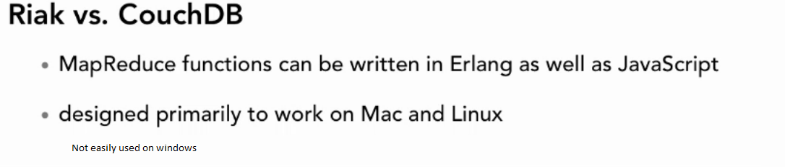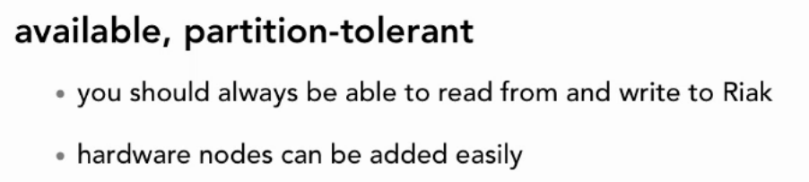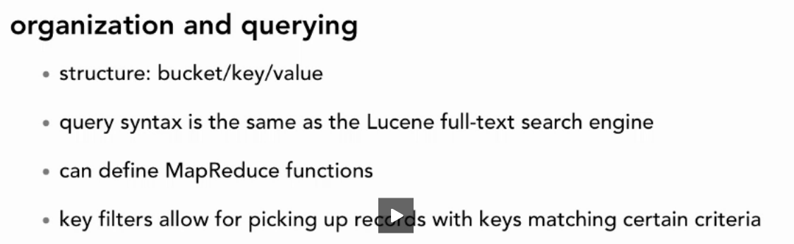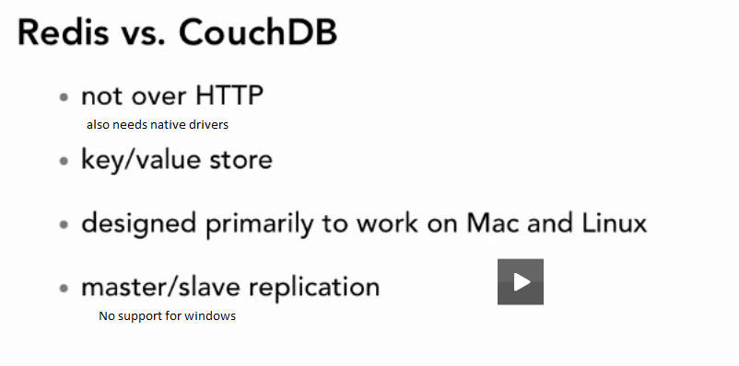

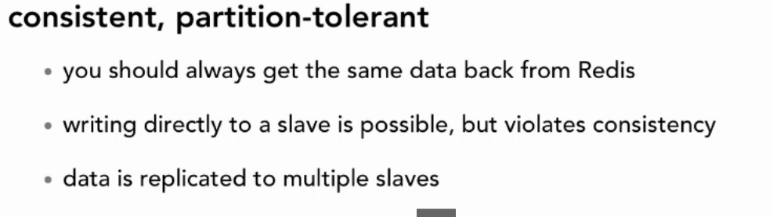

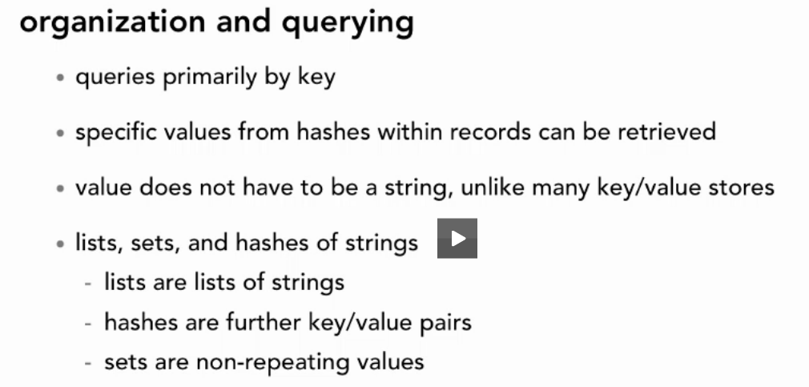

***Refernces:***

***wiki.apache.org/couchdb/basics***