OpenAirInterface

MAC

Design Document Template

# Document Revision History

|  |  |  |  |
| --- | --- | --- | --- |
| Modified by | Date | Version | Comments |
| Paul | 2016/01/02 | 1.0 | RRM Introduction, Modules, Function block introduction |
| Paul | 2016/01/14 | 1.1 | Erase Finite State Machine |
| Vanessa | 2016/03/03 | 2.0 | (1) Modify Introduction  (2) Modify Modules  (3) Delete Function Blocks |
| Vanessa | 2016/03/04 | 2.1 | Add Fig. 1 |
| Vanessa | 2016/03/09 | 2.2 | (1) Add Fig. 2  (2) Add Fig. 3 |
| Vanessa | 2016/03/15 | 2.3 | Modify Function Flow of Each Module |
| Vanessa | 2016/03/29 | 2.4 | Modify Fig.2 |
| Vanessa | 2016/04/02 | 2.5 | (1) Modify Fig.2  (2) Modify Fig.3 |
| Eric | 2016/04/03 | 2.6 | Add Mudule/Process Table after System/Block Figures |
| Eric | 2016/06/08 | 2.7 | Modify Parameters of signal lines Table Format in System/Block level |
| Eric | 2016/07/10 | 3.0 | Draw left Process Figures and revise table numbers |
| Eric | 2016/11/10 | 3.1 | Modify DD Template base on Original DD and add Chapter 3 Channel, Chapter 4 Signal |
| Eric | 2016/11/16 | 3.2 | Modify Chapter Channel in DD Template and Modify Chapter 4 from Signal to Data Structure |
| Eric | 2016/12/05 | 3.3 | Finish Chapter 3 |

# Table of Content

Document Revision History 2

Table of Content 3

1 Reference 4

2 Introduction 5

2.1 Definition and Abbreviations 5

2.2 Overview 5

3 Channel 7

3.1 MAC-RRC 7

3.1.1 UL_CCCH 7

3.1.2 DL_BCCH 8

3.1.3 RA_CCCH 8

3.1.4 Config_BCCH 9

3.1.5 Config_CCCH 9

3.1.6 Config_DCCH 11

3.2 MAC-RLC 12

3.2.1 UL_DCCH 12

3.2.2 UL_DTCH 12

3.2.3 DL_DCCH 13

3.2.4 DL_DTCH 13

3.3 MAC-PHY 14

3.3.1 TX_DLSCH 14

3.3.2 RX_ULSCH 15

3.3.3 TX_DCI 17

3.3.4 To_MAC 17

3.3.5 To_PHY 19

3.4 Inter Blocks 22

3.4.1 PHY_UL 22

3.4.2 UL_PHY 22

3.4.3 PHY_RX 23

3.4.4 PHY_DL 23

3.4.5 DL_PHY 24

3.4.6 PHY_SI 24

3.4.7 SI_PHY 25

3.4.8 PHY_RA 25

3.4.9 RA_PHY 26

3.4.10 Config_PHY 26

4 Important Data Structure 27

4.1 eNB_MAC_INST 27

4.2 eNB common channels 28

4.3 eNB *RA_template 29

4.4 eNB DCI_PDU* 31

4.5 eNB ULSCH_PDU* 31

4.6 eNB DLSCH_PDU* 31

4.7 eNB CCCH_PDU* 31

4.8 eNB BCCH_PDU* 32

4.9 UE list* 32

4.10 mac_rlc_status_resp_t 33

5 Block 33

5.1 PHY_MAC_Interface 34

5.1.1 Introduction 34

5.2 DLSCH_Process 35

5.2.1 Introduction 35

5.3 ULSCH_Process 37

5.3.1 Introduction 37

5.4 RA_Process 39

5.4.1 Introduction 39

5.5 SI_Process 41

5.5.1 Introduction 41

5.6 Configuration 43

5.6.1 Introduction 43

# 1 Reference

|  |  |  |  |
| --- | --- | --- | --- |
| **Spec.** | **Release** | **Page** | **Related work** |
| 3GPP 36.321 | V8.6 |  |  |
| 3GPP 36.321 | V13.2 |  |  |

Table 1. Related work will be the chapter in this document.

# 2 Introduction

## 2.1 Definition and Abbreviations

|  |  |
| --- | --- |
| **Term** | **Definition** |
| RRM | Radio Resource Management |
| RRC | Radio Resource Control |
| PDCP | Packet Data Convergence Protocol |
| RLC | Radio Link Control |
| MAC | Media access control |
| PHY | Physical layer |

Table 2. Abbreviations and definition

## 2.2 Overview

Fig. 1 shows the modules implemented in the MAC layer .

In this chapter, need to point out :

1. Modules within MAC layer

2. The upper or lower relationship between Modules

Fig.1 System level of MAC layer. 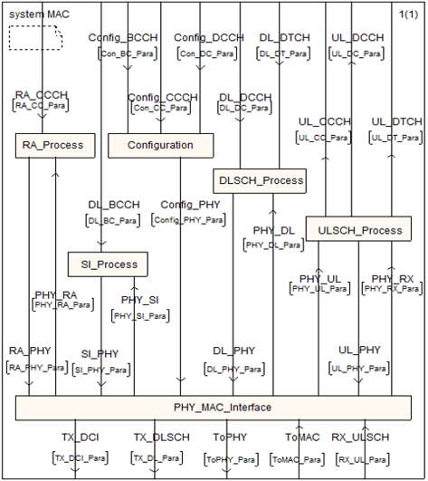

# 3 Channel

## 3.1 MAC-RRC

### 3.1.1 UL_CCCH

|  |  |  |  |  |
| --- | --- | --- | --- | --- |
| **Block** | **Primitives** | **Direction** | **Input Parameters** | **Output Parameters**  (UL_CC_Para) |
| ULSCH_process | mac_rrc_data_ind() | MAC→RRC | enb_mod_idP,  CC_idP, frameP,subframeP, rntiP, CCCH, (uint8_t*)payload_ptr, rx_lengths[i], ENB_FLAG_YES, enb_mod_idP,  0 | (uint8_t*)payload_ptr, rx_lengths[i], |

Table . Parameters of Cross Layer Channel.

### 3.1.2 DL_BCCH

|  |  |  |  |  |
| --- | --- | --- | --- | --- |
| **Block** | **Primitives** | **Direction** | **Input Parameters** | **Output Parameters**  (DL_BC_Para) |
| SI_Process | mac_rrc_data_req() | RRC→MAC | module_idP  CC_id  frameP  BCCH  1  &eNB->common_channels[CC_id].BCCH_pdu.payload[0],  1  module_idP | rrc_sdu_length  BCCH_pdu.payload[0] |

Tablex . Parameters of Cross Layer Channel.

### 3.1.3 RA_CCCH

|  |  |  |  |  |
| --- | --- | --- | --- | --- |
| **Block** | **Primitives** | **Direction** | **Input Parameters** | **Output Parameters**  (RA_CC_Para) |
| RA_Process | mac_rrc_data_req() | RRC→MAC | module_idP,  CC_id,  frameP,  CCCH,  1,  &eNB->common_channels[CC_id].CCCH_pdu.payload[0],  ENB_FLAG_YES,  module_idP | rrc_sdu_length,  CCCH_pdu.payload[0] |

Tablex . Parameters of Cross Layer Channel.

### 3.1.4 Config_BCCH

|  |  |  |  |  |
| --- | --- | --- | --- | --- |
| **Block** | **Primitives** | **Direction** | **Input Parameters** | **Output Parameters** |
| Configuration | mac_rrc_config_req() | RRC→MAC | Mod_id  CC_id  eNB_flagP  *RadioResourceConfigCommonSIB-NB  *SIwindowsize  *SIperiod  *ul_CarrierFreq  *additionalSpectrumEmission  (rntiP)NULL  (eNB_index) NULL  (PhysicalConfigDedicated-NB) NULL  (*MAC-MainConfig-NB) NULL  (logicalChannelIdentity) NULL  (*LogicalChannelConfig-NB) NULL | N/A |

Table . Parameters of Cross Layer Channel.

### 3.1.5 Config_CCCH

|  |  |  |  |  |
| --- | --- | --- | --- | --- |
| **Block** | **Primitives** | **Direction** | **Input Parameters** | **Output Parameters** |
| Configuration | mac_rrc_config_req() | RRC→MAC | Mod_id  CC_id  eNB_flagP  rntiP  PhysicalConfigDedicated-NB  *MAC-MainConfig-NB  logicalChannelIdentity  *LogicalChannelConfig-NB  (eNB_index ) NULL  (*RadioResourceConfigCommonSIB-NB) NULL  (*SIwindowsize) NULL  (*SIperiod) NULL  (*ul_CarrierFreq) NULL  (*additionalSpectrumEmission) NULL | N/A |

Table . Parameters of Cross Layer Channel.

### 3.1.6 Config_DCCH

|  |  |  |  |  |
| --- | --- | --- | --- | --- |
| **Block** | **Primitives** | **Direction** | **Input Parameters** | **Output Parameters** |
| Configuration | mac_rrc_config_req() | RRC→MAC | Mod_id  CC_id  eNB_flagP  rntiP  PhysicalConfigDedicated-NB  *MAC-MainConfig-NB  logicalChannelIdentity  *LogicalChannelConfig-NB  (eNB_index ) NULL  (*RadioResourceConfigCommonSIB-NB) NULL  (*SIwindowsize) NULL  (*SIperiod) NULL  (*ul_CarrierFreq) NULL  (*additionalSpectrumEmission) NULL | N/A |

## 3.2 MAC-RLC

### 3.2.1 UL_DCCH

|  |  |  |  |  |
| --- | --- | --- | --- | --- |
| **Block** | **Primitives** | **Direction** | **Input Parameters**  (UL_DC_Para) | **Output Parameters** |
| ULSCH_Process | mac_rlc_data_ind() | MAC→RLC | enb_mod_idP, rntiP, enb_mod_idP,  frameP, ENB_FLAG_YES,MBMS_FLAG_NO, rx_lcids[i],  (char*)payload_ptr,  rx_lengths[i],  1, NULL | (char*)payload_ptr,  rx_lengths[i], |

Tablex . Parameters of Cross Layer Channel.

### 3.2.2 UL_DTCH

|  |  |  |  |  |
| --- | --- | --- | --- | --- |
| **Block** | **Primitives** | **Direction** | **Input Parameters**  (UL_DT_Para) | **Output Parameters** |
| ULSCH_Process | mac_rlc_data_ind() | MAC→RLC | enb_mod_idP, rntiP, enb_mod_idP,  frameP, ENB_FLAG_YES,MBMS_FLAG_NO, rx_lcids[i],  (char*)payload_ptr,  rx_lengths[i],  1, NULL | (char*)payload_ptr,  rx_lengths[i], |

Tablex . Parameters of Cross Layer Channel.

### 3.2.3 DL_DCCH

|  |  |  |  |  |
| --- | --- | --- | --- | --- |
| **Block** | **Primitives** | **Direction** | **Input Parameters** | **Output Parameters**  (DL_DC_Para) |
| DLSCH_Process | mac_rlc_data_req() | MAC→RLC | module_idP, rntiP, eNB_index, frameP, enb_flagP, channel_idP, buffer_pP | ret_tb_size  Put RLC data from different mode to MAC dlsch_buffer |
| mac_rlc_serialize_tb() | RLC→MAC | buffer_pP, transport_blocksP | ret_tb_size  Put RLC data to MAC dlsch_buffer  //Used by mac_rlc_data_req() |
| mac_rlc_status_ind | MAC→RLC | module_idP,  rntiP,  eNB_index,  frameP,  enb_flagP,  channel_idP,  tb_sizeP | mac_rlc_status_resp  a structure have data information which for scheduled |

Tablex . Parameters of Cross Layer Channel.

### 3.2.4 DL_DTCH

|  |  |  |  |  |
| --- | --- | --- | --- | --- |
| **Block** | **Primitives** | **Direction** | **Input Parameters** | **Output Parameters**  (DL_DT_Para) |
| DLSCH_Process | mac_rlc_data_req() | MAC→RLC | module_idP, rntiP, eNB_index, frameP, enb_flagP, channel_idP, buffer_pP | ret_tb_size  Put RLC data from different mode to MAC dlsch_buffer |
| mac_rlc_serialize_tb() | RLC→MAC | buffer_pP, transport_blocksP | ret_tb_size  Put RLC data to MAC dlsch_buffer  //Used by mac_rlc_data_req() |
| mac_rlc_status_ind | MAC→RLC | module_idP,  rntiP,  eNB_index,  frameP,  enb_flagP,  channel_idP,  tb_sizeP | mac_rlc_status_resp  a structure have data information which for scheduled |

Tablex . Parameters of Cross Layer Channel.

## 3.3 MAC-PHY

### 3.3.1 TX_DLSCH

|  |  |  |  |  |
| --- | --- | --- | --- | --- |
| **Block** | **Primitives** | **Direction** | **Input Parameters** | **Output Parameters**  (TX_DL_Para) |
| PHY_MAC_Interface | get_dlsch_sdu() | PHY→MAC | phy_vars_eNB->Mod_id,  phy_vars_eNB->CC_id,  phy_vars_eNB->proc[sched_subframe].frame_tx,  phy_vars_eNB->dlsch_eNB[(uint8_t)UE_id][0]->rnti,  0 | (unsigned char *)&eNB->UE_list.DLSCH_pdu[CC_id][TBindex][UE_id].payload[0] |
| get_dlsch_sdu() | PHY→MAC | phy_vars_eNB->Mod_id, phy_vars_eNB->CC_id, phy_vars_eNB->proc[sched_subframe].frame_tx, SI_RNTI, 0 | (unsigned char *)&eNB->common_channels[CC_id].BCCH_pdu.payload[0] |

Tablex . Parameters of Cross Layer Channel.

### 3.3.2 RX_ULSCH

|  |  |  |  |  |
| --- | --- | --- | --- | --- |
| **Block** | **Primitives** | **Direction** | **Input Parameters**  (RX_UL_Para) | **Output Parameters**  (PHY_RX) |
| PHY_MAC_Interface | rx_sdu() | PHY→MAC | phy_vars_eNB->Mod_id, phy_vars_eNB->CC_id, frame,  subframe, phy_vars_eNB->ulsch_eNB[i]->rnti, NULL, 0, harq_pid, &phy_vars_eNB->ulsch_eNB[i]->Msg3_flag | phy_vars_eNB->Mod_id, phy_vars_eNB->CC_id, frame,  subframe, phy_vars_eNB->ulsch_eNB[i]->rnti, NULL, 0, harq_pid, &phy_vars_eNB->ulsch_eNB[i]->Msg3_flag |
| rx_sdu() | PHY→MAC | phy_vars_eNB->Mod_id, phy_vars_eNB->CC_id, frame,  subframe,  phy_vars_eNB->ulsch_eNB[i]->rnti, phy_vars_eNB->ulsch_eNB[i]->harq_processes[harq_pid]->b, phy_vars_eNB->ulsch_eNB[i]->harq_processes[harq_pid]->TBS>>3, harq_pid, &phy_vars_eNB->ulsch_eNB[i]->Msg3_flag | phy_vars_eNB->Mod_id, phy_vars_eNB->CC_id, frame,  subframe,  phy_vars_eNB->ulsch_eNB[i]->rnti, phy_vars_eNB->ulsch_eNB[i]->harq_processes[harq_pid]->b, phy_vars_eNB->ulsch_eNB[i]->harq_processes[harq_pid]->TBS>>3, harq_pid, &phy_vars_eNB->ulsch_eNB[i]->Msg3_flag |
| rx_sdu() | PHY→MAC | phy_vars_eNB->Mod_id, phy_vars_eNB->CC_id, frame,  subframe, phy_vars_eNB->ulsch_eNB[i]->rnti, phy_vars_eNB->ulsch_eNB[i]->harq_processes[harq_pid]->b, phy_vars_eNB->ulsch_eNB[i]->harq_processes[harq_pid]->TBS>>3, harq_pid, NULL | phy_vars_eNB->Mod_id, phy_vars_eNB->CC_id, frame,  subframe, phy_vars_eNB->ulsch_eNB[i]->rnti, phy_vars_eNB->ulsch_eNB[i]->harq_processes[harq_pid]->b, phy_vars_eNB->ulsch_eNB[i]->harq_processes[harq_pid]->TBS>>3, harq_pid, NULL |

Tablex . Parameters of Cross Layer Channel.

### 3.3.3 TX_DCI

|  |  |  |  |  |
| --- | --- | --- | --- | --- |
| **Block** | **Primitives** | **Direction** | **Input Parameters** | **Output Parameters**  (TX_DCI_Para) |
| PHY_MAC_Interface | get_dci_sdu() | PHY→MAC | phy_vars_eNB->Mod_id, phy_vars_eNB->CC_id, phy_vars_eNB->proc[sched_subframe].frame_tx, subframe | &eNB_mac_inst[module_idP].common_channels[CC_id].DCI_pdu |

Tablex . Parameters of Cross Layer Channel.

### 3.3.4 To_MAC

|  |  |  |  |  |
| --- | --- | --- | --- | --- |
| **Block** | **Primitives** | **Direction** | **Input Parameters**  (PHY_Para) | **Output Parameters** |
| PHY_MAC_Interface | eNB_dlsch_ulsch_scheduler() | PHY→MAC | phy_vars_eNB->Mod_id,  0,  phy_vars_eNB->proc[sched_subframe].frame_tx,  subframe | N/A |
| initiate_ra_proc() | PHY→MAC | phy_vars_eNB->Mod_id, phy_vars_eNB->CC_id, frame, preamble_max, preamble_delay_list[preamble_max]*update_TA, 0,  subframe,0 | (RA_TEMPLATE *)&eNB_mac_inst[module_idP].common_channels[CC_id].RA_template[0] |
| cancel_ra_proc | PHY→MAC | phy_vars_eNB->Mod_id, phy_vars_eNB->CC_id, phy_vars_eNB->proc[sched_subframe].frame_tx, crnti | (RA_TEMPLATE *)&eNB_mac_inst[module_idP].common_channels[CC_id].RA_template[0] |
|  | cancel_ra_proc | PHY→MAC | phy_vars_eNB->Mod_id, phy_vars_eNB->CC_id, frame, phy_vars_eNB->eNB_UE_stats[i].crnti | (RA_TEMPLATE *)&eNB_mac_inst[module_idP].common_channels[CC_id].RA_template[0] |
|  | cancel_ra_proc | PHY→MAC | phy_vars_eNB->Mod_id, phy_vars_eNB->CC_id, frame, phy_vars_eNB->eNB_UE_stats[i].crnti | (RA_TEMPLATE *)&eNB_mac_inst[module_idP].common_channels[CC_id].RA_template[0] |
|  | fill_rar() | PHY→MAC | phy_vars_eNB->Mod_id, phy_vars_eNB->CC_id, phy_vars_eNB->proc[sched_subframe].frame_tx, dlsch_input_buffer, phy_vars_eNB->lte_frame_parms.N_RB_UL, input_buffer_length | eNB_mac_inst[module_idP].common_channels[CC_id].RA_template[ra_idx].rnti,  *rar |

Tablex . Parameters of Cross Layer Channel.

### 3.3.5 To_PHY

|  |  |  |  |  |
| --- | --- | --- | --- | --- |
| **Block** | **Primitives** | **Direction** | **Input Parameters**  (PHY_Para) | **Output Parameters** |
| PHY_MAC_Interface | phy_config_dedicated_eNB() | MAC→PHY | Mod_id,  CC_id, UE_RNTI(Mod_id, UE_id), physicalConfigDedicated | phy_vars_eNB->physicalConfigDedicated[UE_id] |
| phy_config_sib2_eNB() | MAC→PHY | Mod_id,  CC_id, radioResourceConfigCommon,  ul_CarrierFreq, ul_Bandwidth, additionalSpectrumEmission, mbsfn_SubframeConfigList | &PHY_vars_eNB_g[Mod_id][CC_id]->lte_frame_parms |
| get_ue_active_harq_pid() | MAC→PHY | module_idP,  CC_id,  RA_template->rnti,  frameP,  subframeP,  &harq_pid,  &round,  0 | *harq_pid  *round |
| get_ue_active_harq_pid() | MAC→PHY | module_idP,CC_id,rnti, frameP,  subframeP, &ue_sched_ctl->harq_pid[CC_id],&ue_sched_ctl->round[CC_id], 0 | *harq_pid  *round |
| get_ue_active_harq_pid() | MAC→PHY | module_idP,  CC_id,  rnti,  frameP,  subframeP,  &harq_pid,  &round,  1 | *harq_pid  *round |
| get_ue_active_harq_pid() | MAC→PHY | module_idP,  CC_id,  rnti,  frameP,  subframeP,  &harq_pid,  &round,  1 | *harq_pid  *round |
| get_TBS_DL() | MAC→PHY | mcs,  nb_rb | TBS |
| get_TBS_UL() | MAC→PHY | mcs,  rb_table[rb_table_index] | TBS |
| get_lte_frame_parms() | MAC→PHY | module_idP,  CC_id | &PHY_vars_eNB_g[Mod_id][CC_id]->lte_frame_parms |
| get_rballoc() | MAC→PHY | (DCI1A_1_5MHz_TDD_1_6_t*)&RA_template->RA_alloc_pdu1[0])->vrb_type, ((DCI1A_1_5MHz_TDD_1_6_t*)&RA_template->RA_alloc_pdu1[0])->rballoc | ((DCI1A_1_5MHz_TDD_1_6_t*)&RA_template->RA_alloc_pdu1[0])->rballoc is from  computeRIV() |
| get_rballoc() | MAC→PHY | 0,  ((DCI1A_1_5MHz_TDD_1_6_t*)BCCH_alloc_pdu)->rballoc | ((DCI1A_1_5MHz_TDD_1_6_t*)BCCH_alloc_pdu)->rballoc is from  computeRIV() |
| computeRIV() | MAC→PHY | PHY_vars_eNB_g[module_idP][CC_id]->lte_frame_parms.N_RB_DL,  first_rb,  4 | RIV |
| …. | …. | … | … | … |

## 3.4 Inter Blocks

### 3.4.1 PHY_UL

|  |  |  |  |
| --- | --- | --- | --- |
| **From Block** | **To Block** | **Channel Parameters**  **(**PHY_UL_Para**)** | **Note** |
| PHY_MAC_Interface | ULSCH_Process | module_idP  frameP  cooperation_flag  subframeP  sched_subframe | The input parameter of  function schedule_ulsch(),  Sched_subframe = subframeP+4 |

Tablex . Parameters of Inter Blocks Channel.

### 3.4.2 UL_PHY

|  |  |  |  |
| --- | --- | --- | --- |
| **From Block** | **To Block** | **Channel Parameters**  **(**UL_PHY_Para**)** | **Note** |
| ULSCH_Process | PHY_MAC_Interface | &eNB_mac_inst[module_idP].common_channels[CC_id].DCI_pdu | Return the position of DCI_pdu |

Tablex . Parameters of Inter Blocks Channel.

### 3.4.3 PHY_RX

|  |  |  |  |
| --- | --- | --- | --- |
| **From Block** | **To Block** | **Channel Parameters**  **(**PHY_RX_Para**)** | **Note** |
| PHY_MAC_Interface | ULSCH_Process | phy_vars_eNB->Mod_id, phy_vars_eNB->CC_id, frame,subframe,  phy_vars_eNB->ulsch_eNB[i]->rnti, phy_vars_eNB->ulsch_eNB[i]->harq_processes[harq_pid]->b,  phy_vars_eNB->ulsch_eNB[i]->harq_processes[harq_pid]->TBS>>3, harq_pid, NULL | This function describe how MAC received data from PHY |

Tablex . Parameters of Inter Blocks Channel.

### 3.4.4 PHY_DL

|  |  |  |  |
| --- | --- | --- | --- |
| **From Block** | **To Block** | **Channel Parameters**  **(**DL_PHY_Para**)** | **Note** |
| DLSCH_Process | PHY_MAC_Interface | module_idP,  frameP,  subframeP,  *nb_rb_used0,  *nCCE_used,  mbsfn_flag | The input parameter of  function schedule_ue_spec() |

Tablex . Parameters of Inter Blocks Channel.

### 3.4.5 DL_PHY

|  |  |  |  |
| --- | --- | --- | --- |
| **From Block** | **To Block** | **Channel Parameters**  **(**PHY_DL_Para**)** | **Note** |
| DLSCH_Process | PHY_MAC_Interface | (unsigned char *)&eNB->UE_list.DLSCH_pdu[CC_id][TBindex][UE_id].payload[0],  &eNB_mac_inst[module_idP].common_channels[CC_id].DCI_pdu | MAC PDU to PHY which  from RLC logical channel  Return the DCI PDU |

Tablex . Parameters of Inter Blocks Channel.

### 3.4.6 PHY_SI

|  |  |  |  |
| --- | --- | --- | --- |
| **From Block** | **To Block** | **Channel Parameters**  **(**PHY_SI_Para**)** | **Note** |
| PHY_MAC_Interface | SI_Process | module_idP  frameP  nprbP  nCCEP | The input parameter of  function schedule_SI() |

Tablex . Parameters of Inter Blocks Channel.

### 3.4.7 SI_PHY

|  |  |  |  |
| --- | --- | --- | --- |
| **From Block** | **To Block** | **Channel Parameters**  **(**SI_PHY_Para**)** | **Note** |
| SI_Process | PHY_MAC_Interface | BCCH_pdu.payload[0] | Return the position of BCCH_pdu.padload |

Tablex . Parameters of Inter Blocks Channel.

### 3.4.8 PHY_RA

|  |  |  |  |
| --- | --- | --- | --- |
| **From Block** | **To Block** | **Channel Parameters**  **(**PHY_RA_Para**)** | **Note** |
| PHY_MAC_Interface | RA_Process | RA_template->RA_active | Flag to indicate this process is active. |
| RA_template->generate_rar | Flag to indicate the eNB should generate RAR. This is triggered by detection of PRACH. |
| RA_template->generate_Msg4 | Flag to indicate the eNB should generate Msg4 upon reception of SDU from RRC. This is triggered by first ULSCH reception at eNB for new user. |

Tablex . Parameters of Inter Blocks Channel.

### 3.4.9 RA_PHY

|  |  |  |  |
| --- | --- | --- | --- |
| **From Block** | **To Block** | **Channel Parameters**  **(**RA_PHY_Para**)** | **Note** |
| RA_Process | PHY_MAC_Interface | RA_template->RA_alloc_pdu2[0] | Actual DCI to transmit for Msg4/ContRes. |

Tablex . Parameters of Inter Blocks Channel.

### 3.4.10 Config_PHY

|  |  |  |  |
| --- | --- | --- | --- |
| **From Block** | **To Block** | **Channel Parameters**  **(**Config_PHY_Para**)** | **Note** |
| Configuration | PHY_MAC_Interface | Mod_id  CC_id  rntiP  PhysicalConfigDedicated-NB | The Channel Parameters is the input of  phy_config_dedicated_eNB() |

Tablex . Parameters of Cross Layer Channel.

# 4 Important Data Structure

The following data structure define in LAYER2/MAC/defs.h

## 4.1 eNB_MAC_INST

/*! \brief top level eNB MAC structure */

typedef struct {

///

uint16_t Node_id;

/// frame counter

frame_t frame;

/// subframe counter

sub_frame_t subframe;

/// Common cell resources

COMMON_channels_t common_channels[MAX_NUM_CCs];

UE_list_t UE_list;

///subband bitmap configuration

SBMAP_CONF sbmap_conf;

/// CCE table used to build DCI scheduling information

int CCE_table[MAX_NUM_CCs][800];

/// active flag for Other lcid

uint8_t lcid_active[NB_RB_MAX];

/// eNB stats

eNB_STATS eNB_stats[MAX_NUM_CCs];

// MAC function execution peformance profiler

/// processing time of eNB scheduler

time_stats_t eNB_scheduler;

/// processing time of eNB scheduler for SI

time_stats_t schedule_si;

/// processing time of eNB scheduler for Random access

time_stats_t schedule_ra;

/// processing time of eNB ULSCH scheduler

time_stats_t schedule_ulsch;

/// processing time of eNB DCI generation

time_stats_t fill_DLSCH_dci;

/// processing time of eNB MAC preprocessor

time_stats_t schedule_dlsch_preprocessor;

/// processing time of eNB DLSCH scheduler

time_stats_t schedule_dlsch; // include rlc_data_req + MAC header + preprocessor

/// processing time of eNB MCH scheduler

time_stats_t schedule_mch;

/// processing time of eNB ULSCH reception

time_stats_t rx_ulsch_sdu; // include rlc_data_ind

} eNB_MAC_INST;

## 4.2 eNB common channels

/*! \brief eNB common channels */

typedef struct {

/// Outgoing DCI for PHY generated by eNB scheduler

DCI_PDU DCI_pdu;

/// Outgoing BCCH pdu for PHY

BCCH_PDU BCCH_pdu;

/// Outgoing BCCH DCI allocation

uint32_t BCCH_alloc_pdu;

/// Outgoing CCCH pdu for PHY

CCCH_PDU CCCH_pdu;

RA_TEMPLATE RA_template[NB_RA_PROC_MAX];

/// VRB map for common channels

uint8_t vrb_map[100];

/// MBSFN SubframeConfig

struct MBSFN_SubframeConfig *mbsfn_SubframeConfig[8];

/// number of subframe allocation pattern available for MBSFN sync area

uint8_t num_sf_allocation_pattern;

#ifdef Rel10

/// MBMS Flag

uint8_t MBMS_flag;

/// Outgoing MCCH pdu for PHY

MCCH_PDU MCCH_pdu;

/// MCCH active flag

uint8_t msi_active;

/// MCCH active flag

uint8_t mcch_active;

/// MTCH active flag

uint8_t mtch_active;

/// number of active MBSFN area

uint8_t num_active_mbsfn_area;

/// MBSFN Area Info

struct MBSFN_AreaInfo_r9 *mbsfn_AreaInfo[MAX_MBSFN_AREA];

/// PMCH Config

struct PMCH_Config_r9 *pmch_Config[MAX_PMCH_perMBSFN];

/// MBMS session info list

struct MBMS_SessionInfoList_r9 *mbms_SessionList[MAX_PMCH_perMBSFN];

/// Outgoing MCH pdu for PHY

MCH_PDU MCH_pdu;

#endif

#ifdef CBA

/// number of CBA groups

uint8_t num_active_cba_groups;

/// RNTI for each CBA group

uint16_t cba_rnti[NUM_MAX_CBA_GROUP];

/// MCS for each CBA group

uint8_t group_mcs[NUM_MAX_CBA_GROUP];

#endif

} COMMON_channels_t;

## 4.3 eNB *RA_template

/*! \brief eNB template for the Random access information */

typedef struct {

/// Flag to indicate this process is active

boolean_t RA_active;

/// Size of DCI for RA-Response (bytes)

uint8_t RA_dci_size_bytes1;

/// Size of DCI for RA-Response (bits)

uint8_t RA_dci_size_bits1;

/// Actual DCI to transmit for RA-Response

uint8_t RA_alloc_pdu1[(MAX_DCI_SIZE_BITS>>3)+1];

/// DCI format for RA-Response (should be 1A)

uint8_t RA_dci_fmt1;

/// Size of DCI for Msg4/ContRes (bytes)

uint8_t RA_dci_size_bytes2;

/// Size of DCI for Msg4/ContRes (bits)

uint8_t RA_dci_size_bits2;

/// Actual DCI to transmit for Msg4/ContRes

uint8_t RA_alloc_pdu2[(MAX_DCI_SIZE_BITS>>3)+1];

/// DCI format for Msg4/ContRes (should be 1A)

uint8_t RA_dci_fmt2;

/// Flag to indicate the eNB should generate RAR. This is triggered by detection of PRACH

uint8_t generate_rar;

/// Subframe where preamble was received

uint8_t preamble_subframe;

/// Subframe where Msg3 is to be sent

uint8_t Msg3_subframe;

/// Flag to indicate the eNB should generate Msg4 upon reception of SDU from RRC. This is triggered by first ULSCH reception at eNB for new user.

uint8_t generate_Msg4;

/// Flag to indicate that eNB is waiting for ACK that UE has received Msg3.

uint8_t wait_ack_Msg4;

/// UE RNTI allocated during RAR

rnti_t rnti;

/// RA RNTI allocated from received PRACH

uint16_t RA_rnti;

/// Received preamble_index

uint8_t preamble_index;

/// Received UE Contention Resolution Identifier

uint8_t cont_res_id[6];

/// Timing offset indicated by PHY

int16_t timing_offset;

/// Timeout for RRC connection

int16_t RRC_timer;

} RA_TEMPLATE;

## 4.4 eNB DCI_PDU*

/*!\brief DCI PDU filled by MAC for the PHY */

typedef struct {

uint8_t Num_ue_spec_dci ;

uint8_t Num_common_dci ;

// uint32_t nCCE;

uint32_t num_pdcch_symbols;

DCI_ALLOC_t dci_alloc[NUM_DCI_MAX] ;

} DCI_PDU;

## 4.5 eNB ULSCH_PDU*

/*! \brief Uplink SCH PDU Structure */

typedef struct {

int8_t payload[SCH_PAYLOAD_SIZE_MAX]; /*!< \brief SACH payload */

uint16_t Pdu_size;

} __attribute__ ((__packed__)) ULSCH_PDU;

## 4.6 eNB DLSCH_PDU*

/*! \brief Downlink SCH PDU Structure */

typedef struct {

int8_t payload[8][SCH_PAYLOAD_SIZE_MAX];

uint16_t Pdu_size[8];

} __attribute__ ((__packed__)) DLSCH_PDU;

## 4.7 eNB CCCH_PDU*

/*! \brief CCCH payload */

typedef struct {

uint8_t payload[CCCH_PAYLOAD_SIZE_MAX] ;

} __attribute__((__packed__))CCCH_PDU;

## 4.8 eNB BCCH_PDU*

/*! \brief BCCH payload */

typedef struct {

uint8_t payload[BCCH_PAYLOAD_SIZE_MAX] ;

} __attribute__((__packed__))BCCH_PDU;

## 4.9 UE list*

/*! \brief UE list used by eNB to order UEs/CC for scheduling*/

typedef struct {

/// DLSCH pdu

DLSCH_PDU DLSCH_pdu[MAX_NUM_CCs][2][NUMBER_OF_UE_MAX];

/// DCI template and MAC connection parameters for UEs

UE_TEMPLATE UE_template[MAX_NUM_CCs][NUMBER_OF_UE_MAX];

/// DCI template and MAC connection for RA processes

int pCC_id[NUMBER_OF_UE_MAX];

/// sorted downlink component carrier for the scheduler

int ordered_CCids[MAX_NUM_CCs][NUMBER_OF_UE_MAX];

/// number of downlink active component carrier

int numactiveCCs[NUMBER_OF_UE_MAX];

/// sorted uplink component carrier for the scheduler

int ordered_ULCCids[MAX_NUM_CCs][NUMBER_OF_UE_MAX];

/// number of uplink active component carrier

int numactiveULCCs[NUMBER_OF_UE_MAX];

/// number of downlink active component carrier

uint8_t dl_CC_bitmap[NUMBER_OF_UE_MAX];

/// eNB to UE statistics

eNB_UE_STATS eNB_UE_stats[MAX_NUM_CCs][NUMBER_OF_UE_MAX];

/// scheduling control info

UE_sched_ctrl UE_sched_ctrl[NUMBER_OF_UE_MAX];

int next[NUMBER_OF_UE_MAX];

int head;

int next_ul[NUMBER_OF_UE_MAX];

int head_ul;

int avail;

int num_UEs;

boolean_t active[NUMBER_OF_UE_MAX];

} UE_list_t;

## 4.10 mac_rlc_status_resp_t

* \brief Primitive exchanged between RLC and MAC informing about the buffer occupancy of the RLC protocol instance.

*/

typedef struct {

rlc_buffer_occupancy_t bytes_in_buffer; /*!< \brief Bytes buffered in RLC protocol instance. */

rlc_buffer_occupancy_t pdus_in_buffer; /*!< \brief Number of PDUs buffered in RLC protocol instance (OBSOLETE). */

frame_t head_sdu_creation_time; /*!< \brief Head SDU creation time. */

sdu_size_t head_sdu_remaining_size_to_send; /*!< \brief remaining size of sdu: could be the total size or the remaining size of already segmented sdu */

boolean_t head_sdu_is_segmented; /*!< \brief 0 if head SDU has not been segmented, 1 if already segmented */

} mac_rlc_status_resp_t;

# 5 Block

Table 4. lists the modules provided in \openairinterface5g\openair2\LAYER2\MAC

|  |  |  |
| --- | --- | --- |
| **Block** | **Description** | **3GPP Specification** |
| PHY_MAC_Interface | Primitives between MAC and PHY | N/A |
| DLSCH_Process | Schedule info on DLSCH  …. | 5.4 UL-SCH data transfer |
| ULSCH_Process | Schedule info on ULSCH  …. | 5.3 DL-SCH data trsansfer |
| RA_Process | Schedule message related random access(Msg2、Msg4)  … | 5.1 Random Access procedure |
| SI_Process | Schedule system information  … | 5.6 BCH reception |
| Configuration | Brief RRC Configuration primitive for PHY/MAC. Allows configuration of PHY/MAC resources based on System Information (SI), RRC Connection Setup and RRC Connection Reconfiguration messages.  ….. | 5.8 MAC reconfiguration  ….. |

Table x. MAC Modules and Functionality

## 5.1 PHY_MAC_Interface

### 5.1.1 Introduction

## 5.2 DLSCH_Process

### 5.2.1 Introduction

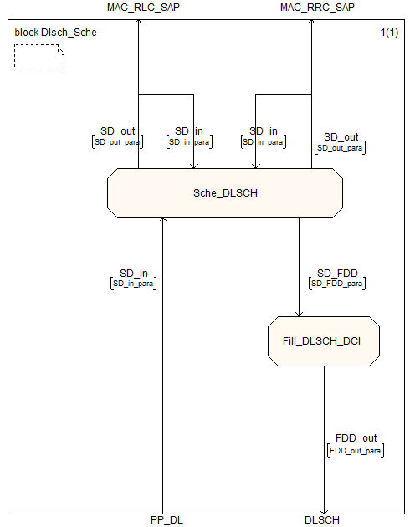

Fig.6 Block level of Dlsch_Sche.

|  |  |  |  |
| --- | --- | --- | --- |
| **Process Name** | **Description** | **File Name** | **Function Name** |
| Sche_DLSCH | Schedule info on DLSCH | eNB_scheduler.c | schedule_ue_spec() |
| Fill_DLSCH_DCI | Second stage of DLSCH scheduling, after schedule_SI, schedule_RA and schedule_dlsch have been called. This routine first allocates random frequency assignments for SI and RA SDUs using distributed VRB allocations and adds the corresponding DCI SDU to the DCI buffer for PHY. It then loops over the UE specific DCIs previously allocated and fills in the remaining DCI fields related to frequency allocation. It assumes localized allocation of type 0 (DCI.rah=0). The allocation is done for transmission modes 1, 2, 4. | eNB_scheduler.c | fill_DLSCH_dci() |

Table 10. Processes in Dlsch_Sche.

|  |  |  |
| --- | --- | --- |
| **Signal** | **Parameters** | |
| SD_FDD | module_idP, frame_t frameP, subframeP, * RBallocP, RA_scheduledP, * mbsfn_flagP | |
| **Signal** | **Interface** | **Parameters** |
| SD_in | PP_DL | module_idP, cooperation_flag, frameP, subframeP(1, 2, 3, 4, 6, 7, 8, 9) |
| SD_in | MAC_RRC_SAP | Get UE context status or RRC_INACTIVE |
| SD_out | MAC_RRC_SAP | module_idP, rntiP |
| SD_in | MAC_RLC_SAP | Get SDU length( bytes) from RLC through DCCH(SRB1)、DCCH1(SRB2)、DTCH |
| Get status response from RLC through DCCH(SRB1)、DCCH1(SRB2)、DTCH |
| SD_out | MAC_RLC_SAP | module_idP, rntiP, eNB_index, frameP, enb_flagP, MBMS_flagP, channel_idP, *buffer_pP |
| module_idP, rntiP, eNB_index, frameP, enb_flagP, MBMS_flagP, channel_idP, tb_sizeP |
| FDD_out | DLSCH | DLSCH Message |

Table 11. Parameters of signal lines.

## 5.3 ULSCH_Process

### 5.3.1 Introduction

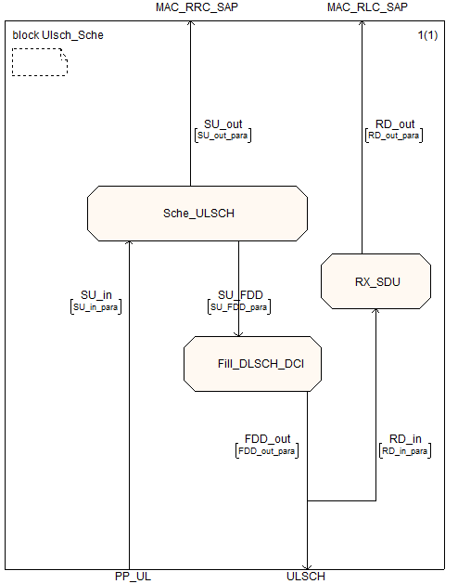

Fig.9 Block level of Ulsch_sche.

|  |  |  |  |
| --- | --- | --- | --- |
| **Process Name** | **Description** | **File Name** | **Function Name** |
| Sche_ULSCH | Schedule info on ULSCH | eNB_scheduler.c | schedule_ulsch() |
| Fill_DLSCH_DCI | Second stage of DLSCH scheduling, after schedule_SI, schedule_RA and schedule_dlsch have been called. This routine first allocates random frequency assignments for SI and RA SDUs using distributed VRB allocations and adds the corresponding DCI SDU to the DCI buffer for PHY. It then loops over the UE specific DCIs previously allocated and fills in the remaining DCI fields related to frequency allocation. It assumes localized allocation of type 0 (DCI.rah=0). The allocation is done for transmission modes 1, 2, 4. | eNB_scheduler.c | fill_DLSCH_dci() |
| RX_SDU | Brief function to indicate a received SDU on ULSCH | eNB_scheduler_ulsch.c | rx_sdu() |

Table 14. Processes in Ulsch_Sche.

|  |  |  |
| --- | --- | --- |
| **Signal** | **Parameters** | |
| SD_FDD | module_idP, frame_t frameP, subframeP, * RBallocP, RA_scheduledP, * mbsfn_flagP | |
| **Signal** | **Interface** | **Parameters** |
| SU_in | PP_UL | module_idP, cooperation_flag, frameP, subframeP(1, 2, 3, 4, 6, 8, 9), |
| SD_out | MAC_RRC_SAP | Get UE context status or RRC_INACTIVE |
| RD_in | ULSCH | enb_mod_idP, CC_idP, frameP, subframeP, rntiP, *sduP, sdu_lenP,  harq_pidP, *msg3_flagP  Get status response from RLC through DCCH(SRB1)、DCCH1(SRB2)、DTCH |
| RD_out | MAC_RLC_SAP | module_idP, rntiP, eNB_index, frameP, enb_flagP, MBMS_flagP, channel_idP, *buffer_pP, tb_sizeP, num_tbP, *crcs_pP |
| FDD_out | ULSCH | ULSCH Message |

Table 15. Parameters of signal lines.

## 5.4 RA_Process

### 5.4.1 Introduction

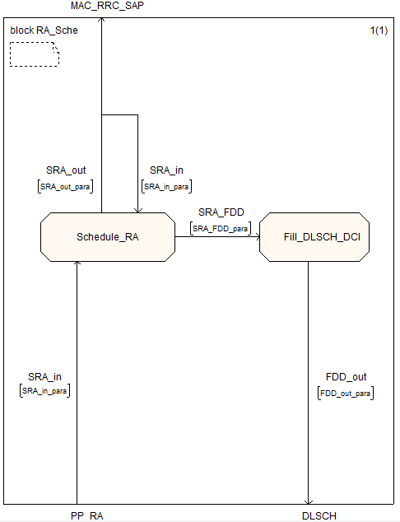

Fig.13 Block level of RA_Sche.

|  |  |  |  |
| --- | --- | --- | --- |
| **Process Name** | **Description** | **File Name** | **Function Name** |
| Schedule_RA | Schedule Msg2; Msg4 whenever it need. | eNB_scheduler_RA.c | Schedule_RA() |
| Fill_DLSCH_dci | Add DCI format | eNB_scheduler.c | fill_DLSCH_dci() |

Table.19 Processes in RA_Sche.

|  |  |  |
| --- | --- | --- |
| **Signal** | **Parameters** | |
| SRA_FDD | module_idP, frameP, subframeP, * RBallocP, RA_scheduledP, * mbsfn_flagP | |
| **Signal** | **Interface** | **Parameters** |
| SRA_out | MAC_RRC_SAP | module_idP, CC_idP, frameP,  srb_idP, nb_tbP, buffer_pP,  eNB_flagP, eNB_indexP,  mbsfn_sync_areaP |
| SRA_in | PP_RA | module_idP, cooperation_flag, frameP, subframeP(0,5,6,7,9) |
| SRA_in | MAC_RRC_SAP | Get SDU length from RRC through CCCH(SRB0) |
| FDD_out | DLSCH | XXX |

Table 20. Parameters of signal lines.

## 5.5 SI_Process

### 5.5.1 Introduction

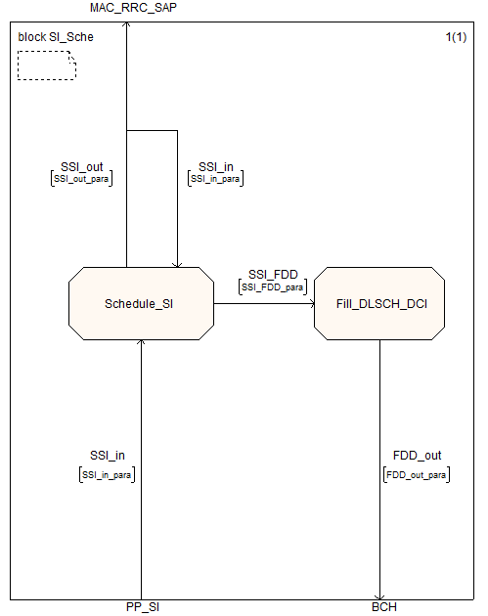

Fig.16 Block level of SI_Sche.

|  |  |  |  |
| --- | --- | --- | --- |
| **Process Name** | **Description** | **File Name** | **Function Name** |
| Schedule_SI | Schedule System Information | eNB_scheduler_bch.c | schedule_SI() |
| Fill_DLSCH_dci | Add DCI format | eNB_scheduler.c | fill_DLSCH_dci() |

Table 23. Processes in SI_Sche.

|  |  |  |
| --- | --- | --- |
| **Signal** | **Parameters** | |
| SSI_FDD | module_idP, frameP, subframeP, * RBallocP, RA_scheduledP,* mbsfn_flagP | |
| **Signal** | **Interface** | **Parameters** |
| SSI_in | PP_SI | module_idP, cooperation_flag, frameP, subframeP(1, 2, 3, 4, 6, 7, 8, 9) |
| SSI_in | MAC_RRC_SAP | Get SDU length from RRC through BCCH |
| SSI_out | MAC_RRC_SAP | module_idP, CC_idP, frameP, srb_idP, nb_tbP, buffer_pP,  eNB_flagP, eNB_indexP, mbsfn_sync_areaP |
| FDD_out | BCH | BCH Message |

Table 24. Parameters of signal lines.

## 5.6 Configuration

### 5.6.1 Introduction

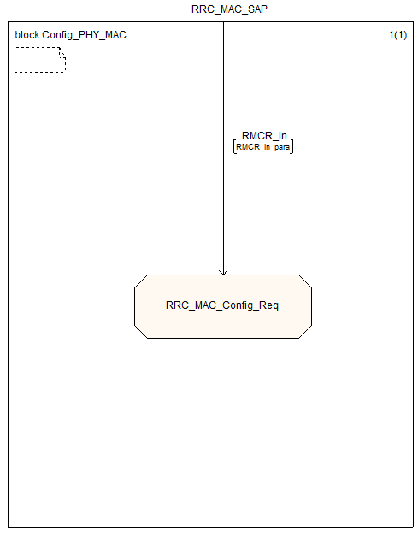

Fig.19 Block level of Config_PHY_MAC.

|  |  |  |  |
| --- | --- | --- | --- |
| **Process Name** | **Description** | **File Name** | **Function Name** |
| RRC_MAC_Config_Req | Brief RRC Configuration primitive for PHY/MAC. Allows configuration of PHY/MAC resources based on System Information (SI), RRCConnectionSetup and RRCConnectionReconfiguration messages. | config.c | rrc_mac_config_req() |

Table 27. Processes in Config_PHY_MAC.

|  |  |  |
| --- | --- | --- |
| **Signal** | **Parameters** | |
| N/A | N/A | |
| **Signal** | **Interface** | **Parameters** |
| RMCR_in | RRC_MAC_SAP | module_idP, CC_id, eNB_flag, rntiP, eNB_index, *radioResourceConfigCommon,  *physicalConfigDedicated,  #ifdef Rel10  *sCellToAddMod_r10,  #endif  **measObj, *mac_MainConfig, logicalChannelIdentity,  *logicalChannelConfig, *measGapConfig, *tdd_Config,  *mobilityControlInfo, *SIwindowsize, *SIperiod,  *ul_CarrierFreq, *ul_Bandwidth,  *additionalSpectrumEmission,  *mbsfn_SubframeConfigList  #ifdef Rel10  MBMS_Flag,  *mbsfn_AreaInfoList,  *pmch_InfoList  #endif  #ifdef CBA  ,num_active_cba_groups, cba_rnti  #endif |

Table 28. Parameters of signal lines.