
Guidelines for SSAR Speech Transcriptions
Transcription supervisor: Saeid Mokaram
Version 1.4 May 2015
** Please note that you must read the entire document before starting to transcribe. **

Background to Project
The Sheffield Search and Rescue (SSAR) corpus is a two-party human/human conversational speech corpus which was made based on an abstract communication model during search process in a simulation environment. In this model the main speaker plays the role of a First-Responder by exploring a simulated environment (Fig 1) and reports his/her observations back to a Task-Leader (second speaker). The design of SSAR corpus targets the automated extraction and understanding of valuable information in human/human conversations in the context of crisis response communication scenario.
In projects related to automated speech recognition and spoken language understanding, availability of high quality annotated databases is a critical issue. Therefore, an effort has been made to design, collect and annotate a two-party human/human conversational speech which includes 12 hours of audio, word level annotation, speaker location and actions information for each conversation. The aims is to make the SSAR corpus widely available for the research community, thereby contributing to the research infrastructure in the field. This work is a part of a PhD research which is started in December 2012 and is expected to finish at this stage by the end of 2015 and may continue afterwards.
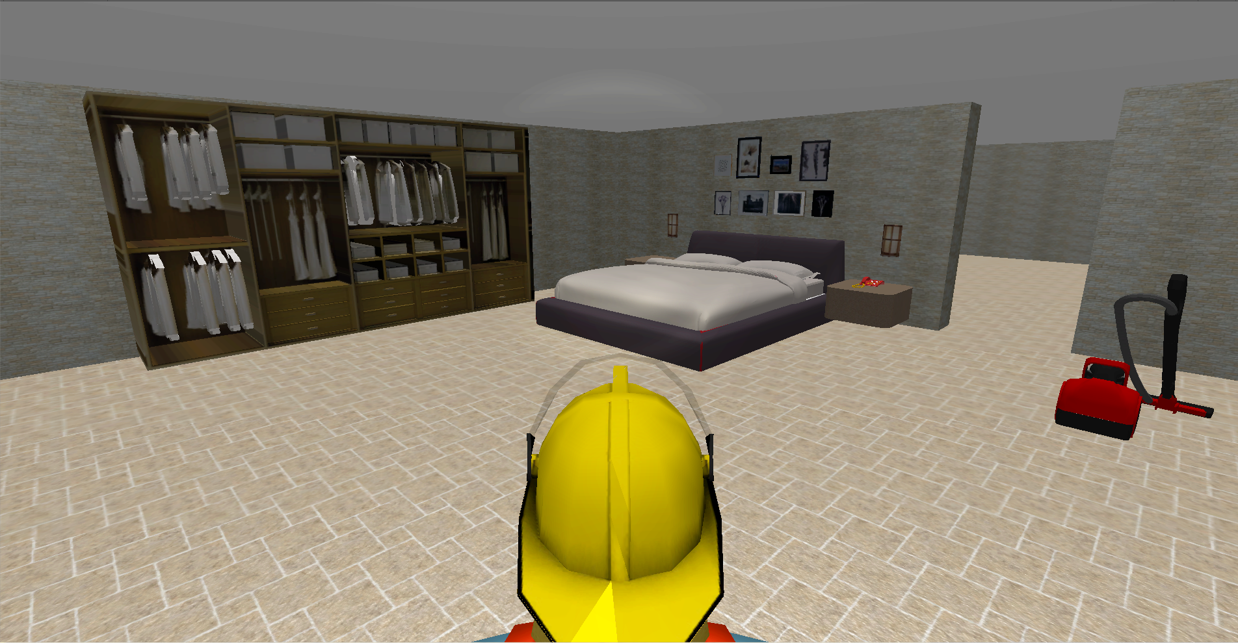

Figure 1: Simulation environment

TranscriberAG software
TranscriberAG is a tool for segmenting, labelling and transcribing speech documents. Here is the link to the TranscriberAG web-page: http://trans.sourceforge.net/en/presentation.php
You can find Linux, Windows and Mac OS versions of TranscriberAG in ”TranscriberAG” folder or download the latest version from the TranscriberAG web-page. For installation please follow the “binary installations” manuals in this link: http://trans.sourceforge.net/en/install.php
After installation you need to load the provided configuration file (”config.cfg”) by following “Options->Load_configuration_file...” in TranscriberAG menu.
TranscriberAG is a general purpose transcribing software therefore not all its functions are required for transcribing the SSAR corpus. A list of functions that are required is provided in the Appendix of this guideline sheet.
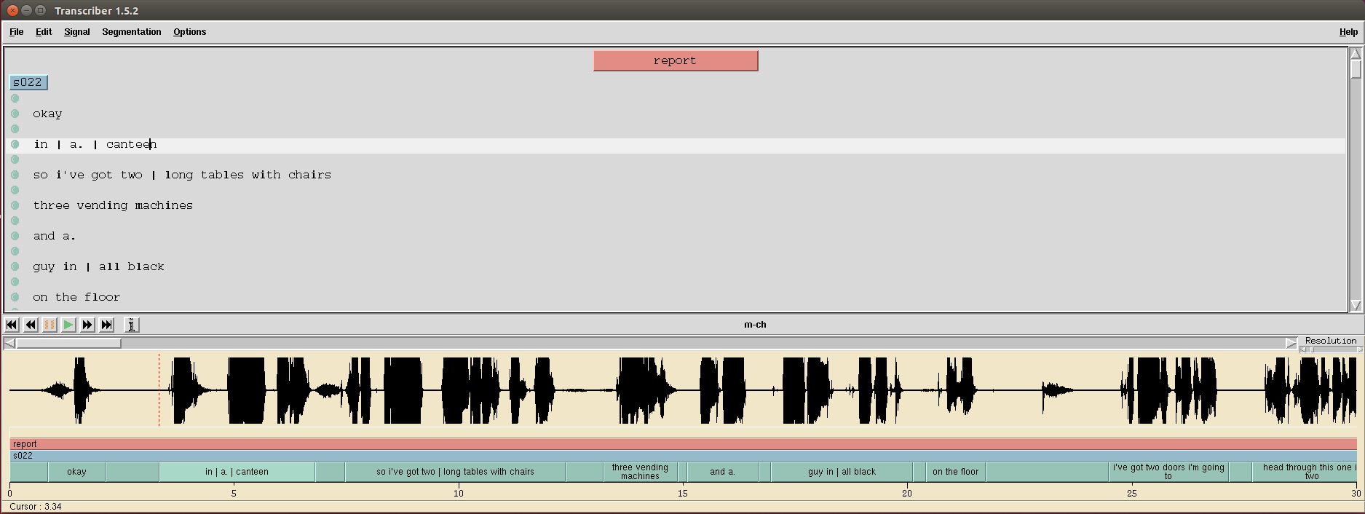
Figure 2: The interface of TranscriberAG. The gray area is where the text transcriptions are inserted. The yellow area shows the wave form of the speech signal. The green horizontal bar shows the speech/non-speech segments and below that is time.

Ask for help
Any time you need help, you can contact Saeid Mokaram:
Email: s.mokaram@sheffield.ac.uk ; Mobile: 07453678187
Address: Speech and Hearing research group, room 141, Department of computer science, University of Sheffield, S1 4DP

Transcription Guidelines
The following flow chart (Fig 3) outlines briefly the basic steps of the transcription process. Each of these steps is then explained in detail below.

Figure 3: basic steps of the transcription process

How to Open a Transcription
You may have received either “m-ch-command_file.txt” or “s-ch-command_file.txt”. It includes lines of commands with the format such as (in Linux version) “trans map1/start-room6/s022-s021/16kHz_16bit/m-ch.wav map1/start-room6/s022-s021/transcript/m-ch.trs”
- First you need to open a command window (terminal Linux/Mac or command prompt Windows).
- Then change your current directory to the “data” folder (e.g. “cd ~/trans/data”).
- What you need to do is just copy one line at a time and past it in the Terminal. After pressing Enter the TranscriberAG starts and automatically loads an audio file and its corresponding automatic segmentation and transcription file.
- Now one audio document is ready for transcription.
- Remember to save (Ctrl+S) frequently during transcription.
- After finishing one transcription go back to step 3 until finishing all the lines of commands.
It is recommended that you make a copy of “m-ch-command_file.txt” and “s-ch-command_file.txt” files so when you finished with one audio document you can remove the corresponding line of command in the copied file. It will help you keep track of the audio documents which are not transcribed yet.
All the audio documents are auto-segmented and auto-transcribed. This is just to make the task slightly easier for you; however it doesn't mean that they are correct and reliable. So you need to check the transcriptions and correct them according to the presented standards in this guideline.
This is a two-party conversation similar to a telephone talk. The main speaker voice and the second speakers voice are recorded on m-ch and s-ch channels respectively. This means that you will hear one speaker at a time while you are transcribing. These two types of audio documents are slightly different. The difference is that all the “m-ch”s are mainly speech, while all the “s-ch”s are mainly silent with just very short speech parts (such as confirming, asking questions etc.). Transcription supervisor will allocate you with either m-ch or s-ch type of data.

Segmentation
Each audio document must be broken into small segments, ideally separating speech from non-speech/silence regions. This task can be very time consuming, and for this reason we have used an automatic pre-segmentation system to do a first pass on the data.
As you listen to the audio documents the main task here is to check and adjust the boundaries of the segments. The segment boundaries should be adjusted to ensure they accurately indicate when the speech starts, when it stops (ensuring not to cut any sounds off at the beginning or end of the segment).
Automatically detected segments may need to be broken into smaller segments, or have their boundaries adjusted. Silence/pause is really the main determiner, perhaps followed by syntax.
These smaller segments are often called utterances. The speech can be broken into chunks based on pauses within the speech stream, preferably at syntactic boundaries corresponding to sentences.
At first this may seem a little difficult as clear grammatical sentences are not often present in natural speech. However, once you become more experienced doing speech transcriptions the task of where to place segment boundaries becomes clearer and quite natural.
The general rule is that if you have to think too long and hard about where to place a segment boundary, you probably don’t need to put one in.

Important things to remember about segmentation:
- Each segment should be padded by a small buffer of silence (¼ - ½ second) on both sides (before and after the speech) if possible.
- Breakpoints should be inserted at natural linguistic points in the utterance such as sentence or phrase boundaries to the extent possible.
- Generally most of the speech segments (utterances) are only a few seconds and not more that 1 minute in length.
- Utterances may start or end with Vocal-Noises such as “aspiration”, “cough”, “laugh” and etc.; if there is absolutely no silence between them and speech region you need to include them in speech segment (the vocal-noise is mixed with part of speech). You can ignore those vocal noises that are not loud and you can hardly hear them.
- Vocal noises can be at the middle of the utterances with no or a small silence gap before or after them. You don't need to break the utterances because of them. You just need to add proper Vocal-Noise-Tags in their place.
- If a segment only contains vocal-noise it doesn't need to be annotated. Leave it as blank similar to a silence segment. If it is already automatically annotated with some words or tags, you need to remove them.

Words and Vocal Noise Tags
In this section we explain the steps and guidelines for transcribing the speech within a given time segment. In general, we break noises that are made using the mouth into two categories, Words and Vocal-Noise-Tags.
Most of the speech you encounter can be transcribed into words with standard orthographic representations, such as you would find in a dictionary. But you will also encounter several other types of “verbal” events which will also need to be transcribed. These include words that may not appear in a standard dictionary but that are common in speech, such as reduced forms like “dunno” or “wanna”, or acknowledgements like “uh-huh”, or pause-fillers like um, em, erm, uh, eh, yep, yep, yeah, yup… . In addition, when speech is broken off, there may be word fragments. Finally, there will be vocal sounds, like laughs and coughs and sighs which do not have usual lexical representations. For this transcription effort, we consider all except this last category to be “words” and transcribe them as such, using a standardized set of spellings; the members of the last group are instead transcribed using special tags more fully described below.
It is important to remember that (where possible) the transcription should be an accurate record of what was actually said, and speakers should not be corrected to make their speech more grammatically correct. For example if the participant says “I dunno” this should be transcribed as it is heard, not as “I don’t know”.
In case you encounter spoken phrases which you are not confident what written form to use, write what you think is correct in parentheses ( e.g. (whatcha) ) so later they will be checked by transcription supervisor.
Vocal-Noise-Tags describe sounds that are made using the mouth (or nose) but that do not have standard lexical representations. In these transcriptions, we have reduced the number of these which will be annotated to four, each of which has a simple symbolic representation. These will be:
Vocal Noise Tags | Notes
@ | aspiration
% | cough, throat clearing
$ | laugh
# | other prominent vocal noise (e.g. creaky voice, yawn, tongue click, etc)
Table 1: Vocal-Noise-Tags
The following text provides an example:
okay % i'm in the first room and it's a kitchen
* It will probably be useful to make a list of these symbols and keep them handy when you are transcribing, perhaps on a sticky note glued to your monitor.

Important information about transcribing words and vocal noises
- Transcribe verbatim, without correcting grammatical errors, e.g. “I seen this room before”.
- Standard spoken language should be transcribed as it is spoken, e.g. “gonna” not “going to”, “wanna” not “want to”, “kinda” not “kind of”, etc.
- Avoid word abbreviations, i.e. “doctor” not “Dr”, and “mountain” not “Mt”.
- Remember to watch for common spelling confusions like “its” and “it’s”, “they’re” and “there” and “their”, “by” and “bye”, “of” and “off”, “to” and “too”, etc. which are common in the automatic transcription.
- Mispronunciations: if a speaker mispronounces a word and you know what word was intended, transcribe the word as it should be spelled and mark it with an asterisk after the last letter, e.g. spaghetti*. If you do not know what word was intended, transcribe what you hear and mark it with parentheses, e.g. (fligop).
- Spell out number sequences, e.g. “forty four” not “44”.
- Acronyms should be spelt as they are pronounced, e.g. “nasa”, “t_v_ ” or “d_v_d_” (be careful it is automatically transcribed like “t. v.” ; Please change it to t_v_ ).
- If a speaker does not finish a word, and you think you know what the word was, you can spell out as much of the word as was pronounced inserting a single dash as the last letter of the word, e.g. “ I'm in a kitch- ”.
- Punctuation should be limited in the corpus. You should only use full stops and question marks to punctuate a ‘sentence’. Most of the speech segments are utterances (not sentences) therefore, most of them do not need full stops. Some of the utterances are the final segment of a 'sentence'. If you could detect them use full stops or question marks.
- Some times there are small silence gaps at the middle of utterances (about ¼ to ½ second). Some of them are automatically detected and marked with | however, if there is an undetected silence gap you need to add | at its place or if there is a miss-detection you need to remove the | or replace it with proper words/vocal-noise-tags. In the example below, the speaker made a small pause after saying “there are” and then immediately starts the “two fridge freezers”; so a | indicates this small silence.
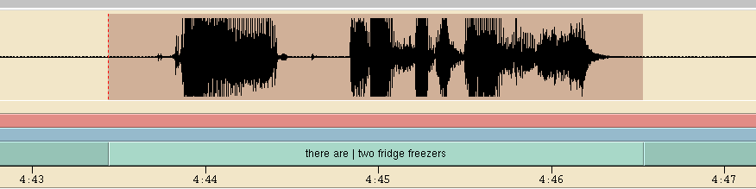
Figure 4: “there are | two fridge freezers”
- Where the speaker interrupts himself to correct or restart or repeat, you need to repeat it as it is. For example in “two one one large cupboard area” which the speaker repeated “one” to correct himself.
- In similar cases when there is a small silence gap use a | . For example: “I just meant | I mean ...”.
- Please note that we are using British standard spelling throughout the transcriptions, i.e. colour vs. color, realise vs. realize.

Practical Procedure
This section outlines the practical procedure for annotating the speech in transcriptions.
You should have just adjusted the time boundaries for a given segment. By the time that you have done this, it is likely that you have understood a lot of what is said in that segment. For this reason, it is a good idea to transcribe this segment before moving on to the next one. The following steps will help you to accurately transcribe the speech.
Remember we are interested in a balance between quality, consistency and accuracy.

The procedure below explains how to transcribe each speech segment:
1) Is what you heard a Vocal-Noise or silence?
Yes: Type proper Vocal-Noise-Tag or | for silence.
No: Go to Question 2 .
2) Did you understand what was said?
Yes: Go to Question 3.
No: Listen again, if you think you might know what the word is but are very uncertain, type that word inside parentheses, e.g. (egg). If after the second listen you still don’t know what a word is, mark the transcription with a ‘(??)’, i.e. using question marks inside the parentheses, where that word should go. Move on to the next word and start again at Question 1. Parentheses should not be used for any purpose other than to indicate uncertainty in these transcriptions. You should in fact mark anything you are uncertain about with parentheses, so that transcription supervisor will easily be able to identify any problem areas.
3) Are you sure about the its spelling (British standard spelling)?
Yes: Go to Question 4.
No: Type the word as you think is correct inside parentheses, e.g. (apple).

4) Does it seem to be a word fragment or unfinished word?
Yes: Transcribe as many of the phonemes as you hear, marking that the word has been cut off with a ‘-‘ as the last letter. If you are uncertain about the phonemes you hear, mark the whole thing with parentheses. e.g. “ I'm in a kitch- ”.
No: Go to Question 5.
5) Is that an acronym:
Yes: Type as they are pronounced, e.g. “nasa”, “t_v_ ” or “d_v_d_” (be careful it is automatically transcribed like “t. v.” ; Please change it to t_v_ ).
No: Type the word and move on to the next word and start again at Question 1.

Appendix

The following table provides details of the TranscriberAG functions that are required when you are transcribing the SSAR corpus.
Functions | Notes
Segmentation | You will note that the transcription has already been divided into speech/ non-speech segments for each channel.
Save: Ctrl+S | Remember to save frequently during transcription.
Select a section of the transcription: Leftclick on green bar | If you left click your mouse on one of the sections in the green transcription channels, that section of the audio channel will be highlighted. If you play the audio now it will only play the audio for that section.
To select several segments together: Shift+leftclick on green bar | If you left click your mouse on one of the sections in the green transcription channels, that section of the audio channel will be highlighted. If you play the audio now it will only play the audio for that section.
Change a segment boundary: Ctrl+leftclick+drag boundary | If you find that the automatic segmentation boundary needs adjusting (perhaps it cuts off the end of the last word that the person says) then you should hold down CONTROL and LEFTCLICK and DRAG the boundary to its new position.
To add a section boundary: Enter | If the automatic segmentation has missed a segment (for example a section of silence) you should first CLICK on the green channel, then position the cursor at the point in the audio where the section break should appear, and then hit ENTER to add a break.
To delete a section boundary: Shift+Backspace | If the automatic segmentation has incorrectly split what should be a single segment into two segments, you should remove the border between them. LEFTCLICK in the second segment (on the green bar) and hit SHIFT and BACKSPACE.
Play/ Pause: Tab | The TAB key will toggle between play and pause. However, if you have a single segment selected, only that segment will play when you hit TAB. If you then hit TAB again (after it has played that segment), it will play that segment again.  (It may be worth noting that you can modify playback options using the appropriate pull-down menu. It is sometimes helpful to switch to continuous playback or pause-and-continue mode, rather than stopping at segment boundaries.)
Quit/ Exit: Ctrl+q | Quit/ Exit
Up/Down cursor keys | Move between segments
Table 2

Annotators may choose to print this summary table and keep it nearby (perhaps attaching it to their computer screen) while they become more familiar with the software.
Task | Short-cut |  | Example | Description
Save | Ctrl+S |  | (egg) | You are not sure it is actually pronounced “egg”
Select section | Leftclick on green bar |  | (??) | You don't know what is pronounced.
Select several segments | Shift+leftclick on green bars |  | | | There is a short silence gap inside an utterance.
Change segment boundary | Ctrl+leftclick+drag |  | t_v_ | Speaker pronounced TV
Add section boundary | Enter |  | nasa | Speaker pronounced NASA
Delete a section boundary | Shift+Backspace |  | kitch- | uncertain about the rest of phonemes you hear OR it's a word fragment (“kitchen”)
Play/ Pause | Tab |  |  | Table 4
Quit/ Exit | Ctrl-q
Table 3

Consent form
I confirm that I have read and understand the transcriptions guidelines sheet dated 5th May 2015 explaining the above transcription task and have had the opportunity to ask questions about the project.
I understand that my participation is voluntary and that I am free to withdraw at any time without giving any reason and without there being any negative consequences. In addition, should I not wish to answer any particular question or questions, I am free to decline.
I confirm that I do not distribute any copy of this task data in part or in whole to tired parties during or after the task period. In addition, I will not keep any copy of the data after finishing the transcription task.

To be signed when transcriber received the data:
Name of transcriber _ _ _ _ _ _ _ _ _ _ _ _ _ _ _ _ _ _ _ _
Signature _ _ _ _ _ _ _ _ _ _ _ _ _ _ _ _ _ _ _ _
Date dd / mm / yyyy

Transcription supervisor: Saeid Mokaram
Signature _ _ _ _ _ _ _ _ _ _ _ _ _ _ _ _ _ _ _ _
Date dd / mm / yyyy

To be signed when transcriber finished the task:
I confirm that I received the agreed payment in return of the time which I spent for this transcription task.
Name of transcriber _ _ _ _ _ _ _ _ _ _ _ _ _ _ _ _ _ _ _ _
Signature _ _ _ _ _ _ _ _ _ _ _ _ _ _ _ _ _ _ _ _
Date dd / mm / yyyy

