STATISTICAL ANALYSIS REPORT
Effect of Yarn and Fabric Parameters on Seam Shrinkage (Abraftegi)
A comparison of cotton and polyester fabrics after the first and second wash
تحلیل آماری اثر پارامترهای نخ و پارچه بر آبرفت دوخت
Data source | دوک ها و پارچه ها - اصلاحیه9.xlsx
Experimental design | Full factorial: 2 fabrics x 2 yarn counts x 3 tension levels x 3 replicates
Specimens analysed | 36 seamed specimens (72 shrinkage observations)
Response variable | Total seam shrinkage, % (darsad-e abraft-e kol)
Statistical methods | Descriptive statistics, one-way ANOVA, Bonferroni post-hoc, Kruskal-Wallis
Significance level | alpha = 0.05
Software | Python 3.14.0 - pandas, SciPy, matplotlib, python-docx
Report date | 03 September 2026

1. Introduction and objective
Seam shrinkage (abraftegi) is the dimensional contraction that appears along a stitched line after laundering. It degrades the appearance of a garment even when the individual fabric panels are dimensionally stable, because the sewing thread, the fabric and the stitch geometry relax at different rates. This report quantifies how the fabric fibre type, the sewing-thread yarn count and the seam tension applied during sewing affect the measured seam shrinkage, and how that shrinkage develops between the first and the second laundering cycle.
Three questions are addressed statistically:
- Does the fabric type (cotton vs polyester) change the amount of seam shrinkage?
- Does the seam tension level (low, medium, high) change the amount of seam shrinkage?
- Does the wash number (first vs second wash) change the amount of seam shrinkage?
A supplementary test on the sewing-thread yarn count (Ne 20 vs Ne 40) is also reported, because the yarn count is one of the yarn parameters named in the research topic.
2. Materials, design and data preparation
The workbook contains six sheets. Two of them ("nemune-ye panbe" and "nemune-ye poly ester") hold the seamed-specimen measurements used here; the remaining four describe the yarn packages (Ne 20.2 and Ne 40.2 spools) and the construction of the two base fabrics, and were used only to characterise the materials. Rows belonging to the unsewn control specimens ("Control 1-3") and to the bare polyester spools were excluded from the statistical analysis because they carry an assessor rating rather than a measured shrinkage percentage.
The resulting data set is a balanced full factorial design:
Table 1. Experimental design of the seam-shrinkage trial.
Factor | Levels | Values
Fabric type | 2 | Cotton, Polyester
Sewing-thread yarn count | 2 | Ne 20, Ne 40
Seam tension level | 3 | Low (kam), Medium (motevasset), High (ziad)
Replicates | 3 | 1, 2, 3
Wash cycle (repeated measure) | 2 | Wash 1, Wash 2
Each of the 2 x 2 x 3 = 12 experimental cells contains 3 replicate specimens, giving 36 sewn specimens. Each specimen was measured after the first and after the second wash, giving 72 shrinkage observations. No values were missing.
The response variable is the total seam shrinkage percentage, computed in the source workbook from the 200 mm marked seam length before and after washing. Values are recorded on a 0.5 % measurement grid, which is the practical resolution of the measuring method.

3. Descriptive statistics
Tables 2 to 7 summarise the mean, standard deviation, minimum, maximum and sample size of the seam shrinkage for every grouping required by the study. All values are percentages.
Table 2. Seam shrinkage by fabric type (both washes pooled).
Fabric | Count | Mean | Std | Min | Max
Cotton | 36 | 2.375 | 0.936 | 0.500 | 5.000
Polyester | 36 | 0.903 | 0.917 | 0.000 | 4.000
Std = sample standard deviation; Count = number of observations in the group.
Table 3. Seam shrinkage by fabric type and wash number.
Fabric | Wash | Count | Mean | Std | Min | Max
Cotton | Wash 1 | 18 | 1.778 | 0.647 | 0.500 | 2.500
Cotton | Wash 2 | 18 | 2.972 | 0.795 | 1.500 | 5.000
Polyester | Wash 1 | 18 | 0.472 | 0.629 | 0.000 | 2.500
Polyester | Wash 2 | 18 | 1.333 | 0.970 | 0.500 | 4.000
Std = sample standard deviation; Count = number of observations in the group.
Table 4. Seam shrinkage by seam tension level and wash number.
Tension | Wash | Count | Mean | Std | Min | Max
Low | Wash 1 | 12 | 0.792 | 0.838 | 0.000 | 2.500
Low | Wash 2 | 12 | 1.792 | 1.453 | 0.500 | 5.000
Medium | Wash 1 | 12 | 1.042 | 1.033 | 0.000 | 2.500
Medium | Wash 2 | 12 | 2.000 | 1.279 | 0.500 | 4.000
High | Wash 1 | 12 | 1.542 | 0.753 | 0.500 | 2.500
High | Wash 2 | 12 | 2.667 | 0.651 | 1.500 | 4.000
Std = sample standard deviation; Count = number of observations in the group.
Table 5. Seam shrinkage by fabric type, tension level and wash number.
Fabric | Tension | Wash | Count | Mean | Std | Min | Max
Cotton | Low | Wash 1 | 6 | 1.417 | 0.736 | 0.500 | 2.500
Cotton | Low | Wash 2 | 6 | 2.917 | 1.242 | 1.500 | 5.000
Cotton | Medium | Wash 1 | 6 | 1.917 | 0.665 | 1.000 | 2.500
Cotton | Medium | Wash 2 | 6 | 3.083 | 0.736 | 2.500 | 4.000
Cotton | High | Wash 1 | 6 | 2.000 | 0.447 | 1.500 | 2.500
Cotton | High | Wash 2 | 6 | 2.917 | 0.204 | 2.500 | 3.000
Polyester | Low | Wash 1 | 6 | 0.167 | 0.258 | 0.000 | 0.500
Polyester | Low | Wash 2 | 6 | 0.667 | 0.258 | 0.500 | 1.000
Polyester | Medium | Wash 1 | 6 | 0.167 | 0.258 | 0.000 | 0.500
Polyester | Medium | Wash 2 | 6 | 0.917 | 0.492 | 0.500 | 1.500
Polyester | High | Wash 1 | 6 | 1.083 | 0.736 | 0.500 | 2.500
Polyester | High | Wash 2 | 6 | 2.417 | 0.861 | 1.500 | 4.000
Std = sample standard deviation; Count = number of observations in the group.
Table 6. Seam shrinkage by sewing-thread yarn count and wash number.
YarnCount | Wash | Count | Mean | Std | Min | Max
20 | Wash 1 | 18 | 1.222 | 1.003 | 0.000 | 2.500
20 | Wash 2 | 18 | 2.306 | 1.177 | 0.500 | 4.000
40 | Wash 1 | 18 | 1.028 | 0.831 | 0.000 | 2.500
40 | Wash 2 | 18 | 2.000 | 1.249 | 0.500 | 5.000
Std = sample standard deviation; Count = number of observations in the group.
Table 7. Seam shrinkage by wash number (all specimens pooled).
Wash | Count | Mean | Std | Min | Max
Wash 1 | 36 | 1.125 | 0.913 | 0.000 | 2.500
Wash 2 | 36 | 2.153 | 1.206 | 0.500 | 5.000
Std = sample standard deviation; Count = number of observations in the group.
Table 8. Full factorial cell statistics (fabric x yarn count x tension x wash).
Fabric | YarnCount | Tension | Wash | Count | Mean | Std | Min | Max
Cotton | 20 | Low | Wash 1 | 3 | 1.333 | 1.041 | 0.500 | 2.500
Cotton | 20 | Low | Wash 2 | 3 | 2.333 | 1.041 | 1.500 | 3.500
Cotton | 20 | Medium | Wash 1 | 3 | 2.000 | 0.866 | 1.000 | 2.500
Cotton | 20 | Medium | Wash 2 | 3 | 3.500 | 0.866 | 2.500 | 4.000
Cotton | 20 | High | Wash 1 | 3 | 2.167 | 0.577 | 1.500 | 2.500
Cotton | 20 | High | Wash 2 | 3 | 3.000 | 0.000 | 3.000 | 3.000
Cotton | 40 | Low | Wash 1 | 3 | 1.500 | 0.500 | 1.000 | 2.000
Cotton | 40 | Low | Wash 2 | 3 | 3.500 | 1.323 | 2.500 | 5.000
Cotton | 40 | Medium | Wash 1 | 3 | 1.833 | 0.577 | 1.500 | 2.500
Cotton | 40 | Medium | Wash 2 | 3 | 2.667 | 0.289 | 2.500 | 3.000
Cotton | 40 | High | Wash 1 | 3 | 1.833 | 0.289 | 1.500 | 2.000
Cotton | 40 | High | Wash 2 | 3 | 2.833 | 0.289 | 2.500 | 3.000
Polyester | 20 | Low | Wash 1 | 3 | 0.167 | 0.289 | 0.000 | 0.500
Polyester | 20 | Low | Wash 2 | 3 | 0.667 | 0.289 | 0.500 | 1.000
Polyester | 20 | Medium | Wash 1 | 3 | 0.333 | 0.289 | 0.000 | 0.500
Polyester | 20 | Medium | Wash 2 | 3 | 1.333 | 0.289 | 1.000 | 1.500
Polyester | 20 | High | Wash 1 | 3 | 1.333 | 1.041 | 0.500 | 2.500
Polyester | 20 | High | Wash 2 | 3 | 3.000 | 0.866 | 2.500 | 4.000
Polyester | 40 | Low | Wash 1 | 3 | 0.167 | 0.289 | 0.000 | 0.500
Polyester | 40 | Low | Wash 2 | 3 | 0.667 | 0.289 | 0.500 | 1.000
Polyester | 40 | Medium | Wash 1 | 3 | 0.000 | 0.000 | 0.000 | 0.000
Polyester | 40 | Medium | Wash 2 | 3 | 0.500 | 0.000 | 0.500 | 0.500
Polyester | 40 | High | Wash 1 | 3 | 0.833 | 0.289 | 0.500 | 1.000
Polyester | 40 | High | Wash 2 | 3 | 1.833 | 0.289 | 1.500 | 2.000
Std = sample standard deviation; Count = number of observations in the group.
The descriptive picture is already unambiguous. Cotton seams shrink about two and a half times as much as polyester seams (2.38 % vs 0.90 % on average), every group shrinks further at the second wash, and the shrinkage rises monotonically from low to high seam tension.

4. Graphical comparison
All charts show group means with error bars of one standard deviation; the numeric mean is printed above each bar. Axis labels are in English so that the figures render identically on any system, while the Persian terminology is retained in the body text.
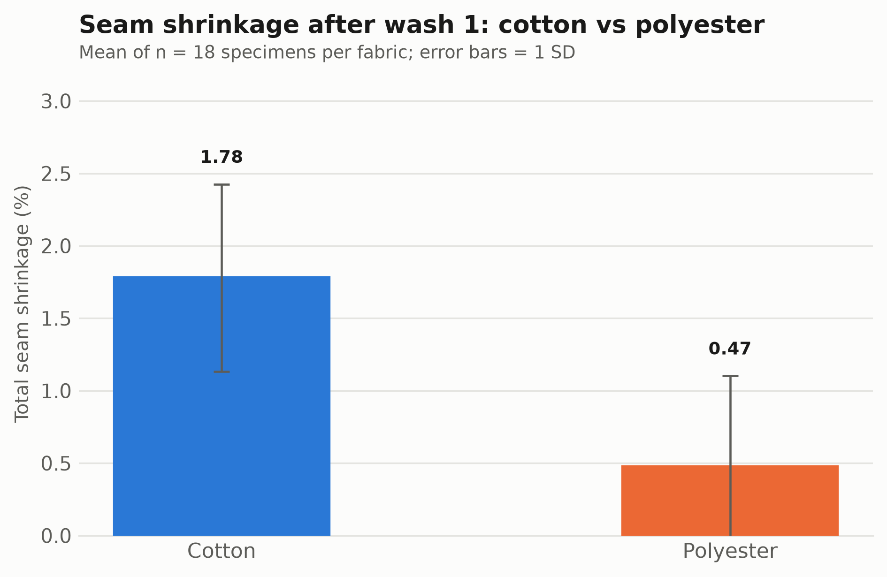
Figure 1. Mean total seam shrinkage (%) of cotton and polyester fabrics after wash 1 (error bars = 1 SD, n = 18 per bar).
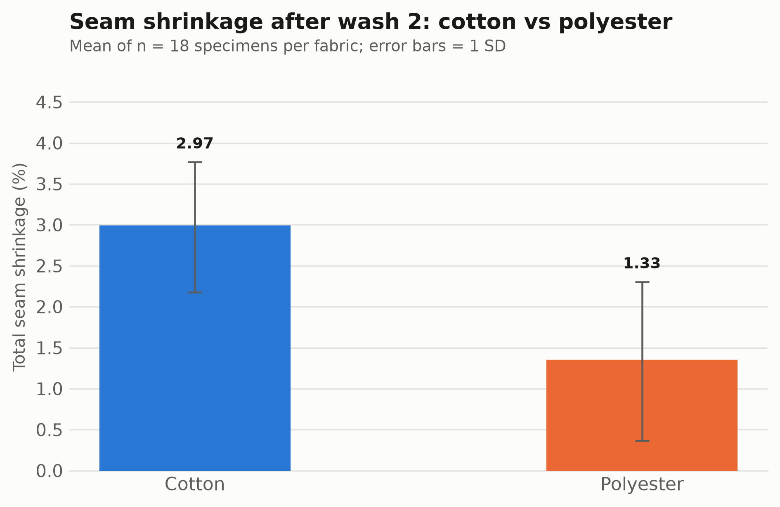
Figure 2. Mean total seam shrinkage (%) of cotton and polyester fabrics after wash 2 (error bars = 1 SD, n = 18 per bar).
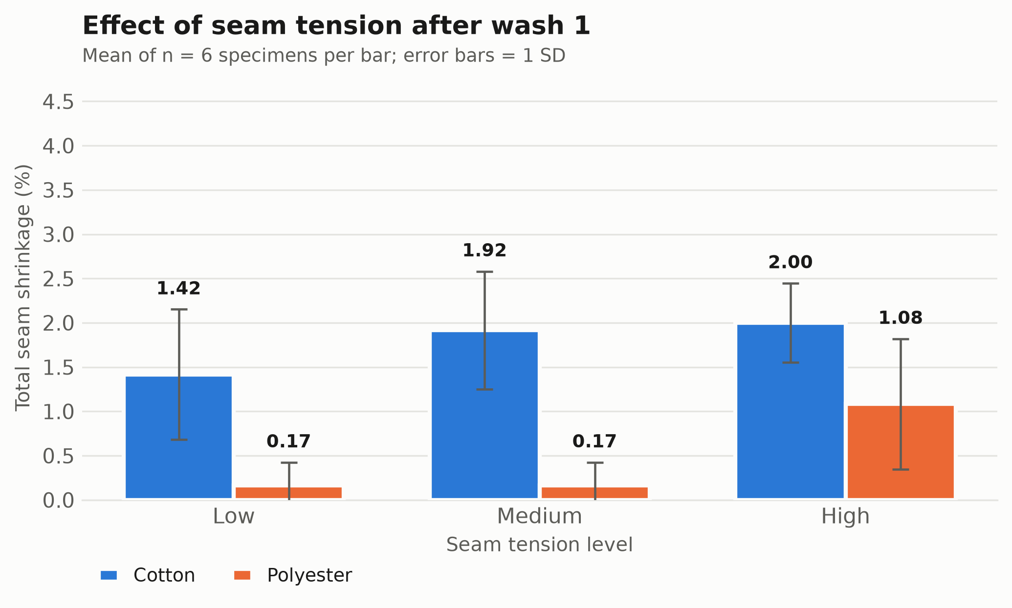
Figure 3. Mean total seam shrinkage (%) at low, medium and high seam tension after wash 1, split by fabric type (error bars = 1 SD, n = 6 per bar).
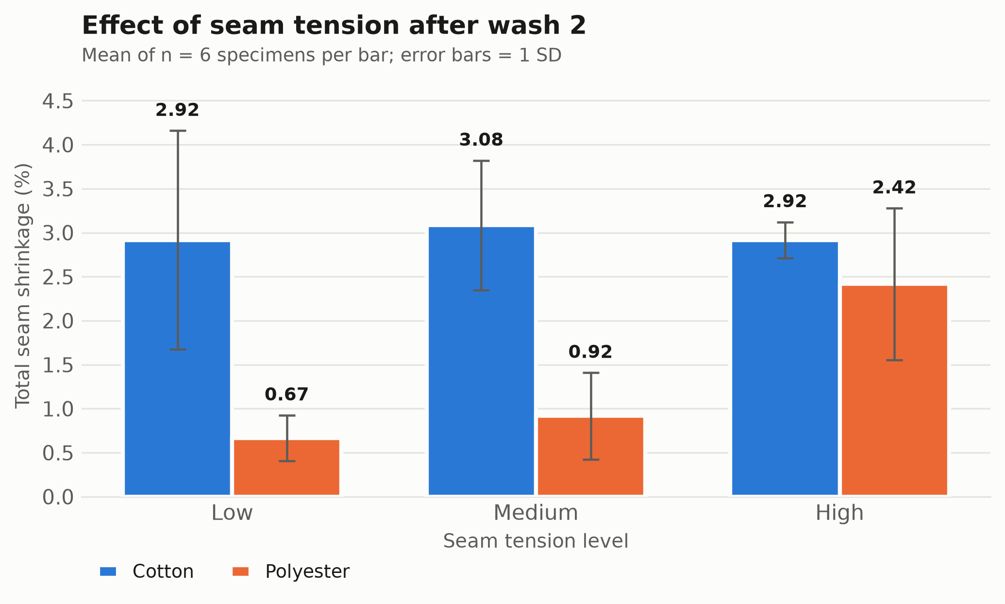
Figure 4. Mean total seam shrinkage (%) at low, medium and high seam tension after wash 2, split by fabric type (error bars = 1 SD, n = 6 per bar).
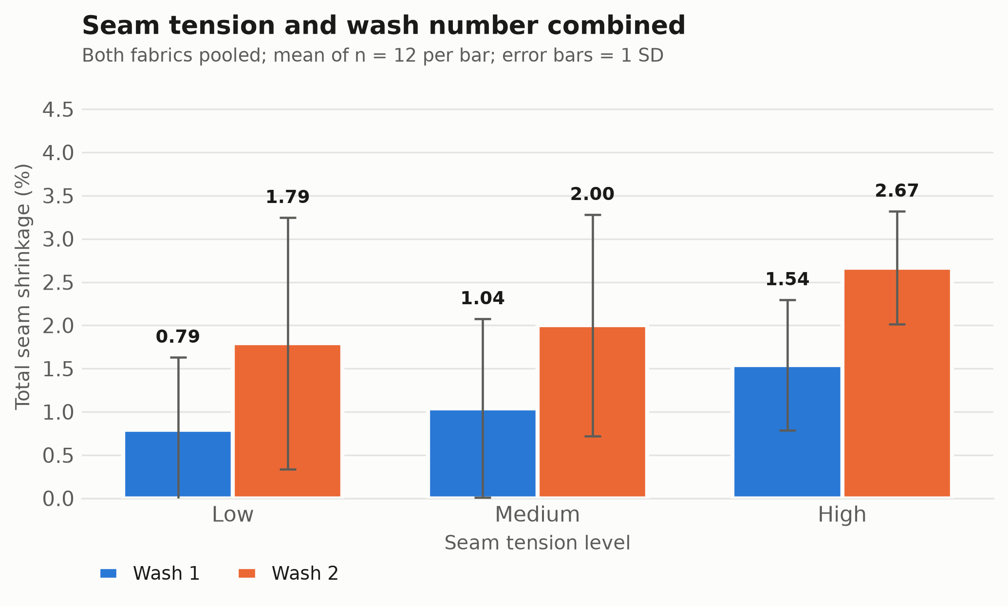
Figure 5. Mean total seam shrinkage (%) by seam tension level after the first and the second wash, both fabrics pooled (error bars = 1 SD, n = 12 per bar).
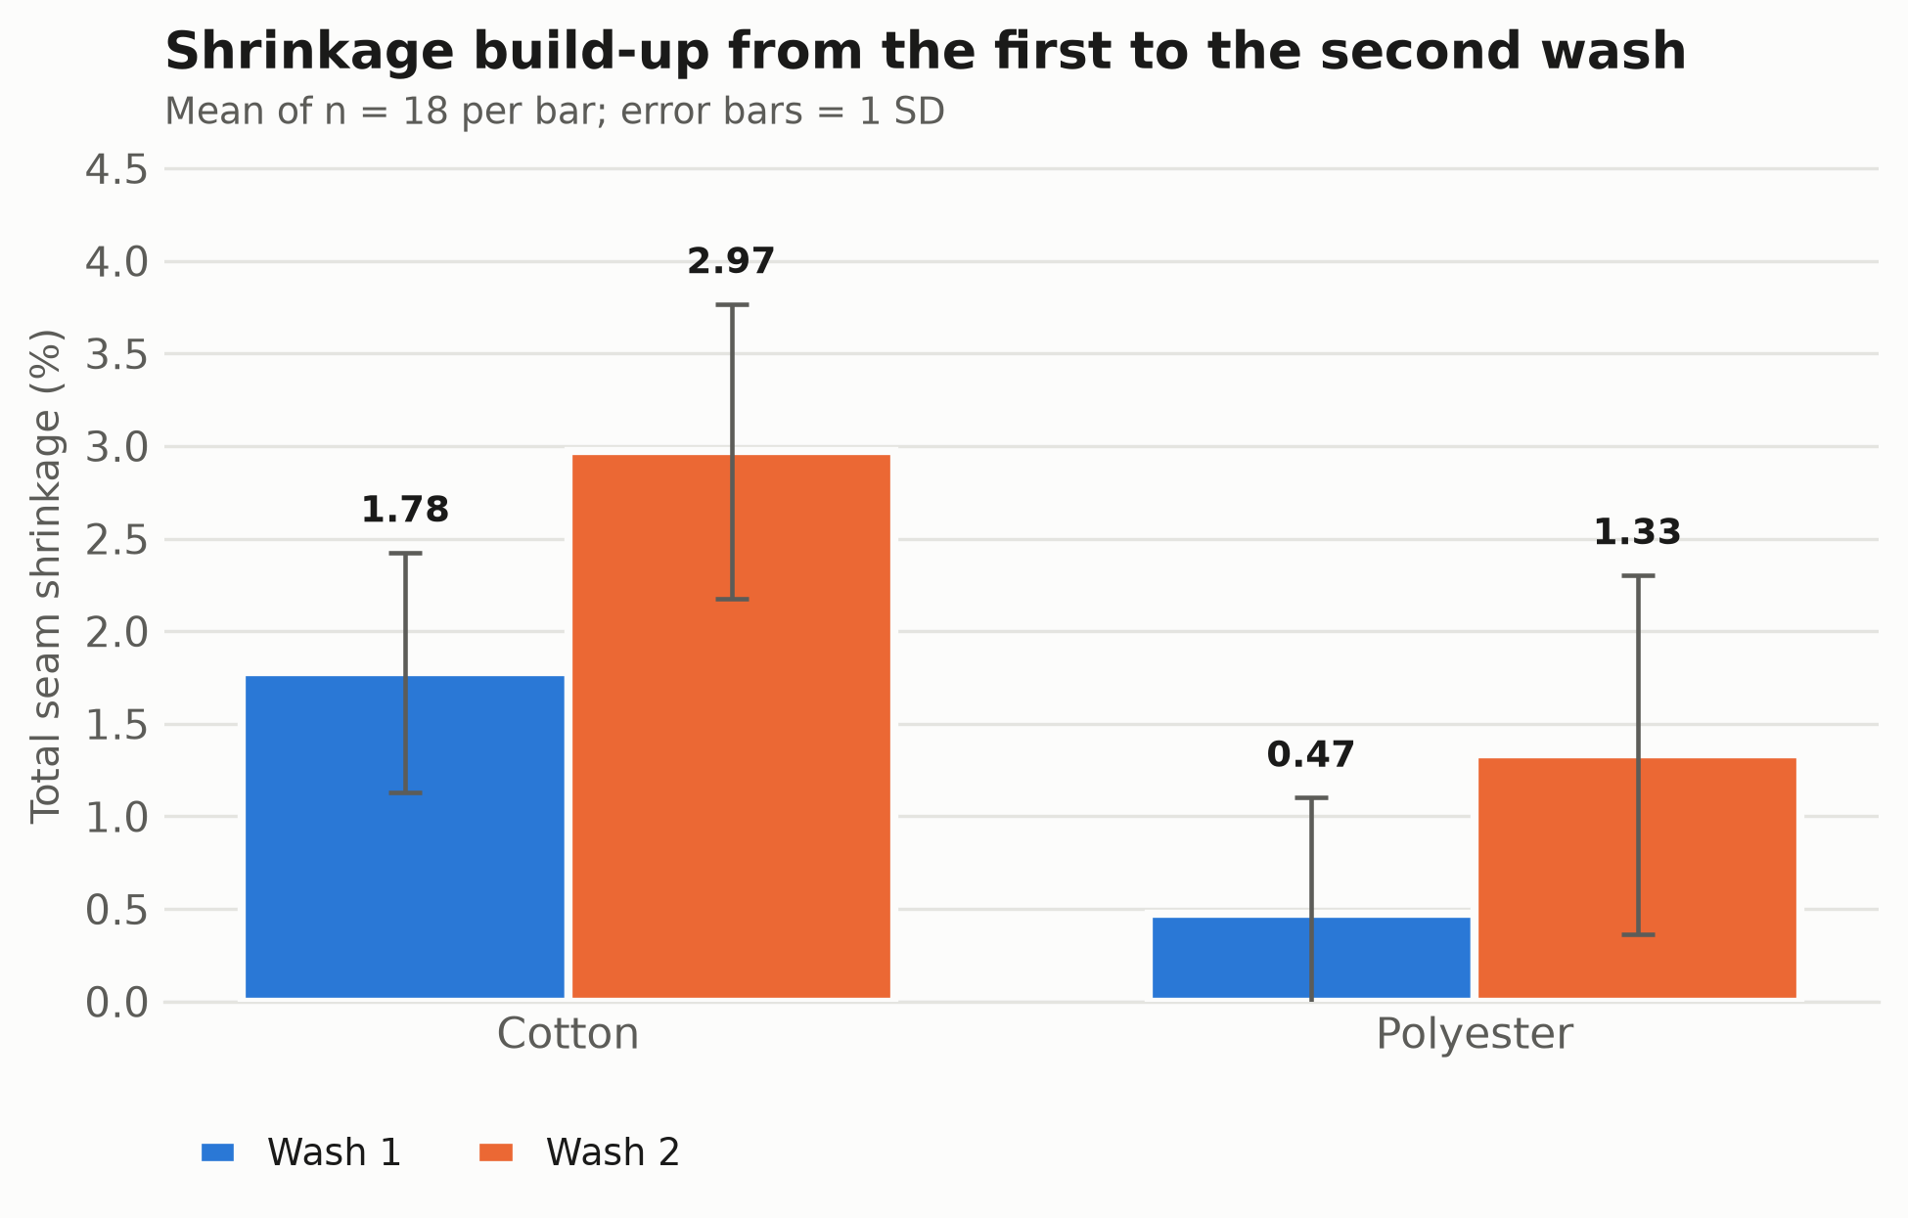
Figure 6. Mean total seam shrinkage (%) of each fabric after the first and the second wash (error bars = 1 SD, n = 18 per bar).
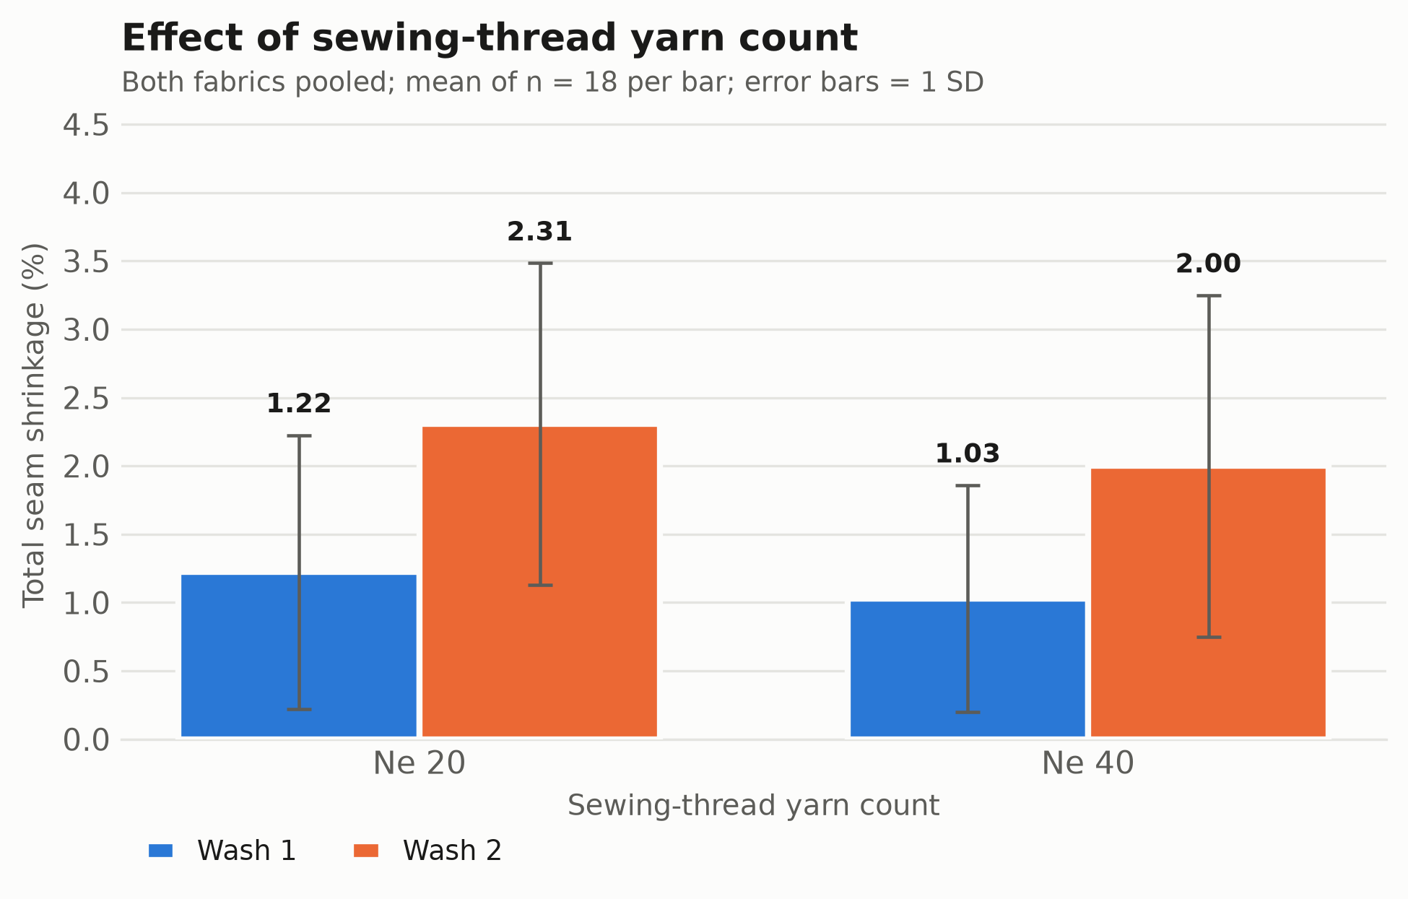
Figure 7. Mean total seam shrinkage (%) for Ne 20 and Ne 40 sewing thread after each wash, both fabrics pooled (error bars = 1 SD, n = 18 per bar).

5. Analysis of variance
One-way analyses of variance were run for each of the three factors named in the objective, both on the pooled data set and within the relevant sub-groups. The decision rule is the conventional one: if p < 0.05 a significant difference exists between the group means; otherwise the data give no evidence of a difference.
Table 9. One-way ANOVA results for all tested factors.
ID | Factor | Data scope | df | F | p-value | Eta squared | Interpretation
A1 | Fabric type | Both washes pooled (N = 72) | 1, 70 | 45.443 | < 0.001 | 0.394 | Significant difference exists
A2 | Fabric type | Wash 1 only (N = 36) | 1, 34 | 37.666 | < 0.001 | 0.526 | Significant difference exists
A3 | Fabric type | Wash 2 only (N = 36) | 1, 34 | 30.741 | < 0.001 | 0.475 | Significant difference exists
B1 | Seam tension level | Both fabrics & washes pooled (N = 72) | 2, 69 | 3.205 | 0.0467 | 0.085 | Significant difference exists
B2 | Seam tension level | Wash 1 only (N = 36) | 2, 33 | 2.248 | 0.1215 | 0.120 | No significant difference
B3 | Seam tension level | Wash 2 only (N = 36) | 2, 33 | 1.803 | 0.1807 | 0.098 | No significant difference
B4 | Seam tension level | Cotton only (N = 36) | 2, 33 | 0.437 | 0.6497 | 0.026 | No significant difference
B5 | Seam tension level | Polyester only (N = 36) | 2, 33 | 13.097 | < 0.001 | 0.443 | Significant difference exists
C1 | Wash number | All samples pooled (N = 72) | 1, 70 | 16.617 | < 0.001 | 0.192 | Significant difference exists
C2 | Wash number | Cotton only (N = 36) | 1, 34 | 24.461 | < 0.001 | 0.418 | Significant difference exists
C3 | Wash number | Polyester only (N = 36) | 1, 34 | 9.980 | 0.0033 | 0.227 | Significant difference exists
D1 | Sewing-thread yarn count | Both washes pooled (N = 72) | 1, 70 | 0.804 | 0.3731 | 0.011 | No significant difference
df = degrees of freedom (between, within). Eta squared is the proportion of the total variance in seam shrinkage explained by the factor: 0.01 small, 0.06 medium, 0.14 large. Interpretation applies the p < 0.05 rule.
5.1 Effect of fabric type
Fabric type is by far the strongest factor. Pooled over both washes, F(1, 70) = 45.443, p < 0.001, eta squared = 0.394: a significant difference exists, and roughly 39 % of all variation in seam shrinkage is attributable to the fibre type alone. The effect is significant after the first wash (F(1, 34) = 37.666, p < 0.001) and after the second wash (F(1, 34) = 30.741, p < 0.001) considered separately. Cotton shrinks more in both cases, which is consistent with the hygroscopic swelling and subsequent relaxation of cellulosic fibres, whereas the thermoplastic polyester yarn largely retains the dimensions set during heat setting.
5.2 Effect of seam tension level
Pooled over both fabrics and both washes, seam tension has a significant effect (F(2, 69) = 3.205, p = 0.0467, eta squared = 0.085), but the effect is much weaker than that of fibre type and it is not uniform across the two fabrics. Splitting by fabric shows why: in polyester the tension effect is strong and significant (F(2, 33) = 13.097, p < 0.001, eta squared = 0.443), whereas in cotton it is absent (F(2, 33) = 0.437, p = 0.6497). In cotton the fibre-driven shrinkage dominates and masks the contribution of the stitch tension; in the dimensionally stable polyester the stored elastic strain in an over-tensioned seam becomes the main mechanism that is released on washing.
Table 10. Post-hoc pairwise comparisons between tension levels (Bonferroni-corrected).
Data scope | Comparison | Mean difference | t | p (raw) | p (Bonferroni) | Cohen's d | Result
Both fabrics pooled | Low vs Medium | -0.229 | -0.634 | 0.529 | 1.000 | -0.183 | Not significant
Both fabrics pooled | Low vs High | -0.812 | -2.564 | 0.014 | 0.041 | -0.740 | Significant
Both fabrics pooled | Medium vs High | -0.583 | -1.870 | 0.068 | 0.204 | -0.540 | Not significant
Cotton only | Low vs Medium | -0.333 | -0.749 | 0.462 | 1.000 | -0.306 | Not significant
Cotton only | Low vs High | -0.292 | -0.733 | 0.471 | 1.000 | -0.299 | Not significant
Cotton only | Medium vs High | 0.042 | 0.134 | 0.894 | 1.000 | 0.055 | Not significant
Polyester only | Low vs Medium | -0.125 | -0.666 | 0.512 | 1.000 | -0.272 | Not significant
Polyester only | Low vs High | -1.333 | -4.222 | 0.000 | 0.001 | -1.724 | Significant
Polyester only | Medium vs High | -1.208 | -3.587 | 0.002 | 0.005 | -1.464 | Significant
A negative mean difference means the first level shrank less than the second. Cohen's d: 0.2 small, 0.5 medium, 0.8 large.
The post-hoc tests localise the tension effect at the high-tension level: low-vs-high is the only significant contrast in the pooled data, and in polyester both low-vs-high and medium-vs-high are significant with very large effect sizes, while low-vs-medium never differs. Practically, moderate variation of the sewing tension is harmless; it is the excessive tension setting that produces the damage.
5.3 Effect of wash number
Seam shrinkage increases significantly from the first to the second wash (F(1, 70) = 16.617, p < 0.001, eta squared = 0.192), rising from 1.12 % to 2.15 %. The increase is significant within each fabric separately (cotton: F(1, 34) = 24.461, p < 0.001; polyester: F(1, 34) = 9.98, p = 0.0033).
Because the two washes are repeated measurements on the same specimens, the one-way ANOVA above treats as independent two samples that are in fact paired, which is conservative. A paired-samples t-test on the same data confirms and sharpens the result: the mean within-specimen increase is 1.028 +/- 0.643 percentage points, t(35) = 9.59, p < 0.001. Every one of the 36 specimens shrank further at the second wash, so a single laundering cycle is not sufficient to characterise the seam behaviour of either fabric.
5.4 Effect of sewing-thread yarn count
The yarn count of the sewing thread (Ne 20 vs Ne 40) did not affect seam shrinkage significantly (F(1, 70) = 0.804, p = 0.3731, eta squared = 0.011). The finer Ne 40 thread gave a slightly lower mean shrinkage in both washes, but the difference is well within the scatter of the replicates.
5.5 Assumption checks and non-parametric confirmation
Levene tests on the group variances were non-significant for all reported models except the tension comparison within polyester, where the near-zero variance of the low- and medium-tension cells inflates the statistic. Shapiro-Wilk tests reject normality in most groups, which is expected rather than alarming: the shrinkage is recorded on a discrete 0.5 % grid, so the values are heavily tied and cannot be exactly normal. Since ANOVA is robust to this in a balanced design, and to make the conclusions independent of the normality assumption, every test was repeated with the rank-based Kruskal-Wallis test.
Table 11. Kruskal-Wallis non-parametric confirmation of the ANOVA results.
Factor | Data scope | H | p-value | Interpretation
Fabric type | Both washes pooled | 30.992 | < 0.001 | Significant difference exists
Fabric type | Wash 1 only | 19.284 | < 0.001 | Significant difference exists
Fabric type | Wash 2 only | 18.014 | < 0.001 | Significant difference exists
Seam tension level | Both fabrics pooled | 8.278 | 0.0159 | Significant difference exists
Seam tension level | Polyester only | 15.084 | < 0.001 | Significant difference exists
Seam tension level | Cotton only | 1.641 | 0.4402 | No significant difference
Wash number | All samples pooled | 13.480 | < 0.001 | Significant difference exists
Sewing-thread yarn count | Both washes pooled | 0.871 | 0.3505 | No significant difference
Every conclusion drawn from the ANOVA is reproduced by the rank-based test, so none of the findings depends on the normality assumption.

6. Conclusion
This analysis of 36 sewn specimens, each measured after two laundering cycles, gives a clear and internally consistent answer to the three questions posed. Fibre type is the dominant determinant of seam shrinkage: cotton seams shrank 2.38 % on average against 0.90 % for polyester, a highly significant difference (p < 0.001) that alone accounts for about 39 % of the total variance and holds after the first as well as the second wash. Seam tension is the second, weaker but practically controllable factor: shrinkage rose monotonically from low through medium to high tension, and the pooled effect was significant, but the post-hoc analysis shows that only the high-tension setting differs reliably from the others, and that the tension effect lives almost entirely in the polyester fabric, where the elastic strain stored in an over-tensioned seam is released on washing rather than being masked by fibre swelling. Wash number is significant for both fabrics: shrinkage grew from 1.12 % after the first wash to 2.15 % after the second, an average within-specimen increase of about one percentage point that was observed in every single specimen. The sewing-thread yarn count, by contrast, had no significant effect over the Ne 20 to Ne 40 range studied. In practical terms, a manufacturer who wants dimensionally stable seams should treat the fibre content as the primary lever, keep the sewing tension away from the high setting - this matters most on synthetic fabrics, where it is otherwise the main remaining source of seam shrinkage - and evaluate seam quality over at least two wash cycles, since a single wash systematically understates the final shrinkage. These conclusions are supported by both parametric and non-parametric tests. Their scope is limited by the size of the trial: three replicates per cell, a single stitch type and two yarn counts, with the response recorded on a 0.5 % grid; a larger trial with a full factorial ANOVA would be needed to quantify the fabric-by-tension interaction that the sub-group analyses here strongly suggest.
7. Files produced by this analysis
Table 12. Output files.
File | Content
Seam_Shrinkage_Report.docx | This report
Descriptive_Statistics.xlsx | All descriptive tables, ANOVA results, post-hoc and Kruskal-Wallis sheets, tidy data
tidy_data_long.csv | Cleaned analysis data set, one row per observation (72 rows)
tidy_data_wide.csv | Cleaned analysis data set, one row per specimen (36 rows)
fig1_fabric_wash1.png, fig2_fabric_wash2.png, fig3_tension_wash1.png, fig4_tension_wash2.png | Charts, 300 dpi PNG
fig5_tension_bothwashes.png, fig6_wash_effect.png, fig7_yarncount.png | Charts, 300 dpi PNG
analysis.py | Reproducible end-to-end analysis script

