**Help**

**[Search mode (Single protein search)]**

You can search a protein by Gene ID (e.g. At5g04140), Symbol (e.g. Glu1), and Description (e.g. Glutamine synthase).

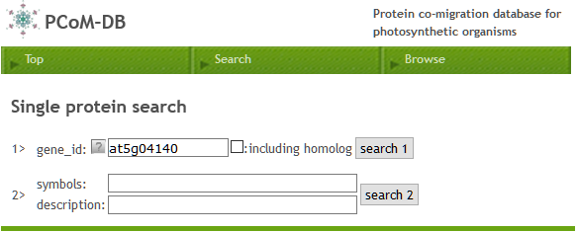

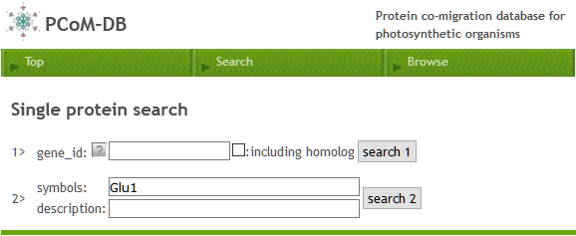

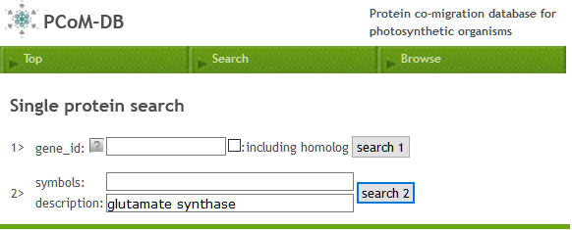

**[Search mode (Multiple protein search)]**

You also can search proteins by Gene IDs after selecting a sample (e.g. stroma).

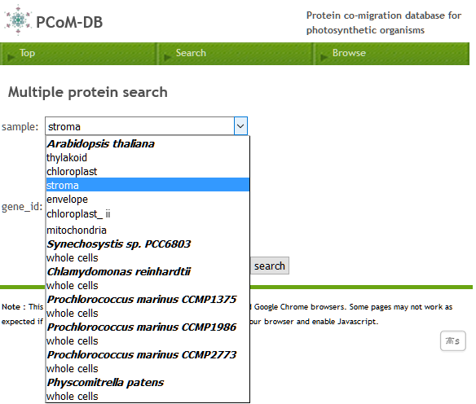

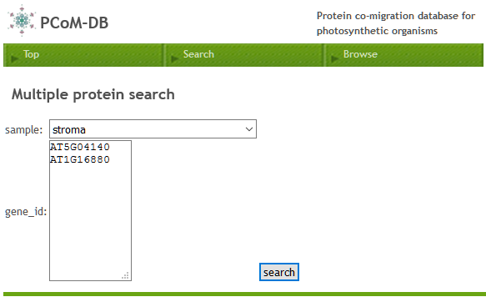

**[Sample selection mode after single protein search]**

After searching a protein, the heat map of a protein migration profile will be appeared.

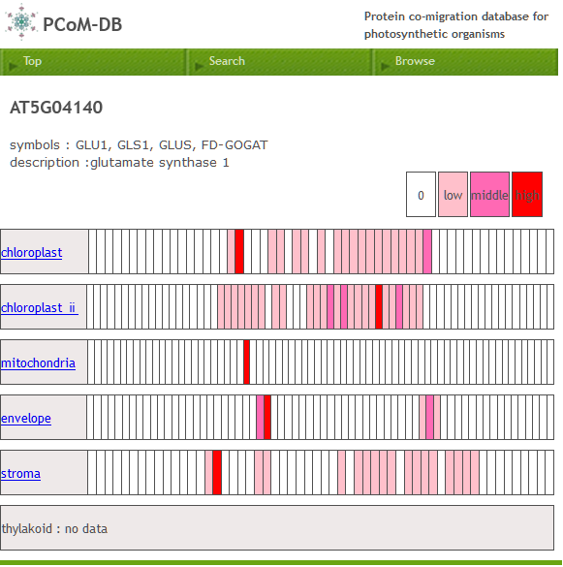

Each column represents a gel slice that are cut from a BN-PAGE gel. Columns are ordered left (a top of gel) to right (a bottom of gel). A red-colored column indicates that your search protein was identified in the corresponding gel slice. The depth of the red-color reflects the relative abundance of the protein accumulation level, which was estimated by a label-free semi-quantitative method, emPAI (Exponentially Modified Protein Abundance Index).

You can click the sample name (i.e. stroma) to get the protein migration profile of your search protein in the sample through “Browse mode”. Using browse mode, you can compare the migration profiles among proteins that are identified in the same sample, which help you to find interacting partners with your protein of interest

.

**[Sample selection mode after multiple protein search]**

After searching proteins, the heat maps of protein migration profiles will be appeared.

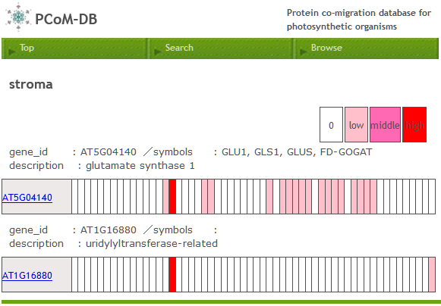

You can compare the heat maps of protein migration profiles among search proteins. Note that a peak on the migration profile correspond a protein band on BN-PAGE. A protein migration profile should be corresponding to the band pattern of protein on BN-PAGE. Thus, protein pairs with the red-colored columns in the same position (i.e. 19th gel slice) are potentially interacted in the corresponding gel slice. You can click the gene ID (i.e. At5G04140 or AT1G1880) to see the migration profile of a selected protein in the sample (i.e. stroma) through “Browse mode”.

**[Browse mode (selection of a protein from a protein list)]**

　　You can select a sample (e.g. stroma) from “Browse” tab.

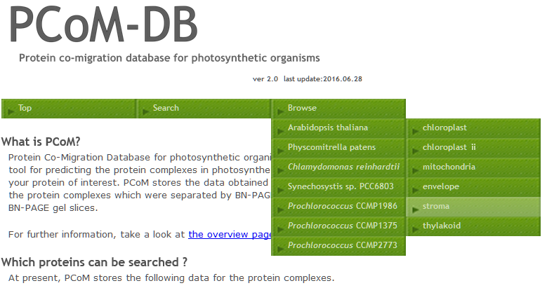

The resulting page will show you the list of the proteins which were identified by LC-MS/MS in the sample.

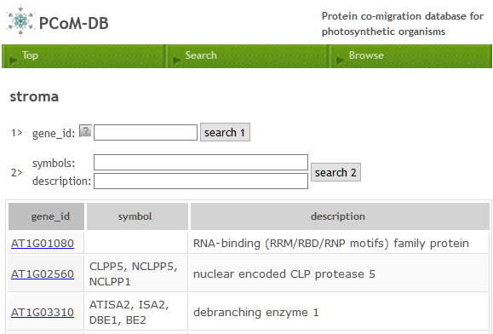

You can click a gene ID (e.g. AT1G01080) see the migration profile of a selected protein.

**[Browse mode (protein migration profile)]**

Through protein search or protein selection from a protein list, you can find a migration profile of a protein of interest.

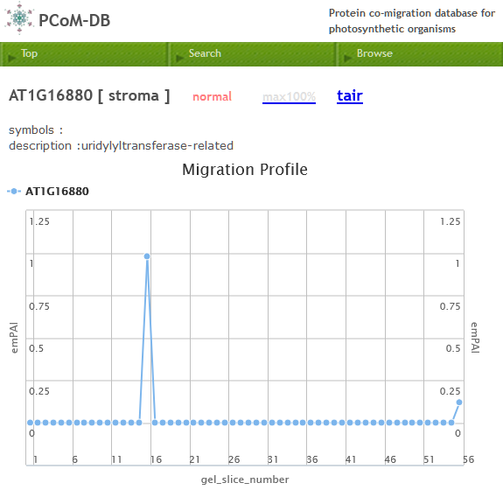

Blue closed circles indicate the emPAI values of the selected protein (e.g. AT1G16880) in the selected sample (e.g. stroma). A peak (e.g. gel slice 16) in the (emPAI-based) migration profile corresponds to the protein band on BN-PAGE. You can click to every closed circle to see the protein list identified in the gel slice.

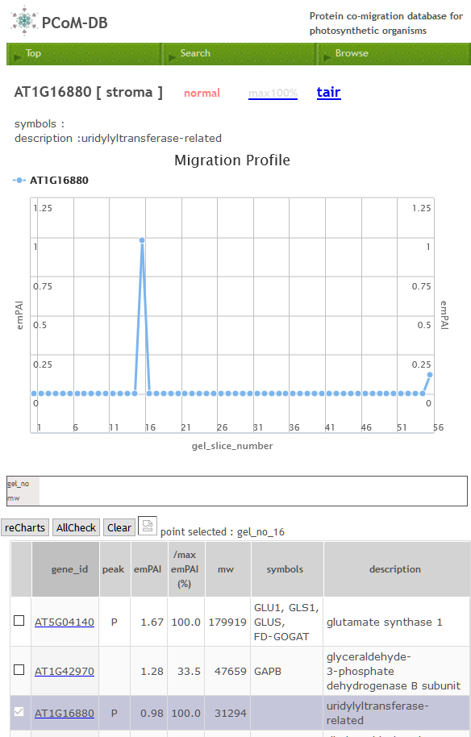

You can select the proteins from the protein list and can compare the migration profiles among them by clicking checkboxes and thereby clicking “reCharts”. “P” in the “peak” column indicates that a peak in the protein migration profile (corresponding to the protein band on BN-PAGE) is detected in the gel slice, suggesting that a protein complex including the protein is existed in the gel slice.

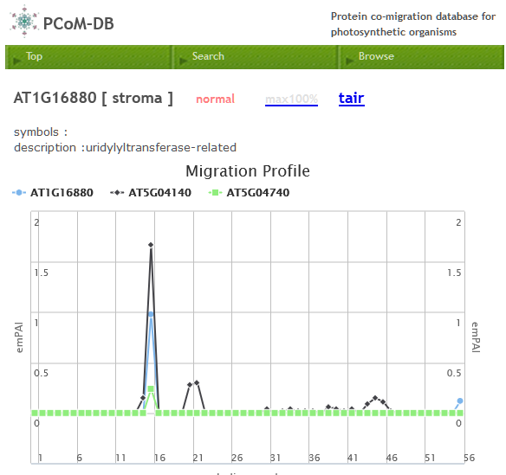

After selecting three proteins (ACR11 (AT1G16880), GLU1 (AT5G04140), ACR12 (AT5G04740))

followed by clicking “reCharts”, their migration profiles will be appeared. The shared peak (n the gel slice 16) among them show that these proteins are co-migrated on BN-PAGE. This further suggests that the protein complex including them can be formed in the position on BN-PAGE.