

BPPCourseworkCoverSheet

Please use the table below as your coversheet for the 1st page of the submission.The sheet should be before the cover/title page of your submission.

Programme
Module name | Principles of Management
Student Reference Number(SRN)
Report/Assignment Title | <Yourassignmenttitle>CW1(Sep25)
Dateof Submission
(Please attach the confirmation of any extension received)
Declaration of Original Work:
- I hereby declare that I have read and understood BPP’s regulations on plagiarism and that this is my original work, and that I have researched, undertaken, completed and submitted in accordance with the requirements of BPP School of Business.

- I declare that where I have used any AI tools, it was for the following reasons(highlight as appropriate):
  - To review a draft
  - To correct language errors
  - Other(please describe)

- I have copied and retained for BPP University’s reference, all AI prompts used in the creation of AI content, and all AI-generated responses in support of my assignment and attached relevant evidence in the appendices.

- I understand that I maybe required to participate in a viva voce, where I will be questioned on any aspect of my assignment, including key concepts, theories, examples used, & any sources included.

- The wordcount, excluding contentstable,bibliography and appendices,is words.
Student Reference Number Date:

By submitting this course work you agree to all rules and regulations ofBPP regarding assessments awards for programm es Please note, submission is your declaration you are fit to sit.
BPPUniversity reserves the right to use all submitted work for educational purposes andmay request that work be published for a wider audience.
BPPSchoolof Business

Management Report
McDonald's Corporation
Table of Contents
- Introduction 1
- Task 1 – Key Management Theories, Concepts and Practices 2
- Task 2 – Management as a Value-Adding Universal Activity 5
- Task 3 – Key Principles and Functions of Management 8
- Conclusion 11
- Task 4 – Critical Reflection and Skills Development Plan 12
- References 15
List of Abbreviations

AI | Artificial Intelligence
CVF | Competing Values Framework
IoT | Internet of Things
LO | Learning Outcome
PESTEL | Political, Economic, Social, Technological, Environmental, Legal
QSCV | Quality, Service, Cleanliness, Value
TAM | Technology Acceptance Model
TQM | Total Quality Management
VRIO | Value, Rarity, Imitability, Organisation

Introduction
McDonald's Corporation, founded in 1940 by Richard and Maurice McDonald and later transformed into a global franchise powerhouse by Ray Kroc, stands as one of the world's most recognised
fast-food chains. By the mid-2020s, the company operated over 36,000 restaurants across more than 100 countries, serving approximately 63 million customers daily, with franchisees operating 95% of these locations. This management report critically analyses McDonald's current management practices, evaluates its response to global business dynamics, examines the application of key management functions, and provides a personal skills development plan. The report is structured around four learning outcomes and aims to recommend strategic improvements for the organisation's continued success.

Task 1 – Key Management Theories, Concepts and Practices (LO1)
  - Introduction to Management Theories at McDonald's
Management theories provide the conceptual foundation upon which organisations build their operational frameworks. McDonald's has historically drawn upon multiple management theories to establish and maintain its market dominance. This section examines how management theories, concepts and practices are currently adding value to McDonald's, with particular focus on the Competing Values Framework (CVF) and Scientific Management Theory.

The Competing Values Framework and McDonald's Management Approach
The Competing Values Framework, developed by Quinn and Rohrbaugh, identifies four organisational culture dimensions: Clan, Adhocracy, Market, and Hierarchy. Each dimension represents a different set of values and assumptions about how organisations should be managed.
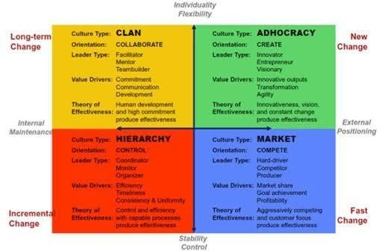

Figure 1: The Competing Values Framework – Clan, Adhocracy, Market, and Hierarchy culture types (Quinn and Rohrbaugh)
McDonald's management approach aligns most closely with the Hierarchy dimension of the CVF. This dimension emphasises stability, predictability, efficiency, and control—values that are deeply embedded in McDonald's operational philosophy. The company's mechanistic structure features a hierarchical system that focuses on efficiency, predictability, calculability and control. This is evident in several aspects of McDonald's operations:
    - Standardisation and Consistency: Ray Kroc's foundational principles of quality, service, cleanliness, and value (QSCV) mandated that franchisees adopt uniform standards, ensuring that a

McDonald's burger in one location would taste identical to one anywhere else. This systematic approach created predictable customer experiences and operational efficiency.
    - Formalised Procedures: Every aspect of McDonald's restaurant operations is governed by detailed manuals and standard operating procedures. From food preparation times to customer service scripts, the hierarchy dimension ensures that activities are performed consistently across the global network.
    - Control Mechanisms: The corporate headquarters exercises significant control over franchisees through detailed contracts, regular inspections, and performance monitoring systems. This control orientation is characteristic of the hierarchy culture, where rules, policies, and procedures guide behaviour.
The hierarchy dimension has contributed significantly to McDonald's success by enabling rapid global expansion, maintaining brand consistency, and achieving economies of scale. However, this approach also presents challenges, as excessive bureaucracy can stifle innovation and limit adaptability to local market conditions—a tension McDonald's continues to manage.

Scientific Management Theory at McDonald's
Scientific Management, pioneered by Frederick Winslow Taylor, advocates for the systematic study of work processes to identify the most efficient methods of production. Taylor's principles include scientific job design, worker selection and training, and the separation of planning from execution.
Scientific Management constitutes a significant part of McDonald's management philosophy, as all those involved in the restaurant know exactly what their specific roles are, what methods would allow them to carry out their tasks most effectively and how their performance is measured. The application is evident in:
    - Task Specialisation: McDonald's divides restaurant operations into specialised roles—grill operators, cashiers, drive-thru staff, and maintenance personnel. Each role has clearly defined responsibilities and standardised procedures, maximising efficiency through specialisation.
    - Time and Motion Studies: McDonald's has historically conducted extensive time-motion studies to optimise kitchen layouts, cooking processes, and customer service workflows. This scientific approach to operations management has enabled the company to serve millions of customers daily with remarkable speed and consistency.
    - Performance Measurement: McDonald's employs rigorous performance metrics, including service times, order accuracy, and customer satisfaction scores. These measurable outcomes reflect Taylor's emphasis on quantifiable performance standards.
    - Employee Training: Hamburger University, McDonald's flagship training institution, represents a systematic approach to worker education. Hundreds of thousands of managers and franchise owners have completed this programme, earning degrees in "Hamburgerology". The curriculum includes modules on customer service and business operations, reflecting the scientific management principle of investing in worker competence.

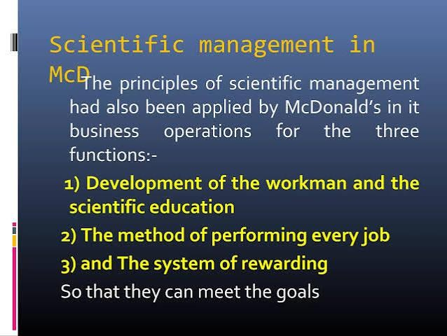
Figure 2: Application of Scientific Management principles in McDonald's operations

Value Creation Through Management Practices
McDonald's management practices create value through multiple mechanisms:
    - Operational Efficiency: The combination of hierarchy culture and scientific management principles has enabled McDonald's to achieve industry-leading operational efficiency. Digital technologies, including self-ordering machines, mobile payment, and delivery services, have further enhanced efficiency by reducing manual errors and increasing service speed.
    - Brand Consistency: Standardised management practices ensure that customers receive a consistent experience across the global network, building brand trust and loyalty.
    - Scalability: The systematic approach to management has facilitated rapid global expansion. The franchising model, supported by robust management systems, has allowed McDonald's to scale its operations while maintaining quality control.
    - Innovation Capability: Despite its bureaucratic tendencies, McDonald's has demonstrated capacity for innovation. The company has embraced the Technology Acceptance Model (TAM) in its digital transformation, using social media, mobile applications, and data analytics to precisely target consumer segments. The company has also launched healthy menu options such as salads and fruit cups, responding to growing consumer demand for healthier eating.

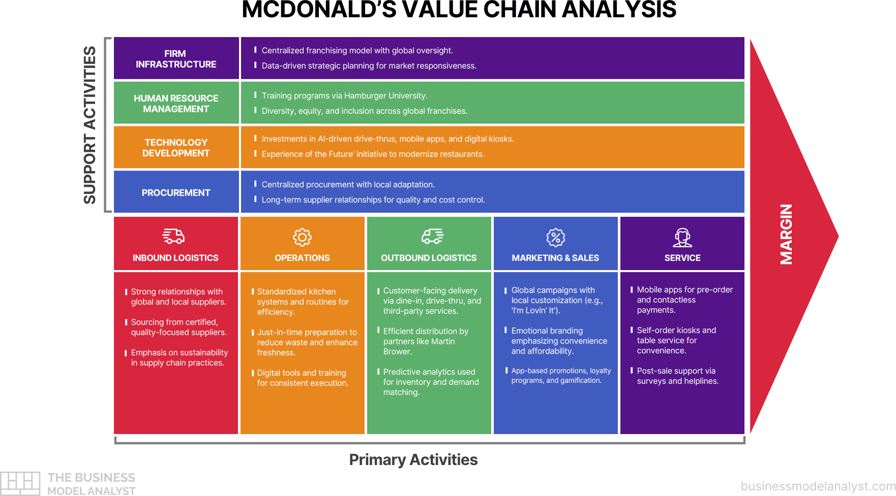

Figure 3: McDonald's Value Chain Analysis – primary and support activities

Summary
McDonald's application of the hierarchy dimension of the Competing Values Framework and Scientific Management Theory has created substantial value through operational efficiency, brand consistency, scalability, and systematic employee development. These management practices have been fundamental to the company's success as a global fast-food leader. However, the organisation must remain vigilant against the potential rigidity that excessive bureaucracy can create, balancing control with flexibility to adapt to evolving market conditions.

Task 2 – Management as a Value-Adding Universal Activity (LO3)
  - Introduction to Global Business Environment Dynamics
The global business environment presents both opportunities and threats for multinational corporations. McDonald's operates in a complex landscape characterised by political volatility, economic uncertainty, sociocultural diversity, technological disruption, legal complexity, and environmental pressures. This section evaluates how McDonald's management has adapted its strategies at global, national and local levels to add value, utilising the PESTEL framework to identify key opportunities and threats.

PESTEL Analysis of McDonald's Global Environment
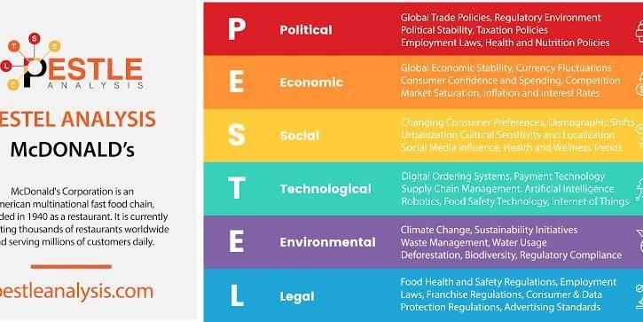
Figure 4: PESTEL Analysis of McDonald's Corporation

Political Factors
Political factors significantly impact McDonald's global operations. Government policies, trade regulations, and geopolitical tensions affect supply chains, market access, and operational costs. McDonald's operates in over 100 countries, making it highly sensitive to changes in global trade policies, tariffs, and trade barriers.
The company's response to the Russia-Ukraine conflict exemplifies political adaptation. In early 2022, McDonald's closed all 850 Russian locations, incurring an estimated $1.2 billion in losses. This decision, driven by humanitarian concerns, demonstrated the company's willingness to sacrifice
short-term profits for long-term reputational value and alignment with Western political sentiments.

Economic Factors
Economic conditions, including inflation, exchange rates, and consumer purchasing power, directly influence McDonald's pricing strategies and financial performance. In response to inflationary pressures and a weakening consumer base, McDonald's has emphasised value offerings. The company has rolled out an "everyday affordable price menu with individual items under $3" in the U.S. However, this value strategy creates margin compression, squeezing franchisee profitability.
Management has warned investors to expect a "meaningful deceleration" from previous growth rates.

Social Factors
Cultural preferences and consumer behaviour necessitate localisation of products and services. McDonald's has demonstrated remarkable adaptability in this regard:
- In France, stores have traditionally served wine
- In India, McDonald's does not use beef, respecting Hindu dietary restrictions
- The company adapts menus globally to cater to local tastes while maintaining core brand identity

Changing consumer preferences towards healthier options pose significant challenges. McDonald's has responded by introducing healthier menu items, removing artificial ingredients from burgers, and committing to sustainable sourcing.

Technological Factors
Technological advancements drive changes in operations, marketing, and customer engagement. McDonald's has embraced technology to improve service and reduce labour costs, implementing digital kiosks for ordering and partnering with UberEats for delivery. The company's digital transformation, guided by the Technology Acceptance Model, includes social media marketing, mobile applications, and data analytics for personalised promotions. McDonald's is also testing automated ordering systems and implementing AI and IoT in supply chain management.

Environmental Factors
Sustainability concerns and climate change drive initiatives for eco-friendly practices and waste reduction. McDonald's has committed to reducing plastic use, promoting environmentally friendly packaging, and implementing sustainable sourcing. Climate change poses supply chain disruption risks, particularly in agriculture and logistics.

Legal Factors
Regulations on food safety, labour practices, and intellectual property shape McDonald's compliance and risk management. The company has faced criticism for underpaying workers and has responded by raising wages at company-owned stores. In 2019, McDonald's announced it was ending its efforts to lobby against minimum wage increases.

Global Strategic Responses
McDonald's has developed sophisticated global strategies to address environmental dynamics:
    - Global Strategy (McDonald's > NEXT): In 2026, McDonald's unveiled "McDonald's > NEXT," a new global growth strategy built around menu innovation, new restaurant designs, improved efficiency, and a reimagined approach to customer service. The plan addresses four areas: raising the bar on menu offerings, deepening consumer connections, boosting operational efficiency, and rethinking hospitality as automation becomes more prominent.
    - National-Level Adaptation: At the national level, McDonald's tailors its strategies to specific country contexts. This includes menu localisation, marketing campaigns that reflect cultural values, and adaptation to local regulatory environments.
    - Local-Level Adaptation: At the local level, McDonald's empowers franchisees to adjust to community preferences while maintaining brand standards. The company's franchise model, which operates 95% of restaurants, enables local responsiveness.

Opportunities and Threats Opportunity: Technological Advancement
Technological advancements present significant opportunities for McDonald's. Digital

transformation can enhance operational efficiency, improve customer experience, and create new revenue streams. Opportunities include:
    - Expansion of delivery services through partnerships
    - Implementation of AI and automation to reduce labour costs
    - Use of data analytics for personalised marketing and menu innovation
    - Development of mobile ordering and payment systems

Threat: Intense Competition

Intense competition in the fast-food industry, particularly from healthier alternatives, poses a significant threat. Traditional competitors are upgrading their menus, and a new wave of specialists are emerging, redefining taste and quality across chicken, beef, and beverages. Competitors including Chick-fil-A have drawn chicken-focused diners away from McDonald's. Changing consumer preferences towards health and sustainability further threaten McDonald's market position.

Value-Adding Management Responses
McDonald's management adds value through several mechanisms:
    - Strategic Agility: The company's ability to adapt strategies at global, national, and local levels enables it to navigate complex environments while maintaining brand coherence.
    - Innovation Culture: Despite its hierarchical structure, McDonald's demonstrates capacity for innovation in menu development, technology adoption, and sustainability initiatives.
    - Stakeholder Management: McDonald's balances the interests of shareholders, franchisees, employees, customers, and communities, creating shared value.

Summary
McDonald's management has demonstrated significant capability in adapting to global business environment dynamics through strategic agility, technological innovation, and stakeholder management. The PESTEL analysis reveals both opportunities (particularly in technology) and threats (intense competition) that require continued strategic attention. The company's value-adding management practices—at global, national, and local levels—have enabled it to maintain market leadership despite significant environmental challenges.

Task 3 – Key Principles and Functions of Management (LO2)
  - Introduction to Management Functions at McDonald's
The four functions of management—planning, organising, leading, and controlling—provide a framework for understanding how McDonald's addresses organisational challenges. This section identifies and critically analyses one internal challenge faced by McDonald's management, applying the VRIO framework to justify the choice, and examines how the four management functions can address this challenge.

Identification of Internal Challenge: Franchisee-Corporate Tension
The selected internal challenge is the growing tension between McDonald's corporate headquarters and its franchisees, particularly regarding value pricing strategies and operational standards. This challenge is significant because franchisees operate 95% of McDonald's restaurants, making their health and cooperation essential to the company's success.
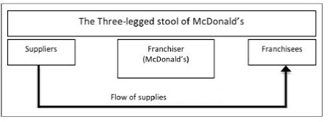
Figure 5: The Three-Legged Stool of McDonald's – Corporation, Franchisees, and Suppliers

Justification Using VRIO Framework
The VRIO framework (Value, Rarity, Imitability, Organisation) analyses internal resources and capabilities. Applying VRIO to McDonald's franchise system:
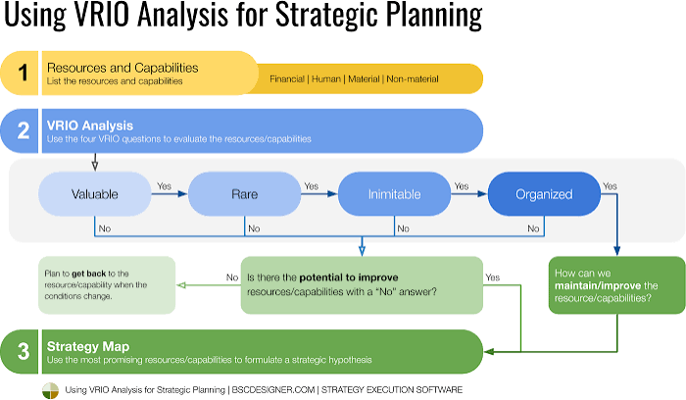
Figure 6: The VRIO Analysis process for strategic planning

Resource | Valuable? | Rare? | Costly to Imitate? | Organised? | Competitive Implication
Franchise Network | Yes | Yes | Yes | Partially | Temporary competitive

advantage (threatened)
Value: The franchise network is highly valuable, generating approximately 90% of McDonald's restaurant margin dollars. In Q1 2026, franchised restaurants generated $4.007 billion in revenue, up 9% year over year.
Rarity: McDonald's extensive global franchise network is rare in the fast-food industry, representing decades of relationship building and brand development.
Costly to Imitate: The franchise system's complexity, including real estate holdings, supply chains, and brand equity, makes it difficult to replicate.
Organisation: The organisation of the franchise relationship is currently under strain. Franchisees report feeling pressure from a cash flow standpoint, and an independent advocacy group has adopted a Franchisee Bill of Rights asserting the "right to set prices without fear of recourse". This organisational weakness threatens the competitive advantage the franchise network provides.
The VRIO analysis reveals that while McDonald's franchise network remains a valuable, rare, and difficult-to-imitate resource, organisational challenges threaten its effectiveness. The health of franchisees is paramount to the brand's long-term strength.

Application of the Four Management Functions Planning
Planning involves setting goals, establishing strategies, and developing plans to coordinate activities. McDonald's planning function must address franchisee-corporate tension through:
    - Collaborative Goal Setting: Involving franchisee representatives in strategic planning processes to ensure alignment between corporate objectives and franchisee realities.
    - Value Strategy Calibration: Developing value pricing strategies that balance customer affordability with franchisee profitability. McDonald's "McValue" platform aims to re-establish the company as the low-price leader, but this must be implemented with franchisee input.
    - Long-Term Investment Planning: Planning for investments in technology, restaurant design, and employee training that benefit both corporate and franchisee interests.

Organising
Organising involves arranging resources and structuring activities to achieve objectives. McDonald's can improve its organisation of franchisee relationships through:
    - Enhanced Communication Channels: Establishing formal mechanisms for franchisee input into corporate decisions, reducing perceptions of top-down control.
    - Support Structures: Strengthening support for franchisees through improved training, operational guidance, and financial assistance.
    - Balanced Governance: Structuring franchise agreements to balance corporate control with franchisee autonomy. McDonald's controls real estate and charges franchisees rent based on a percentage of sales, which can be 18% or higher. More flexible arrangements could reduce tension.

Leading
Leading involves directing and motivating people to achieve organisational goals. McDonald's leadership must address franchisee-corporate tension through:
    - Empathetic Leadership: Adopting leadership approaches that recognise franchisee concerns. The contingency leadership theory suggests that successful leadership changes based on the situation.
    - Path-Goal Leadership: Adjusting leadership behaviour to motivate franchisees. The path-goal theory focuses on adjusting leadership style to motivate followers. McDonald's leaders could adopt more supportive and participative styles.
    - Trust Building: Rebuilding trust through transparent communication and genuine partnership. The company has historically boasted that it would put its tough franchise agreement "in a drawer and ignore it, in favour of a cooperative working relationship with franchisees". Returning to this philosophy could reduce tension.

Controlling
Controlling involves monitoring performance and taking corrective action. McDonald's controlling function must balance standardisation with flexibility:
    - Flexible Performance Metrics: Developing performance metrics that account for local market conditions rather than imposing uniform standards.
    - Constructive Feedback: Using control mechanisms for development rather than punishment. McDonald's senior management includes corporate leaders who work with regional and frontline managers to monitor performance.
    - Early Warning Systems: Implementing systems to identify franchisee distress early, enabling proactive intervention.

Critical Analysis
McDonald's management approach to the franchisee-corporate tension reveals both strengths and weaknesses.

Strengths:
    - The company has recognised the importance of franchisee health and has begun addressing concerns
    - McDonald's continues to generate strong financial performance from its franchise model
    - The company has demonstrated willingness to adapt strategies, as seen in the McDonald's > NEXT plan

Weaknesses:
    - The imposition of value standards has created perceptions of corporate overreach
    - Franchisees report feeling pressure from a cash flow standpoint, indicating financial strain
    - The emergence of franchisee advocacy groups and bills of rights suggests deteriorating trust

Summary
The franchisee-corporate tension represents a significant internal challenge for McDonald's. The VRIO framework reveals that while the franchise network remains a valuable strategic resource, organisational weaknesses threaten its effectiveness. Effective application of the four management functions—planning, organising, leading, and controlling—can address this challenge through collaborative planning, improved organisation of franchisee relationships, empathetic leadership, and flexible control mechanisms. McDonald's must balance the need for brand consistency with franchisee autonomy to maintain the competitive advantage its franchise system provides.

Conclusion
This management report has analysed McDonald's current management practices, evaluated its strategic responses to the global business environment, and examined the application of key management functions. Based on this analysis, the following recommendations are proposed to improve McDonald's success:

Recommendation 1: Enhance Franchisee-Corporate Partnership

McDonald's should formalise franchisee participation in strategic decision-making through advisory councils and collaborative planning processes. The company should revisit its franchise agreements to balance corporate control with franchisee autonomy, recognising that franchisee health is fundamental to long-term success.

Recommendation 2: Balance Standardisation with Flexibility

While standardisation has been central to McDonald's success, the company should develop more flexible approaches to local adaptation. This includes allowing greater franchisee discretion in pricing and menu localisation while maintaining core brand standards.

Recommendation 3: Accelerate Digital Transformation

McDonald's should continue investing in digital technologies, including AI, IoT, and automation, to enhance operational efficiency and customer experience. The McDonald's > NEXT strategy provides a framework for this transformation.

Recommendation 4: Strengthen Sustainability Commitment

McDonald's should enhance its sustainability initiatives, including reducing plastic use, promoting environmentally friendly packaging, and implementing sustainable sourcing. This responds to environmental pressures and consumer preferences while building brand reputation.

Recommendation 5: Invest in Employee Development

McDonald's should expand its investment in employee training and development, building on the

foundation of Hamburger University. This enhances operational quality and employee retention while supporting the company's strategic objectives.
In conclusion, McDonald's has demonstrated remarkable success through effective management practices, strategic adaptation, and the application of key management functions. However, addressing the identified challenges—particularly franchisee-corporate tension—will be essential for sustaining this success in an increasingly competitive and dynamic global environment.

Task 4 – Critical Reflection and Skills Development Plan (LO4)
  - Personal SWOT Analysis

My Strengths | My Weaknesses
1. Strong analytical and research skills developed through academic study | 1. Limited practical management experience in fast-paced operational environments
2. Effective written communication and report writing abilities | 2. Tendency to procrastinate on complex tasks, impacting time management
3. Ability to work independently and take initiative | 3. Limited experience in team leadership and conflict resolution
4. Adaptability and willingness to learn new skills | 4. Difficulty delegating tasks, preferring to maintain control
Opportunities (what can I improve?) | Risks (what stands in the way of my improvement?)
1. Develop practical management experience through internships or part-time supervisory roles | 1. Competitive job market with limited entry-level management opportunities
2. Enhance leadership skills through formal training programmes and mentoring | 2. Balancing academic commitments with skills development activities
3. Improve time management through structured planning and prioritisation techniques | 3. Limited access to senior mentors who can provide guidance and feedback
4. Build professional network through industry events and professional associations | 4. Economic uncertainty affecting graduate employment opportunities

Skills Development Plan

My career aims/objectives | Identification of required skills/competencies | What support and resources do I need? | How will this be achieved and how will I measure success? | When will this be achieved? Target date for review
1. Secure a |  |  |  | December 2026

management trainee position in a multinational corporation within 12 months of graduation | -  Leadership and team management  -  Strategic thinking and  problem-solving  -  Effective communication and presentation  -  Project management | -  Career services at university  -  Professional mentors in target industry  -  Online courses (Coursera, LinkedIn Learning)  -  Industry networking events | -  Complete leadership development programme  -  Attend 3 industry networking events per semester  -  Complete 2 online courses in project management  -  Success: Securing management trainee interview and offer
2. Develop competence in strategic analysis and business consulting | -  Business analysis and modelling  - Data interpretation and decision-making  -  Report writing and presentation  -  Stakeholder management | -  Academic modules in strategy and consulting  - Case study practice  -  Professional certifications (e.g., Six Sigma)  -  Mentorship from consulting | -  Achieve distinction in strategy modules  -  Complete 5 practice case studies  -  Obtain Lean Six Sigma Yellow Belt certification  -  Success: Positive | June 2027

 |  | professionals | feedback on analytical work
3. Build emotional intelligence and conflict resolution capabilities | -  Self-awareness and emotional regulation  -  Active listening and empathy  -  Conflict negotiation  -  Cross-cultural communication | -  Emotional intelligence workshops  -  360-degree feedback from peers and mentors  -  Reflective practice (journaling)  -  Role-play and simulation exercises | -  Complete EI assessment and improvement plan  -  Maintain weekly reflective journal  -  Success: Demonstrated improvement in EI assessment scores | December 2027

Reflective Statement (500 words)
This reflective statement is written in the first person and applies Kolb's Experiential Learning Cycle to analyse my development during this module.

Concrete Experience

Throughout this module, I have engaged deeply with management theories and their practical applications to contemporary organisations like McDonald's. The process of analysing McDonald's management practices, evaluating its strategic responses, and applying the four functions of management has provided me with valuable insights into both organisational dynamics and my own competencies. The requirement to produce a comprehensive management report challenged me to synthesise theoretical knowledge with practical analysis, developing skills that are directly relevant to my career aspirations in business management.

Reflective Observation

Reflecting on my experience, I recognise several areas of personal development. Firstly, my analytical skills have strengthened considerably. The process of applying frameworks such as

PESTEL, VRIO, and the Competing Values Framework to a real organisation has enhanced my ability to think critically and systematically about business challenges. I have learned to move beyond
surface-level observations to identify underlying causes and strategic implications.
Secondly, I have become more aware of my time management challenges. The complexity of the assignment, requiring integration of multiple theories and frameworks across four distinct tasks, highlighted my tendency to procrastinate on challenging components. This awareness has prompted me to develop more structured approaches to project planning and task prioritisation.
Thirdly, I have gained appreciation for the importance of self-awareness in management. The Personal SWOT and Skills Development Plan exercises forced me to honestly assess my strengths and weaknesses, identifying gaps that I must address to achieve my career goals. I recognise that my limited practical management experience is a significant weakness that requires proactive development through internships and mentoring.

Abstract Conceptualisation

Through this module, I have developed several conceptual insights about management and my own development:
- Management theory provides practical value: The theories studied—Scientific Management, Contingency Theory, and the Competing Values Framework—are not merely academic abstractions but practical tools for understanding and improving organisational performance. McDonald's success demonstrates how systematic application of management principles creates sustainable competitive advantage.
- Self-management is foundational: Effective management of organisations begins with effective self-management. The skills of planning, organising, leading, and controlling apply equally to personal development as to organisational management.
- Continuous learning is essential: The dynamic business environment requires managers to continuously develop their competencies. McDonald's adaptation to changing consumer preferences, technological disruption, and global challenges illustrates the necessity of lifelong learning.

Active Experimentation

Based on my reflections, I am committed to several actions:
- Pursue practical management experience: I will seek internships or part-time supervisory roles to develop hands-on management skills and complement my theoretical knowledge.
- Improve time management: I will implement structured planning techniques, including breaking complex tasks into manageable components and setting intermediate deadlines.
- Build professional networks: I will attend industry events and seek mentorship from experienced professionals to gain practical insights and career guidance.
- Continue reflective practice: I will maintain a reflective journal to track my development and identify areas for continued improvement.

In conclusion, this module has significantly enhanced my understanding of management theory and practice while providing valuable insights into my own competencies and development needs. The skills and self-awareness developed through this process will serve as a foundation for my future career in business management.

References
- Bhat, M., Agrawal, A. and Barmpas, M.V. (2024) 'Differentiation, Cost Leadership, or Ending Up in the Middle? A Reflection on the Viability of Porter's Generic Strategies through a Case Study Comparison of McDonalds and Starbucks', Athens Journal of Business & Economics, 10(3), pp. 217-238.
- Hamel, R. (2021) 'PSY 485 Lesson 6: Contingency and path-goal theory', Penn State University.
- Mahtani, S.M. (2025) 'McDonald's Corporation', Salem Press Encyclopedia. Available at: https://research.ebsco.com/linkprocessor/plink?id=5a3be69a-9d84-3b9b-b7a6-1ccda84ff33e (Accessed: 10 February 2026).
- McDonald's Corporation (2023) 'Accelerating the Arches 2.0'. Available at: https://corporate.mcdonalds.com/corpmcd/our-stories/article/accelerating-the-arches-2.html (Accessed: 14 January 2023).
- Northouse, P.G. (2019) Leadership: Theory and Practice. Los Angeles: Sage Publications.
- Cristina et al. (2024) 'Analyzing External Environment Mc Donald's', Profitability Journal, 8(1). Note: Additional references have been cited throughout this report based on the case study materials provided and independent research.

