Again, you may be wondering if there is a way to develop Python programs on AWS resources without dealing with SSH. Luckily, AWS provides a browser-based IDE called Cloud9, which fulfills a similar role as Google Colab. To get started with Cloud9, log in to the AWS management console, select the “services” dropdown, and click on “Cloud9” under the “Developer Tools” section.

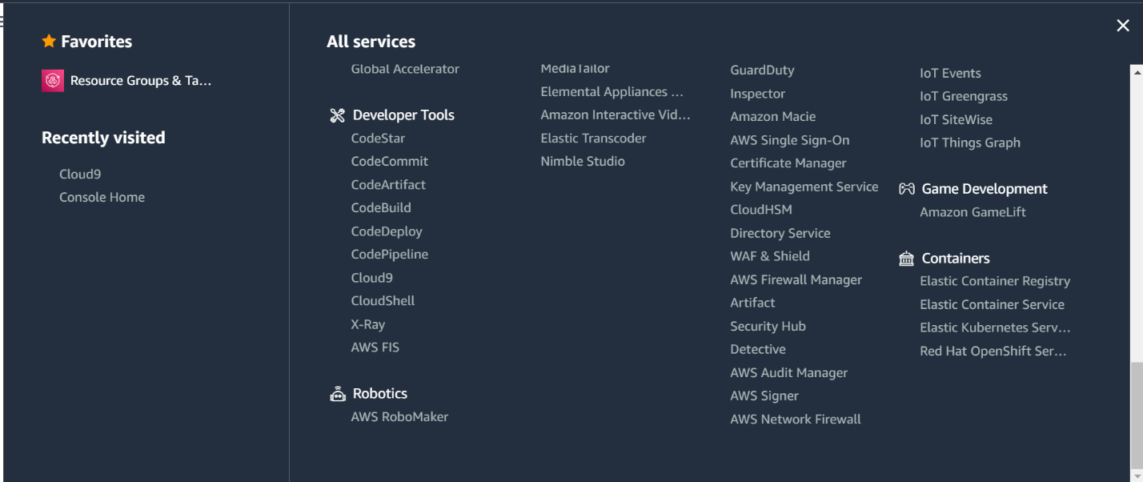

When you click on “Cloud9,” you will see an option to create a new Cloud9 environment. Go ahead and click on this option, give your environment a name, and proceed to the next step. **It’s important that you follow the next instructions closely in order to avoid unwanted charges.**

When prompted, select a “no-ingress” environment type, a “t2.micro” instance type, and an “Amazon Linux 2” platform. As shown in small print below the t2.micro option, this instance type is the only free-tier eligible option. So, if you don’t want to get charged for your Cloud9 environment, you need to select the t2.micro option. Once you’ve configured your environment as shown below, you can keep all other settings on their default options.

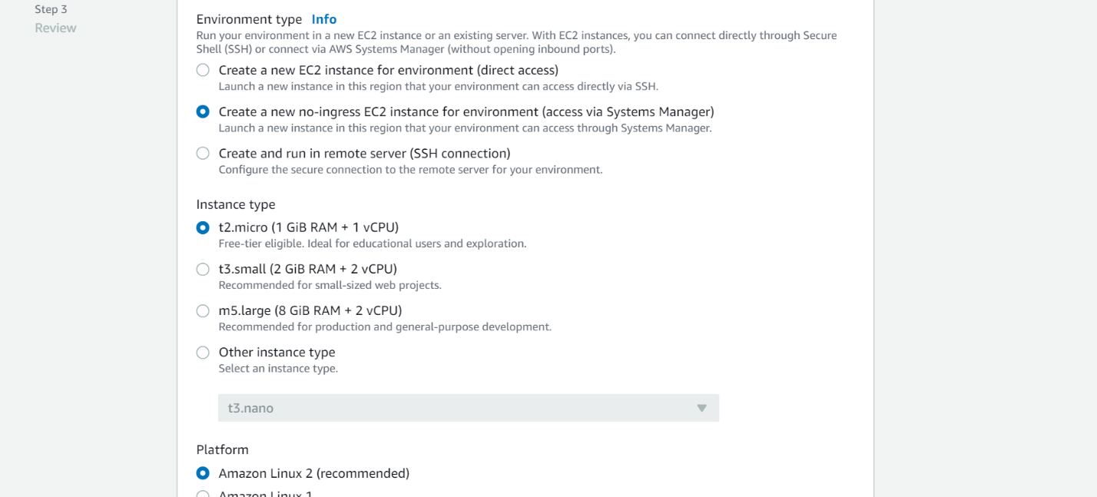

Once you’re done configuring the environment settings, you can go ahead and create your Cloud9 environment. After a few minutes of loading, you will see the browser-based IDE as shown below. There are a few important features here to note.

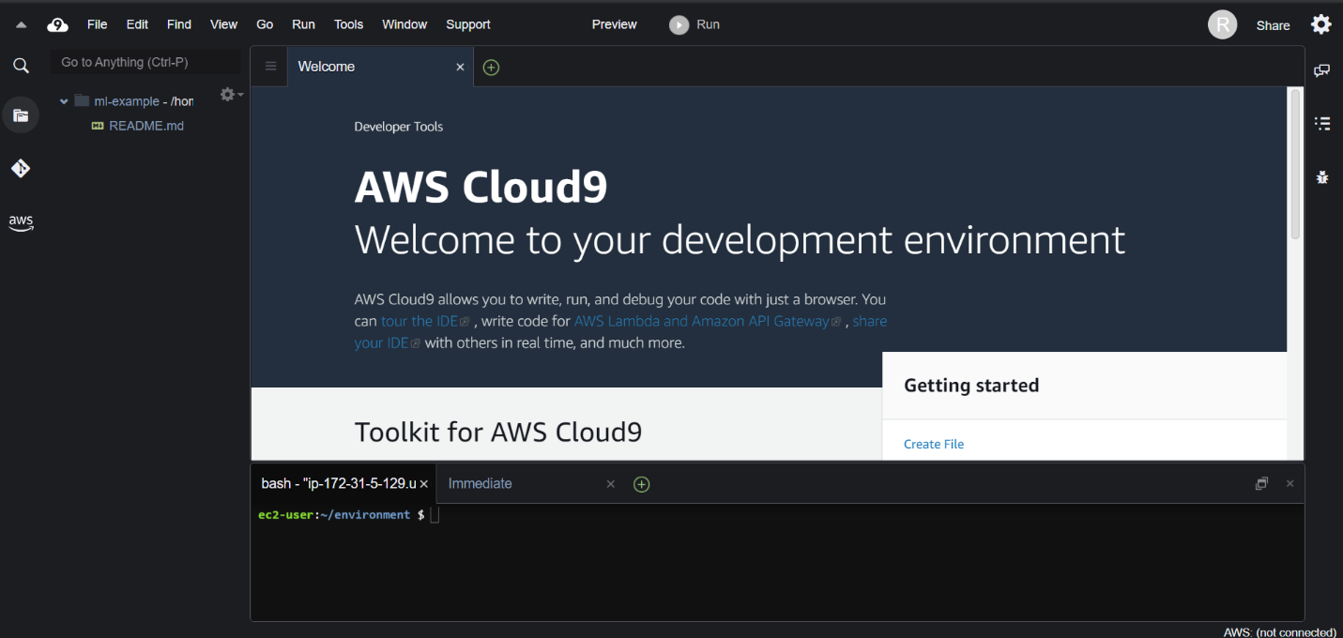

You can create new source files by pressing the green “+” in the central window. Then you can write your programs in that window. The left sidebar displays the working directory, and all created files will show up there. Additionally, in the bottom window, you have access to a bash terminal tab. You can use this terminal the same way you would use a terminal on any Linux machine. Note that when you press “Run,” your program’s console output will show up in a different tab in the terminal window.

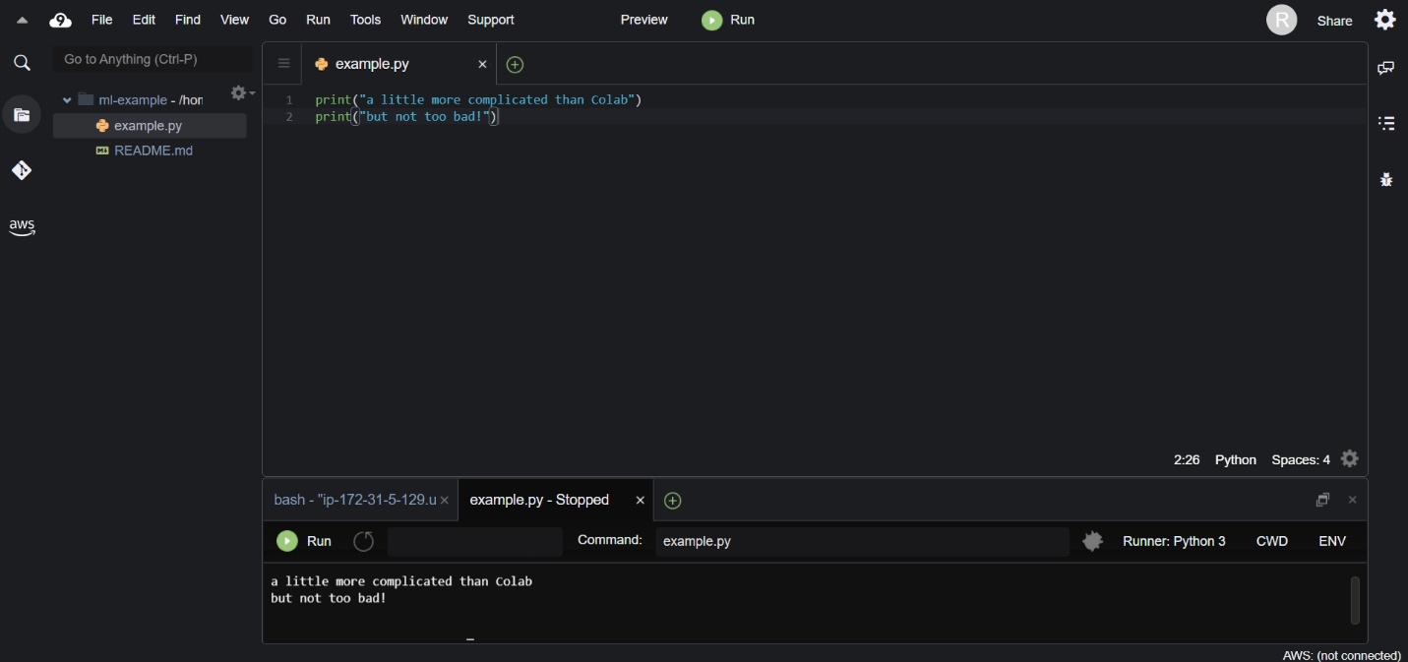

Unlike Google Colab, Cloud9’s Python installation does not come with data science libraries pre-installed. So, you’ll need to install these libraries yourself from the bash terminal as shown below. It’s pretty simple—just “pip install …” any library you’re missing!

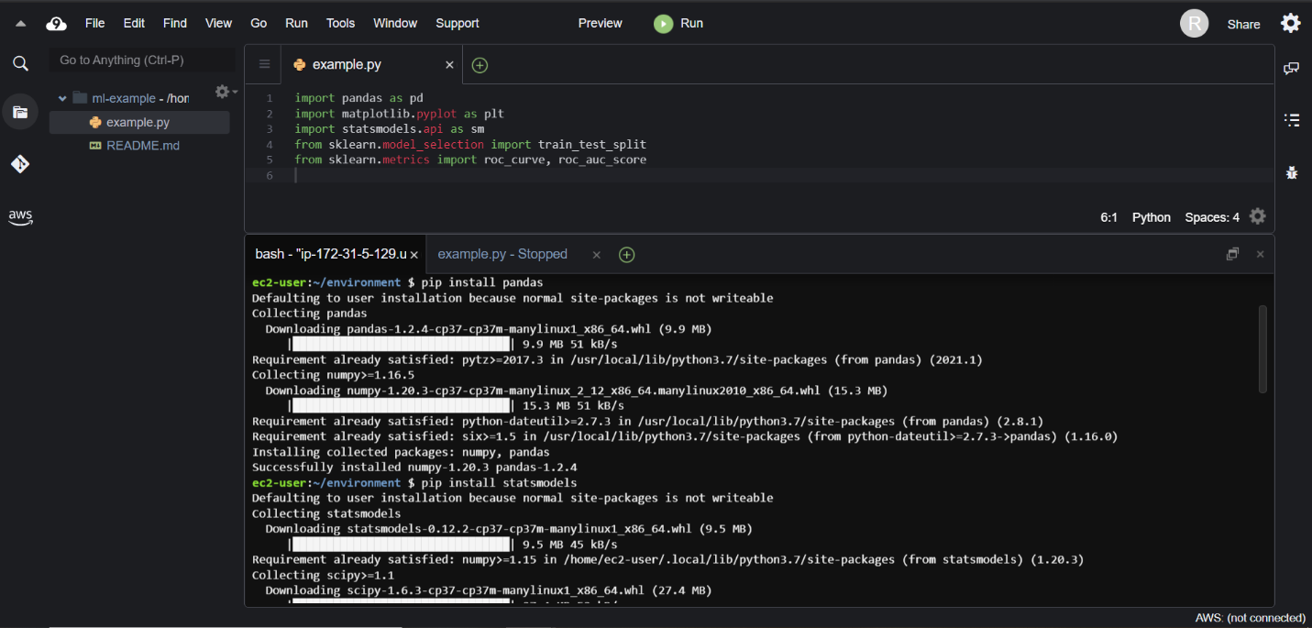

In order to build a machine learning model on Cloud9, you’ll also need to access the training data. Again, we’ll rely on command line tools to achieve this. In order to download a data set from somewhere on the internet, type “wget” followed by the URL leading to the desired data in the terminal, then press enter. By default, the file will be downloaded to your current directory.

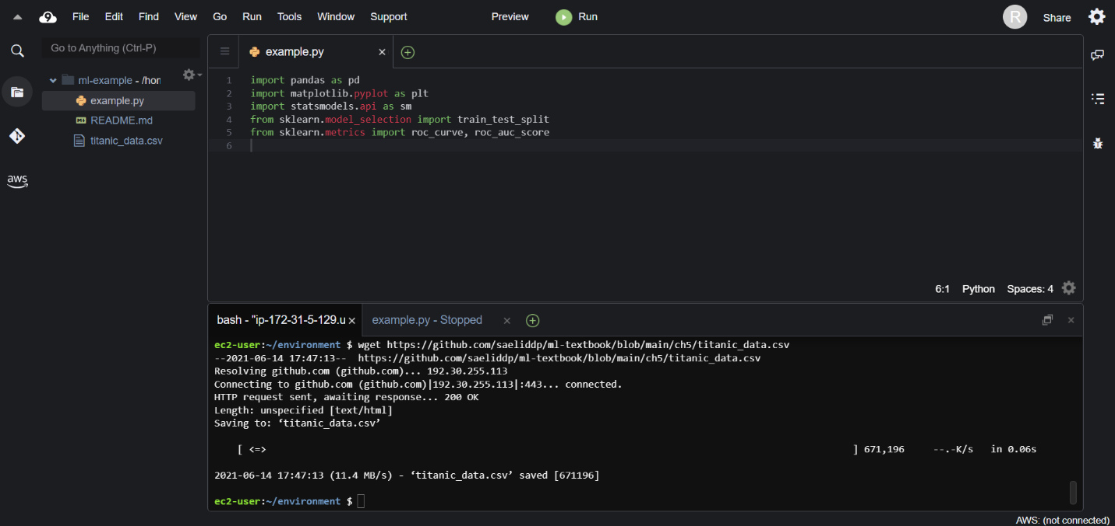

Now that you have the necessary libraries and data, you can build your model! However, it’s important to note that in order to view any graphical output of your program on Cloud9, you’ll have to save the output as a file first. So, if you’re using matplotlib, for instance, you’ll have to type “plt.savefig(…)” rather than “plt.show().”

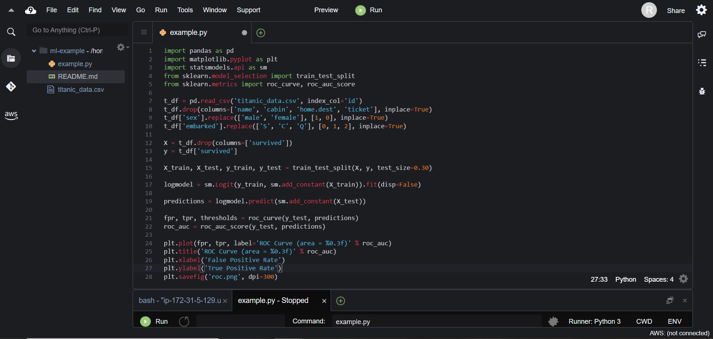

In order to view your visualizations, simply select the file from the browser on the left.

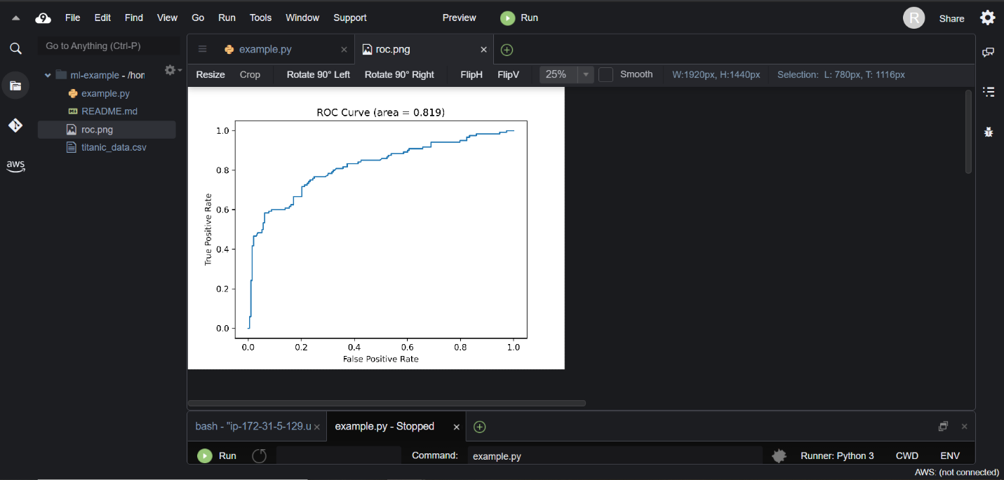

Overall, Cloud9 is a fairly intuitive and powerful development environment from AWS. If you’re not a fan of Colab’s notebook style or you prefer having easy access to a terminal while you work, Cloud9 may be a good option for you. Unfortunately, Cloud9 is only free to a certain storage and processing limit, while Google Colab is always free.