Now, let’s see how to develop Python programs in a browser-based IDE with Azure. First, navigate to “All services” from the Azure portal homepage. Then select the “AI + machine learning” tab. From there, click on the “Machine learning” resource, as shown below.

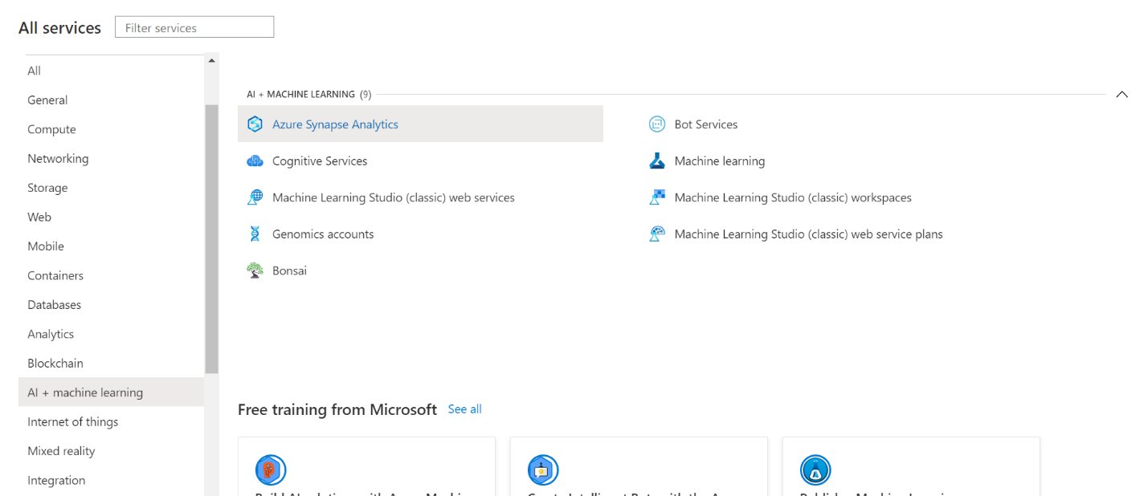

Now, select the option to create a new machine learning workspace. Luckily, “Basics” is the only tab you need to worry about in the configuration menu. Once the basic information has been filled out, select “Review + create.”

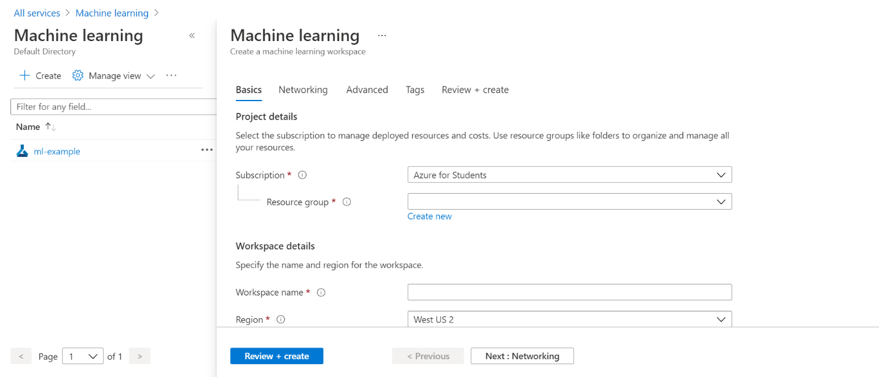

After this, you will land on the machine learning studio home page. There are a lot of resources here, but for now, just click on “Start now” on the Notebooks tile. By creating a new notebook, you can start to write and run Python code in a Jupyter environment on your browser.

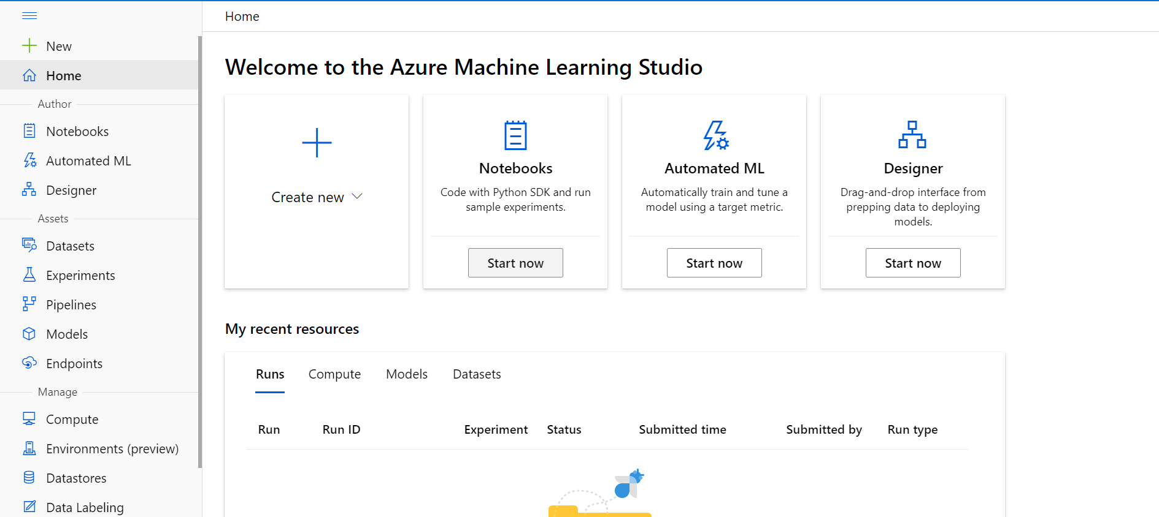

At this point, you’ll likely see a yellow error message about not being connected to a “compute” as shown below. Essentially, this means that you need to connect your notebook environment to an Azure computation resource! To do so, select an existing compute or press new compute.

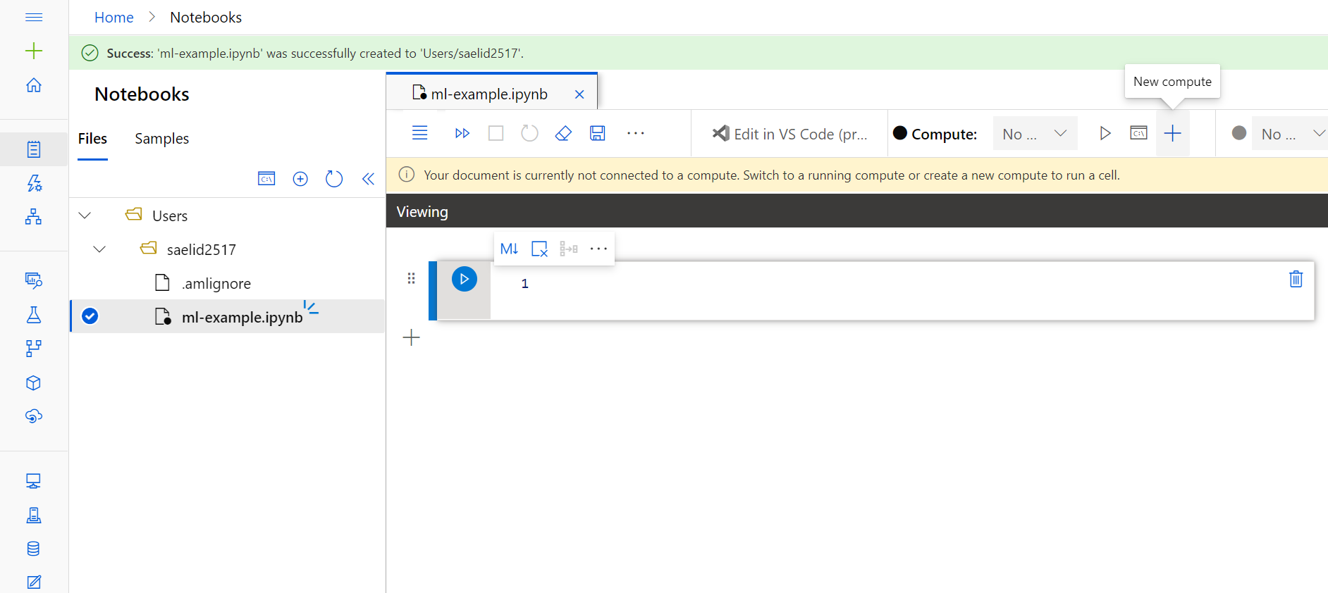

If you’re creating a new compute, you’ll see the configuration menu as shown below. Feel free to select any compute configuration, but note that for most personal/student machine learning projects, the least expensive configuration will be sufficient (even if it’s not lightning-fast).

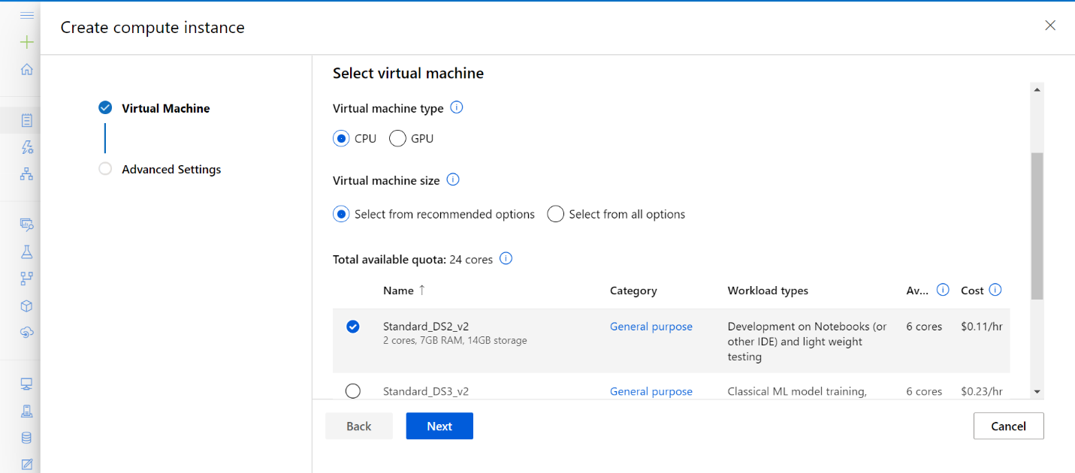

Once you’re connected to a compute resource, you can finally start coding! The Azure notebook environment is in many ways a mix of Google Colab and AWS Cloud9. Like Colab, Azure provides a Jupyter development environment and a Python installation with many data science libraries pre-installed. And like Cloud9, Azure allows a notebook user to open up a terminal and run commands from there.

As such, downloading data sets to Azure notebooks works the same way as it does in Cloud9. Simply open up a terminal tab by clicking on the terminal icon above the file tree, then “wget” the desired files into your current directory.

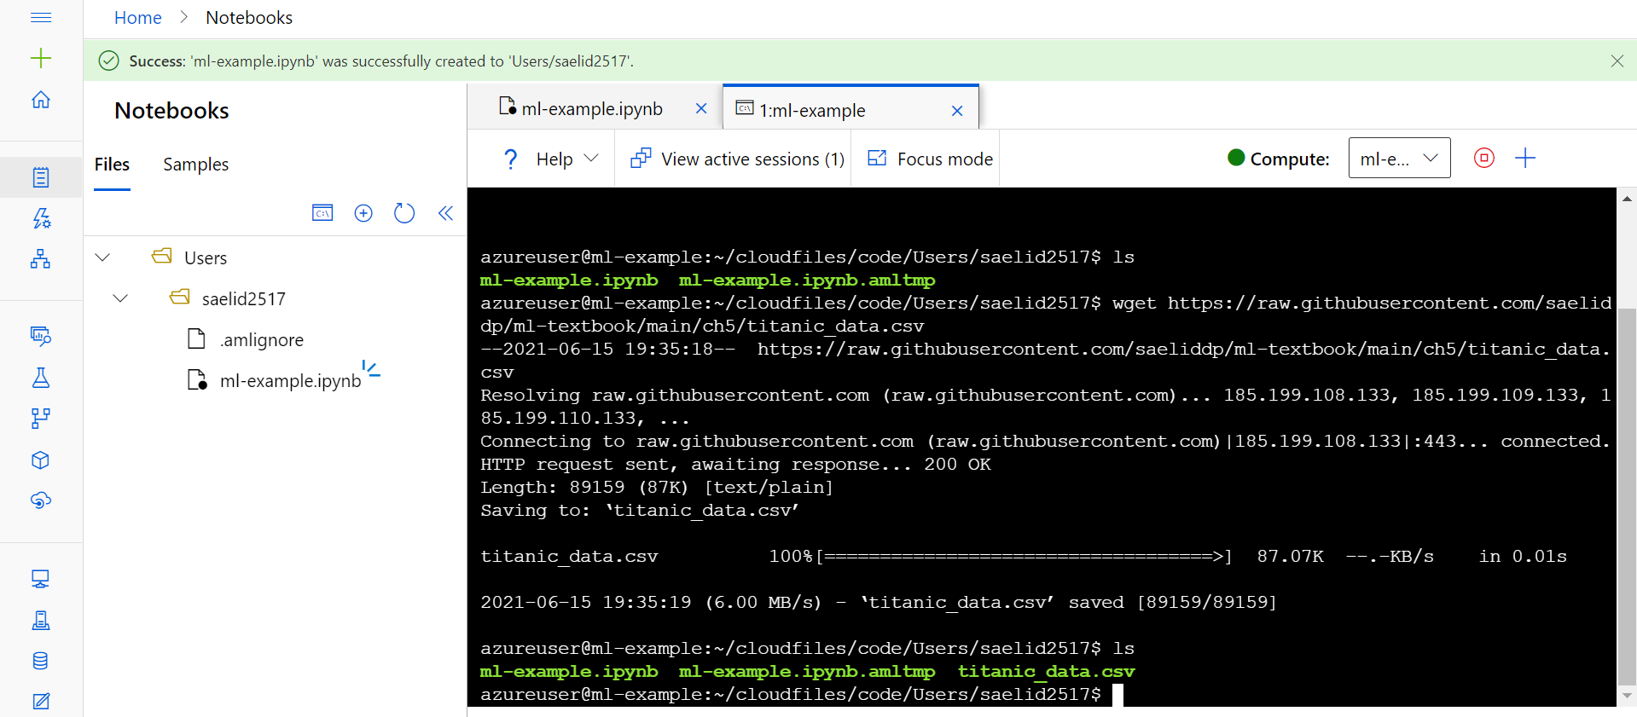

At this point, everything is in place to train and evaluate a model. Note that since this is a Jupyter environment like colab, you don’t need to save every matplotlib visualization as a file—visualizations will show up below the notebook tile where “plt.show()” is called.

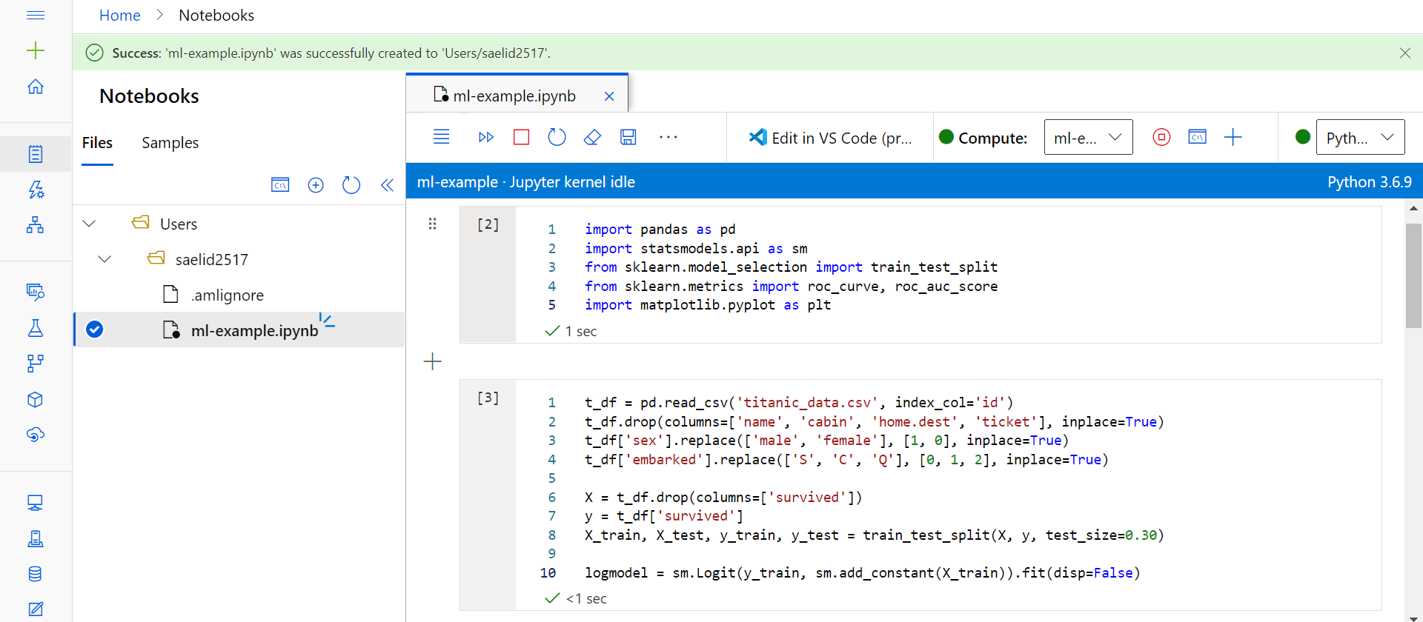

So, how do Azure machine learning notebooks compare to Google Colab and AWS Cloud9? Azure’s development environment combines Colab’s notebook style with Cloud9’s command line capabilities, which is certainly appealing. However, in most contexts for students, using Azure’s machine learning framework is overkill. Azure provides a plethora of services for machine learning, the vast majority of which you’ll never need as a student. The flipside of this is that there is really no limit on what you can achieve with Azure, so long as you’re willing to pay for the resources. Speaking of cost, it’s important to note that while Google Colab is always free and Cloud9 can be free, Azure’s machine learning platform *is never free*. It can be effectively free to use the platform when you have Azure credit, but eventually you’ll run out of credit and wind up incurring costs.