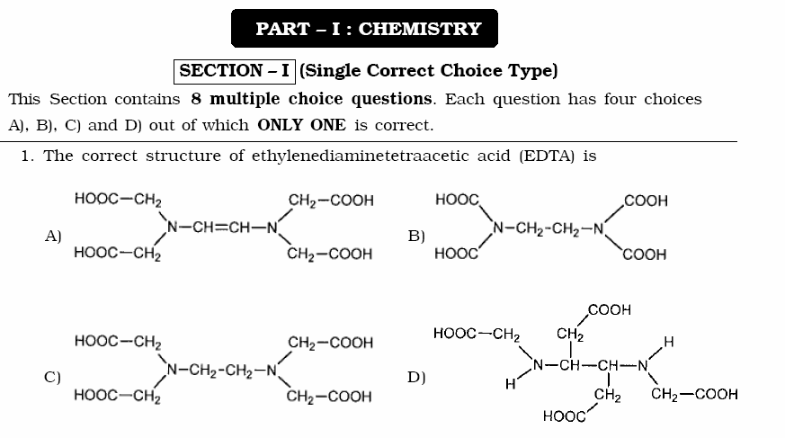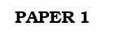

ANSWER: C

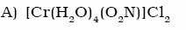

ANSWER: B

ANSWER: D

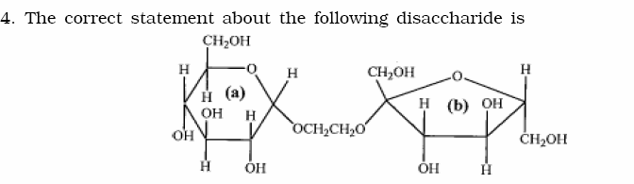

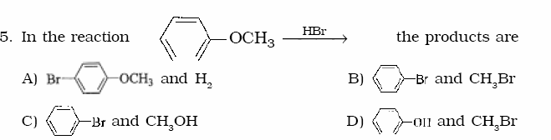
ANSWER: A

ANSWER: D

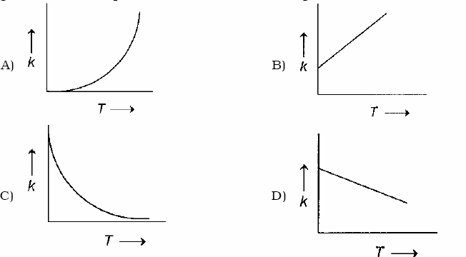

ANSWER: A

ANSWER: B

ANSWER: C



ANSWER: B
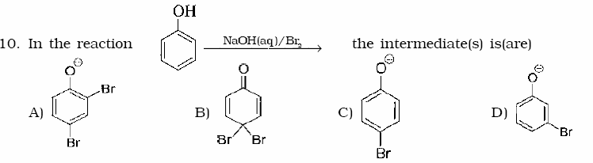
ANSWER: A and C

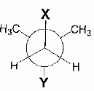
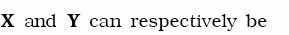
ANSWER: B and D
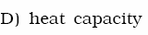

ANSWER: A and B

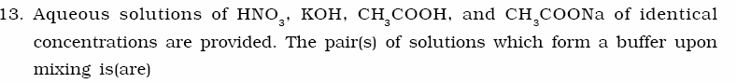

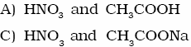
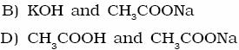

ANSWER: C and D


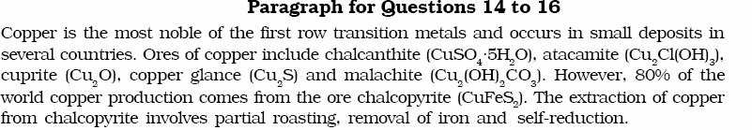
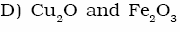

ANSWER: A
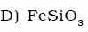

ANSWER: D

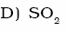

ANSWER: C
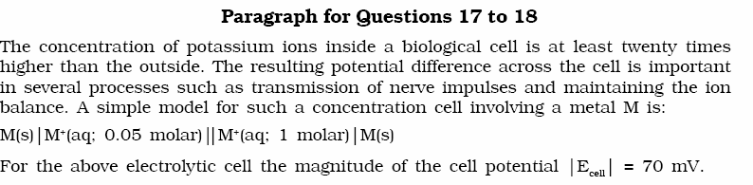

ANSWER: B

ANSWER: C



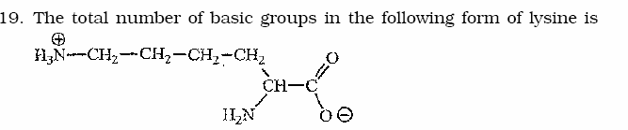
ANSWER: 2

ANSWER: 5
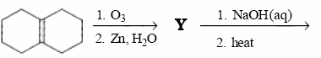

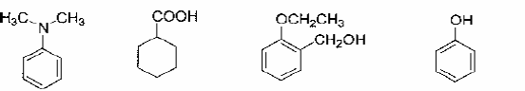
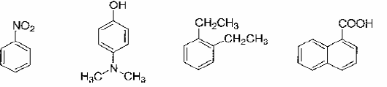
ANSWER: 1

ANSWER: 4

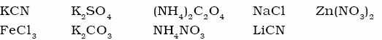

ANSWER: 3

ANSWER: either 0 or 8
ANSWER: 3

ANSWER: 3
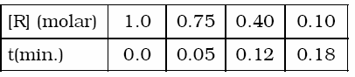

ANSWER: 0
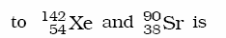
ANSWER: 4



ANSWER: D
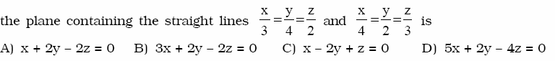
ANSWER: C
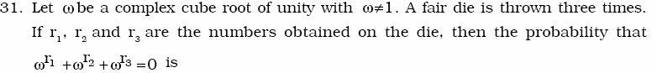
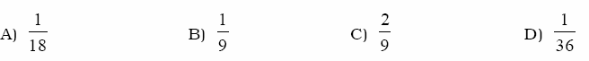

ANSWER: C
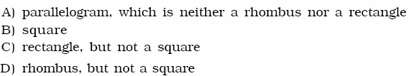

ANSWER: A

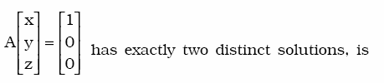
ANSWER: A
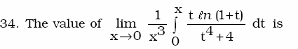

ANSWER: B
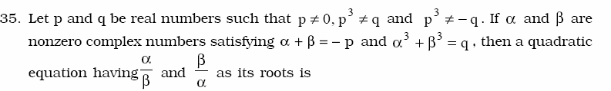
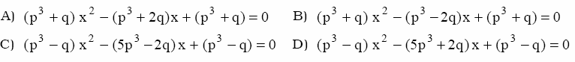

ANSWER: B

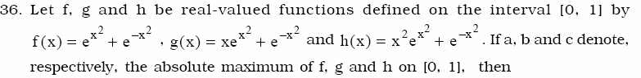

ANSWER: D

ANSWER: C and D
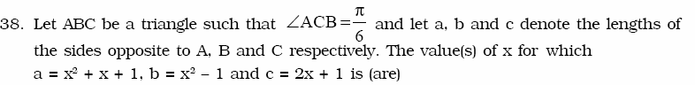

ANSWER: B

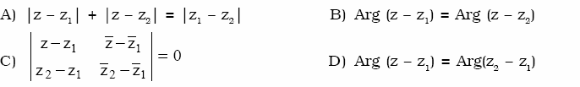

ANSWER: A and C and D

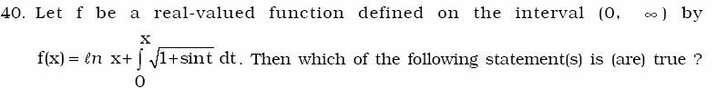
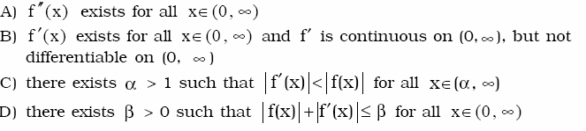

ANSWER: B and C
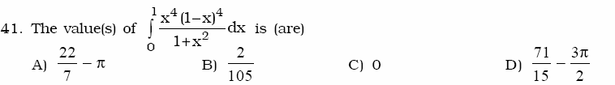

ANSWER: A

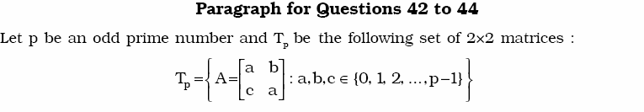
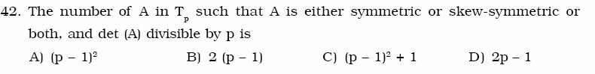

ANSWER: D
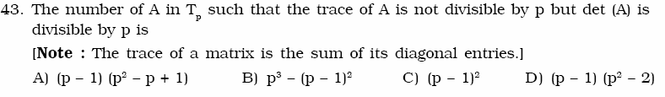
ANSWER: C

ANSWER: D
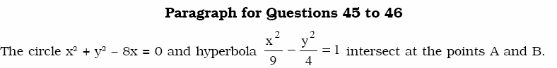

ANSWER: B

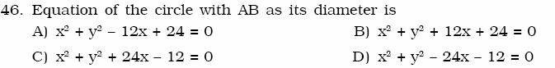

ANSWER: A


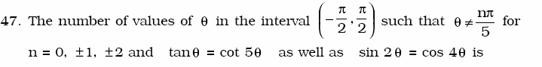
ANSWER: 3

ANSWER: 2

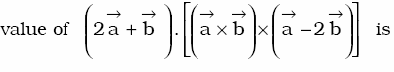

ANSWER: 5
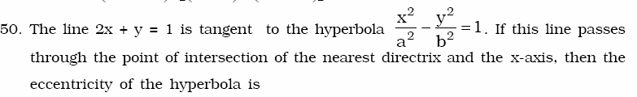
ANSWER: 2

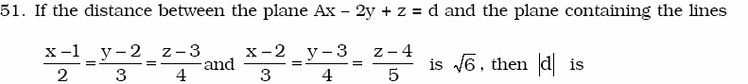

ANSWER: 6
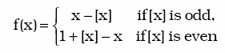
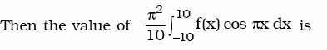
ANSWER: 4
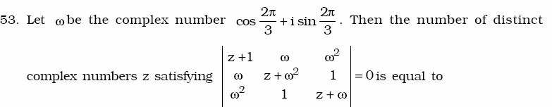
ANSWER: 1

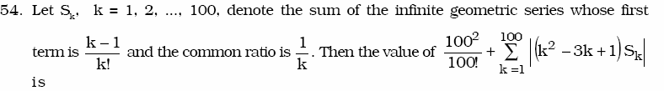
ANSWER: 3
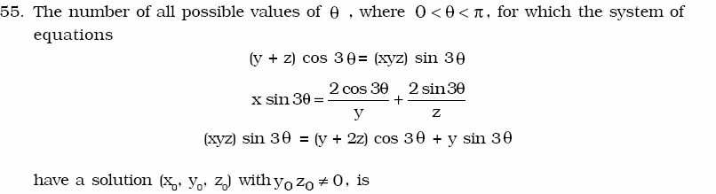

ANSWER: 3
ANSWER: 9

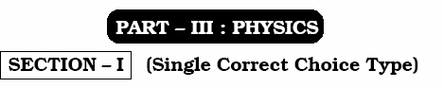

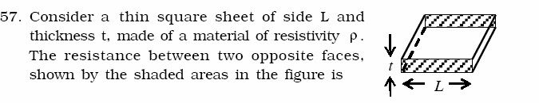
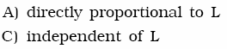
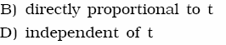

ANSWER: C

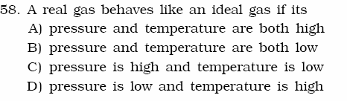
ANSWER: D
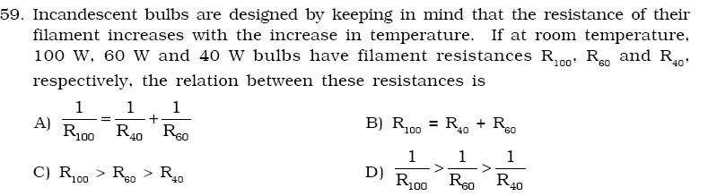

ANSWER: D

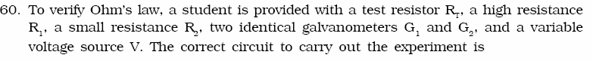
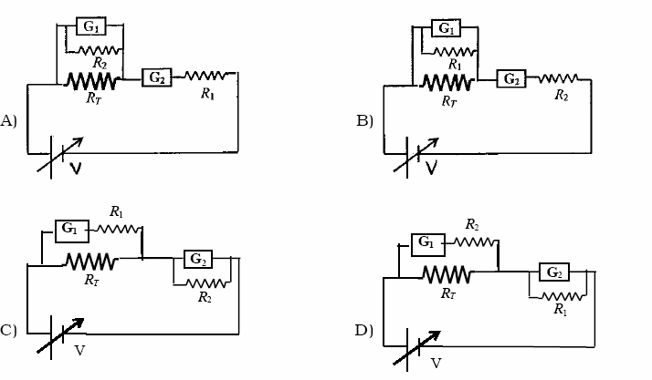

ANSWER: C
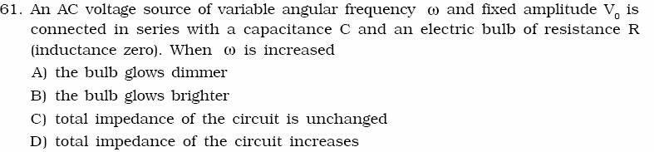

ANSWER: B

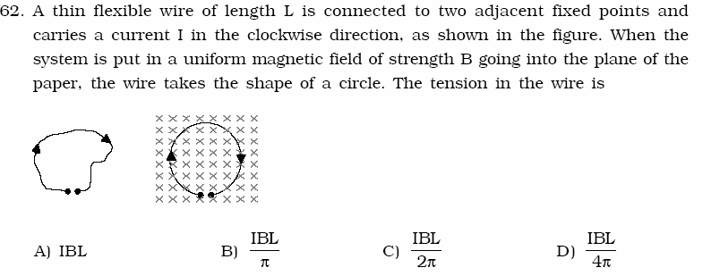

ANSWER: C
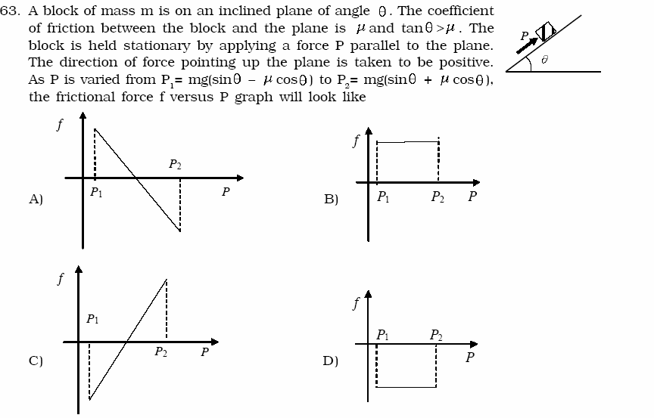

ANSWER: A

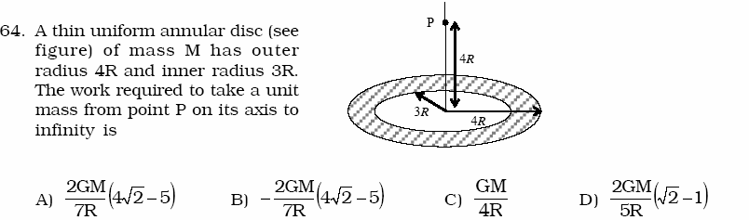

ANSWER: A

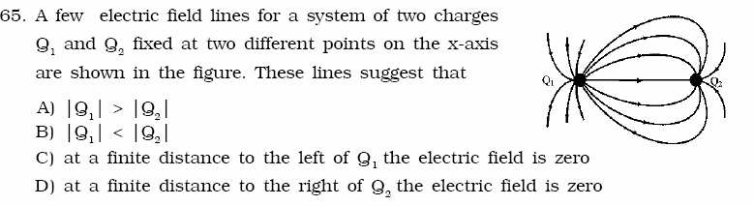

ANSWER: A and D
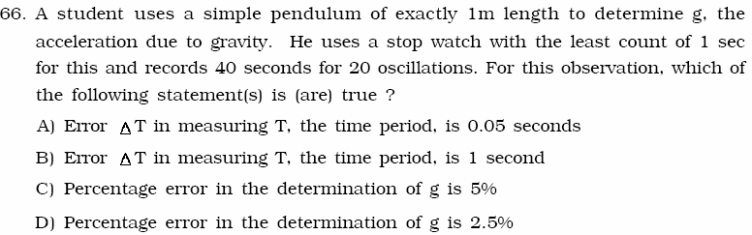
ANSWER: A and C
.

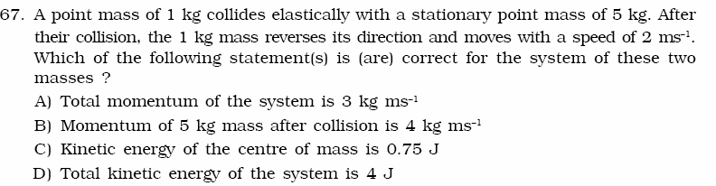

ANSWER: A and C
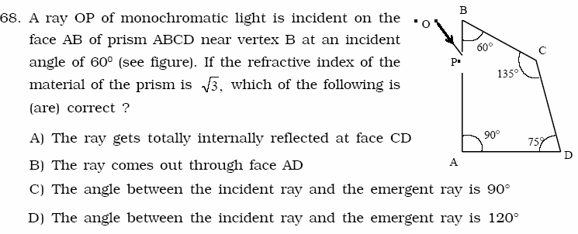
ANSWER: A and B and C

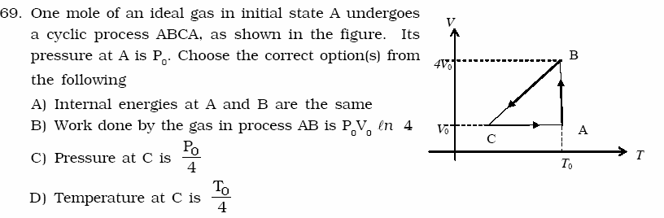

ANSWER: A and B and C and D


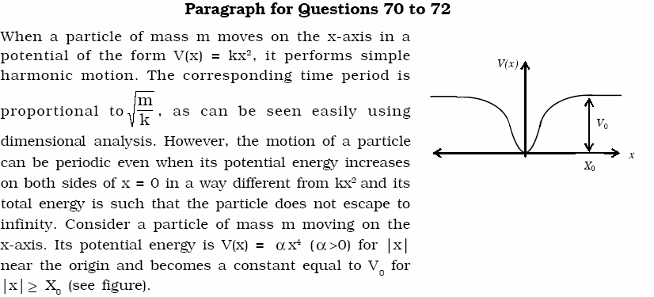

ANSWER: B or C or (B and C) Option C implies option B.
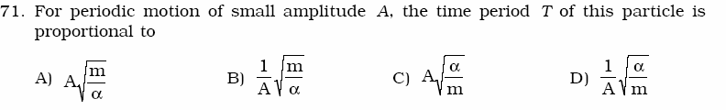

ANSWER: B
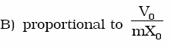
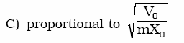
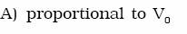
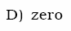

ANSWER: D

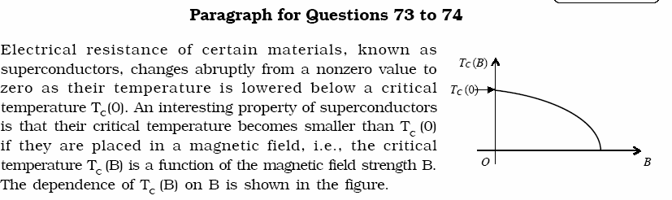
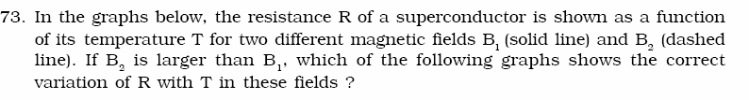
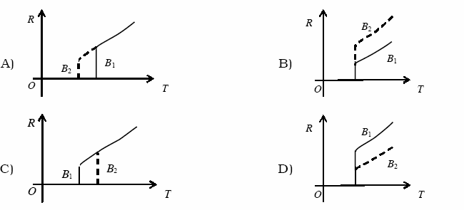

ANSWER: A

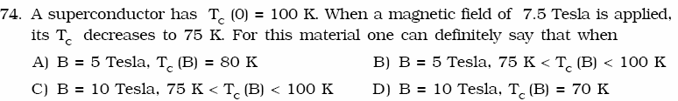

ANSWER: B


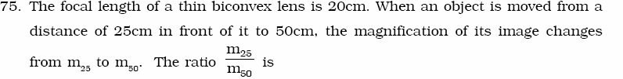

ANSWER: 6
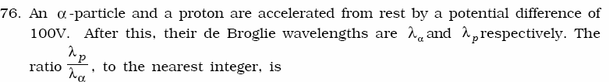
ANSWER: 3
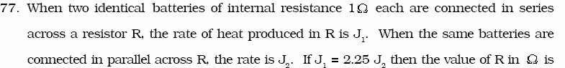
ANSWER: 4
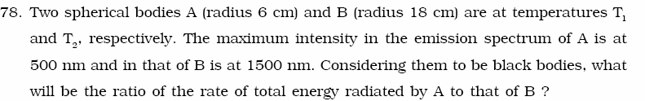

ANSWER: 9

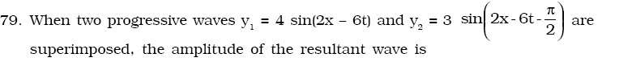
ANSWER: 5

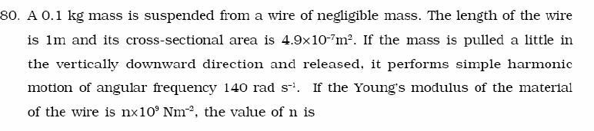
ANSWER: 4
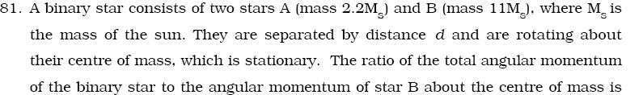
ANSWER: 6
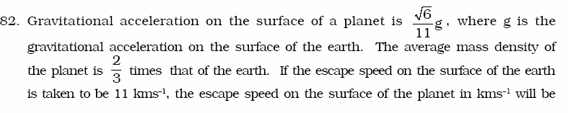
ANSWER: 3
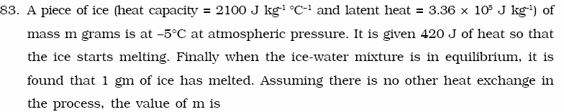
ANSWER: 8

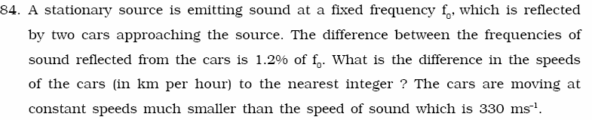
ANSWER: 7
********************************************

