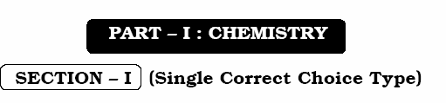

ANSWER: B
ANSWER: D
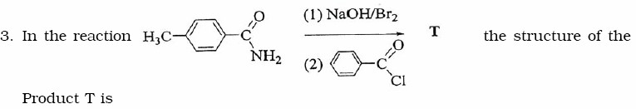
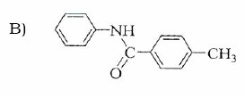
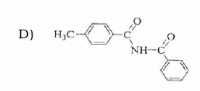

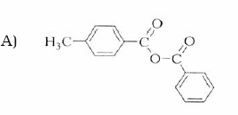
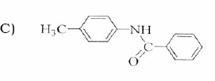
ANSWER: C

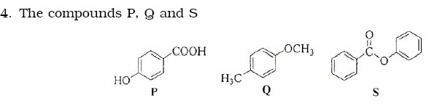
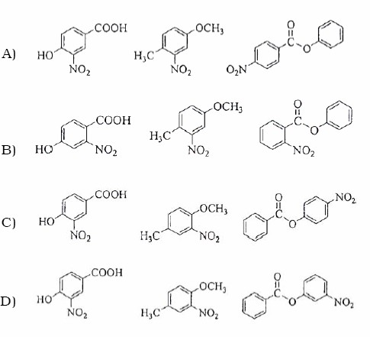
ANSWER: C

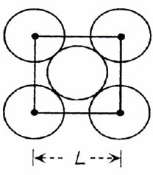

ANSWER: D

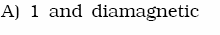
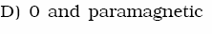
ANSWER: A

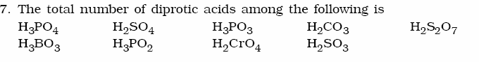

ANSWER: 6

ANSWER: 3
ANSWER: 2
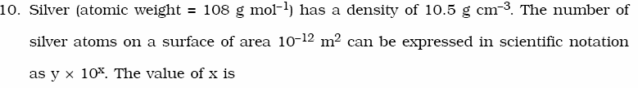

ANSWER: 7

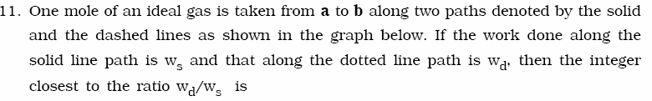

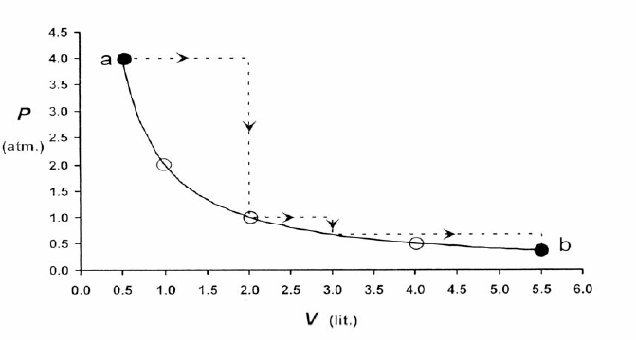
ANSWER: 2


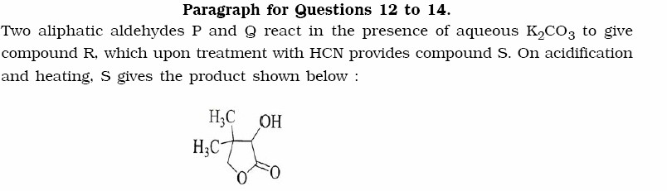

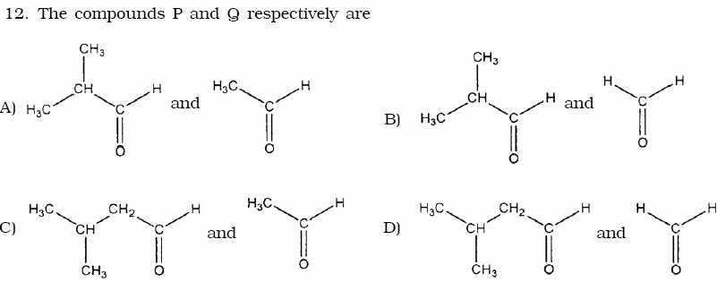

ANSWER: B

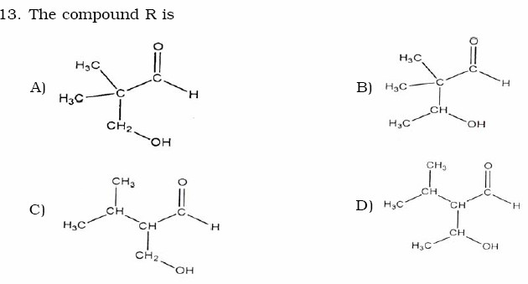

ANSWER: A

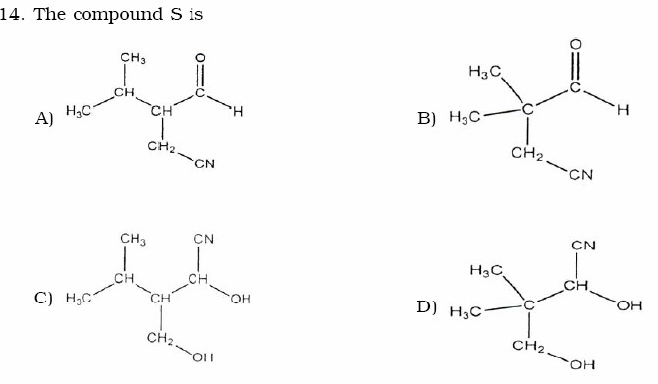
ANSWER: D

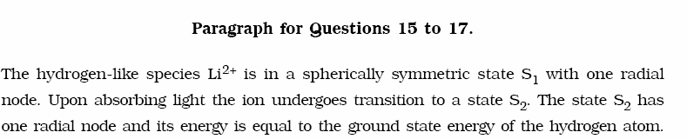
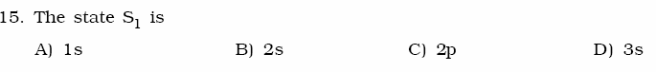
ANSWER: B

ANSWER: C
ANSWER: B


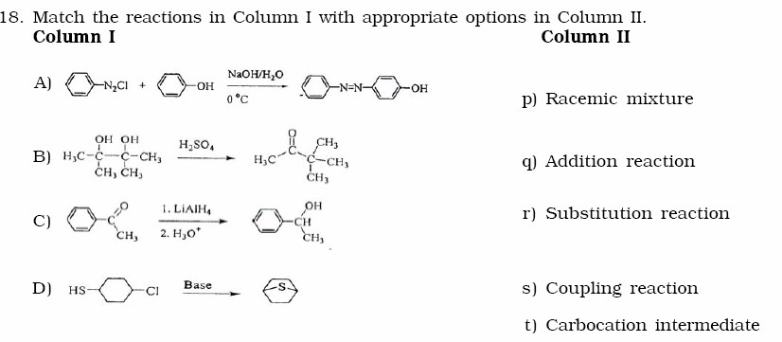

ANSWER: A: r and s
B: t
C: p and q

D: r

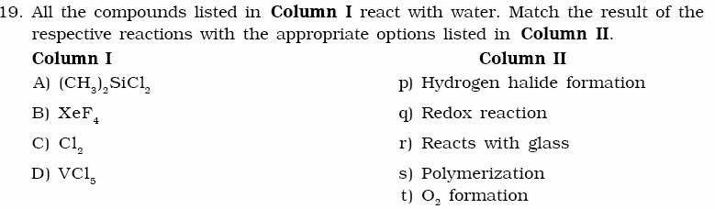

ANSWER: A: p and s
B: p and q and r and t
C: p and q
D: p

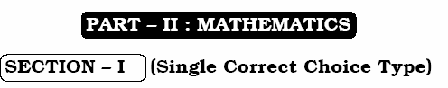
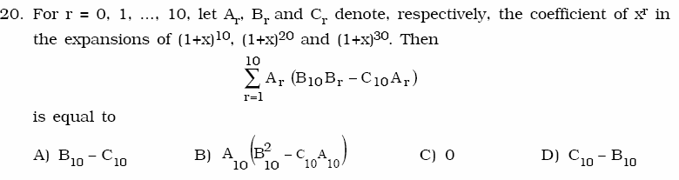

ANSWER: D

ANSWER: D

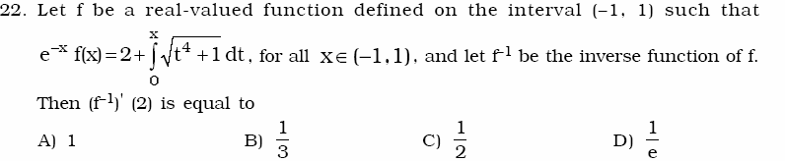

ANSWER: B
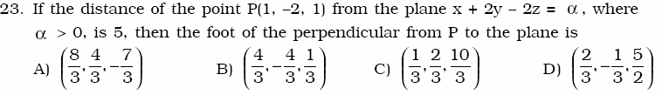

ANSWER: A
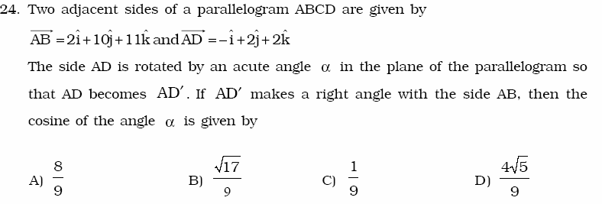
ANSWER: B
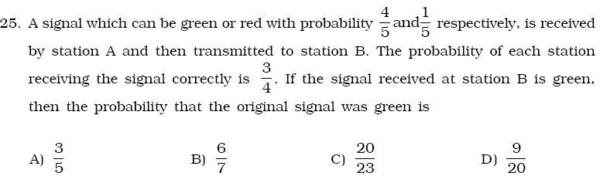
ANSWER: C


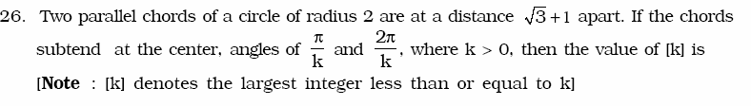

ANSWER: 3
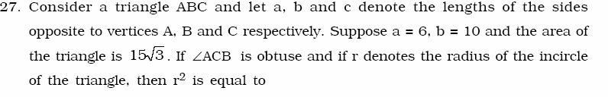

ANSWER: 3
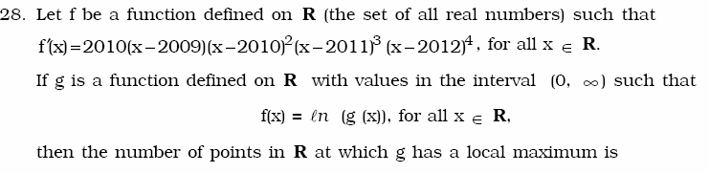
ANSWER: 1
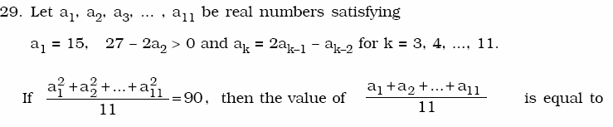
ANSWER: 0

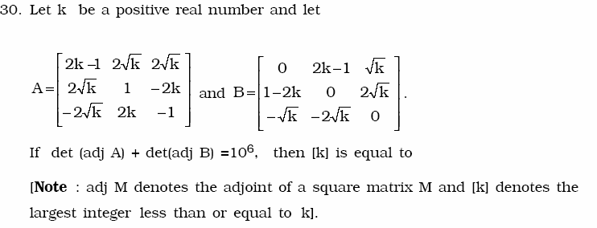
ANSWER: 4

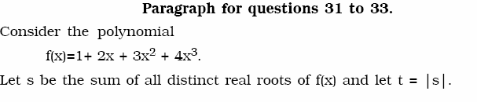
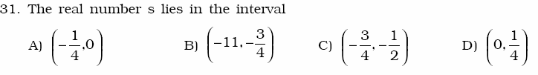

ANSWER: C

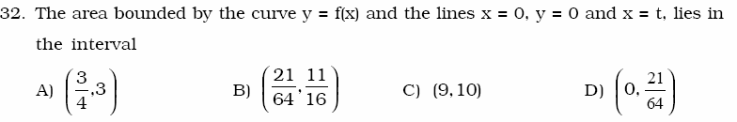

ANSWER: A

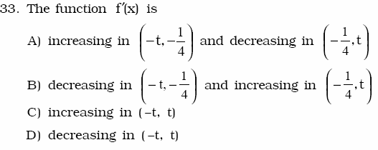

ANSWER: B
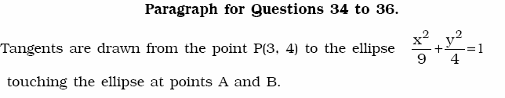
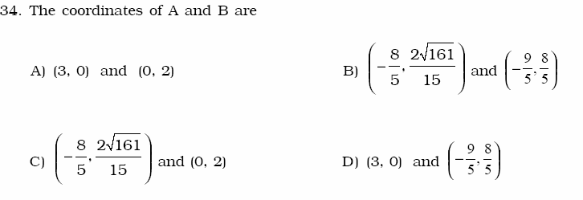

ANSWER: D

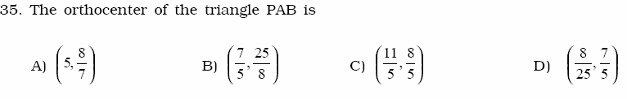
ANSWER: C

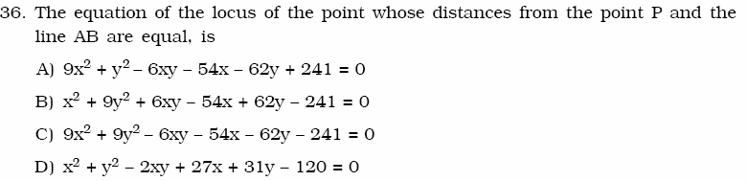
ANSWER: A


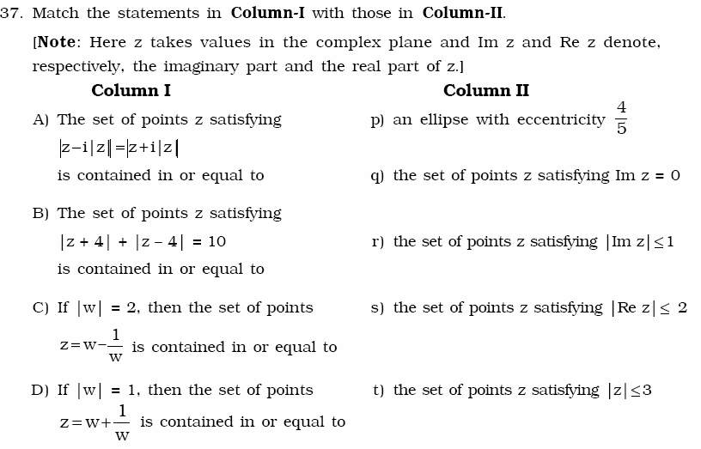
ANSWER: A: q and r B: p

C: p and s and t
D: q and r and s and t

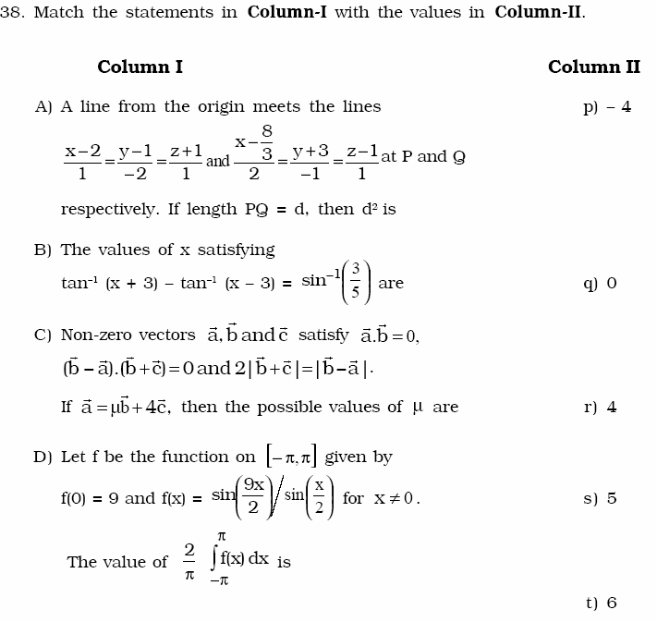

ANSWER: A: t
B: p and r
C: either q or (q and s) D: r

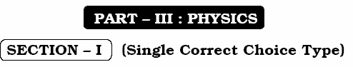
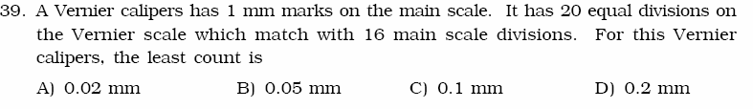

ANSWER: D
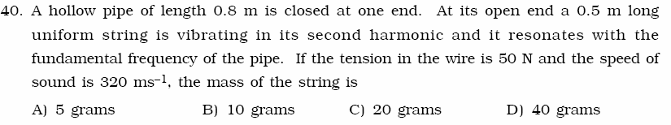
ANSWER: B
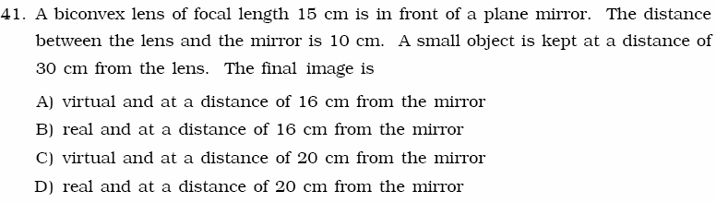

ANSWER: B

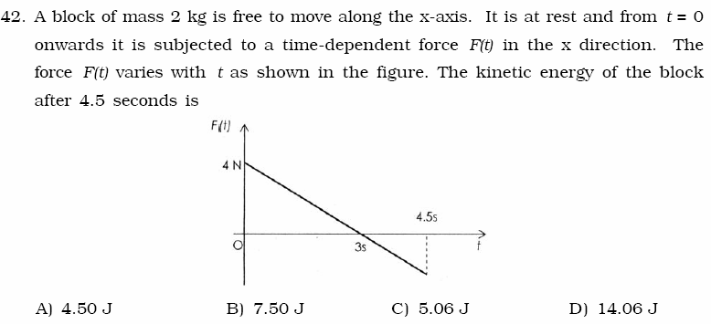

ANSWER: C

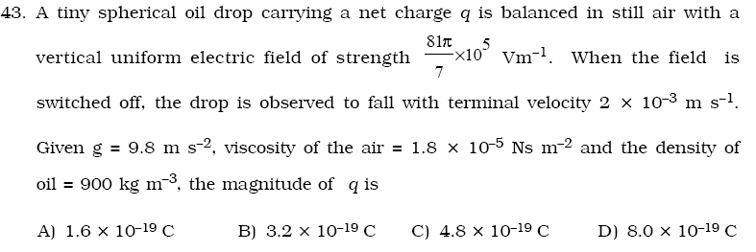

ANSWER: D

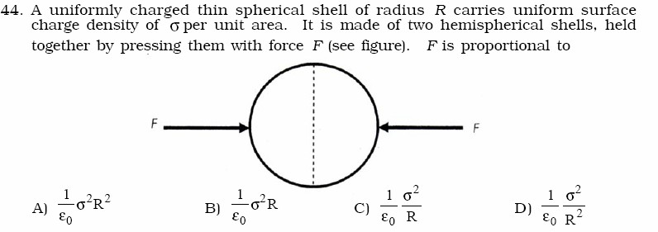
ANSWER: A


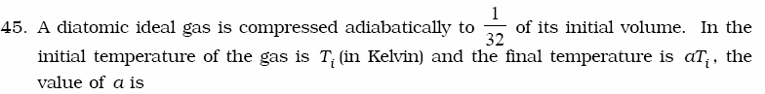

ANSWER: 4

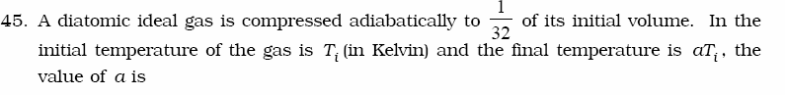
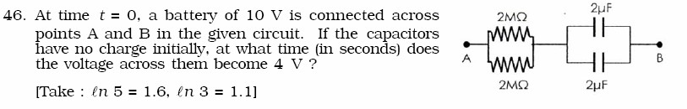

ANSWER: 2
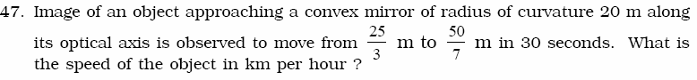

ANSWER: 3

ANSWER: 6

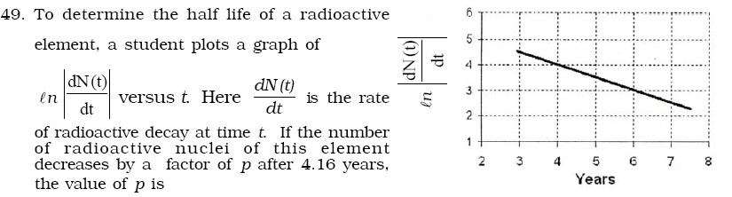

ANSWER: 8

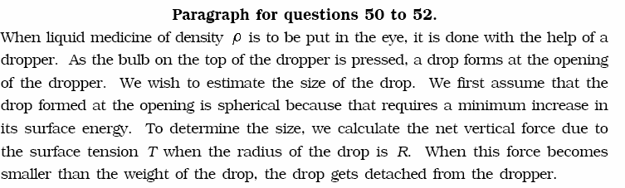

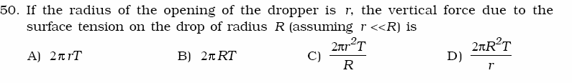
ANSWER: C

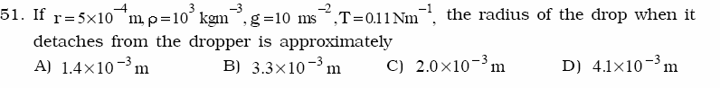

ANSWER: A

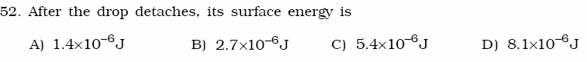
ANSWER: B
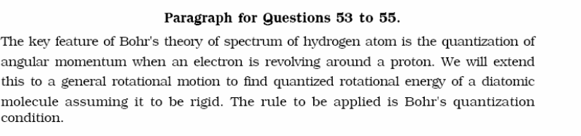

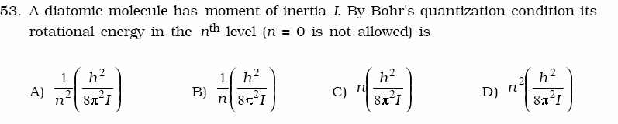

ANSWER: D

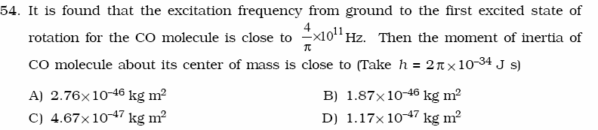

ANSWER: B

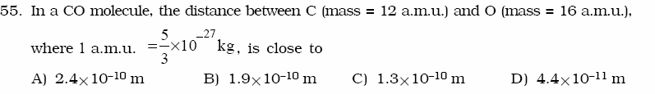

ANSWER: C


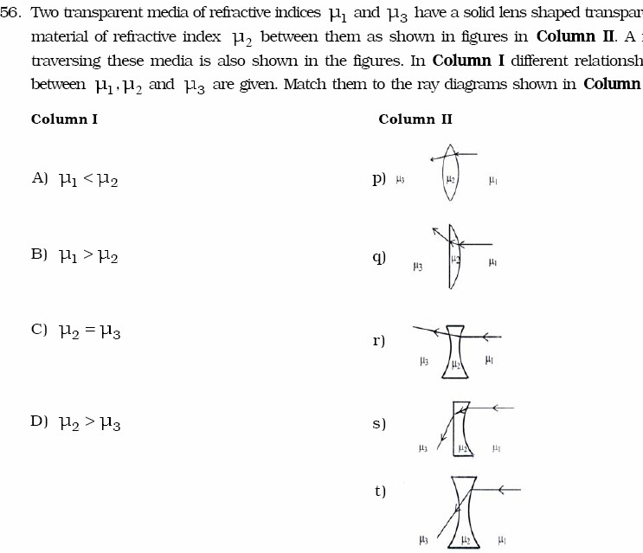

ANSWER: A: p and r

B: q and s and t C: p and r and t D: q and s

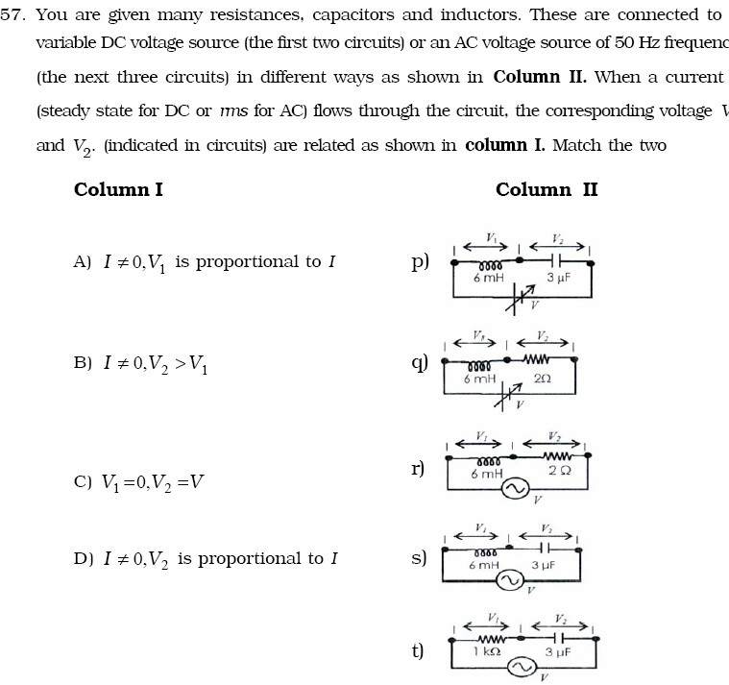

ANSWER: A: r and s and t
B: q and r and s and t
C: p and q
D: q and r and s and t

********************************************

