[ PART I : CHEMISTRY l

SECTION - I (Total Marks : 21)
(Single Correct Answer Type)
This section contains 7 multiple choice questions. Each question has four choices (A), (B), (C) and (D) out of which ONLY ONE is correct.

- Extra pure N2 can be obtained by heating
  - NH3 with CuO
(C) (NH ) Cr O
4 2 2 7

ANSWER:D

  - NH4NO3
(D) Ba(N )
3 2

- Geometrical shapes of the complexes formed by the reaction of Ni + with CC, CN- and H2O, respectively, are
2
  - octahedral, tetrahedral and square planar
  - tetrahedral, square planar and octahedral
  - square planar, tetrahedral and octahedral
  - octahedral, square planar and octahedral

ANSWER:B
- Bombardment of aluminum by a-particle leads to its artificial disintegration in two ways,
(i) and (ii) as shown. Products X, Y and Z respectively are,
27 (ii) 30P
! !
13Al 15 + y

(i)

30Si X 30Si z
₊ +
14 14

(A) proton, neutron, positron | (B) | neutron, positron, proton
(C) proton, positron, neutron | (D) | positron, proton, neutron

ANSWER:A

CHEMISTRY

- Dissolving 120 g of urea (mol. wt. 60) in 1000 g of water gave a solution of density
1.15 g/ml. The molarity of the solution is

- 1.78 M (B) 2.00 M

ANSWER:C
- 2.05 M (D) 2.22 M

- AgNO₃ (aq.) was added to an aqueous KCl solution gradually and the conductivity of the solution was measured. The plot of conductance (A) versus the volume of AgNO₃ is

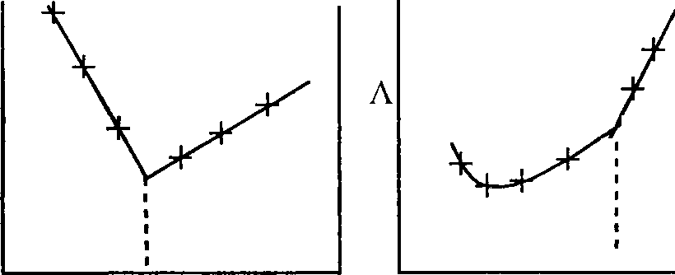
A A A
�
I I I I I
/
-Y..-Y..-Y.. I
I I I I I

volume volume volume volume

  - (P)

(P)

  - (Q)

(Q)
(R) (S)
  - (R) (D) (S)

ANSWER:D
- Among the following compounds, the most acidic is

  - p-nitrophenol
(C) o-hydroxybenzoic acid

ANSWER:C
  - p-hydroxybenzoic acid
(D) p-toluic acid

- The major product of the following reaction is
�

ex
0

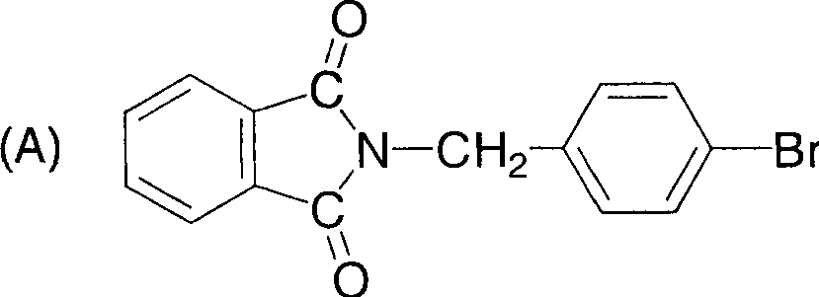
0
//
(Y��N
(C) �
- KOH
NH
c
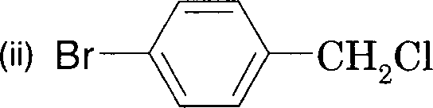
\ \
0

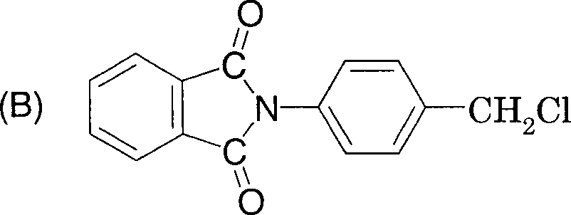

O-CH₂-0-Br

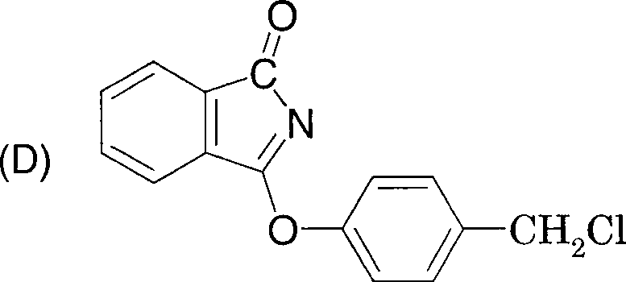
ANSWER:A

SECTION - II (Total Marks : 16)
(Multiple Correct Answers Type)
This section contains 4 multiple choice questions. Each question has four choices (A), (B), (C) and (D) out of which ONE or MORE may be correct.

- Extraction of metal from the ore cassiterite involves
  - carbon reduction of an oxide ore (B) self-reduction of a sulphide ore
(C) removal of copper impurity (D) removal of iron impurity

ANSWER:AD
- The correct statement(s) pertaining to the adsorption of a gas on a solid surface is (are)
  - Adsorption is always exothermic.
  - Physisorption may transform into chemisorption at high temperature.
  - Physisorption increases with increasing temperature but chemisorption decreases with increasing temperature.
  - Chemisorption is more exothermic than physisorption, however it is very slow due to higher energy of activation.

ANSWER:ABD

- According to kinetic theory of gases
  - collisions are always elastic.
  - heavier molecules transfer more momentum to the wall of the container.
  - only a small number of molecules have very high velocity.
  - between collisions, the molecules move in straight lines with constant velocities.

ANSWER:ACD
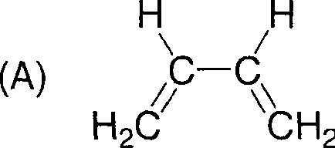
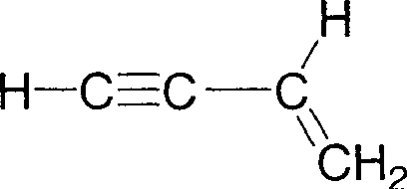
- Amongst the given options, the compound(s) in which all the atoms are in one plane in all the possible conformations (if any), is (are)

(B)

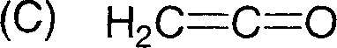
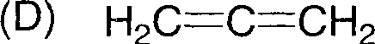

ANSWER:BC

SECTION - Ill (Total Marks : 15)
(Paragraph Type)
This section contains 2 paragraphs. Based upon one of the paragraphs 3 multiple choice questions and based on the other paragraph 2 multiple choice questions have to be answered. Each of these questions has four choices (A), (B), (C) and (D) out of which ONLY ONE is correct.

Paragraph for Question Nos. 12 to 14

When a metal rod M is dipped into an aqueous colourless concentrated solution of compound N, the solution turns light blue. Addition of aqueous NaCl to the blue solution gives a white precipitate 0. Addition of aqueous NH₃ dissolves O and gives an intense blue solution.

- The metal rod M is
  - Fe (B) Cu (C) Ni (D) Co

ANSWER:B
- The compound N is
  - AgNO (B) Zn(NO )
3 3 2
- Al(NO ) (D) Pb(NO )
3 3 3 2

ANSWER:A
- The final solution contains
3+ 2+

(A)

2+ 2-
[Pb(NH3)4] and [CoC14]
+
- [Al(NH3)4] and [Cu(NH3)4]

[Ag(NH)2]
and [Cu(NH

3)4]
²⁺ (D) [Ag(NH ) f and [Ni(NH
2
) ] +
3 6

ANSWER:C
3 2

Paragraph for Question Nos. 15 and 16

An acyclic hydrocarbon P, having molecular formula C₆H₁₀, gave acetone as the only organic product through the following sequence of reactions, in which Q is an intermediate organic compound.

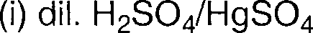

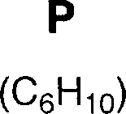
- NaBHiethanol
- dil. acid
- cone. H₂S0₄ (catalytic amount)
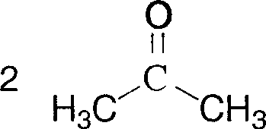
(-H20)

a
- 03
- Zn/H₂0

- The structure of compound P is

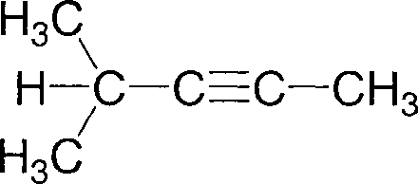
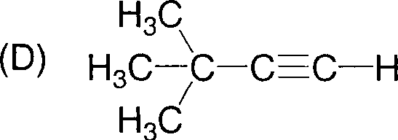
(C)

ANSWER:D
- The structure of the compound Q is

(A)

(C)
H3C\ ?H
H-C-C-CH CH
I
I 2 3
H3C H

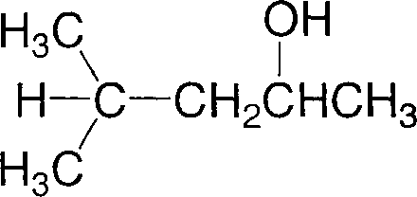

ANSWER:B

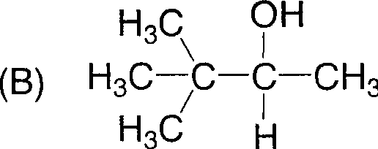

OH
- CH3CH2CHi�HCH2CH3

SECTION - IV (Total Marks : 28)
(Integer Answer Type)
This section contains 7 questions. The answer to each of the questions is a single-digit integer, ranging from O to 9. The bubble corresponding to the correct answer is to be darkened in the ORS.

- The difference in the oxidation numbers of the two types of sulphur atoms in Na2S4O6 is

ANSWER:5
- Reaction of Br2 with Na2CO3 in aqueous solution gives sodium bromide and sodium bromate with evolution of CO2 gas. The number of sodium bromide molecules involved in the balanced chemical equation is

ANSWER:5
- The maximum number of electrons that can have principal quantum number, n = 3, and spin quantum number, ms =-½,is

ANSWER:9

- The work function (<p) of some metals is listed below. The number of metals which will show photoelectric effect when light of 300 nm wavelength falls on the metal is

Metal | Li | Na | K | Mg | Cu | Ag | Fe | Pt | w
<p (eV) | 2.4 | 2.3 | 2.2 | 3.7 | 4.8 | 4.3 | 4.7 | 6.3 | 4.75

ANSWER:4
- To an evacuated vessel with movable piston under external pressure of 1 atm., 0.1 mol of He and 1.0 mol of an unknown compound (vapour pressure 0.68 atm. at 0 0 C) are introduced. Considering the ideal gas behaviour, the total volume (in litre) of the gases at
O °C is close to

ANSWER:7

- The total number of alkenes possible by dehydrobromination of 3-bromo-3-cyclopentylhexane using alcoholic KOH is

ANSWER:5

- A decapeptide (Mol. Wt. 796) on complete hydrolysis gives glycine (Mol. Wt. 75), alanine and phenylalanine. Glycine contributes 47.0 % to the total weight of the hydrolysed products. The number of glycine units present in the decapeptide is

ANSWER:6

[ PART II : PHYSICS l

SECTION - I (Total Marks : 21)
(Single Correct Answer Type)
This section contains 7 multiple choice questions. Each question has four choices (A), (B), (C) and (D) out of which ONLY ONE is correct.

- A police car with a siren of frequency 8 kHz is moving with uniform velocity 36 km/hr towards a tall building which reflects the sound waves. The speed of sound in air is 320 mis. The frequency of the siren heard by the car driver is

  - 8.50 kHz (B) 8.25 kHz

ANSWER:A
(C) 7.75 kHz
- 7.50 kHz

- 5.6 liter of helium gas at STP is adiabatically compressed to 0.7 liter. Taking the initial temperature to be T1, the work done in the process is

  - �RT
8 1
(8) i_ RT
2 1

ANSWER:A
(C) �RT
8 1
- �RT
2 1

- Consider an electric field E = Ea x, where Ea is a constant. The flux through the shaded area (as shown in the figure) due to this field is
z

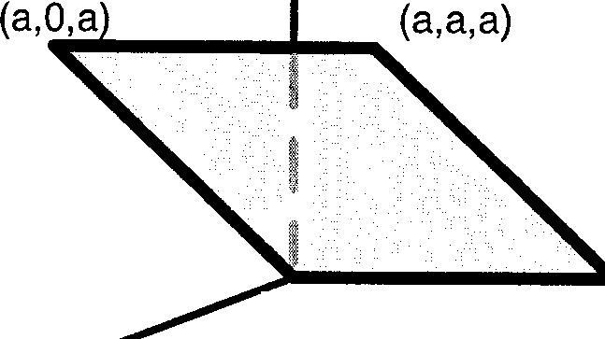
y
(0,0,0)
(0,a,0)

  - 2Eaa2

(8)
X

- 2Eaa2 (C) Eaa2 (D)

Eaa2
✓2

ANSWER:C

( PHYSICS ]
- The wavelength of the first spectral line in the Balmer series of hydrogen atom is 6561 A. The wavelength of the second spectral line in the Balmer series of singly-ionized helium atom is

  - 1215 A (B) 1640 A

ANSWER:A
(C) 2430 A (D) 4687 A

- A ball of mass (m) 0.5 kg is attached to the end of a string having length (L) 0.5 m. The ball is rotated on a horizontal circular path about vertical axis. The maximum tension that the string can bear is 324 N. The maximum possible value of angular velocity of ball (in radian/s) is

  - 9 (B) 18
m

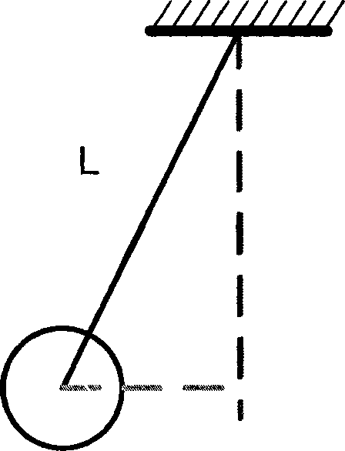
(C) 27 (D) 36

ANSWER:D

( PHYSICS J
- A meter bridge is set-up as shown, to determine an unknown resistance 'X' using a standard 10 ohm resistor. The galvanometer shows null point when tapping-key is at 52 cm mark. The end-corrections are 1 cm and 2 cm respectively for the ends A and B. The determined value of 'X' is

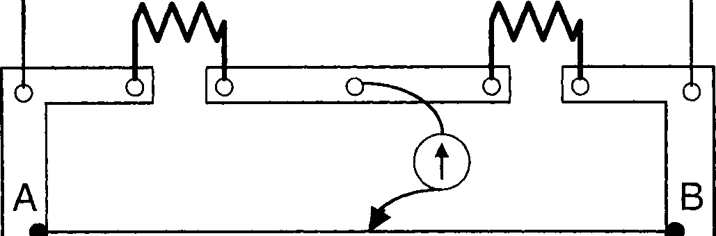
10 Q

X

  - 10.2 ohm (B) 10.6 ohm

ANSWER:B
(C) 10.8 ohm (D) 11.1 ohm


- A 2 µF capacitor is charged as shown in figure. The percentage of its stored energy dissipated after the switch S is turned to position 2 is
j1 s2
8µF
2µF

V

  - 0% (B) 20%

ANSWER:D
- 75% (D) 80%

( PHYSICS
�-�

SECTION - II (Total Marks : 16)
(Multiple Correct Answers Type)
This section contains 4 multiple choice questions. Each question has four choices (A), (B), (C) and (D) out of which ONE or MORE may be correct.

- A spherical metal shell A of radius RA and a solid metal sphere B of radius R8 (< RA) are kept far apart and each is given charge '+Q'. Now they are connected by a thin metal wire. Then
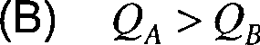
{A) E�111de = 0

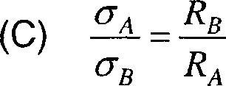
- E�n su1/me< E�n ,urface

ANSWER: ABCD
- An electron and a proton are moving on straight parallel paths with same velocity. They enter a semi-infinite region of uniform magnetic field perpendicular to the velocity. Which of the following statement(s) is/are true?
  - They will never come out of the magnetic field region.
  - They will come out travelling along parallel paths.
  - They will come out at the same time.
  - They will come out at different times.

ANSWER: BC, BD, BCD

PHYSICS

- A composite block is made of slabs A, B, C, D and E of different thermal conductivities (given in terms of a constant K) and sizes (given in terms of length, L) as shown in the figure. All slabs are of same width. Heat 'Q' flows only from left to right through the blocks. Then in steady state

heat
>

1L
>
>

3L
>
A | B 3K | E
2K | C 4K | 6K
2K | D SK | 6K

0 1L SL 6L

4L
- heat flow through A and E slabs are same.
- heat flow through slab E is maximum.
- temperature difference across slab E is smallest.
- heat flow through C = heat flow through B + heat flow through D.

ANSWER:ACD
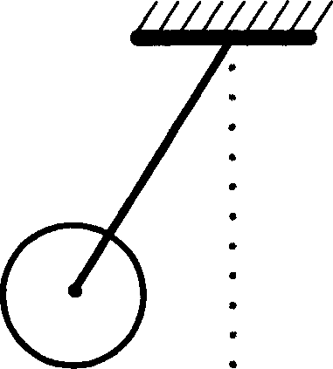
- A metal rod of length 'L' and mass 'm' is pivoted at one end. A thin disk of mass 'M' and radius 'R' (< L) is attached at its center to the free end of the rod. Consider two ways the disc is attached: (case A) The disc is not free to rotate about its center and (case B) the disc is free to rotate about its center. The rod-disc system performs SHM in vertical plane after being released from the same displaced position. Which of the following statement(s) is (are) true?

  - Restoring torque in case A = Restoring torque in case B
  - Restoring torque in case A < Restoring torque in case B
  - Angular frequency for case A > Angular frequency for case B.
  - Angular frequency for case A< Angular frequency for case B.

ANSWER:AD

(�_P_Hv_s_1cs_ ,,]

SECTION - Ill (Total Marks : 15)
(Paragraph Type)
This section contains 2 paragraphs. Based upon one of the paragraphs 3 multiple choice questions and based on the other paragraph 2 multiple choice questions have to be answered. Each of these questions has four choices (A), (B), (C) and (D) out of which ONLY ONE is correct.

Paragraph for Question Nos. 35 to 37
Phase space diagrams are useful tools in analyzing all kinds of dynamical problems. They are especially useful in studying the changes in motion as initial position and momentum are changed. Here we consider some simple dynamical systems in one-dimension. For such systems, phase space is a plane in which position is plotted along horizontal axis and momentum is plotted along vertical axis. The phase space diagram is x(t) vs. p(t) curve in this plane. The arrow on the curve indicates the time flow. For example, the phase space diagram for a particle moving with constant velocity is a straight line as shown in the figure. We use the sign convention in which position or momentum upwards (or to right) is positive and downwards (or to left) is negative.

t
�E
-
s::
Cl)
E
:0:

Position

PHYSICS )
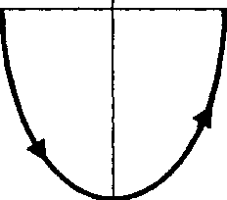
- The phase space diagram for a ball thrown vertically up from ground is Momentum Momentum

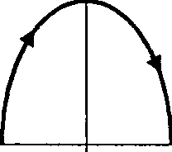
  - (B) Position
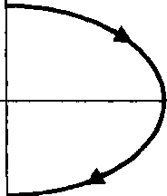
Position

Momentum
Momentum

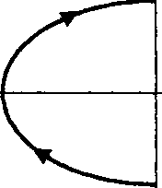
- Position (D) Position

ANSWER:D

- The phase space diagram for simple harmonic motion is a circle centered at the origin. In the figure, the two circles represent the same oscillator but for different initial conditions, and E1 and E2 are the total mechanical energies respectively. Then
[ P_Hv_s_1cs

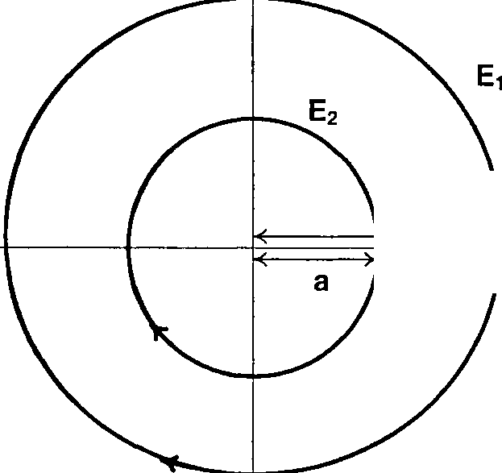
Momentum

2a
,]

  - £₁ =✓2 E₂
- El =4 E2
  - El= 2 E2
(D) El =16E2
Position

ANSWER:C
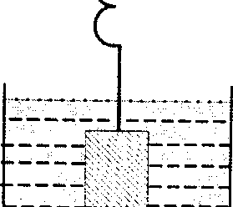
- Consider the spring-mass system, with the mass submerged in water, as shown in the figure. The phase space diagram for one cycle of this system is

Momentum Momentum

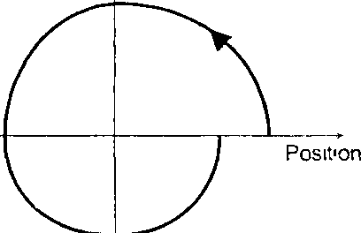
(A) (B)
Pos,t,on

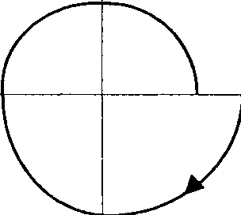
Momentum
Momentum
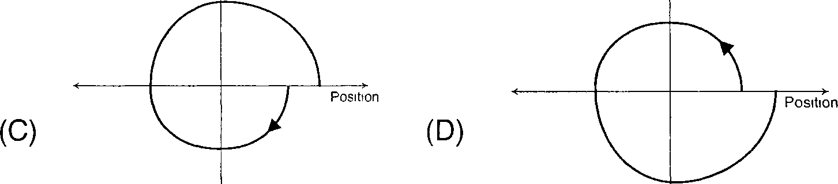

ANSWER:B

PHYSICS )
Paragraph for Question Nos. 38 and 39

A dense collection of equal number of electrons and positive ions is called neutral plasma. Certain solids containing fixed positive ions surrounded by free electrons can be treated as neutral plasma. Let 'N' be the number density of free electrons, each of mass 'm'. When the electrons are subjected to an electric field, they are displaced relatively away from the heavy positive ions. If the electric field becomes zero, the
electrons begin to oscillate about the positive ions with a natural angular frequency 'mp', which is called the plasma frequency. To sustain the oscillations, a time varying electric field needs to be applied that has an angular frequency m, where a part of the energy is
absorbed and a part of it is reflected. As m approaches mp, all the free electrons are set to resonance together and all the energy is reflected. This is the explanation of high reflectivity of metals.

- Taking the electronic charge as 'e' and the permittivity as 'E0 ', use dimensional analysis to determine the correct expression for mp.
f�

(A) �
�-;;;E�

(BJ
��Ne

ANSWER:C
(CJ te'
mE0
- �

- Estimate the wavelength at which plasma reflection will occur for a metal having the density of electrons N :::::; 4 x 1027 m-3. Take e0 :::::: 10-11 and m :::::; 10-30, where these quantities are in proper SI units.

  - 800 nm (B) 600 nm

ANSWER:B
- 300 nm
- 200 nm

PHYSICS

SECTION - IV (Total Marks.: 28)
(Integer Answer Type)
This section contains 7 questions. The answer to each of the questions is a single-digit integer, ranging from 0 to 9. The bubble corresponding to the correct answer is to be darkened in the ORS.

- A boy is pushing a ring of mass 2 kg and radius 0.5 m with a stick as shown in the figure. The stick applies a force of 2 N on the ring and rolls it without slipping with an
2
acceleration of 0.3 mis . The coefficient of friction between the ground and the ring is
large enough that rolling always occurs and the coefficient of friction between the stick and the ring is (P/10). The value of P is
Stick
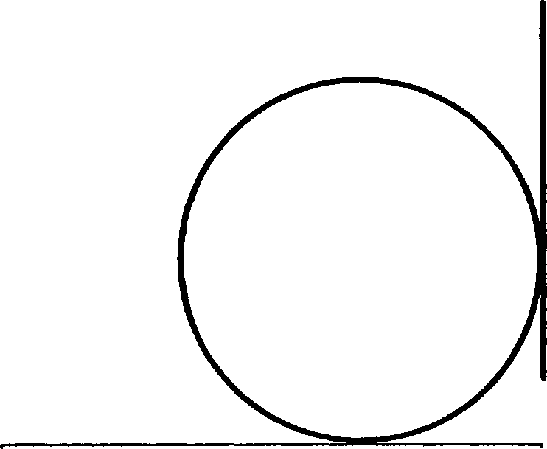
Ground

ANSWER:4
- A block is moving on an inclined plane making an angle 45° with the horizontal and the coefficient of friction is µ. The force required to just push it up the inclined plane is 3 times
the force required to just prevent it from sliding down. If we define N = 1 0 µ, then N is

ANSWER:5

(�_P_H_vs_,c_s )

- Four point charges, each of +q, are rigidly fixed at the four corners of a square planar soap film of side 'a '. The surface tension of the soap film is r The system of charges and
11
planar film are in equilibrium, and a-k[ q:] N, where 'k'is a constant. Then N is

ANSWER:3

- Steel wire of length 'L' at 40°C is suspended from the ceiling and then a mass 'm' is hung
from its free end. The wire is cooled down from 40°C to 30°C to regain its original length 'L'. The coefficient of linear thermal expansion of the steel is 1o-⁵ / °C, Young's modulus
11 2
of steel is 10 N/m and radius of the wire is 1 mm. Assume that L >> diameter of the
wire. Then the value of 'm' in kg is nearly

ANSWER:3
- The activity of a freshly prepared radioactive sample is 10¹⁰ disintegrations per second, whose mean life is 10⁹ s. The mass of an atom of this radioisotope is 10-²⁵ kg. The mass (in mg) of the radioactive sample is

ANSWER:1

(� P_H_v_s_1c_s_ ,
- A long circular tube of length 10 m and radius 0.3 m carries a current I along its curved surface as shown. A wire-loop of resistance 0.005 ohm and of radius 0.1 m is placed inside the tube with its axis coinciding with the axis of the tube. The current varies as I= /0 cos (300 t) where I0 is constant. If the magnetic moment of the loop is N µ0 I0sin (300 t), then 'N' is

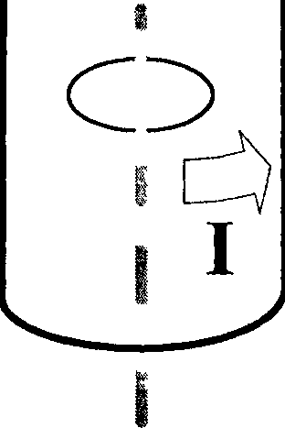
I

ANSWER:6
- Four solid spheres each of diameter ✓5 cm and mass 0.5 kg are placed with their centers at the corners of a square of side 4 cm. The moment of inertia of the system about the diagonal of the square is N x 10-4 kg-m2, then N is
ANSWER:9

[ PART Ill : MATHEMATICS l

SECTION - I (Total Marks : 21)
(Single Correct Answer Type)
This section contains 7 multiple choice questions. Each question has four choices (A), (B), (C) and (D) out of which ONLY ONE is correct.

- Let ( x₀, y₀) be the solution of the following equations

(2x)1°2 = (3y )1°3
3lnx= iny.

Then x₀ is

  - _!_
6

1
  - 3

ANSWER:C

  - 1
2

  - 6

- The value of

1 3
(A)
-In-
� • 2
xsmx dx is
f
- 1n2 sinx² +sin(ln6-x²)

(B)

1 3
-In-

4 2 2 2

(C)
3
In-

(D)
1 3
-In-

2 6 2

ANSWER:A

( MATHEMATICS )

- Let ; = i +] + k , b = i - } + k and � = i - }- k be three vectors. A vector � in the plane of
; and b , whose projection on � is � , is given by

  - i -3] +3k
(C) 3[ - } +3k

ANSWER:C
  - -3i -3}-k
(D) i+3]-3k

- Let P = { 0: sin 0- cos 0 = ✓2 cos 0} and Q = { 0: sin 0 + cos 0 = ✓2sin 0} be two sets. Then

  - P c Q and Q - P 1=0
(C) Pct. Q

ANSWER:D
  - Q ct. P
(D) P =Q

- Let the straight line x = b divide the area enclosed by y = (1- x )2, y = O, and x = O into

two parts R1

  - 3
4
(0 s x s b) and R₂

  - 1
2
(b s x s1) such that R1 -R2

  - _!_
3
= 1 . Then b equals 4
  - 1
4

ANSWER:B

- Let a and f3 be the roots of x² -6x-2 = 0,with a> f3. If a,, = a" - /3" for n � l, then the

value of
a10 -2a 2a9
8 is

  - 1 (B) 2 (C) 3 (D) 4

ANSWER:C
- A straight line L through the point (3,-2) is inclined at an angle 60° to the line
.fix+ y = l . If L also intersects the x-axis, then the equation of L is

  - y+✓3x+2-3✓3 =0
(C) ✓3y-x+3+2✓3 =0

ANSWER:B
(8) y-✓3x+ 2+3✓3 = 0
- ✓3y +x-3+ 2✓3 = 0

SECTION - II (Total Marks : 16)
(Multiple Correct Answers Type)
This section contains 4 multiple choice questions. Each question has four choices (A), (B), (C) and (D) out of which ONE or MORE may be correct.

- The vector(s) which is/are coplanar with vectors i +] + 2k and i + 2] + k, and perpendicular to the vector i+] + k is/are

  - J-f (B)

A A
-i + j
(C) A A (D) -] +k

ANSWER:AD
l - J
- Let Mand N be two 3x3 non-singular skew-symmetric matrices such that MN= NM. It
pT denotes the transpose of P, then M²N² (MT Nf¹(MN-¹/ is equal to

(A) M² (B) -N² (C) -M² (D) MN

ANSWER: MARKS TO ALL
1 0
- Let the eccentricity of the hyperbola x: - Y: = 1 be reciprocal to that of the ellipse
a~ b-
x² + 4 y2 = 4. If the hyperbola passes through a focus of the ellipse, then
1 1
  - the equation of the hyperbola is :c _z.::_ = 1
3 2
  - a focus of the hyperbola is (2, O)
  - the eccentricity of the hyperbola is J"¾

  - the equation of the hyperbola is x² -3y2 = 3

ANSWER:BD

- Let J: IR➔ IR be a function such that
J(x+ y) = f(x) + J(y), \Jx, yE IR.
If J (x) is differentiable at x = 0, then
  - f(x) is differentiable only in a finite inteNal containing zero
  - f(x) is continuous 'vxE IR
  - .f'(x) is constant 'vxE IR
  - J (x) is differentiable except at finitely many points

ANSWER: BC, BCD

SECTION - Ill (Total Marks : 15)
(Paragraph Type)
This section contains 2 paragraphs. Based upon one of the paragraphs 3 multiple choice questions and based on the other paragraph 2 multiple choice questions have to be answered. Each of these questions has four choices (A), (B), (C) and (D) out of which ONLY ONE is correct.
Paragraph for Question Nos. 58 to 60
Let a , b and c be three real numbers satisfying

[a b c] 8 2 7
ll 9 7]
7 3 7
=[0 0 0)
. (E)

- If the point P(a, b, c), with reference to (E), lies on the plane 2x + y + z =1, then the value of 7a +b+c is

  - 0
  - 12 (C) 7

ANSWER:D
(D) 6

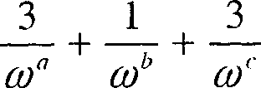
- Let w be a solution of x³ - 1 = o with Im(w) > O. If a= 2 with b and c satisfying (E), then the value of

is equal to
  - -2

  - 2

ANSWER:A

  - 3 (D) -3

- Let b = 6, with a and c satisfying (E). If a and j3 are the roots of the quadratic equation
ax² +bx+ c = 0 , then
= 1 1
/1
I-( +-

is

  - 6 (B) 7
11=0 a /J3

(C) 6
7

(D) =

ANSWER:B

Paragraph for Question Nos. 61 and 62

Let U1 and U2 be two urns such that U1 contains 3 white and 2 red balls, and U2
contains only 1 white ball. A fair coin is tossed. If head appears then 1 ball is drawn at random from u and put into U . However, if tail appears then 2 balls are drawn at random from U and put into u . Now 1 ball is drawn at random from U .
1 2
1 2 2

- The probability of the drawn ball from u being white is
2

  - 13
30
  - 23
30

ANSWER:B
  - 19
30
  - 11
30

- Given that the drawn ball from U₂ is white, the probability that head appeared on the coin is

  - 17
23
  - 11
23

ANSWER:D
  - 15
23
  - 12
23

SECTION - IV (Total Marks : 28)
(Integer Answer Type)
This section contains 7 questions. The answer to each of the questions is a single-digit integer, ranging from 0 to 9. The bubble corresponding to the correct answer is to be darkened in the ORS.

- Consider the parabola y2 = 8x. Let Li1 be the area of the triangle formed by the end points of its latus rectum and the point P(�, 2) on the parabola, and Li2 be the area of the triangle formed by drawing tangents at P and at the end points of the latus rectum.
Then� is
Li2

ANSWER:2

p
- Let a1 , a2, a3 , ... , a100 be an arithmetic progression with a1 = 3 and Sr =Ia, , 1 :s: p :s:100 .

For any integer n with 1:::;: n :::;: 20, let m = 511 . If� does not depend on 11 , then a, is
� -

ANSWER: 3, 9, 3 &9 BOTH

- The positive integer value of n > 3 satisfying the equation

1 = 1 1

sin (:) s•m ( -2n-);; +
is

ANSWER:7
s•m ( -3n-);-

- Let f : [l, =) � [2, 00) be a differentiable function such that f (1) = 2. If

X
6f f(t)dt = 3xf(x)-x³
I
for all x �I, then the value of f (2) is

ANSWER: MARKS TO ALL
- If z is any complex number satisfying lz-3-2fl::;2, then the minimum value of l2z-6+5il is

ANSWER:5

- The minimum value of the sum of real numbers a-⁵, a-⁴, 3a-³, 1, a⁸ and a¹⁰ with a> O is

ANSWER:8

Let f(0) = sm• (

is

tan-¹(✓
sin0 JJ, where --n< 0 <n-. Then the value of
cos20 4 4
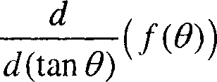

ANSWER:1

