Independent Learning Form

By: J. Adam Saenzpardo

# Summary:

I’ve created a simple application using ReactJS and Meteor. The application is a to-do list that can be shared with a team and I want to deploy the application. I’ve attempted to deploy the application using Amazon Web Services, but I’m receiving build errors. The application runs as intended locally.

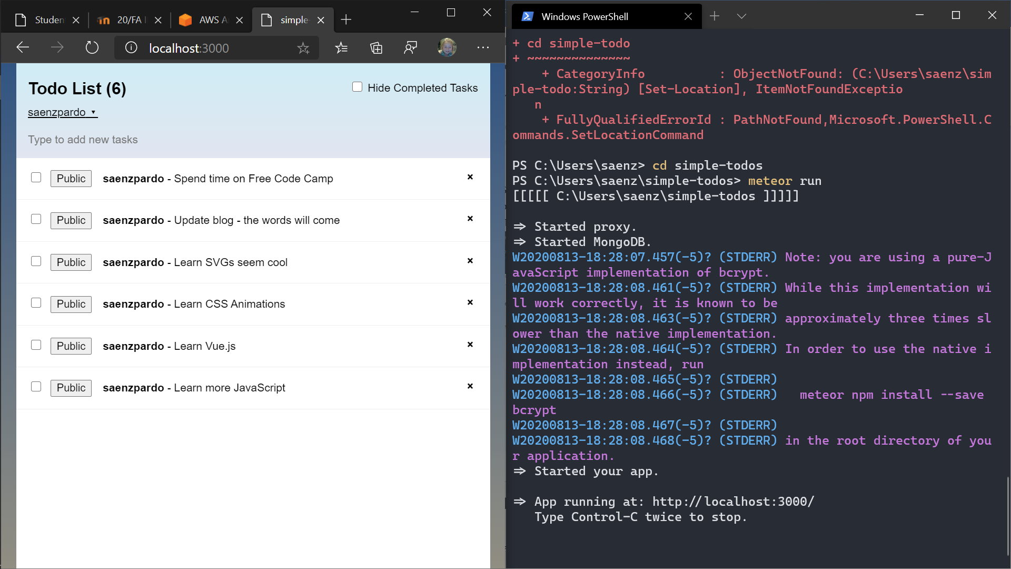

## Identify the problem:

The application fails to build in the Amazon Web Services Dashboard.

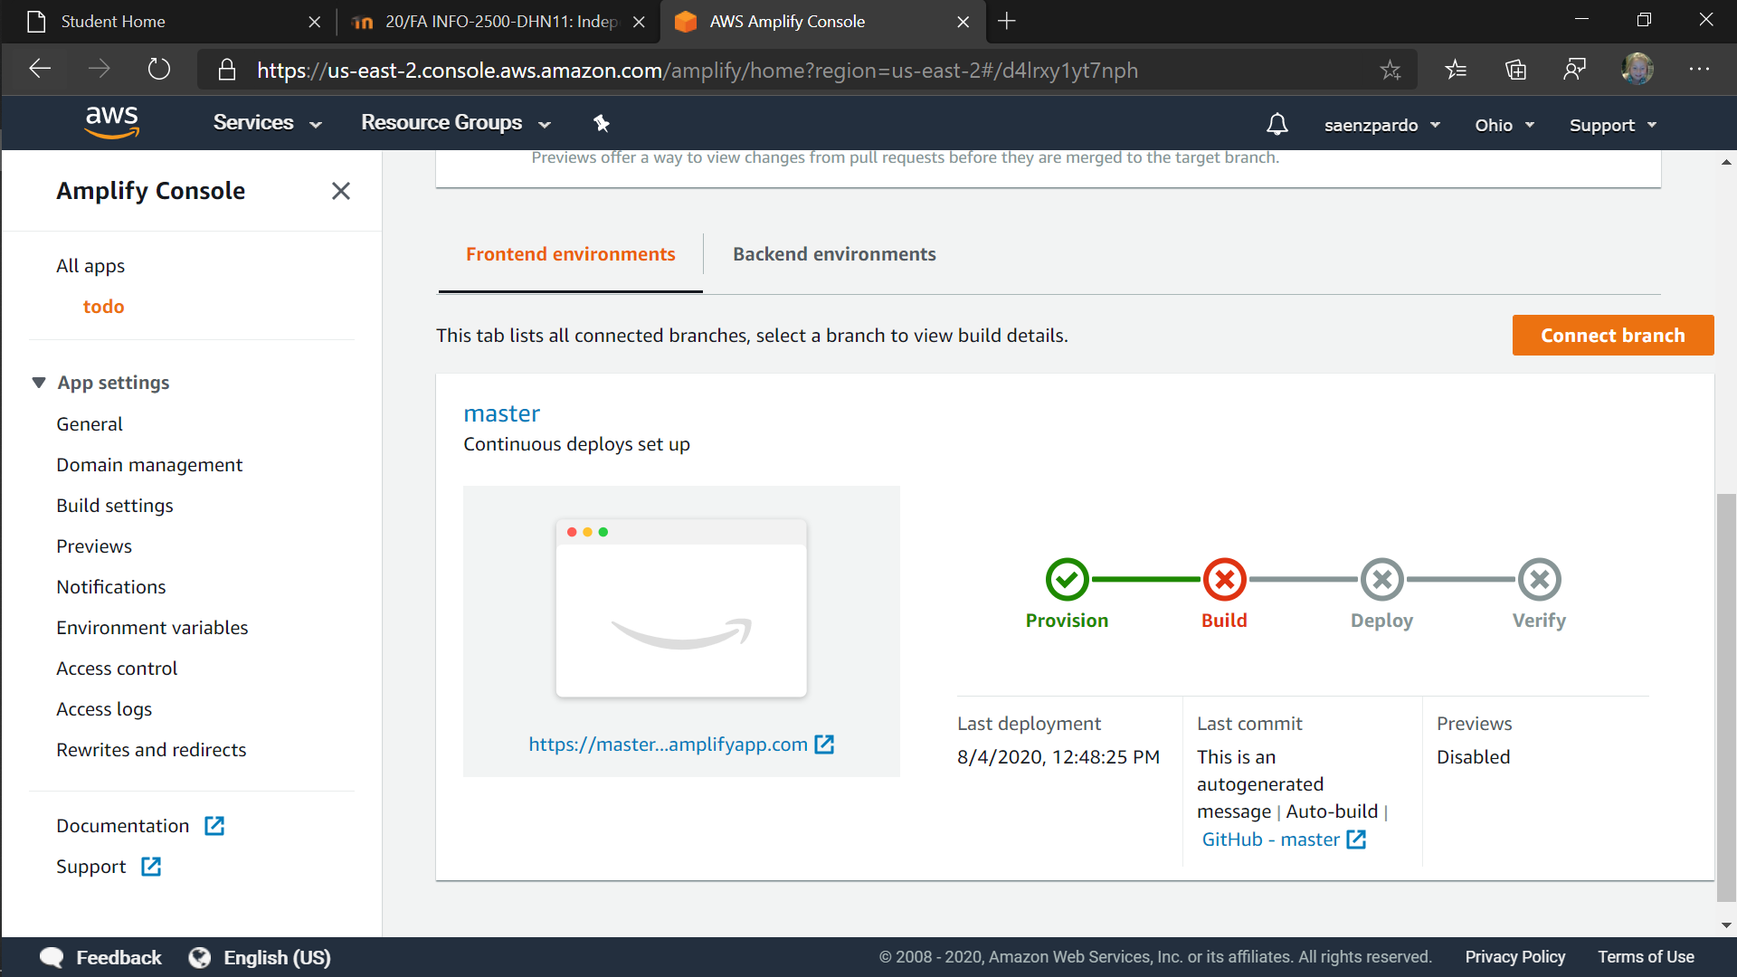

## Identify the cause of the problem:

I’ve never tried to deploy an application to the cloud, so I’m not sure at this point. My knowledge of node.js, React, Meteor and AWS is limited. At this point I’m going to assume it’s a framework, API or library issue.

## Research and Identify Credible Sources:

I’ve started with the AWS documentation which is beyond my comprehension at this point. I searched the AWS forums for similar issues and did find someone that must have followed the same tutorial I found. The post was two years old and still unanswered.

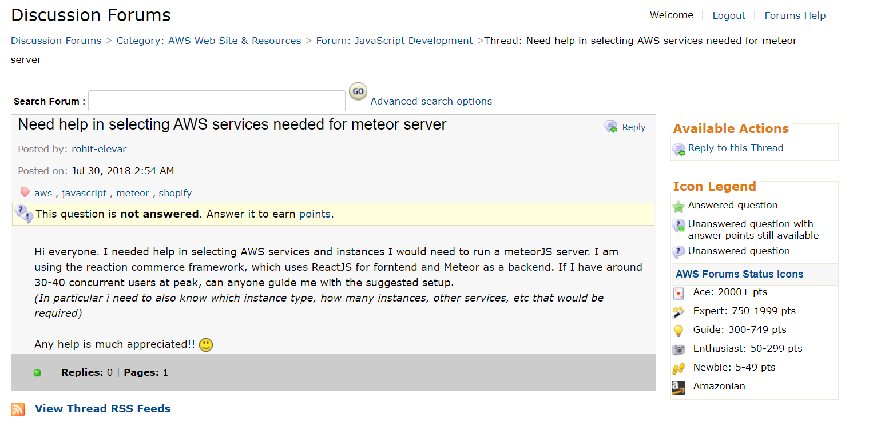

Looking through stackoverflow posts, I believe the problem is with the AWS service I selected.

## Identify Possible Solutions:

I believe I have the issue is related to the backend use of Meteor. I was trying to use the AWS service Amplify, which I believe is a backend framework. I went back to the AWS console and found the terminal output of the application when it launched. Meteor used the Chocolatey package manager meant for Windows machines and the build failed at the “choco” command.

Solutions may include:

1. Attempt to find a suitable platform on AWS I can use to run the ReactJS/Meteor application.
2. Consider Microsoft’s Azure platform that may support Chocolatey.
3. Try an alternative SaaS platform such as Heroku or Netlify.

## Implement a Solution: