# Node.js Crash Course

## By: Adam Saenzpardo

Installing Node.JS

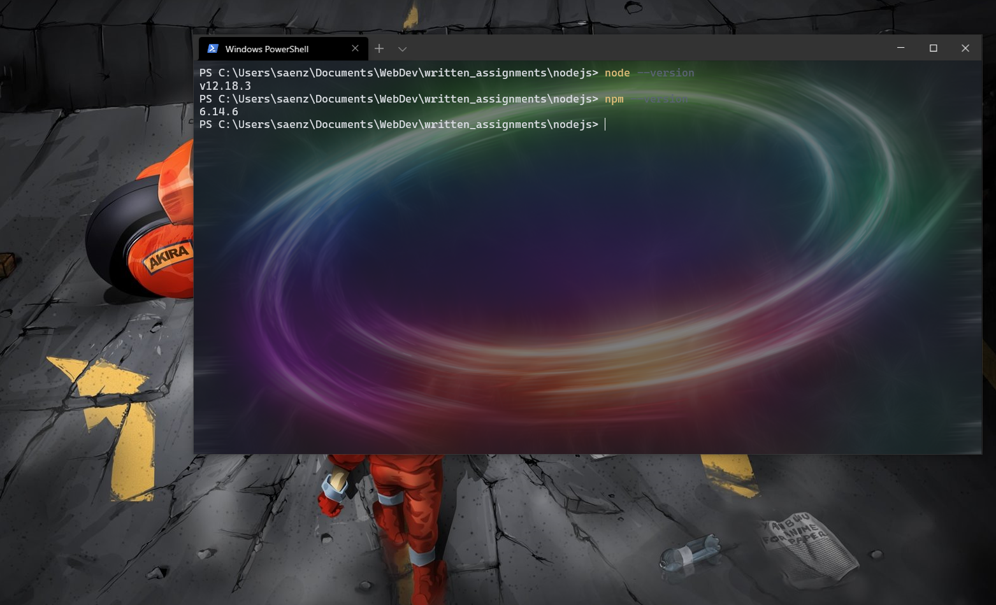

Creating the Person Class – 22:45

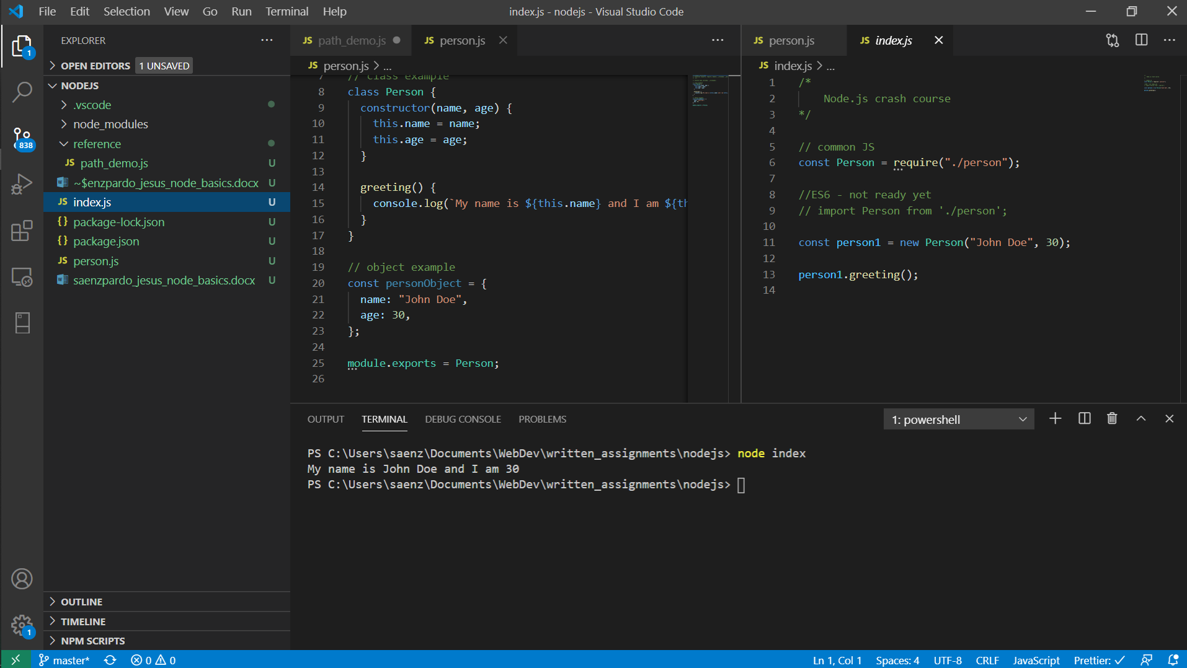

Path Demo – 28:45

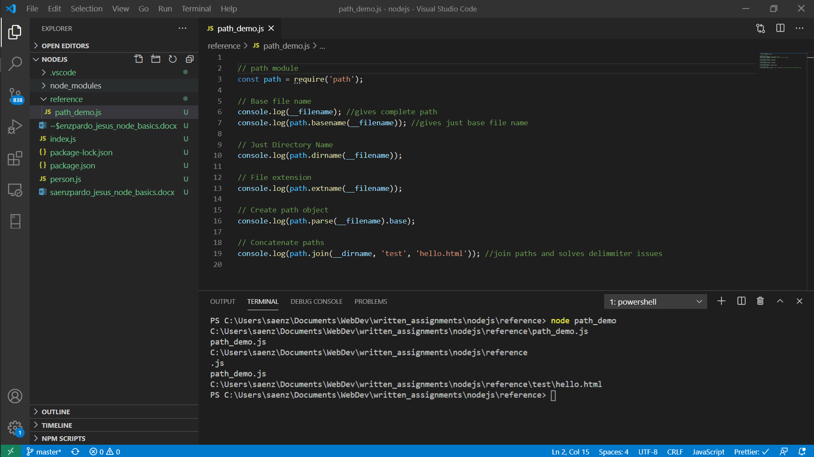

File Demo – 38:00

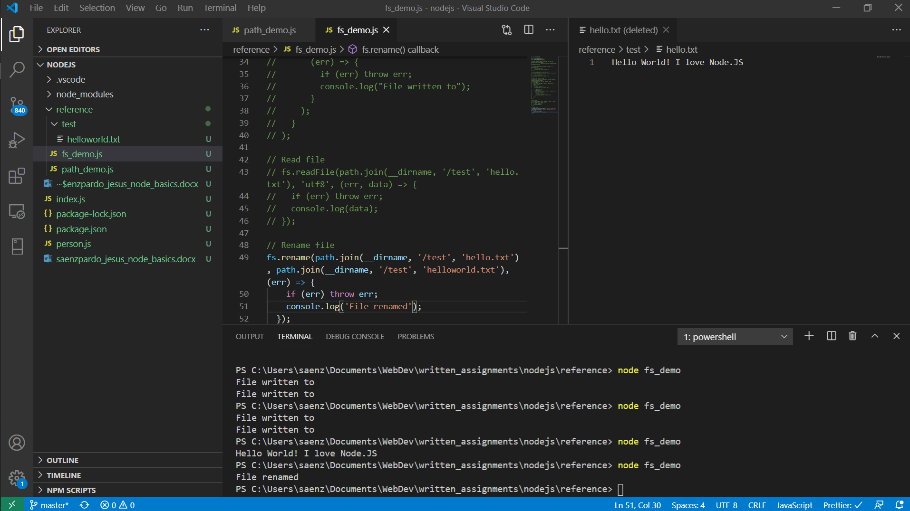

OS Demo – 41:15

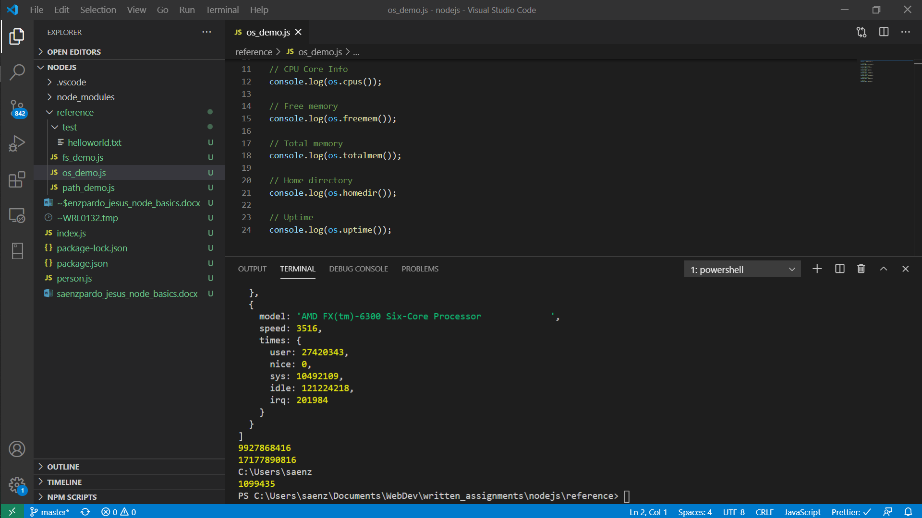

URL Demo – 46:54

