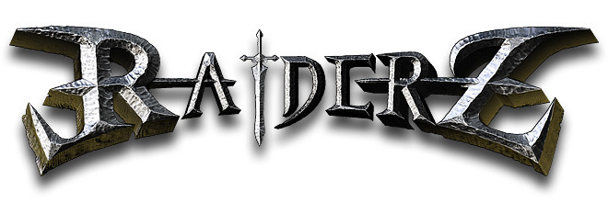

**How to Install**

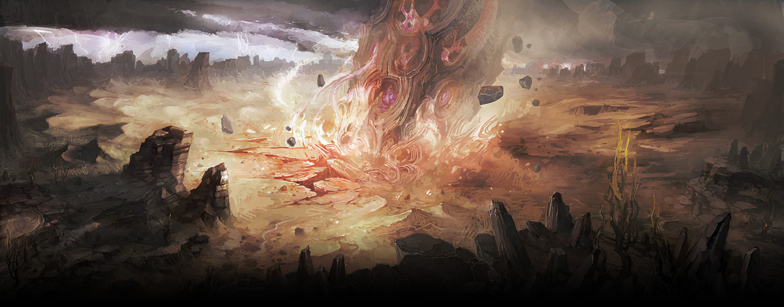

10 years ago a huge meteoroid has fallen to this world called Rendel. Since then, ceaseless challenges from the adventurers has whelmed upon this land of changes.

You have also arrived here to realize your dream. There are many adventures and threats waiting before you.

**Action MMORPG**

**MAIET Entertainment**

[**http://www.maiet.net**](http://www.maiet.net)

Table of Contents

Download RaiderZ 3

Subscribe for account 5

Install RaiderZ 6

Start RaiderZ 8

Start 8

Log in 8

Character creation 9

Enter 10

Loading 10

Welcome to RaiderZ. 11

Interface 12

Controls 13

**Download RaiderZ**

**To download**

The RaiderZ installation file is distributed at MAIET webhard.

You can connect to MAIET webhard (<http://maiet.bizhard.com/en/>) by using web browser.

Type in the below information on the upper left corner, where you should type in the account information, then press Login button.

**ID**: maiet **Password**: maiet1248

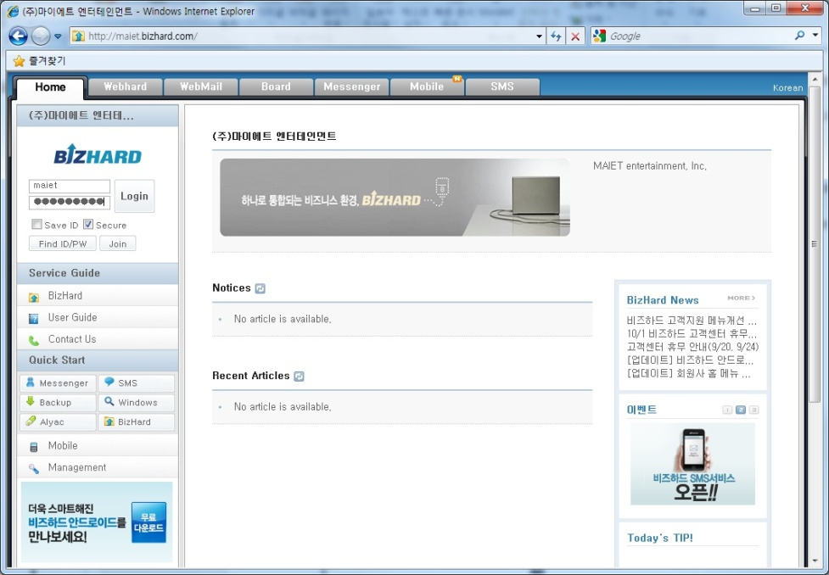

**1**

The installation file is located at RaiderZ folder in the webhard.

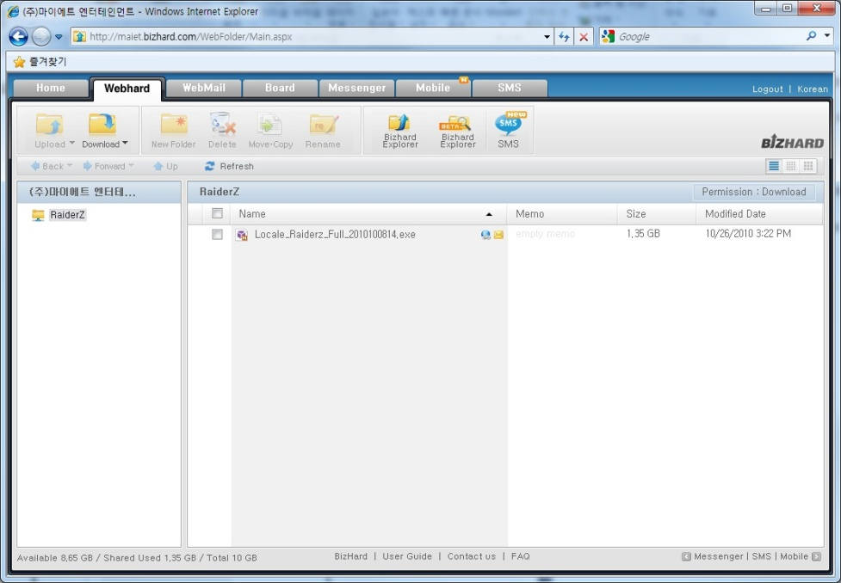

Click the file name and press “save” to download the installation file.

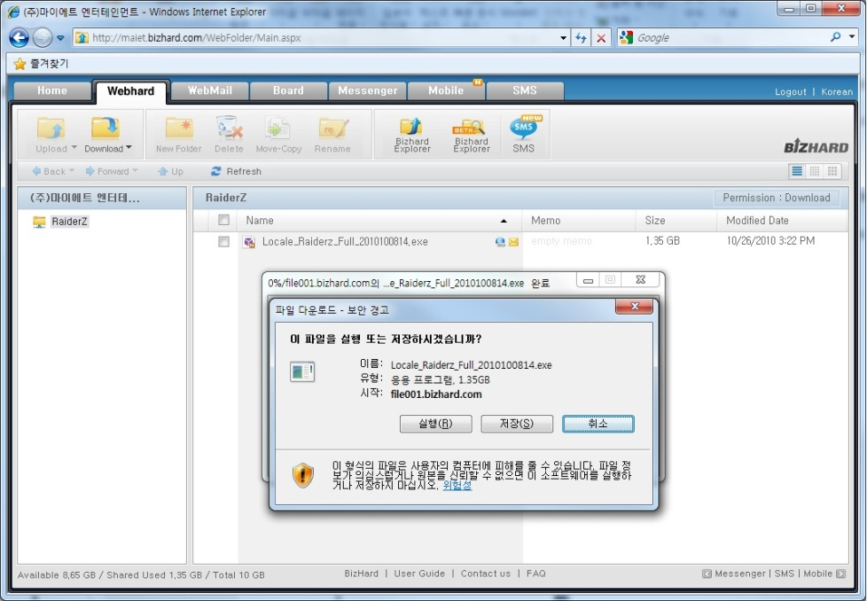

**3**

**2**

**Recommended specification**

The recommended specification for the hardware to run RaiderZ is the following.

**CPU:** Intel Pentium 4 2.0G / AMD Sempron 2800

**VGA:** GeForce 8800

**RAM:** 2GB

**HDD:** 4GB

**OS:** Windows 2000, 2003, XP, Vista, 7

The project is still developing and working for optimization. The video card specification will be lower after optimization.

**Subscribe for Account**

In order to start RaiderZ, you must need a registered account. If you don’t have registered account, please fill out the Account registration form below. The form shall be sent to ([lsa2007@maiet.net](mailto:lsa2007@maiet.net)) via e-mail. This account belongs to our International brand manager and your registration form will be forward to the team to complete the registration and the result will be sent back to the e-mail address which the registration is sent by.

Please use the Account registration form below. If you are not aware of the information regarding Outside interface, please consult with your system or network manager.

|  |  |
| --- | --- |
| **Account Registration form** | |
| **Your Account ID** |  |
|  |
| **You may add more space if you need** |
| **Outside interface**  **IP** |  |
| **You may add more space if you need** |
| **Outside interface**  **MAC address** |  |
| **You may add more space if you need** |

/

**Install RaiderZ**

Run the distributed client installization file. The file should look like this.

C:\Users\praptor.MAIETDEV\Desktop\RaiderZ installer.jpg

You shall always download the newest version of the install file. The RaiderZ will not run properly if the client is not the newest version.

**Licence Agreement**

Press “*I Agree* “ button.

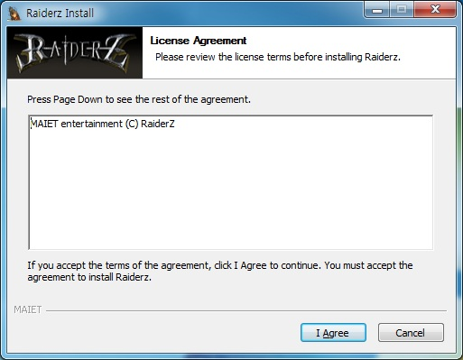

**Choose Components**

Choose the options to be installed with “RaiderZ”.

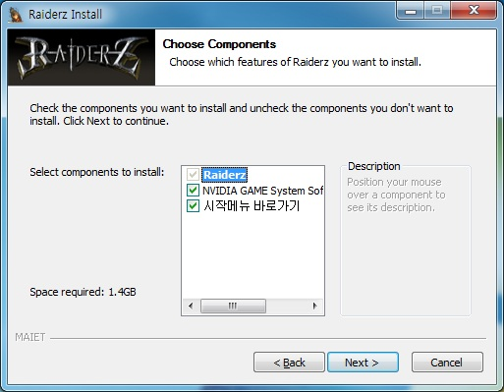

**Choose Install Location**

Choose a location where “RaiderZ” shall be installed.

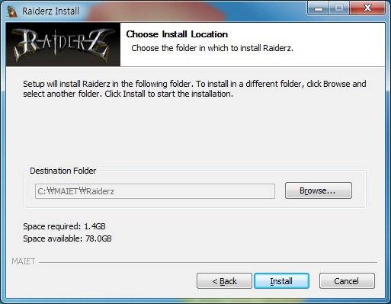

**Installing**

Installation for RaiderZ is in progress.

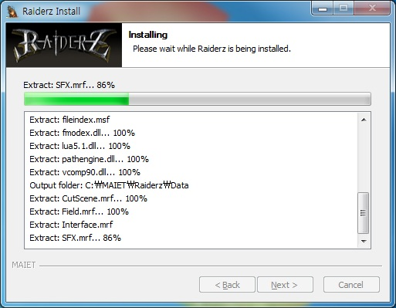

**Completing the RadierZ Setup Wizard**

RaiderZ Installation is finished.

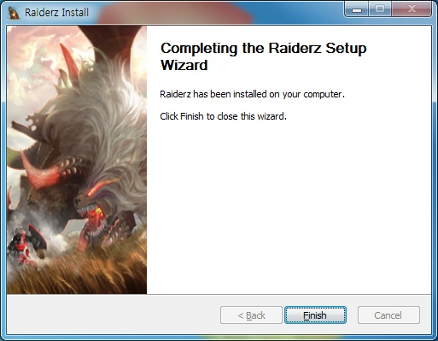

**Start with RaiderZ**

**Start**

Click on the shortcut button for “RaiderZ” on the wallpaper to start “RaiderZ”

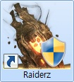

**Log in**

When the launcher starts, type in the ID that you have received through account registration. Press “Start” button.

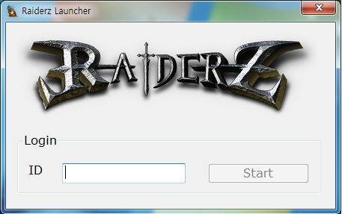

**Character Creation**

You need to create a character that you will play in “RaiderZ”.

Press “Create Character” button.

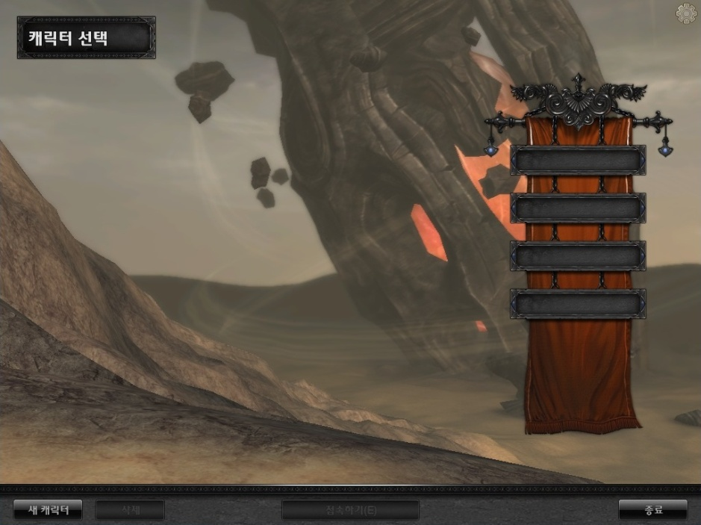

**1**

Type in the name you would like to use for your character using English alphabet from 4 to 16 letters without gaps nor special characters.

Choose gender, face, hair color and rest of options to define the character.

When you are ready, press “Create Character” button.

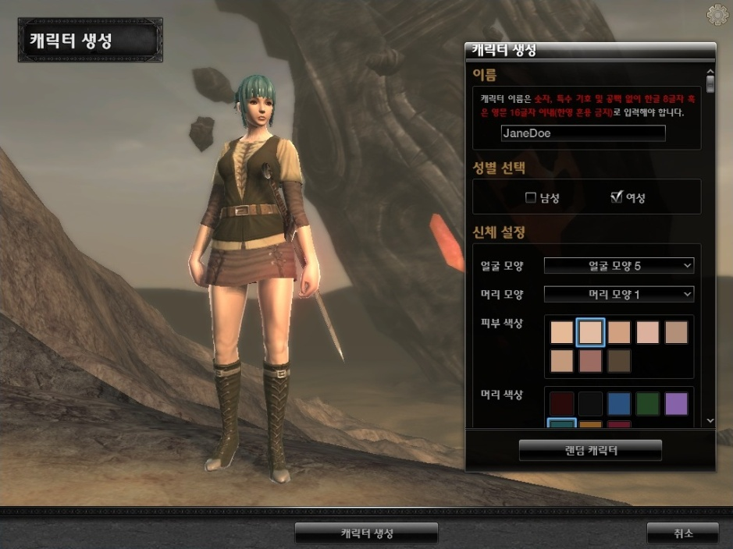

**6**

**5**

**4**

**2**

**3**

**Start RaiderZ**

Choose the character’s name that you’ve just created.

Press “Connect” button.

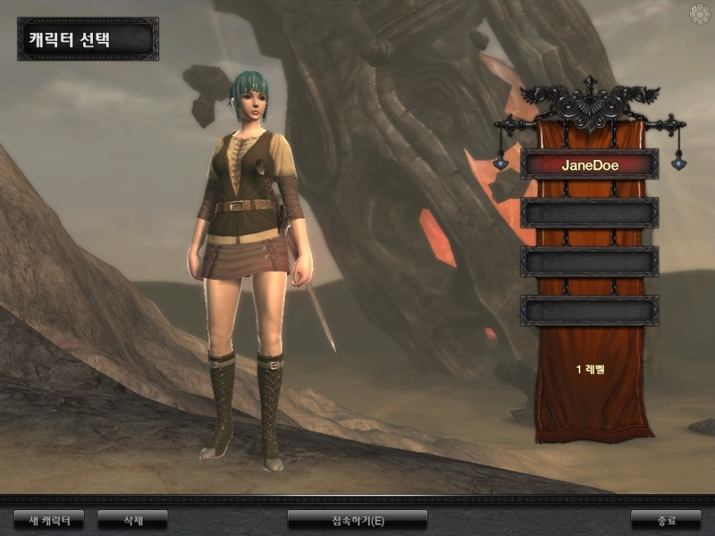

**2**

**1**

**Loading**

You are currently logging into RaiderZ. Please wait until the loading is finished.

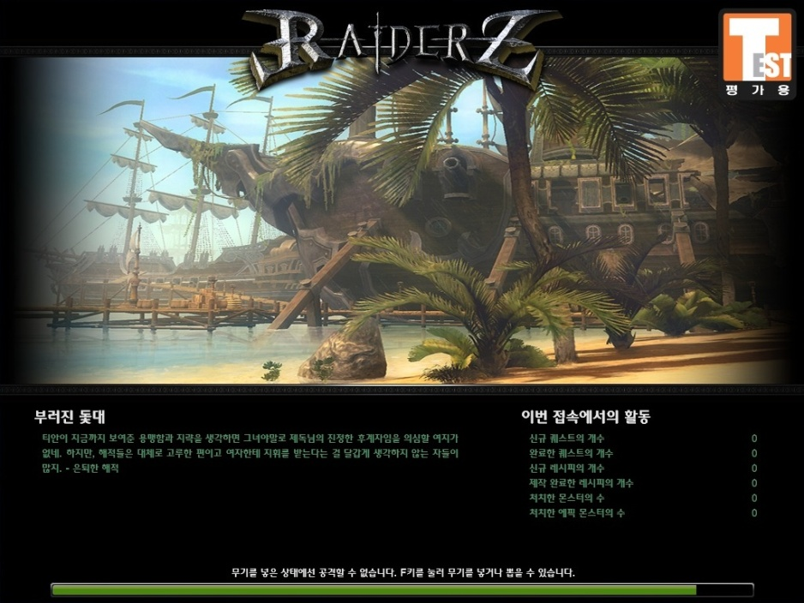

**Welcome to RaiderZ.**

The world to fulfill your dream is waiting for you. Enjoy the adventure.

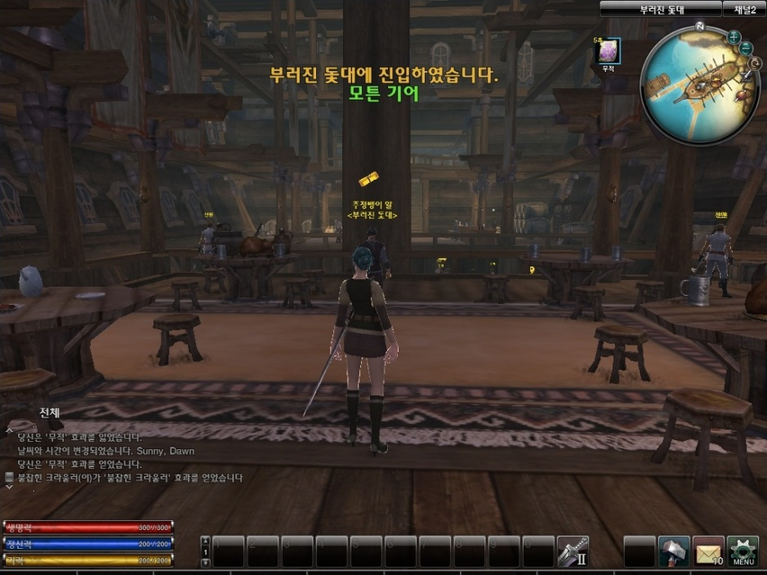

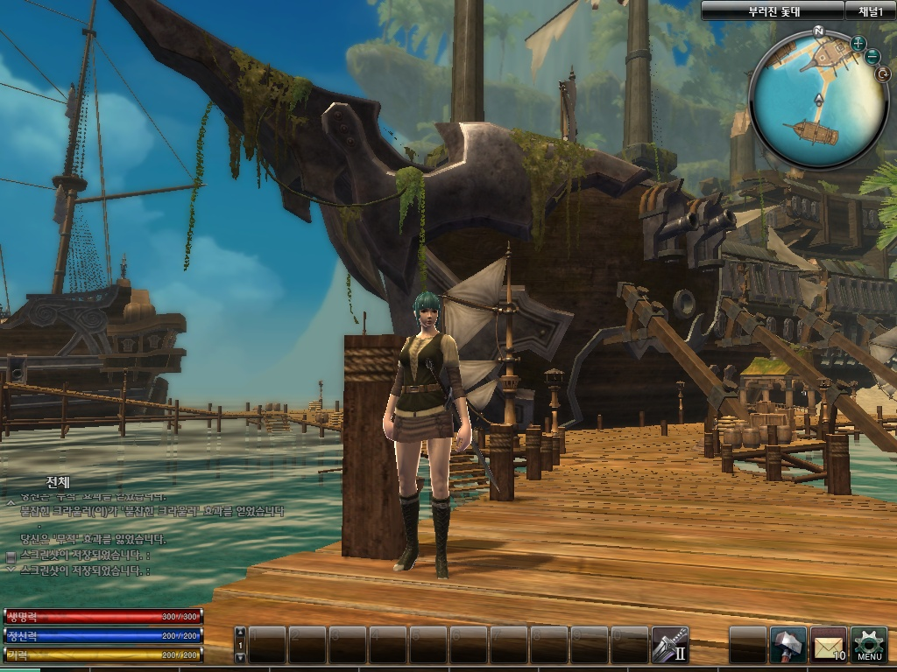

Interface

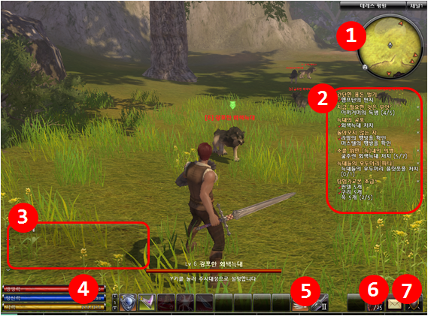

|  |  |
| --- | --- |
| 1 | Mini map : display nearby map and character’s location  Shows quest target point with an arrow |
| 2 | Quest list : Shows currently active quests and their situation  Press X button to show on/off |
| 3 | Log window : display conversation or system log |
| 4 | Display the character’s current **\***Health, **\***Energy, **\***Stamina  Each **\***Talent consumes different amount of Energy and Stamina |
| 5 | Quick Slot : display talent icons set with shortkeys |
| 6 | widget : display the durability of armor/weapon and received mails  (The current version only shows the durability) |
| 7 | System window : opens various windows such as game option or others that are necessary for the game play |

\***Health** : Character’s life point that reduces when attacked by enemy and the character dies if

his/her Health reaches 0.

\***Energy** : Energy is necessary for using magic or other special skills.

\***Stamina** : Stamina is for special motions such as evade or block.

\***Talent** : All the actions of the character is called Talent and such as attack skill, recovery magic or

even salute are part of Talent.

**Controls**

|  |  |  |
| --- | --- | --- |
| battle | **Weapon draw/ put back in** | **F** |
| attack | Mouse left button |
| **Defend(When holding weapon) /**  **Drawing strike(when not holding weapon)** | **Q /**  **Mouse left button + Mouse right button** |
| **Evade** | **Mouse right button + move key** |
| Weapon change | TAB |
| Quick slot | 1~+ |
| attention | Y |

|  |  |  |
| --- | --- | --- |
| behavior | move(forward, move left, backward, move right) | W,A,S,D |
| **collect item / talk(Interaction)** | **E** |
| jump | SPACE BAR |
| sit | X |
| Run automatically | R |
| speak | ENTER |

|  |  |  |
| --- | --- | --- |
| system | quest, recipe list | J |
| Character window | H |
| Inventory window | I |
| Show / hide cursor | CTRL |
| Entire map | M |
| Talent window | T |
| party, **\***guild, **\***friend list  (**\***cannot use at the test version) | P |
| Option, channel, character selection,  Exit game | ESC |
| Camera zoom in/out | Mouse wheel |

**MAIET Entertainment**

**http://www.maiet.net**