**Supplementary Figures and Tables**

***Copy number variations shape genomic structural diversity underpinning ecological adaptation in the wild tomato Solanum chilense***

Kai Wei1*, Remco Stam2, Aurélien Tellier1*, Gustavo A Silva-Arias1,3

1Professorship for Population Genetics, Department of Life Science Systems, School of Life Sciences, Technical University of Munich, Liesel-Beckmann Strasse 2, 85354 Freising, Germany

2Department of Phytopathology and crop protection, Institute of Phytopathology, Faculty of Agricultural and Nutritional Sciences, Christian Albrechts University, Hermann Rodewald Str 9, 24118, Kiel, Germany

3Instituto de Ciencias Naturales, Facultad de Ciencias, Universidad Nacional de Colombia, Sede Bogotá, Av. Carrera 30 # 45-03, 111321, Bogotá, Colombia

*Corresponding authors: Aurélien Tellier: aurelien.tellier@tum.de;

Kai Wei: kai.wei@tum.de

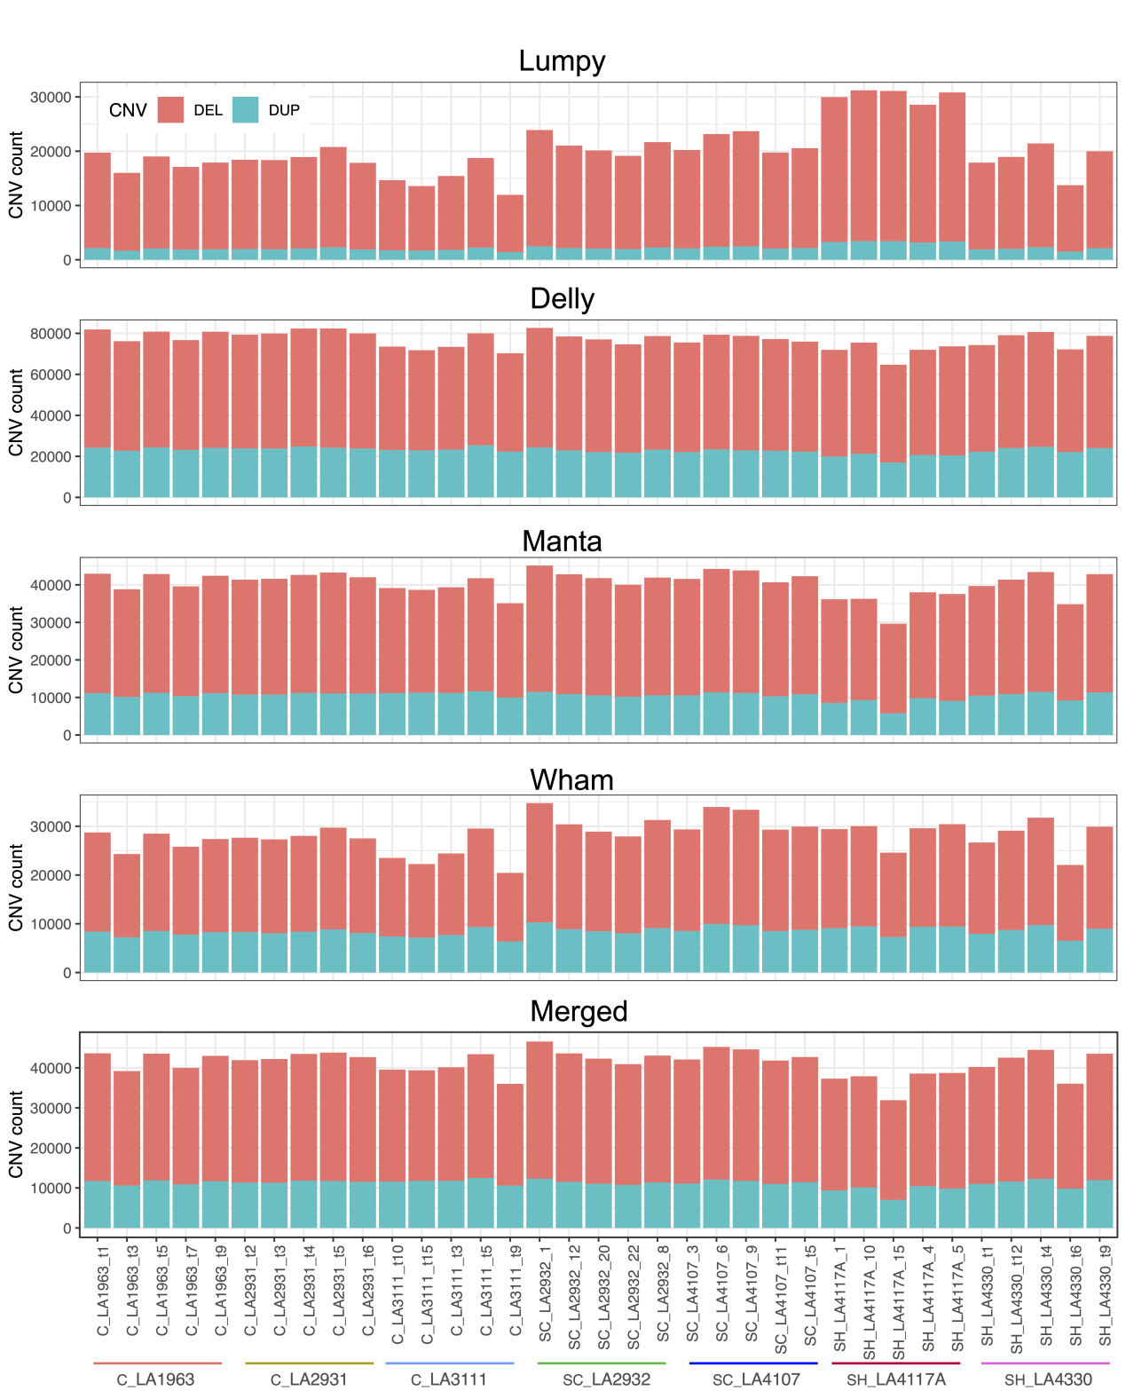

**Figure S1.** The summary of deletion (DEL) and duplication (DUP) using four CNV callers in each population, and merged result when CNVs need to be identified by at least two callers. See also Dataset S2 and Table S2.

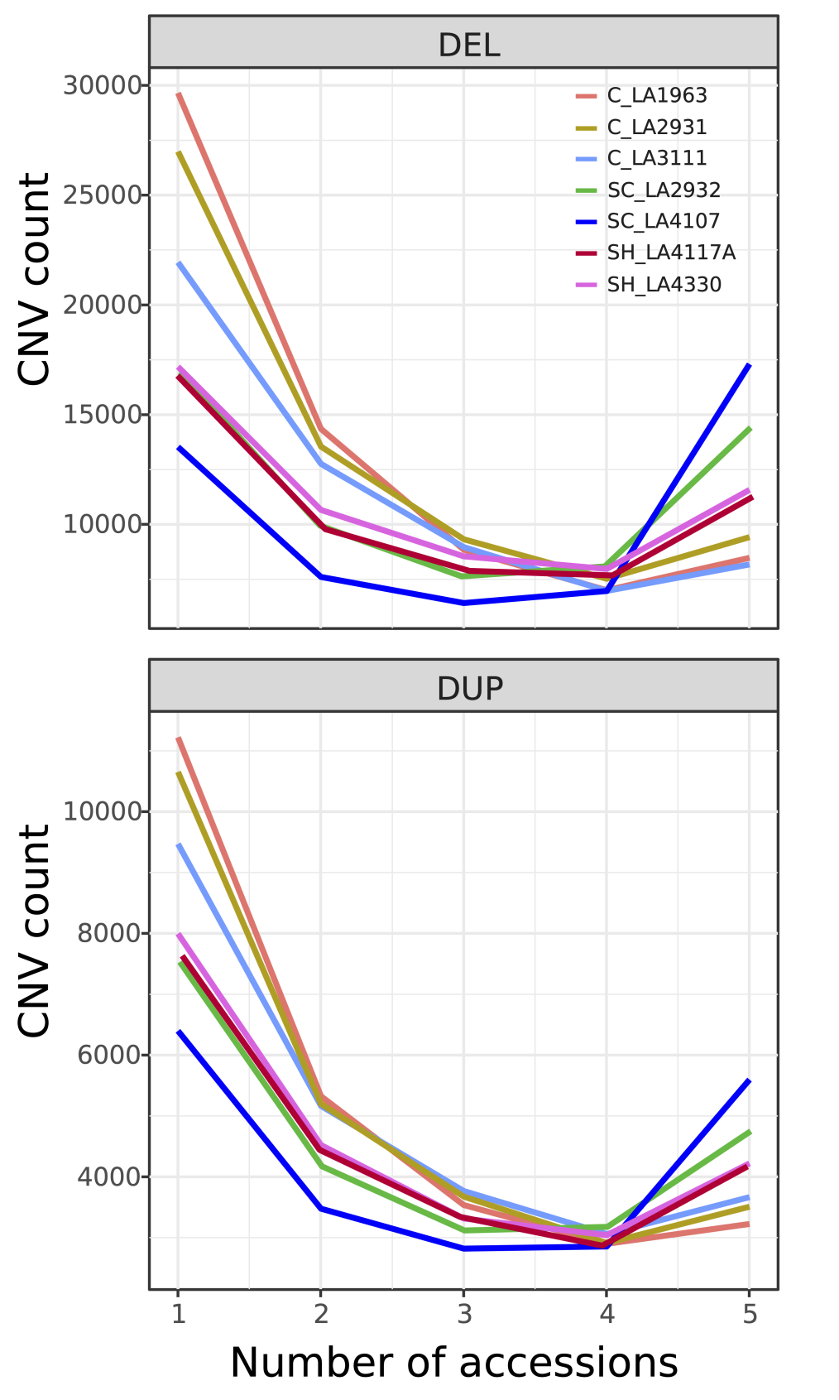

**Figure S2.** The number of CNVs identified in 1, 2, 3, 4 or 5 individuals in each population, respectively. DEL: deletion; DUP: duplication.

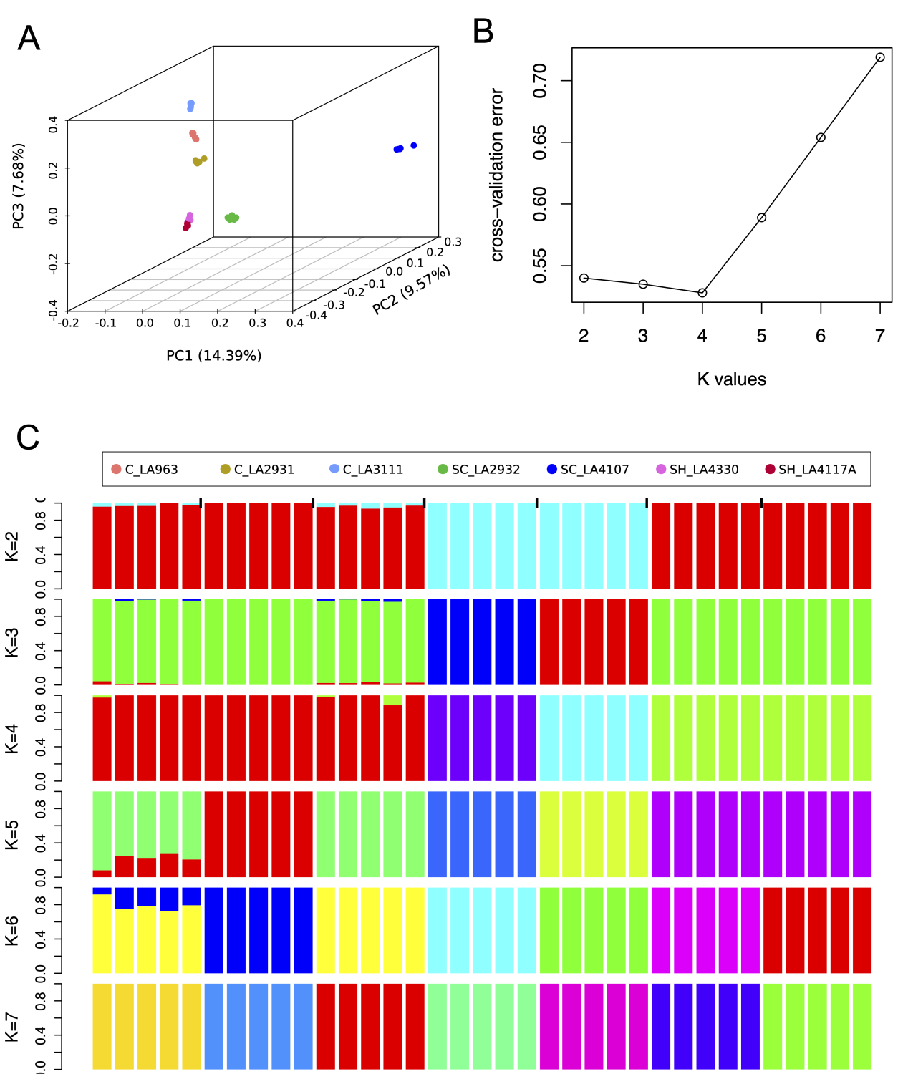

**Figure S3.** The population structure. (A) PCA based on genome-wide SNPs. (B) the cross-validation error based on different K values. (C) The admixture based on genome-wide SNPs.

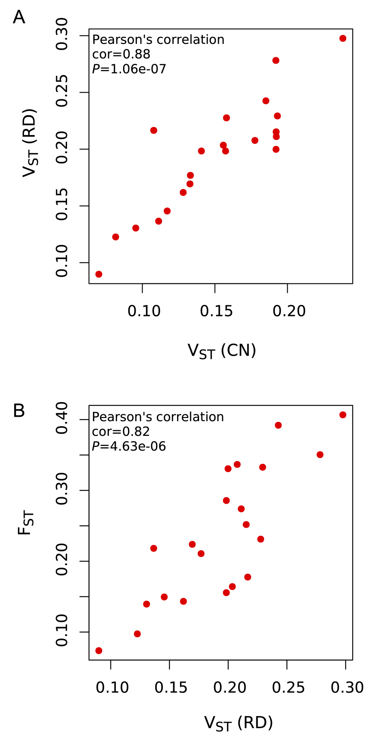

**Figure S4.** The correlations between VST(CN) and VST(RD) (A) and between VST(RD) and FST (B).

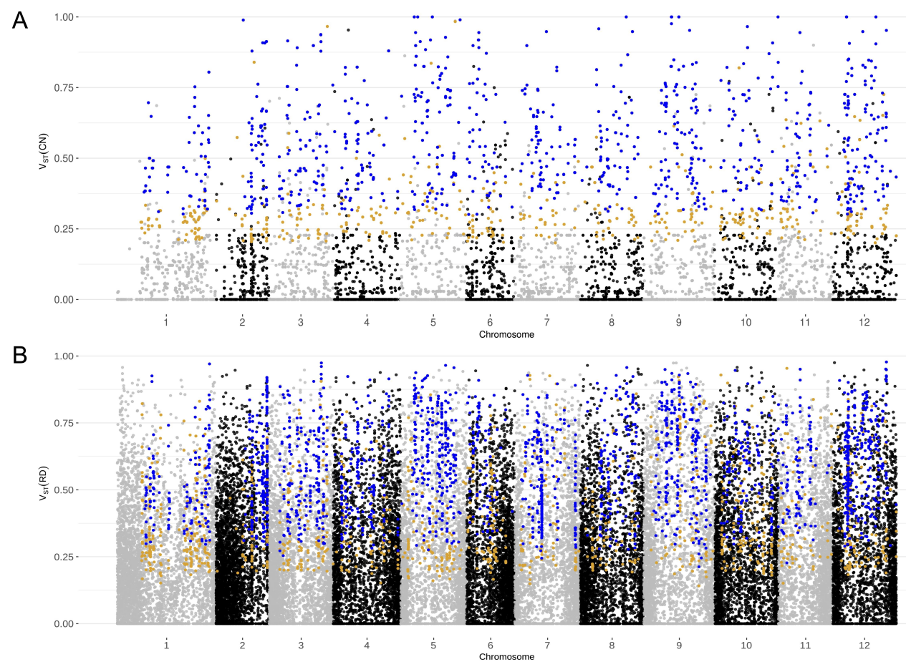

**Figure S5.** The identification of the differentiated genes based on VST(CN) (A) and VST(RD) (B) using gene copy number quantified by Control-FREEC and Read Depth, respectively. The orange dots denote the differentiated genes based 95th percentile using the permuted test (1,000 times), the blue dots denote the strongly differentiated genes based 99th percentile using the permuted test (1,000 times).

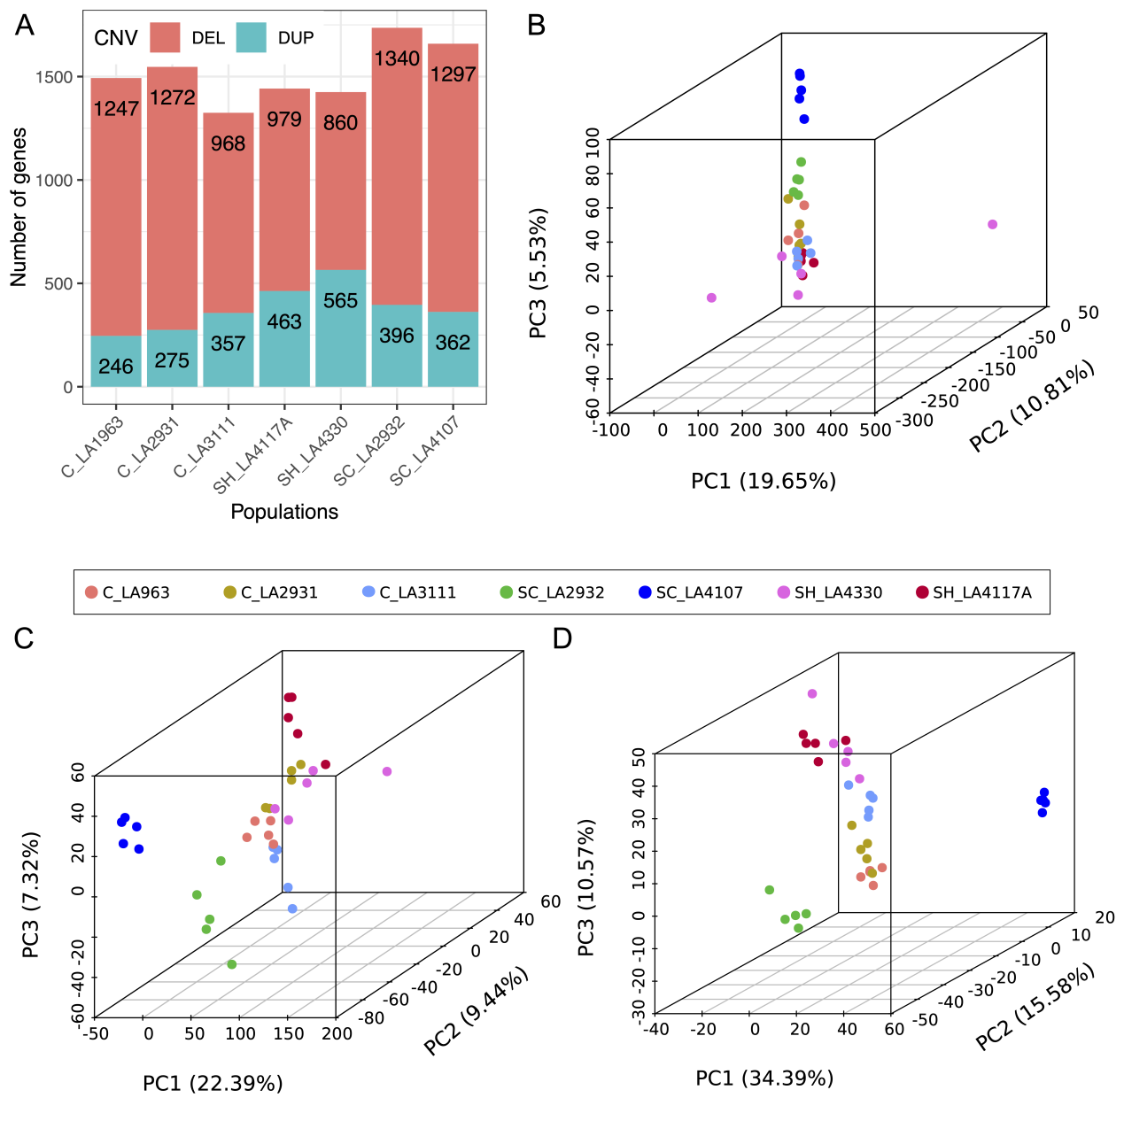

**Figure S6.** Genes with differentiated CN profiles among seven populations. (A) The distributions of 3,539 CN differentiated genes located at deletion (DEL) and duplication (DUP) regions in seven populations. (B) PCA based on CN values of 23,911 genes with CN values. (C) PCA based on CN values of 12,392 CN-variable genes with VST(CN) > 0. (D) PCA based on 2,192 strongly differentiated gene CN values.

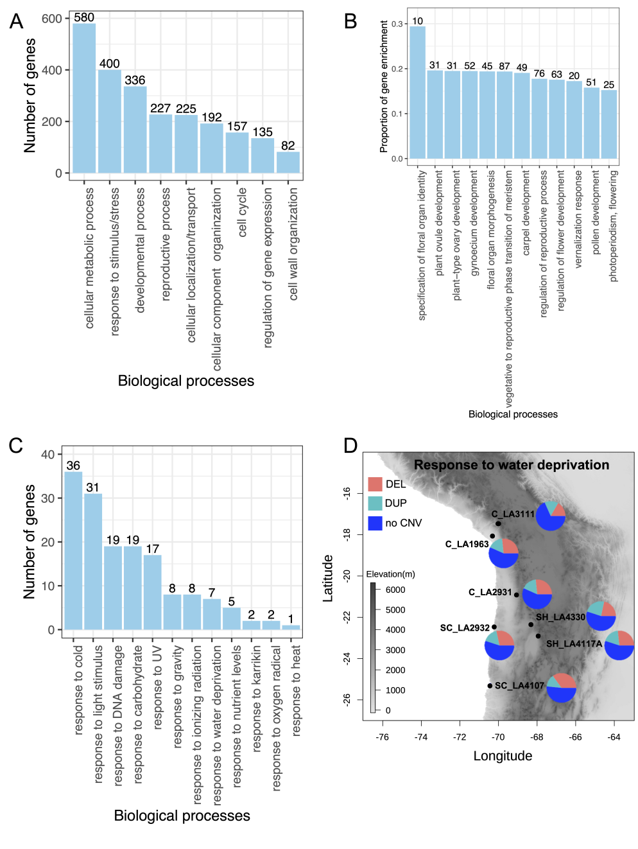

**Figure S7.** GO enrichment analysis of 3,539 CN differentiated genes. (A) The summary of GO enrichment. All significantly enriched GO terms (*P* < 0.05) were assigned into nine categories. (B) The proportions of differentiated genes enriched in different reproductive processes. The proportion of gene enrichment is equal to the number of genes enriched in one GO category divided by the number of background genes in this category. The number on top of each bar represents the number of genes enriched in that GO category. (C) The number of genes responded to external stimulus/stresses overlapping with genes enriched in reproductive process. (D) The 60 CN differentiated genes involved in response to water deprivation with deletion (DEL) and duplication (DUP) in seven populations, respectively. The pie charts denote number of CN differentiated genes with DEL, DUP or no CNV (see also Table S8).

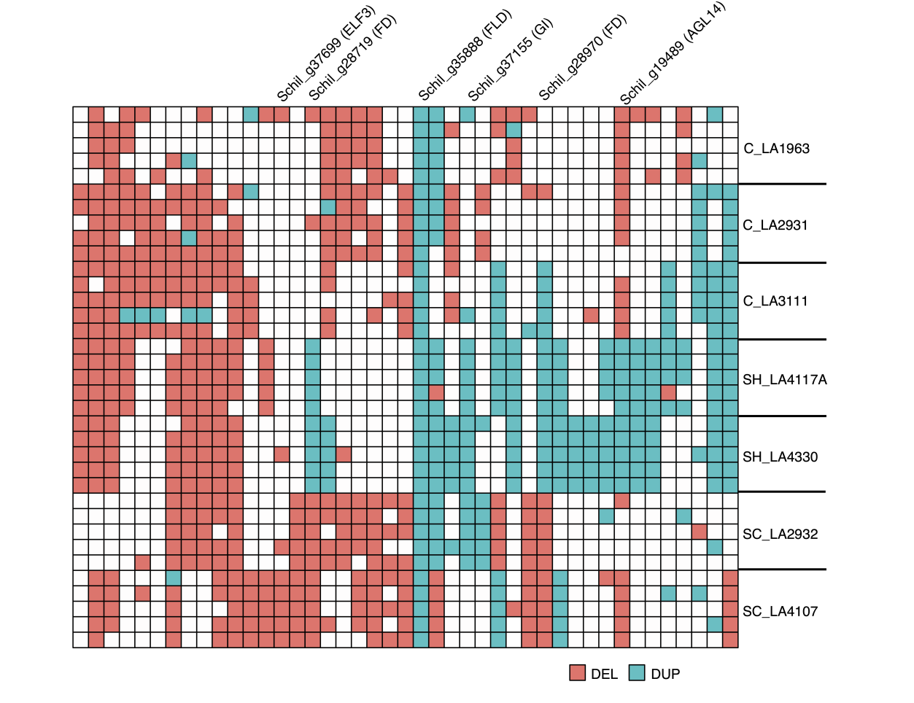

**Figure S8.** CN-differentiated genes enriched in photoperiod and vernalization pathways show the different CNV patterns across seven populations. Few putative homologs (see also Dataset S5) are validated as flowering regulatory genes in other plant species. White boxes indicate genes without CNV.

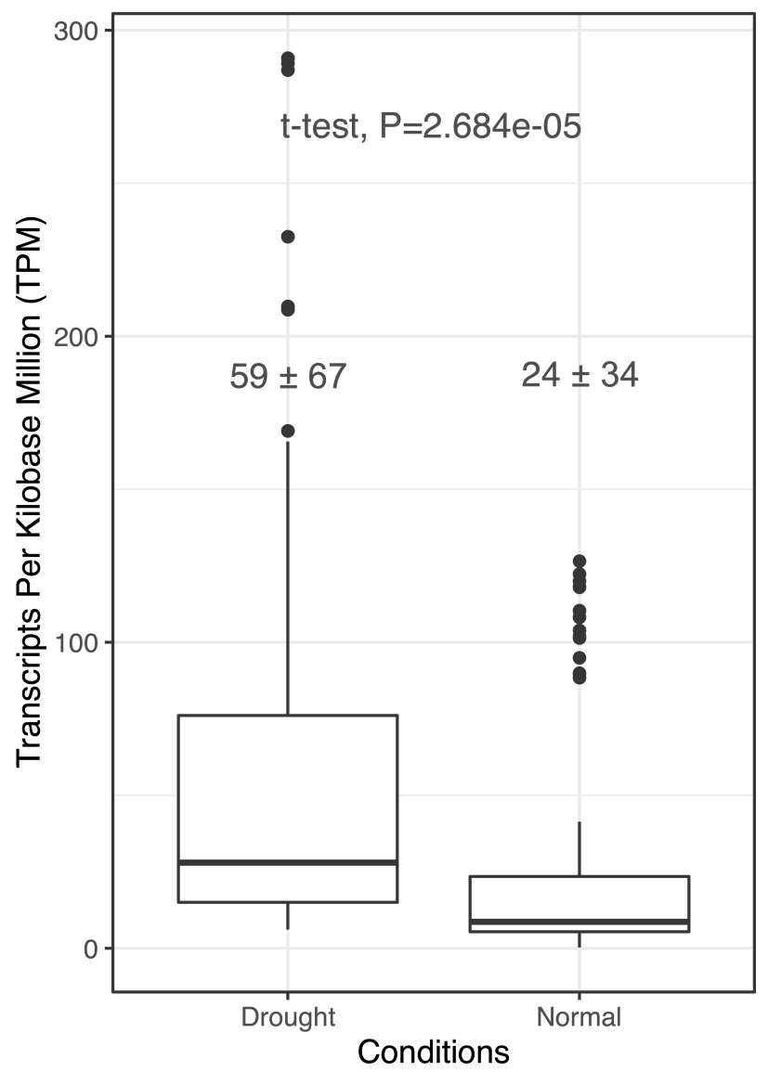

**Figure S9.** Gene expression of 11 genes responded to water deprivation overlapped with drought-responsive genes in metabolic network from the previous study of transcriptomes (Wei et al. 2023a).

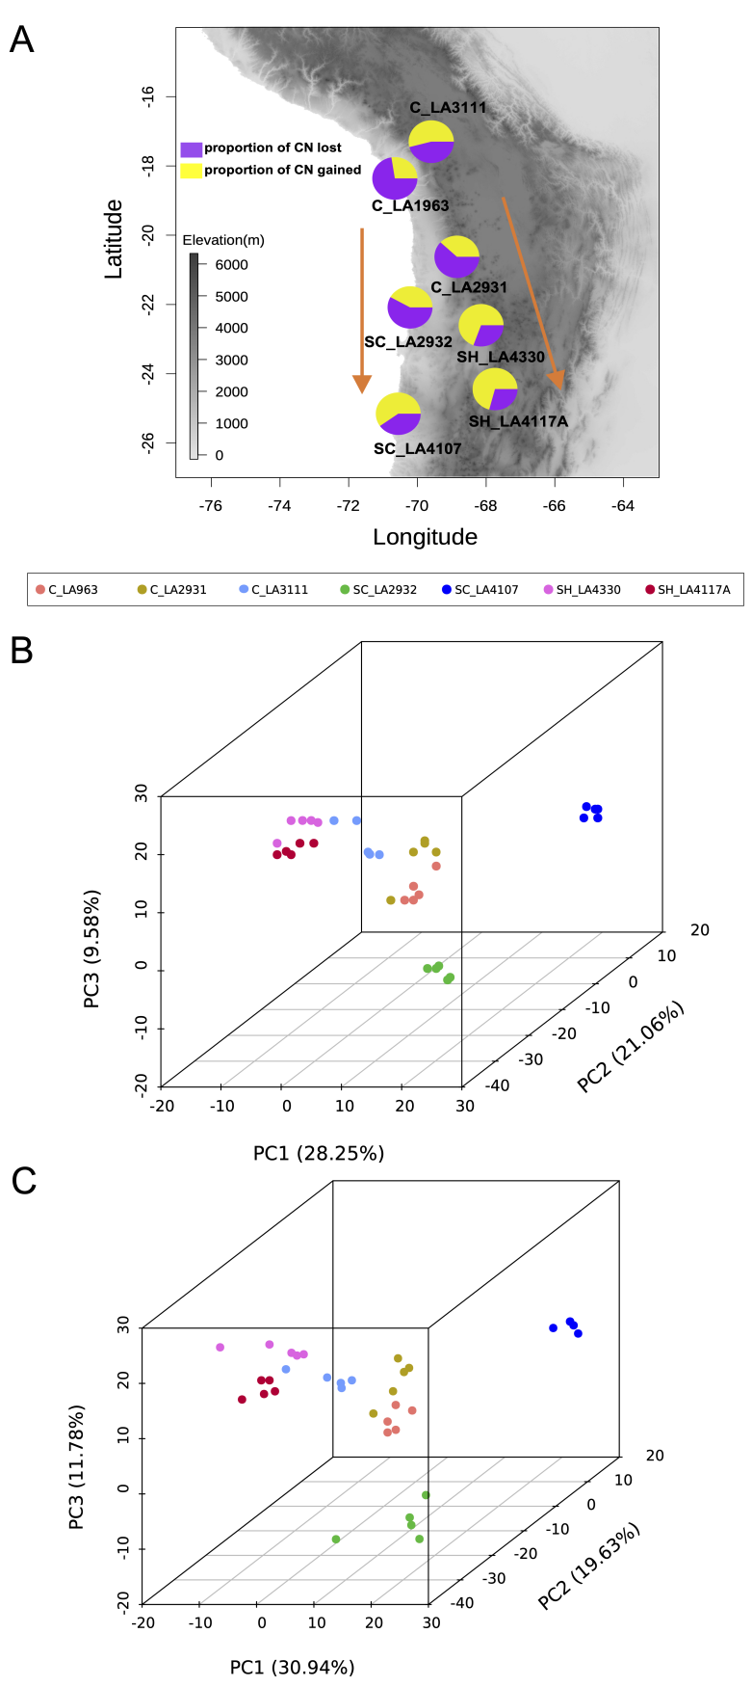

**Figure S10.** (A) The map and pie charts show that the dynamics of CN lost and gained in the processes of two southward colonization events, first to the southern coast (SC) and second to the southern highland (SH) (orange arrows) using the reference genome of *S. pennellii* (see also Table S9). (B) PCA based on CN of rapidly evolving genes with significant CN expansion or contraction (Viterbi *P* < 0.05) using the reference genome of *S. chilense*. (C) PCA based on CN of rapidly evolving genes with significant CN expansion or contraction (Viterbi *P* < 0.05) using the reference genome of *S. pennellii*.

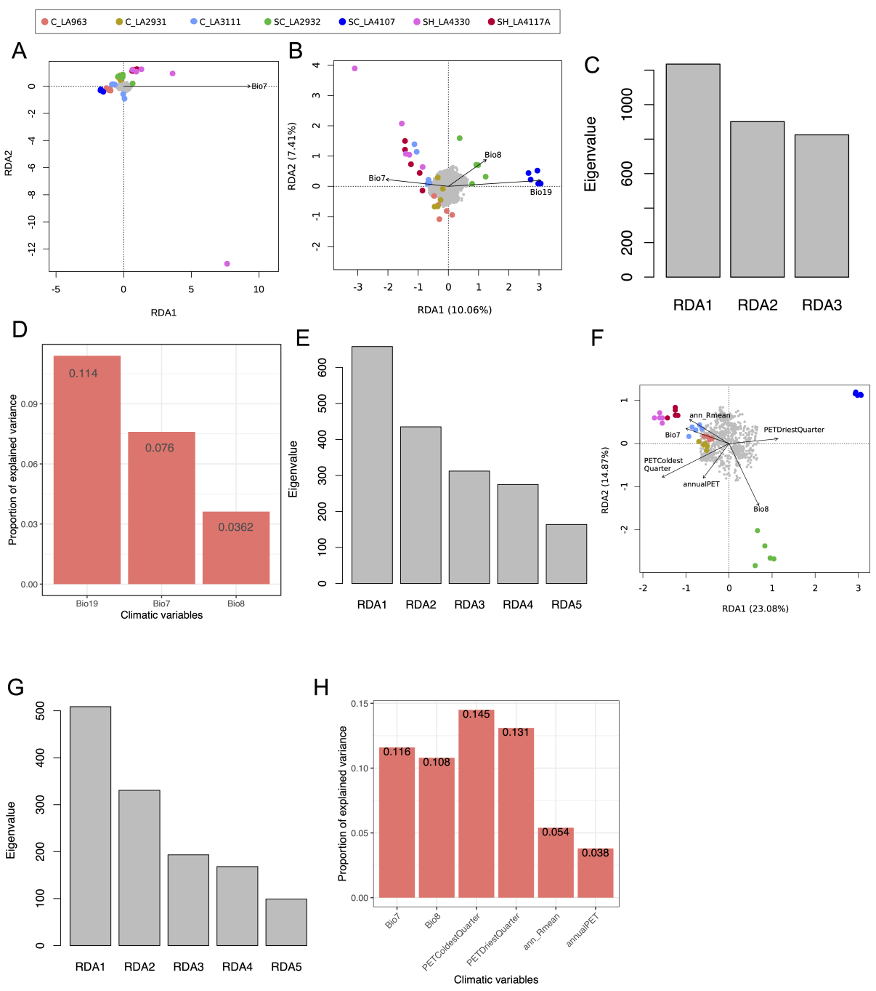

**Figure S11.** (A) RDA model shows no significant result based on CN of 23,911 genes. (B) RDA model based on CN of 12,391 genes with VST >0. (C) The eigenvalues of three significant ordination axes in RDA model based on CN of 12,391 genes with VST >0. (D) The proportion of explained variance of three overrepresented climate variables in RDA model based on CN of 12,391 genes with VST >0. (E) The eigenvalues of five significant ordination axes in RDA model based on CN of 3,539 differentiated genes. (F) RDA model based on CN of 2,192 strongly differentiated genes. (G) The eigenvalues of five significant ordination axes in RDA model based on CN of 2,192 strongly differentiated genes. (H) The proportion of explained variance of six overrepresented climate variables in RDA model based on CN of 2,192 strongly differentiated genes. In RDA models, the loading of the climatic variables or the length of the vector indicates the strength of the correlation with the ordination axis. Vectors of climate variables pointing in the same direction that populations indicate a high positive correlation, vector pointing at right angles indicate no correlation, and vectors pointing in opposite directions indicate high negative correlations. The grey dots represent genes. Colored dots represent different populations.

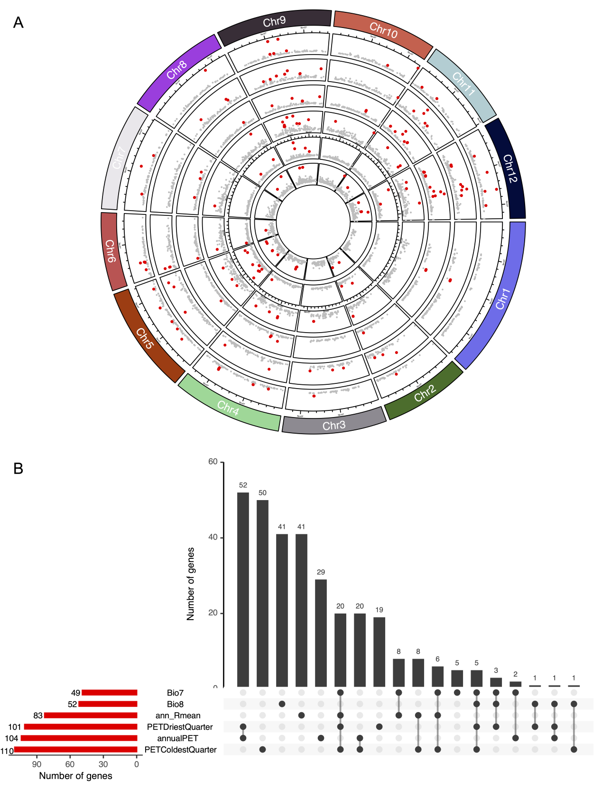

**Figure S12.** (A) The analyses of gene CN associated with six climatic variables using LFMM2. The circles from inside to outside are Bio7, Bio8, ann_Rmean, PETDriestQuarter, annualPET, PETColdestQuarter, respectively. (B) The number of candidate genes associated with six climatic variables (red bar), respectively, and shared candidate genes across climatic variables (black bar).

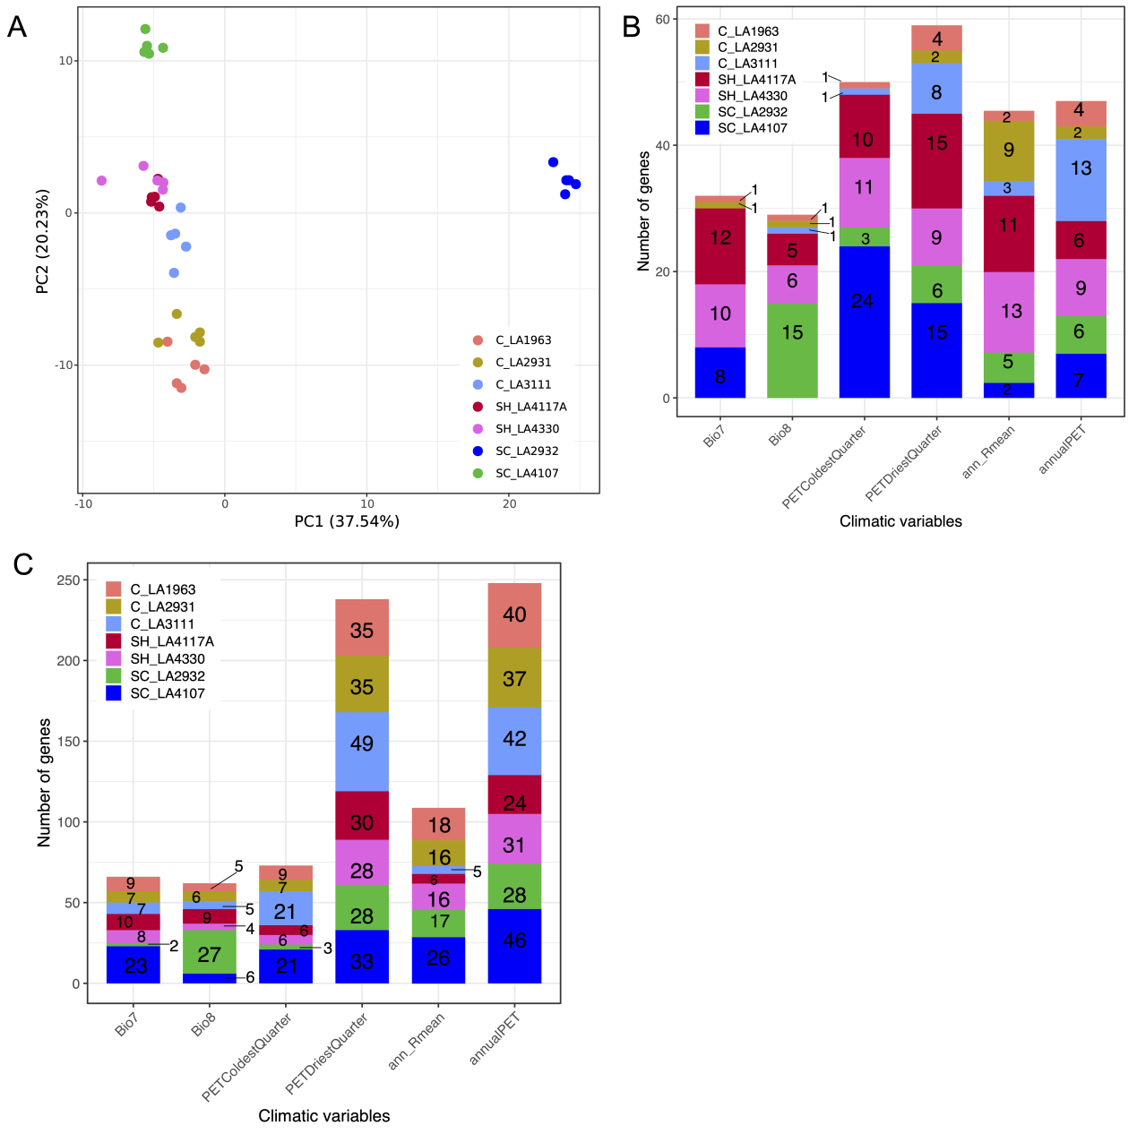

**Figure S13.** The GEA using LFMM2. (A) PCA based on CN of 312 candidate genes identified by LFMM2 correlated with six climatic variables. (B) The number of candidate genes identified by LFMM2 located at duplication (DUP) regions in seven populations. (C) The number of candidate genes identified by LFMM2 located at deletion (DEL) regions in seven populations.

**Table S1.** The number of deletion (DEL) and duplication (DUP) in each population

|  |  |  |
| --- | --- | --- |
| Populations | DEL | DUP |
| C_LA1963 | 68393 | 26228 |
| C_LA2931 | 66859 | 25970 |
| C_LA3111 | 58859 | 25133 |
| SC_LA2932 | 56914 | 22576 |
| SC_LA4107 | 51849 | 21165 |
| SH_LA4117A | 54314 | 22504 |
| SH_LA4330 | 55661 | 23117 |

**Table S2**. The number of deletion (DEL) and duplication (DUP) in each accession

|  |  |  |  |  |  |
| --- | --- | --- | --- | --- | --- |
| Groups | Populations | Accessions | DEL | DUP | Total |
| central | C_LA1963 | C_LA1963_t1 | 31891 | 11736 | 43627 |
| central | C_LA1963 | C_LA1963_t2 | 28596 | 10605 | 39201 |
| central | C_LA1963 | C_LA1963_t5 | 31627 | 11908 | 43535 |
| central | C_LA1963 | C_LA1963_t7 | 29069 | 10913 | 39982 |
| central | C_LA1963 | C_LA1963_t9 | 31312 | 11679 | 42991 |
| central | C_LA2931 | C_LA2931_t2 | 30586 | 11342 | 41928 |
| central | C_LA2931 | C_LA2931_t3 | 30871 | 11334 | 42205 |
| central | C_LA2931 | C_LA2931_t4 | 31676 | 11809 | 43485 |
| central | C_LA2931 | C_LA2931_t5 | 32074 | 11730 | 43804 |
| central | C_LA2931 | C_LA2931_t6 | 31133 | 11556 | 42689 |
| central | C_LA3111 | C_LA3111_t3 | 28357 | 11789 | 40146 |
| central | C_LA3111 | C_LA3111_t5 | 30898 | 12507 | 43405 |
| central | C_LA3111 | C_LA3111_t9 | 25406 | 10597 | 36003 |
| central | C_LA3111 | C_LA3111_t10 | 27963 | 11594 | 39557 |
| central | C_LA3111 | C_LA3111_t15 | 27623 | 11765 | 39388 |
| southern coast | SC_LA2932 | SC_LA2932_1 | 34249 | 12330 | 46579 |
| southern coast | SC_LA2932 | SC_LA2932_8 | 31684 | 11379 | 43063 |
| southern coast | SC_LA2932 | SC_LA2932_t2 | 32097 | 11514 | 43611 |
| southern coast | SC_LA2932 | SC_LA2932_20 | 31230 | 11074 | 42304 |
| southern coast | SC_LA2932 | SC_LA2932_22 | 30155 | 10765 | 40920 |
| southern coast | SC_LA4107 | SC_LA4107_3 | 30991 | 11103 | 42094 |
| southern coast | SC_LA4107 | SC_LA4107_6 | 33141 | 12096 | 45237 |
| southern coast | SC_LA4107 | SC_LA4107_9 | 32849 | 11761 | 44610 |
| southern coast | SC_LA4107 | SC_LA4107_t5 | 31243 | 11456 | 42699 |
| southern coast | SC_LA4107 | SC_LA4107_t11 | 30818 | 11006 | 41824 |
| southern highland | SH_LA4117A | SH_LA4117A_1 | 27913 | 9391 | 37304 |
| southern highland | SH_LA4117A | SH_LA4117A_4 | 28128 | 10452 | 38580 |
| southern highland | SH_LA4117A | SH_LA4117A_5 | 28858 | 9865 | 38723 |
| southern highland | SH_LA4117A | SH_LA4117A_10 | 27772 | 10131 | 37903 |
| southern highland | SH_LA4117A | SH_LA4117A_15 | 24905 | 7018 | 31923 |
| southern highland | SH_LA4330 | SH_LA4330_t1 | 29186 | 11019 | 40205 |
| southern highland | SH_LA4330 | SH_LA4330_t4 | 32217 | 12281 | 44498 |
| southern highland | SH_LA4330 | SH_LA4330_t6 | 26220 | 9823 | 36043 |
| southern highland | SH_LA4330 | SH_LA4330_t9 | 31562 | 11964 | 43526 |
| southern highland | SH_LA4330 | SH_LA4330_t12 | 30934 | 11610 | 42544 |

**Table S3.** The number of deletion (DEL) and duplication (DUP) identified in different numbers of accessions (1 to 5)

|  |  |  |  |  |  |  |  |  |  |  |  |
| --- | --- | --- | --- | --- | --- | --- | --- | --- | --- | --- | --- |
| Populations | DEL | | | | | DUP | | | | | |
| 1 | 2 | 3 | 4 | 5 | 1 | 2 | 3 | 4 | 5 |
| C_LA1963 | 29655 | 14361 | 8856 | 7025 | 8496 | 11222 | 5330 | 3541 | 2904 | 3231 |
| C_LA2931 | 26987 | 13566 | 9337 | 7540 | 9429 | 10654 | 5204 | 3680 | 2918 | 3514 |
| C_LA3111 | 21943 | 12756 | 8982 | 6990 | 8188 | 9471 | 5165 | 3767 | 3064 | 3666 |
| SC_LA2932 | 16850 | 9546 | 7218 | 7852 | 14748 | 7469 | 4031 | 2987 | 3101 | 4788 |
| SC_LA4107 | 13530 | 7604 | 6436 | 6971 | 17308 | 6399 | 3482 | 2825 | 2861 | 5598 |
| SH_LA4117A | 16031 | 9824 | 7891 | 6360 | 11208 | 7562 | 4242 | 3085 | 2585 | 3030 |
| SH_LA4330 | 17009 | 10618 | 8547 | 7981 | 11506 | 7996 | 4528 | 3320 | 3047 | 4226 |

**Table S4.** The number of deletion (DEL) and duplication (DUP) overlapping different genomic features

|  |  |  |  |  |  |  |  |  |  |  |  |  |
| --- | --- | --- | --- | --- | --- | --- | --- | --- | --- | --- | --- | --- |
| Populations | Gene | | Intergenic | | Exon | | Intron | | 5kb upstream | | 5kb downstream | |
| DEL | DUP | DEL | DUP | DEL | DUP | DEL | DUP | DEL | DUP | DEL | DUP |
| C_LA1963 | 21672 | 12519 | 59522 | 23183 | 15857 | 11691 | 18869 | 10848 | 28199 | 13711 | 34051 | 15037 |
| C_LA2931 | 21179 | 12465 | 58187 | 22915 | 15562 | 11681 | 18356 | 10774 | 27443 | 13653 | 33338 | 14991 |
| C_LA3111 | 19582 | 12199 | 51632 | 22415 | 15096 | 11586 | 16899 | 10516 | 25201 | 13282 | 30024 | 14473 |
| SC_LA2932 | 17478 | 10621 | 49333 | 19655 | 13448 | 10049 | 15018 | 9163 | 22927 | 11636 | 27365 | 12631 |
| SC_LA4107 | 16319 | 10128 | 45631 | 18590 | 12712 | 9583 | 14034 | 8765 | 21296 | 11053 | 25220 | 12031 |
| SH_LA4117A | 16677 | 10590 | 47525 | 20331 | 12039 | 9970 | 14250 | 8795 | 22691 | 11555 | 26246 | 12527 |
| SH_LA4330 | 17871 | 11132 | 48811 | 20468 | 13742 | 10565 | 15464 | 9627 | 23292 | 12165 | 27540 | 13197 |

**Table S5.** The validation of pipeline of CNV calling using 1,000 simulated deletions (DELs) and duplications (DUPs), respectively.

|  |  |  |
| --- | --- | --- |
| CNV caller | Number of DEL | Number of DUP |
| Lumpy | 878 (21) | 842(13) |
| Manta | 795 (29) | 774(36) |
| Wham | 767 (33) | 698 (19) |
| Delly | 849 (40) | 861 (22) |
| SURVIVOR merged | 918(12) | 879 (4) |

Numbers in parentheses indicate the number of incorrect CNVs (false-positive).

**Table S6.** The measures of population differentiation based on copy number (VST(RD) and VST(CN)) and SNPs (FST).

|  |  |  |  |
| --- | --- | --- | --- |
| Pairwise populations | VST(RD) | VST(CN) | *F*ST |
| C_LA1963 vs C_LA2931 | 0.090 ±0.153 | 0.070±0.125 | 0.074±0.131 |
| C_LA1963 vs C_LA3111 | 0.123±0.177 | 0.082±0.138 | 0.097±0.146 |
| C_LA2931 vs C_LA3111 | 0.131±0.194 | 0.095±0.162 | 0.139±0.155 |
| SH_LA4117A vs SH_LA4330 | 0.217±0.239 | 0.108±0.188 | 0.178±0.247 |
| C_LA3111 vs SH_LA4330 | 0.137±0.212 | 0.111±0.177 | 0.218±0.227 |
| C_LA2931 vs SH_LA4330 | 0.146±0.198 | 0.117±0.165 | 0.150±0.163 |
| C_LA1963 vs SH_LA4330 | 0.162±0.203 | 0.128±0.190 | 0.143±0.147 |
| C_LA2931 vs SC_LA2932 | 0.169±0.245 | 0.133±0.134 | 0.224±0.270 |
| C_LA1963 vs SC_LA2932 | 0.177±0.248 | 0.133±0.174 | 0.211±0.196 |
| C_LA1963 vs SH_LA4117A | 0.198±0.244 | 0.141±0.189 | 0.156±0.149 |
| C_LA2931 vs SH_LA4117A | 0.204±0.248 | 0.156±0.206 | 0.164±0.172 |
| SC_LA2932 vs C_LA3111 | 0.198±0.276 | 0.157±0.196 | 0.286±0.311 |
| C_LA3111 vs SH_LA4117A | 0.228±0.257 | 0.158±0.218 | 0.231±0.255 |
| SC_LA2932 vs SH_LA4330 | 0.208±0.267 | 0.178±0.230 | 0.337±0.382 |
| SC_LA4107 vs SH_LA4330 | 0.243±0.291 | 0.185±0.259 | 0.392±0.431 |
| C_LA1963 vs SC_LA4107 | 0.215±0.272 | 0.192±0.236 | 0.252±0.277 |
| C_LA2931 vs SC_LA4107 | 0.211±0.275 | 0.192±0.244 | 0.274±0.278 |
| SC_LA2932 vs SC_LA4107 | 0.200±0.281 | 0.192±0.254 | 0.331±0.337 |
| SC_LA2932 vs SH_LA4117A | 0.278±0.300 | 0.192±0.259 | 0.350±0.414 |
| C_LA3111 vs SC_LA4107 | 0.229±0.284 | 0.193±0.262 | 0.333±0.401 |
| SC_LA4107 vs SH_LA4117A | 0.298±0.315 | 0.238±0.287 | 0.407±0.448 |

**Table S7.** The number of candidate genes with differentiated gene CN across seven populations

|  |  |  |  |  |
| --- | --- | --- | --- | --- |
| VST | Differentiated (95th percentile) | | Extremely differentiated (99th percentile) | |
| Threshold | Number of genes | Threshold | Number of genes |
| VST(CN) | 0.194 | 4,843 | 0.305 | 3,219 |
| VST(RD) | 0.157 | 16,655 | 0.244 | 12,228 |
| Overlaps |  | 3,539 |  | 2,192 |

The differentiated and extremely genes were identified using 95th and 99th percentile in 1,000 permutation tests, respectively.

**Table S8.** The number of CN differentiated genes involved in four GO terms in seven populations located in deletion (DEL) and duplication (DUP) regions.

|  |  |  |  |  |  |  |  |  |  |  |  |  |
| --- | --- | --- | --- | --- | --- | --- | --- | --- | --- | --- | --- | --- |
| Populations | photoperiod | | | vernalization | | | response to water deprivation | | | root development | | |
| DEL | DUP | no CNV | DEL | DUP | no CNV | DEL | DUP | no CNV | DEL | DUP | no CNV |
| C_LA1963 | 6 | 1 | 18 | 8 | 1 | 11 | 16 | 10 | 34 | 26 | 17 | 30 |
| C_LA2931 | 10 | 1 | 14 | 9 | 3 | 8 | 16 | 10 | 34 | 12 | 4 | 57 |
| C_LA3111 | 8 | 2 | 15 | 7 | 5 | 8 | 10 | 9 | 41 | 11 | 8 | 54 |
| SC_LA2932 | 10 | 2 | 13 | 7 | 2 | 11 | 17 | 10 | 33 | 27 | 18 | 28 |
| SC_LA4107 | 9 | 2 | 14 | 10 | 1 | 9 | 21 | 8 | 31 | 25 | 18 | 30 |
| SH_LA4117A | 5 | 8 | 12 | 5 | 8 | 7 | 16 | 11 | 33 | 14 | 7 | 52 |
| SH_LA4330 | 4 | 10 | 11 | 4 | 7 | 9 | 13 | 14 | 33 | 12 | 6 | 55 |

**Table S9.** The summary of CN expansion and contraction in different branches/populations using the reference of *S. pennellii*.

|  |  |  |  |  |  |  |
| --- | --- | --- | --- | --- | --- | --- |
| Groups/Populations | Number of CN expanded genes | Number of CN contracted genes | Number of CN gained | number of CN contracted | aRate of average expansion/  contraction | bNumber of rapidly evolving genes |
| inland | 63 | 48 | 344 | 86 | 2.324 | 28(+21/-7) |
| Central (C) | 186 | 568 | 427 | 937 | -0.676 | 35(+15/-20) |
| southern highland (SH) | 522 | 384 | 1506 | 648 | 0.947 | 51(+38/-13) |
| southern coast (SC) | 67 | 115 | 184 | 211 | -0.1483 | 11(+4/-7) |
| C_LA1963 | 149 | 456 | 322 | 851 | -0.874 | 27(+9/-18) |
| C_LA2931 | 116 | 292 | 360 | 587 | -0.556 | 14(+3/-11) |
| C_LA3111 | 215 | 374 | 762 | 646 | 0.197 | 19(+11/-8) |
| SH_LA4117A | 627 | 484 | 2007 | 824 | 1.065 | 54(+39/-15) |
| SH_LA4330 | 471 | 304 | 1340 | 588 | 0.970 | 43(+43/-0) |
| SC_LA2932 | 215 | 559 | 747 | 1035 | -0.372 | 17(+5/-12) |
| SC_LA4107 | 384 | 306 | 1132 | 692 | 0.638 | 38(+26/-12) |

aRate of average expansion / contraction = (Number of CN gained - Number of CN lost) / (Number of CN expanded genes + Number of CN contracted genes). Positive values indicate CN expansion and negative values indicate CN contraction.

bThe rapidly evolving genes indicate significant higher CN expansion or contraction (Viterbi *P* < 0.05) across the different groups/populations. Values outside parentheses represent the total number of the rapidly evolving genes. Positive values in parentheses denote the number of significantly expanded genes and negative values denote the number of significantly contracted genes.

**Table S10.** The number of CN differentiated genes associated with temperature annual range (Bio7) and solar radiation (ann_Rmean) in seven populations located in deletion (DEL) and duplication (DUP) regions.

|  |  |  |  |
| --- | --- | --- | --- |
| Populations | DEL | DUP | no CNV |
| C_LA1963 | 7 | 1 | 26 |
| C_LA2931 | 6 | 3 | 25 |
| C_LA3111 | 2 | 1 | 31 |
| SC_LA2932 | 7 | 2 | 25 |
| SC_LA4107 | 10 | 1 | 23 |
| SH_LA4117A | 2 | 5 | 27 |
| SH_LA4330 | 6 | 6 | 22 |