MARVIN: A 3D Printed, Internet Enabled Product Design and Staff Development Project.
Paper written by: Dr. Richard Salmon SFHEA  Academic Coordinator/Chief Academic Officer,  SAE Creative Media Institute, Sydney Campus,  Level 1, 39 Regents St, Chippendale, Sydney,  NSW 2008 Australia. r.salmon@sae.edu | Project conducted in collaboration with;  Thejaswi Padmanabha, Department Coordinator, Games, Animation & Design.  Duncan Maclean, (Acting) Senior Lecturer, Design.  Michael Banks, Lecturer, Animation.

ABSTRACT
This paper examines an example of the use of mobile technologies integrated into a staff and curriculum development project instigated within the context of educational professional development. The project was initiated in response to a request to write and prepare for the delivery of two 5-credit point masters’ degree modules. The main intention for the two modules was to focus student’s attention on the design and build of a 3D Printed Internet enable product destined for the Internet of Things (IoT) marketplace. The physical outcome of the project, which is a work in progress, is called Marvin.
INTRODUCTION
Lecturing, department and faculty management staff with experience working within educational environments will be familiar with a common scenario where professional development activities are prescriptively organised by an institution for their staff. Often the activities organised will be focused on matters related to teaching such as lesson planning, classroom delivery strategies and/or curriculum planning and development etc. Whilst some focus on such activities is important, especially for staff that may not have had formal teacher training, it is not uncommon for more experienced staff to complain about such activities as being a waste of their time. Naturally as a faculty manager I would suggest to these more experienced staff that sharing their experience with younger and less experienced staff is not a waste of time, it is important to share good practice as a senior member of staff and revisiting something you already know how to do may well improve your own practices anyway. These more experienced staff may also complain that their professional development time would be better spent on activities that are more focused on keeping up to date with practices in their main discipline area, to which the institutional response is normally something analogous to ‘keeping up with advances in your main discipline area is a prerequisite for employment within your role as an educationalist, it is a contractual requirement of your position description over and above any other professional development activities that the institution deems appropriate, therefore activities related to keeping up with practice in your discipline do not count towards professional development time allocations’. I do sympathize with the frustrations and insecurities that some of the above complaints carry with them, and indeed, I have felt these frustrations and insecurities personally during various stages of my own career development, it can be very concerning and undermine ones confidence when your teaching takes the lions share of your time and you feel as if your main subject area is marching forward at a pace with technological advancements faster than you are able to keep up with it. However, I can see both sides of the arguments presented from each of the perspectives put forward above. The institutional, management and staff perspectives and related concerns each hold some validity and I embarked upon this particular project with the express intention of trying to rectify these differing perspectives in a project space where the concerns of each of the parties involved are satisfactorily addressed to the agreement of all.
We are in need of an increasingly highly skilled workforce with lots of high tech jobs being created in areas such as the IoT while manual and low skilled jobs are in long term, and possibly permanent recession, due in no small part to automation, robotics and the proliferation of information and communication technologies.
This wide context has clear implications for the professional development of teaching staff and practice in higher education, as the sector plays a pivotal role in developing our highly skilled workforce. It is vital therefore to keep higher education learning and teaching current and relevant to developing learners who can take advantage of the highly skilled jobs market place.
With the above points in mind, it is critical that higher education teachers engage in continuing professional development to nurture a deeper and broader skill set, and to update their knowledge in developing areas of the curriculum. Lifelong learning and continued professional development is necessary to meet the emerging needs of a teachers’ evolving role in the educational space.
However, none of the professional development activities mentioned above actually expresses the need to push forward with the development of new skillsets that take staff into new areas of teaching, curriculum delivery as well as beyond the discipline in which they were first employed to work. In fact, technological advancements and their impact on practice in a creative space are significant, not only does one need to keep up with changes; convergence, interdisciplinary and transdisciplinary activities are becoming more prevalent, especially in the higher education space. Leaders with the socio-political skills to navigate this interdisciplinary and transdisciplinary terrain and traverse the cultural, methodological and philosophical differences inherent within these project arenas are very important to collaborative progress.
With all the above somewhat serious points made, I am of the view that continuing professional development can and should be fun! It needs to be fun in an educational context in particular, because life-long learning is one of the key elements that make for a happier life here on Earth. That last sentence may come across as ‘sweet sentiment’ and nothing more but there is in fact a significant empirical body of work that clearly supports this sentiment conducted by The National Institute of Adult Continuing Education (NIACE) amongst others; see the work of and a summary of “The Impact of Lifelong Learning on Happiness and Well-being” . It is therefore critical to acquire the investment and commitment to a sustained engagement with lifelong learning and continuing professional development from all those present within society for the health and wellbeing of us all.
Research is often referred to in relation to activities conducted for the generation of new knowledge within a discipline area, and the outcome of a Higher Degree of Research (PhD) will frequently contribute some aspect of new knowledge to a discipline. It should however be noted that research (or investigation) may also be conducted to place or procure new knowledge within ones consciousness, whether that knowledge be new to a discipline or not. In fact the latter is rather more common than the former, and in terms of lifelong learning and continuing professional development in an educational context, the latter constitutes the vast majority of all learning that takes place within our society, after all there is very little you can tell me that somebody else does not already know about the knowable universe. Granted one may be able to impart tacit knowledge about individuals and private interactions to me but that is not the type of knowledge I am referring to here. It is the type of research that places new knowledge into the consciousness of individuals that is the basis for the staff development activities and learning that are detailed with regard to this project henceforth.
BODY
Having set the scene and historical motivations that led to the instigation of this staff development project – we move on to the integration of mobile technologies within the project and educational space; the outcome of which is a character named Marvin, the dancing dude!
MOBILE TECHNOLOGIES IN EDUCATION (a different take)
When mentioning mobile technologies in education most people would think of mobile phones and tablets (iPhone, iPad, Android devices etc.) and their real-time use for facilitating interaction in an educational space to answer quizzes, questionnaires and surveys, or to execute project management strategies and remote practices, the use of software such as Padlet , Kahoot , Slack , Trello , Asana and a whole host of other applications spring to mind in this forum. However, this project is somewhat different in that the design and use of the mobile technologies and software integrated into the project are the main focus and catalyst for the research and learning taking place.
It should be stated here that this project idea started off as a bit of a joke. Having been charged with the responsibility of writing two masters degree modules targeting 3D Printed Internet enabled product design; I envisioned a small character, which would appear animated. The character was pictured as having purple rubbery hair and a Denis the Menace type demeanor. I wanted this character to be 3D printed, and I wanted him to jump up and down when a Google calendar event was pending. The idea was that this 3D printed, Internet enabled device would be an aid to any individual engaged in activities at home or at work whilst away from their main computer workstation. The device would be a novelty collector’s item that demonstrated functionality similar to an alarm clock for pending calendar events. Granted the functionality envisioned presents nothing new to the user that cannot be achieved with an iPhone or similar device but the device envisioned would bring quirkiness, humour and collectability to the table giving it the edge of being a real marketable product that could be manufactured at a very low price.
As Head of Faculty, I have been visiting classes to deliver short presentations about the IoT, and telling students how important it is to the generation of new job opportunities over the next two decades. I firmly believe that we should practice what we preach, and since I had no time allocation available in my own workload to work on these masters’ modules – but still believed the module developments should go ahead, because of their direct relevance to learner community employment opportunities. I took the radical approach of taking on supervision of the development of these two modules, whilst allowing the development time to be allocated to three other staff members commissioned to assist me in the development activities, and for us to learn from each other with regard to expertise in electronics, MCU application and deployment, programming and 3D Printed Internet Enabled product design as part of a strategy for continuing professional development and quality assurance within my faculty. It should also be noted here that another motivation for this interdisciplinary teaching team was that there is a regulatory body requirement for all teaching staff on an Australian Qualifications Framework (AQF) validated qualification to be qualified to a level of AQF +1, i.e. for teaching on a masters degree (AQF-9) one should have a PhD (AQF-10) - or if not, then at the very least, one must be supervised by someone who has.
We started by writing the ‘two Masters Degree modules, one module is focused on the research and planning of a 3D Printed, Internet Enable Product Design destined for the Internet of Things marketplace. The second module focuses on executing the planned 3D Printed, Internet Enable Product Design through to a fully functional working prototype. The two modules are interdisciplinary in nature, and require a significantly board range of expert skills in order to achieve the teaching delivery including; a programming expert with skills in multiple programming languages, a 3D printing and 3D Product Design expert, and someone conversant with modular electronic design and the application and deployment of Micro-Controller Units (MCU) etc.
The plan was to then execute the projects so that all three staff members and myself had in fact conducted the modules, and assessments, before attempting the first pass at teaching these modules. This was a strategic initiative enacted by myself that would mean incorporation of subject and pedagogic research, and scholarship, integrated within a project-based learning and staff development environment at the lecturer level within the institution, therefore acknowledging the wider context of higher education, its links to employment, and the implications for professional practice, continuing professional development and life long learning cited earlier in this paper. Furthermore, any subsequent students passing through the modules would have at least one clear documented physical project example of the sort of response staff would be expecting from the module guides and assessments, scoped to take account of a students starting place and subsequent distance travelled of course.
MARVIN
Having written the two masters degree modules attention was turned to executing the module assignments amongst the staff team. We took the idea of the jumping man with purple hair as a starting point. The details that follow impart the general design decisions taken to execute the project without going into the specifics of soldering, electronic design, programming and coding decisions as these details are beyond the scope of this paper. However, we are sharing the files, code and open source materials used in the project on GitHub for use here; https://github.com/saesydney/iot3dprint The files and code are all working at the date of posting, for any adventurous individuals who would like to cannibalise the materials to pursue the creation of similar projects.
After discussion amongst the team we decided upon a dancing man on top of a mounting box that would contain the electronics required to give the device its functionality. The dancing action would be achieved through the use of a servo, the MCU would provide the Wi-Fi connectivity and we decided that we would provide a simple HTML control page so that the device functionality could be debugged, tested and controlled via any browser on any mobile device or computer on a network as the project build progressed.
Our very first consideration in terms of the project build was to select a MCU that was very small, had the requisite Wi-Fi functionality, and gave some options for expansion of functionality so that we could develop the original idea once we had a better idea of what we were doing. It did not take long before we decided upon the WIMOS D1 Mini .
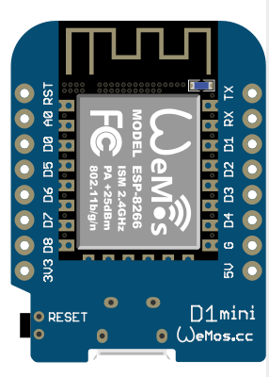
Figure 1
The D1 Mini is small and of a very similar size to the image shown in Figure 1 above. The unit has the requisite Wi-Fi functionality and can be run from a 5-volt power source. The MCU also comes with a range of other circuit boards called shields that can be connected to it via convenient plug and play connector blocks making experimentation and testing easier without the need for too much soldering. The ultimate factor in the choice of the D1 Mini was that not only was it Arduino IDE compatible (a prerequisite) but we found we could get the board for around Aus$3 from China. The electronics for the whole project cost about $25 in total and if one were to mass-produce the device then this figure could be drastically reduced again by buying items in bulk.
Having selected the DI Mini we also selected a D1 OLED Shield shown in Figure 2 with connectors displayed beside the shield.
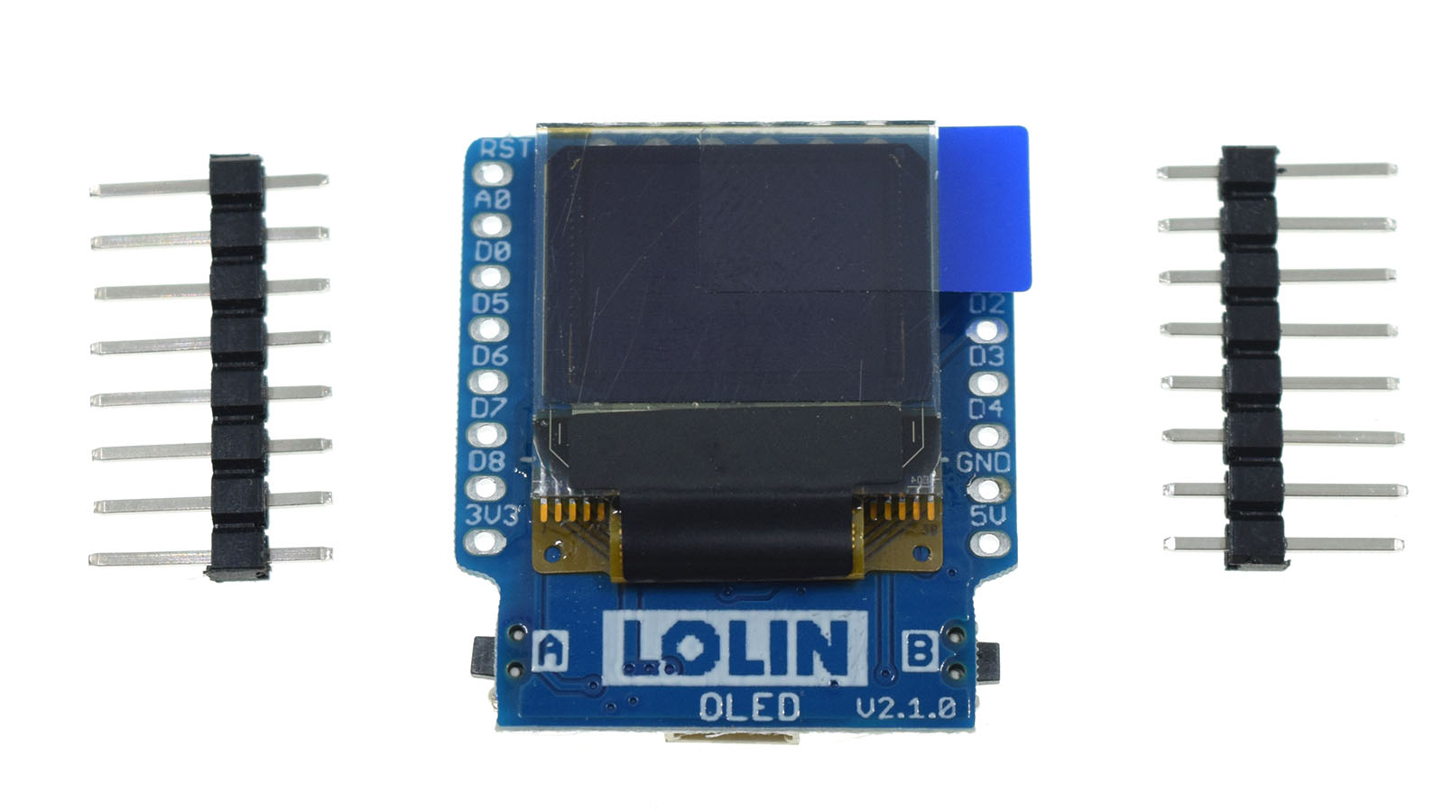
Figure 2
The purpose of the OLED shield was two fold; firstly it is used to display the dynamic URL/IP address that the device is given by the Wi-Fi server when connecting to the Wi-Fi network, secondly it can be used to display details about the pending calendar invite. The IP address shown on the LED screen is used in a browser to connect to the D1 Mini that becomes a server in its own right - delivering the D1 Mini HTML simple control panel to the connecting browser. We discovered with experimentation that the OLED screen could be used to add other functionality such as displaying a clock face with the correct time on it while the device was otherwise idle for instance. In development of this ‘work in progress’ we will indeed add more functionality to the device but we were also careful to avoid what we call ‘feature creep’, it is all to easy to dream up new features for a project and blow the scope out of time constraints.
The next addition to our plan was an OPEN-SMART serial mp3 player shown in Figure 3. We choose this board, again for size and simplicity, and also because it was Arduino IDE compatible and could be easily controlled from the D1 Mini. A further reason for the choice was again price, the board was less than Aus$7. The mp3 player comes with a small 2-inch diameter speaker that allows for an audience to hear what the board is playing. The board also sports a mini 2-watt amplifier that powers the speaker so that there is no need for a separate board to power the speaker.
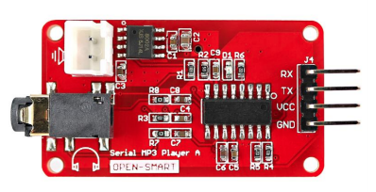
Figure 3
The initial plan with the mp3 player was to write mp3 files to the SD card over Wi-Fi generated with a Mac laptop based text to speech engine. By extracting calendar event text from the calendar using AppleScript, converting the text to mp3 with the text to speech engine and then transmitting the audio over Wi-Fi using Cycling 74 Max to the on board SD card shown in Figure 4.
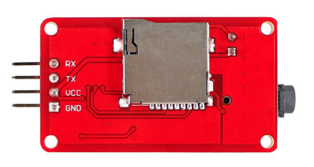
Figure 4
I later discovered that it is not possible to write to the micro-SD card over Wi-Fi as the on board Micro SD card reader on the mp3 player did not have write functionality. Whist this issue presented an irritating roadblock to progress with the project, it had already been written into the learning outcomes for the modules that reflection on the faults and foibles of the project as it went along with suggestions for rectification would also gain marks for the module grade. I am therefore declaring some of the faults we made as we went along, as an example to others – it is not a perfect world! As a work around, it was decided that a generic mp3 calendar message would be played when triggered by a pending calendar event. At this juncture it occurred to us that the device could also play music when idle, presenting another function to the owner beyond its original intention, a simple but significant addition to its attraction as a marketable product.
So we had the D1 Mini, the OLED screen and the Open-Smart mp3 player at the centre of the devices functionality. We also added a switch to switch the device between USB powered or mains powered via a step down transformer and rectifier to give a 5-volt DC supply. Naturally we added a power socket for plugging in the transformer-powered option to the device. In further development it makes sense to give the option to power the device from a 9-volt battery through a 5-volt regulator but this was not implemented in our first version of the prototype.
The next step was to take measurements of all the electronic components and to work out how they would all fit snuggly into the box. Our team member Duncan completed most of the base design. The image in Figure 5 below shows a version of the box design in Blender . We used blender for this exercise because it is free and one of our key aims was to keep the module resource requirements and costs as low as possible. The image shows the box closed with the servo in yellow at the back/top and OLED screen slot to the left/front. The speaker holes are indicated to the left/front. You can also see a gap for the Micro SD card access, headphone socket and USB port indicated on the sides.
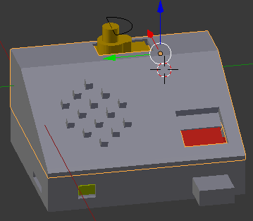
Figure 5
Figure 6 below shows the base box opened in Blender . In addition to the elements identified with the closed box in Figure 5 you can now see where the switch and power socket elements are mounted in the back of the box in pink. You can also see the OLED board and screen in Orange, which is piggybacked on top of the D1 Mini board shown in Orange underneath. The Open-Smart mp3 board is shown in yellow at the front.
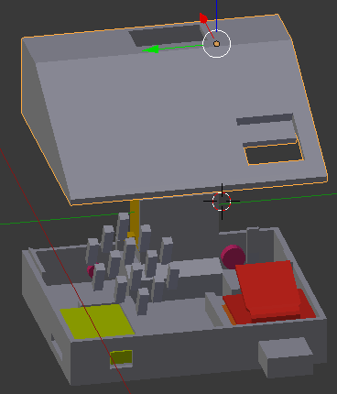
Figure 6
In Figure 7 below you can see a fully rendered version of the final box design. We went through a few iterations and prints before arriving at the final design. Revisions were made to the board mounts, port positions and the recessed USB.
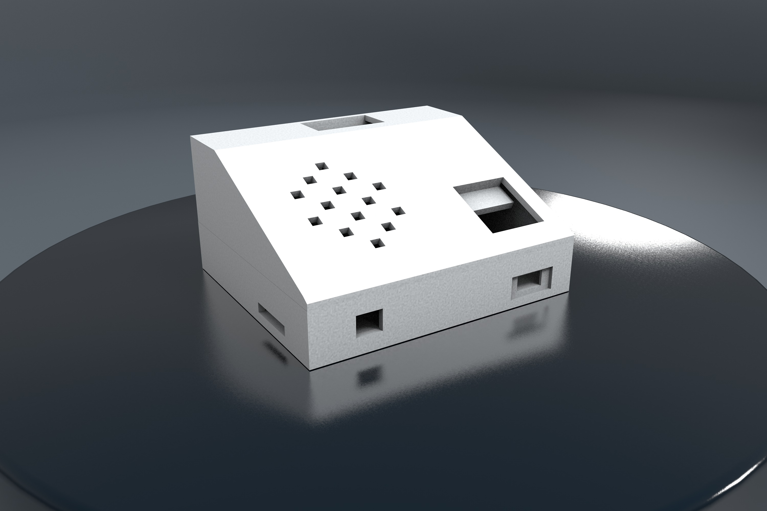
Figure 7
Having completed the box design the next move was to fit the electronics into the box and wire up the circuit, this was a fairly rapid process as I have a fair bit of experience with soldering and electronics in general. Figure 8 below shows a photograph of the box insides with the electronics built in. You can also see how we mounted the speaker on the top section of the box.
Figure 9 is a photograph of the completed box with the electronics built in. You can see the servo mount protruding from the top of the box; this is where we will be mounting our 3D Character, the dancing man.
Our team member Michael was responsible for generating our 3D Character now called Marvin, which was modeled in Maya. Figure 8 shows Marvin’s’ head and body as they look just after coming out of the 3D printer. Figure 9 shows the final version of Marvin mounted on the base.
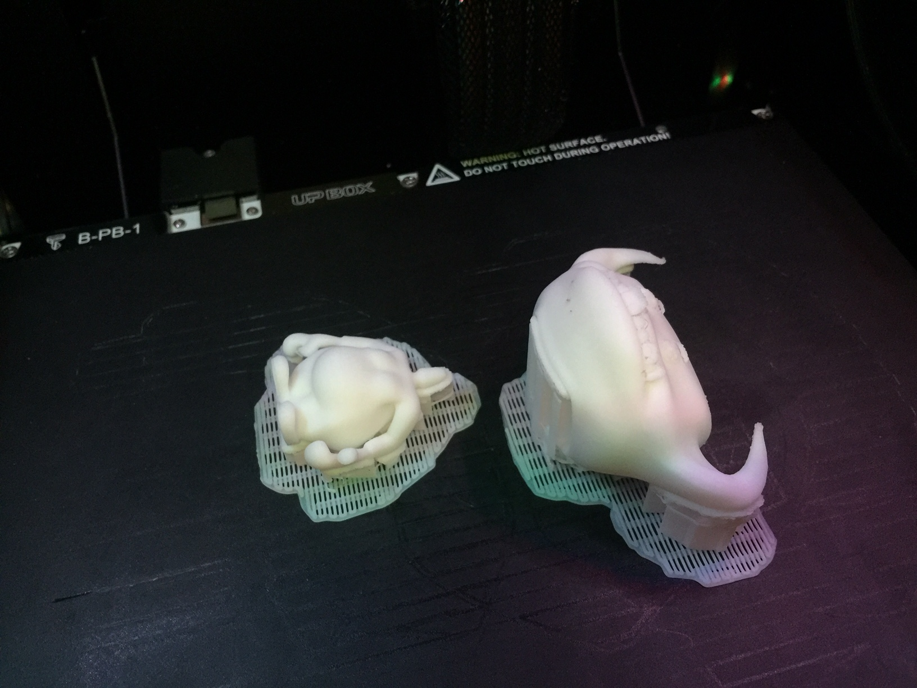
Figure 8
Marvin’s’ two parts, the head and the body were 3D printed, cleaned up using a craft knife, and then the head was connected to the body physically with a spring. Finally Marvin was mounted on top of the servo via a toothed sprocket and arm mount fitted to the base of Marvin’s shoes.
That concludes the physical build decisions, and Marvin in his complete prototype form is shown in the photograph below in Figure 11 sporting his goofy teeth and beady eyes. Painting him and giving him the rubbery hair strands could easily enhance him but we have not had time to do that yet.
Another key point to the assignments in the said two masters degree modules, is that IoT project concept envisioned should have a tangible marketable application. Marvin’s crowning beauty in this respect is that he is detachable and one can have a range of 3D characters that could be mounted on the base so you can have collectable sets of 3D characters, and that range can cater for different age groups and audiences. Think characters from Star Wars, Wallace and Gromit, Dr Who, the Telly Tubbies, Shrek, the Wiggles, Blinky Bill, the list is endless, giving this simple fun idea that started off as a joke some real commercial weight.
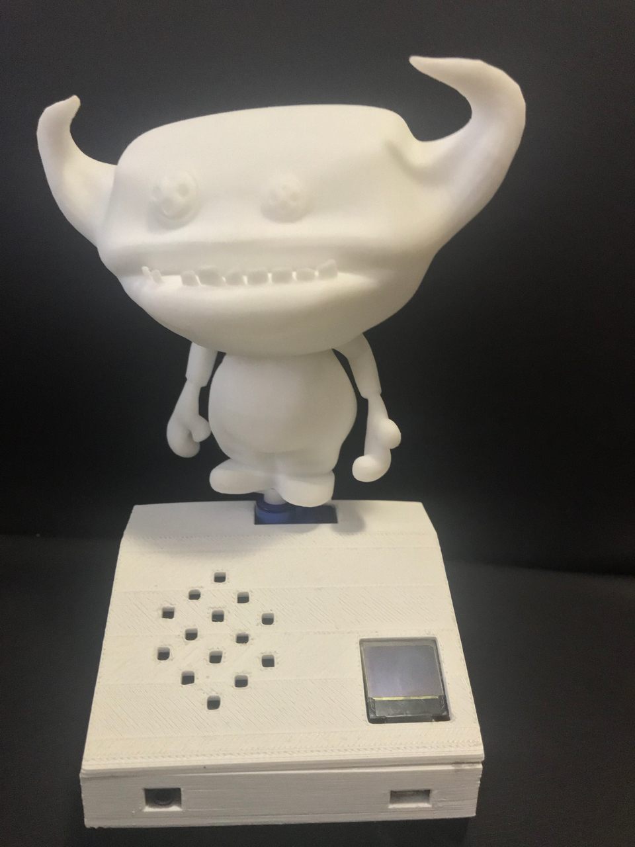
Figure 9
Naturally whilst the physical device was being constructed I had built a version of the electronics outside of the physical box so that Thejaswi and myself could spend time on programming some of the functionalities with Arduino, Cycling 74 Max and AppleScript. Our first step was to get Arduino to communicate with the D1 Mini, which was fairly easy because you can download the Arduino D1 libraries from the WIMOS website via a GitHub share, follow the installation instructions and you are up and running in no time. There are also libraries for the OLED shield from Wemos website and mp3 player from Open-Smart website accordingly. The libraries carry some example scripts which one can copy sections of code from in order to tailor a script that adds the functionalities you wish the program and device to perform.
Whilst getting started with the programming was fairly easy, the amount of time spent to achieve what we have so far was very restricted, in total we only had 2 hours of staff time per week for a period of 13 weeks dedicated to the curriculum development and project build; that is 26 hours all up for the writing of the two modules, and the planning and project build time including; the 3D Design, electronics and programming. When you consider that this time was divided between the team and technically speaking two members of the team were not really allocated any time at all as they were already over deployed, it means that each staff member had about half an hour a week allocated to do this work and all members of the team were fully deployed in full time teaching and other duties in parallel with this project. Naturally all of us put in more time than we were given, partly because we were enjoying the challenge. However, we did not manage to achieve all of the functionalities that we set out to achieve ~ but we did manage to achieve all of the following;
- We did achieve the coding of the simple HTML interface that is served to a browser from the D1 Mini
- We are able to pass text from the browser to the D1 Mini and to display it on the OLED Screen
- We successfully extracted calendar text from a pending event using AppleScript and passed it into Cycling 74 Max which processes the text string and then passes it on to the D1 Mini over the Wi-Fi network
- Marvin the dancing man can be controlled via the browser simple HTML interface via a mobile phone or computer – we can tell him to dance or to stop
- We can control events played by the mp3 player using commands typed into a field in the simple web interface
- We can trigger all of the above from a pending calendar event
The above functionality along with the completed physical product with all of the electronics working stands as clear ‘Proof of Concept’ to any potential manufacturer and also shows a potential student an example of the kind of idea that would pass the modules.
REFLECTION
This integrated approach to staff and curriculum development adopted whilst preparing for these masters degree modules has been very successful and all members of the team have acknowledged learning something new in the process, dare I say it we had some fun executing this work and that is a serious success!
Clear evidence of the influence and impact that this exercise has had on the staff involved is present in the physical product that the staff have designed and made collaboratively in very little time, and in the fact that the first run of the modules has taken place.
My collaborators have both expanded their research and understanding of electronics and MCU deployment in Internet of Things products and one of those members has actually designed and built two subsequent projects with great enthusiasm. Another member of the team has started to automate his household with self-designed and programed IoT devices and all of the team is eager to teach others these skills. This outcome constitutes a clear success to me and I am generally perceived as somewhat cynical by my colleagues, which makes the success all the brighter! My collaborators were somewhat daunted at the outset of this exercise and they are all now firmly onboard. I also learnt much from this exercise, particularly about 3D product design and printing.
I believe that a sustained approach to continuing professional development and curriculum design practices along the lines of the above exercise, with a consolidated approach to both research led practice and practice led research (Smith & Dean, 2009) conducted in interdisciplinary project-based learning environments should become the norm within the learner community, and to this end, I intend to install a similar approach to curriculum development and learning and teaching practices within my faculty wherever the opportunity arises, starting with the delivery of these two masters modules where we have retained the interdisciplinary development team for teaching and have just completed the first cycle through the two said modules.
CONCLUSION
This paper was written with the somewhat evangelical sentiment that is the focus of contemporary media such as the portrayal of CS Lewis’ story in the film Narnia , The Lion The Witch and The Wardrobe, where Aslan - the messiah of said country breaths magic into the narrative that ensues, as the kings and queens of olde fight for a free Narnia, or the bravery and selflessness of the throws of Bruce Willis in the closing scenes of the film Armageddon , where the said actor sacrifices his life for the good of all mankind. The outcomes of this paper are significantly more humble but the sentiment is just as powerful, I bare witness to this sentiment as a living benefactor of the point that; lifelong learning is one of the keys to a fruitful life, and a fruitful life is one of the keys to happiness here on this Earth!
CITATIONS
* Please note that some text in this document is copied, edited and paraphrased from a case study and application form written and submitted by myself (Dr.Richard Salmon) for recognition as a Senior fellow of the Higher Education Academy - this text was not formally cited here because the said application form is to the best of my knowledge not a formally published document

