* Homework #4

**# Due date: 14/Nov, 23:59:59**

**# Submit a zipped file of your application project folder**

**# In the application source, you MUST give comments for important lines. Without comments, your solutions will be considered copy&paste codes.**

**# You also need to provide a screenshot of your result (i.e., Screen of AVD or physical phone).**

**# Put your answers in “AnswerSheet” section**

**# You must use Kotlin language.**

**1) ColorsWap**

- You need to create an Android UI with one text field, centered at the top of the screen, and one button.

- The text field will initially display the text “*Tap to Change Color”*.

- Every time you tap the button, your application needs to generate a random color using RGB values, change the text to that color, and display the values for the color in the following format (assuming you are displaying a light grey with values 100/100/100): *COLOR: 100r, 100g, 100b*.

- Write a report on how your application works

- Zipped file name should be colorswap.zip

Example)

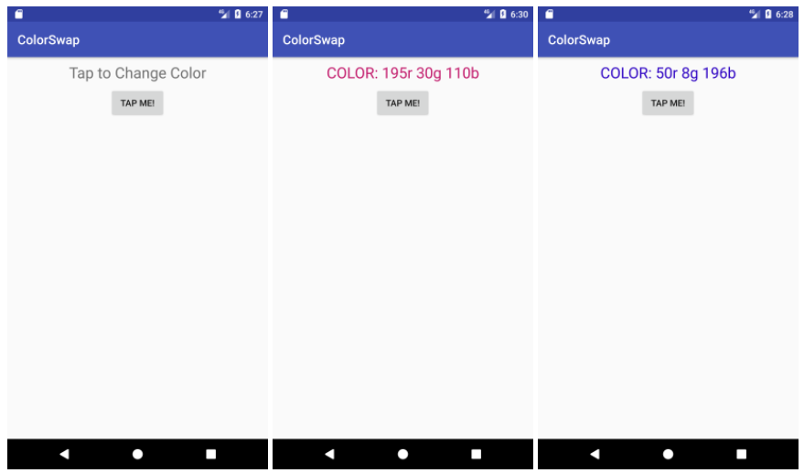

**AnswerSheet – Screenshot & Short Analysis on your code**

**2) Your Portfolio**

- Create an application to introduce yourself!

- Create your own Application icon

- Include at least 2 activities

- Use at least 1 container component and 1 popup component

- No restrictions on the contents (you can choose your own items/menus)

- Include a short demo video

- Zipped file name should be selfintro.zip

Example)

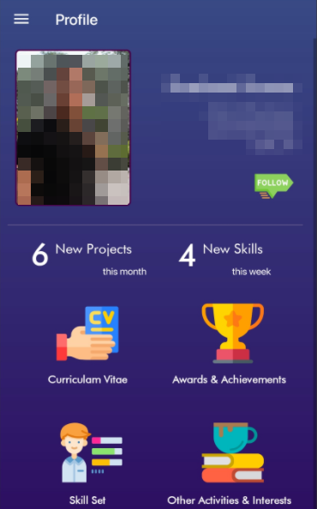 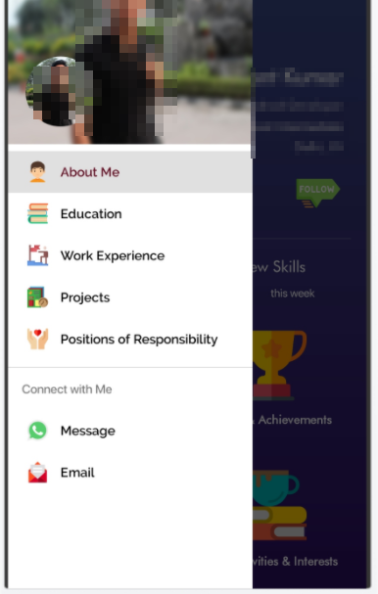

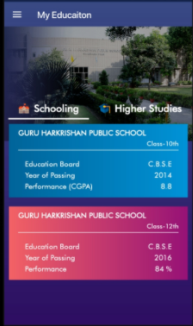

**3) Complete the following instructions.**

**1. Create MainActivity and SubActivity for this assignment.**

**2. Edit the layout of MainActivity as follows:**

**3. Write the code of MainActivity and SubActivity to complete the following scenario:**

**a) Launch your application. MainActivity must be opened.**

**b) Type any search keyword in the textedit field.**

**c) Press “Search” button**

**d) Your MainActivity must send “implicit intent” to find an application that can handle “web search”, and your application must be shown in the app chooser! (Add an intent-filter to your SubActivity to receive this implicit intent)**

**4. If you choose a normal browser application, Chrome application must show the search keyword you provided as well as the web search result.**

**5) Press back button to go back to your application**

**6) Press Search button again in the MainActivity**

**7) In an app chooser dialog, if you choose your own application (e.g., HW04Application), your SubActivity must handle this request:**

**a) Take the search keyword included in the intent**

**b) Display the search keyword on the top**

**c) Take some messages from the user using a multiline text view**

**d) Once completed, press Return button**

**8) MainActivity must display the text from the subactivity using Snackbar dialog!**

**For this question, you have two options**

**1) Use startActivityForResult() APIs (deprecated ones)**

**2) Use Activity Result APIs (new recommendations)**

**Try to use Activity Result APIs first.**

**If you fail to use them, then use old APIs (startActivityForResult)**

**AnswerSheet – Logic description (Explain how your application works, briefly)**

**AnswerSheet – Screenshot**