Alicia Custodia García Yuen

marie Estelle Melaine pamen

RODRIGO SÁEZ ESCOBAR

Master Mind user´s manual

Content

1) Installation 2

1.1 VSCode and Project 2

1.2 Extensions 2

1.3 Build 2

1.4 Run 3

2) Play 3

2.1 Master Mind basics 3

2.2 Game Controls 4

3) Code 5

3.1 Code diagram 5

3.2 Code function explanation 6

4) Participation 6

# Installation

The first step to play this Mastermind game is to have a Z80 compiler.

## VSCode and Project

First, we need VSCODE to run the code, where you can check the last version here <https://code.visualstudio.com/download>

Obviously, the project itself which is public in GitHub here <https://github.com/saezro/Mastermind>

## Extensions

To be able to run compile and run the code is necessary to have these two extensions.

## Build

The folder of the project has already been built but to save any change follow these steps.

To build the project first we have to the add the folder to VSCode like this:

Then select the project folder called “Mastermind” and that will open the project and should look like this:

To build it we must open the archive “.asm” and select “Terminal => Run Build Task”

## Run

To run the game after building it select “Run => Start Debugging”

# Play



## Master Mind basics

The game Mastermind consists in someone creating a code of 4 colors and other one trying to solve it.

The solver tries a combination of colors and the coder gives hints about it, red(if a color is in the right place), white(if a color is right but not in his place) and nothing(if nothing is right.)

For example the code is (**RED RED BLUE YELLOW**) and the solver says (**BLUE BLUE BLACK WHITE**) so the hits are (**WHITE WHITE**) because only the blue is right but not in the right place and theres 2 of them.

This is and example of the game we have done.

In the first column the only color that is right is **BLACK** so the hint is just **WHITE**.

In the second column **BLACK** is in the right place and **RED** is not so the hint is **RED** **WHITE**.

In the last column all the colors are right in the place the should so the hints are **RED RED RED RED** that means that the game ends whith a win.

## Game Controls

To play this game there’s only 3 main keys to control it “z” to change to the next color, “x” to change to the color before and “c” to accept the color.

The list of colors is (**BLACK RED PINK GREEN BLUE YELLOW WHITE**) starting in black.

When you finish the game winning or loosing you can press “v” to restart the game.

# Code



## Code diagram

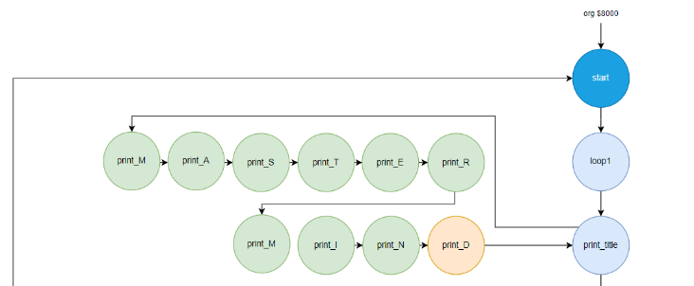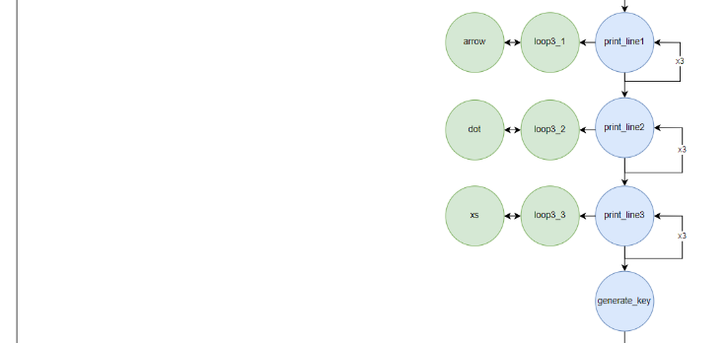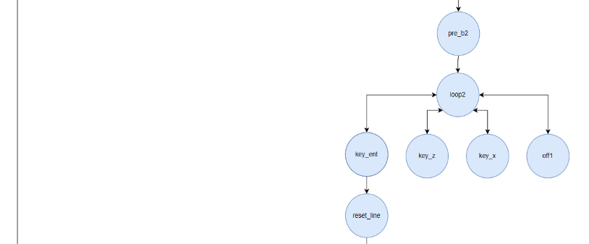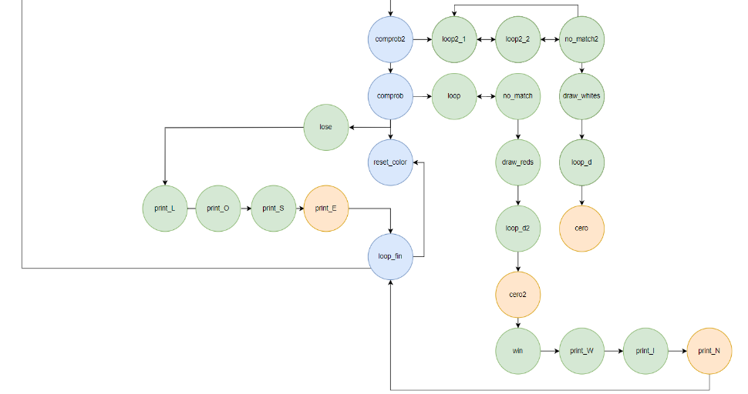

## Code function explanation

“start” initializes the registers to start to draw in the screen.

“loop1” is the loop that prints all the screen with **BLUE**, and then it prints where is going to be the message of win or lose.

“print_title” prints “MASTER MIND” in 11 squares where HL aims.



# Participation