Saif Ezzat.

Report for project 3:

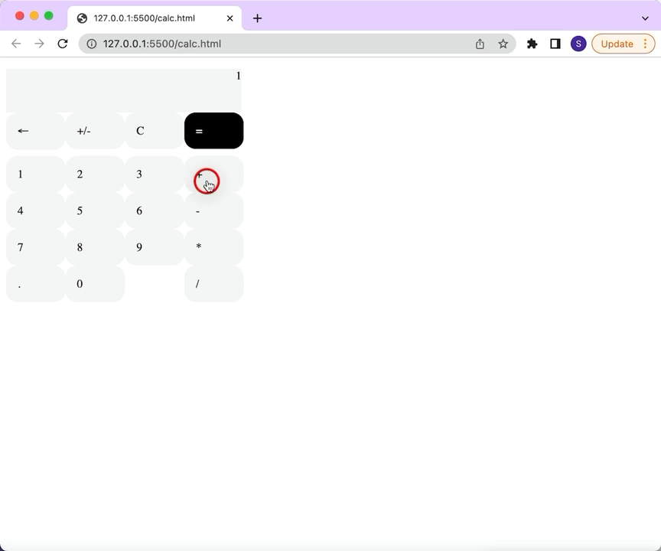For project 3, I designed a simple calculator. Here is a short video to show the functionalities of the application.