METRIC CAGE
A probability engine for mixed martial arts
76% on high-conviction calls · AUC 0.691 on an unseen season
Eleven times it overruled its own rating system and was right
14 events · 175 fights · January to May 2026, entirely unseen
Report prepared 6 August 2026

What is Metric Cage?
Metric Cage is a probability engine for mixed martial arts. Give it two names and a date and it returns a calibrated view of the fight: who wins and by how much, an estimate of how the fight ends, and the features driving the call. It does not hand you a name. It hands you a number that means what it says.
That distinction is the whole design. Most fight analysis collapses into a binary pick, which is right or wrong and tells you nothing about how sure anyone was. MMA generates enough noise that binary scoring is close to useless: a perfectly timed counter ends a fight in nine seconds regardless of who prepared better, and under a right-or-wrong scoreboard, being correct about the shape of a fight looks identical to guessing.
The goal is not to be right more often. It is to be right about how often you will be right.
So the model is built and judged on calibration. When it says 69 per cent, the fighter should win about 69 per cent of the time. That is a harder standard than accuracy and a more useful one, because a calibrated number can be acted on and a pick cannot.
Across the 2026 season the winner head scored an AUC of 0.691 on fights it had never seen, and on the 55 occasions it committed to a fighter at 65 per cent or better, that fighter won 42 times. Seventy-six per cent, with no betting-market information of any kind.
Underneath is a four-model ensemble trained on every UFC bout since 2010, a little over 7,200 fights, with 102 engineered features per matchup. Training data ends on 4 May 2025.

What it produces, and how much each part is worth
Being specific about this up front matters, because the three outputs are not equally good and this report does not pretend otherwise.
Output | What it is | How much to trust it
Win probability | Calibrated probability for each fighter | Strong — AUC 0.691, well calibrated
Method of victory | Decision, knockout, or submission | Weak on this season — see chapter six
Round of finish | Round-by-round distribution | A fixed base rate, not a prediction
The round distribution is worth being blunt about. It is a hard-coded prior of 40, 30, 15, 10 and 5 per cent across rounds one to five, identical in every fight the model has ever scored. It reflects how UFC finishes are historically distributed and it carries no information about the specific fight in front of it. Anywhere a round appears in this report, read it as a base rate rather than a forecast.
It also produces the features driving each call, and warnings when the four internal models disagree, when a fighter carries a recent knockout loss, or when there is too little history to say anything at all.

How it predicts sequences in fights
A fight is a chain of questions, and Metric Cage answers them separately before multiplying them back together into a shape.

The chain
The first question is who wins. That is the ensemble, and it is the part of the system that works.
The second is how. This runs through a two-stage classifier: stage one asks whether the fight gets finished at all, and only if it does does stage two ask whether the finish is a knockout or a submission. The split is well motivated. "Will this end early" and "how will it end" are almost unrelated problems, the first being about pace, damage and the collision of two styles, the second about which finishing door is open. Whether the split works in practice is chapter six.
Combining the two gives six outcomes: either fighter, by any of three methods. That six-way tree is the object this report keeps returning to, because it is where a probability model says something a pick cannot.

What a tree buys you
Take Vallejos against Emmett, a five-round main event in March. The model put Vallejos at 69.6 per cent and then split that across methods: knockout 26.8, decision 24.7, submission 18.1. The knockout branch outranked the decision branch, which is unusual, because in championship-distance fights the decision branch is normally the safe bet.
Branch | Question | What the model said
Level 1 | Who wins | Vallejos 69.6%, Emmett 30.4%
Level 2 | How it ends | Of Vallejos's 69.6%: knockout 26.8%, decision 24.7%, submission 18.1%
Shape | Both together | A Vallejos knockout was the single heaviest branch of six
Vallejos knocked Emmett out in the first round. The pick was right and so was the shape, and the shape is what a favourite-backing heuristic cannot produce.
A winner is a coin. A shape is a claim about how the fight actually goes.

Why the round is not in the tree
An earlier draft of this report ran the tree out to a third level and reported how often the model named the round. That was wrong and it has been removed.
The round distribution is constant. Across all 175 fights of the 2026 season the model gave round one a 40 per cent share of finish probability every single time, with a standard deviation of zero. It ranked round one as the likeliest round in 175 of 175 fights. Any apparent skill at "calling the round" was the base rate doing the work, and a naive rule of always saying round one would have matched it exactly.
So the tree stops at two levels. Fighter and method. Where the round is mentioned, it is describing what happened rather than what was predicted.

How the model works
There is no single model. There are four, and they disagree with each other on purpose.

The four streams
Stream | What it is | What it contributes | Weight
Logistic regression | A linear model over all 102 features | Stable, hard to overfit, sane on thin data | 0.292
Gradient boosting | XGBoost over 67 pruned features, depth 3, 800 trees | Catches interactions the linear model cannot see | 0.353
Elo rating | A custom MMA Elo with method and inactivity adjustments | Strength of schedule, independent of any statistic | 0.124
Career LSTM | A sequence network reading each fighter's career in order | Trajectory: improving, plateauing or sliding | 0.231
Ensemble weights were fitted on a 2023 validation slice by minimising log loss, not chosen by hand.
Each stream produces its own win probability. They are then blended using the weights above, and the blend is passed through two layers of correction: an isotonic calibrator that maps raw model output onto observed frequencies, and a temperature adjustment that pulls extreme calls back toward the middle. Both exist because raw ensembles are systematically overconfident, and an overconfident probability is worse than no probability at all.
The disagreement between streams is itself a useful signal. When the boosted model and the Elo rating land twenty points apart, that spread is reported as a warning rather than averaged away quietly. A wide spread usually means the matchup sits in a region where the historical data is thin or contradictory.

The 102 features
Every fight is reduced to a row of 102 numbers before any model sees it. Most of them are differentials, computed as fighter A minus fighter B, so a positive value favours A. Rate statistics are decayed with a 365-day half-life, meaning a bout from a year ago counts half as much as a recent one and a bout from three years ago counts about an eighth.
The set breaks into eleven families. What follows describes each one, what it is measuring, and whether it actually works. That last part matters, because a feature that sounds clever and carries no signal is worse than no feature at all.
A note on the evidence below. Each response curve splits every UFC bout from 2015 onward, 5,522 fights, into five equal groups by the feature in question and reports the observed outcome rate in each. This is descriptive rather than causal. Features correlate with each other, so these curves show what a feature carries, not what it independently contributes.

1. Elo and strength of schedule (4 features)
A custom MMA Elo rating sits underneath everything. It differs from chess Elo in three ways: the K-factor scales down as a fighter accumulates bouts, so a debutant's rating moves faster than a veteran's; finishes update ratings more than decisions, with knockouts at 1.15 times the base and submissions at 1.10; and a fighter idle for more than a year is regressed toward the mean, capped at a quarter of the way back. The features are the rating difference, the Elo-implied win probability, and each fighter's raw pre-fight rating. Elo difference and Elo-implied probability sit fifth and sixth in the boosted model's importance ranking.

2. Raw performance (14 features)
The conventional numbers, all decayed and all differenced: significant strikes landed and absorbed per minute, net striking, striking accuracy, striking defence, takedowns landed and conceded per fifteen minutes, takedown accuracy and defence rate, submission attempts per fifteen minutes, knockdowns landed and absorbed per fifteen minutes, and share of fight time spent in control.
Net striking differential is the third most important feature in the whole model. Striking defence is a close relative and behaves cleanly: fighters in the top group by defence differential win 59.7 per cent of the time against 43.4 per cent in the bottom group. Control time is weaker than most people expect, moving win rate only from 46.3 to 53.4 per cent across its range.

3. Physical, form and experience (10 features)
Age, reach, binary stance mismatch, recent win percentage, career finish rate, total career rounds as a proxy for championship-round experience, current streak capped at five, days since the last bout, and each fighter's UFC fight count. Age difference is the fourth most important feature overall.
Reach is real but modest. Giving away more than three inches drops win rate to 45.3 per cent; holding more than three inches raises it to 53.8. That is a six-point swing at the extremes of a range most fights never reach, which is roughly the right size for something the sport treats as decisive.

4. Style archetypes (18 features)
Each fighter is scored against eight archetypes, using division-normalised z-scores of their career statistics rather than any label anyone applied to them. The eight are: power puncher, Muay Thai volume striker, Dutch kickboxer, counter striker, wrestle-striker, grappling-first, pressure striker, and decision fighter. They are soft memberships, not categories. A fighter usually scores meaningfully on several, and the mixture shifts across a career.
Sixteen of the features are the two fighters' archetype vectors. The remaining two summarise the pairing: the distance between the two vectors and their overlap. Grappling-first membership for both fighters sits in the model's top twelve features, and the archetype vectors are the input to everything in the next four families.

5. Striker against grappler (6 features)
This family asks how each fighter actually wins, then checks whether that route is open against this specific opponent. The grappler path score takes a fighter's takedown rate and submission threat and discounts it by the opponent's takedown defence, clamped at 95 per cent so nobody is treated as untakedownable. The striker path score does the reverse, rewarding fighters who can keep the fight standing against someone who wants it on the floor. The net mismatch across the pairing, plus a takedown-dominance differential, complete the family.
This is one of the better-behaved feature groups in the model. Win rate climbs from 43.6 per cent in the bottom group to 57.5 per cent in the top, and the curve is close to monotone throughout.

6. Knockout threat against chin durability (7 features)
Rather than treating power as a property of a fighter, this family treats it as a property of a pairing. Knockout danger is built as half a knockout-per-round rate, three-tenths a knockdown bonus, and two-tenths career finish rate. Chin durability runs against it, combining knockdowns absorbed, strikes absorbed per minute, a knockout-fragility term, and an accumulated-trauma penalty that grows exponentially with career knockout losses, knockdowns taken and total fights.
The features are each fighter's knockout danger and chin durability, the net threat across the pairing, the differential, and a binary flag when fighter B's chin reads as a live vulnerability.
Signal | What happens | Baseline
Knockout danger differential, top group | A wins 57.8% | A wins 49.4%
Knockout danger differential, bottom group | A wins 40.9% | A wins 49.4%
Net knockout threat, top group | 39.5% of fights end by KO | 31.4%
Chin-vulnerable flag raised (274 fights) | 44.2% end by KO, A wins 59.9% | 31.4% / 48.8%
The chin flag is the strongest single binary signal in the feature set. When it fires, the knockout rate is thirteen points above the base rate. It fires rarely, on about five per cent of fights, which is what a flag should do.

7. Submission chains (5 features)
This is the most elaborate piece of feature engineering in the model, and its 2026 performance is the most instructive thing in this report.
The design does not use submission attempts as a rate. It reasons about position. Each fighter's archetype vector is converted into an estimated distribution over eight grappling positions, then each position is assigned a base submission probability derived from historical rates:
Position | Base submission probability | Position | Base submission probability
Back control | 0.38 | Half guard | 0.12
Mount | 0.22 | Guard top | 0.08
Guard bottom | 0.19 | Clinch | 0.08
Side control | 0.14 | Standing | 0.01
A fighter's grappling-first and wrestle-striker scores drive the position distribution toward the dominant spots. Someone with a high grappling score is estimated to spend up to 40 per cent of ground time in back control and very little standing; a pure striker sits at the opposite end. Guard bottom is only populated for fighters whose grappling-first score exceeds 0.30, since submitting off your back is a specialist's move rather than a general one.
Three more adjustments follow. A chain-weight factor of up to 1.4 rewards fighters who string attempts together rather than hunting a single hold. A round-fatigue multiplier scales the danger upward as the fight goes on, from 1.00 in round one to 1.25 in round five, because tired fighters get caught. And the whole thing is gated by whether the fight reaches the ground at all, modulated by the opponent's takedown defence. Sparse fighters are regressed toward a population mean of 0.12.
The result is a per-fighter submission danger, a differential, a combined pairing threat, and a submission-attempt-rate differential. The combined threat is also injected into the method head as a soft prior, because the raw classifier under-ranks grapplers on its own.
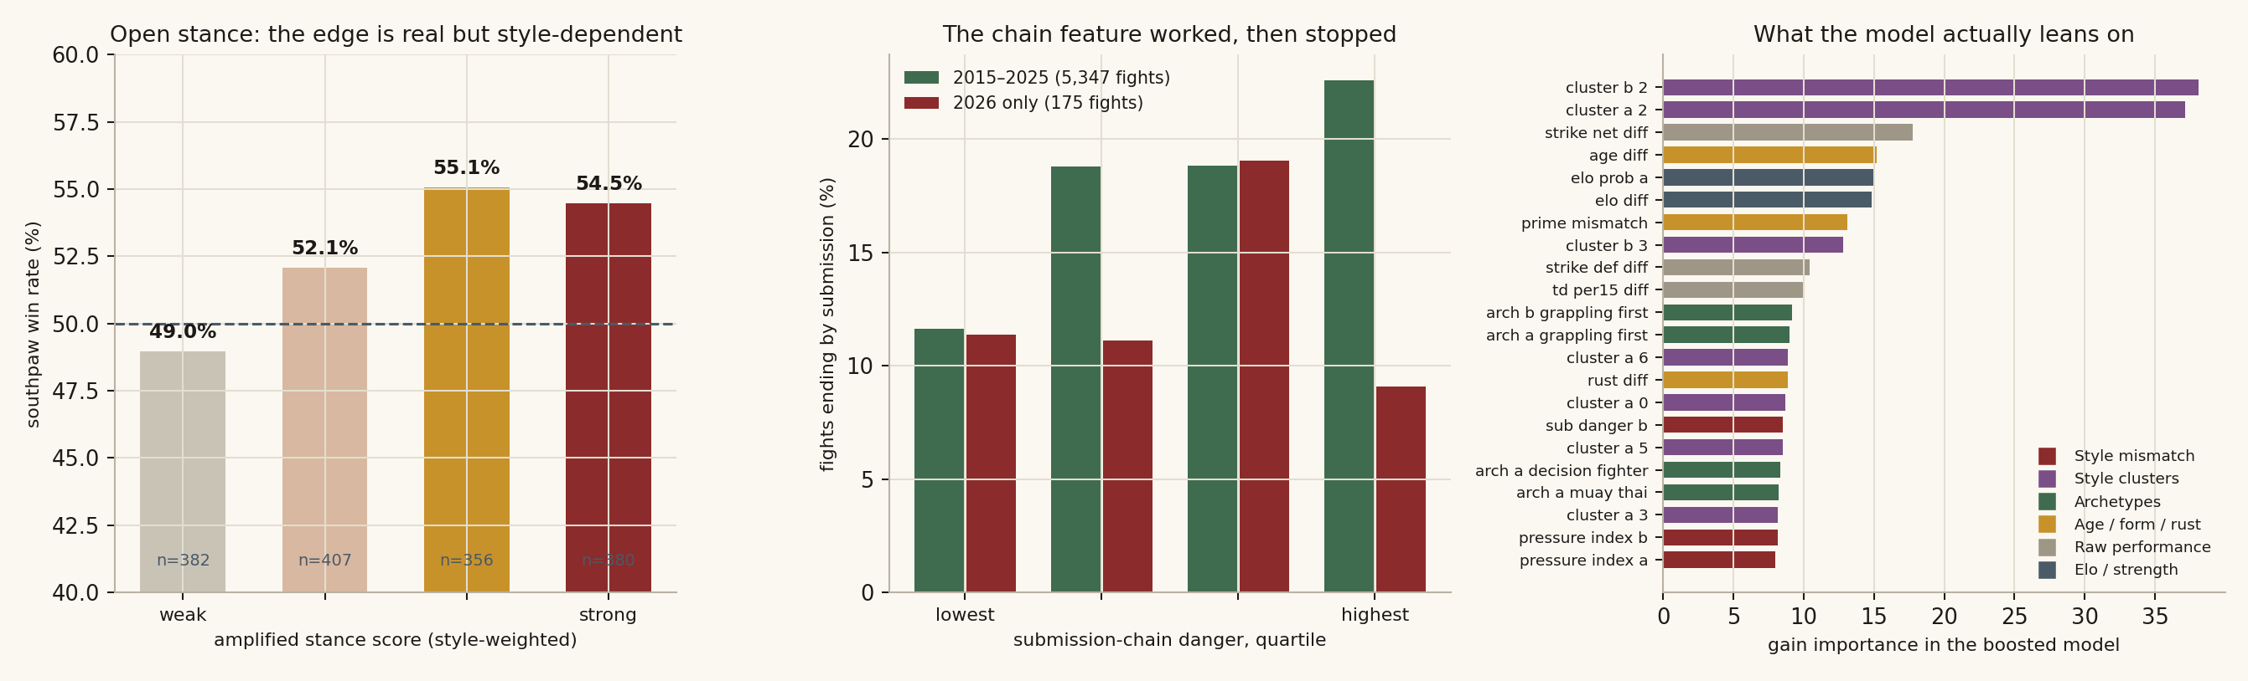
Figure 1. Left: the open-stance effect, split by how much the fighters' styles amplify it. Centre: submission-chain danger against actual submission rates, historical against 2026. Right: gain importance in the boosted model, coloured by feature family.
Across 2015 to 2025 the feature does exactly what it was built to do. Fights in the bottom quartile of chain danger ended by submission 11.6 per cent of the time; fights in the top quartile, 22.6 per cent. That is close to a doubling, and the model's own submission probability tracks the feature with a correlation of 0.81.
Then the 2026 season arrived and the relationship evaporated. Fights in the top quartile of submission danger produced submissions 9.1 per cent of the time, the lowest of any group.
Across the season, the fights that actually ended in a submission sat at the 49.6th percentile of chain danger. The median. The feature had no idea. This is the mechanism behind the finding reported later that none of the season's twenty-two submissions was ranked first: it is not that the method head ignores grappling, it is that the positional proxy it relies on stopped predicting anything. Whether that is a one-season fluctuation on a sample of twenty-two, or the consequence of takedown defence improving to the point where the archetype-to-position mapping no longer holds, cannot be settled from a single year of data.

8. Pace, pressure and counter dynamics (7 features)
Pace is scored from combined striking volume, both landed and absorbed, since a fight's tempo is set by two people. The pressure index weights the pressure-striker archetype at 1.4 against output and forward movement. Counter efficiency relates finish rate to volume, so a fighter who finishes without throwing much reads as a counter threat rather than a low-output fighter. Counter threat is then computed directionally, once for each fighter against the other, because a counter striker's value depends entirely on whether the opponent brings pressure to counter.
Cardio is handled by a fade-risk term, the ratio of strikes absorbed to strikes landed. It is one of the more reliable features: fighters in the best two groups win 56 per cent of the time, those in the worst group 44 per cent. There is also a flag for when fighter B is set up as a counter-based upset threat, which fires on 476 fights and drops A's win rate by five points.

9. Stance geometry (4 features)
The plain stance-mismatch binary is retained, but three calibrated features sit on top of it. Open stance, meaning orthodox against southpaw, occurs in 27.6 per cent of bouts since 2015. The southpaw wins 52.6 per cent of those, which is a real but small edge.
The interesting part is that the edge is not uniform, and the model encodes why. Each archetype carries a stance multiplier reflecting how much that style depends on angles and geometry:
Style | Stance multiplier | Style | Stance multiplier
Dutch kickboxer | 1.40 | Pressure striker | 1.10
Muay Thai | 1.35 | Wrestle-striker | 0.85
Power puncher | 1.30 | Decision fighter | 0.70
Counter striker | 1.20 | Grappling-first | 0.50
A southpaw kickboxer gets close to the full benefit of the open-stance geometry. A southpaw wrestler gets very little, because the fight he wants does not happen at kicking range. The score is then adjusted for how rare southpaws are in that particular division, since the advantage comes partly from unfamiliarity, and converted into an estimated win-probability uplift at 6.5 per cent per unit of amplified score.
The data supports the design. Splitting open-stance fights by amplified score, the southpaw wins 49.0 per cent in the weakest quartile and 55.1 per cent in the third. In other words, the naive version of this feature, a simple binary, would be averaging a genuine six-point edge together with nothing at all. Open-stance fights are also slightly more likely to end early, 51.5 per cent against 49.5.

10. Trajectory, age curve and rust (13 features)
This family exists because a fighter's record describes where they have been rather than where they are going. An ascending-trajectory score weights recent results with a 200-day half-life and adjusts for opponent quality. Elo form divergence measures the gap between recent performance and standing rating, catching fighters whose ranking has not caught up with their form in either direction. The age-curve term places each fighter on a division-specific ageing curve rather than treating thirty-four as one thing across all weights, and a prime-mismatch flag fires when the two fighters sit at different points on it.
Rust is a penalty on layoff, computed per fighter and differenced, plus a specific flag for when the favourite is the rusty one. That flag fires on only 77 fights, but when it does, the favourite's win rate falls from 49.5 to 39.0 per cent. There is also a first-round danger differential and a composite upset-risk score built from the whole family.
Trajectory is the strongest curve in the entire feature set: 40.3 per cent win rate in the bottom group rising to 60.7 in the top, a twenty-point spread. The composite upset score runs the same distance in the other direction, from 62.3 down to 39.3.
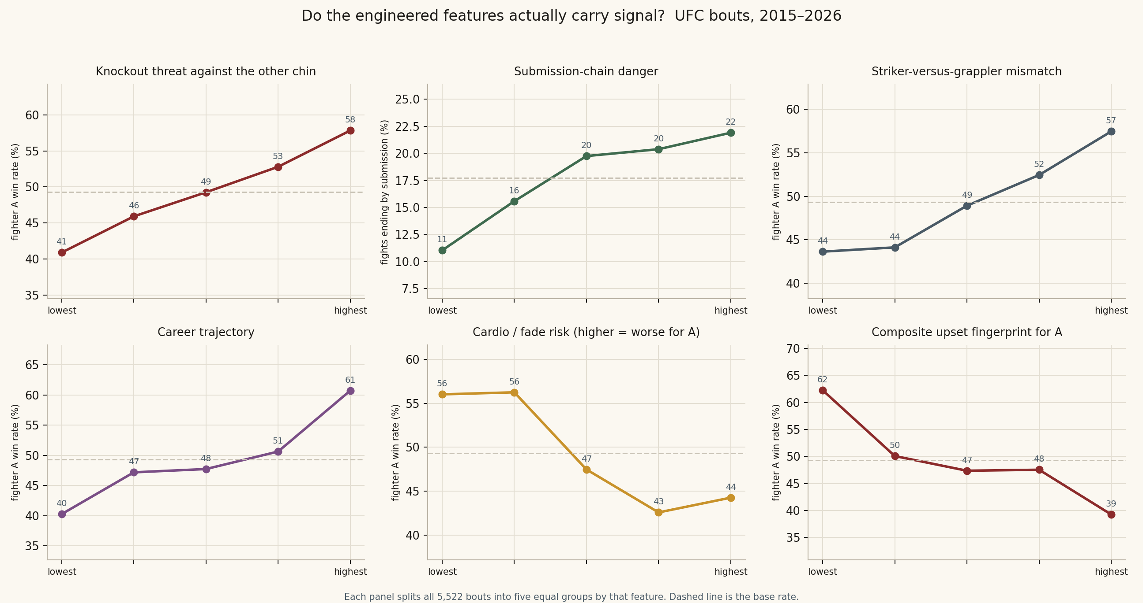
Figure 2. Six feature families tested against outcomes. Each panel splits 5,522 bouts from 2015 onward into five equal groups. The dashed line is the base rate.

11. Learned style clusters (14 features)
The last family is the one the model leans on hardest, and it was not designed by hand at all. A Gaussian mixture model with seven components is fitted to fighter statistic vectors from the training period only, with the number of components chosen by information criterion and sparse fighters shrunk toward their division prior. Each fighter gets seven soft membership probabilities that sum to one.
These clusters are the two highest-gain features in the boosted model by a wide margin. Cluster 2 membership for both fighters carries more than twice the importance of net striking, which is the best of the hand-built features. The model has found something in the data that none of the eight hand-defined archetypes captures, and nobody can say precisely what it is. That is worth stating plainly rather than dressing up. A hand-built feature can be argued about; a learned cluster can only be measured.

Two features that do not earn their place
Not everything works, and a report that only lists the wins is not worth much.
Pace mismatch is close to inert. Across its full range the win rate moves between 47.4 and 50.7 per cent, and the finish rate barely responds either. The idea, that a tempo gap should let the faster fighter dictate, does not survive contact with the data. Archetype distance and archetype similarity are similarly flat as win predictors, though distance does show a mild U-shape against finishing, with both very similar and very dissimilar pairings ending early more often than middling ones.
Prime mismatch is a different problem. It ranks seventh by importance, yet it is a binary that fires on only 8.1 per cent of fights. High gain on a rare flag is a pattern that usually means the boosted model has found a narrow pocket of the data to memorise. It may be genuine. It should be checked.

The rule that keeps it honest
Every feature for a fight on a given date is computed using only data from strictly before that date. This sounds obvious and is very easy to get wrong. A career average that quietly includes the fight being predicted will produce beautiful accuracy and no predictive power whatsoever. The codebase enforces this with regression tests that check a fight's feature row is bit-identical whether or not later fights are present in the input.

What it does not know
Three gaps are worth stating plainly, because they explain most of the misses later in this report.
- The fighter database contains UFC bouts only. A debutant arriving from a regional circuit has no history, and the model declines to predict rather than inventing one.
- There is no feature for a weight-class change or a short-notice replacement. A fighter moving up a division looks identical to one who is not.
- Nothing about the camp is visible. Injuries, a bad weight cut, a coaching change, a fighter who stopped sparring three weeks out: none of it reaches the data.
There is also no positional data of any kind. Every ground feature in the model is inferred from archetype scores rather than observed, because the source data records takedowns and submission attempts but not where a fighter spent the round. The submission-chain family is an elaborate attempt to work around that gap, and the 2026 result suggests the workaround has limits.
The round predictor is not a model at all. It is a fixed prior of 40, 30, 15, 10 and 5 per cent across rounds one to five, identical in every fight. It carries no fight-specific information and nothing in this report treats it as a prediction.

How has it tracked so far?
Training stopped on 4 May 2025. The model was then rerun across every card from January to May 2026 in order, with ratings and fighter histories updated only as each event finished, so nothing from a later card was visible when an earlier one was scored. Fourteen events, 175 fights, no odds feature, no hindsight.

High conviction only
A model that hedges everything to 52 per cent can never be interestingly wrong. The calls worth judging are the ones where it committed, and on 55 of the 175 fights it put a fighter at 65 per cent or better.
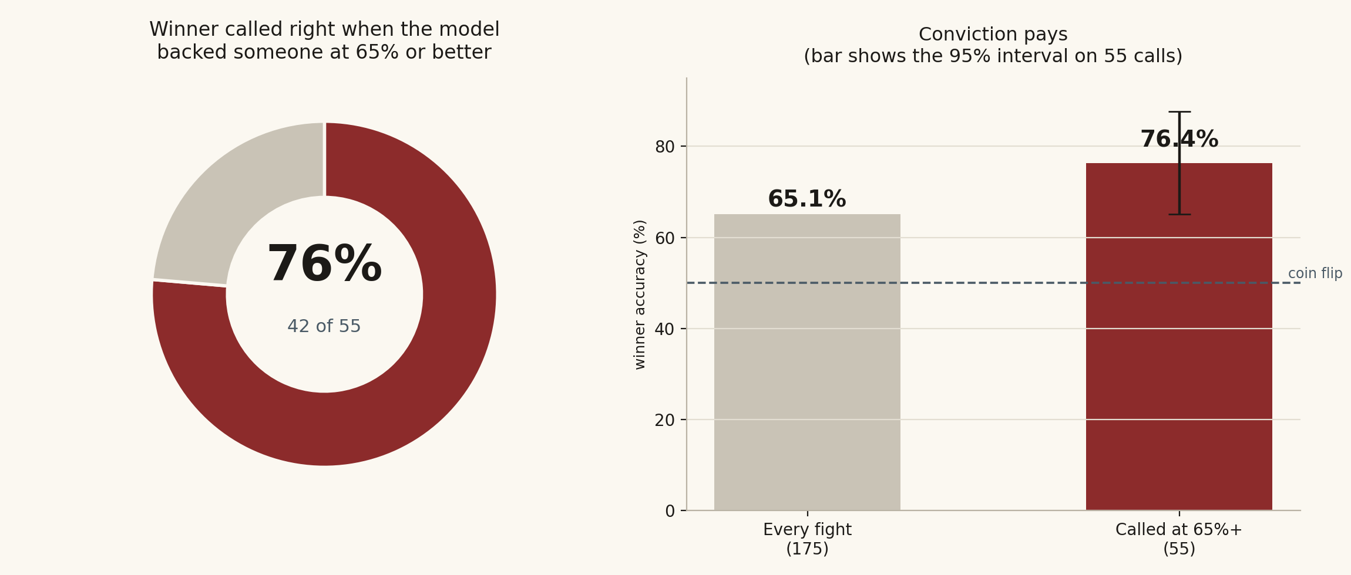
Figure 3. Winner accuracy on the 55 fights where the model committed to 65 per cent or higher, with the 95 per cent interval on that estimate.
Measure | Result
High-conviction calls correct | 42 of 55 — 76.4%
95% interval on that figure | 65.1% to 87.6%
All 175 fights | 114 of 175 — 65.1%
Winner-head AUC | 0.691 (interval 0.614 to 0.764)
Cards where high-conviction calls hit 65% or better | 12 of 14
Cards where every high-conviction call landed | 4
Two things need saying about that 76.4 per cent. It is measured on 55 fights, which is a small sample, and the interval runs from 65 to 88 per cent. Even the bottom of that range beats backing every betting favourite. But the honest reading is that the model is somewhere in that band rather than precisely at 76.

The number that matters more
Accuracy on a filtered subset is a headline. AUC across all 175 fights is the measurement, because it cannot be improved by choosing which fights to count.
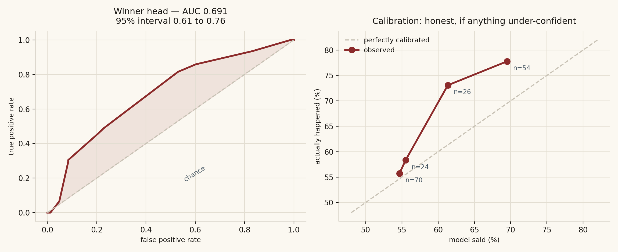
Figure 4. Left: the winner head's ROC curve across all 175 fights. Right: predicted against observed win rates.
The winner head scored 0.691 with a bootstrap interval of 0.614 to 0.764. Published academic models on UFC data sit between 0.68 and 0.74, and those mostly include betting odds as a feature. This one does not. The project set itself a target of 0.74 and has not reached it, but 0.691 on a genuinely blind season is a real result rather than a hopeful one.
The calibration curve is the encouraging part. In the lower bands the model is almost exactly right. In the upper bands it undersells itself: when it said around 69 per cent, the fighter won 78 per cent of the time. Being too modest is a better failure than being too bold, and it points at the temperature correction being tuned a little hard.

Card by card
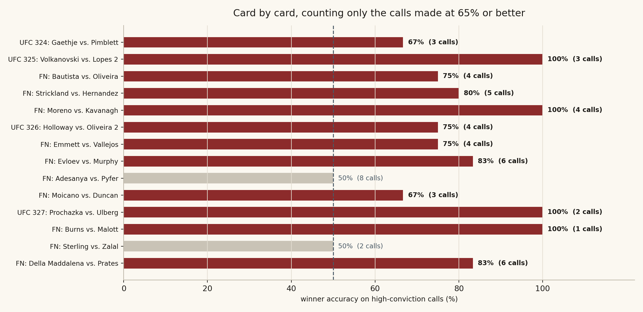
Figure 5. Every 2026 card, counting only the calls made at 65 per cent or better.
The tables below list those calls: who the model backed, how confident it was, its method estimate, and what happened. Method estimates are included for completeness rather than as a claim, for reasons chapter six goes into.

UFC 324: Gaethje vs. Pimblett
2026-01-24 · 3 high-conviction calls · 2 of 3 correct (67%)
Bout | Model backed | Conf. | Method estimate | What happened
Paddy Pimblett v Justin Gaethje | Paddy Pimblett | 73.4% | KO/TKO 40% | Gaethje by Decision | ×
Andrey Pulyaev v Ateba Gautier | Ateba Gautier | 67.3% | KO/TKO 39% | Gautier by Decision | ✓
Derrick Lewis v Waldo Cortes Acosta | Waldo Cortes Acosta | 67.3% | KO/TKO 54% | Acosta by KO/TKO | ✓

UFC 325: Volkanovski vs. Lopes 2
2026-01-31 · 3 high-conviction calls · 3 of 3 correct (100%)
Bout | Model backed | Conf. | Method estimate | What happened
Quillan Salkilld v Jamie Mullarkey | Quillan Salkilld | 73.4% | Decision 50% | Salkilld by Submission | ✓
Benoit Saint Denis v Dan Hooker | Benoit Saint Denis | 69.6% | KO/TKO 36% | Denis by KO/TKO | ✓
Junior Tafa v Billy Elekana | Billy Elekana | 67.3% | Decision 57% | Elekana by Submission | ✓

UFC Fight Night: Bautista vs. Oliveira
2026-02-07 · 4 high-conviction calls · 3 of 4 correct (75%)
Bout | Model backed | Conf. | Method estimate | What happened
Jailton Almeida v Rizvan Kuniev | Jailton Almeida | 79.9% | Submission 36% | Kuniev by Decision | ×
Farid Basharat v Jean Matsumoto | Farid Basharat | 69.6% | Decision 51% | Basharat by Decision | ✓
Priscila Cachoeira v Klaudia Sygula | Klaudia Sygula | 67.3% | KO/TKO 54% | Sygula by Decision | ✓
Marc-Andre Barriault v Michal Oleksiejczuk | Michal Oleksiejczuk | 67.3% | KO/TKO 52% | Oleksiejczuk by Decision | ✓

UFC Fight Night: Strickland vs. Hernandez
2026-02-21 · 5 high-conviction calls · 4 of 5 correct (80%)
Bout | Model backed | Conf. | Method estimate | What happened
Alden Coria v Luis Gurule | Alden Coria | 73.4% | KO/TKO 38% | Coria by Decision | ✓
Carli Judice v Juliana Miller | Carli Judice | 69.6% | KO/TKO 38% | Judice by Decision | ✓
Anthony Hernandez v Sean Strickland | Anthony Hernandez | 69.6% | Decision 50% | Strickland by KO/TKO | ×
Melquizael Costa v Dan Ige | Melquizael Costa | 69.6% | Decision 55% | Costa by KO/TKO | ✓
Joselyne Edwards v Nora Cornolle | Joselyne Edwards | 69.6% | Decision 53% | Edwards by Submission | ✓

UFC Fight Night: Moreno vs. Kavanagh
2026-02-28 · 4 high-conviction calls · 4 of 4 correct (100%)
Bout | Model backed | Conf. | Method estimate | What happened
Cristian Quinonez v Kris Moutinho | Cristian Quinonez | 69.6% | KO/TKO 39% | Quinonez by Decision | ✓
Santiago Luna v Angel Pacheco | Santiago Luna | 69.6% | Decision 44% | Luna by Decision | ✓
Ryan Gandra v Jose Daniel Medina | Ryan Gandra | 69.6% | Decision 44% | Gandra by KO/TKO | ✓
Francis Marshall v Erik Silva | Francis Marshall | 69.6% | KO/TKO 39% | Marshall by Submission | ✓

UFC 326: Holloway vs. Oliveira 2
2026-03-07 · 4 high-conviction calls · 3 of 4 correct (75%)
Bout | Model backed | Conf. | Method estimate | What happened
Donte Johnson v Cody Brundage | Donte Johnson | 73.4% | Decision 47% | Johnson by Decision | ✓
Raul Rosas Jr. v Rob Font | Raul Rosas Jr. | 69.6% | Decision 53% | Jr. by Decision | ✓
Charles Oliveira v Max Holloway | Max Holloway | 67.3% | KO/TKO 38% | Oliveira by Decision | ×
Cody Durden v Nyamjargal Tumendemberel | Nyamjargal Tumendemberel | 67.3% | KO/TKO 35% | Tumendemberel by Decision | ✓

UFC Fight Night: Emmett vs. Vallejos
2026-03-14 · 4 high-conviction calls · 3 of 4 correct (75%)
Bout | Model backed | Conf. | Method estimate | What happened
Gillian Robertson v Amanda Lemos | Gillian Robertson | 69.6% | Decision 49% | Robertson by Decision | ✓
Kevin Vallejos v Josh Emmett | Kevin Vallejos | 69.6% | KO/TKO 38% | Vallejos by KO/TKO | ✓
Ion Cutelaba v Oumar Sy | Oumar Sy | 67.3% | Decision 48% | Cutelaba by Submission | ×
Chris Curtis v Myktybek Orolbai | Myktybek Orolbai | 67.3% | KO/TKO 35% | Orolbai by Decision | ✓

UFC Fight Night: Evloev vs. Murphy
2026-03-21 · 6 high-conviction calls · 5 of 6 correct (83%)
Bout | Model backed | Conf. | Method estimate | What happened
Mantas Kondratavicius v Antonio Trocoli | Mantas Kondratavicius | 73.4% | KO/TKO 40% | Kondratavicius by Decision | ✓
Christian Leroy Duncan v Roman Dolidze | Christian Leroy Duncan | 69.6% | Decision 44% | Duncan by Decision | ✓
Sam Patterson v Michael Page | Sam Patterson | 69.6% | KO/TKO 38% | Page by Decision | ×
Brando Pericic v Louie Sutherland | Brando Pericic | 69.6% | Decision 44% | Pericic by KO/TKO | ✓
Losene Keita v Nathaniel Wood | Nathaniel Wood | 67.3% | Decision 44% | Wood by Decision | ✓
Felipe Franco v Mario Pinto | Mario Pinto | 67.3% | KO/TKO 37% | Pinto by Decision | ✓

UFC Fight Night: Adesanya vs. Pyfer
2026-03-28 · 8 high-conviction calls · 4 of 8 correct (50%)
Bout | Model backed | Conf. | Method estimate | What happened
Michael Chiesa v Niko Price | Michael Chiesa | 73.4% | Decision 58% | Chiesa by Submission | ✓
Chase Hooper v Lance Gibson Jr. | Chase Hooper | 73.4% | Decision 37% | Jr. by KO/TKO | ×
Ignacio Bahamondes v Tofiq Musayev | Ignacio Bahamondes | 73.4% | KO/TKO 39% | Musayev by Decision | ×
Casey O'Neill v Gabriella Fernandes | Casey O'Neill | 69.6% | Decision 60% | O'Neill by KO/TKO | ✓
Tyrell Fortune v Marcin Tybura | Marcin Tybura | 67.3% | Decision 43% | Fortune by Decision | ×
Bruna Brasil v Alexia Thainara | Alexia Thainara | 67.3% | Decision 54% | Thainara by Decision | ✓
Alexa Grasso v Maycee Barber | Maycee Barber | 67.3% | Decision 58% | Grasso by KO/TKO | ×
Bruno Lopes v Navajo Stirling | Navajo Stirling | 67.3% | Decision 42% | Stirling by KO/TKO | ✓

UFC Fight Night: Moicano vs. Duncan
2026-04-04 · 3 high-conviction calls · 2 of 3 correct (67%)
Bout | Model backed | Conf. | Method estimate | What happened
Alice Pereira v Hailey Cowan | Alice Pereira | 69.6% | Decision 55% | Pereira by KO/TKO | ✓
Azamat Bekoev v Tresean Gore | Azamat Bekoev | 69.6% | KO/TKO 38% | Gore by Submission | ×
Brendson Ribeiro v Abdul Rakhman Yakhyaev | Abdul Rakhman Yakhyaev | 67.3% | KO/TKO 47% | Yakhyaev by Submission | ✓

UFC 327: Prochazka vs. Ulberg
2026-04-11 · 2 high-conviction calls · 2 of 2 correct (100%)
Bout | Model backed | Conf. | Method estimate | What happened
Aaron Pico v Patricio Pitbull | Aaron Pico | 69.6% | KO/TKO 37% | Pico by Decision | ✓
Jiri Prochazka v Carlos Ulberg | Carlos Ulberg | 67.3% | KO/TKO 54% | Ulberg by KO/TKO | ✓

UFC Fight Night: Burns vs. Malott
2026-04-18 · 1 high-conviction calls · 1 of 1 correct (100%)
Bout | Model backed | Conf. | Method estimate | What happened
Mike Malott v Gilbert Burns | Mike Malott | 69.6% | Decision 42% | Malott by KO/TKO | ✓

UFC Fight Night: Sterling vs. Zalal
2026-04-25 · 2 high-conviction calls · 1 of 2 correct (50%)
Bout | Model backed | Conf. | Method estimate | What happened
Michelle Montague v Mayra Bueno Silva | Michelle Montague | 69.6% | Decision 59% | Montague by Decision | ✓
Cody Durden v Jafel Filho | Jafel Filho | 67.3% | Submission 40% | Durden by Decision | ×

UFC Fight Night: Della Maddalena vs. Prates
2026-05-02 · 6 high-conviction calls · 5 of 6 correct (83%)
Bout | Model backed | Conf. | Method estimate | What happened
Gerald Meerschaert v Jacob Malkoun | Jacob Malkoun | 74.4% | KO/TKO 35% | Malkoun by Decision | ✓
Colby Thicknesse v Vince Morales | Colby Thicknesse | 73.4% | Decision 53% | Thicknesse by Decision | ✓
Cam Rowston v Robert Bryczek | Cam Rowston | 69.6% | Decision 44% | Rowston by Decision | ✓
Quillan Salkilld v Beneil Dariush | Quillan Salkilld | 69.6% | Submission 40% | Salkilld by KO/TKO | ✓
Marwan Rahiki v Ollie Schmid | Marwan Rahiki | 69.1% | Decision 44% | Rahiki by KO/TKO | ✓
Kody Steele v Dom Mar Fan | Dom Mar Fan | 67.3% | Decision 58% | Steele by Submission | ×

The calls that landed
The hardest thing a fight model can do is disagree with the consensus and be right. Metric Cage carries its own consensus in the form of an Elo rating, which is one of its four streams, and the cleanest test of whether the other three are earning their place is how often the blend overrules Elo and wins.
In 2026 that happened eleven times at 60 per cent conviction or better.
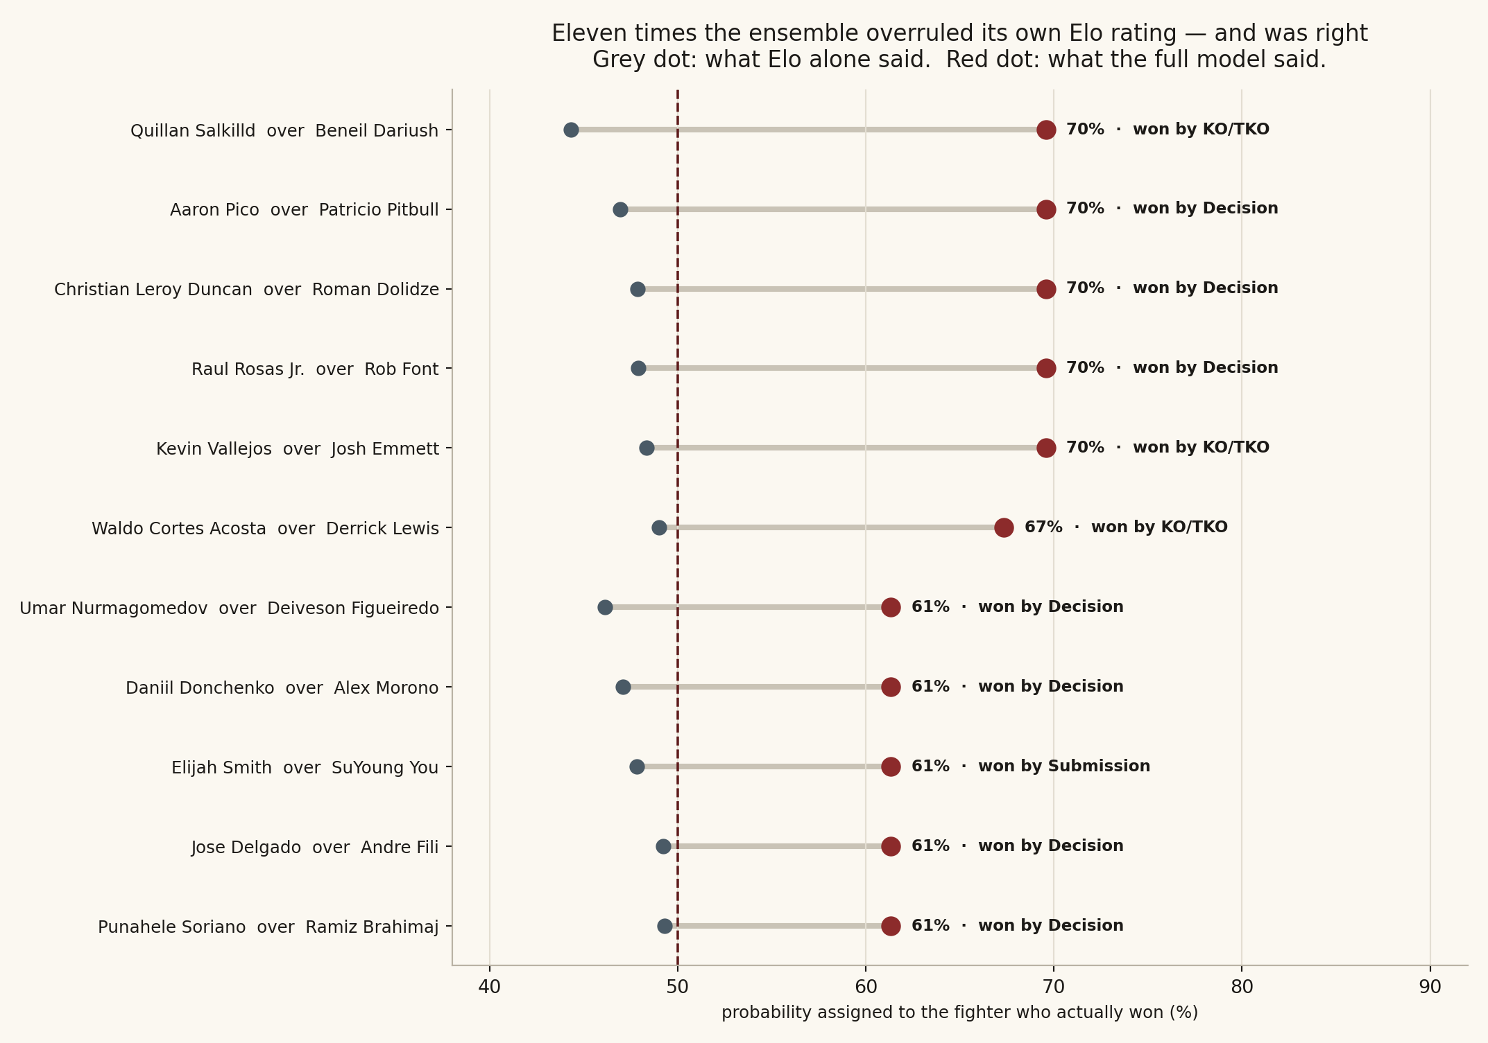
Figure 6. Eleven fights where the ensemble contradicted its own Elo rating and the fighter it backed won.
Elo is a strength-of-schedule measure and nothing more. It cannot see that a fighter is thirty-eight, or coming off a long layoff, or stylistically wrong for the man in front of him. The other three streams can, and these eleven are where they paid for themselves.

Vallejos vs Emmett
UFC Fight Night main event, 14 March 2026. Josh Emmett, long-established; Kevin Vallejos, sixteen years younger and thirty-eight career rounds lighter.
Elo made Emmett the marginal favourite at 52 per cent. The ensemble put Vallejos at 69.6, and the drivers it reported were the age gap, a shorter layoff, and a positive net striking differential. Then the method head split that 69.6 with knockout on top at 26.8 per cent, ahead of the decision branch.
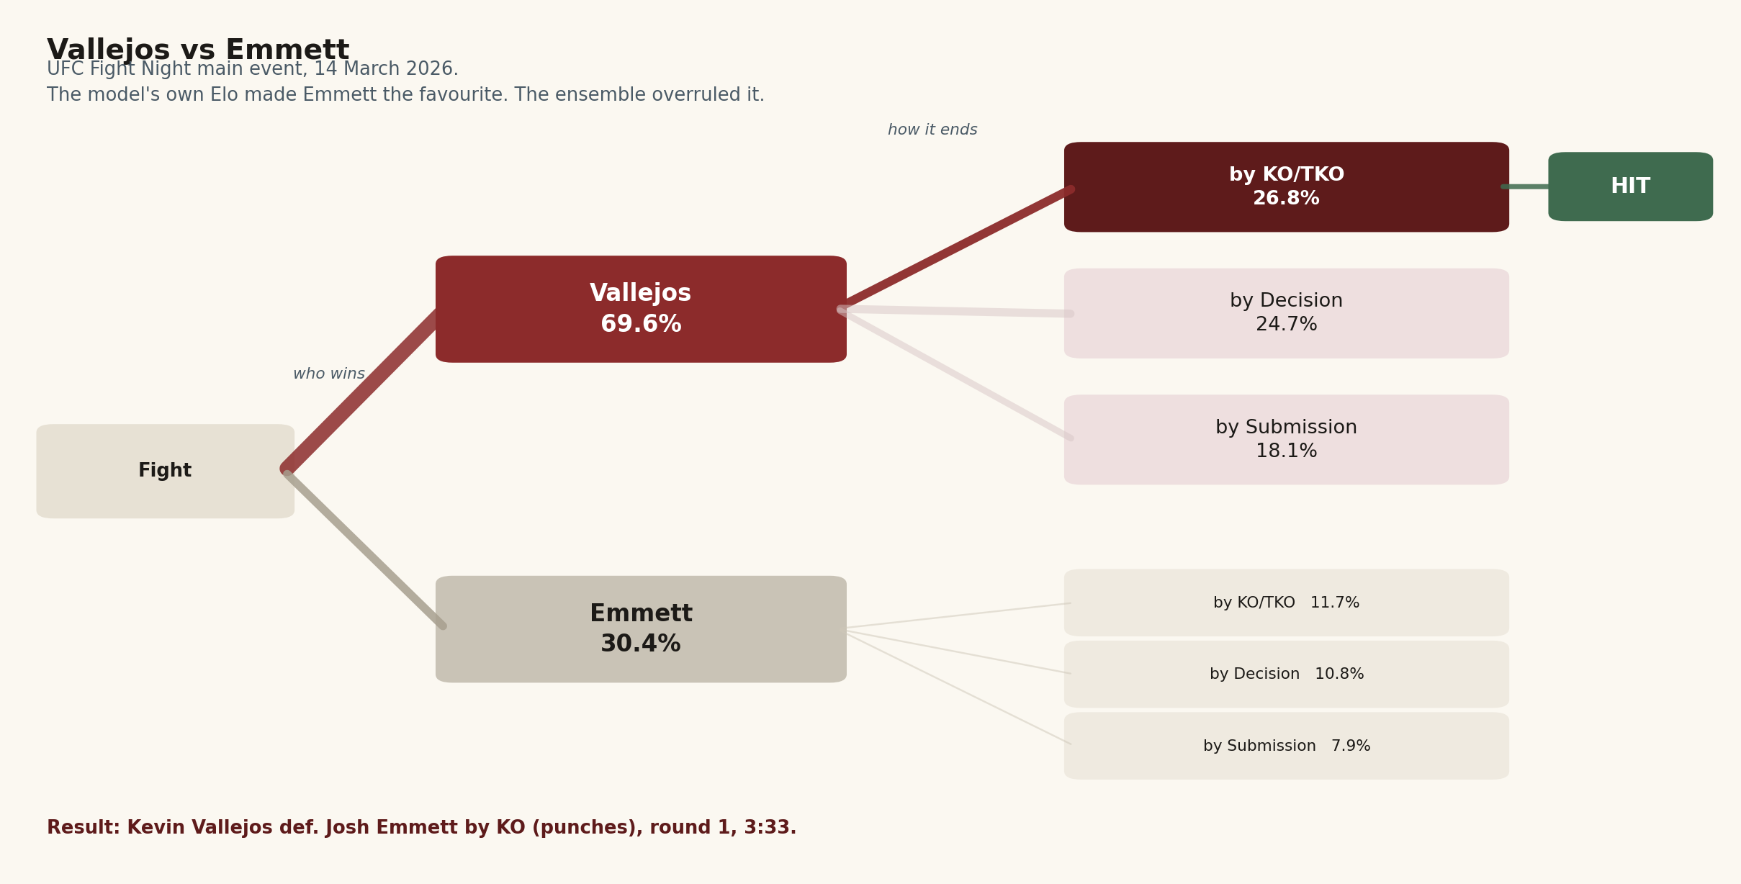
Figure 7. Vallejos vs Emmett as the model priced it. The knockout branch outranked the decision branch, which is unusual in a five-round fight.
Vallejos knocked Emmett out with punches at 3:33 of round one.

Prochazka vs Ulberg
UFC 327 main event, 11 April 2026, and the strongest method call the model produced all year: Ulberg at 67.4 per cent to win, and 53.7 per cent to do it by knockout. No other fight in 2026 drew that much method conviction.
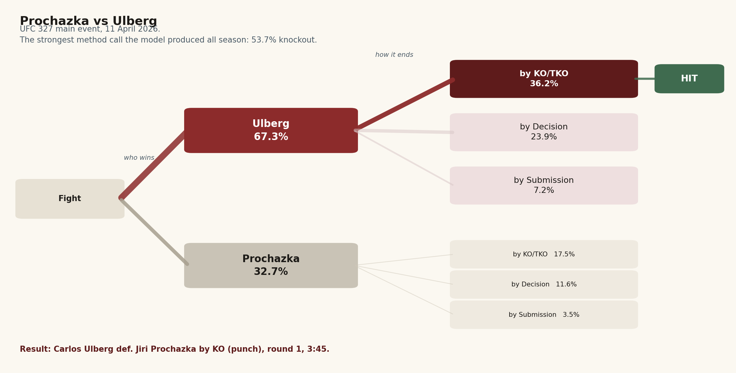
Figure 8. Prochazka vs Ulberg. The model's highest single method probability of the season.
Ulberg knocked Prochazka out with a punch at 3:45 of the first round. Two five-round main events, four weeks apart, where the model had both the fighter and the shape.
One caveat, applied honestly: chapter six shows the method head has no measurable edge across the season as a whole. These two calls were right, and they were right in the way the model intended, but they sit inside a distribution that does not beat a simple rule. Two good calls are two good calls.

Discoveries
A full blind season tells you things a good season does not. Three findings, in order of how much they change the picture.

The method head did not work this season
This is the most important result in the report and it is a negative one.
Stage one of the method classifier asks whether a fight reaches the judges. Across the 175 fights of 2026 its AUC was 0.416, with a bootstrap interval running from 0.330 to 0.501. An AUC of 0.5 means no information. Below 0.5 means the ranking is inverted: the fights the model flagged hardest as decisions were disproportionately the ones that got finished. Ninety-seven per cent of bootstrap samples came in below chance, so this is not a rounding artefact.
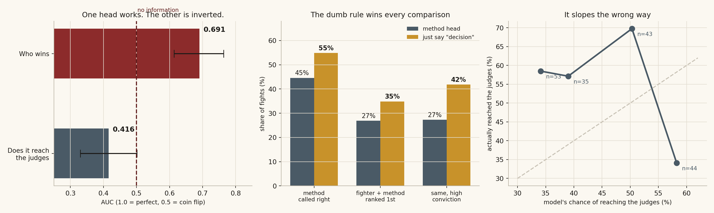
Figure 9. Left: the two heads compared, with 95 per cent intervals. Centre: the model against a rule that always guesses "decision". Right: predicted against observed distance rates.
Comparison | Method head | Always say "decision"
Method called correctly | 44.6% | 54.9%
Fighter and method ranked first, all fights | 26.9% | 34.9%
Fighter and method ranked first, high-conviction calls | 27.3% | 41.8%
A rule with no model in it at all beats the method head on every comparison. Taking the model's favourite and assuming a decision every single time would have ranked the correct outcome first on 35 per cent of fights against the model's 27, and on high-conviction fights the gap widens to fourteen points.
The winner head earns its place. The method head, on this season, is subtracting value rather than adding it.
Two qualifications are due. Stage two, which asks whether a finish is a knockout or a submission, scored 0.580 across the 79 finished fights, which is modestly above chance. The problem is concentrated in stage one. And the model's average distance estimate was 45.1 per cent against an actual 54.9, so part of the failure is a level error: it was trained across the whole history of the sport and still carries a finishing rate from an era that has passed. But a level error would show up as poor calibration with intact ranking. An AUC of 0.416 is a ranking failure, which is worse.

Fights that go the distance are the most predictable thing in the sport
Ninety-six of the 175 fights reached the judges, and this is where the winner head does its best work: 63.5 per cent accuracy on fights that went to a decision. It is also where the base rate is most useful, since more than half of all modern UFC fights end this way.
Distance is legible because it is the absence of an event rather than an event. Two fighters with sound defence, similar pace and no obvious finishing route produce fifteen minutes of scoring, and every one of those conditions is visible in career data. A knockout depends on one shot landing in one instant, and nothing in career data predicts an instant.
The sport has been drifting this way for fifteen years. The decision rate has climbed from about 48 per cent in the early 2010s to 54.9 in 2026, with average fight time up from 10.8 minutes to 11.4.

Surprise submissions came out of nowhere
The model carries the most elaborate feature in its whole set for this: position distributions estimated from style, base choke probabilities by position, chain weighting, round fatigue, and a takedown gateway, all described in chapter three. Across 2015 to 2025 it worked. Bottom quartile of danger, 11.6 per cent of fights ended in a submission; top quartile, 22.6 per cent. Close to a doubling.
In 2026 the relationship inverted.
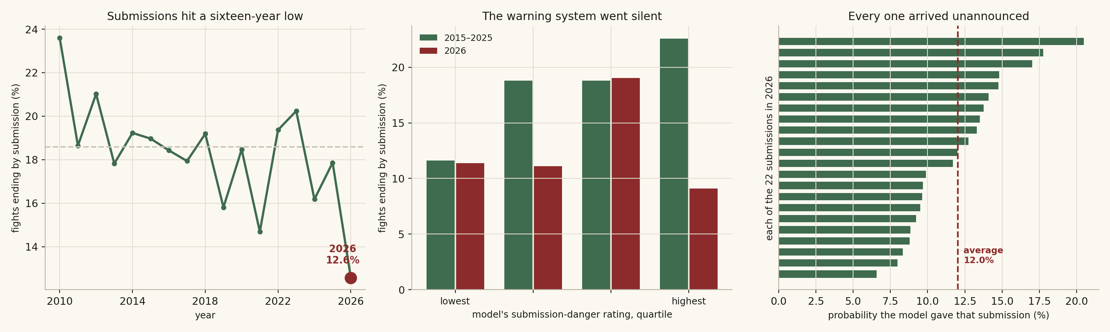
Figure 10. Left: submission rate across sixteen years. Centre: the danger rating against actual submissions, historical against 2026. Right: what the model gave each of the season's twenty-two submissions.
Submission-danger quartile | 2015–2025 | 2026
Lowest | 11.6% | 11.4%
Second | 18.8% | 11.1%
Third | 18.8% | 19.0%
Highest | 22.6% | 9.1%
The fights it flagged hardest produced the fewest submissions. Across the season, bouts that actually ended in a submission sat at the 49.6th percentile of danger. The median. None of the twenty-two was the model's first-ranked outcome and only one made its top two.
This connects directly to the method-head failure above, and it is probably the same problem seen from a different angle. Submissions in 2026 ran at 12.6 per cent of all fights, the lowest in sixteen years of data and well below the 18.6 per cent average of the preceding years. They got rarer, and the ones that landed came from fighters the style data did not mark. Whichever way that resolves, the archetype-to-position mapping the feature depends on has stopped describing how the ground game currently works.

How styles make fights
The archetype system's real job is not classifying fighters. It is predicting what happens when two particular kinds of fighter are locked in together. The pairing generates the outcome, not the fighter.
The clearest effect is on whether a fight gets finished. Splitting every bout since 2015 on whether a given style is strongly present:
Style present in the matchup | Fights reaching the judges | When that style is absent | Shift
Points fighter | 52.1% | 45.7% | +6.4 pts
Pressure striker | 51.9% | 49.1% | +2.8 pts
Muay Thai volume striker | 47.1% | 51.4% | −4.3 pts
Power puncher | 48.4% | 51.5% | −3.1 pts
Grappling-first | 48.8% | 50.7% | −1.9 pts
Counter striker | 49.4% | 50.9% | −1.5 pts
Two readings there are worth pausing on. The Muay Thai striker, who wins by accumulated volume and body work rather than single shots, shortens fights more reliably than the power puncher does. Volume beats power as a finishing mechanism. And the pressure striker slightly lengthens fights despite the reputation: forward pressure produces damage, but it also produces clinches, fence time and rounds that get scored rather than stopped.
The model encodes these interactions explicitly rather than hoping they emerge. Knockout danger runs against the specific opponent's chin durability. Submission threat runs against their takedown defence. A counter striker's value is computed directionally, against the other fighter's pressure, because a counter puncher with nobody coming forward has nothing to counter. Roughly a fifth of the feature set exists for this.
The Vallejos call is that reasoning in miniature. Emmett's chin durability had eroded across a long career; Vallejos scores high on power puncher and pressure striker; the age curve gap was sixteen years. Three separate feature families pointed at the same branch, which is why a knockout outranked a decision in a five-round main event. Given chapter six, the fair way to read that is as one good call from a component that did not work reliably across the season, rather than as evidence the component works.

How MMA is changing, and what the model says about the next card
Three shifts show up consistently across sixteen years of data, and all three point the same way: the sport is getting harder to finish and harder to specialise in.
Fights are lasting longer. The decision rate has climbed roughly seven points since the early 2010s and average fight time is up more than half a minute. Defensive standards have risen faster than offensive ones.
Submissions are disappearing. Down to 12.6 per cent in 2026, the lowest in the data, and the ones that land no longer come from the fighters style data marks as grapplers. Grappling-first prevalence is simultaneously at a fifteen-year low.
The points fighter is winning the evolutionary argument. Its prevalence has risen almost without interruption for fifteen years, from 0.50 to 0.59, and the rising decision rate is that trend expressed in results.
There is a modelling consequence to all of this, and chapter six is it. A method classifier trained across the whole history of the sport is fitting a distribution of finishes that is actively moving. The winner head is insulated from this because who wins is a more stable question than how. The method head is not.
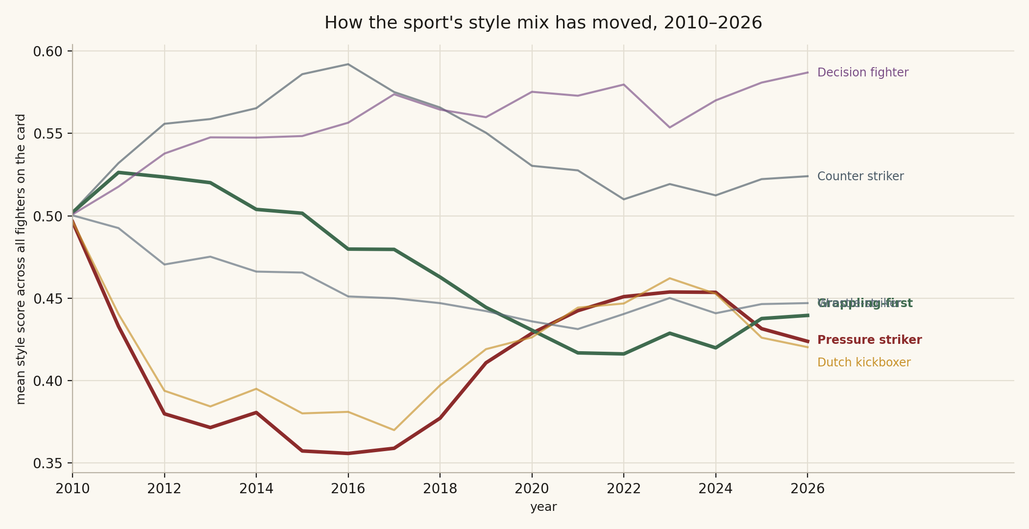
Figure 11. Mean archetype scores across all fighters competing each year, 2010 to 2026.

UFC Fight Night: Gamrot vs. Salkilld — Saturday 8 August 2026
Two things to note before the numbers. The fighter database ends on 2 May 2026, so anything from the last three months is invisible. And four of the twelve bouts pair a fighter with no UFC record at all, where the model declines to predict rather than guessing.
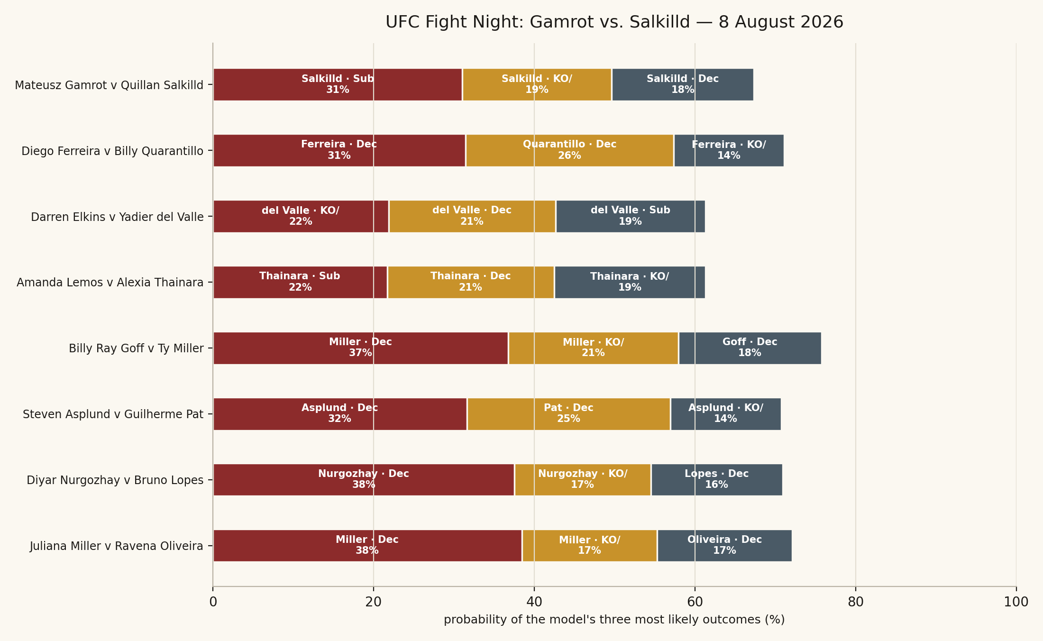
Figure 12. The three most likely outcomes for each predictable bout on the 8 August card.

Main card
Bout | Division | Model backs | Most likely outcome | Second
Mateusz Gamrot v Quillan Salkilld | Lightweight | Quillan Salkilld 67.3% | Quillan Salkilld by submission — 31.1% | Quillan Salkilld by KO/TKO — 18.6%
Diego Ferreira v Billy Quarantillo | Lightweight | Diego Ferreira 54.8% | Diego Ferreira by decision — 31.4% | Billy Quarantillo by decision — 25.9%
Darren Elkins v Yadier del Valle | Featherweight | Yadier del Valle 61.3% | Yadier del Valle by KO/TKO — 21.9% | Yadier del Valle by decision — 20.8%
Amanda Lemos v Alexia Thainara | Women's Strawweight | Alexia Thainara 61.3% | Alexia Thainara by submission — 21.7% | Alexia Thainara by decision — 20.8%
Billy Ray Goff v Ty Miller | Welterweight | Ty Miller 67.3% | Ty Miller by decision — 36.7% | Ty Miller by KO/TKO — 21.2%

Preliminary card
Bout | Division | Model backs | Most likely outcome | Second
Steven Asplund v Guilherme Pat | Heavyweight | Steven Asplund 55.5% | Steven Asplund by decision — 31.6% | Guilherme Pat by decision — 25.3%
Diyar Nurgozhay v Bruno Lopes | Light Heavyweight | Diyar Nurgozhay 69.6% | Diyar Nurgozhay by decision — 37.5% | Diyar Nurgozhay by KO/TKO — 17%
Louie Sutherland v Jose Montanha da Silva | Heavyweight | No prediction — opponent has no UFC record
Manoel Sousa v Richie Miranda | Lightweight | No prediction — opponent has no UFC record
Miles Johns v Jessie Rosas | Bantamweight | No prediction — opponent has no UFC record
Juliana Miller v Ravena Oliveira | Women's Flyweight | Juliana Miller 69.6% | Juliana Miller by decision — 38.4% | Juliana Miller by KO/TKO — 16.8%
Gigi Canuto v Carol Foro | Women's Strawweight | No prediction — opponent has no UFC record

Reading the card
Only three bouts clear the 65 per cent bar, and on this report's evidence they are the only ones worth anything: Salkilld at 67.3 per cent over Gamrot in the main event, and Nurgozhay and Juliana Miller both at 69.6. Everything else on the card is inside the range where the model is close to a coin.
The main event is the boldest of the three. Backing Quillan Salkilld over Mateusz Gamrot is a strong statement about a fighter with four UFC bouts against an established contender, and it is worth noting the model has already gone out on this limb twice in 2026 and was right both times: Salkilld submitted Jamie Mullarkey in January and knocked out Beneil Dariush in May.
The method columns should be read as decoration rather than information. Chapter six is unambiguous about that, and the two submission-first estimates on this card, Salkilld and Thainara, are exactly the kind of call the head got wrong all season. If you want a method prior for this card, the base rate is the better one: expect a little over half of these to reach the judges.
The model also flags unusual uncertainty here. Every fight it could price triggered a stream-disagreement warning, with the four models spreading between eleven and thirty-three percentage points, which reflects a card built largely from fighters with short UFC histories.

A closing note on what these numbers are
These are calibrated probability estimates from a model with documented limits, running on data that stops three months before the card it is predicting. Not betting advice, not a forecast of any individual result. The winner head is good and measured; the method head did not work this season and is reported as such; the round is a base rate wearing a prediction's clothes. About a third of the calls will miss. The value is in the number attached to each one.

Appendix: the complete feature list
All 102 features in the deployed model, in the order the bundle stores them. Suffix _diff means fighter A minus fighter B, so a positive value favours A. Suffix _a or _b means the value belongs to that fighter alone. All rate statistics are decayed with a 365-day half-life and computed using only fights that took place strictly before the bout being predicted.

Elo and strength
Feature | What it measures
elo_diff | MMA Elo rating, A minus B, evaluated before the fight
elo_prob_a | Elo-implied win probability for A: logistic of elo_diff / 400
a_elo_pre | A’s raw pre-fight Elo rating
b_elo_pre | B’s raw pre-fight Elo rating

Striking
Feature | What it measures
slpm_diff | Significant strikes landed per minute
sapm_diff | Significant strikes absorbed per minute (lower is better)
strike_net_diff | Net striking: landed minus absorbed
strike_acc_diff | Significant strike accuracy, landed over attempted
strike_def_diff | Striking defence: one minus opponent accuracy

Grappling
Feature | What it measures
td_per15_diff | Takedowns landed per fifteen minutes
td_def_per15_diff | Takedowns conceded per fifteen minutes
td_acc_diff | Takedown accuracy rate
td_def_acc_diff | Takedown defence rate
sub_att_per15_diff | Submission attempts per fifteen minutes
control_pct_diff | Share of fight time spent in a control position

Knockdowns
Feature | What it measures
kd_per15_diff | Knockdowns landed per fifteen minutes
kd_absorbed_per15_diff | Knockdowns absorbed per fifteen minutes (chin proxy)

Physical, form and experience
Feature | What it measures
age_diff | Age in years at the fight date
reach_diff | Reach in inches
stance_mismatch | One if the two stances differ, else zero
win_pct_diff | Recent win percentage
finish_rate_diff | Career finishes as a share of wins
rounds_exp_diff | Total career rounds fought (championship-round experience)
streak_diff | Current win streak, capped at five
days_inactive_diff | Days since the last bout
n_fights_a | A’s UFC fight count (data-density context)
n_fights_b | B’s UFC fight count

Style archetypes
Feature | What it measures
arch_a_power_puncher / arch_b_power_puncher | Explosive knockout threat, lower volume
arch_a_muay_thai / arch_b_muay_thai | High volume, high finish rate, moderate takedowns
arch_a_dutch_kickboxer / arch_b_dutch_kickboxer | Very high strikes landed and absorbed; wins by accumulation
arch_a_counter_striker / arch_b_counter_striker | Reactive, timing-based, efficient
arch_a_wrestle_striker / arch_b_wrestle_striker | High takedowns, moderate volume, low submission threat
arch_a_grappling_first / arch_b_grappling_first | Takedown-oriented with a submission chain
arch_a_pressure_striker / arch_b_pressure_striker | Forward pressure, high output
arch_a_decision_fighter / arch_b_decision_fighter | Points-based, distance management
arch_distance | Distance between the two archetype vectors
arch_similarity | Overlap between the two archetype vectors

Striker against grappler
Feature | What it measures
grappler_path_a / grappler_path_b | How much each fighter wins through grappling, discounted by opponent takedown defence
striker_path_a / striker_path_b | How much each fighter wins standing, given their ability to keep it there
sg_mismatch_net | Net striker-versus-grappler mismatch across the pairing
td_dominance_diff | Takedown-dominance differential

Knockout threat and chin
Feature | What it measures
ko_danger_a / ko_danger_b | Knockout threat: 0.50 knockout-per-round rate, 0.30 knockdown bonus, 0.20 finish rate
chin_durability_a / chin_durability_b | Resistance to being finished, with an accumulated-trauma penalty
ko_threat_net | Net knockout threat across the pairing
ko_danger_differential | Knockout danger, A minus B
b_chin_vulnerable | Flag: B’s chin reads as a live vulnerability

Submission chain
Feature | What it measures
sub_danger_a / sub_danger_b | Position-weighted submission threat, gated by opponent takedown defence
sub_danger_diff | Submission threat, A minus B
sub_danger_combined | Combined ground-finishing threat; also a soft prior in the method head
sub_att_rate_diff | Submission-attempt-rate differential

Pace, pressure and counters
Feature | What it measures
pace_mismatch_diff | Tempo gap between the two fighters
pressure_index_a / pressure_index_b | Forward-pressure index, pressure archetype weighted 1.4
counter_efficiency_diff | Counter-striking efficiency: finish rate relative to volume
counter_threat_a_vs_b | A’s counter threat given B’s pressure
counter_threat_b_vs_a | B’s counter threat given A’s pressure
gas_out_risk_diff | Cardio fade risk: strikes absorbed over strikes landed
b_counter_upset_setup | Flag: B is set up as a counter-based upset threat

Stance geometry
Feature | What it measures
stance_advantage_a | Plus one if A is the southpaw in an open-stance fight, minus one if B is
stance_score_amplified | Stance advantage weighted by archetype multipliers and division southpaw rarity
stance_win_prob_uplift | Estimated win-probability uplift: 0.065 per unit of amplified score
open_stance | One if orthodox meets southpaw, else zero

Trajectory, age and rust
Feature | What it measures
trajectory_diff | Ascending-trajectory score, 200-day half-life, opponent-quality adjusted
elo_form_divergence_a / elo_form_divergence_b | Gap between recent form and standing Elo rating
age_curve_a / age_curve_b | Position on the division-specific ageing curve
age_curve_diff | Age-curve position, A minus B
prime_mismatch | Flag: the two fighters sit at different points of their primes
rust_a / rust_b | Layoff penalty per fighter
rust_diff | Layoff penalty, A minus B
favourite_rusty | Flag: the favourite is the one coming off the long layoff
fr1_danger_diff | First-round danger differential
a_upset_risk_score | Composite upset-risk score for A

Learned style clusters
Feature | What it measures
cluster_a_0 … cluster_a_6 | A’s soft membership across seven Gaussian-mixture clusters, summing to one
cluster_b_0 … cluster_b_6 | B’s soft membership across the same seven clusters

One further feature exists in the codebase but is switched off in the deployed model: implied_prob_a, the vig-removed closing-line probability. Every number in this report comes from the no-odds model. Adding the market as an input is the single largest available gain in discrimination, and also the point at which the model stops being independent of the betting line.

