ELECTRONIC ASSIGNMENT COVERSHEET | 

Student Number | 35908163
Surname | Pilakkal
Given name | Safana Jasin
Email | Sj50025010@gmail.com
Unit Code | ICT206
Unit name | ICT206 Intelligent Systems
Enrolment mode | Offline
Date | 26.03.2026
Assignment number | 2
Assignment name | Project
Tutor | Mr. Nahil Abed Abdallah

Student’s Declaration:

- Except where indicated, the work I am submitting in this assignment is my own work and has not been submitted for assessment in another unit.
- This submission complies with Murdoch University's academic integrity commitments. I am aware that information about plagiarism and associated penalties can be found at http://www.murdoch.edu.au/teach/plagiarism/. If I have any doubts or queries about this, I am further aware that I can contact my Unit Coordinator prior to submitting the assignment.
- I acknowledge that the assessor of this assignment may, for the purpose of assessing this assignment:
  - reproduce this assignment and provide a copy to another academic staff member; and/or
  - submit a copy of this assignment to a plagiarism-checking service. This web-based service may retain a copy of this work for the sole purpose of subsequent plagiarism checking, but has a legal agreement with the University that it will not share or reproduce it in any form.
- I have retained a copy of this assignment.

I am aware that I am making this declaration by submitting this document electronically and by using my Murdoch ID and password it is deemed equivalent to executing this declaration with my written signature.

SAFANA JASIN
Signed

(Write your name in the space above)

A Rule-Based Decision Support System for Quotation Pricing in Advertising Services (Django-Based)

INTRODUCTION

Quotation pricing in advertising services is not simple. It depends on many factors such as job size, materials, urgency, installation needs, and customer type. In real situations, quotations are usually prepared by salespersons based on their own judgement, and experience. This can lead to difference in pricing wrong understanding of job complexity, and higher business risk, especially for urgent and high value jobs.

This project focuses on building a rule-based decision support system to help with quotation evaluation in an advertising company. The system is designed mainly for internal use within the company. A salesperson enters the job details and the system generates recommendations that are visible to both salesperson and the admin. These recommendations help guide the process, while the final decision is made by the admin.

In addition, a simple public website is also included. This allows customers to view services and submit enquiries. These enquiries are then handled internally by the admin and assigned to a salesperson for further processing.

The system takes the following inputs:
- Service Type
- Material Category
- Quantity
- Job Size
- Urgency
- Installation Requirement
- Customer Category

Based on these inputs, the system produces:
- pricing tier (Basic / Standard / Premium)
- recommended profit margin range
- review requirement level (Normal / High / Admin Review Required)
- explanation of the recommendation
- Total Score

For e.g., a large and urgent signage job with installation and premium materials would give a high score This would lead to a Premium pricing tier and a higher level of review requirement.

The main goal of the system is to improve consistency and reliability in quotation evaluation. This is measured by how well the system outputs match the expected rule-based results. In this project, a target of at least 85% accuracy is considered acceptable.

The system is also expected to correctly identify risky or uncertain cases and assign stricter review levels when needed.

By giving structured recommendations along with clear explanations, the system helps support decision making while allowing the admin to have full control over the final approval.

BACKGROUND

Expert system and knowledge-based decision support systems are widely used to support business decision making, especially in situations where human judgement is needed but consistency is hard to maintain. Research shows that validating expert systems is important to make sure the results are reliable and consistent [1]. This is important in areas like quotation evaluation, where wrong decision can increase financial risk.

Knowledge acquisition is one of the main challenges in building expert systems. Studies show that system performance depends on how well expert knowledge and decision rules are captured and organised [2]. In quotation pricing, this means turning practical judgement, such as urgency, job complexity and customer importance into clear rules. However, this process can take time and need regular updates when business conditions change.

Rule based systems are also commonly used in business environments. Research shows that they can improve consistency and reduce repetitive work, while also making decisions easier to understand through clear rules [3]. This is useful in business setting where decisions need to be explained. However, these systems are less flexible compared to learning based systems, since the rules have to be updated manually.

In pricing and cost estimation, other methods like case-based reasoning have been used. These methods compare new cases with past examples to generate results [4]. They can work well when there is large amount of data, but they depend heavily on data quality and may not always give clear explanations.

Some studies also show that decision support systems can improve efficiency and reduce human error in daily operations [5]. They help make sure that similar cases are handled in the same way, which is important for quotation evaluation.

Another important point is explainability. Research shows that users need to understand how decisions are made, especially in business systems [6]. This supports the use of rule-based systems, as they provide clear and transparent reasoning.

Overall previous research shows that rule-based expert systems are suitable for structured decision problems that need consistency, transparency and clear explanations. Based on this, the project uses a rule-based approach to support quotation evaluation while keeping the final decision under admin control.

AI METHOD AND TOOLS

This project uses a rule-based expert system approach to support quotation evaluation in an advertising company. This method was chosen because the problem involves structured decision-making based on clearly defined factors such as job size, urgency, material, installation, and customer category. Rule-based systems are suitable in such cases as they provide consistent, transparent, and explainable recommendations, which are important in business environments where decisions need to be justified [2].

KNOWLEDGE ACQUISITION

The knowledge used in the system was obtained from a combination of real quotation data and domain understanding of advertising services.

A set of 12 real quotations cases was analysed to identify patterns in pricing and approval decisions. From this, key variables affecting decision-making were identified. These include service type, material, quantity, job size, urgency, installation requirement, and customer category.

Based on these variables, a scoring-based rule model was developed. Each input was given a score to represent its impact on job complexity and cost. For e.g., larger jobs, urgent requests, installation needs, and premium materials contribute to higher scores.

The total score is then used to decide:
- Pricing tier (Basic/ Standard/ Premium)
- Margin Range
- Review Requirement Level (Normal/ High/ Admin Review Required)
Additional rules were added to handle special cases:
- Unknown inputs - Preliminary Recommendation
- High-risk conditions - High Admin Review Required.

This approach helps reflect decision behaviour while keeping the system consistent and structured.

RULE DESIGN AND IMPLEMENTAION

The system logic is implemented using a combination of if-then rules and a scoring mechanism. These rules link input conditions to outputs in a clear and easy-to-understand way.

For e.g.,
IF job size is large and urgency is high and installation is required, THEN increase the total score and assign a higher review requirement level.

These rules work together with the scoring system, so more complex or risky jobs lead to stricter evaluation results.

The system was developed using the Django web framework in Python, with a modular design that separates input handling, rule processing, and output generation. The rule engine calculates a total score based on user inputs and applies predefined thresholds to generate recommendations. Each output includes a short explanation to show how the result was generated.

A simplified representation of the rule logic is provided in Appendix A for reference.

TOOLS USED

- Python (Django Framework): backend logic and system implementation
- SQLite DB: storage of enquiries, quotations, customers, users, system recommendations, admin decisions, materials, and service types.
- HTML, CSS, Bootstrap: UI design
- Django Models and Forms: structured input and validation

These tools support fast development, clear structure, and easy integration of rule-based logic into a web system.

JUSTIFICATION OF APPROACH

Compared to other methods such as machine learning or case-based reasoning, the rules-based approach was chosen because it does not require large amount of data and provides clear and explainable outputs. This is important in quotation evaluation, where decisions need to be transparent and easy to justify.

The system is designed as a decision support tool, not a fully automated system. Quotation pricing involves financial and business considerations, so full automation may not be suitable. The system provides recommendations to guide decision-making, while the final approval remains with the admin. This ensures that human judgement is still part of important decisions.

EVALUATION METHOD

The system was evaluated using a set of realistic quotation cases base don advertising service scenarios. A total of 12 cases were selected to represent different job conditions. These included variations in job size, quantity, urgency, installation requirements, and customer category.

To make the evaluation more complete, additional edge cases were included. These involved “Unknown” material and service type inputs and “VIP” customer situations. These cases were not taken from the original quotations but were added on purpose to test how the system behaves in uncertain and strategic conditions.

Due to the lack of access to the industry professionals and the need for ethical approval for the human data collection, the evaluation used expected results based on domain knowledge and common industry practice.

The system was assessed using the following measures:

RULE CORRECTNESS
The system outputs were checked to ensure that the pricing tier and recommendations followed the defined scoring rules. Higher scores correctly resulted in Premium recommendations, while lower scores produced Basic or Standard tiers as expected.
The review requirement levels (Normal, High, and Admin Review Required) were also verified. It was observed that more complex or risky jobs consistently resulted in stricter review levels before final approval. This shows that the system rules are working correctly and are aligned with the intended decision logic.
CONSISTENCY OF OUTPUT
The same inputs were tested multiple times. The system produced identical results each time. This shows that the rule-based system is stable and does not produce random outputs.

RISK DETECTION
Certain cases were designed to represent higher risk situations, such as urgent jobs, large projects or job requiring installation. These cases were expected to require a higher level of review.

The results show that such cases were correctly flagged with outcomes like “High Review Required” or “Admin Review Required”. This indicates that the system is able to recognise complex or risky situations and ensure that they are reviewed more carefully before a final administrative decision (Approve/ Reject) is made.

HANDLING SPECIAL CASES (UNKNOWN/VIP)
Cases with “Unknown” material or service type were expected to trigger a Preliminary Recommendation. This ensures that such cases are flagged for strong admin review.

VIP cases were expected to result in higher scores and stronger recommendations, reflecting their higher business importance. This reflects real business practice, where important customers may be treated differently.

COMPLETENESS AND RELEVANCE
Each output was checked to ensure that all required parts were included. These include pricing tier, margin range, approval decision, and explanation. The explanation was also reviewed to confirm that it matches the input conditions.

All results were recorded in table, comparing expected outcomes with system generated outputs for each test case.

PRACTICAL LIMITATIONS

The evaluation didn’t involve real users or industry experts due to time constraints and the need for ethical approval when collecting human data.

As a result, the expected outcomes are based on assumed expert judgement rather than actual professional validation.

In real-world situations, pricing decision can vary depending on business strategy, market conditions, and individual experience. Therefore, the evaluation focused on whether the system produces reasonable and logical decisions rather than exact pricing values.

PROPOSED IMPROVED EVALUATION

If more resources were available, the evaluation could be improved by involving industry professionals. A group of 3 to 5 experts such as advertising sales manager or pricing specialist, could review the same test cases.

Each expert would provide their own pricing tier and approval decision. The system output could then be compared with the majority opinion of the experts. Additional measures, such as agreement between experts and user feedback, could also be used to assess the system.

This approach would provide more realistic benchmark and improve the reliability of the evaluation.

RESULTS

The system was evaluated using 14 test cases, consisting of 12 real quotation scenarios and 2 additional edge cases (Unknown input and VIP customer). The results show that the system produced outputs that were consistent with the defined rule-based logic across most cases.

A summary of the results is presented in the Table 1:

TABLE 1: SUMMARY OF SYSTEM RESULTS

CATEGORY | NO. OF CASES | SYSTEM BEHAVIOUR
High Complexity Jobs | 10 | Premium tier with High Review Required.
Medium Complexity Jobs | 2 | Standard tier with Normal Review Required.
Unknown Inputs Case | 1 | Preliminary Recommendation with Admin Review Required
VIP Customer Case | 1 | Higher score with Premium Recommendation

The VIP case is included within the Premium category, as it results in a high overall score and strong recommendation. However, it is highlighted separately to demonstrate business sensitivity, where important customers may influence decision outcomes.

ACCURACY OF RESULTS

Out of the 14 test cases, 13 test cases produced outputs that matched the expected rule-based outcomes, while 1 case showed minor variation due to inputs assumptions.

Accuracy = $\frac{13}{14}$ x 100
= 92.8 %

This indicates a high level of accuracy in classification and recommendation.

GRAPHICAL REPRESENTATION

Figure 1 shows the distribution of system recommendations across all test cases.

The graph shows that the majority of the cases resulted in Premium Recommendations, reflecting the higher complexity of the selected dataset.

KEY OBSERVATIONS

- CORRECT CLASSIFICATION:
High score jobs consistently resulted in Premium Recommendations, while moderate jobs produced Standard tiers.

- REVIEW REQUIREMENT BEHAVIOUR:
More complex or risky cases were correctly assigned High Admin Review Required, confirming effective risk detection.

- HANDLING OF UNCERTAINTY:
The unknown input case correctly triggered a Preliminary Recommendation, ensuring cautious decision making.

- BUSINESS SENSITIVITY:
The VIP case showed increased scoring and stronger recommendations, reflecting real-world business considerations.

ADDITIONAL DATA

Detailed comparisons between expected outcomes and system outputs for all test cases are provided in Appendix B.

Sample system outputs are provided in Appendix C.

OVERALL RESULT

Overall, the results show that the system performs well across different scenarios and can support consistent decision making in quotation evaluation. The high accuracy, stable rule behaviour, and correct handling of special cases show that the rule-based approach is suitable and effective for this type of application. It is also noted that no test cases fell into the Basic category, as the selected dataset mainly consisted of medium to high complexity jobs.

The system successfully generated recommendations for all test cases without any errors. This indicates that the system demonstrates stable and reliable performance.

Conclusion

The results of the evaluation show that the system performs consistently and produces outputs that follow the defined rule-based logic. The recommendations for pricing tier, margin range, and review requirement levels matched the expected results across the test cases. This shows that the system is working as intended and that the scoring and rules are correctly implemented.

The main goal of the project was to improve consistency and reliability in quotation evaluation. Based on the results, this goal has been achieved. The system was able to produce stable and logical recommendations, while also correctly identifying higher-risk cases that require stricter review. The explanation provided with each output also improves transparency and supports better decision making.

The overall outcome of the system is as expected. The rule-based approach works well for handling structured inputs such as job size, urgency, and material type. The system performed especially well in identifying complex cases and assigning suitable review levels like “High Review Required” and “Admin Review Required”.

Several important points were learned during this project. One key point is that knowledge acquisition and rule design are very important in an expert system. Even small changes in scoring or thresholds can affect the final results. Another point is the need to balance automation and human control. In business situations, full automation may not always be suitable, especially for high-risk decisions.

There are also areas of the system that worked well. The modular design helped separate input handling, rule processing and output generation clearly. The system also produces consistent results and simple explanation of how the recommendation is generated, which makes it easier to understand and trust.

However, there are some limitations. The system depends on predefined rules and does not adapt automatically to changes in business conditions. Also, the evaluation was based on expected results rather than real expert validation, which may affect how accurate the assessment is.

In the future, the system could be improved by using feedback from industry professionals to refine the rules and scoring. It could also be enhanced by adding features such as learning from past quotations or using more dynamic pricing factors.

Overall, the project shows that a rule-based expert system can support quotation evaluation effectively by improving consistency, transparency, and decision quality, while still keeping final control with the admin.

ACKNOWLEDGEMENTS (IF NEEDED)

The author acknowledges the use of standard documentation and online resources related to Django and web development, which supported the implementation of this project.

The quotation data used in this project was based on real-world scenarios from Illumina Advertising L.LC. This helped in designing realistic rules and evaluation test cases.

REFERENCES
[1] D. E. O’Leary, “Validation of expert systems with applications to auditing and accounting expert systems,” Decision Sciences, vol. 18, no. 3, pp. 468–486, 1987.
[2] S. J. Russell and P. Norvig, Artificial Intelligence: A Modern Approach, 3rd ed. Pearson, 2010.
[3] G. Engin, B. Aksoyer, M. Avdagic, D. Bozanli, U. Hanay, D. Maden, and G. Ertek, “Rule-based expert systems for supporting university students,” Procedia Computer Science, vol. 31, pp. 22–31, 2014.
[4] K. Zima and A. Leśniak, “Cost estimation using case-based reasoning model based on macro BIM,” Preprints, 2018.
[5] E. Turban, R. Sharda, and D. Delen, Decision Support and Business Intelligence Systems, 9th ed. Pearson, 2011.
[6] F. Doshi-Velez and B. Kim, “Towards a rigorous science of interpretable machine learning,” arXiv:1702.08608, 2017.

APPENDIX (IF NEEDED)

APPENDIX A: RULE LOGIC REPRESENTATION

- SCORING LOGIC: quotes/services/rules/scoring_rules.py
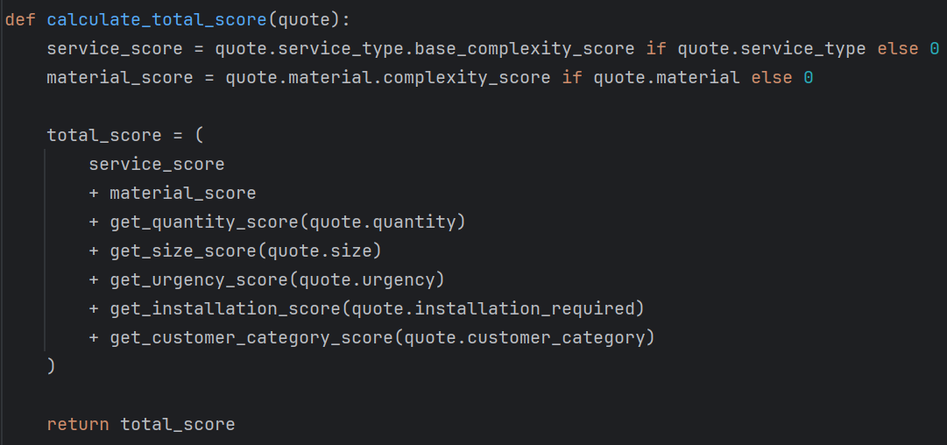
- SCORE DECISION MAPPING: quotes/services/rules/ recommendation_rules.py

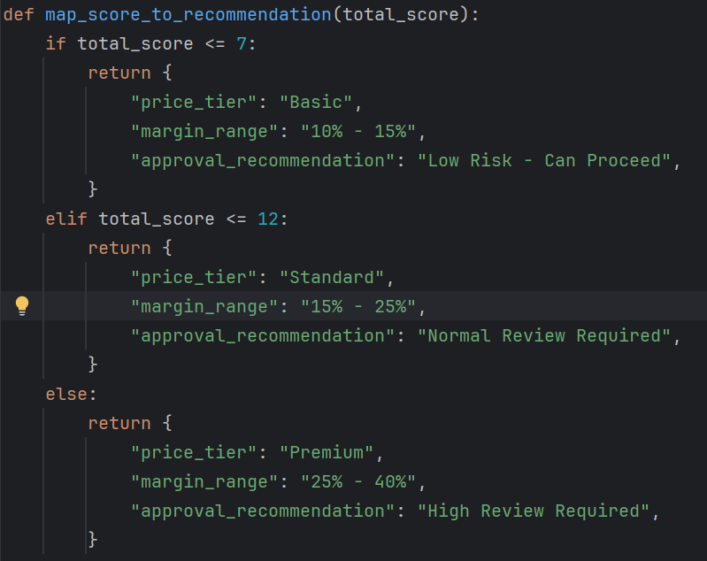

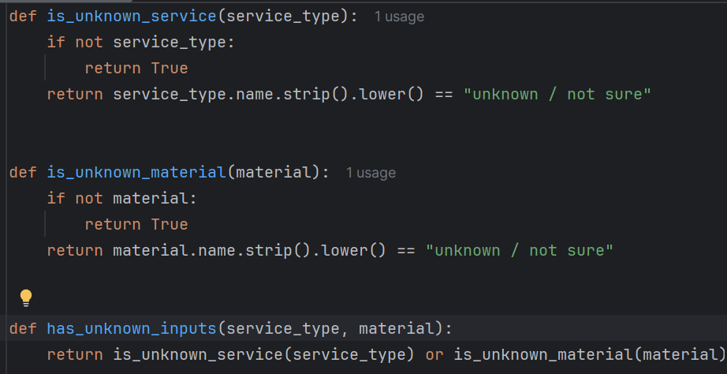
- UNKNOWN HANDLING: quotes/services/ classifiers/input_classifier.py

APPENDIX B: TEST CASE EVALUATION RESLUTS

This appendix presents the comparison between expected outcome and system-generated outputs for all test cases used in the evaluation.
The following test cases are based on real quotation scenarios, with simplified descriptions for clarity.
TABLE B1: TEST CASE INPUTS
TC | Client Type | Service Type | Material | Qty | Size | Urgency | Install | Job Description
1 | Retail Client | Maintenance / Repair | LED / Electronics | 1 | Small | Low | Yes | Display tab change and LED adjustment
2 | Electrical Services | Maintenance / Repair | LED / Electronics | 32 | Small | Low | No | Power cable supply
3 | Skincare Brand | Display Stand / Kiosk | Mixed / Composite | 2 | Small | Low | Yes | Acrylic panel + vinyl + LED stand
4 | Hardware Store | Signage | LED / Electronics | 4 | Medium | Medium | Yes | Pillar lightbox signage
5 | Retail Fixtures | Display Stand / Kiosk | Metal / Steel | 5 | Medium | Medium | No | Metal display stand fabrication
6 | Entertainment Venue | Display Stand / Kiosk | Wood / Joinery | 2 | Medium | Medium | Yes | MDF gondola stand with graphics
7 | Hardware Store | Signage | LED / Electronics | 6 | Large | Medium | Yes | Fabric lightbox signage
8 | Automotive Client | Vehicle Graphics | Vinyl | 1 | Large | Medium | Yes | Vehicle branding
9 | Marketing Agency | Digital Printing | Banner / Flex | 63 | Large | Medium | No | Bulk signage and flex printing
10 | Laundry Business | Interior Fit-Out | Mixed / Composite | 20 | Large | High | Yes | Interior work incl. racks, signage, painting
11 | Exhibition Team | Event / Exhibition | Mixed / Composite | 5 | Large | High | Yes | Event setup with stand, TV, platform
12 | Corporate Client | Display Stand / Kiosk | Mixed / Composite | 25 | Medium | Medium | No | Automotive display stand fabrication
13 | Unknown Client | Unknown / Not sure | Unknown / Not sure | 20 | Medium | Medium | Yes | Customer unsure
14 | VIP Client | Event / Exhibition | Mixed / Composite | 5 | Large | High | Yes | Same as TC11 but VIP

TABLE B2: EXPECTED VS ACTUAL SYSTEM RESULTS
TC | File / Case | Expected Tier | Actual Tier | Expected Review | Actual Review | Recommendation Type | Result
1 | q30.pdf | Premium | Premium | High Review Required | High Review Required | System | Match
2 | q25.pdf | Standard | Standard | Normal Review Required | Normal Review Required | System | Match
3 | q35.pdf | Premium | Premium | High Review Required | High Review Required | System | Match
4 | q32.pdf | Premium | Premium | High Review Required | High Review Required | System | Match
5 | q34.pdf | Premium | Premium | High Review Required | High Review Required | System | Match
6 | q36.pdf | Premium | Premium | High Review Required | High Review Required | System | Match
7 | q12.pdf | Premium | Premium | High Review Required | High Review Required | System | Match
8 | q24.pdf | Premium | Premium | High Review Required | High Review Required | System | Match
9 | q7.pdf | Premium | Premium | High Review Required | High Review Required | System | Match
10 | q17.pdf | Premium | Premium | High Review Required | High Review Required | System | Match
11 | q37.pdf | Premium | Premium | High Review Required | High Review Required | System | Match
12 | q28.pdf | Premium | Premium | High Review Required | High Review Required | System | Match
13 | Manual (Unknown) | Standard | Standard | Admin Review Required | Admin Review Required | Preliminary | Match
14 | VIP Test | Premium | Premium | High Review Required | High Review Required | System | Match

APPENDIX C: SYSTEM OUTPUT SCREENSHOTS

This appendix presents selected screenshots of system generated outputs for representative test cases. The screenshots show how the system produces pricing tiers, margin ranges, review requirement levels, and explanations based on how the system generates recommendations.

FIGURE C1: STANDARD CASE – SYSTEM RECOMMENDATION OUTPUT
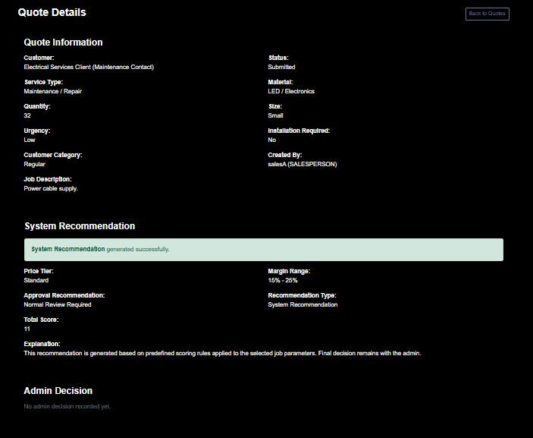

FIGURE C2: PREMIUM CASE - SYSTEM RECOMMENDATION OUTPUT
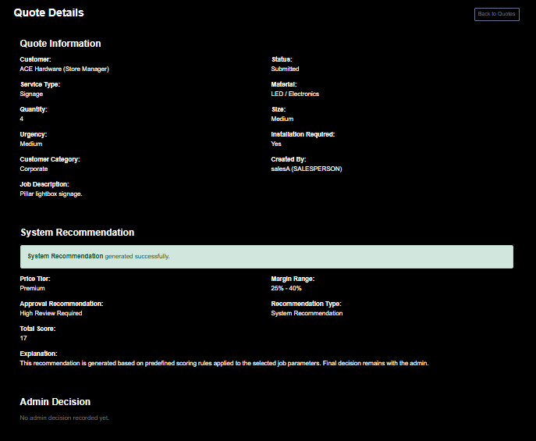

FIGURE C3: PREMIUM CASE (DIFFERENT SCENARIO) - SYSTEM RECOMMENDATION OUTPUT

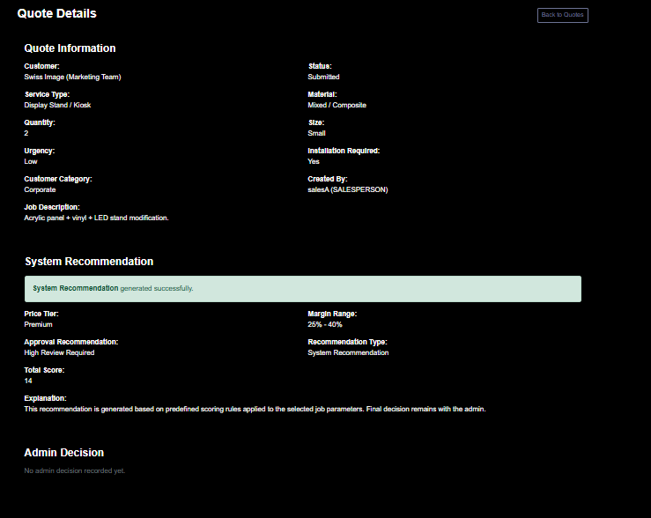

FIGURE C4: HIGH COMPLEXITY CASE – SYSTEM RECOMMENDATION OUTPUT
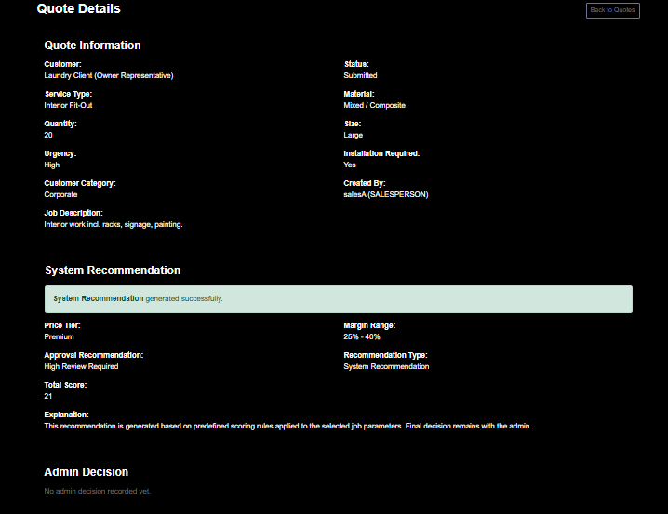

FIGURE C5: UNKNOWN INPUT CASE - Preliminary Recommendation Output

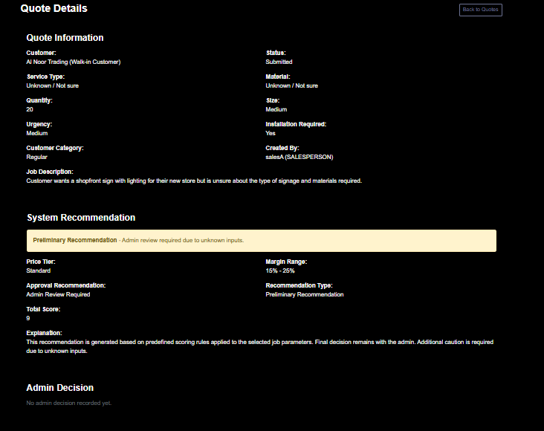

FIGURE C6: VIP CASE – SYSTEM RECOMMENDATION OUTPUT
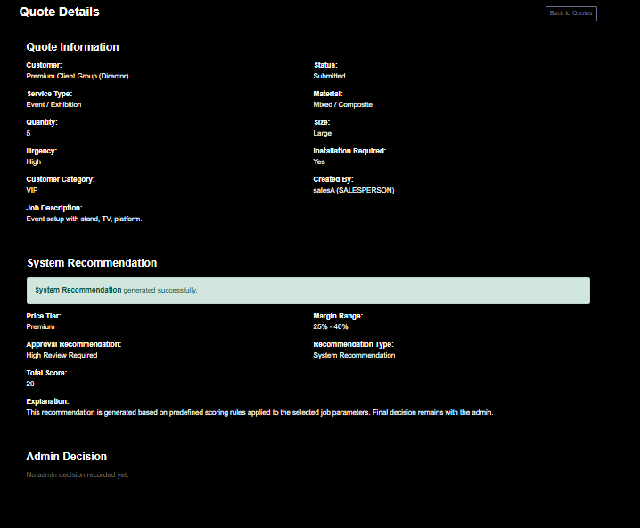

FIGURE C7: ADMIN REVIEW INTERFACE SHOWING SYSTEM RECOMMENDATION

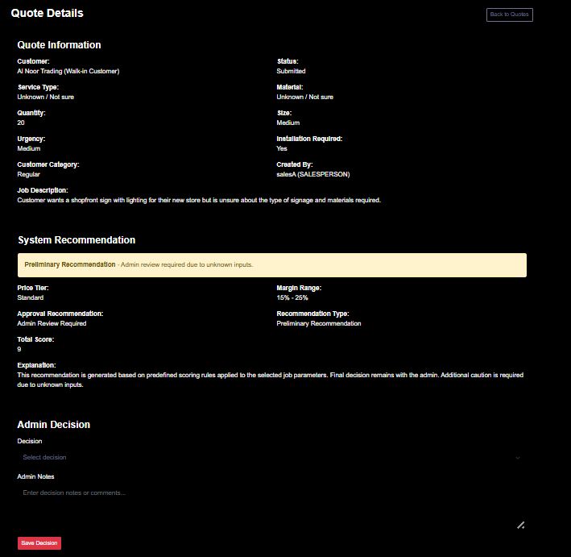

User Guide

- Log in using provided user credentials
- Admin username: admin, password: admin
- Salesperson username: salesA, password: sales@123

- First log in as a Salesperson
- Create or select customer
- Create new quotation
- Enter required details
- Service Type
- Material
- Quantity
- Job Size
- Urgency
- Installation Requirement
- Job Description
- Click on the Submit button after creating quote

- After submitting the quote to admin, the system will redirect to Quote Detail page with system recommendation automatically generated with:
- Pricing Tier
- Margin Range
- Review Requirement Level
- Explanation
- Total Score

- As an Admin:
- Review submitted quotation
- View system recommendation
- Make final decision (Approve/Reject) with appropriate reason.

REPRODUCING RESULTS

To reproduce the results presented in this report:
- Use same test cases provided in Appendix B
- Enter the corresponding input values into the quotation form.
- Compare the system-generated outputs with the results shown in the report.

Make sure your work is properly checked for grammar and spelling before submitting. Submit one file (this filled-in Word template) by the due date via the ICT206 unit website. Students are warned about taking material from the Web or generated by an LLM without proper acknowledgment, which is considered misconduct.

The submission will be marked using the following rubric:

CATEGORY | 5 | 4 | 3 | 2 | 1 | 0
On Time/Late  Without Extension | On time  0 marks | 1-2 days late  -1 marks | 3-4 days late  -2 marks | - days late  -3 marks | 7 or more days late  -4 marks
Presentation  (Coversheet, diagrams, captions, references in IEEE format, clarity and style) | Excellent  +5 marks | Very good  +4 marks | Good  +3 marks | Acceptable  +2 marks | Poor  +1 mark | Very Poor  0 marks
Description  (Problem, background research and goal) | Excellent  +5 marks | Very good  +4 marks | Good  +3 marks | Acceptable  +2 marks | Poor  +1 marks | Very Poor  0 marks
Solution & Implementation  (Good solution, good use of tools and resources) | Excellent  +5 marks | Very Good  +4 marks | Good  +3 marks | Acceptable  +2 marks | Poor  +1 mark | Very Poor  0 marks
Performance of Solution  (Solution runs according to design, goals reached) | Excellent  +5 marks | Very Good  +4 marks | Good  +3 marks | Acceptable  +2 marks | Poor  +1 mark | Very Poor  0 marks
Evaluation & Conclusion  (Quality of evaluation, conclusion) | Excellent  +5 marks | Very Good  +4 marks | Good  +3 marks | Acceptable  +2 marks | Poor  +1 mark | Very poor  0 marks

Tutor’s Comments

