SuperAwesomeChess
User Manual

v1.0.0

Peter Beissinger
Mark Schultz
Sean Fox
Table of Contents

- Web server setup
- Multiplayer server setup
- Single-player mode
- Multiplayer mode
- Web server setup

This guide assumes you have server software installed or otherwise have your own hosting. The files to be hosted are:

ai.js
chess.html
chess.js
network.js
style.css

All files must be present in the same directory. Here is a screenshot of the files being hosted via HFS, a stand-alone HTTP File Server:

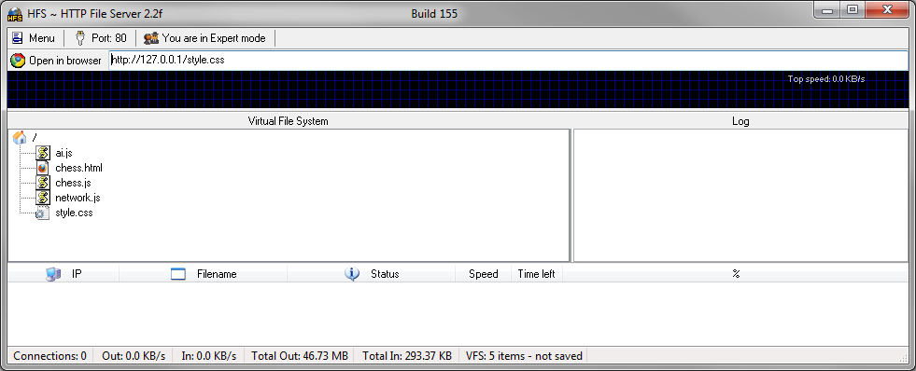

- Multiplayer server setup

The multiplayer server requires NodeJS to run. NodeJS can be obtained by visiting their official website.

Decide which port you want the server to listen on. The server port can be modified by changing

var port = 8000;

at the top of “server.js” to the desired port number. Note that common ports in the range 0 to 1024 may require administrator or root privileges in order to listen on.

Once NodeJS is installed on the server, open a terminal or command prompt and change directories so “server.js” is in the current path. Then execute the command

node server.js

using the proper privileges. The multiplayer server will now be listening on the server's public IP address at the defined port.

We now need to modify the hardcoded multiplayer server URL in the file “network.js” on the web server. Make a note of the multiplayer server's public IP address or domain name. At the top of “network.js” on the web server, modify the line

server: 'http://127.0.0.1:8000'

to the URL or public IP address and port number of the multiplayer server. This will direct users who wish to play against human opponents to the multiplayer server.

- Single-player mode

Single-player mode starts by default whenever a user visits the “chess.html” page hosted on the web server. Here is a screenshot of what the user will see when they arrive:

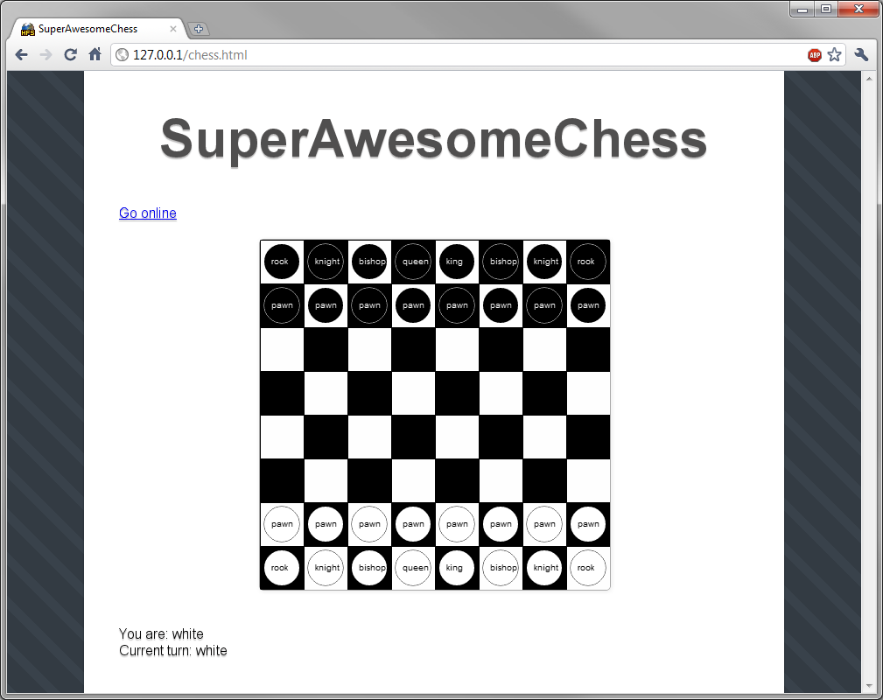

Displayed at the top is a link to enter multiplayer mode. At the bottom is information telling the user what color they are and whose turn it is.

The opponent is a naïve chess AI. The user's color is randomly assigned, then white gets to go first. Each piece is labeled with text to distinguish it from the others.

In order to move a piece, the user must click and release to select it. The piece will then follow the user's mouse. To place a piece, the user must click and release over the location they wish to place it. To cancel a move, place the piece back in it's original location. The user will not be able to set the piece down if it is an illegal move.

Play progresses according to the standard rules of chess.

If the user is in check, a note is displayed next to their color. The user is then forced to move their king to a safe position. Here is a screenshot of a user in check:

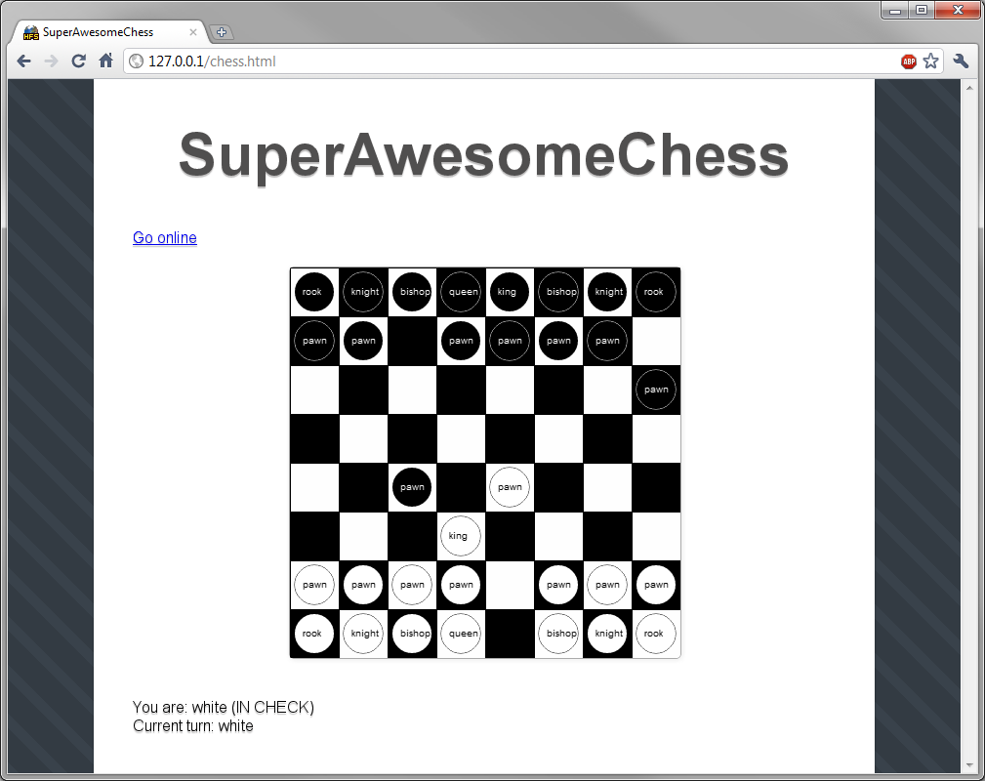

The game ends when a checkmate occurs. A message that checkmate has occurred is displayed at the bottom, and the user will no longer be able to interact with the chessboard. The page must be refreshed to reset the single player game, or the user may click “Go online” to enter multiplayer mode.

- Multiplayer mode

Once the user enters single-player mode as described in Section 3, at any point in time they may click the “Go online” link at the top to enter multiplayer mode. When that occurs, the multiplayer server is notified that there is a new user who wishes to be paired up.

The server then randomly pairs two users who are waiting to be assigned a partner, and initializes a game for them. The server randomly decides who is what color and notifies the users of this. As in single-player mode, white always goes first.

Play progresses exactly as in single-player mode, with the exception that the opponent is a human. The game ends and the users are disconnected when a checkmate occurs, as in the screenshot below:

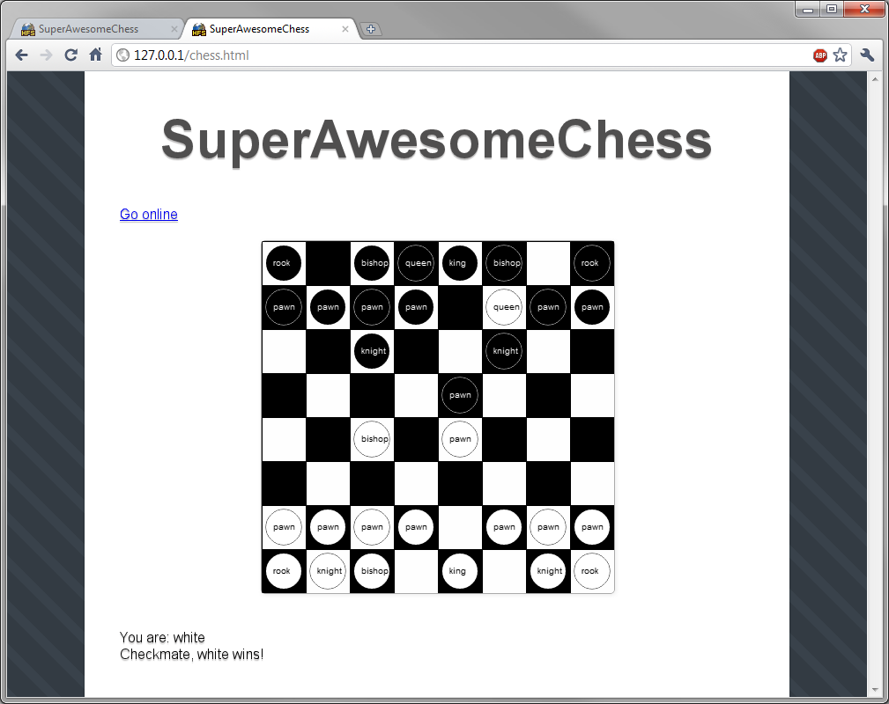

The user may click “Go online” again to be paired with another player.

