Project Description: The name of my project is “Panda Escape”. It is a game where a panda has to escape its enemies by maneuvering through ice blocks and attempting to eat food to add to its score. To officially escape, the panda must enter its home, or igloo which will be positioned in a place hard to get to. There will be a time limit and enemies continually walking by, if the panda bumps into the enemies it loses 1 out of its 3 lives.

Competitive Analysis: My project idea was inspired by a game my friend introduced me to called “Bad Ice-cream”. Bad ice-cream is a popular online multiplayer game where the players control a character whose mission is to collect all the fruits in a maze while avoiding obstacles and enemies. By collecting the fruits, the character’s score increases. The game is easy, but difficult to master as players have to navigate mazes and avoid blocks of ice that can be melted and also avoid enemies who could have powers too. As the levels increase, the game becomes significantly harder whether it be more enemies added to the game or harder nazes to go through.

My project is going to be quite similar to this game in the sense that I have a character who I need to control to collect its food in order for it to escape. The main goal of the game however is to collect the foods and also enter the player’s home which will be an igloo. Whenever the player finishes a maze and enters an igloo, the game will be over and the next level will start. The enemies will just be walking by, blocking the food. If the player bumps into the enemy more than 3 times, it loses all its lives. Additionally, unlike the actual game, this game is not multiplayer and the character would be next to me.

Structural Plan: There will be different files for big chunks of code. For instance now I have a separate file for the main menu screen and a separate file for the main game play file. I will use object oriented programming to create buttons on the main menu screen. In order to move between two screens I am going to turn big chunks of code into a more simple function that will be called.

Algorithmic Plan:At the moment the trickiest part of my game is making sure the characters and the objects collide, although my game will just get trickier. From research, in order to make a static object and moving object collide, like in this case if the panda character tries to move around the ice blocks but bumps into it, the character should still be able to recreate a path that avoids the said ice block and moves around it. I will also code a function to melt the ice blocks through a keypress which will involve blitting and unblitting a character. Other tricky aspects are trying to increment more complex levels, adding a song and timer as well as trying to get the enemies to shoot super powers on the player to slow it down. I will do the last one by creating more images that look like superpowers, and if they collide with the prayer. To code the character I am moving, I need to make sure the player's character can be picked from a range.

Timeline Plan: A timeline for when you intend to complete the major features of the project.

The timeline is to finish the main menu screen and figure out how to make objects collide before Sunday the 9th so that the maze is functionable. After that the coding should be easier as I plan to have my scores and food depictions done by Tuesday 11 August.

Module List: pygames and maybe CMU/graphics, time, math, my other files

Version Control Plan:

In my game right now, I have a starting cover page that welcomes the players presenting the logo of the game (which will be changed later to represent the details of my game). In the main screen, the background is moving to represent the falling snowflakes as my game is following the central theme of winter. My code for the background involves adding a picture into the 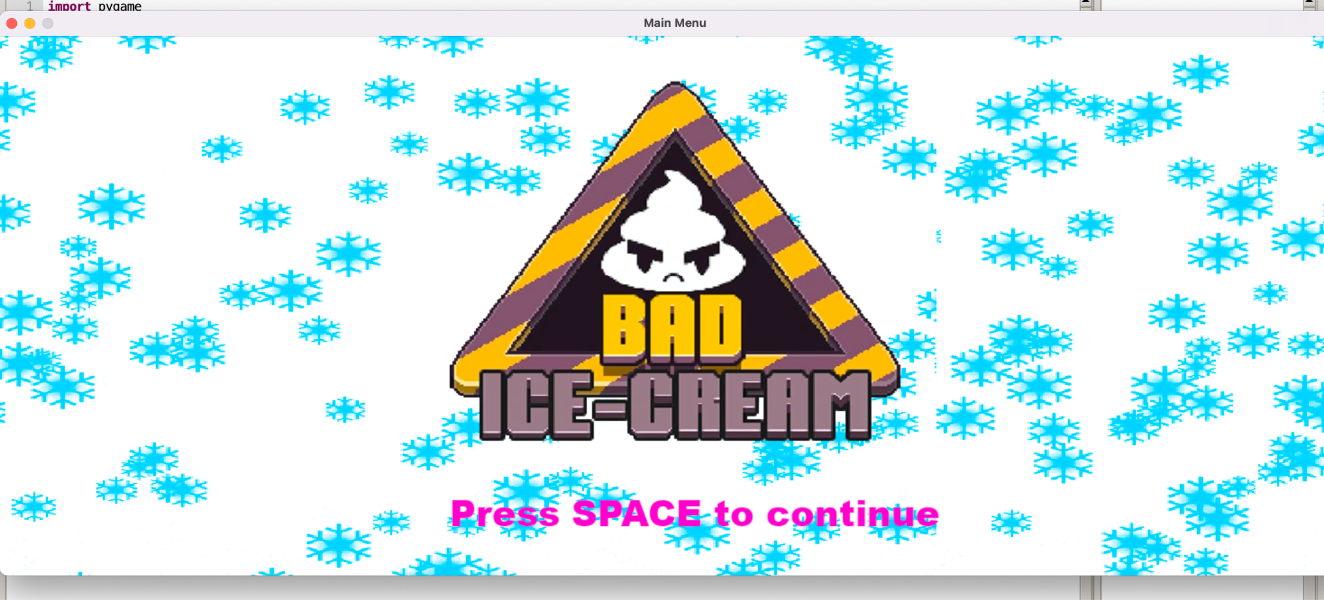

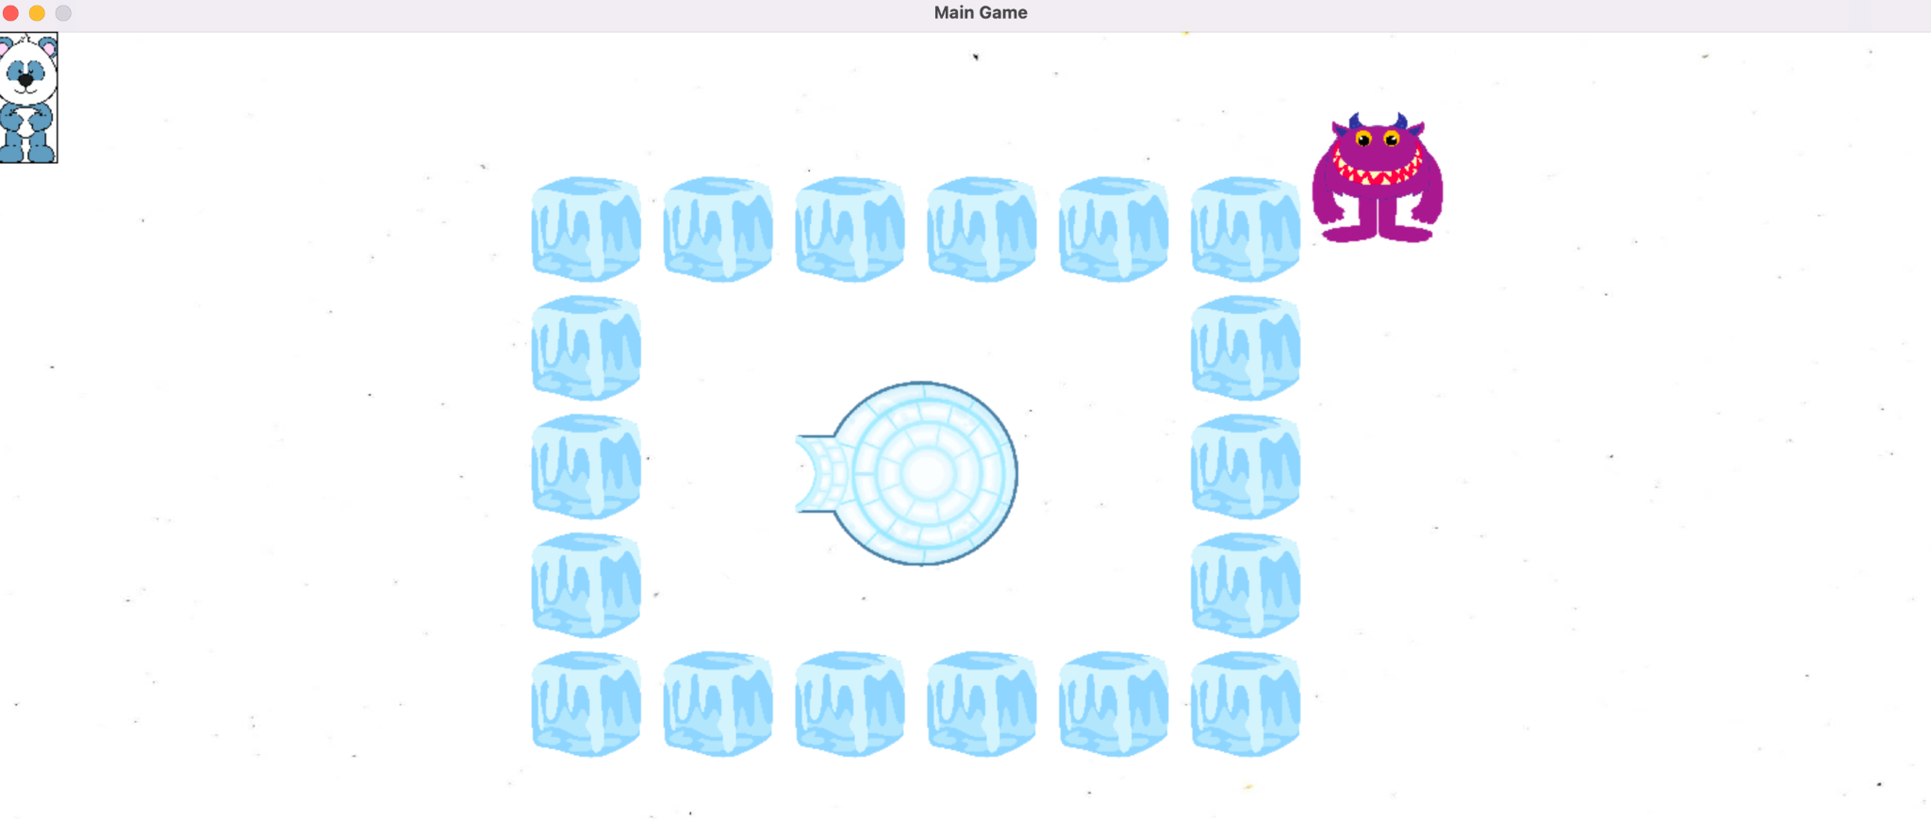

background and adding another one right after in the empty space. I also resize the background to fit the whole screen. I then make the image move to the left in a loop to give the effect of scrolling by decreasing the count and using clock and velocity to add the motion effect. In the main game screen the background is also moving and there is a main character which is the panda that moves. It moves through using key presses that just increment or reduce the count of the x-coordinates. The other static objects like the igloo and blocks are placed using screen.blit. The enemy which is the monster moves up and down continuously from the top of the screen to the bottom of the screen. This is done through using x and y coordinates of the image and multiplying it by -1 and changing the image speed and direction. This monster acts as an obstacle for the panda.