Abstract

In this project, we develop and evaluate predictive models to estimate the likelihood that a client of a Portuguese banking institution will subscribe to a term deposit, based on the UCI Bank Marketing dataset. Our workflow encompasses comprehensive data pre‐processing—including handling of sentinel values, correction of distributional skew, standardization of numeric attributes, and one‐hot encoding of categorical variables.

We compare seven classifiers—logistic regression, K‐nearest neighbors, decision tree, random forest, naive Bayes, support vector machine, and a feed‐forward neural network (64–32 ReLU layers with sigmoid output)—using stratified train/test splits and class‐weighting to address the positive‐class imbalance. Performance is assessed in terms of accuracy, F1‐score, precision and recall.

These findings demonstrate that careful feature engineering—especially sentinel handling, skew reduction, and imbalance mitigation—significantly improves predictions in financial marketing contexts.

Table of Contents

Introduction 3
Dataset Description 3
Dataset Breakdown 3
Dataset Imbalance 4
Exploratory Data Analysis (EDA) 4
Dataset Pre-processing 5
Handling Null Values 5
Handling Categorical Values 5
Label Encoding 5
Handling Skewness 6
Dataset Splitting 6
Model Training and Testing 6
Model Selection / Comparison Analysis 6
ROC and AUC 6
Confusion Matrix 7
Conclusion 8
Model-wise Conclusion 8
Overall Conclusion 8
Reasons behind Conclusion 8
Challenges Faced 9

Introduction

This project focuses on building a machine learning model that predicts whether a customer will subscribe to a specific programme based on their personal and campaign related information. The model can efficiently identify potential customers who are likely to respond positively. The motivation behind this project is to enable easier data-driven decision-making and optimize the cost of marketing campaigns and make them more targeted, efficient and cost-effective.

Dataset Description

Dataset Breakdown
- Features: 20 Columns
- Outcome: y (Categorical)
- Data: 41188 Rows
- The dataset has 10 categorical and 10 quantitative features.
- The heatmap shows the correlation between all features, including ‘y’. It visually highlights strong and weak linear relationships between variables.
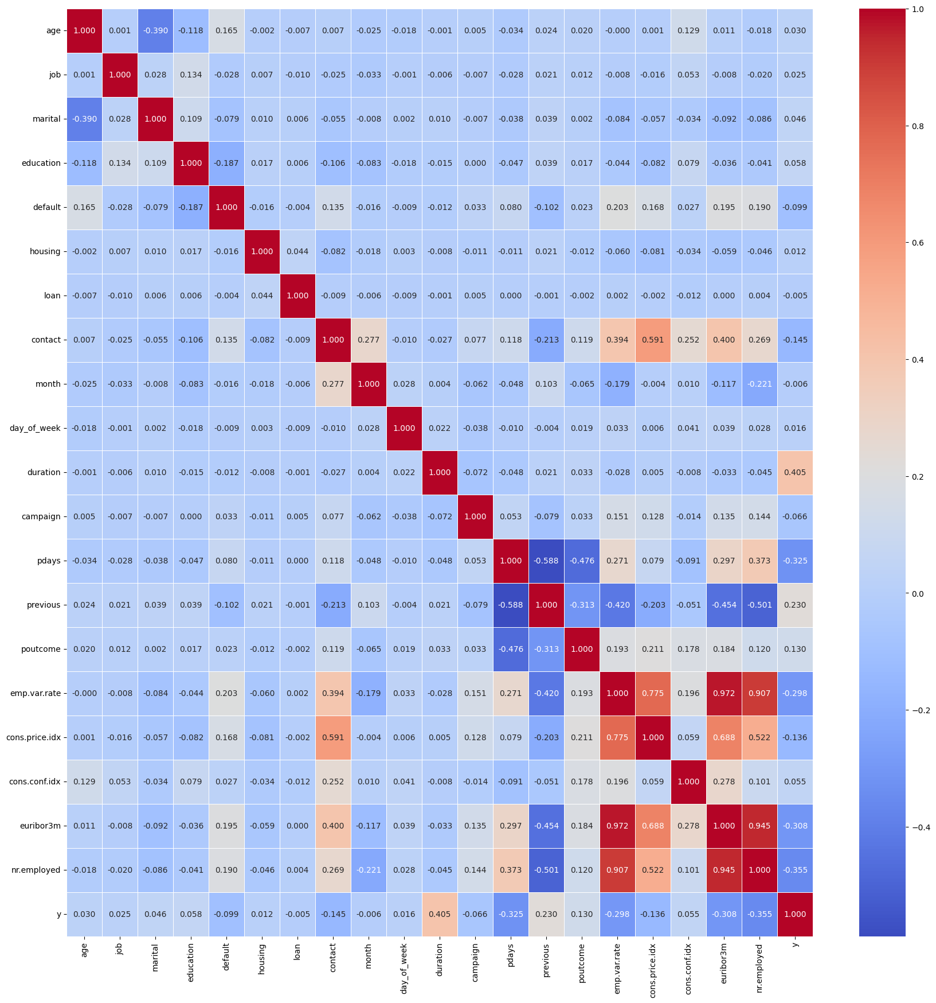
- From the correlation test, values closer to 0 (typically between -0.3 and 0.3) indicate little to no linear correlation, while values closer to ±1 (especially above 0.9 or below -0.9) indicate strong positive or negative correlation. From the heatmap we see there are weak or no correlation between some features and also there are highly correlated values.
‘emp.var.rate’ and ‘euribor3m’ – 0.972
‘emp.var.rate’ and ‘nr.employed’ – 0.907
‘euribor3m’ and ‘nr.employed’ – 0.945
There are highly correlated values and carry similar information which make the models redundant and affect the performance of the models. Correlation test helps in selecting relevant features and removing redundant ones to improve model efficiency

Dataset Imbalance
- The output feature is imbalanced in the dataset as the unique classes do not have an equal number of instances. In the dataset the class ‘no’ appears significantly more than the class ‘yes’.
Outcome count percentage
0 36548 34.81
1 4640 4.42

- In the dataset number of classes in y = 2.
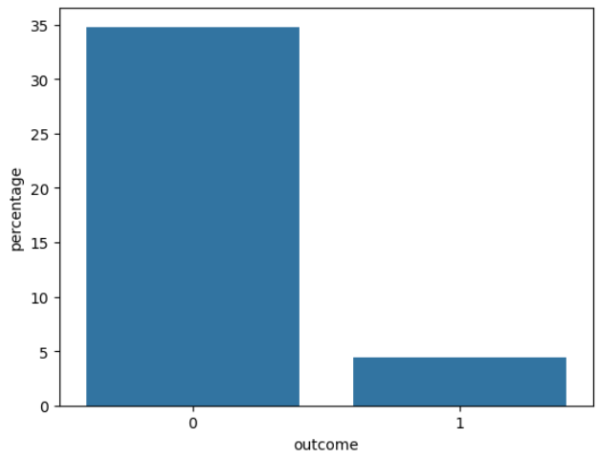

Exploratory Data Analysis (EDA)
- Descriptive analysis
- Skewness
- Plotting histogram & box plots
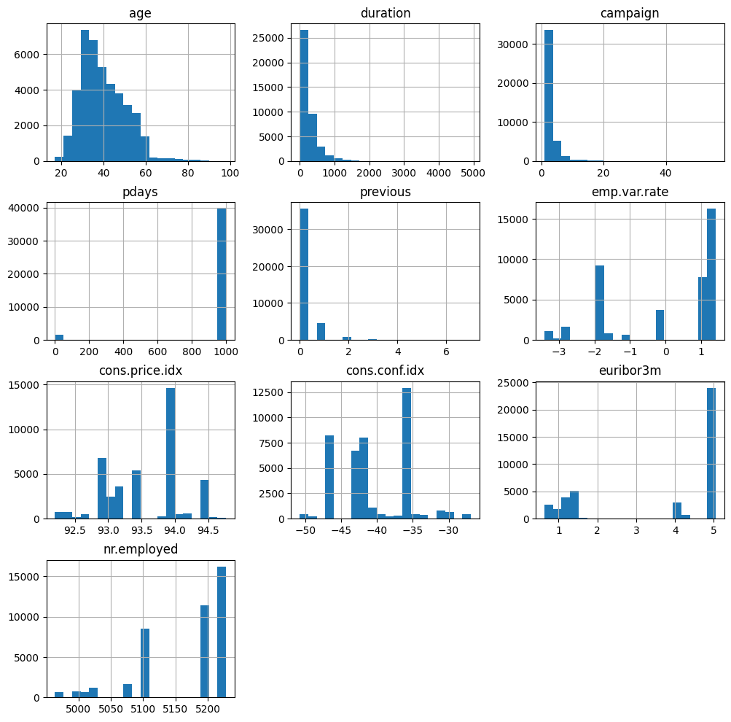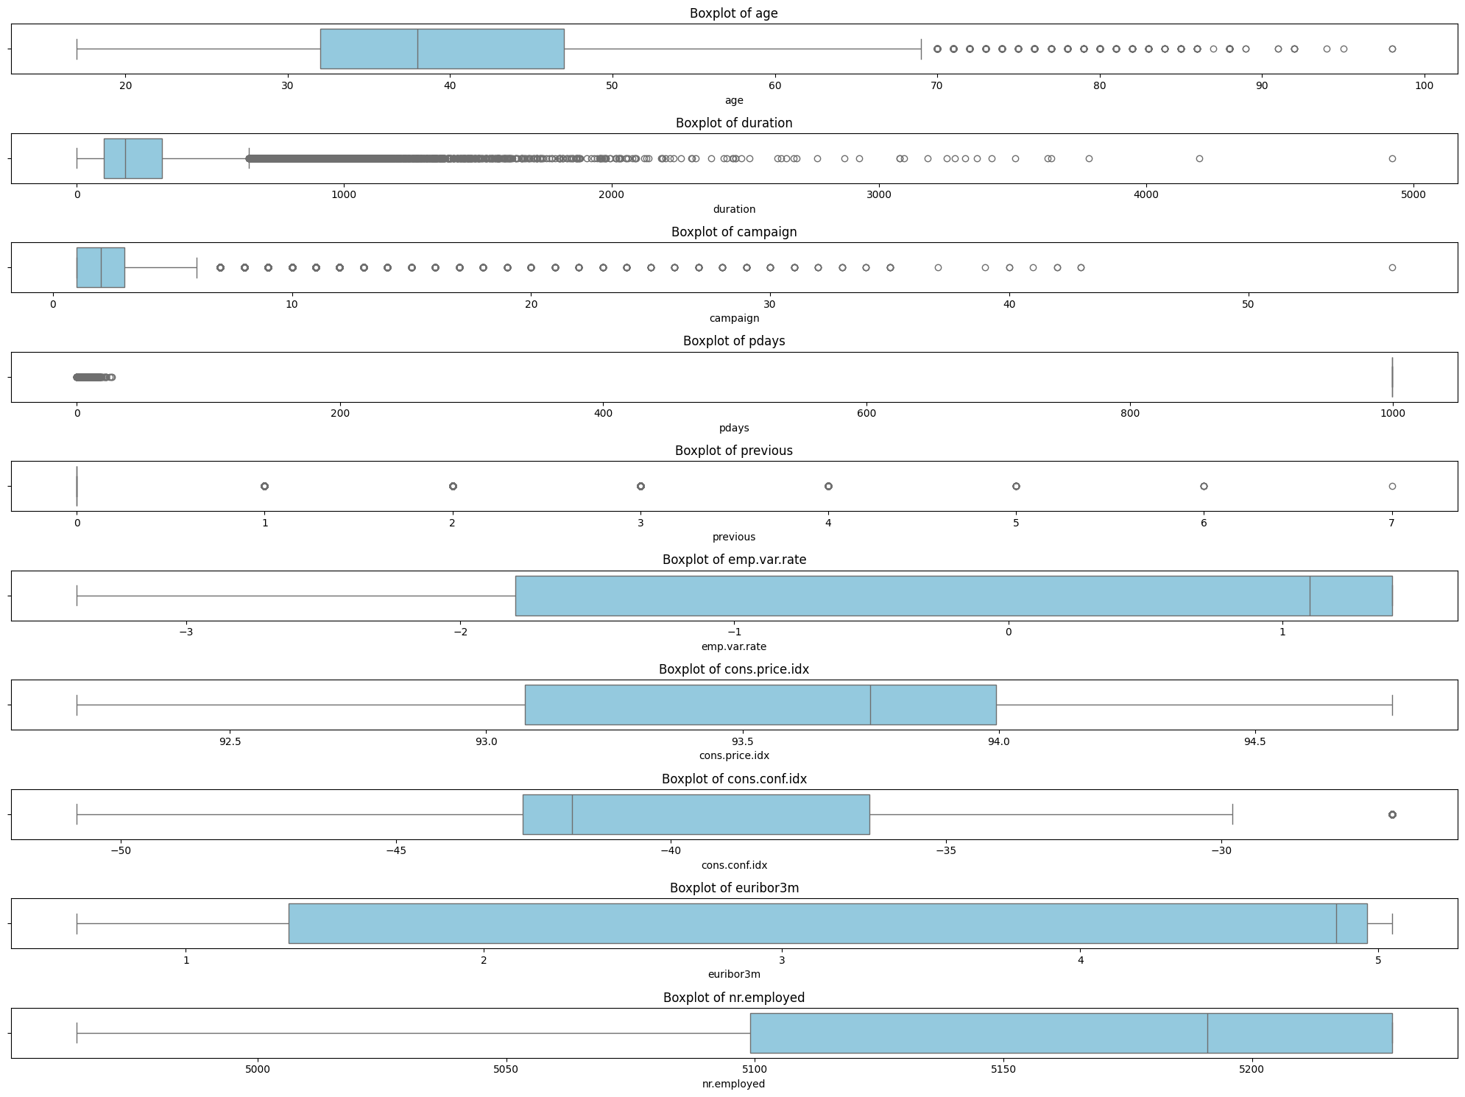
- Finding number of unique Values in each features
- Bar Plot of unique values in categorical features
- Correlation analysis and plotting heatmap of correlation matrix

Dataset Pre-processing

Handling Null Values
- There were no Null values present in the dataset at the beginning of preprocessing.

Handling Categorical Values
- The pdays variable, which indicates the number of days since a client was last contacted, was transformed to better reflect its meaning. A binary feature pdays_contacted was created to indicate whether a client was previously contacted (pdays ≠ 999) and pdays_notcontacted for clients who were not previously contacted. For clients who were contacted, the pdays values were log-transformed (log1p) to normalize their distribution, with 999 values treated as missing (NaN). The original pdays column was then dropped to avoid redundancy.

Label Encoding
- The binary target variable y was label-encoded to convert its string values (e.g., “yes”/“no”) into numeric 0/1 for model compatibility. All remaining categorical predictors were one-hot encoded: each category level becomes a separate dummy column, with the first level dropped (drop_first=True) to avoid multicollinearity.

Handling Skewness
- All numeric columns (int64 and float64) were inspected for skewness. Those with a skewness greater than 1 were flagged as highly skewed. For each skewed column (excluding the target y) that contained only non-negative values, a log-plus-one transformation (log1p) was applied to reduce skew and stabilize variance.

Dataset Splitting

- As there was high data imbalance, data was stratified during train-test(70-30) splitting to ensure balanced class distribution
Test Data: 28,831 Rows
Train Data: 12,357 Rows
- Used SMOTE (Synthetic Minority Over-sampling Technique) so the dataset is balanced and the model learns from both classes more equally
- To further balance data, the models were run with class_weight='balanced'

Model Training and Testing
- For model training and evaluation, several classification algorithms were applied
Logistic Regression
K-Nearest Neighbors (KNN)
Decision Tree
Random Forest
Naive Bayes
SVM
Neural Network (64-32-1)
- Linear Regression was not applied because it is a classification problem, where the target variable is categorical ("yes"/"no"), and linear regression is designed for predicting continuous numerical outcomes.

Model Selection / Comparison Analysis

ROC and AUC
- The ROC and AUC graph gave a preliminary overview of each models’ performance
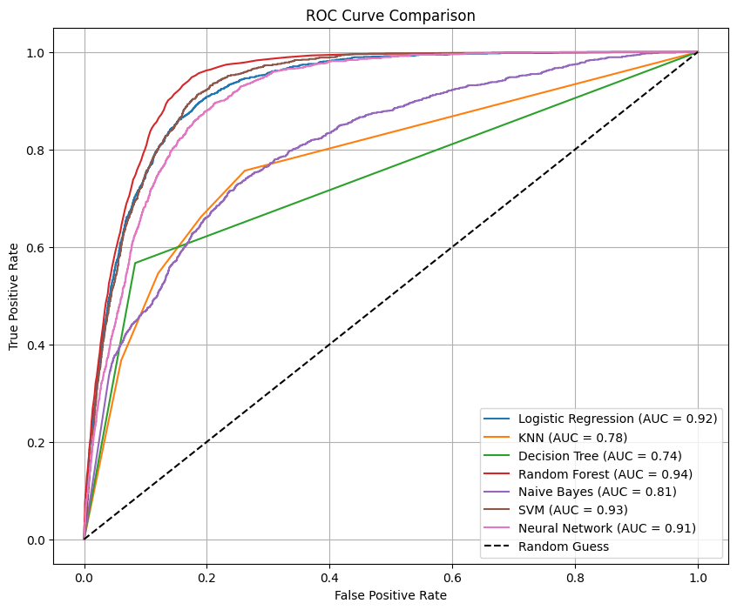

Confusion Matrix
- A comparative analysis of each models’ True Positive, True Negative, False Positive and False Negative values.
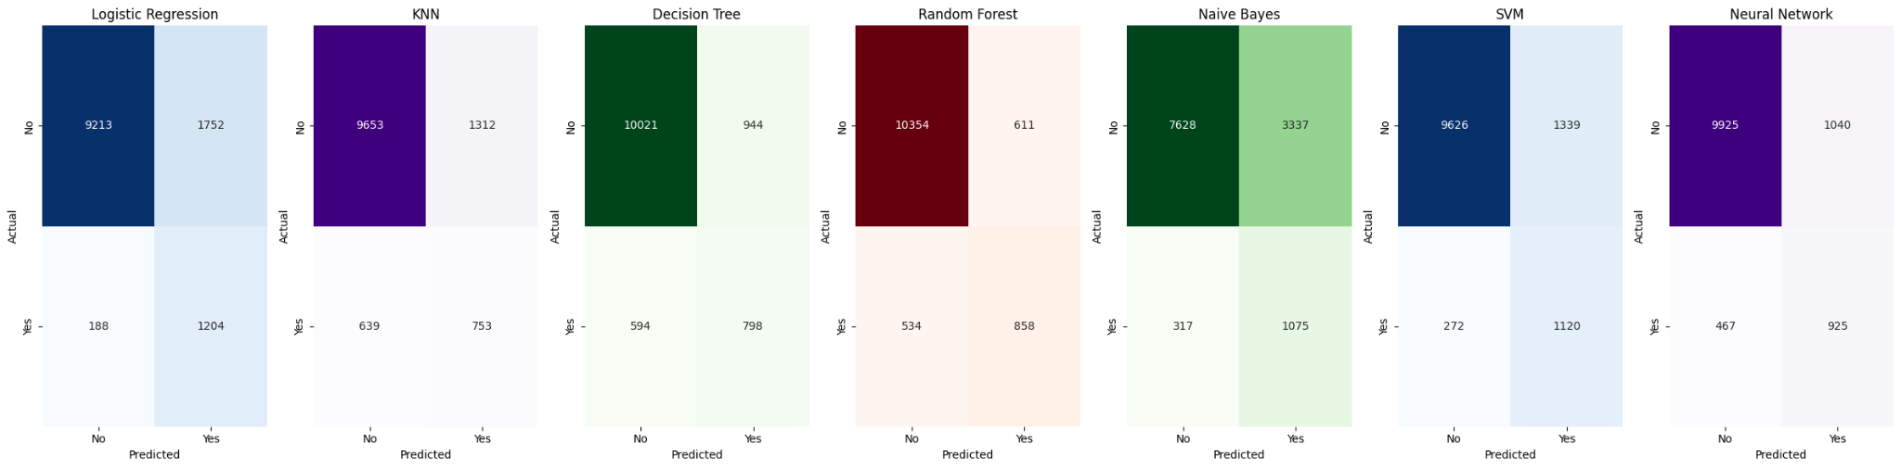

Accuracy, F1 Score, Precision, Recall
- A bar graph showcasing the prediction accuracy of all models
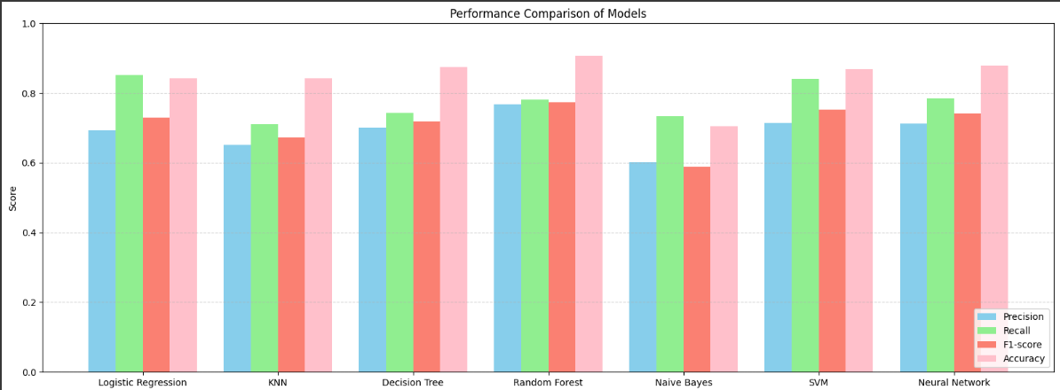
- Precision and recall scores determine how well each model identifies positive cases. Logistic Regression and Random Forest performed well, with Logistic Regression showing the best recall, making it suitable for detecting actual positives.

Conclusion

Model-wise Conclusion
- Random Forest: Performed best overall; high accuracy and AUC indicate strong generalization and balance in predictions.
- Logistic Regression: High recall makes it ideal for identifying the minority class; simpler and interpretable model.
- KNN: Struggled with precision and recall. Affected by high-dimensional data and class imbalance.
- Decision Tree: Performed decently.
- Naive Bayes: Weak performance due to strong independence assumptions not holding true in this dataset.
- SVM: Good balance between precision and recall, effective at finding decision boundaries.
- Neural Network: Performed well but slightly less than ensemble methods; may benefit from more tuning.

Overall Conclusion
- From the results, we see that Random Forest performed strongly in terms of accuracy, precision, and AUC score, indicating its effectiveness in correctly classifying both classes. However, Logistic Regression achieved the highest recall, making it more suitable for this classification problem where correctly identifying the positive class (e.g., customers likely to subscribe) is more important.

Reasons behind Conclusion
- We got such results because models like random forest and SVM handle imbalanced data better than other models. Logistic Regression handles linear relationships effectively which increases the recall. Naive Bayes performs poorly as there are feature dependencies. KNN also struggles due to the high imbalance, which affects its distance based classification.

Challenges Faced
- One of the major challenges faced during the project was dealing with highly imbalanced data, which required careful analysis to ensure that models did not become biased toward the majority class. Another key challenge was selecting relevant features to avoid overfitting and improve generalization. Additionally, handling the ‘pdays’ feature was tricky, as many values were set to 999, which skewed the results if not addressed separately.

