Assignment 2 instructions
Jackie Lambert is preparing the 2025 budget for EScooter Inc., a leading manufacturer of electric scooters for adults. You are tasked to help her prepare the Master Budget.
The assignment consists of 1 component: Data Analytics Assignment 2 Quiz.
In a first Excel Sheet, prepare by month and in total for 2025 the following:
o Sales budget
o Production budget
o Direct materials budget
o Direct labour budget
o Manufacturing overhead budget
o Selling and administrative budget
o Budgeted income statement
In a second Excel Sheet, prepare the cash budget by month and in total for 2025
In a third Excel Sheet, prepare the budgeted annual balance sheet as of December 31, 2025 (no monthly information needed for the budgeted balance sheet). Here is the master budget case information: Jackie Lambert is preparing the 2025 budget for EScooter Inc. Based on extensive market research, EScooter Inc. prepared the following monthly production schedule of electric scooters for 2025 (including November and December 2024).
Monthly required production quantity: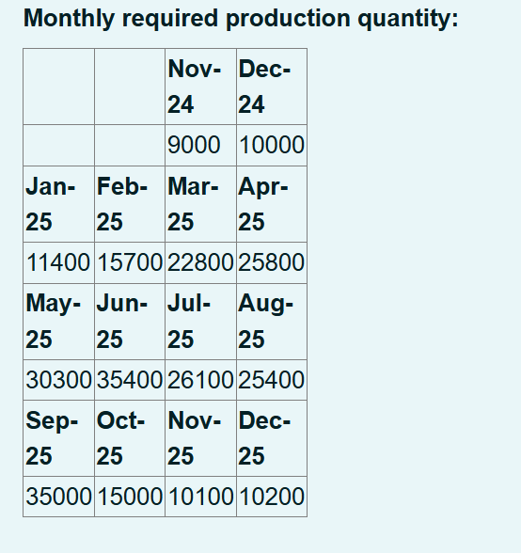

EScooter’s policy is to have finished goods ending inventory in a month equal to 20% of the next month’s required production quantity (see table above). This policy has also been applied in previous years.
The preliminary production schedule for 2026 are 12000 units for January and 15000 for February.
Selling price is $409.
EScooter Inc. plans to give a price discount on his selling price for their back-to-work sales campaign in September.

All sales are on credit. The company expects that it can collect 30% of sales in the month of sales, 40% of sales in the next month, and the remaining 30% in second month.
Sales in November and December 2024 selling price is $409.
The manufacturing process of electric scooters entails fabrication and assembly. During the fabrication process alloy steel and plastic components are cut, bended, and welded into the desired shape. During the assembly process the different parts and components are assembled into a finished electric scooter.
Each electric scooter requires 0.5 square metre of alloy steel, 2 kg of plastic, and one assembly kit. The assembly kit includes, among others, the front and back light, brakes, the lithium-ion battery, a charging set, the display, the batter management system, two handlebar covers, and two rubber wheels. Company policy is that the ending inventory of alloy steel and plastic should be 21% of the amount needed for production in the next month. Further, EScooter’s policy is to always keep 1531 finishing kits as ending inventory. This means for example that the ending inventory of finishing kits is 1531 units on December 31, 2024. The alloy steel costs $46 per square meter, the plastic costs $1.2 per kilogram, and the assembly kits cost $156 each.
The fabrication process requires 2 hours of time per electric scooter by fabrication employees and 0.43 hours of finishing time by assembly employees. Direct labour costs for fabrication employees are $20 per hour and $14 per hour for assembly employees.
EScooter expects variable manufacturing overhead costs to fluctuate with the production volume based on the following rates per fabrication direct labour hours:

Maintenance: $0.40 per fabrication direct labour hour
Utilities: $0.70 per fabrication direct labour hour
Indirect materials: $1.20 per fabrication direct labour hour
Indirect labour: $1.40 per fabrication direct labour hour
In addition, EScooter expects the following fixed manufacturing overhead to occur each month:

Supervisory salaries: $18779
Depreciation: $3671
Property taxes and insurance: $8679
Maintenance: $5435
The Company uses labour hours of fabrication employees to allocate manufacturing overhead. The predetermined manufacturing overhead is calculated based on annual estimates.

Variable selling and administrative expenses for this line are expected to be 3% of sales for sales commissions and $8 per unit for freight out. In addition, monthly fixed selling and administrative expenses are estimated to be as follows:

Advertising: $7500
Sales salaries: $17000
Office salaries: $7000
Depreciation: $712
Property taxes and insurance: $1000
EScooter pays 50% of its direct materials purchases in the month purchased and the remaining 50% in the next month. All other cash-effective costs are paid in the months incurred.

Include following additional assumptions in the preparation of the Master Budget:

The beginning cash balance is 95000, which is the required minimum cash balance.

Ignore income taxes.

Assume that the direct materials prices, direct labour rates, variable manufacturing rates, and monthly fixed manufacturing costs remain constant in 2024 and 2025. This means, for example, that you can use the product unit cost from 2025 to determine the beginning finished goods inventory or the direct materials prices from 2025 to calculate the beginning raw materials inventory.

The balance of Property, Plant, and Equipment, net of depreciation is $420000 as of December 31, 2024.

Equity: EScooter Inc. finances its operations with common share equity of $600000. It plans to pay out dividends of $120000 in October 2025.
Use the following formula to determine the beginning retained earnings balance: Beginning retained earnings = $95000 beginning cash balance + Beginning accounts receivable balance + Beginning finished goods balance + Beginning raw materials balance + $420000 Property, Plant, and Equipment, net of depreciation – Beginning accounts payable balance - $200000 beginning long-term liabilities - $600000 beginning common shares balance. Note that the amount of retained earnings is most likely as decimal number – do not round it in your Excel sheet.
Long-term liabilities: EScooter finances its operations with an interest-bearing long-term loan of $200000. An interest expense of 8% per annum is expected for the long-term loan, which is paid monthly. Note that the interest expense for the long-term loan is included in the financing section of the cash budget. EScooter plans to pay back 11% of its long-term loan at the end of December, if the cash balance allows for it.
Short-term financing: In case additional, short-term debt is needed, EScooter has a line of credit available with its bank at an interest rate of 8% per annum. This potential short-term loan works as follows: The company will borrow and repay in multiples of $5000 from the line of credit. It makes all borrowings from the line of credit at the beginning of a month and makes all repayments at the end of a month. It pays interest only on the portion of the short-term loan (line of credit) that is repaid.

