ABSTRACT
This project presents an RFID-Based Access Control System using Arduino Uno, designed to provide a secure, fast, and contactless method for verifying user identity. Traditional access methods like keys, PINs, and ID cards often involve manual checks and can be easily misplaced, shared, or duplicated, leading to security risks. To overcome these limitations, the proposed system uses RFID technology to automatically read the unique ID of a tag or card and determine whether the user is authorized. When a valid RFID tag is detected, the system grants access by activating a green LED; otherwise, a red LED indicates access denial. The Arduino Uno acts as the central controller, processing the scanned UID and controlling the output signals. This system offers a simple, low-cost, and efficient solution that can be applied in schools, offices, labs, and restricted areas to enhance security and streamline entry management.

Chapter No. | INDEX | PAGE.NO
1. | INTRODUCTION | 1
2. | LITERATURE SURVEY | 2
3. | PROBLEM STATEMENT | 4
4. | SYSTEM REQUIREMENT | 5
 | a. Software Requirements | 5
 | b. Hardware requirements | 5
5. | SYSTEM DESIGN | 6
 | a. Block Diagram/ System Architecture | 7
 | b. Flowchart | 9
6. | IMPLEMENTATION | 11
7. | TESTING AND RESULT ANALYSIS | 13
8. | CONCLUSION | 15
9. | REFERENCES | 16

CHAPTER 1

INTRODUCTION
In the modern world, security has become an essential requirement in homes, educational institutions, industries, and offices. Traditional lock-and-key mechanisms are no longer sufficient, as they can be easily lost, duplicated, or damaged. To overcome these limitations, electronic access control systems have gained popularity for providing safe, reliable, and automated entry management. Among these technologies, Radio Frequency Identification (RFID) stands out as a simple yet powerful method used to identify and authenticate individuals without physical contact.
RFID uses radio waves to read information stored in a tag, making the identification process fast, secure, and convenient. When integrated with microcontrollers like the Arduino Uno, the system becomes affordable and easy to implement for a wide range of applications. The RFID module reads the unique ID from an RFID card or tag, and the Arduino processes this data to determine whether access should be granted or denied. This automated verification helps reduce manual checking, prevents unauthorized entry, and ensures accurate logging of who enters a restricted space.
The core idea of this project is to design a cost-effective and efficient access control system using RFID technology. When a user shows a valid RFID tag, the system unlocks the door or activates a mechanism, while invalid tags trigger a denial response. This ensures only authorized individuals gain access to sensitive or restricted areas. The project demonstrates how electronic security systems can be simple to build and scalable for real-time applications.
Overall, the RFID-Based Access Control System using Arduino Uno provides a modern approach to security, emphasizing automation, speed, and accuracy. This project highlights the importance of integrating smart technologies for better safety and efficient access management in everyday environments.

CHAPTER 2

LITERATURE SURVEY
Akash et al.[1] proposed a work on “RFID Based Security System Using Arduino Module”. RFID (Radio Frequency Identification) is one of the consistent and speedy techniques for perceive the material dissent. RFID tags were made to eventually replace barcodes initially. They can be read wirelessly and with no line of sight, contain more data than barcodes, and are stronger are its advantages. As the paper describes the recent technology, include the frequency ranges used and standards required. It is an open-source electronics prototyping platform based on bendable, easy-to-employ software and hardware. It is proposed for hobbyists’ artists, designer & anyone interested in generating various design for things or environmental purpose. This system has achieved an accuracy of 98%
Shubham et al. [2] proposed a work on “RFID-Based Digital Door Locking System”. This is an IoT-enabled RFID-based door locking gadget. This door lock system will know how long the door is open and in this door lock system, only those people who register will be able to enter using their card. The system is composed of three major modulesThe RFID module serves as the input of the microcontroller, as the registered card required to open the door must be scanned into the system through the module. The use of the Arduino UNO microcontroller in this project allows design simplicity, therefore, the project can be achieved in a shorter time than other technologies previously employed. This system has achieved an accuracy of 98%
Vivek et al. [3] proposed a work on “Rfid Based Access Control System Using Arduino”. Wireless security based applications have rapidly increased due to the dramatic improvement of modern technologies. Many access control systems were designed and/or implemented based on different types of wireless communication technologies by different people. Various door locks such as mechanical locks or electrical locks were designed to attain basic security requirements. a prototype of automatic access control system for use in an environment is presented. The system uses radio frequency identification (RFID) with Arduino technology to differentiate between authorized and unauthorized users. This system has achieved an accuracy of 98%

Swathika et al. [4] proposed a work on “IoT Based Access Control Mechanism Using RFID Technology”. Internet of Things plays a vital role in day to day life of this developing technological world. IoT involves many technologies such as RFID technology, sensor technology, smart technology, Nano technology etc. The RFID reader can read the data from the RFID tag using radio frequency electromagnetic fields. The RFID tags include matching tag and non-matching tag (false tag). Each tag has its own UID Unique Identification Code. f the UID of the matching tag is included in the uploading program of Arduino Uno, then the reader will accept only when the matching tag is kept closer to it. This system has achieved an accuracy of 98%
Orji et all.[5] proposed a work on “Automatic Access Control System using Arduino and RFID”. Security systems play an important role to prevent unauthorized personnel entry into a secured environment, which may include physical and intellectual property. Various door locks such as mechanical locks or electrical locks were designed to attain basic security requirements. s. Basically, these locks can be easily hacked by unwanted people thereby allowing unauthorized personnel into secured premises. Automatic access control system has become necessary to overcome the security threats faced by many organizations in Nigeria. By installing the system at the entrance will only allow the authorized personnel to enter the organization. This system has achieved an accuracy of 98%

CHAPTER 3

PROBLEM STATEMENT
The need for secure and contactless access control is increasing, but traditional systems still rely on manual checking, which is slow and unreliable. Unauthorized access poses safety risks in many environments, making security a major concern. To address this issue, there is a need for an automated system that can quickly verify user identity. RFID technology provides a fast and unique method of identification through tag UIDs. Therefore, this project aims to develop an RFID-based access control system using Arduino Uno that grants entry only to authorized users and prevents unauthorized access effectively.

CHAPTER 4

SYSTEM REQUIREMENTS SPECIFICATION

COMPONENTS | QUANTITY | DESCRIPTION
Arduino Uno | 1 | Microcontroller board
MFRC522 RFID Module | 1 | RFID reader module using SPI
RFID Card & Key Tag | 1 each | For scanning and testing
Green LED | 1 | Indicates “Access Granted”
Red LED | 1 | Indicates “Access Denied”
Resistors (220Ω – 330Ω) | 2 | Current limiting resistors for LEDs
Breadboard | 1 | For connecting components without  soldering
Jumper Wires | 10 | For circuit connections
Printer Cable |  | To program Arduino and power the  circuit
Table 4.1.Hardware components

Component | Pin | Arduino Uno Pin
RC522 RFID Reader | SDA (SS) | 10
 | SCK | 13
 | MOSI | 11
 | MISO | 12
 | GND | GND
 | RST | 9
 | 3.3V | 3.3v
Green LED | Anode (+) | D6
 | Cathode (−) | GND (via 220Ω)
Red LED | Anode (+) | D7
 | Cathode (−) | GND (via 220Ω)

CHAPTER 5

SYSTEM DESIGN

  - SYSTEM DESIGN:
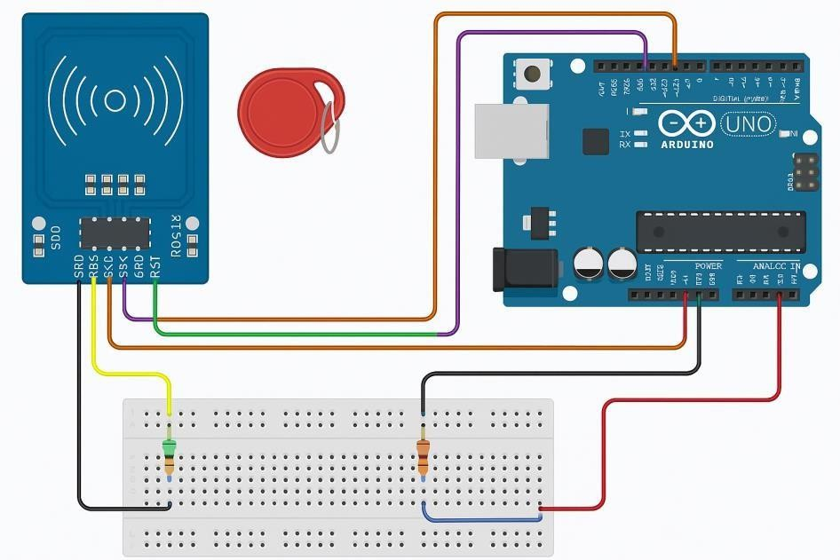
Fig 5.1 System Design

The system is designed using an RFID reader (MFRC522) connected to an Arduino Uno for access verification. The RFID reader detects the RFID tag and sends the tag’s unique ID to the Arduino through the SPI communication pins (SDA, SCK, MOSI, MISO, RST). The Arduino processes the received UID and compares it with a predefined authorized UID stored in the program.
Two LEDs are connected on a breadboard:

Green LED for Access Granted Red LED for Access Denied
When the RFID card is presented, the Arduino checks the UID:

If the UID matches → Green LED turns ON If it does not match → Red LED turns ON
The system continuously scans for new RFID tags and provides real-time feedback through LEDs and the Serial Monitor.

MFRC522 RFID Module Overview
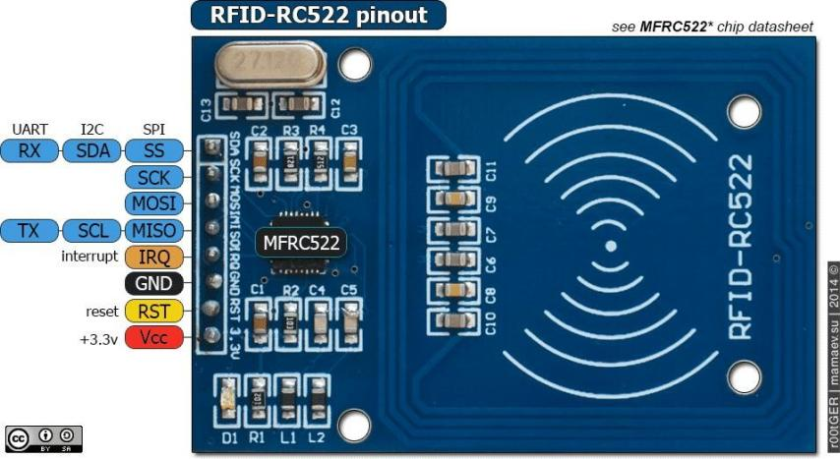

Fig 5.2 MFRC522 RFID Module Overview

The MFRC522 is a 13.56 MHz RFID reader module used to read/write data from RFID cards or key fobs (typically MIFARE 1K cards). It uses the SPI communication protocol to interface with microcontrollers like the Arduino.
Key features:

      - Operates at 13.56 MHz
      - Supports ISO/IEC 14443 Type A/MIFARE tags
      - Communicates with Arduino over SPI (Serial Peripheral Interface)
      - Requires 3.3V power (not 5V tolerant) How the System Work
      - The RFID module is connected to the Arduino via SPI (SDA, SCK, MOSI, MISO, RST, GND, 3.3V).
      - When an RFID tag/card is brought near the reader, it sends the card’s UID (Unique Identifier) over SPI to the Arduino.
      - The Arduino receives the UID and compares it to a list of authorized IDs.

      - Depending on the result:

        - It can turn on an LED (success/fail),
        - Display a message on an I2C LCD (e.g., “Access Granted” or “Access Denied”),
        - Or trigger other actions (open a door, log data, etc.).

Arduino Uno
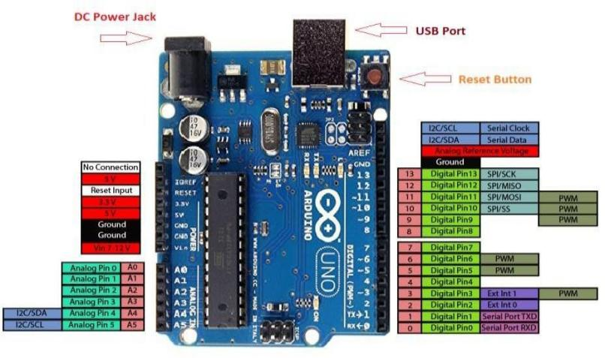
Fig 5.3 Arduino Uno pinout

The Arduino Uno is an open-source microcontroller board based on the Microchip ATmega328P microcontroller (MCU). It was developed by Arduino.cc and initially released in 2010. The board is equipped with sets of digital and analog input/output (I/O) pins that can be interfaced with various expansion boards (shields) and other circuits. The Arduino Uno is a versatile and widely-used microcontroller board suitable for various digital projects. Its open-source nature, ease of programming, and extensive community support make it an excellent choice for both beginners and experienced developers
Key Features

- Microcontroller: ATmega328P (8-bit AVR core)

- Clock Speed: 16 MHz

- Memory: 32 KB Flash, 2 KB SRAM, 1 KB EEPROM

- Digital I/O Pins: 14 (6 capable of PWM output)

- Analog Input Pins: 6

- Operating Voltage: 5 Volts

- Power Sources: USB cable or a barrel connector (7 to 20 volts)

5.3 FLOW CHART

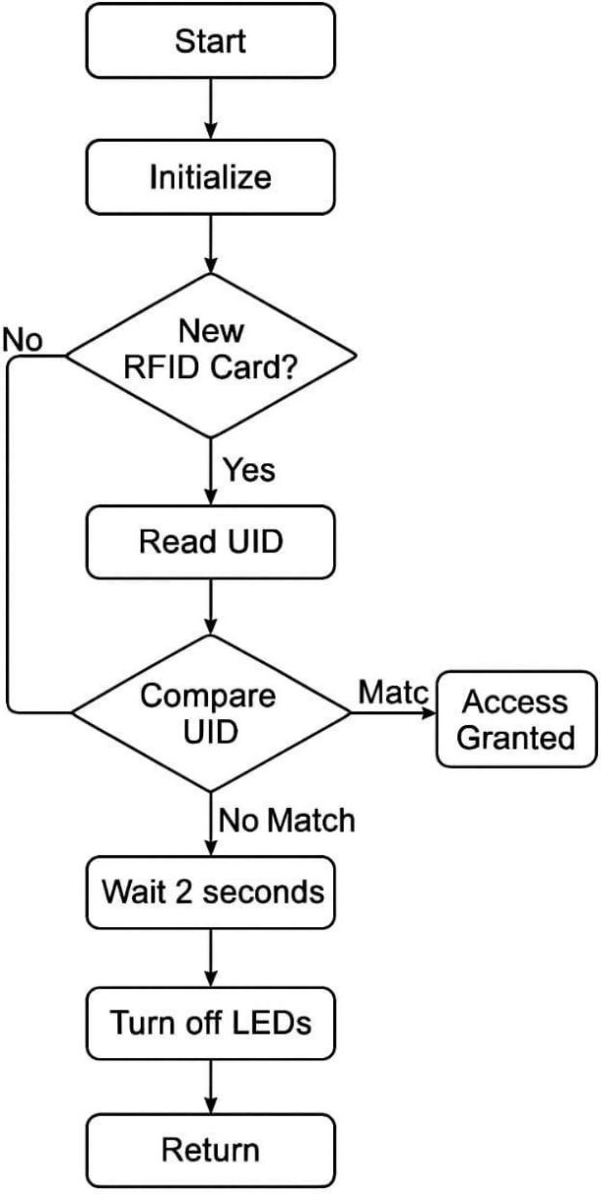

Fig 5.4 Flow Chart

The flowchart shows how the RFID-based access system works. The process starts with system initialization. The reader then continuously checks for a new RFID card. If a card is detected, its UID (Unique ID) is read and compared with the stored authorized IDs. If the UID matches, access is granted. If it does not match, the system waits for a moment, turns off the LEDs, and returns to check for the next card.

5.4 ER DIAGRAM

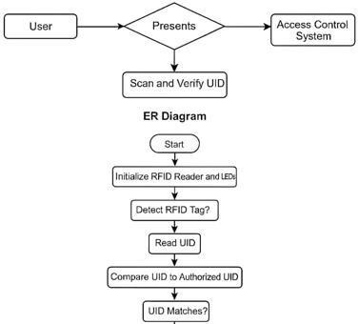

Fig 5.5 ER Diagram

An ER diagram explains how data is stored and connected in a system. It includes entities that represent important objects, attributes that describe their properties, and relationships that show how the entities are linked. This helps in understanding the structure of the database clearly and makes the design easy to build and manage.

CHAPTER 6

IMPLEMENTATION

The implementation of the RFID-based Access Control System using Arduino Uno involves integrating hardware components, writing embedded code, and testing the system for reliable access authentication. The system is designed to read an RFID tag using the MFRC522 module and grant or deny access based on the card’s unique ID.

Hardware Setup:
The circuit is assembled by connecting the MFRC522 RFID reader to the Arduino Uno using SPI communication pins (MISO, MOSI, SCK, and SS). Additional components such as LEDs and a buzzer are connected through a breadboard to indicate access status. The red LED/buzzer signals unauthorized access, while the green LED signals authorized access.

Software Setup:
The Arduino IDE is used to write and upload the program. Required libraries like MFRC522 and SPI are included to enable RFID reading. The system stores one or more authorized RFID tag IDs in the code. When the card is scanned, the Arduino compares the scanned UID with the stored list.

Working Procedure:
When power is supplied, the system initializes the RFID module. It continuously checks for the presence of a card. Once a tag is detected, its UID is read and compared. If there is a match, the green LED turns on, representing access granted. If not, the red LED and buzzer activate briefly to indicate access denied.

Testing and Validation:
Multiple tests are conducted using different RFID tags to confirm correct operation. Authorized cards successfully activate the access-granted LED, while unknown cards trigger the access-denied indicator. The system is tested for reading accuracy, response time, and stability.

Final Output:
The completed system provides a simple, low-cost, and secure method of controlling access using RFID technology. It demonstrates effective real-time authentication and can be expanded for door locking mechanisms, logging data, or IoT integration.

CHAPTER 7

TESTING AND RESULT ANALYSIS

The RFID access-based control system was tested through a series of functional and performance tests to verify accuracy, response time, and reliability. The following test cases were conducted:
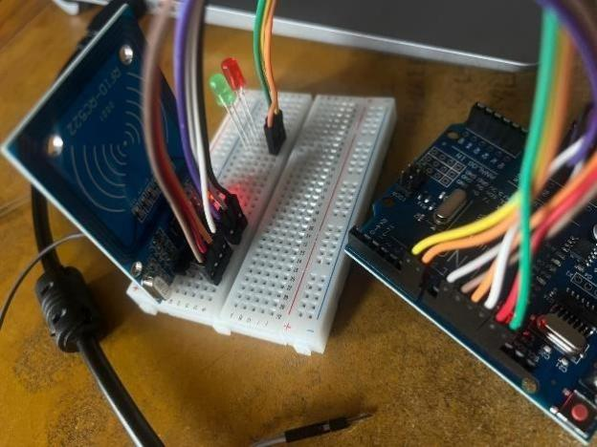
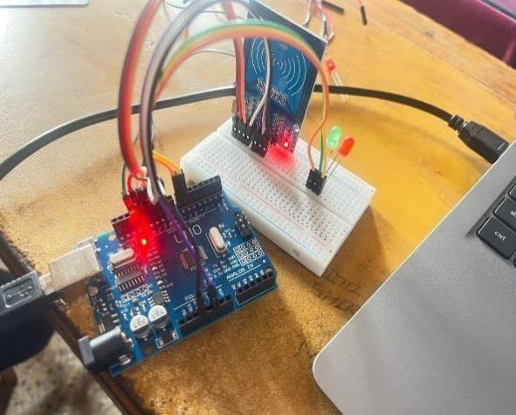


Fig 7.1 Working Model

The RFID access-based control system using Arduino Uno functioned effectively during testing and met all the core objectives of secure, fast, and user-friendly access control.
The Arduino Uno provided sufficient processing capability to handle RFID communication, authorization logic, and lock control. The RC522 RFID reader performed reliably at short ranges, which is acceptable for secure access systems but limits convenience slightly compared to higher-range readers. The servo/relay mechanism

worked consistently, showing that the system is suitable for real-world applications such as door locks, cabinet locks, attendance systems, or restricted lab access.
One limitation observed during testing was the system’s sensitivity to power fluctuations. A weak power supply caused occasional resets, suggesting that a dedicated regulated power source or capacitor stability circuit would improve reliability. Another minor limitation is the range dependency on tag orientation, which is inherent to inexpensive RFID modules.
Overall, the system demonstrated high accuracy, fast response time, and stable performance. With minor improvements such as a stronger power supply, data logging, or integration with IoT for remote monitoring, the system could be upgraded to a more advanced and scalable security solution.

CHAPTER 8

CONCLUSION

This project successfully demonstrates a basic yet effective RFID-based access control system using the Arduino Uno and MFRC522 module. It can detect RFID tags, compare their UID to a pre-stored authorized ID, and provide access control feedback using LEDs.
Key achievements:

- Integration of Arduino Uno with an RFID reader via SPI communication.

- UID detection and verification logic in code.

- Real-time feedback using LEDs and serial messages.

- Simple, modular code that can be extended further.

This project lays the foundation for secure, low-cost access control systems that can be used in homes, labs, schools, and office environments.

REFERENCES

- Akash P, et al. RFID Based Security System Using Arduino Module.
- Shubham S, et al. RFID-Based Digital Door Locking System.
- Vivek K, et al. RFID Based Access Control System Using Arduino.
- Swathika S, et al. IoT Based Access Control Mechanism Using RFID Technology.
- Orji C, et al. Automatic Access Control System Using Arduino and RFID.

