**PROJECT REPORT**

**on**

**Restaurant Management System**

**Submitted To:**

Sir Hussain Gillani

Department of Computer Science

**Submitted By:**

Safa Waseem (Roll No.242201054)

Misbah Saeed (Roll No. 242201059)

Sania Shabbir (Roll No.242201055)

Fiza Jabbir (Roll No.242201091)

Course: Database Management Systems (DBMS)

Semester:2nd Semester - BSCS

**Restaurant Management System**

# 1. Introduction

## Purpose

The purpose of this project is to design and develop a Restaurant Management System that streamlines day-to-day restaurant operations such as customer management, order placement, billing, reservations, and employee management. The system aims to reduce manual work and improve efficiency and accuracy.

## Project Scope

The system will manage customer details, menu items, table reservations, order processing, bill generation, and employee records. The scope is limited to in-house restaurant operations and does not include food delivery services.

# 2. Overall Product Description

## Functions

* Maintain customer records.
* Display menu items with prices.
* Take and manage customer orders.
* Generate itemized bills automatically.
* Reserve tables for customers.
* Manage employee data including roles and salaries.

## Operating Environment

* Database: Oracle 10g
* Frontend : Java, PHP, or C#
* Operating System: Windows or Linux
* Hardware Requirements: A basic PC with 4 GB RAM and 20 GB disk space

# 3. Design

## ERDs (Entity-Relationship Diagrams)

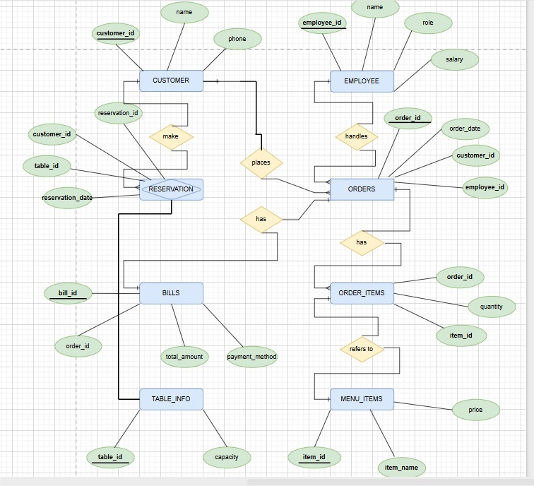

## Implementation Constraints

* Each table will have a Primary Key (e.g., Customer\_ID, Order\_ID).
* Foreign Keys will enforce relationships (e.g., Order.Customer\_ID → Customer.Customer\_ID).
* Oracle-compatible data types like NUMBER, VARCHAR2, and DATE will be used

# 4. Requirements

## Functional Requirements

* Register and manage customer profiles
* View and update the menu with item prices
* Process customer orders with multiple items
* Automatically calculate and generate bills
* Manage reservations and table availability
* Record employee information and roles

## Non-Functional Requirements

* Performance: The system should handle multiple users without lag
* Security: Access should be restricted to authorized users
* Usability: Interface should be intuitive and easy to use
* Scalability: The system should support future feature additions

# 5. User Interface

## Creating Tables:

**Customer Table Creation:**

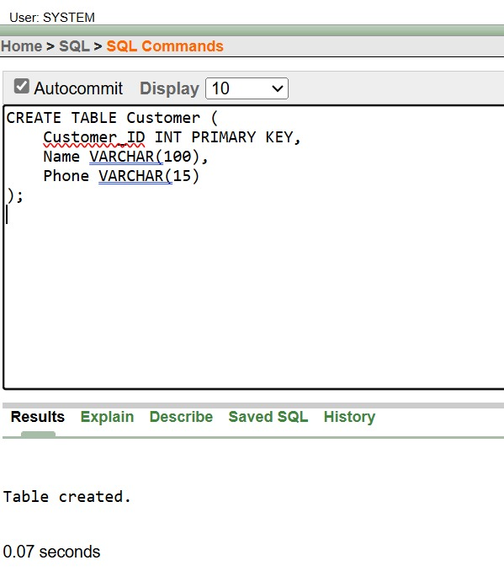

**Employee Table creation:**

**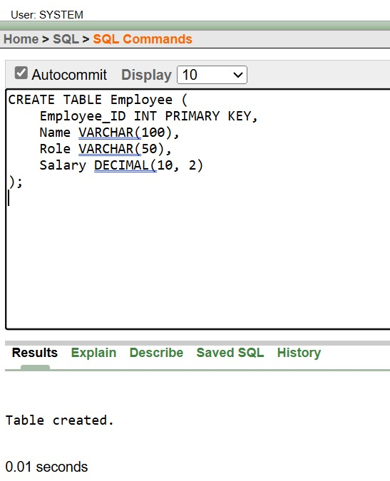**

**Menu-item table creation:**

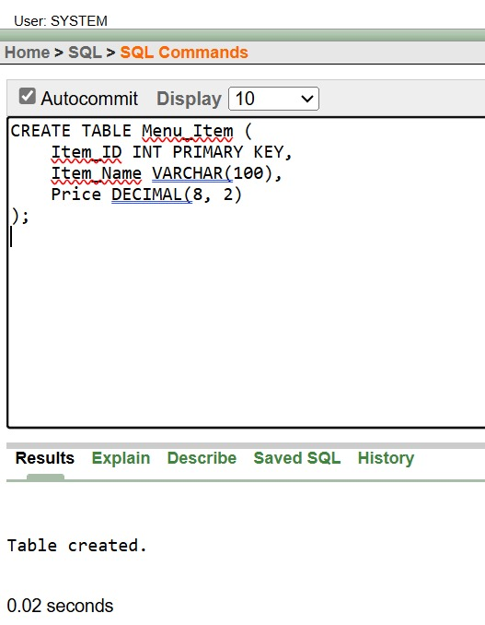

**Orders table Creation:**

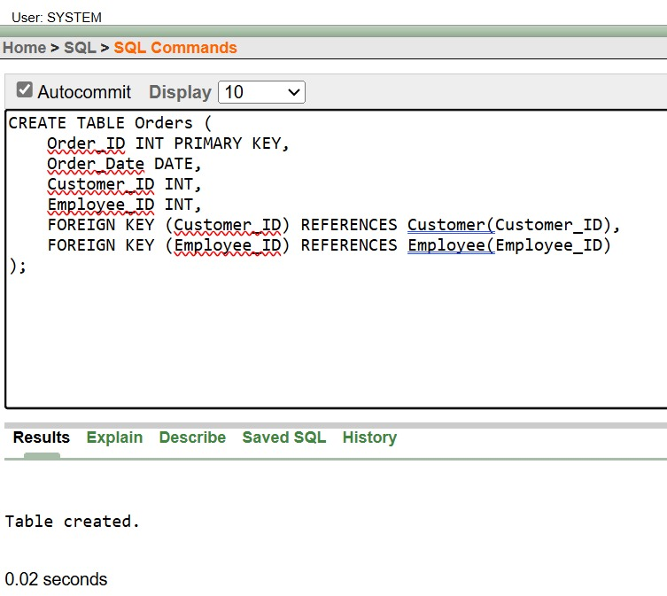

**Order-item table Creation:**

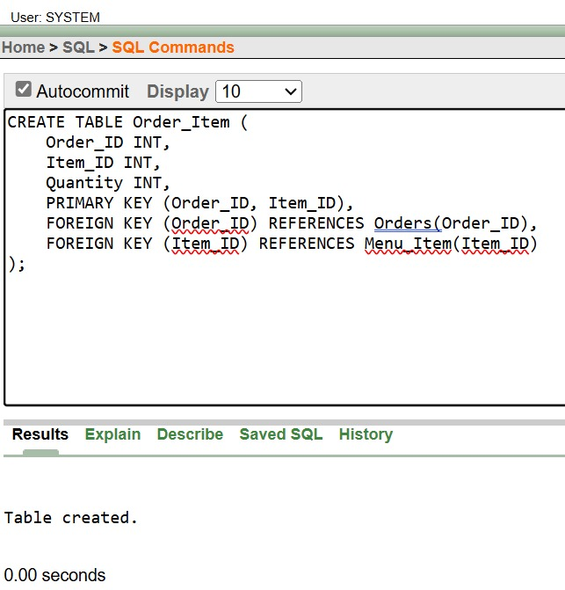

**Bill Table Creation**:

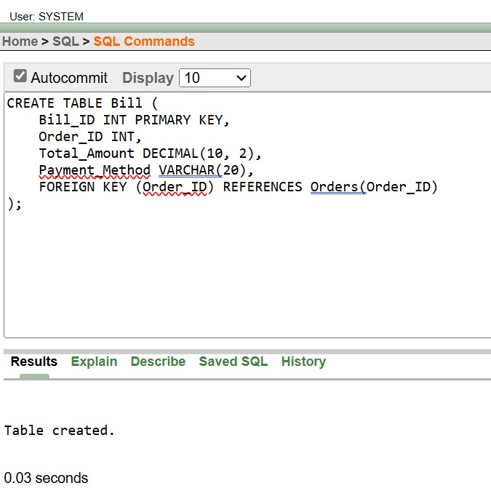

**Table-Info Creation:**

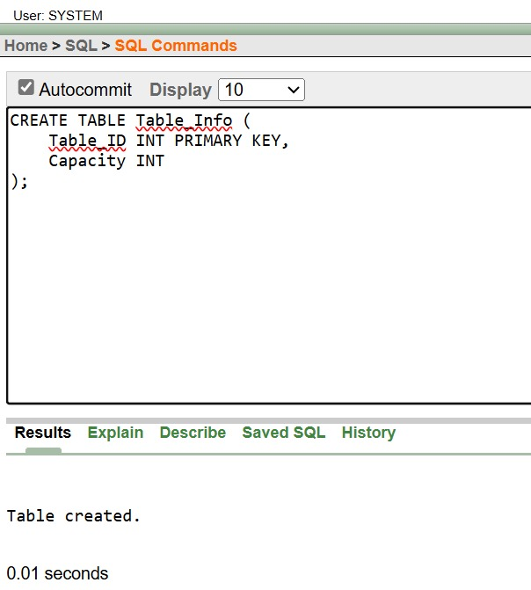

**Reservation table creation**:

## WhatsApp Image 2025-05-31 at 17.18.18_39ecbcce

## Insertion:

## Insert record into Customer:

## WhatsApp Image 2025-05-31 at 17.18.32_56ba6b08

**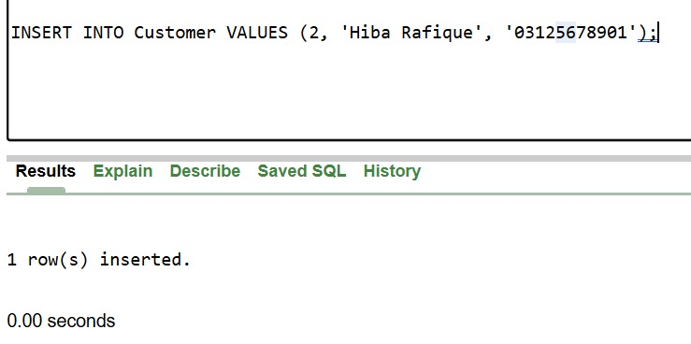**

**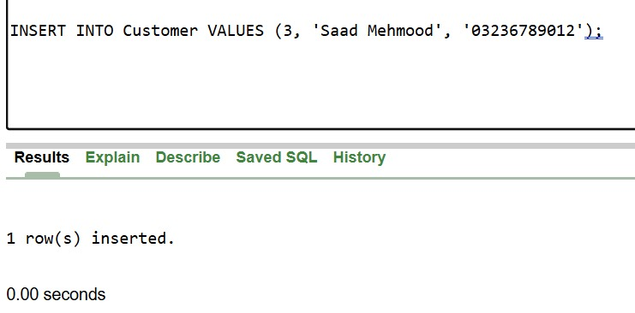**

**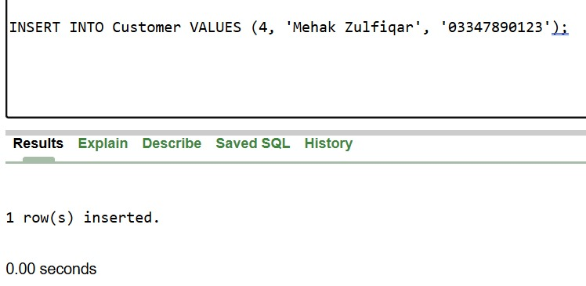**

**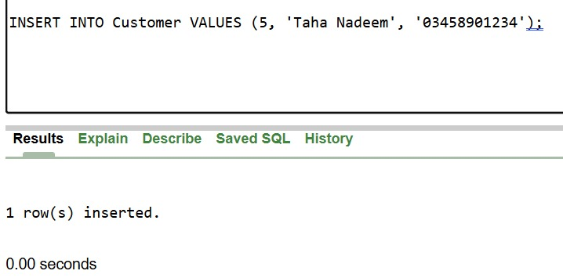**

**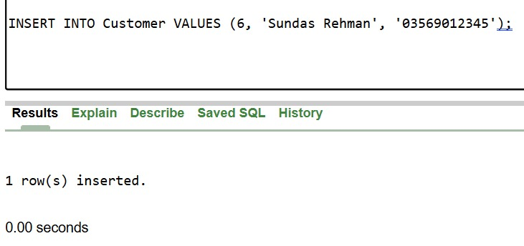**

**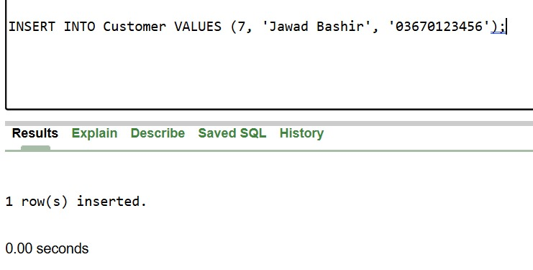**

**Insert Record into Employee:**

**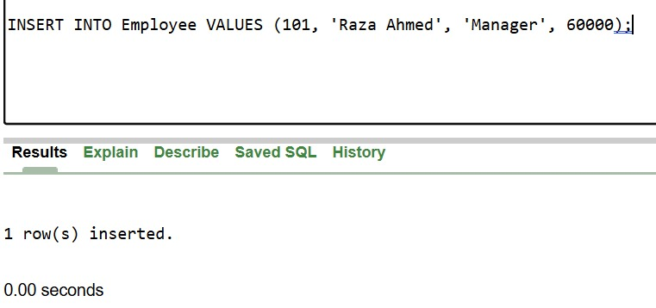**

**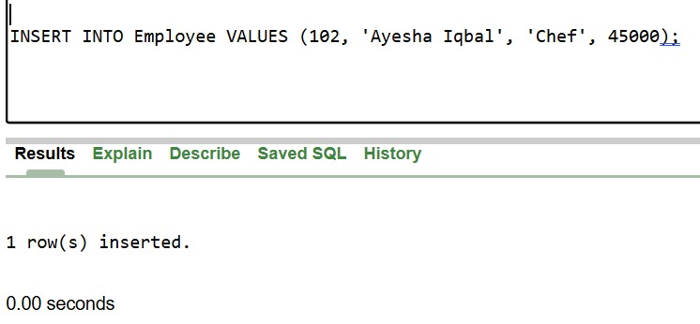**

**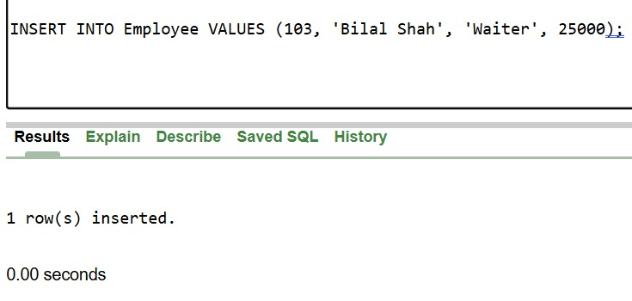**

**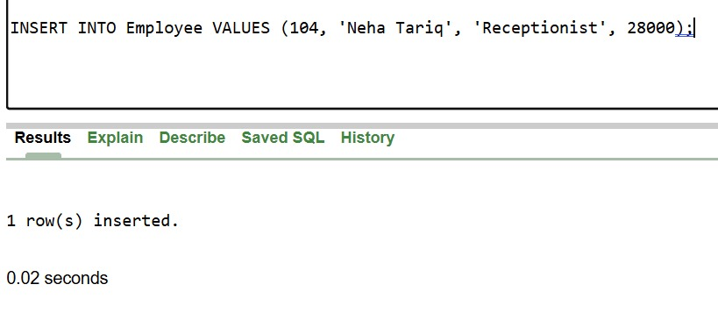**

**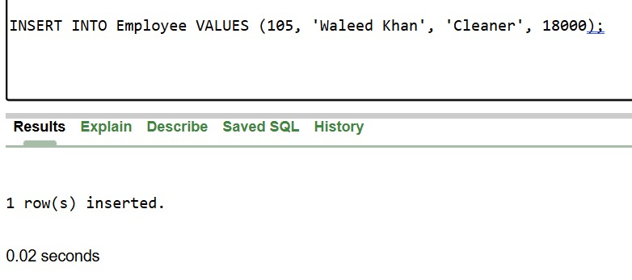**

**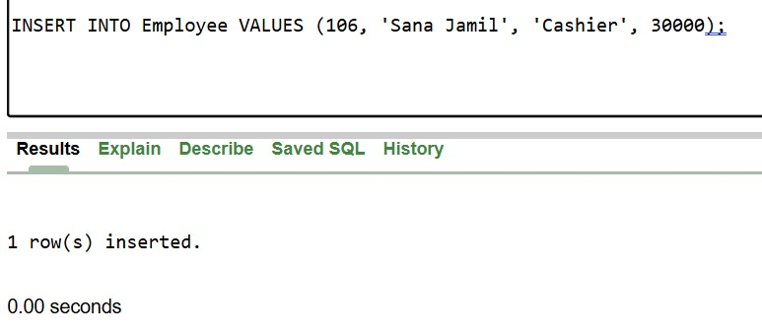**

**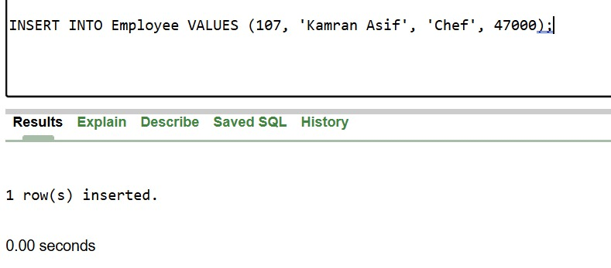**

**Insert Record into Menu-item:**

**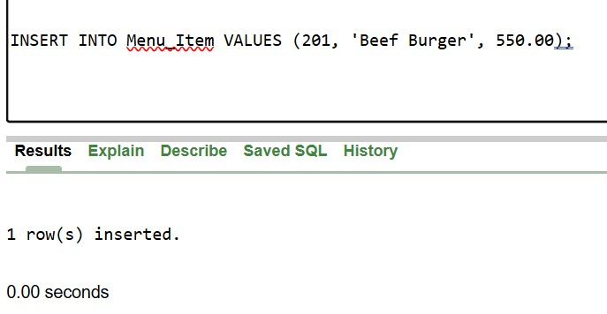**

**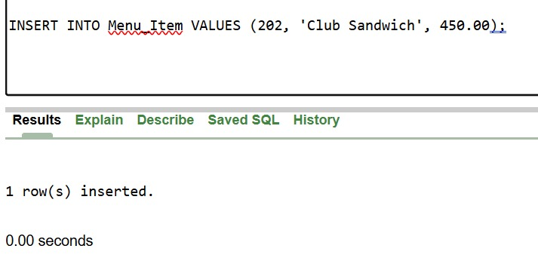**

**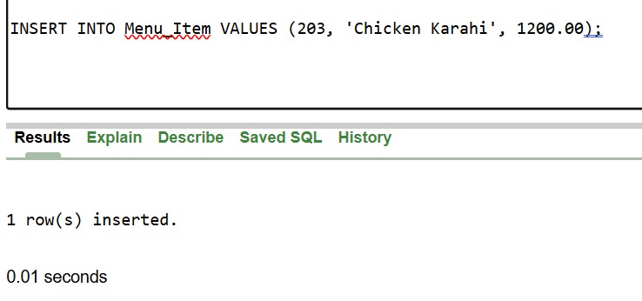**

**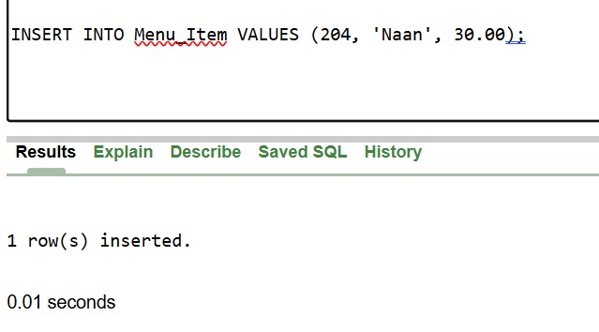**

**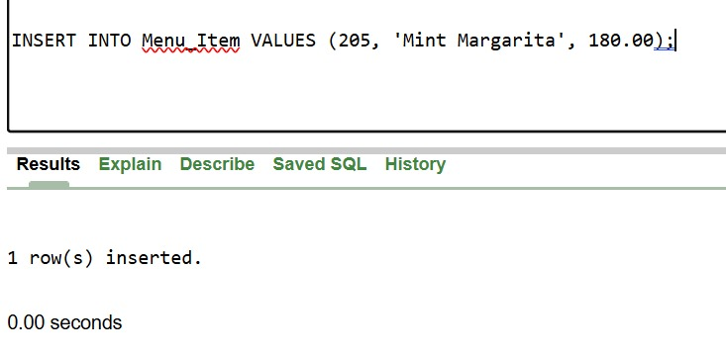**

**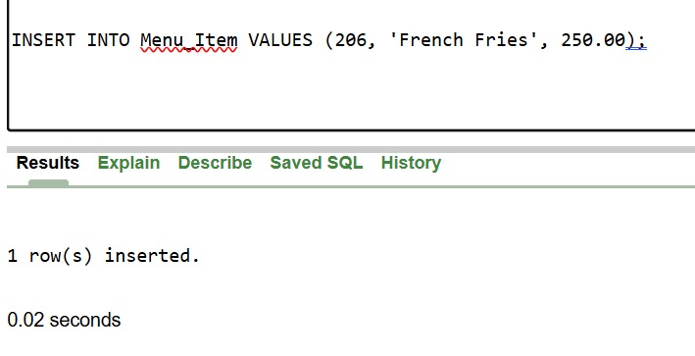**

**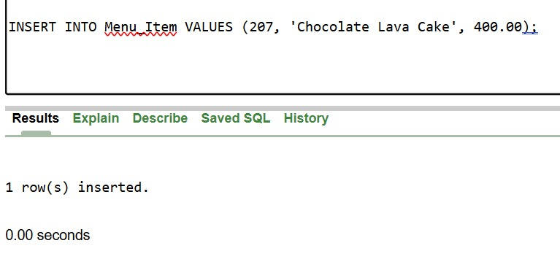**

**Insert Record Into Orders:**

**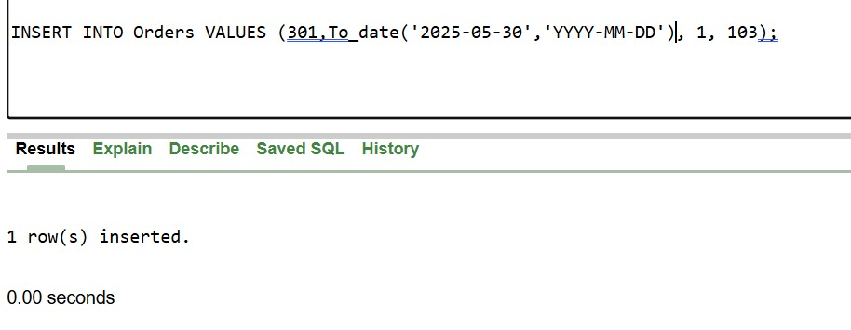**

**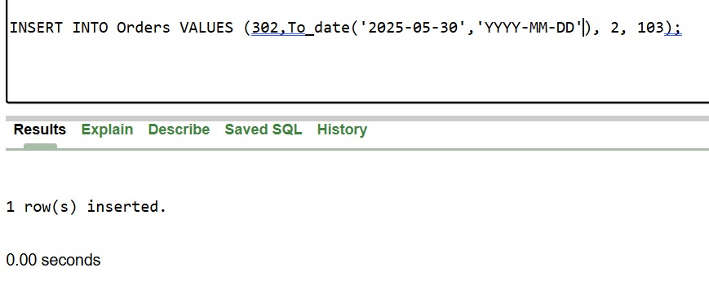**

**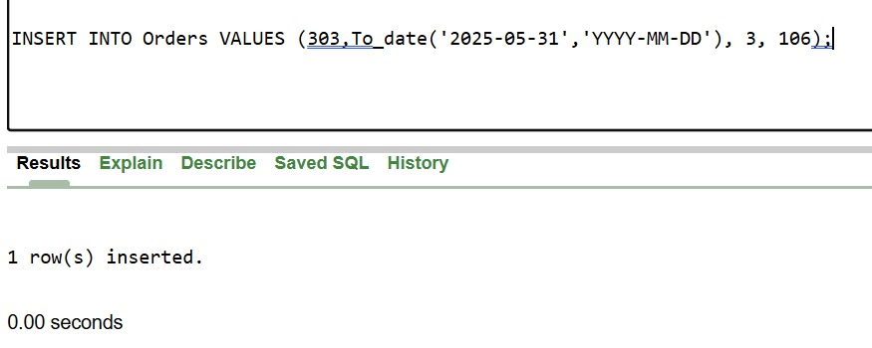**

**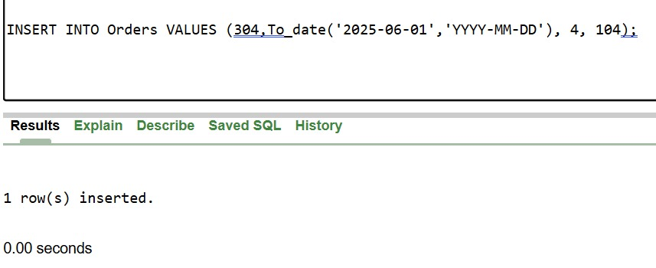**

**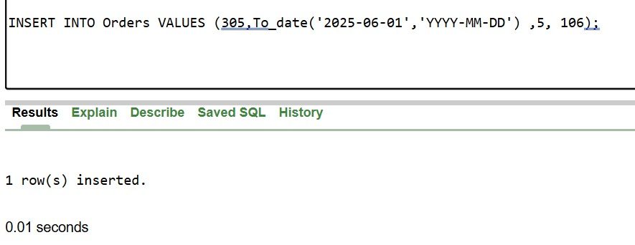**

**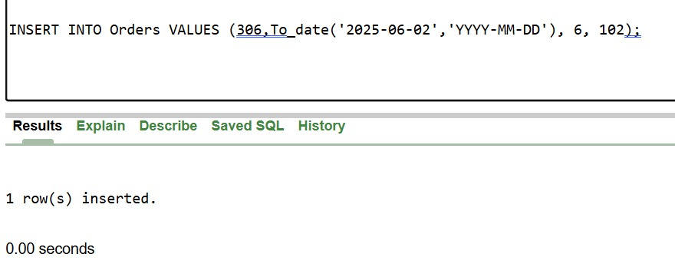**

**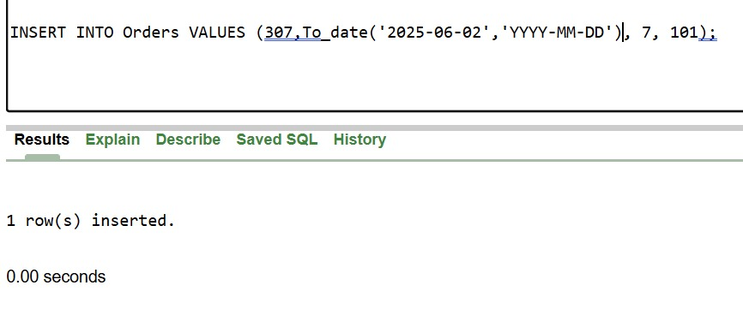**

**Insert Record into Order-item:**

**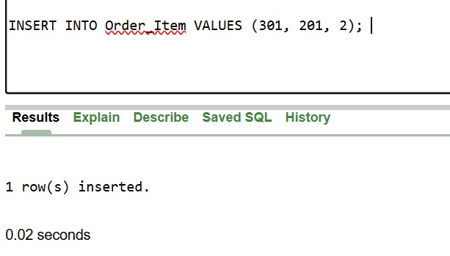**

**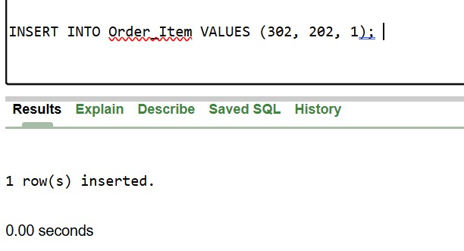**

**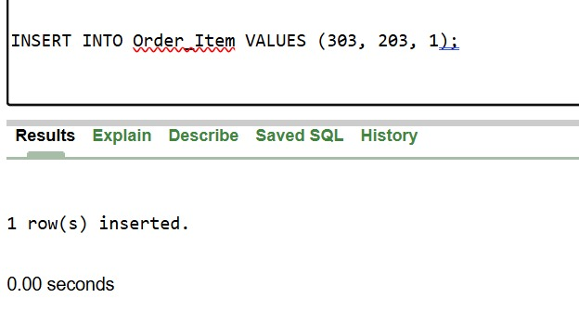**

**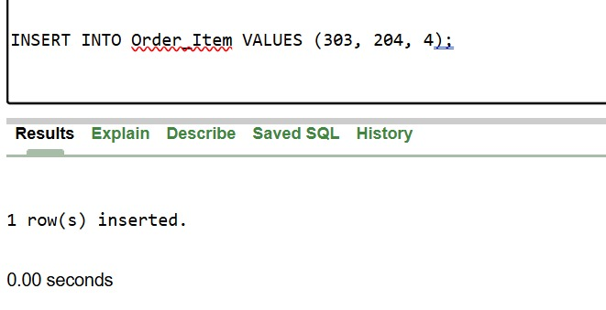**

**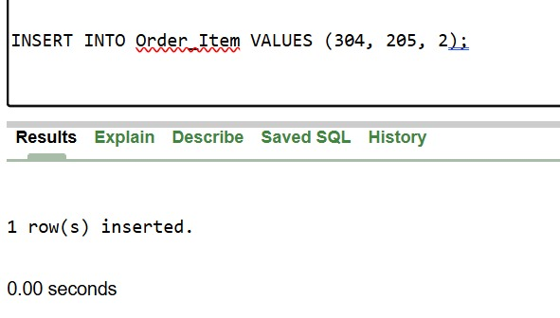**

**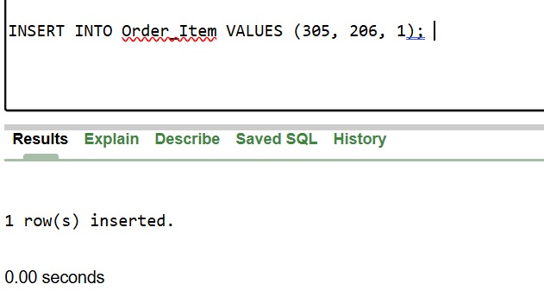**

**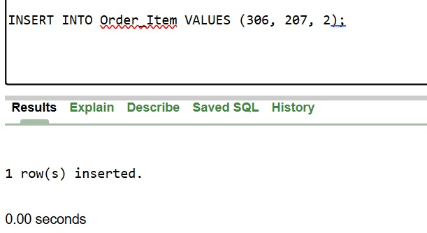**

**Insert Record into Bill:**

**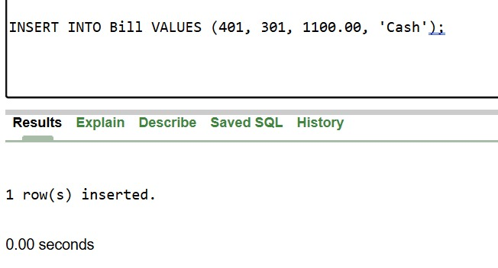**

**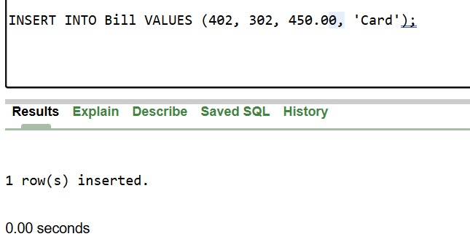**

**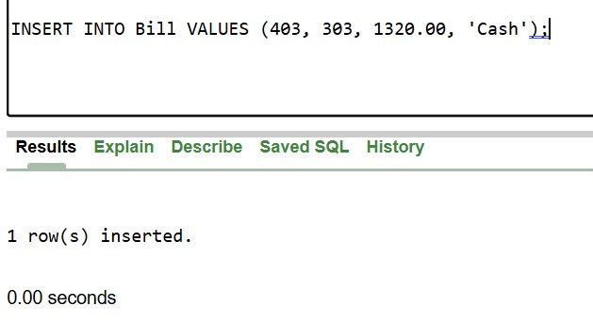**

**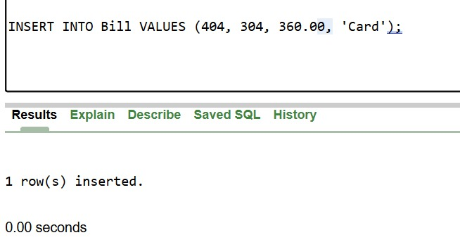**

**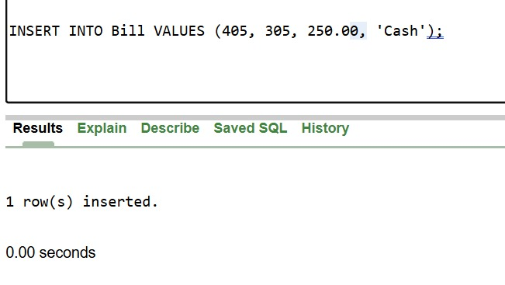**

**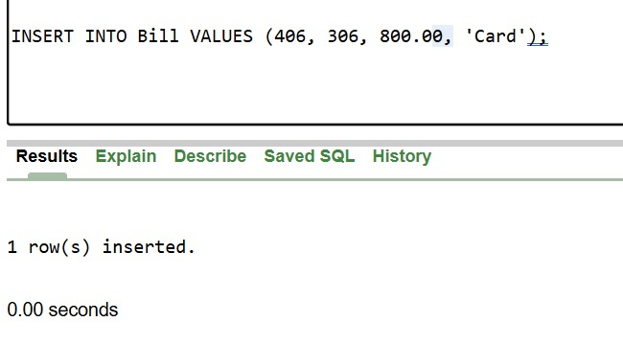**

**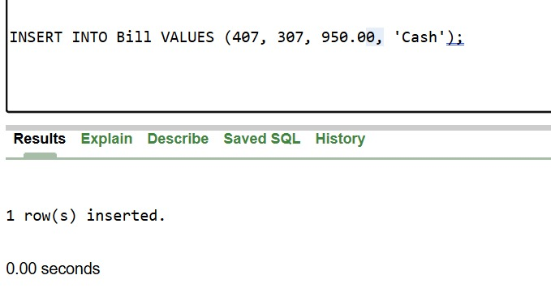**

**Insert Record Into Table-Info:**

**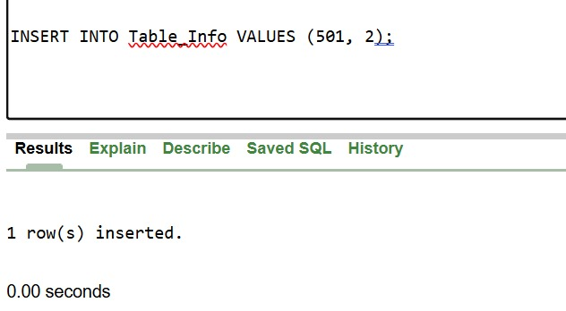**

**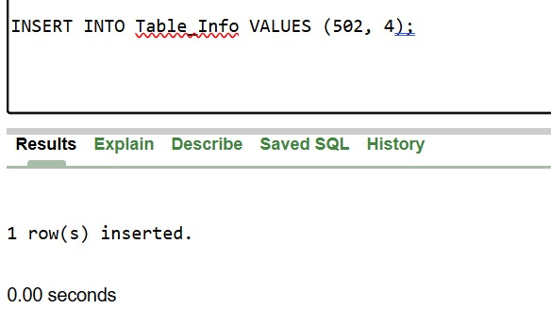**

**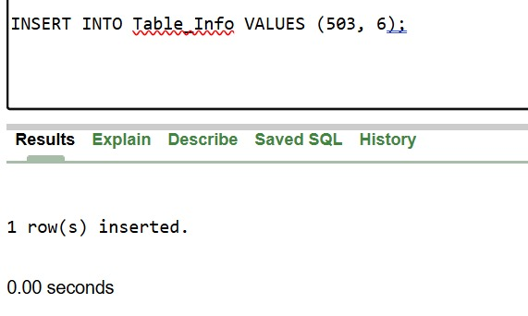**

**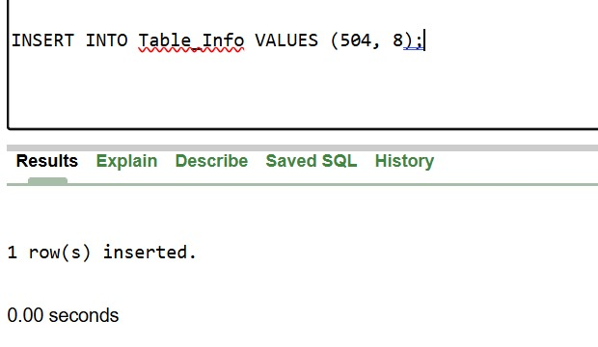**

**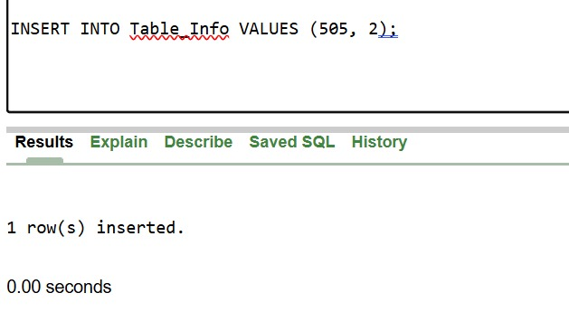**

**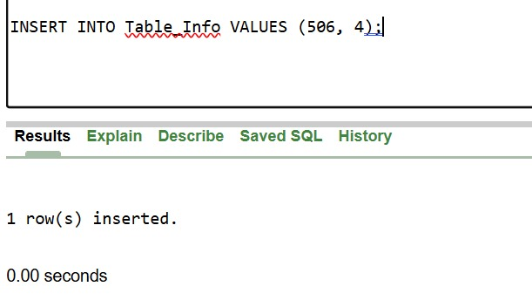**

**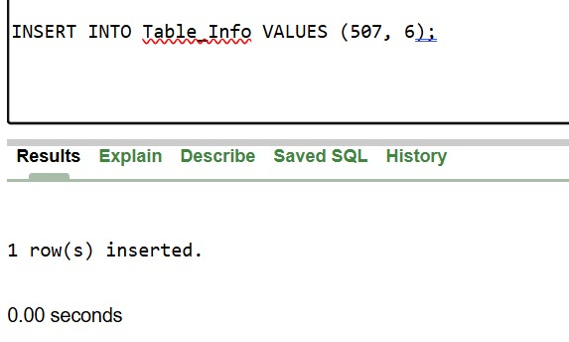**

**Insert Record Into Reservation:**

**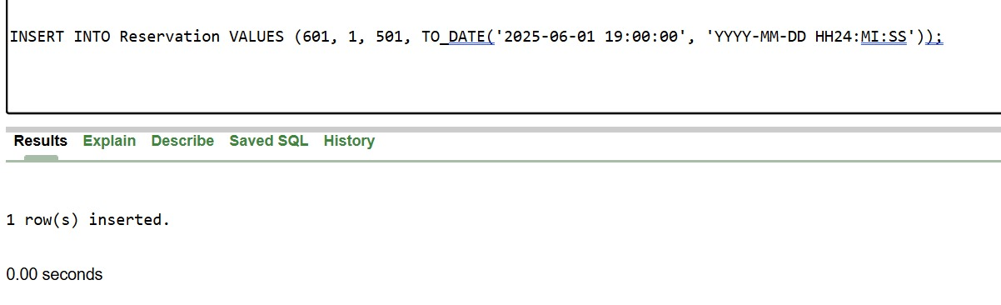**

**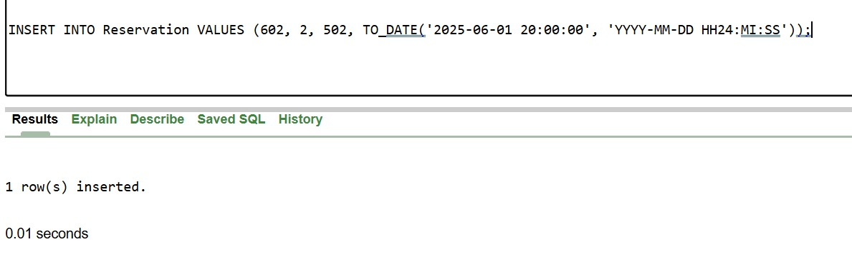**

**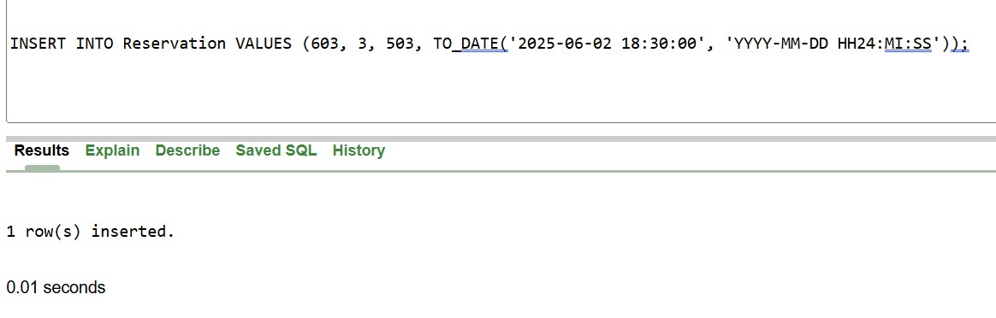**

**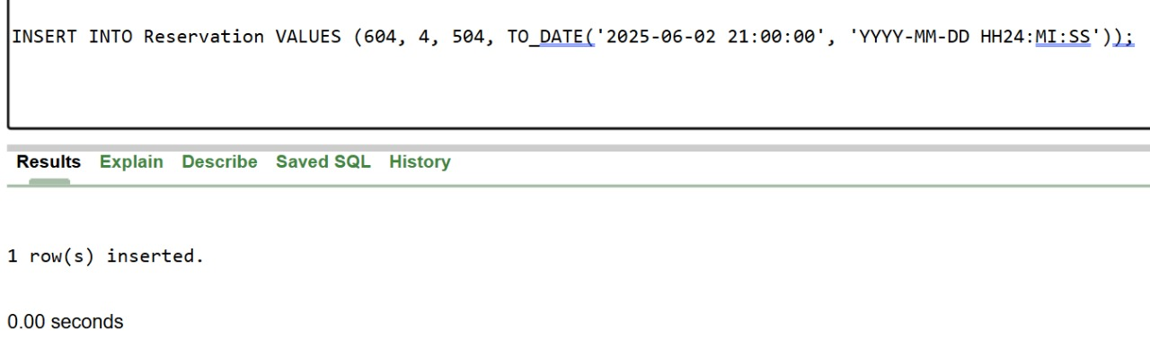**

**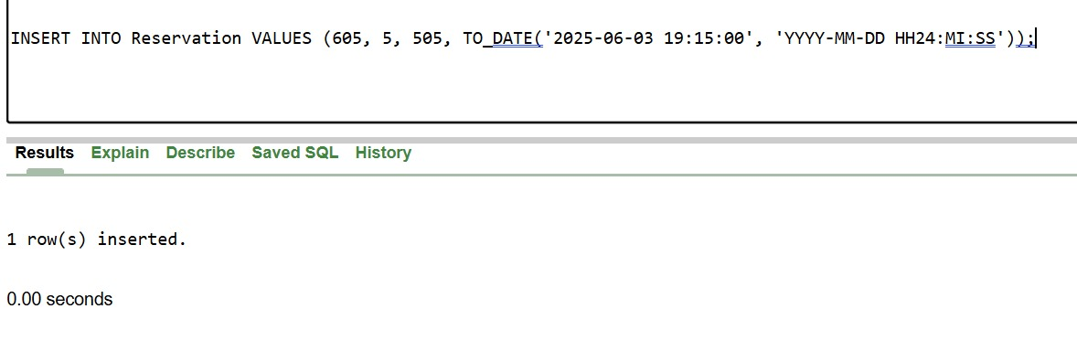**

## View Tables:

**Customer Table view:**

**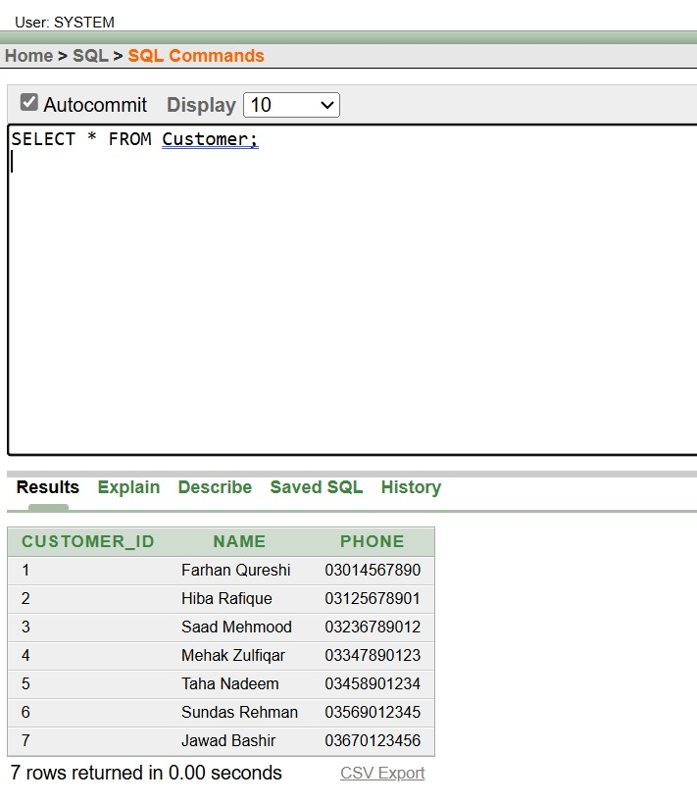**

**Employee Table View:**

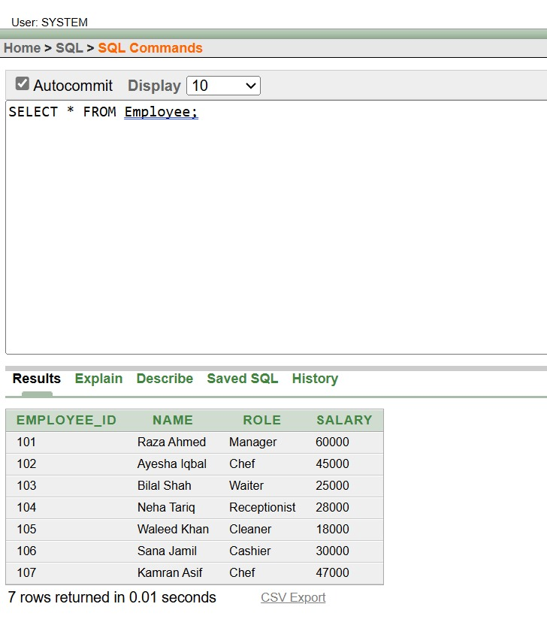

**Menu\_Item Table View:**

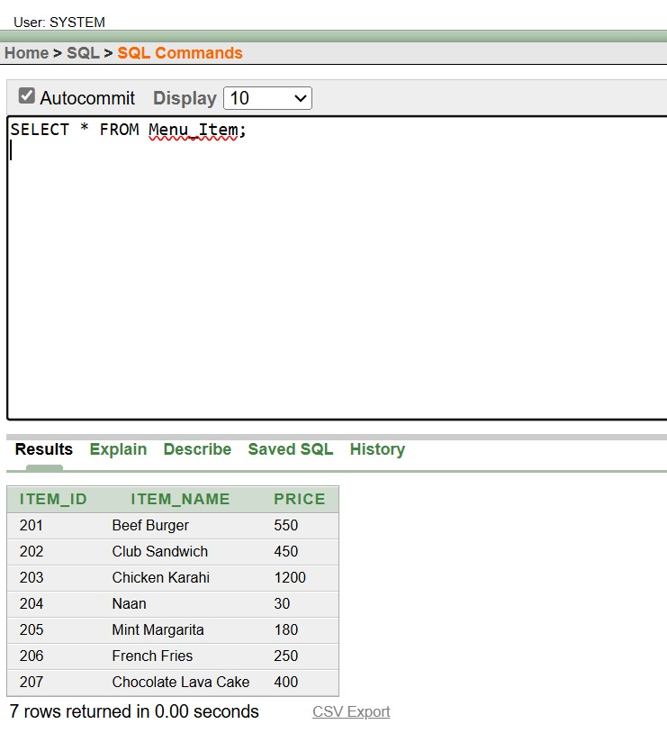

**Orders Table View:**

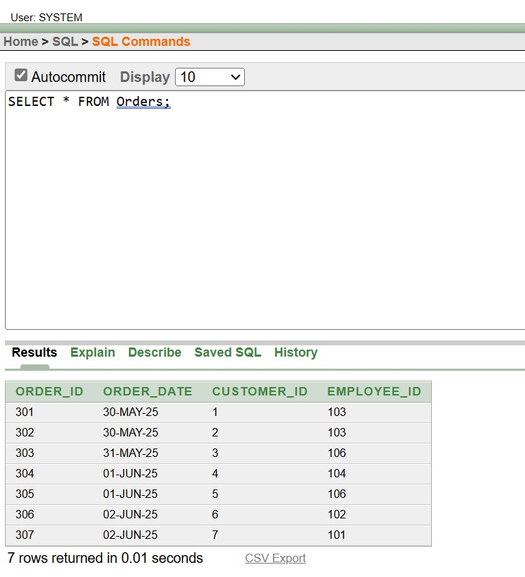

**Order\_Item Table View:**

**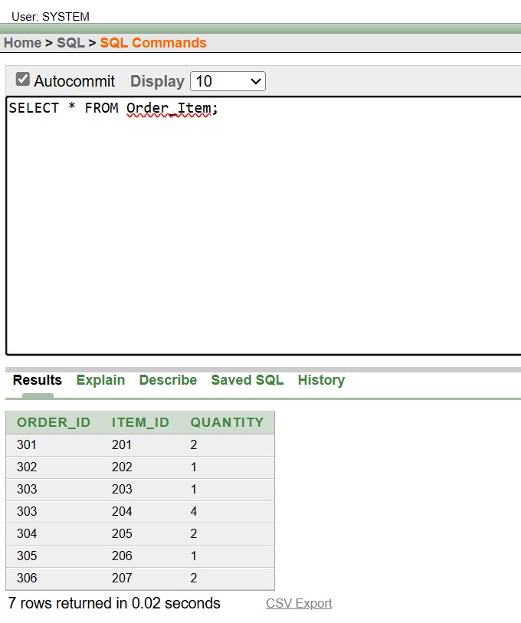**

**Bill Table View:**

**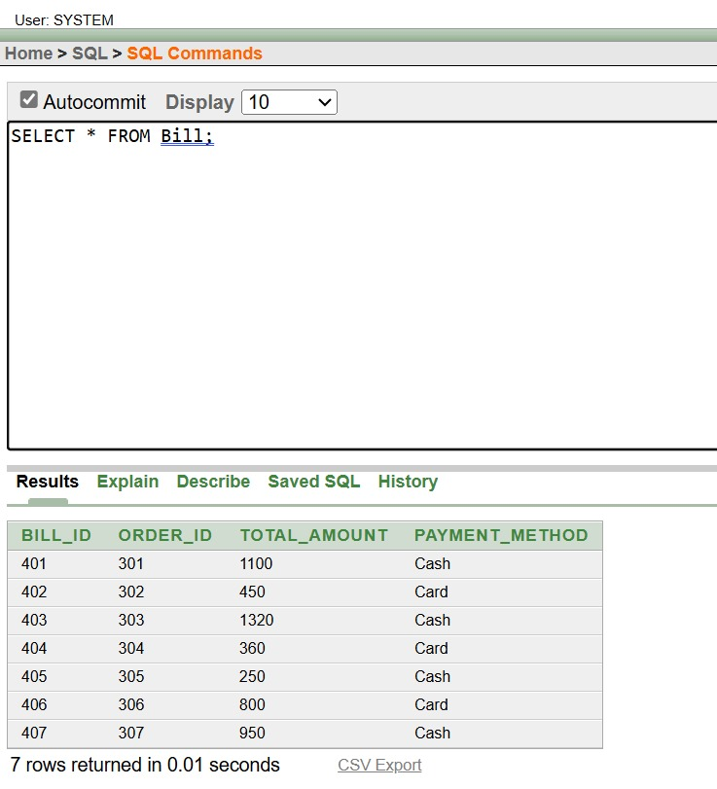**

**Table\_Info View:**

**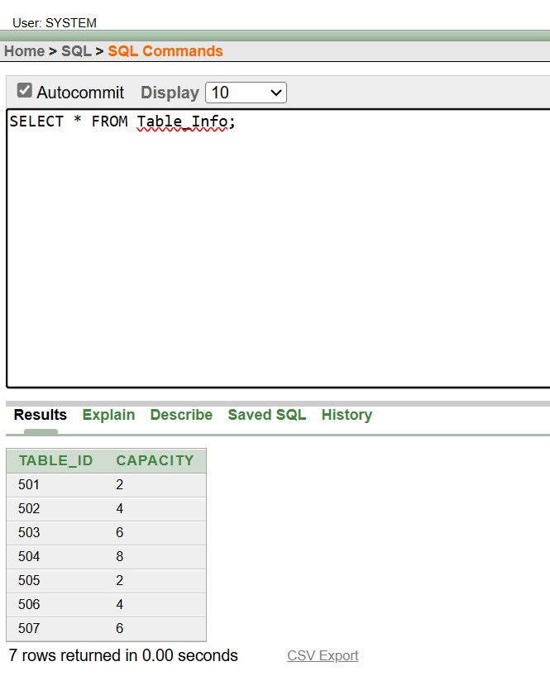**

**Reservations Table View:**

**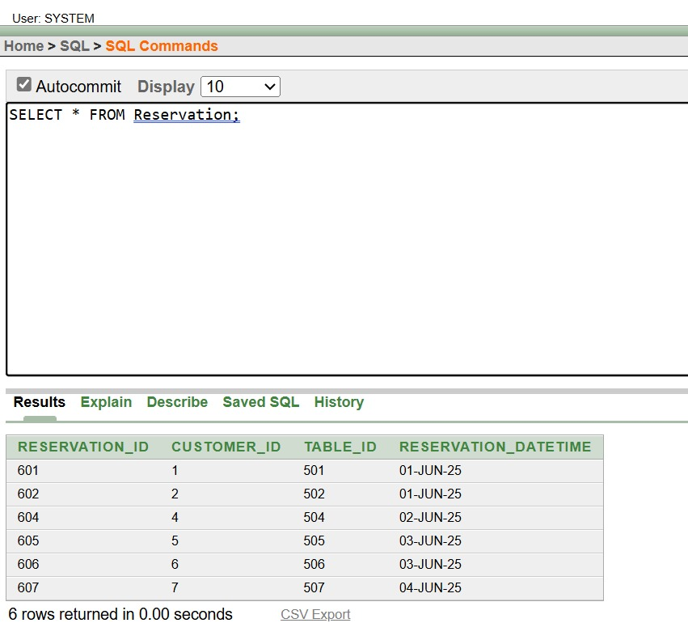**

## Views:

**Order view with Customer and Emloyee:**

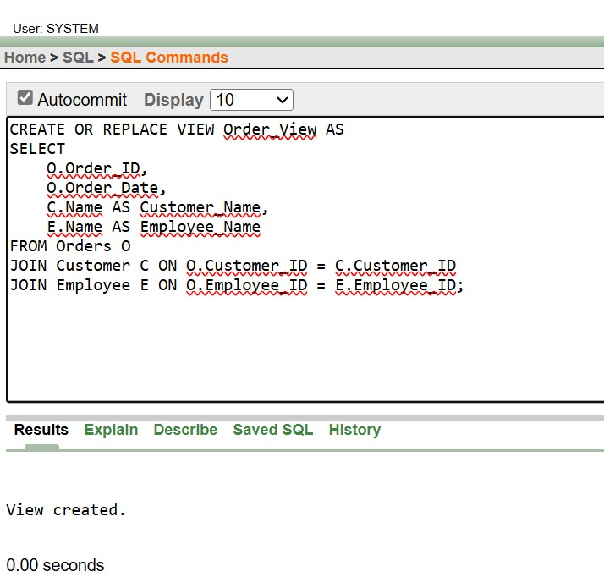

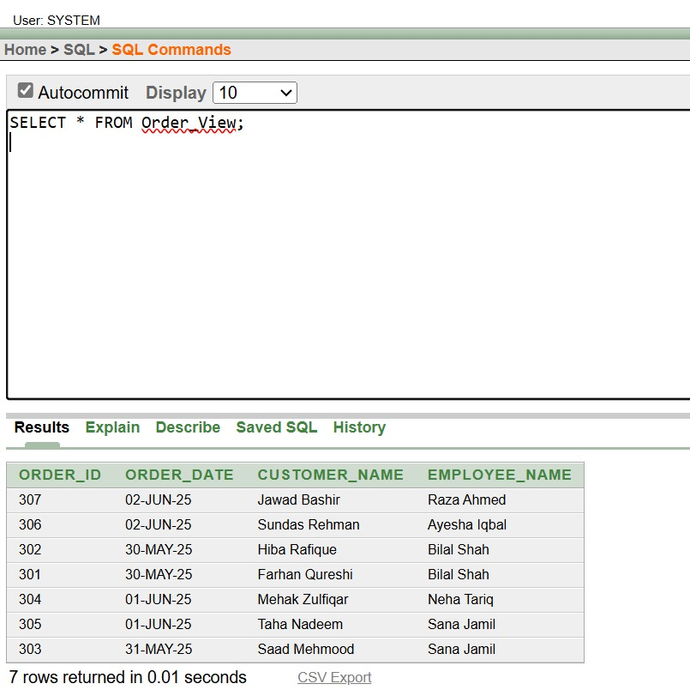

**Bill view with Customer and Order:**

**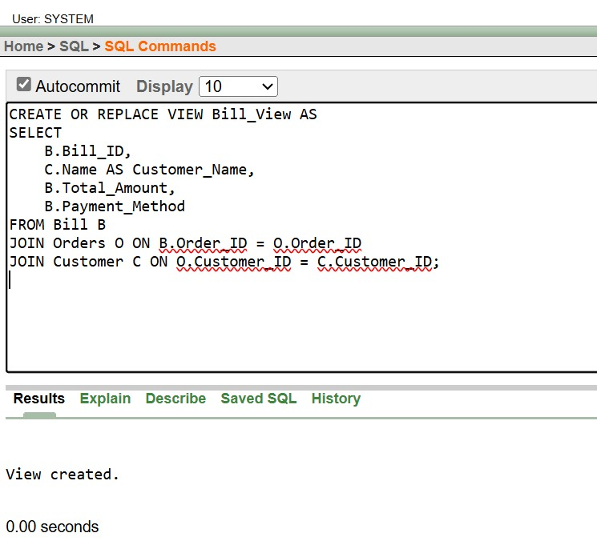**

**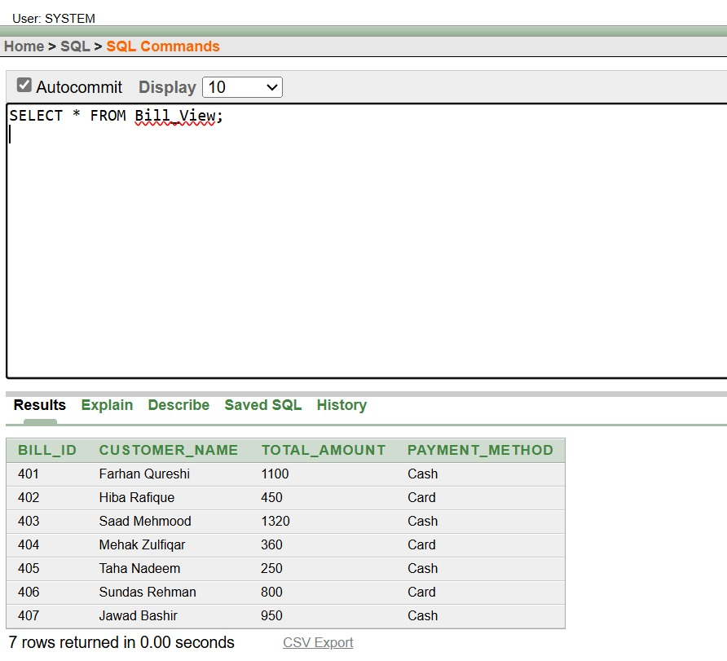**

**Reservation view with Customer and Order:**

**