Nama : Safara Risda Agastya

NIM : A11.2022.14670

Kelp. : A11.4415

Mata Kuliah : Pemograman Berorientasi Objek

**Tugas 1**

Program sederhana untuk menampilkan data pribadi

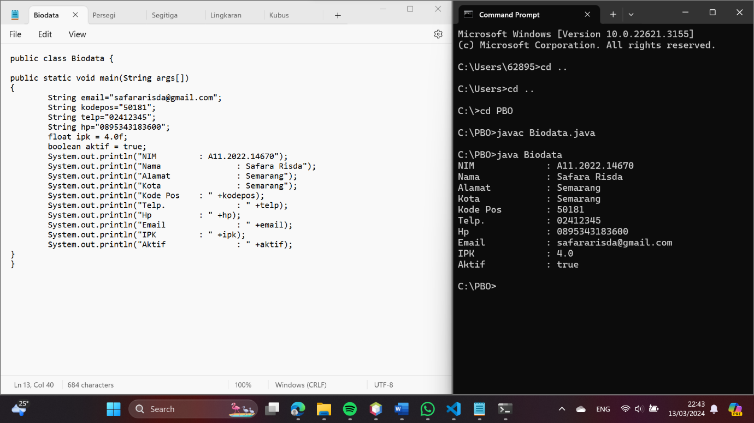

**Code Program :**

public class Biodata {

public static void main(String args[])

{

  String email="safararisda@gmail.com";

  String kodepos="50181";

  String telp="02412345";

String hp="0895343183600";

    float ipk = 4.0f;

    boolean aktif = true;

    System.out.println("NIM : A11.2022.14670");

        System.out.println("Nama         : Safara Risda");

System.out.println("Alamat : Semarang");

        System.out.println("Kota : Semarang");

        System.out.println("Kode Pos     : " +kodepos);

        System.out.println("Telp.       : " +telp);

        System.out.println("Hp       : " +hp);

    System.out.println("Email       : " +email);

    System.out.println("IPK     : " +ipk);

    System.out.println("Aktif       : " +aktif);

}

}

**Tugas 2**

Program menghitung luas dan keliling

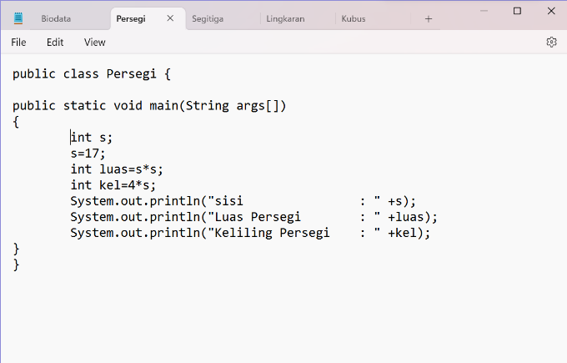 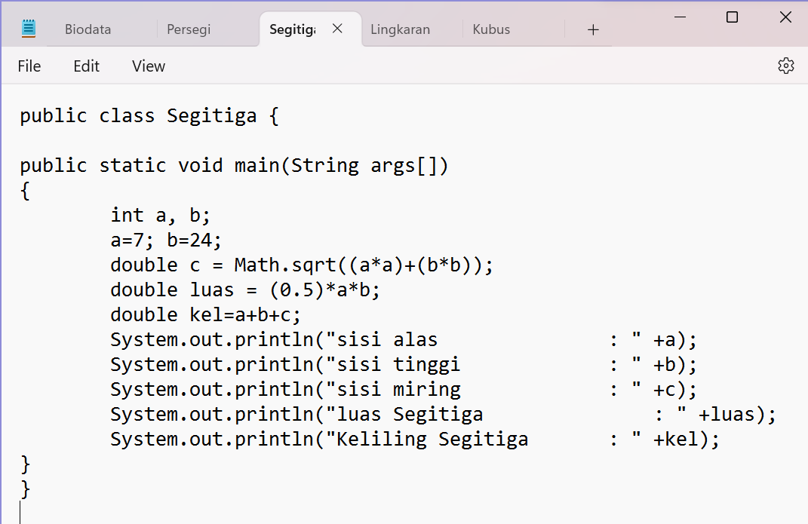

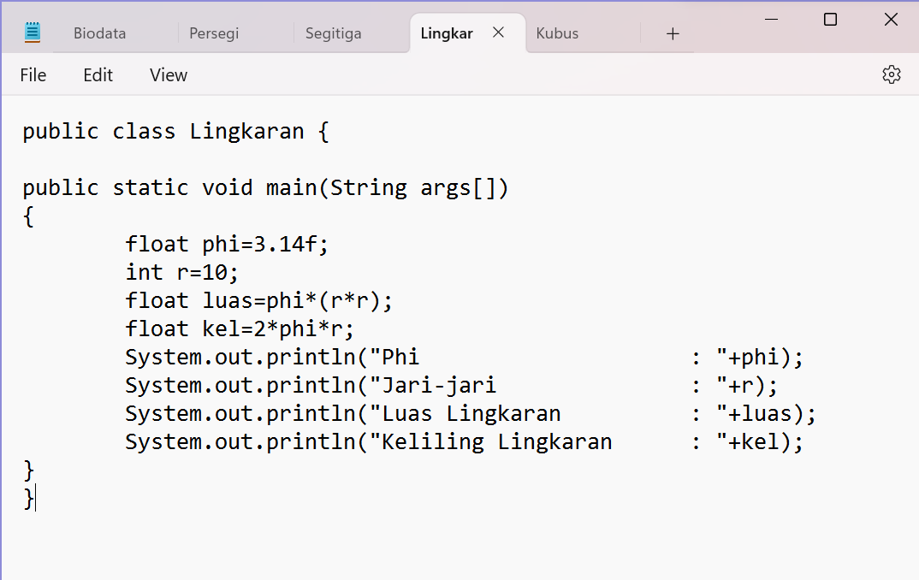 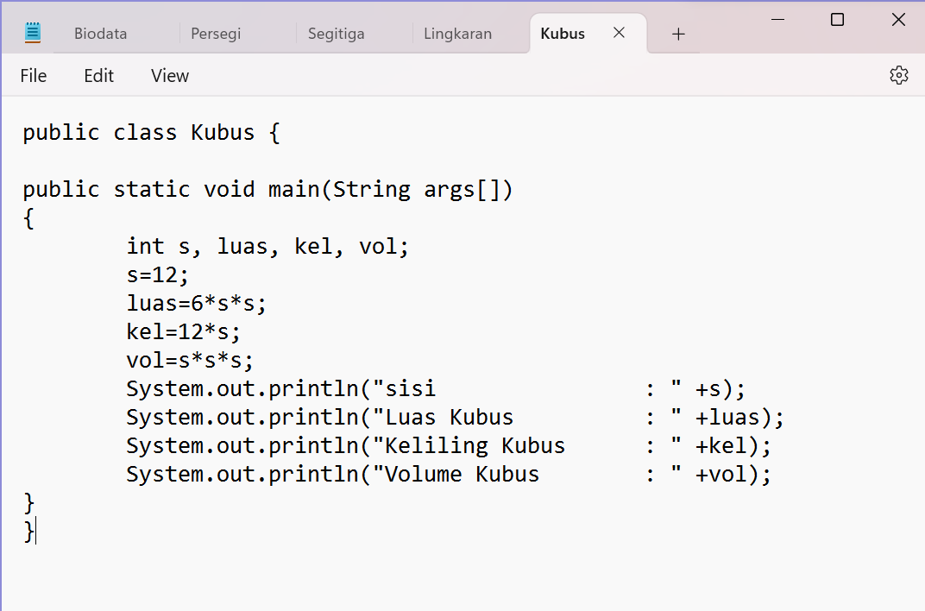

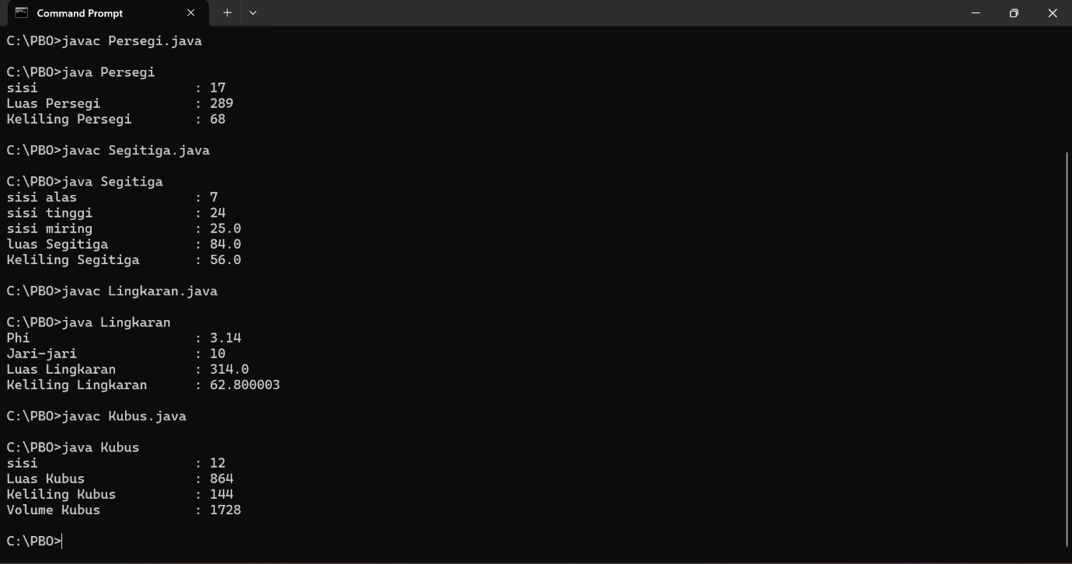

**Code Program :**

* **Persegi**

public class Persegi {

public static void main(String args[])

{

  int s;

s=17;

int luas=s*s;

int kel=4*s;

System.out.println("sisi : " +s);

System.out.println("Luas Persegi : " +luas);

System.out.println("Keliling Persegi : " +kel);

}

}

* **Segitiga**

public class Segitiga {

public static void main(String args[])

{

int a, b;

a=7; b=24;

double c = Math.sqrt((a*a)+(b*b));

double luas = (0.5)*a*b;

double kel=a+b+c;

System.out.println("sisi alas : " +a);

System.out.println("sisi tinggi : " +b);

System.out.println("sisi miring : " +c);

System.out.println("luas Segitiga : " +luas);

System.out.println("Keliling Segitiga : " +kel);

}

}

* **Lingkaran**

public class Lingkaran {

public static void main(String args[])

{

float phi=3.14f;

int r=10;

float luas=phi*(r*r);

float kel=2*phi*r;

System.out.println("Phi : "+phi);

System.out.println("Jari-jari : "+r);

System.out.println("Luas Lingkaran : "+luas);

System.out.println("Keliling Lingkaran : "+kel);

}

}

* **Kubus**

public class Kubus {

public static void main(String args[])

{

int s, luas, kel, vol;

s=12;

luas=6*s*s;

kel=12*s;

vol=s*s*s;

System.out.println("sisi : " +s);

System.out.println("Luas Kubus : " +luas);

System.out.println("Keliling Kubus : " +kel);

System.out.println("Volume Kubus : " +vol);

}

}