Nama : Safara Risda Agastya

NIM : A11.2022.14670

Kelompok : A11.4415

Mata Kuliah : Pemrograman Berorientasi Objek

PRAKTIKUM 2

**Latihan 1**

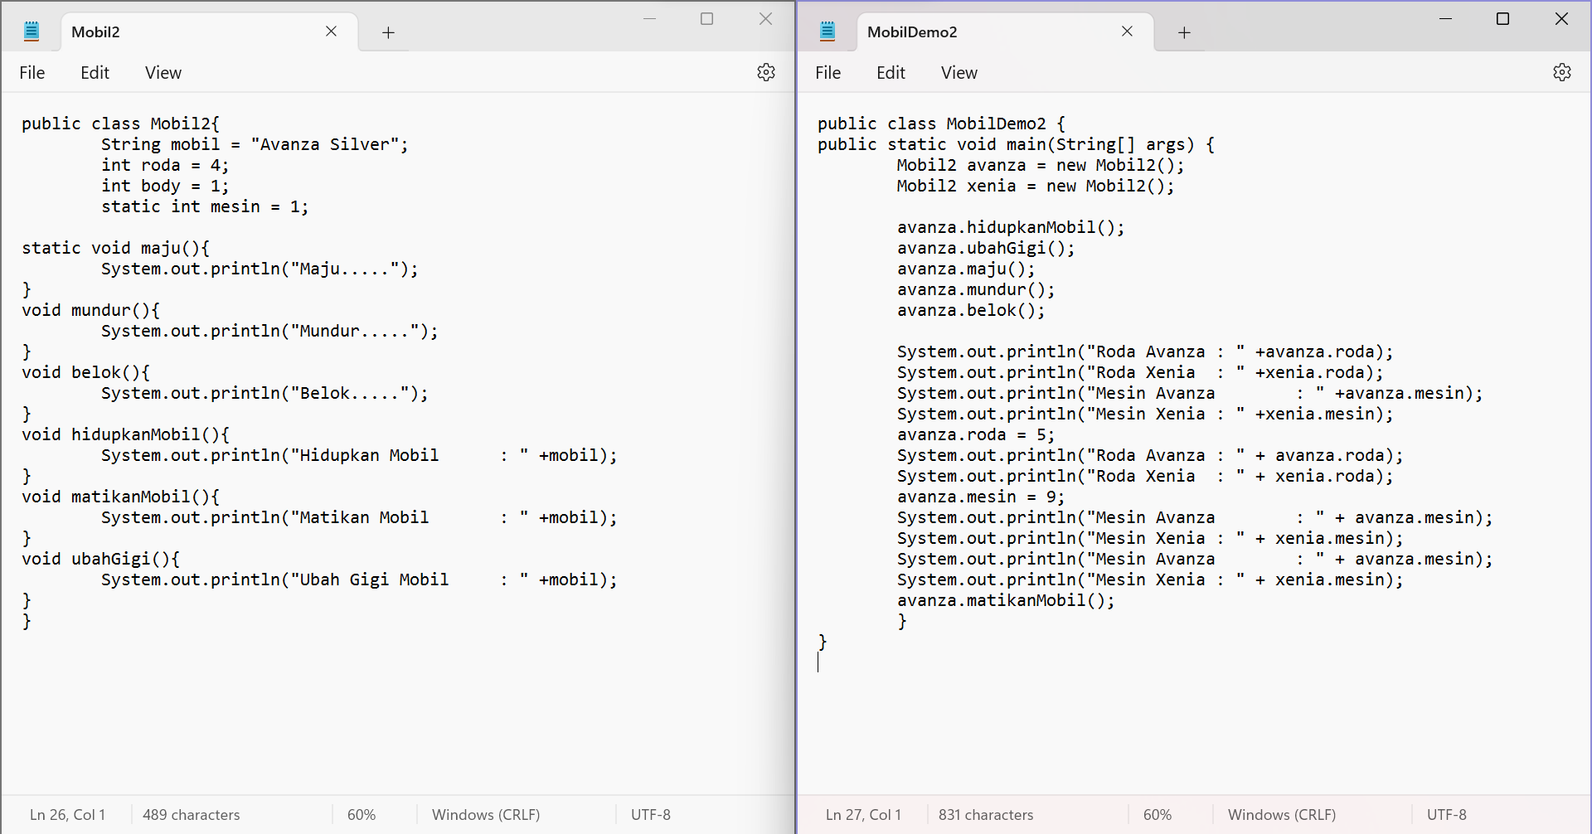

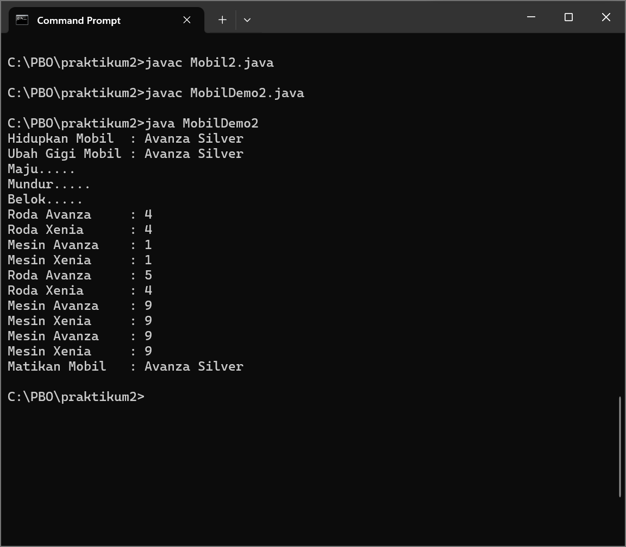

Code Program :

1. **Code Mobil2** (Mobil2.java)

public class Mobil2{

String mobil = "Avanza Silver";

int roda = 4;

int body = 1;

static int mesin = 1;

static void maju(){

System.out.println("Maju.....");

}

void mundur(){

System.out.println("Mundur.....");

}

void belok(){

System.out.println("Belok.....");

}

void hidupkanMobil(){

System.out.println("Hidupkan Mobil : " +mobil);

}

void matikanMobil(){

System.out.println("Matikan Mobil : " +mobil);

}

void ubahGigi(){

System.out.println("Ubah Gigi Mobil : " +mobil);

}

}

1. **Code DemoMobil2** (DemoMobil2.java)

public class MobilDemo2 {

public static void main(String[] args) {

Mobil2 avanza = new Mobil2();

Mobil2 xenia = new Mobil2();

avanza.hidupkanMobil();

avanza.ubahGigi();

avanza.maju();

avanza.mundur();

avanza.belok();

System.out.println("Roda Avanza : " +avanza.roda);

System.out.println("Roda Xenia : " +xenia.roda);

System.out.println("Mesin Avanza : " +avanza.mesin);

System.out.println("Mesin Xenia : " +xenia.mesin);

avanza.roda = 5;

System.out.println("Roda Avanza : " + avanza.roda);

System.out.println("Roda Xenia : " + xenia.roda);

avanza.mesin = 9;

System.out.println("Mesin Avanza : " + avanza.mesin);

System.out.println("Mesin Xenia : " + xenia.mesin);

System.out.println("Mesin Avanza : " + avanza.mesin);

System.out.println("Mesin Xenia : " + xenia.mesin);

avanza.matikanMobil();

}

}

**Latihan 2**

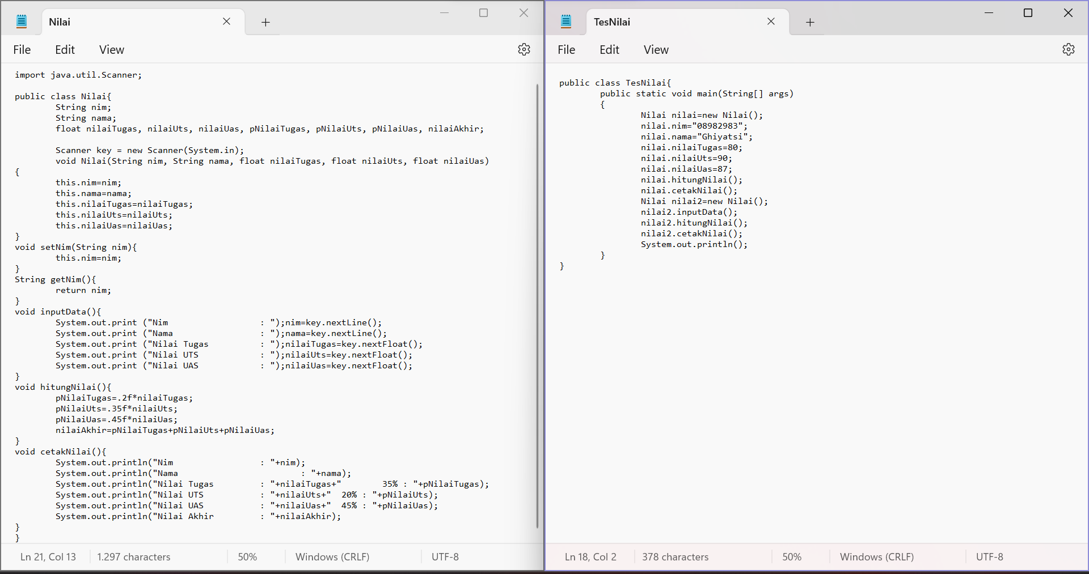

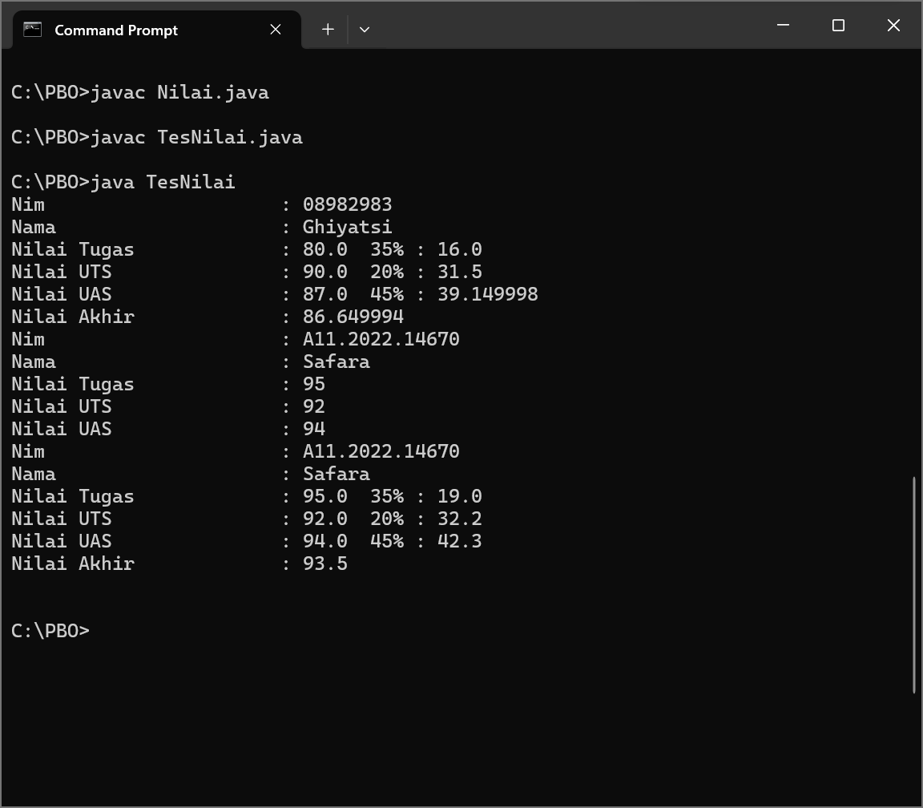

Code Program :

1. **Code Nilai** (Nilai.java)

import java.util.Scanner;

public class Nilai{

String nim;

String nama;

float nilaiTugas, nilaiUts, nilaiUas, pNilaiTugas, pNilaiUts, pNilaiUas, nilaiAkhir;

Scanner key = new Scanner(System.in);

void Nilai(String nim, String nama, float nilaiTugas, float nilaiUts, float nilaiUas)

{

this.nim=nim;

this.nama=nama;

this.nilaiTugas=nilaiTugas;

this.nilaiUts=nilaiUts;

this.nilaiUas=nilaiUas;

}

void setNim(String nim){

  this.nim=nim;

}

String getNim(){

return nim;

}

void inputData(){

System.out.print ("Nim           : ");nim=key.nextLine();

System.out.print ("Nama         : ");nama=key.nextLine();

System.out.print ("Nilai Tugas       : ");nilaiTugas=key.nextFloat();

System.out.print ("Nilai UTS         : ");nilaiUts=key.nextFloat();

System.out.print ("Nilai UAS         : ");nilaiUas=key.nextFloat();

}

void hitungNilai(){

pNilaiTugas=.2f*nilaiTugas;

pNilaiUts=.35f*nilaiUts;

pNilaiUas=.45f*nilaiUas;

nilaiAkhir=pNilaiTugas+pNilaiUts+pNilaiUas;

}

void cetakNilai(){

System.out.println("Nim : "+nim);

System.out.println("Nama : "+nama);

System.out.println("Nilai Tugas : "+nilaiTugas+" 35% : "+pNilaiTugas);

System.out.println("Nilai UTS : "+nilaiUts+" 20% : "+pNilaiUts);

System.out.println("Nilai UAS : "+nilaiUas+" 45% : "+pNilaiUas);

System.out.println("Nilai Akhir : "+nilaiAkhir);

}

}

1. **Code TesNilai** (TesNilai.java)

public class TesNilai{

public static void main(String[] args)

{

Nilai nilai=new Nilai();

nilai.nim="08982983";

nilai.nama="Ghiyatsi";

nilai.nilaiTugas=80;

nilai.nilaiUts=90;

nilai.nilaiUas=87;

nilai.hitungNilai();

nilai.cetakNilai();

Nilai nilai2=new Nilai();

nilai2.inputData();

nilai2.hitungNilai();

nilai2.cetakNilai();

System.out.println();

}

}