Azure Cloud Fundamentals and Data Pipeline Implementation using ADF
By: Safaa Jamil
Objective:
To understand Azure cloud concepts and build a complete data pipeline using Storage Account and Azure Data Factory.
This project demonstrates the implementation of an end-to-end data pipeline using Microsoft Azure. A Resource Group, Storage Account, Blob Storage containers, and Azure Data Factory were created. The Superstore CSV dataset was uploaded to Blob Storage and connected to Azure Data Factory using a Linked Service and datasets. A pipeline containing Get Metadata and Copy Data activities was created to validate and copy the dataset from the source container to the destination container. The pipeline executed successfully, metadata validation was completed, and the data was copied successfully, demonstrating an end-to-end Azure Data Factory pipeline.
Task 1: Explore Azure Portal
Create a Resource Group
Deliverable:
Screenshot of Resource Group
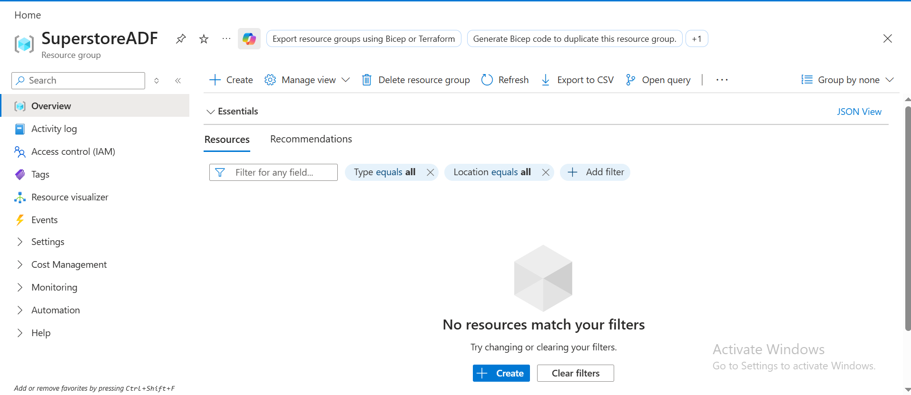
Task 2: Storage Setup
Do:
Create a Storage Account
Create a Blob Container
Upload a CSV file
Deliverable:
Screenshot of container with uploaded file
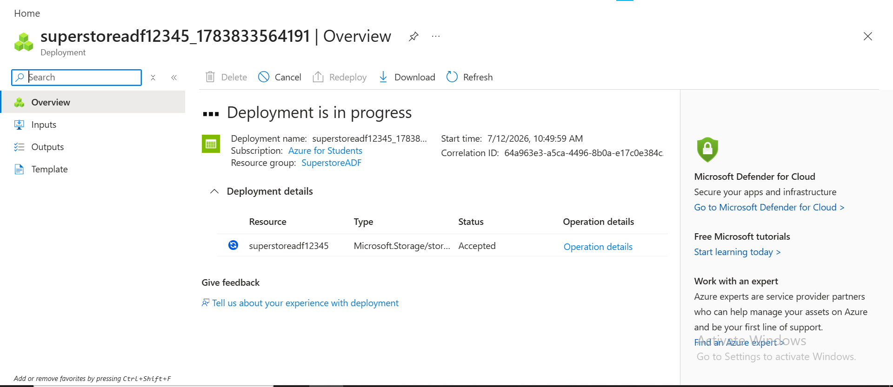

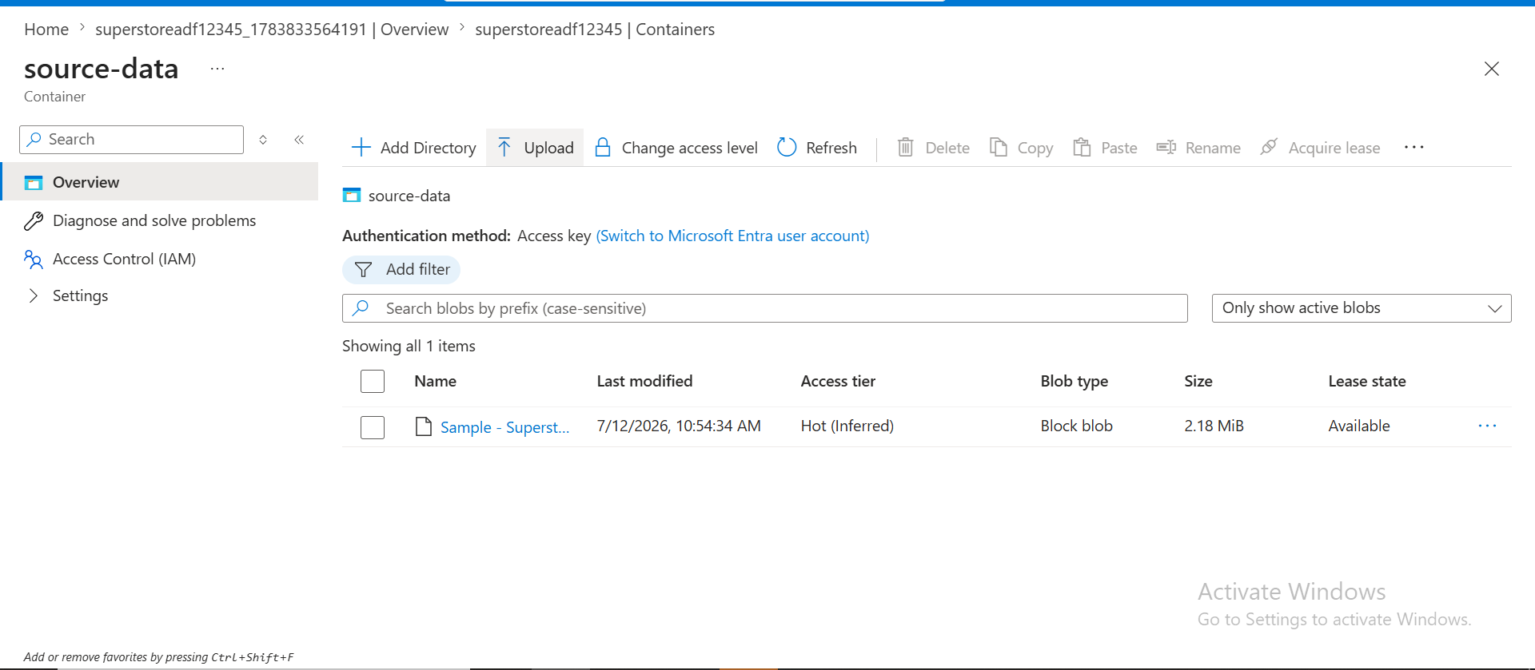
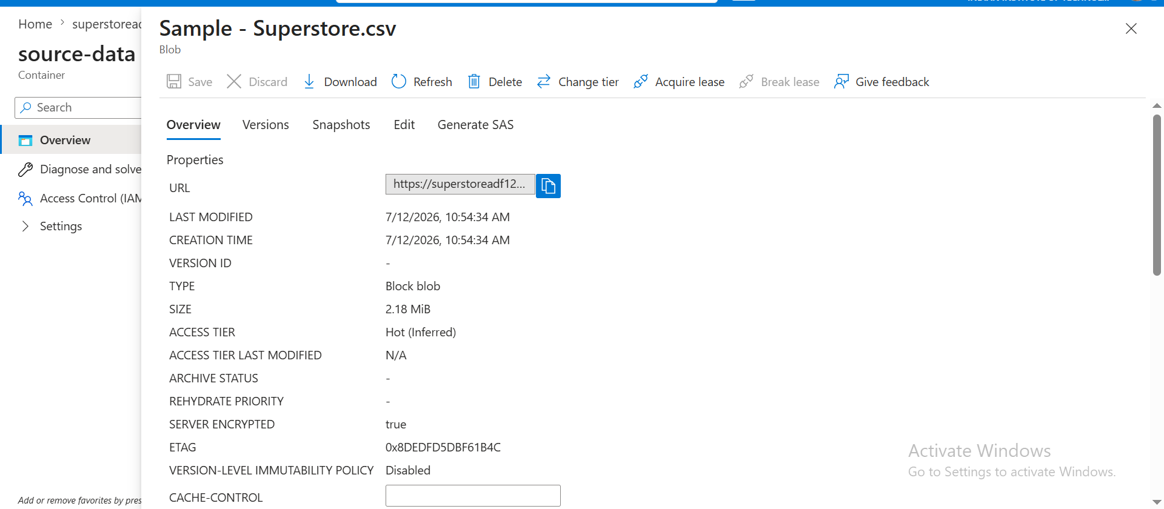
Task 3: ADF Basics
Do:
Create Azure Data Factory
Explore ADF UI (Author, Monitor, Manage)
Create Linked Service (Blob Storage)
Create datasets (source + destination)
Use Get Metadata activity
Deliverable:
Screenshot of Linked Service
Screenshot of dataset
Screenshot of Get Metadata activity
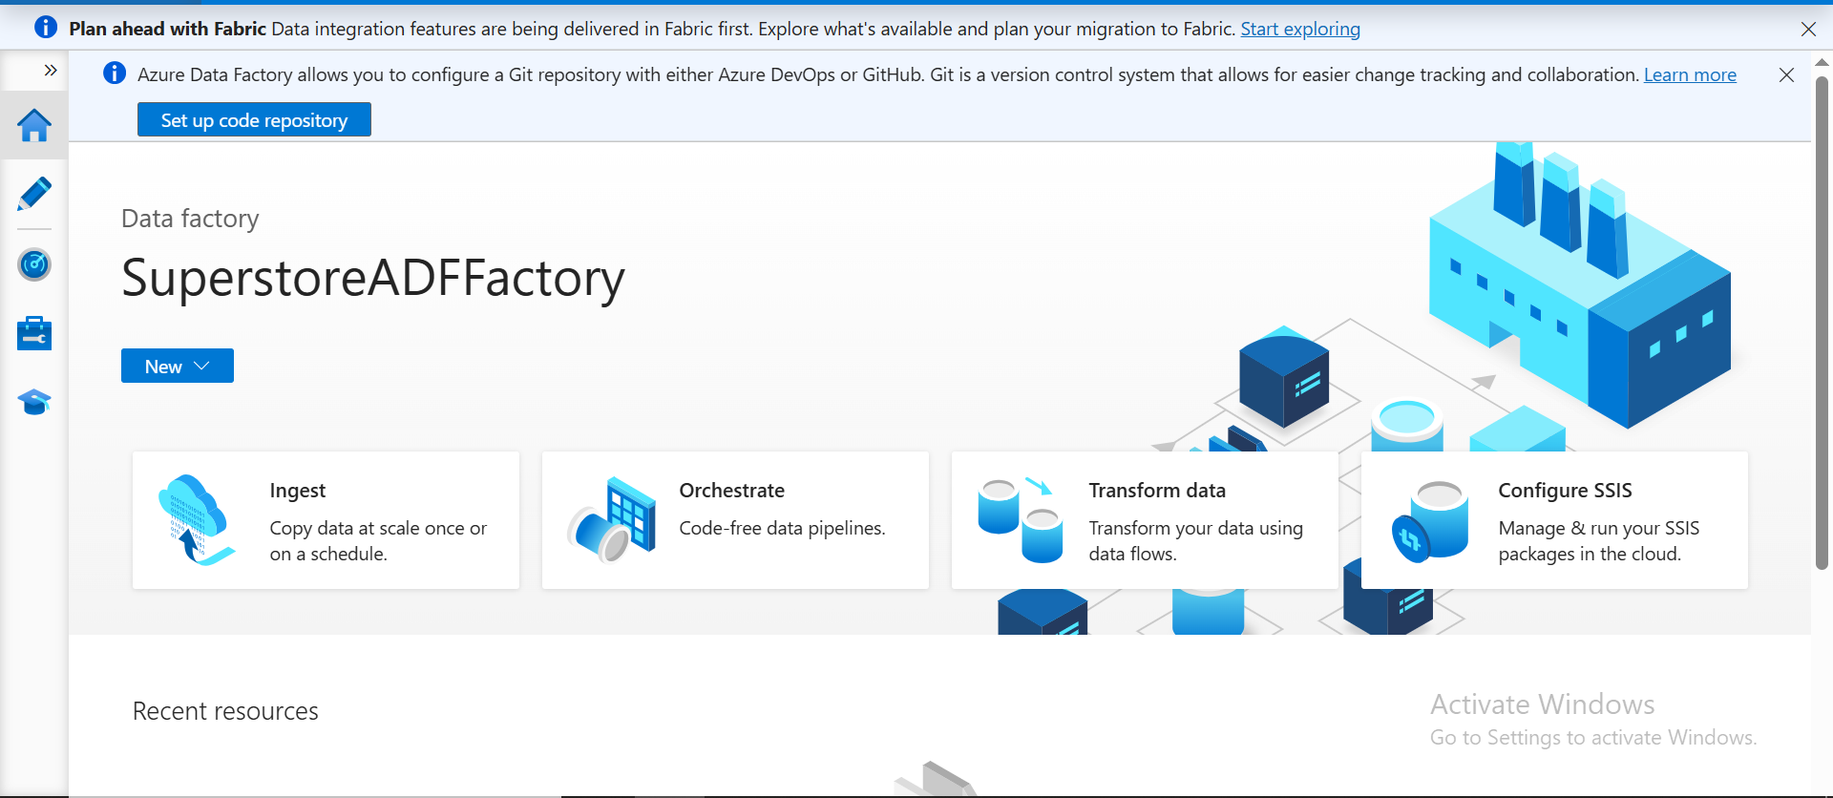
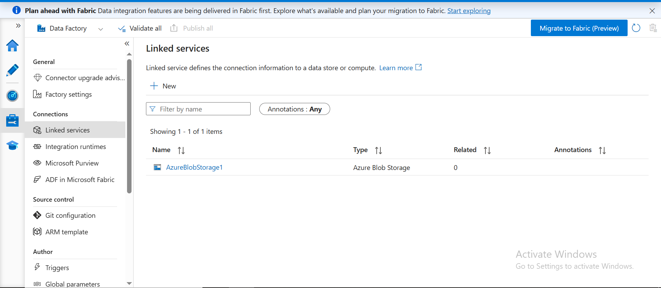
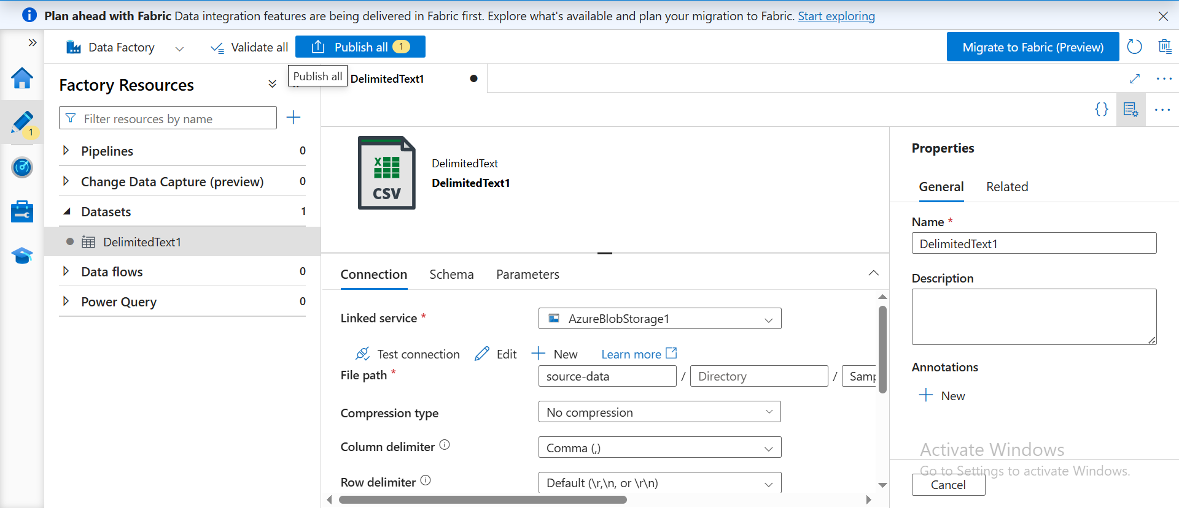
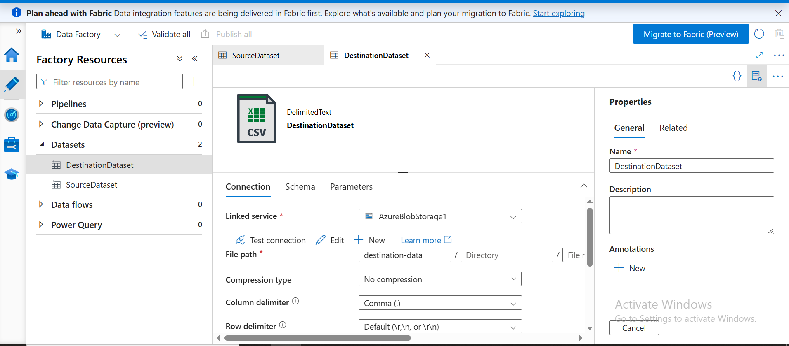
Task 4: Pipeline Development
Do:
Create pipeline using Copy Data activity
Configure source and destination
Add ForEach activity (optional if multiple files)
Deliverable:
Screenshot of pipeline design
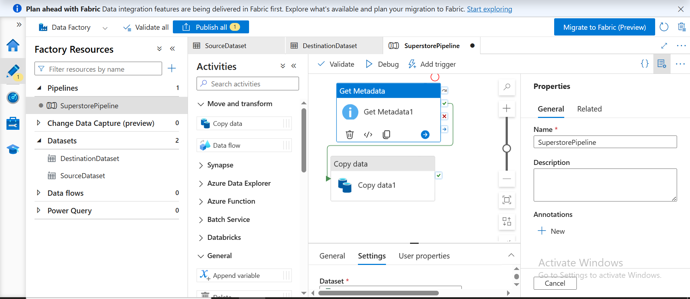
Task 5: Pipeline Execution
Do:
Run pipeline using Debug/Trigger
Deliverable:
Screenshot showing pipeline execution (Succeeded)
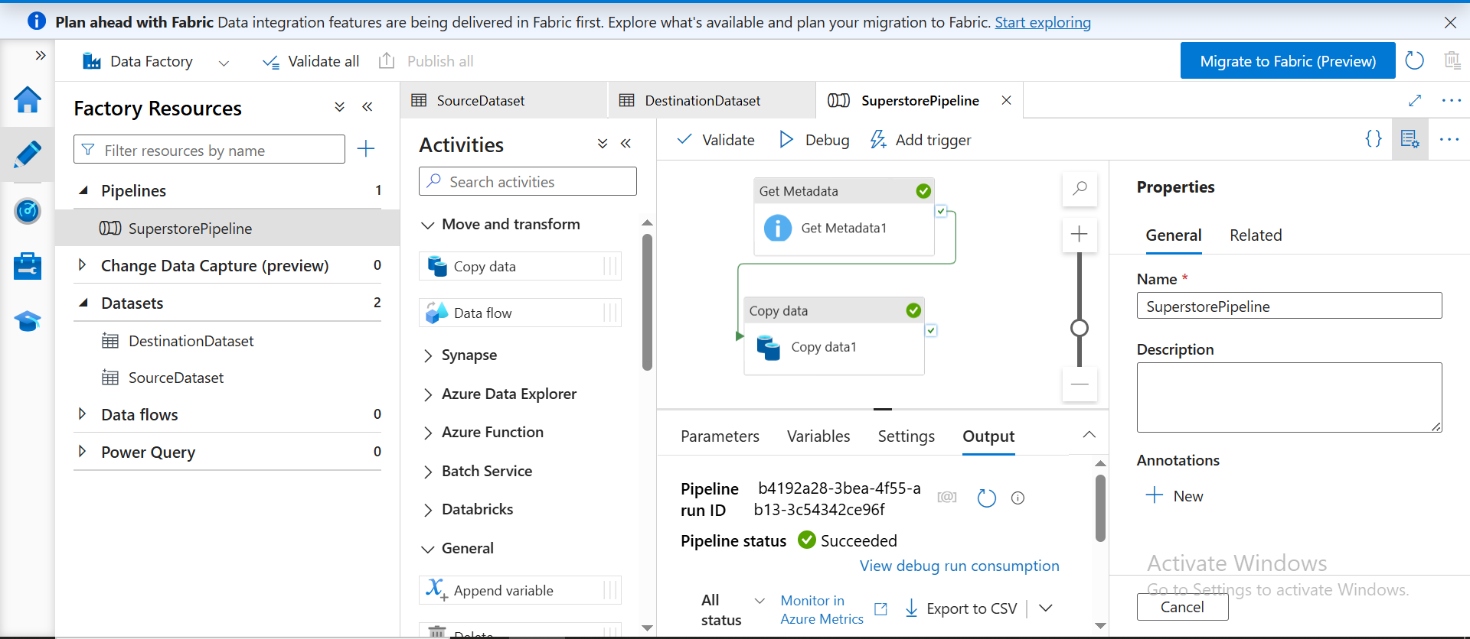
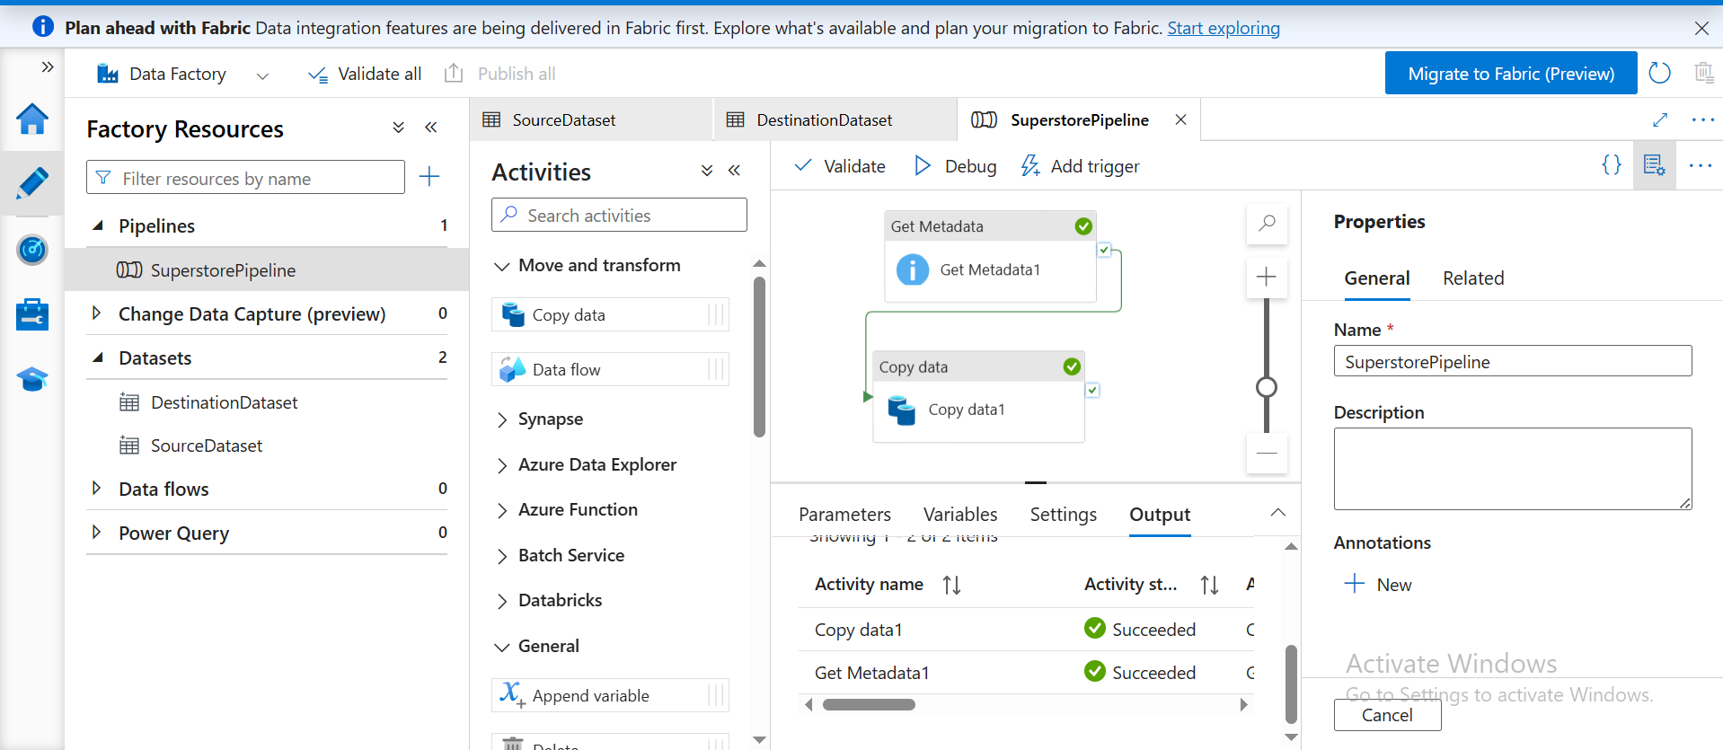

Task 6: IAM Roles
Do:
Assign roles:
Reader
Contributor
Provide access to ADF for Storage
