AL WATEEN - Implementation Essentials
A concise handover / discussion guide: what we need in Database, API, OutSystems and Angular
Version 4.0 | September 2026

1. The Process in One View
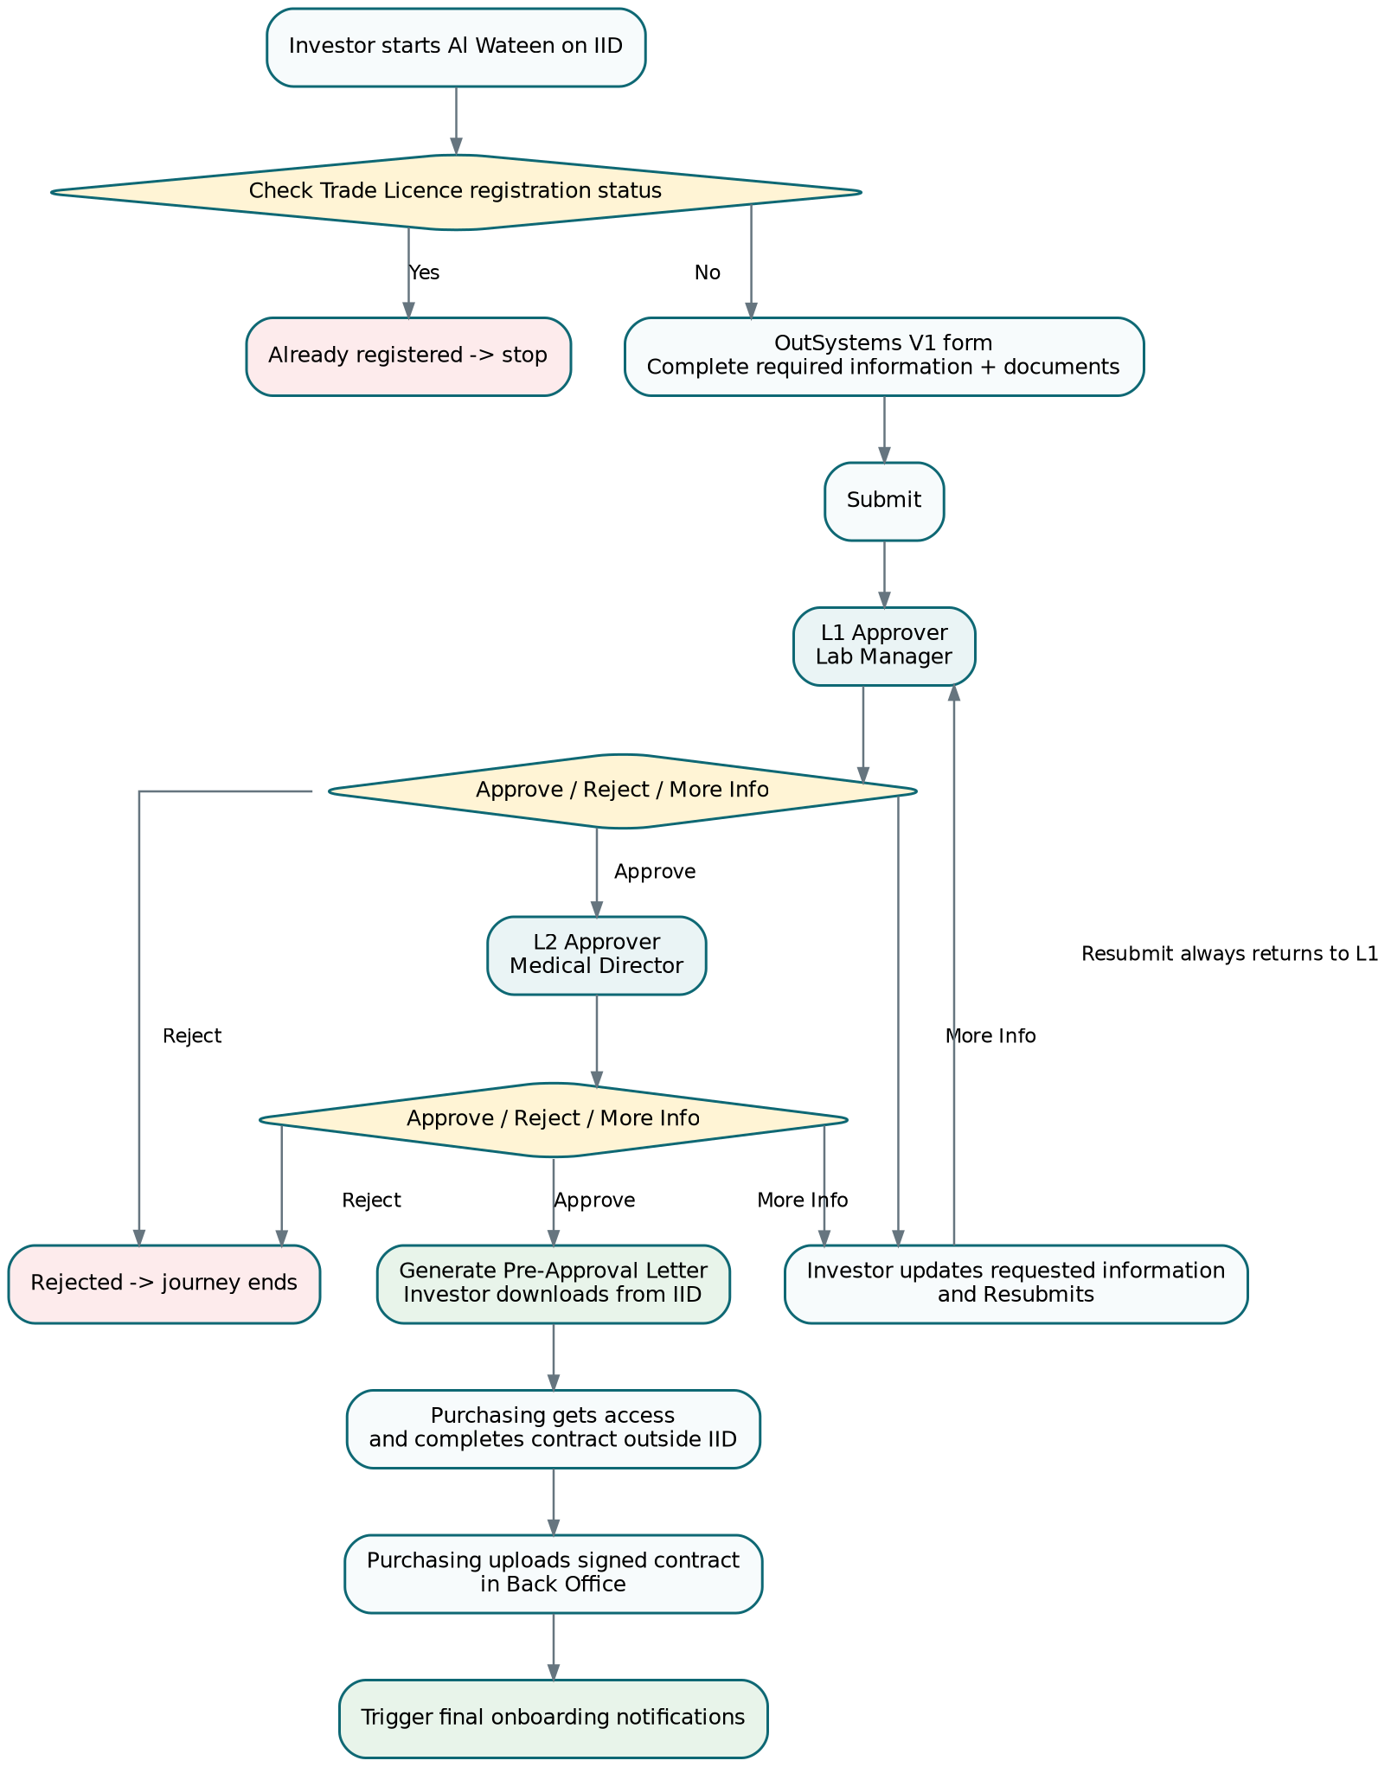
Core rule. IID / OutSystems covers the investor journey through final L2 approval and access to the Pre-Approval Letter. Purchasing and contracting happen outside IID, but the signed contract is uploaded in our Back Office to trigger final onboarding notifications.

2. What We Need in the Database
Table | Why we need it
Application | Current request data/status/stage and all PRD form/read-only context fields.
ApplicationAttachment | Current DHA License and Lab Medical Director License metadata/storage references.
ApplicationMedicalSpecialty | Selected medical specialties.
WorkflowHistory | Single timeline for Submit, More Info, Resubmit, L1/L2 decisions, letter/contract events.
ServiceOutput | Pre-Approval Letter metadata and IID availability.
Contract | Signed contract metadata/file reference uploaded by Purchasing.
- Use SQL Server constraints for simple integrity: facility type, beds >= 0, contract date order, one active Trade Licence request, one current attachment per type.
- Use RowVersion for concurrent decisions.
- Use indexes for Trade Licence, role/stage queue and workflow history.
- Keep files outside the hot application table; store only secure references/metadata.
- No custom stored procedures initially. EF Core + transactions + indexes are enough.

3. What We Need in the .NET API
API area | Need
OutSystems GET | Registration check, optional status/lookup GETs and letter download where supported through Services 360 integration layer.
Services 360 adapter | Receive ApplicationObject submission/resubmission; synchronize status/decision; publish output. Exact external contracts TBC.
Back Office queue/detail | Paged queue and application detail for internal roles.
Decision endpoint | One generic endpoint for L1/L2 Approve, Reject, More Information. Server determines caller level/state.
Pre-Approval Letter | Auto-generate after L2 approval; secure download endpoint; official IID hand-off TBC.
Contract upload | Purchasing-only endpoint; save contract then trigger onboarding notifications.
- Server-side validation is authoritative.
- Role/state authorization on every command.
- RowVersion/ETag concurrency for decisions.
- Page size maximum 100; allow-list sorting/filtering.
- RFC 7807 errors with correlation ID; no secrets/stack traces.
- No raw storage paths accepted from clients.

4. What We Need in OutSystems
- One DET ServiceForm application/module with V1 screen.
- ApplicationObject_V1 matching the form fields; camelCase attributes; register schema for the service version.
- Simple steps: Facility Information, Documents, Review & Submit.
- Auto-populated/read-only DUL and applicant data.
- DET attachment component/pattern for required documents.
- Client + server validation as required by the Developer Guide.
- More Information uses the same V1 form in edit mode; Resubmit always returns to L1.
- Custom calls to our Back Office are GET REST through the Services 360 integration layer/BackofficeGetRequest.
- Arabic translation through Multilingual Locales.
- Configure Site Properties: BackofficeBaseURL/EnableProxyServiceCall when needed, plus EntityAPIKey, ServiceId and ServiceLifeCycle using values supplied for the environment.

5. What We Need in Angular Back Office
- Two main routed screens only: Application Queue and Application Detail.
- Queue is role-aware: L1 sees L1 work, L2 sees L2 work, Purchasing sees final-approved requests.
- Detail screen shows Summary, Documents, Workflow and Contract section.
- Decision dialog inside detail: Approve, Reject, More Information.
- L1 = Lab Manager. L2 = Medical Director.
- After L2 approval, Purchasing gains access to the approved request.
- Purchasing completes the contract with the investor outside IID and uploads the signed contract in Back Office.
- Investor Facility Admin is a Back Office role, but its exact functions in this registration scope are still TBC.

6. Validation We Must Cover
Layer | What it must do
Client / OutSystems / Angular | Required fields, lengths, integer beds, file feedback, fixed dropdowns, accessible errors, disable duplicate clicks.
.NET server | Repeat all field validation; verify lookup values, workflow state, role/permission, document content/size, read-only fields, concurrency.
SQL Server | FK/unique/check constraints, one active Trade Licence request, rowversion, date checks, indexes.
Files | Secure storage reference, verified type/signature, size limit, safe filename and scanning policy once confirmed.

7. Performance We Should Keep
- Queue queries are paged and indexed; default 25, max 100.
- Queue returns only summary columns. Detail/history/documents load when opened.
- Use EF Core AsNoTracking and projection for reads.
- Use short SQL transactions only for state-changing actions; no network call inside an open DB transaction.
- Stream documents instead of loading them into SQL/application lists.
- No unnecessary caching or stored procedures until measurements show a need.

8. What We Still Need From Services 360 / Business
Owner | Confirmation needed
Services 360 | ServiceId, ServiceLifeCycle values, EntityAPIKey process, DEV/QA/PROD URLs and V1 catalogue registration owner.
Services 360 | Official ApplicationObject submission/resubmission callback contract and authentication.
Services 360 | Official lifecycle/decision status synchronization API.
Services 360 | Official Pre-Approval Letter document/output hand-off to IID.
Business | Exact fields/documents editable when More Information is requested.
Business | Whether Reject reason and Approve comment are mandatory.
Business / Integration | Medical Specialties authoritative source/codes.
Security / Platform | Back Office SSO/claims and permissions for Admin, L1, L2, Investor Facility Admin and Purchasing.
Documents | Allowed file formats/size, secure storage and malware-scanning ownership.
Onboarding | Final notification recipients, channel/API and retry/support ownership.

9. Suggested Implementation Order
# | Action
1 | Confirm Services 360 IDs/access/contracts that block integration.
2 | Create the six SQL tables, constraints, indexes and EF Core entities/migrations.
3 | Build Back Office GET queue/detail and generic decision endpoint.
4 | Build Angular Queue + Detail + Decision dialog.
5 | Build OutSystems V1 form, ApplicationObject, mappings, attachments and validations.
6 | Connect the Services 360 submission/resubmission adapter.
7 | Implement final L2 approval -> PDF generation -> IID output hand-off.
8 | Implement Purchasing contract upload -> onboarding notification.
9 | Run end-to-end DEV/QA testing, role tests, concurrency tests and file/security tests; deploy through LifeTime for OutSystems.

