AL WATEEN - .NET API Specification
Lean ASP.NET Core API contracts aligned to the PRD, Developer Guide and confirmed L1/L2/Purchasing workflow
Version 4.0 | September 2026

1. Integration Boundary
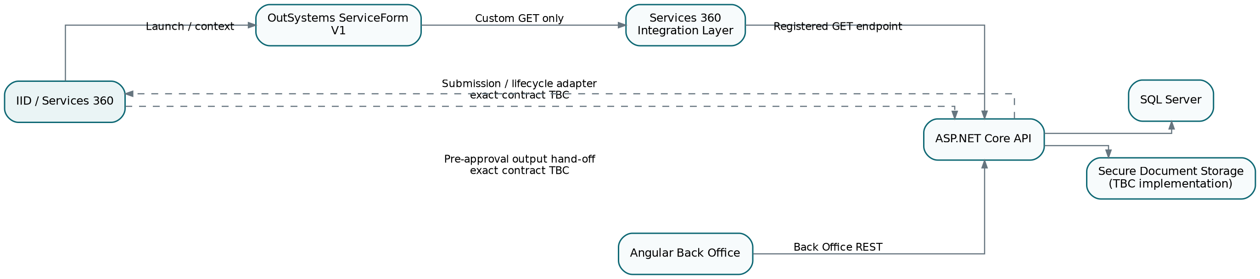
The API serves the Angular Back Office and the Services 360 integration boundary. The Developer Guide confirms that custom calls from the OutSystems ServiceForm to our Back Office must be GET REST calls registered in the Services 360 integration layer. Investor form submission itself is handled through the Services 360 Application Object submission pattern; the exact service-specific callback/authentication contract is still TBC.

2. Roles and Workflow
Role | Where | Current scope
Admin | Back Office | Operational access across applications. Exact identity/user-management permissions TBC.
L1 Approver | Back Office | Lab Manager. Approve, Reject or Request More Information for L1 applications.
L2 Approver | Back Office | Medical Director. Approve, Reject or Request More Information after L1 approval.
Purchasing Department | Back Office | Receives L2-approved requests; uploads the signed contract after completing contracting outside IID.
Investor Facility Admin | Back Office | Role exists in Back Office; exact registration-scope permissions still TBC.
Investor | IID / OutSystems | Starts application, fills form, responds to More Information, resubmits and downloads the approved letter from IID.
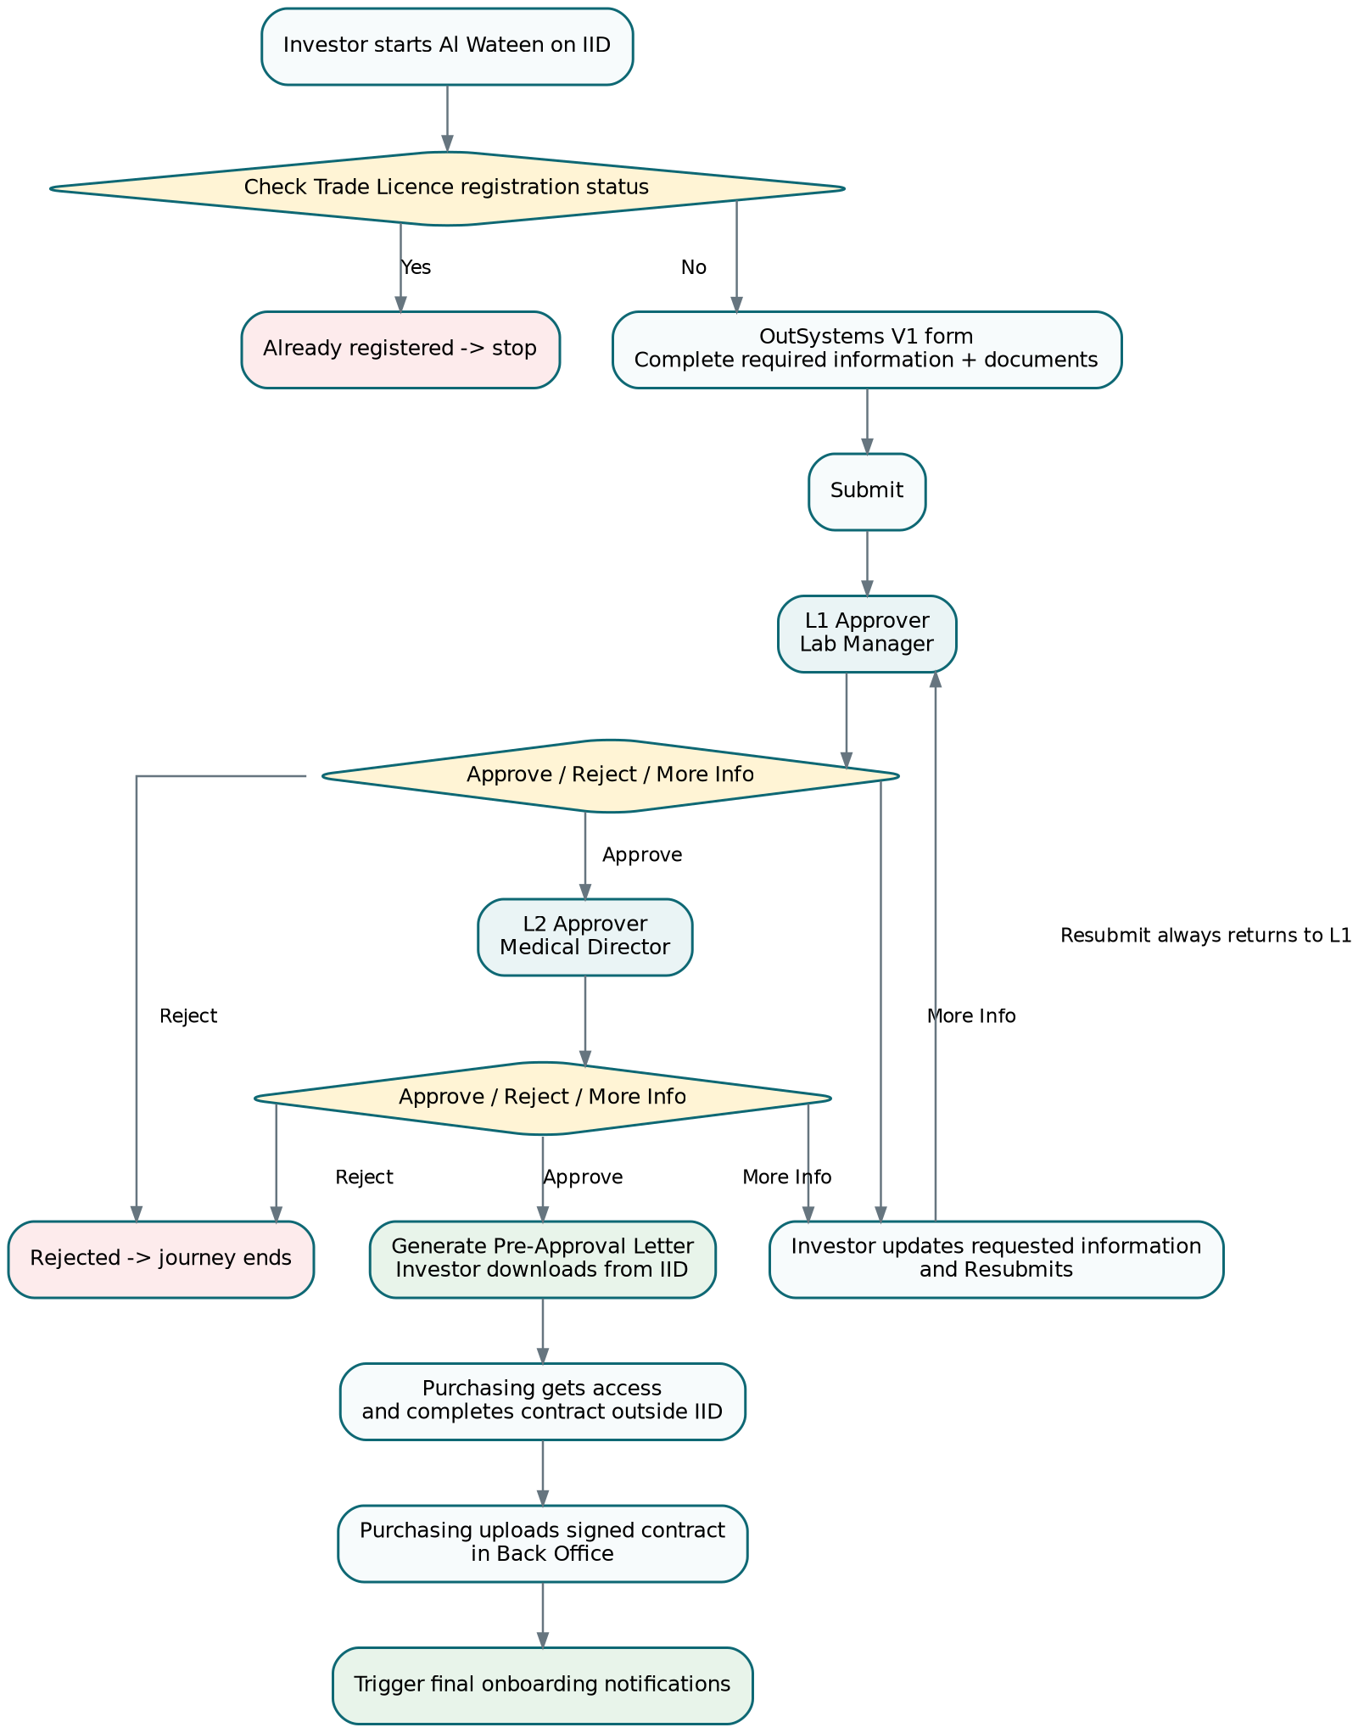

3. Developer Guide Rules That Affect the API
- OutSystems application uses a ServiceForm module and a V1 screen, commonly /[ModuleName]/V1.
- ApplicationObject_V1 is configured/registered and is serialized to JSON for submission.
- Custom OutSystems calls to our Back Office are GET REST calls through the Services 360 integration layer using BackofficeGetRequest.
- BackofficeBaseURL and EnableProxyServiceCall are Site Properties used when reference/back-office GET calls are needed.
- EntityAPIKey, ServiceId and ServiceLifeCycle are framework configuration values. Exact Al Wateen values/issuance remain environment-specific.
- The Developer Guide requires both client-side and server-side form validation.
- Exact Services 360 submission, lifecycle/status and output/document API contracts are not defined in the captured generic guide and remain TBC.

4. API Catalog

4.1 GET endpoints used from OutSystems through Services 360 proxy
ID | Method | Route | Purpose
G01 | GET | /api/v1/registrations/status | Check whether Trade Licence can start/proceed with Al Wateen.
G02 | GET | /api/v1/applications/{applicationId}/status | Return current investor-facing status / More Information message when our solution is the source.
G03 | GET | /api/v1/applications/{applicationId}/pre-approval-letter/download | Stream the approved Pre-Approval Letter. Final IID document hand-off may instead use the official Services 360 output API once confirmed.
G04 | GET | /api/v1/lookups/medical-specialties | Only if our API is confirmed as the lookup source; otherwise do not implement locally.

4.2 Services 360 inbound adapter operations
ID | Operation | Our responsibility
S01 | Receive initial ApplicationObject submission | Create/update Application, documents/specialties metadata and place request at L1.
S02 | Receive investor resubmission | Update requested data/documents and reset workflow to SUBMITTED / L1.
S03 | Send decision/lifecycle status | Exact endpoint/payload TBC; adapter maps our internal state to the official Services 360 contract.
S04 | Publish Pre-Approval Letter to IID | Exact output/document API TBC; mark AvailableToIID only after successful hand-off/confirmation.
Do not hard-code the external routes yet. The generic Developer Guide explains the pattern but not the Al Wateen service-specific submission, status and output contracts. Keep these behind an integration adapter until the official API documentation/credentials are received.

4.3 Angular Back Office endpoints
ID | Method | Route | Purpose
B01 | GET | /api/v1/backoffice/applications | Paged role-aware queue. Server determines allowed stage from caller role.
B02 | GET | /api/v1/backoffice/applications/{applicationId} | Application detail including fields, documents metadata and workflow history.
B03 | POST | /api/v1/backoffice/applications/{applicationId}/decision | L1/L2 Approve, Reject or More Information. Server determines current review level.
B04 | GET | /api/v1/backoffice/applications/{applicationId}/pre-approval-letter/download | Back Office preview/download when authorized.
B05 | POST | /api/v1/backoffice/applications/{applicationId}/contract | Purchasing uploads signed contract + contract metadata; triggers onboarding notification after successful save.
B06 | GET | /api/v1/backoffice/applications/{applicationId}/contract | Return contract metadata for authorized Back Office users.

5. Critical Endpoint Contracts

5.1 G01 - Registration status
GET /api/v1/registrations/status?tradeLicenseNumber=123456
200 OK
{
"tradeLicenseNumber": "123456",
"isRegistered": false,
"hasActiveRequest": false,
"hasRejectedHistory": false,
"canProceed": true
}
Server validation: tradeLicenseNumber is required, trimmed and <= 50 characters. The API must combine the authoritative registration-status source with our local active/rejected history rule. If the authoritative source is unavailable, do not silently allow a new registration.

5.2 B03 - Review decision
POST /api/v1/backoffice/applications/{applicationId}/decision
If-Match: <rowversion/etag>
{
"decision": "APPROVE | REJECT | MORE_INFO",
"comment": "Required when MORE_INFO; Reject reason requirement TBC"
}
Current step + decision | New status | New stage | Additional action
L1 + APPROVE | SUBMITTED | L2 | Create workflow history row.
L1 + MORE_INFO | MORE_INFO | INVESTOR | Investor updates and resubmits.
L1 + REJECT | REJECTED | L1 | End registration journey; IsActiveRequest = 0.
L2 + APPROVE | APPROVED | PURCHASING | Final approval; generate Pre-Approval Letter and initiate IID output hand-off.
L2 + MORE_INFO | MORE_INFO | INVESTOR | Investor updates; any resubmission returns to L1.
L2 + REJECT | REJECTED | L2 | End registration journey; IsActiveRequest = 0.

5.3 Investor resubmission rule
Business rule. Regardless of whether More Information was requested by L1 or L2, a successful investor resubmission returns the application to L1. This is a business clarification and should not be presented as a PRD quote.

5.4 G03 / B04 - Download Pre-Approval Letter
GET /api/v1/applications/{applicationId}/pre-approval-letter/download
200 OK
Content-Type: application/pdf
Content-Disposition: attachment; filename="AlWateen_PreApproval_<reference>.pdf"
<body: streamed PDF bytes>
- Application must be finally approved by L2.
- ServiceOutput PRE_APPROVAL_LETTER must exist and be available for the requested channel.
- Do not accept a storage path from the client. Resolve StorageReference on the server.
- Authorize access to the application/output before streaming.
- Return 404 when the letter does not exist and 409/422 when the application is not in an allowed state.

5.5 B05 - Upload signed contract
POST /api/v1/backoffice/applications/{applicationId}/contract
Content-Type: multipart/form-data
contractNumber = "..."
startDate = "2026-10-01"
endDate = "2029-09-30"
file = <signed contract>
- Purchasing role only; application must already be APPROVED by L2.
- Contract number, start date, end date and signed file are required.
- End date must be on/after start date.
- Validate file size, extension, verified MIME/signature, filename and secure-storage success server-side.
- After database commit, trigger final onboarding notifications. If the notification call fails, preserve the uploaded contract and retry through the integration mechanism rather than asking Purchasing to upload again.

6. Server-Side Validation
Area | Server rule
Application/form fields | Required fields; max lengths; integer beds; facility type enum; specialty existence/active state; do not accept client override of trusted DUL/applicant fields.
Documents | Both required on submit/resubmit where applicable; size/type/signature/scanning/storage policy enforced server-side.
Workflow | Validate current status/stage and caller role for every decision. Client button visibility is not authorization.
Concurrency | Require If-Match / rowversion for decisions and other mutable Back Office commands. Return 409 if stale.
Resubmission | Only accepted when current status is MORE_INFO; destination is always L1.
L2 approval | Only valid after L1 approval/current stage L2. Generates/queues the Pre-Approval Letter.
Contract | Purchasing only after APPROVED; one current contract in scope; date/file validations.
Mass assignment | Use dedicated DTOs; never bind EF entities directly from JSON.
Errors | RFC 7807 Problem Details; safe correlationId; never expose stack traces, secrets, tokens or storage paths.

7. Client Validation vs Server Validation
Validation | Client | Server
Required / lengths / number format | Yes, immediate UX feedback | Yes, authoritative
Allowed Facility Type / specialties | Yes, fixed UI choices | Yes, verify codes/values
File type/size | Early browser feedback | Yes, verify real content + storage
Read-only IID/DUL fields | Disabled/read-only | Ignore/reject client overrides
Current stage / role permissions | Hide/disable inappropriate actions | Always enforce
Concurrency | Send ETag/rowversion | Detect stale write and return 409
SQL injection / mass assignment | N/A | Parameterized access + DTO allow-list

8. Performance and Security Defaults
- EF Core async calls and cancellation tokens for request operations.
- AsNoTracking() + projections for queue/detail reads; do not load document bytes or large history collections on queue calls.
- Default page size 25; maximum 100. Sort/filter values are server allow-listed.
- Use one transaction per state-changing command. Do not keep a database transaction open while making external network calls.
- Use secure document storage abstraction and stream downloads; do not put signed URLs/storage paths in logs.
- Use structured logging with correlation IDs. OutSystems monitoring remains available in Service Center; .NET monitoring follows the application platform standards.
- Authentication/authorization model and claims must be confirmed before production; roles are enforced server-side once available.

9. TBC Before Production
- Official Services 360 submission/resubmission callback contract and authentication.
- Official decision/lifecycle status synchronization contract.
- Official Pre-Approval Letter output/document hand-off to IID.
- EntityAPIKey issuance/use, exact ServiceId/ServiceLifeCycle values and environment URLs.
- Back Office SSO/claims and exact permissions for Admin and Investor Facility Admin.
- Authoritative Medical Specialties source and file upload/scanning limits.
- Final onboarding notification recipients/channel/endpoint and retry ownership.

