AL WATEEN - UI / UX Screens
Simple OutSystems investor form and reusable Angular Back Office screens
Version 4.0 | September 2026

1. UI Scope
The UI is intentionally small. OutSystems is only the investor-facing ServiceForm inside IID. All five internal roles - Admin, L1 Approver, L2 Approver, Investor Facility Admin and Purchasing Department - belong to the Angular Back Office, not OutSystems.
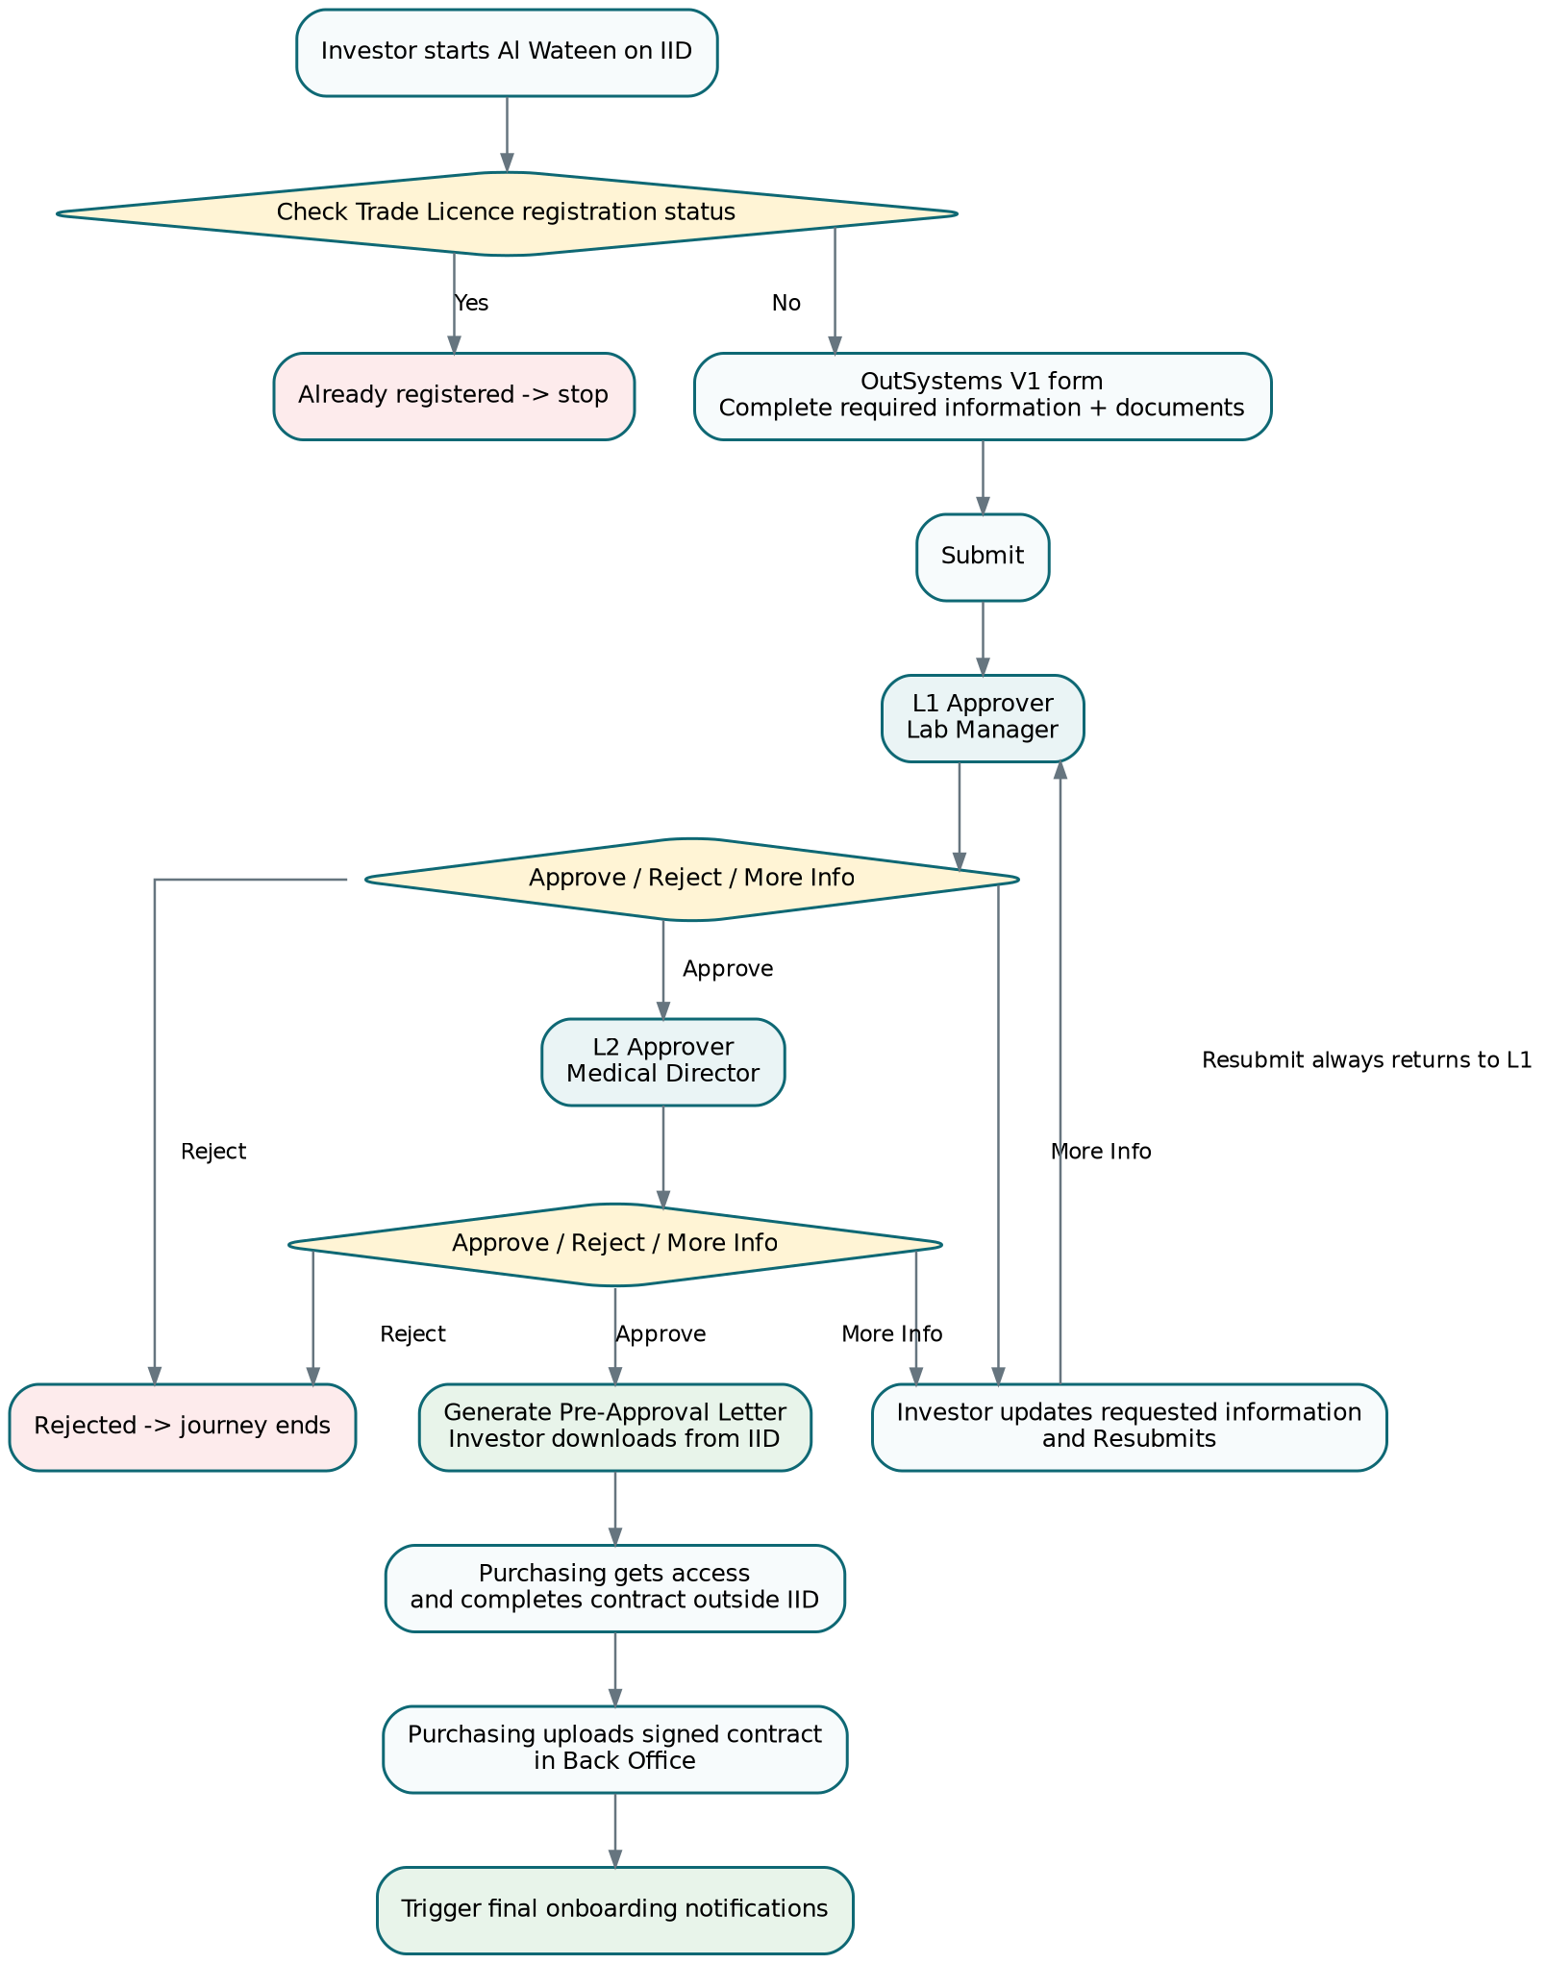

2. OutSystems / IID

2.1 One ServiceForm module, one V1 screen
- Use the DET ServiceForm template and default V1 screen/route pattern defined by the Developer Guide.
- Configure ApplicationObject_V1 with camelCase attributes and register the application schema for the service version.
- Use AppSteps only for simple form sections; do not create separate physical pages unless needed by the template.
- Use adaptive/responsive DET layouts and translate all labels to Arabic through Multilingual Locales.
- Use the template read-only logic for DUL/applicant fields and read mode.

2.2 Recommended V1 form sections
Section | Content
1. Facility Information | Facility Type, Facility Name, DHA License No., Number of Beds, Medical Specialties, Lab Medical Director License No.
2. Documents | DHA License attachment and Lab Medical Director License attachment using the DET attachment component/pattern.
3. Read-only Licence / Applicant | Trade Licence No., business name, issue authority, address, phone/email, licence dates/activities, applicant name/mobile/email.
4. Review & Submit | Summary of entered data, required validation messages, Submit/Resubmit action.

2.3 More Information / Resubmission
Do not build a second form. Reuse the same V1 screen in edit mode when the application is returned for More Information. Display the latest request/comment, allow the investor to update the permitted fields/documents, and expose Resubmit. After successful resubmission, the Back Office workflow returns to L1.
TBC. Exactly which fields/documents are editable during More Information is not specified in the PRD/Developer Guide. Keep this configurable until business confirms it.

2.4 OutSystems validation
Field / action | Client-side behavior
Facility Type | Required; Government/Private only.
Facility Name | Required; trim; max 200.
DHA License No. | Required; max 50; exact pattern TBC.
Number of Beds | Required integer; no decimals; >= 0.
Medical Specialties | At least one.
Lab Medical Director License No. | Required; max 50; exact pattern TBC.
Both attachments | Required before submit; early client size/type feedback from configuration.
Read-only DUL/applicant values | Never editable in UI.
Submit / Resubmit | Run full client validation, disable while pending, display server/business errors clearly.
The Developer Guide explicitly requires the same form input validation approach on both client side and server side. The .NET/API boundary remains authoritative for business/security validation.

2.5 OutSystems back-office integration rule
Developer Guide rule. Custom calls from the ServiceForm to our Back Office are GET REST calls registered in the Services 360 integration layer and consumed through BackofficeGetRequest. Do not call our POST decision/submission endpoints directly from the OutSystems form.

3. Angular Back Office
Use two primary routed screens plus small dialogs/sections. This is enough for the registration workflow and avoids duplicating pages for every role.

3.1 Screen A - Application Queue
Role | Queue behavior
Admin | Can view the permitted overall queue; exact admin scope follows final authorization policy.
L1 Approver | Defaults to SUBMITTED / L1 requests.
L2 Approver | Defaults to SUBMITTED / L2 requests.
Purchasing Department | Defaults to APPROVED requests awaiting/containing contract.
Investor Facility Admin | Role exists; exact queue/actions in this registration scope remain TBC.
- Columns: Reference/Application ID, Trade Licence, Facility Name, Facility Type, Status, Stage, Submitted/Updated date.
- Filters: Trade Licence, Facility Name, Status, Stage and date range. Do not build a large dashboard unless business asks for it.
- Server-side pagination; default 25, maximum 100. Debounce text search.

3.2 Screen B - Application Detail
One reusable detail screen for Admin, L1, L2 and Purchasing. The server returns allowed actions; the UI shows only what the current role/state permits.
Section / tab | Content
Summary | Facility, trade licence, applicant and selected specialties.
Documents | DHA License and Lab Medical Director License with secure view/download actions.
Workflow | Simple timeline from WorkflowHistory: Submit, More Info, Resubmit, L1/L2 decisions, Letter Generated, Contract Uploaded.
Contract | Visible/editable to Purchasing after L2 approval; read-only to other authorized roles as required.

3.3 Decision dialog
- Available only to L1 or L2 when the application is currently at that stage.
- Actions: Approve, Reject, Request More Information.
- More Information comment is required because the investor needs to know what to change.
- Reject reason mandatory/optional remains TBC unless business confirms it.
- Confirmation before Approve/Reject. Buttons disable while request is in progress.
- If server returns a concurrency conflict, refresh the application and show that another user already changed it.

3.4 Purchasing contract section
Control | Rule
Contract Number | Required, max 100.
Start Date | Required.
End Date | Required; cannot be earlier than Start Date.
Signed Contract | Required; early file validation in UI, authoritative validation on server.
Upload Contract | Enabled only for Purchasing and only after L2 approval.
After successful upload, show a clear success state and onboarding-notification status only if the final integration exposes that status. Do not ask Purchasing to upload again if only the notification integration fails.

4. Role / Action Matrix
Role | View applications | Approve | Reject | More Info | Upload contract
Admin | Yes | Per policy | Per policy | Per policy | Per policy
L1 Approver | L1 queue | Yes - L1 | Yes - L1 | Yes - L1 | No
L2 Approver | L2 queue | Yes - L2 | Yes - L2 | Yes - L2 | No
Purchasing | Approved queue | No | No | No | Yes
Investor Facility Admin | TBC | TBC | TBC | TBC | TBC

5. Common Client-Side UX Rules
- Client validation improves UX only; every rule is repeated server-side.
- Use inline field errors plus one page-level business error area.
- Encode filenames/comments/text; never render server text as raw HTML.
- Disable state-changing buttons while a request is pending to prevent duplicate actions.
- Lazy-load Workflow and document content from the detail screen instead of loading everything in the queue.
- Do not store tokens, secrets, contract files or application payloads in browser localStorage.
- Use keyboard-accessible labels, visible focus, meaningful required indicators and readable contrast.
- Use the current server status/stage after every action rather than assuming the transition succeeded.

6. What Is Not a Separate Screen
- No separate L1 screen and L2 screen: both use the same Application Detail screen with role/state-based actions.
- No separate More Information page in Angular: use the decision dialog.
- No separate Service Output management page unless business later requires manual regeneration/versioning; letter generation follows final L2 approval.
- No separate Integration Logs business screen in the initial scope. Technical monitoring belongs to platform logging/Service Center and the .NET observability solution.
- No dedicated Investor Facility Admin screen until its exact post-onboarding responsibilities are confirmed.

7. TBC Before Final UI Build
- Exact Back Office permissions for Admin and Investor Facility Admin.
- Exact investor-editable fields during More Information.
- Final Arabic labels/content approval and Pre-Approval Letter template/checklist.
- Official IID behaviour for displaying/downloading the Pre-Approval Letter.
- File limits/types and attachment/contract storage/scanning integration.
- Authentication/SSO claims supplied to Angular/.NET and any role mapping source.

