Al Wateen UI / UX Screen Specification
OutSystems Investor Journey + Angular Back Office
Version 1.1

1. Purpose and Scope
This specification translates the approved Al Wateen service journey into implementation-ready investor-facing and back-office screen designs. The OutSystems application serves the IID / Service 360 investor journey. The Angular back office uses the shared ASP.NET Core API and SQL database for review, decisions, output, and post-approval operational steps.
The screen layouts shown in this document are implementation mockups. They are not represented as Service 360 official UI designs. Business outcomes, application fields, and journey rules are traceable to the PRD; page composition, routing, component placement, and interaction patterns are internal design choices.

Document Status Legend
Status | Meaning
CONFIRMED FROM PRD | Business rule, data item, or journey behavior explicitly present in the approved PRD material.
CONFIRMED FROM DEVELOPER GUIDE | Service 360 / OutSystems framework concept explicitly established in the reviewed Developer Guide material.
INTERNAL DESIGN | Implementation decision for the Al Wateen solution. It can be changed without changing the approved business requirement.
TBC WITH SERVICE 360 / BUSINESS | Not sufficiently defined in the supplied source material. It must not be treated as a final implementation fact until confirmed.
All UI routes, component names, .NET endpoint names, DTO shapes, database implementation details, and infrastructure controls that are not prescribed by the PRD are treated as internal design unless specifically marked otherwise.

2. Cross-Cutting UX, Security and Performance Standards
Area | Implementation Standard
Server authority | Client-side validation improves usability only. All business rules, status transitions, ownership checks, and data integrity rules are enforced by the ASP.NET Core API.
Sensitive data | Display only the data required for the current task. Do not expose secrets, integration credentials, raw exception details, or unnecessary personal data in browser responses.
Attachments | Validate allowed extension/MIME type/size at the API boundary; show metadata first; download content only on explicit user action. Malware scanning/storage mechanism remains subject to final infrastructure decision.
Caching | Do not cache application details, attachments, or personal data in shared/browser caches. Reference data may use controlled caching with an explicit refresh/expiry strategy.
Lists | All back-office lists use server-side pagination, filtering and sorting. Do not load the complete application population into the browser.
Concurrency | Edit/decision actions must use optimistic concurrency so a stale browser session cannot silently overwrite a newer application state.
Auditability | Decision actions, information requests, output generation, contract upload and privileged document access should create auditable server-side events.
Accessibility | Keyboard-accessible controls, explicit labels, visible focus states, sufficient contrast, semantic headings, clear validation messages and no status communicated by color alone.
Error handling | Show a correlation/reference ID for support on unexpected server/integration failures. Never show stack traces or infrastructure details to end users.
Responsive behavior | Investor screens should remain usable at common desktop/tablet widths. Back-office is desktop-first but should not rely on fixed pixel widths for data entry.

3. Screen Inventory
ID | Client | Screen | Actor | Status | Primary API IDs
O01 | OutSystems | Registration / V1 Form | Investor | PRD CONFIRMED + INTERNAL DESIGN | A01, A02, A04, A05, A06, A10
O02 | OutSystems | Already Registered State | Investor | PRD CONFIRMED + INTERNAL DESIGN | A01
O03 | OutSystems | Submitted / Result State | Investor | INTERNAL DESIGN implementing PRD journey | A08
O04 | OutSystems | Request More Information / Resubmission | Investor | PRD CONFIRMED + INTERNAL DESIGN | A03, A05, A07, A09, A10
O05 | OutSystems | Approved / Pre-Approval Output | Investor | PRD CONFIRMED + INTERNAL DESIGN | A08, A17
O06 | OutSystems | Rejected State | Investor | PRD CONFIRMED + INTERNAL DESIGN | A08
B01 | Angular | Applications Queue / Dashboard | Back Office | INTERNAL DESIGN | A11, A20
B02 | Angular | Application Review | Back Office | INTERNAL DESIGN implementing manual review | A12, A19
B03 | Angular | Request More Information Dialog | Back Office | PRD CONFIRMED outcome + INTERNAL DESIGN | A13
B04 | Angular | Approve Dialog | Back Office | PRD CONFIRMED outcome + INTERNAL DESIGN | A14
B05 | Angular | Reject Dialog | Back Office | PRD CONFIRMED outcome + INTERNAL DESIGN | A15
B06 | Angular | Service Output / Pre-Approval Letter | Back Office | PRD CONFIRMED output + INTERNAL DESIGN | A16, A17
B07 | Angular | Purchasing / Contract | Purchasing | PRD CONFIRMED post-approval step + INTERNAL DESIGN | A18
B08 | Angular | Integration Logs | Technical Support | INTERNAL DESIGN | A21

O01. OutSystems - Registration / V1 Form
CONFIRMED FROM PRD + INTERNAL DESIGN
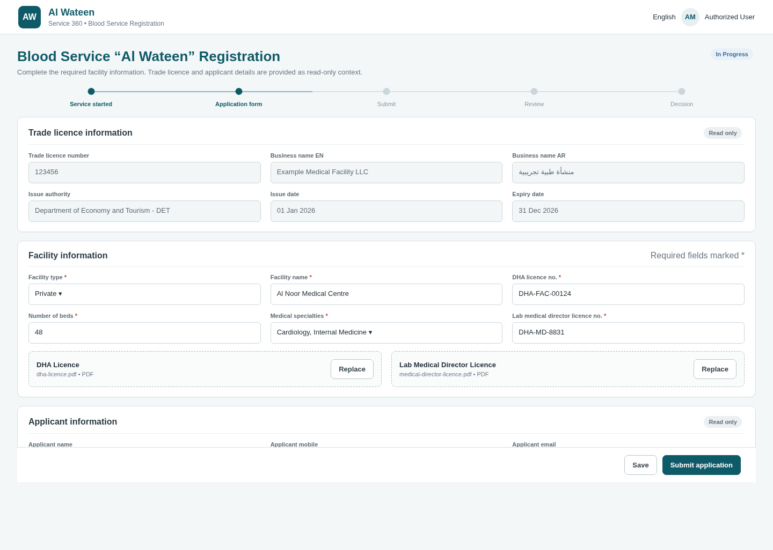
Illustrative implementation mockup - OutSystems - Registration / V1 Form

O01. Detailed Screen Specification
Aspect | Specification
Purpose | Capture the required Al Wateen registration data inside the IID / Service 360 journey while presenting DUL / applicant context as read-only information.
Data / fields | Editable: Facility Type (Government / Private), Facility Name, DHA Licence No., Number of Beds, Medical Specialties (multi-select), Lab Medical Director Licence No., DHA Licence attachment, Lab Medical Director Licence attachment. Read-only context includes Trade Licence No., business name, issue authority, licence dates/address/contact where supplied, and applicant context.
Primary actions | Start/initialize application, upload/replace required documents, submit. A Save Draft action is an internal design option; if retained it does not change the PRD Manual Submission rule.
Workflow / validation | Before allowing registration, the solution performs the PRD-required Trade Licence registration check. The API remains authoritative for re-application restrictions, active-instance rules, required fields and submitted-state integrity.
Performance | Load DUL/applicant context once per application start; load reference data with a compact lookup call; upload documents independently rather than embedding large binary payloads in the application DTO.
Security | Treat read-only UI as presentation only; the server must independently validate immutable context and must not trust manipulated browser fields. Apply attachment validation and prevent direct object access to another application.

O02. OutSystems - Already Registered State
CONFIRMED FROM PRD + INTERNAL DESIGN
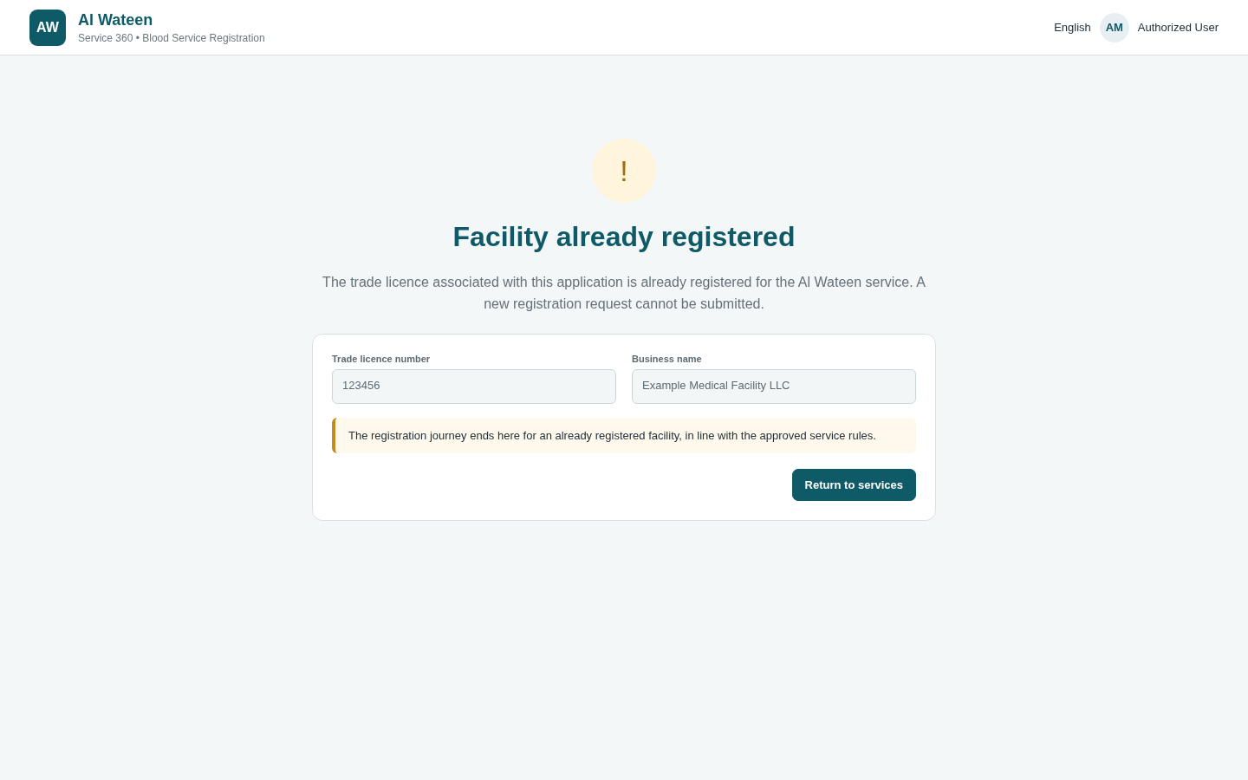
Illustrative implementation mockup - OutSystems - Already Registered State
Aspect | Specification
Purpose | Terminate the investor registration journey when the Trade Licence identifies a facility that is already registered.
Data / fields | Trade Licence and business context sufficient to explain which facility was checked. No editable registration form.
Primary actions | Return to services / exit journey.
Workflow / validation | PRD: if the facility is already registered, the investor is notified and the journey ends. A new request is not submitted.
Performance | Use the registration-check result already returned by A01; do not issue redundant status calls merely to render this state.
Security | Do not reveal registration details for a different legal entity. Only show context already belonging to the authenticated journey; exact identity mechanism remains TBC with Service 360.

O03. OutSystems - Submitted / Result State
INTERNAL DESIGN implementing CONFIRMED PRD journey
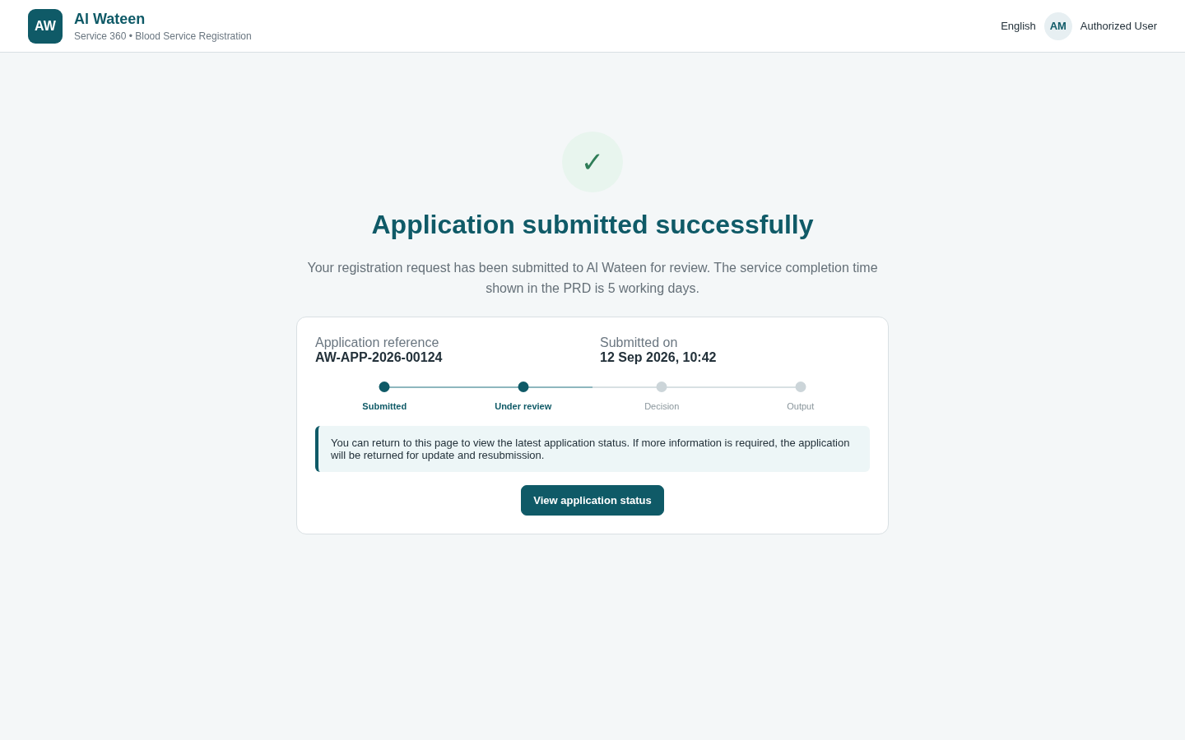
Illustrative implementation mockup - OutSystems - Submitted / Result State
Aspect | Specification
Purpose | Give the investor a stable post-submit result/state view after Manual Submission.
Data / fields | Application reference, submitted date/time, current business state and expected service completion target of 5 working days.
Primary actions | Return to services; optionally refresh status through the supported journey pattern once confirmed with Service 360.
Workflow / validation | Submission is manual. Technical mapping between internal status and ServiceLifecycle is TBC with Service 360.
Performance | Avoid polling at short intervals. Prefer explicit refresh or Service 360 lifecycle navigation once the official contract is known.
Security | Only application status and minimal contextual data should be returned. Resource ownership authorization is mandatory at the API even if the page URL is guessed.

O04. OutSystems - Request More Information / Resubmission
CONFIRMED FROM PRD + INTERNAL DESIGN
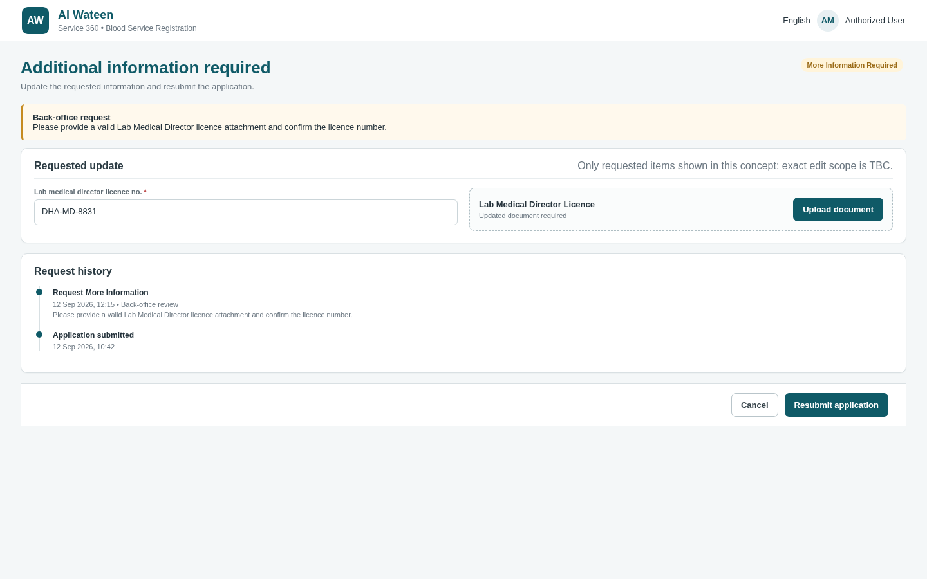
Illustrative implementation mockup - OutSystems - Request More Information / Resubmission
Aspect | Specification
Purpose | Return the workflow to the investor after the back office selects Request More Information and allow resubmission.
Data / fields | Information-request comments plus editable fields/documents. The exact subset that may be edited is TBC and must not be hard-coded as final until confirmed.
Primary actions | Replace/update allowed information and Resubmit.
Workflow / validation | PRD: IID/S360 notifies the investor by email/SMS and returns the workflow so the investor can update and resubmit. The back-end enforces that resubmission is allowed only while a valid information request is open.
Performance | Load only the active information request and current application projection. Reuse the same attachment endpoints for replacement to avoid duplicate transport patterns.
Security | Do not let a client choose arbitrary editable property names. The server determines the allowed mutation set for the current workflow state.

O05. OutSystems - Approved / Pre-Approval Output
CONFIRMED FROM PRD + INTERNAL DESIGN
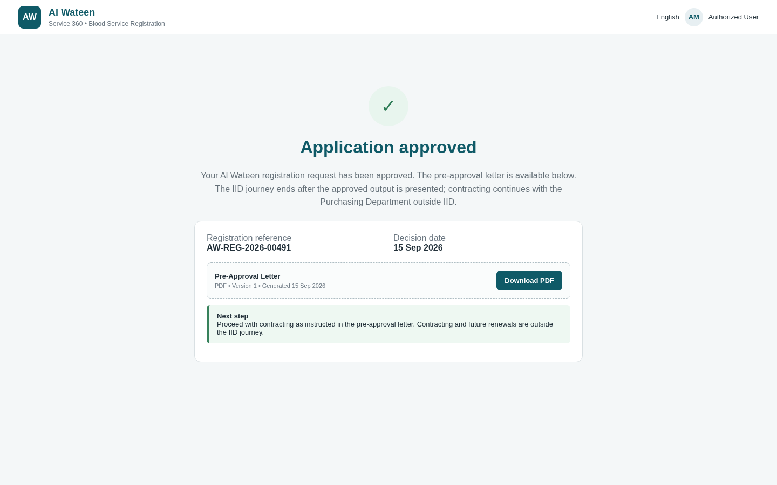
Illustrative implementation mockup - OutSystems - Approved / Pre-Approval Output
Aspect | Specification
Purpose | Represent the investor-facing approved outcome and make the pre-approval letter available through the IID journey once the output hand-off is completed.
Data / fields | Approved outcome, application reference and output metadata. PDF technical transfer to IID is TBC with Service 360.
Primary actions | View/download output if the platform contract exposes it; continue/return as defined by IID.
Workflow / validation | PRD: Our Company generates the pre-approval PDF, DET displays it to the investor, email/SMS notification is sent, and the IID journey ends with instructions for next steps.
Performance | Return output metadata first; stream/download the PDF on demand. Avoid embedding Base64 PDF content in general application-status responses.
Security | Use authenticated/authorized document retrieval, short-lived or controlled download access, and content disposition/type validation. Do not expose storage paths.

O06. OutSystems - Rejected State
CONFIRMED FROM PRD + INTERNAL DESIGN
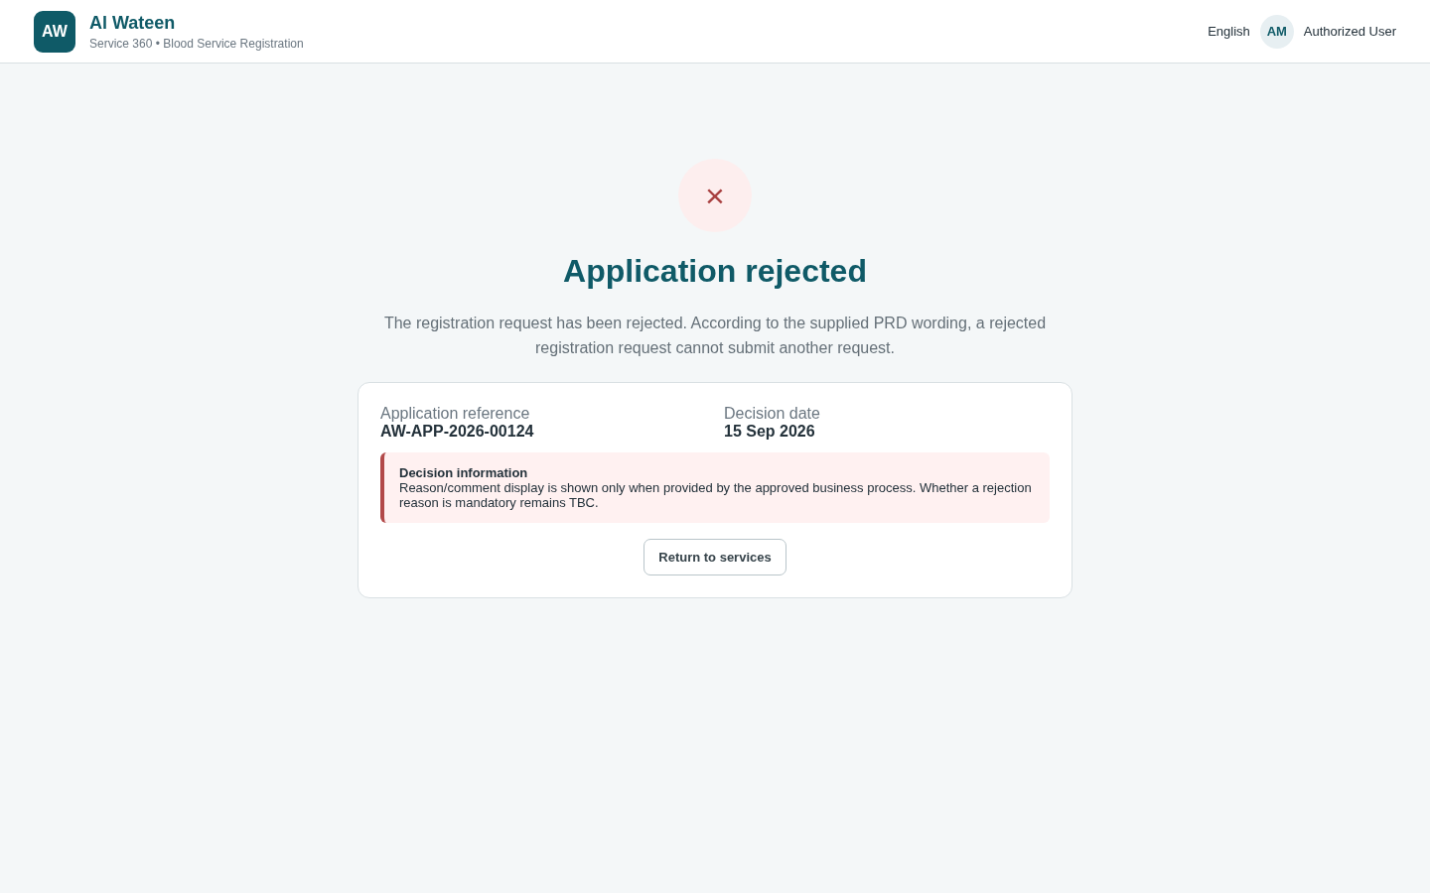
Illustrative implementation mockup - OutSystems - Rejected State
Aspect | Specification
Purpose | Represent the rejected business outcome and end the investor journey.
Data / fields | Application reference, rejected outcome and approved investor-safe message. Whether a rejection reason is mandatory/displayed is TBC with business.
Primary actions | Return to services / end journey.
Workflow / validation | PRD: rejection ends the journey; the captured PRD wording states a rejected registration request cannot submit another request.
Performance | Render from the persisted current status; no heavy dependent data is needed.
Security | If rejection comments can include internal notes, separate internal and investor-visible text. Never expose reviewer-only comments by default.

B01. Angular - Applications Queue / Dashboard
INTERNAL DESIGN supporting CONFIRMED manual review
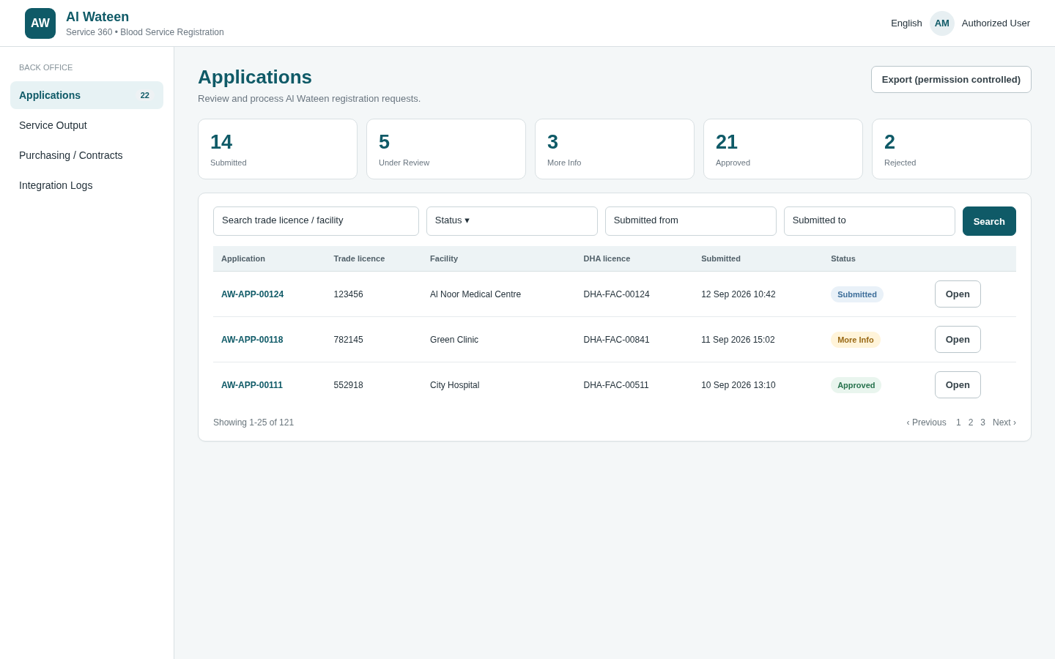
Illustrative implementation mockup - Angular - Applications Queue / Dashboard
Aspect | Specification
Purpose | Provide a performant work queue for submitted applications and a lightweight operational summary.
Data / fields | Application reference, Trade Licence, facility, submission date, current state, completion target/age where useful.
Primary actions | Search, filter, sort, paginate, open application. Counters are summary queries, not client-side aggregation.
Workflow / validation | Manual back-office review is confirmed. Assignment, SLA escalation, and reviewer ownership are not introduced unless separately approved.
Performance | Server-side pagination/sorting/filtering; indexed filters on status, submitted date, trade licence and facility search fields; avoid N+1 history/document queries in list endpoints.
Security | Restrict the queue to authorized back-office users. Return only columns required by the list and avoid attachment/content payloads.

B02. Angular - Application Review
INTERNAL DESIGN supporting CONFIRMED manual review
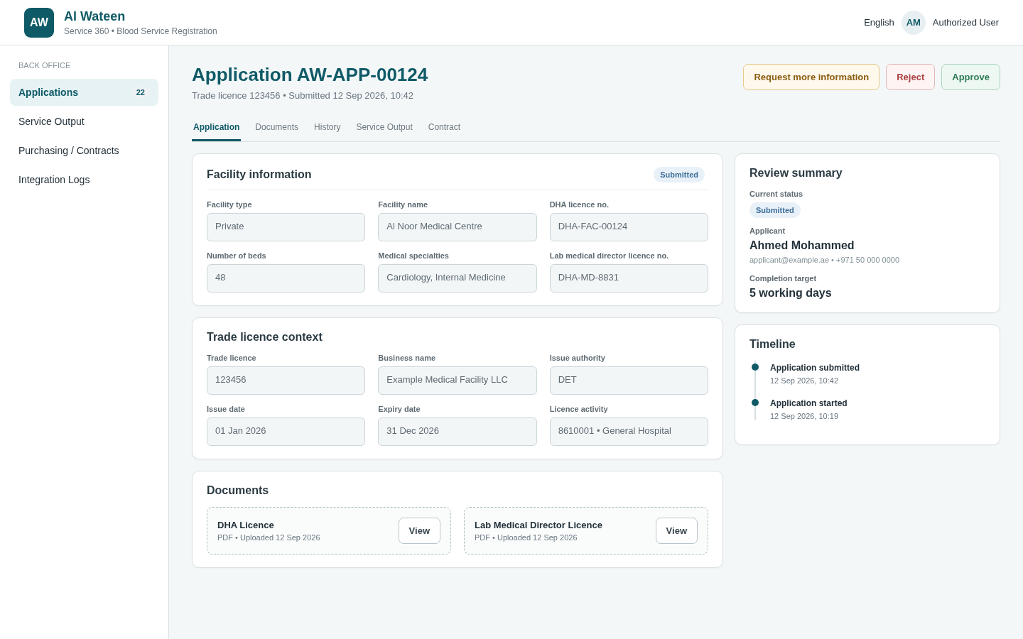
Illustrative implementation mockup - Angular - Application Review
Aspect | Specification
Purpose | Single review workspace for the confirmed form data, DUL context, required documents, history and decision actions.
Data / fields | Facility information, Trade Licence context, applicant context, specialties, document metadata, current state and timeline/history.
Primary actions | View documents, Request More Information, Approve, Reject, navigate to output/contract when applicable.
Workflow / validation | Decision actions are available only in compatible workflow states. Business rules remain server-side. One user interface action must map to one atomic API decision operation.
Performance | Use a purpose-built review-detail projection rather than many small page-load requests. Lazy-load document binaries, full history and outputs only when the relevant tab/action is opened.
Security | Prevent UI-only authorization. Decision endpoints require server-side permission and current-state checks; document access is separately authorized and audited.

B03. Angular - Request More Information Dialog
CONFIRMED outcome + INTERNAL DESIGN
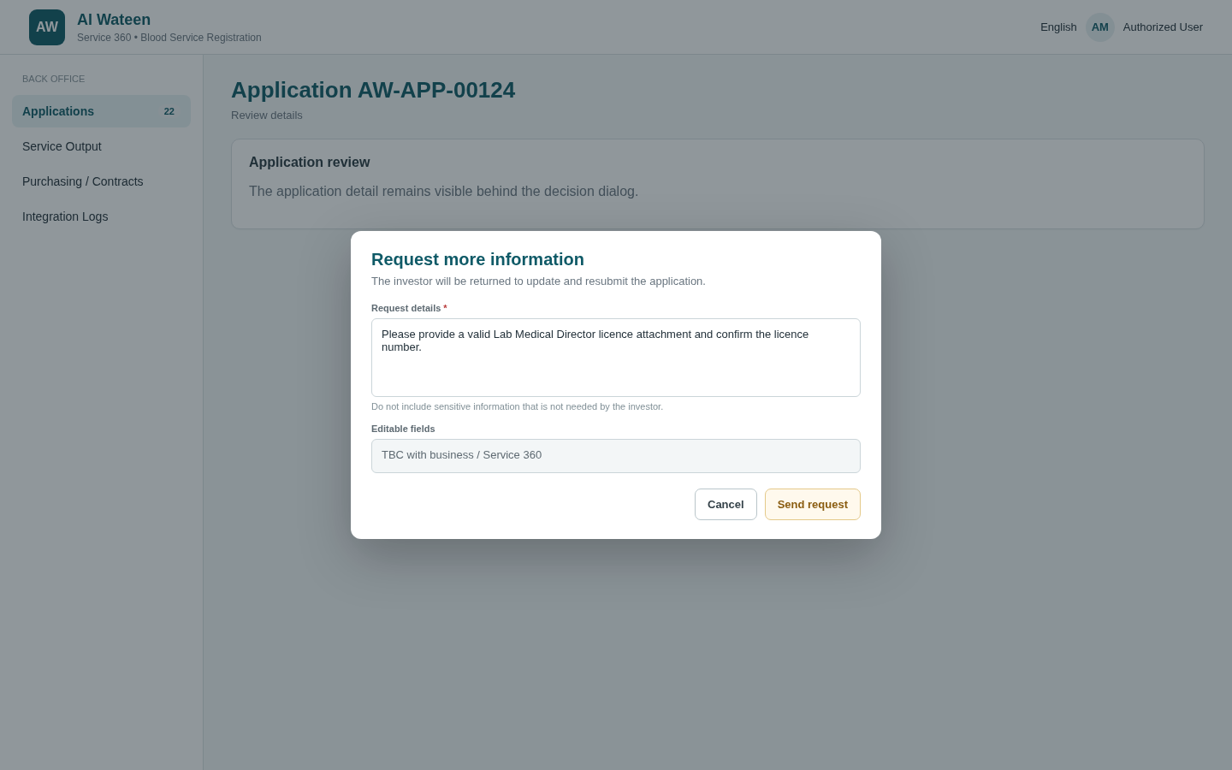
Illustrative implementation mockup - Angular - Request More Information Dialog
Aspect | Specification
Purpose | Capture the back-office Request More Information decision and the comments that will drive the investor return journey.
Data / fields | Request text/comments. Structured field/document selection remains optional/TBC until confirmed.
Primary actions | Cancel or send request.
Workflow / validation | Creates an information-request record and moves the application into the internal More Information state as one transaction. Exact S360 lifecycle synchronization is TBC.
Performance | No full application reload required after success; invalidate/update the local review projection.
Security | Validate text length and reject markup/script content. Maintain a distinction between investor-visible request text and internal audit metadata.

B04. Angular - Approve Dialog
CONFIRMED outcome + INTERNAL DESIGN
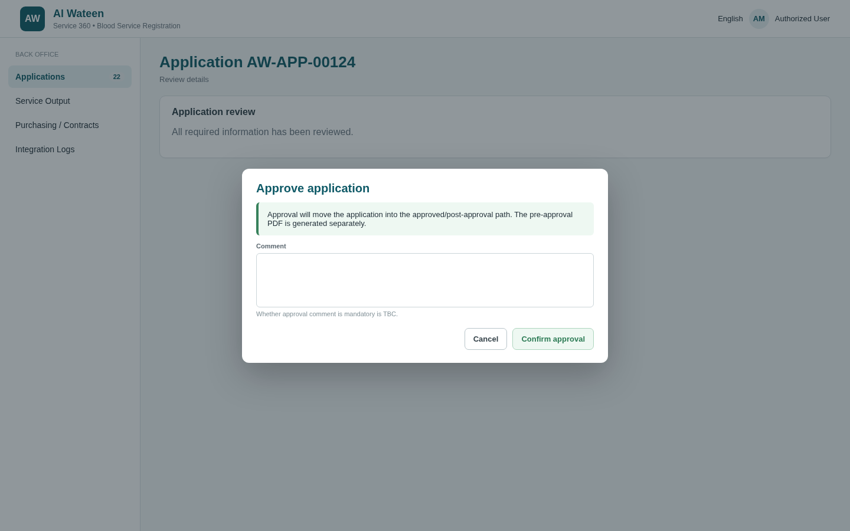
Illustrative implementation mockup - Angular - Approve Dialog
Aspect | Specification
Purpose | Confirm the Approved decision before committing the state transition.
Data / fields | Optional comment unless the business later makes it mandatory.
Primary actions | Cancel or Approve.
Workflow / validation | Approval is a single atomic server operation and must fail on stale/invalid state. After approval, the request becomes available to the Purchasing view and output generation can proceed.
Performance | Use optimistic concurrency to prevent double decisions. The API should return the new version/state so the UI can update without a second full fetch.
Security | Decision privilege is enforced server-side and audit data records the acting user, timestamp, decision and correlation/reference information.

B05. Angular - Reject Dialog
CONFIRMED outcome + INTERNAL DESIGN
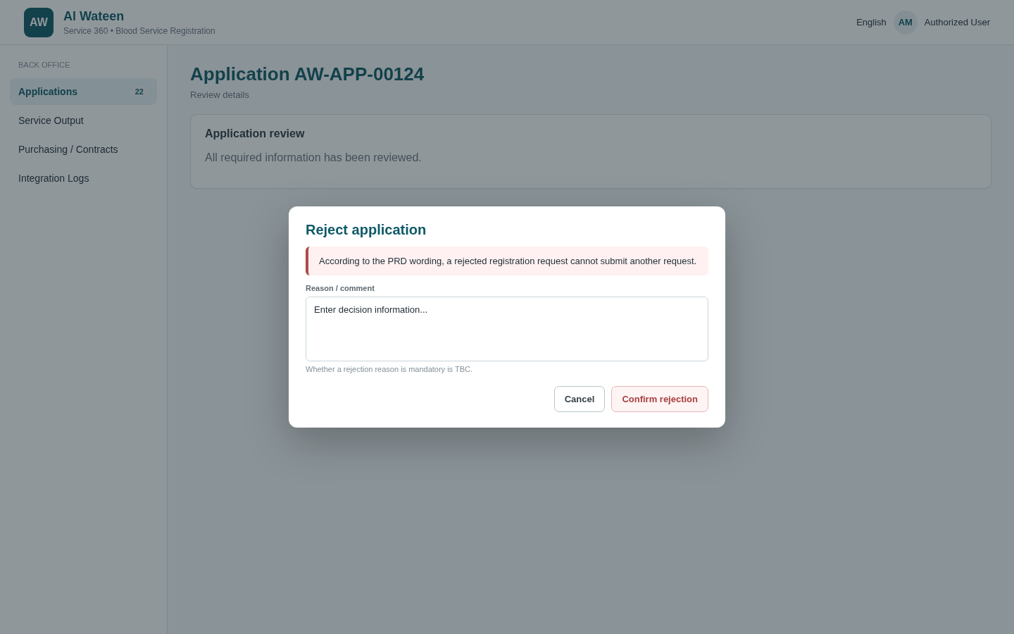
Illustrative implementation mockup - Angular - Reject Dialog
Aspect | Specification
Purpose | Confirm the Rejected decision and capture a reason if required by the final business rule.
Data / fields | Rejection reason/comment. Mandatory status is TBC with business.
Primary actions | Cancel or Reject.
Workflow / validation | Rejection ends the IID journey. The captured PRD wording prevents another request after rejection; implementation should enforce this at the domain/API layer.
Performance | Same concurrency pattern as approval; no duplicate state/history writes on retry.
Security | Separate internal reason from investor-visible wording if both are needed. Reject any attempt to alter application ownership/context while making a decision.

B06. Angular - Service Output / Pre-Approval Letter
CONFIRMED output + INTERNAL DESIGN
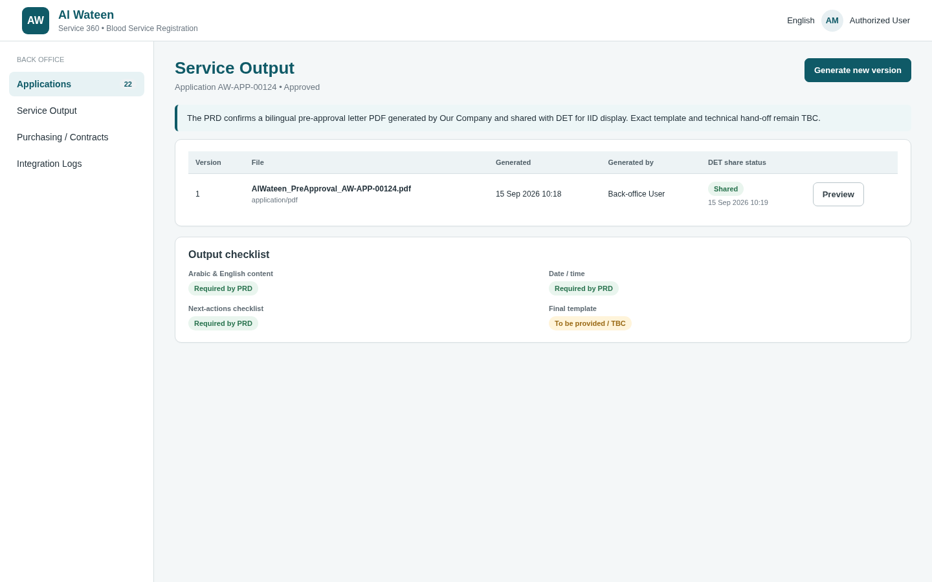
Illustrative implementation mockup - Angular - Service Output / Pre-Approval Letter
Aspect | Specification
Purpose | Generate, version, preview and track the confirmed pre-approval letter output for an approved application.
Data / fields | Output type, version, generated date/time, generated by, file metadata and hand-off status/reference when the Service 360 contract is known.
Primary actions | Generate/regenerate under controlled conditions, preview/download, initiate platform hand-off once defined.
Workflow / validation | The PRD output is a PDF and should include Arabic/English date/time and a checklist of next actions. The final template/sample is still TBC.
Performance | Generate PDF asynchronously if template rendering is expensive; persist metadata and object/storage reference rather than repeatedly regenerating on every view.
Security | Output generation uses trusted persisted data, not client-supplied template fields. Store/serve PDFs through controlled document access and audit output generation/download.

B07. Angular - Purchasing / Contract
CONFIRMED post-approval step + INTERNAL DESIGN
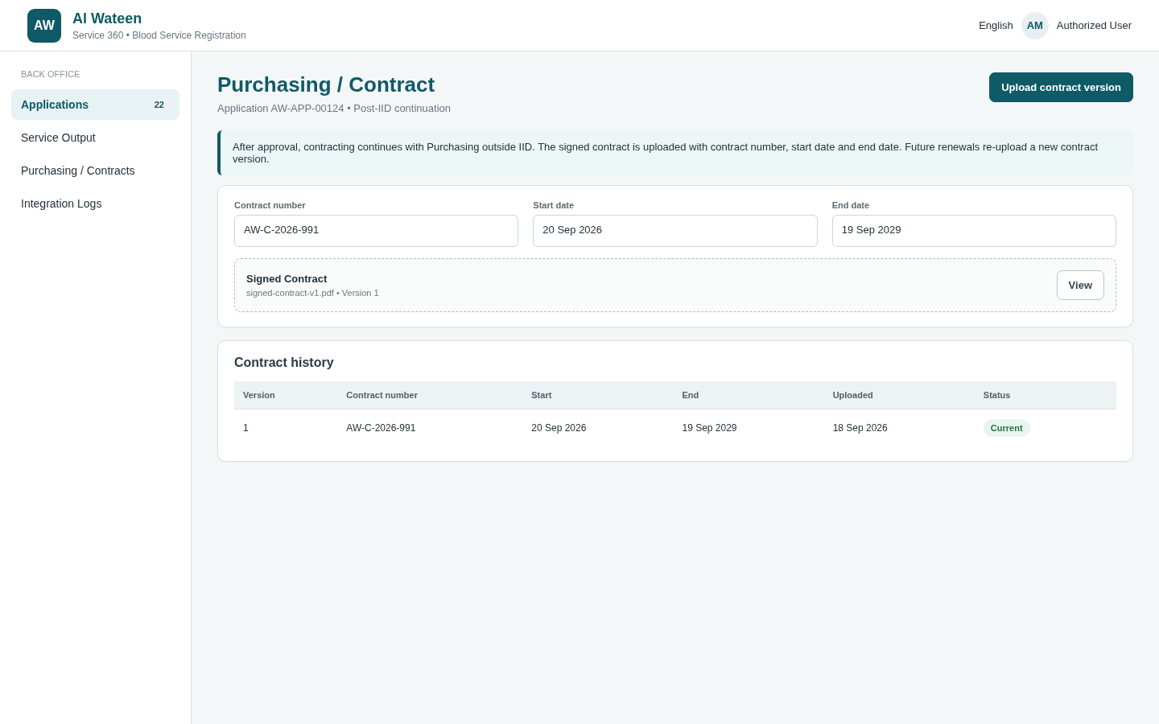
Illustrative implementation mockup - Angular - Purchasing / Contract
Aspect | Specification
Purpose | Support the confirmed post-approval Purchasing step that occurs outside the IID investor journey.
Data / fields | Signed contract document plus contract number, start date and end date as described in the PRD.
Primary actions | Upload/replace contract, persist contract metadata, mark operational hand-off ready. Exact notification/event mechanism to LIS/DH is TBC.
Workflow / validation | PRD: investor proceeds with contracting; Purchasing uploads the signed contract to Al Wateen with contract number/start/end dates. LIS team is notified by DH system after upload; future renewals are handled directly with Purchasing.
Performance | Stream document upload; do not load contract binaries in queue responses. Index contract/application reference and relevant dates for operational search.
Security | Restrict to appropriate internal function; validate document content/size; maintain version/audit history; never expose contract storage path in the browser.

B08. Angular - Integration Logs
INTERNAL DESIGN
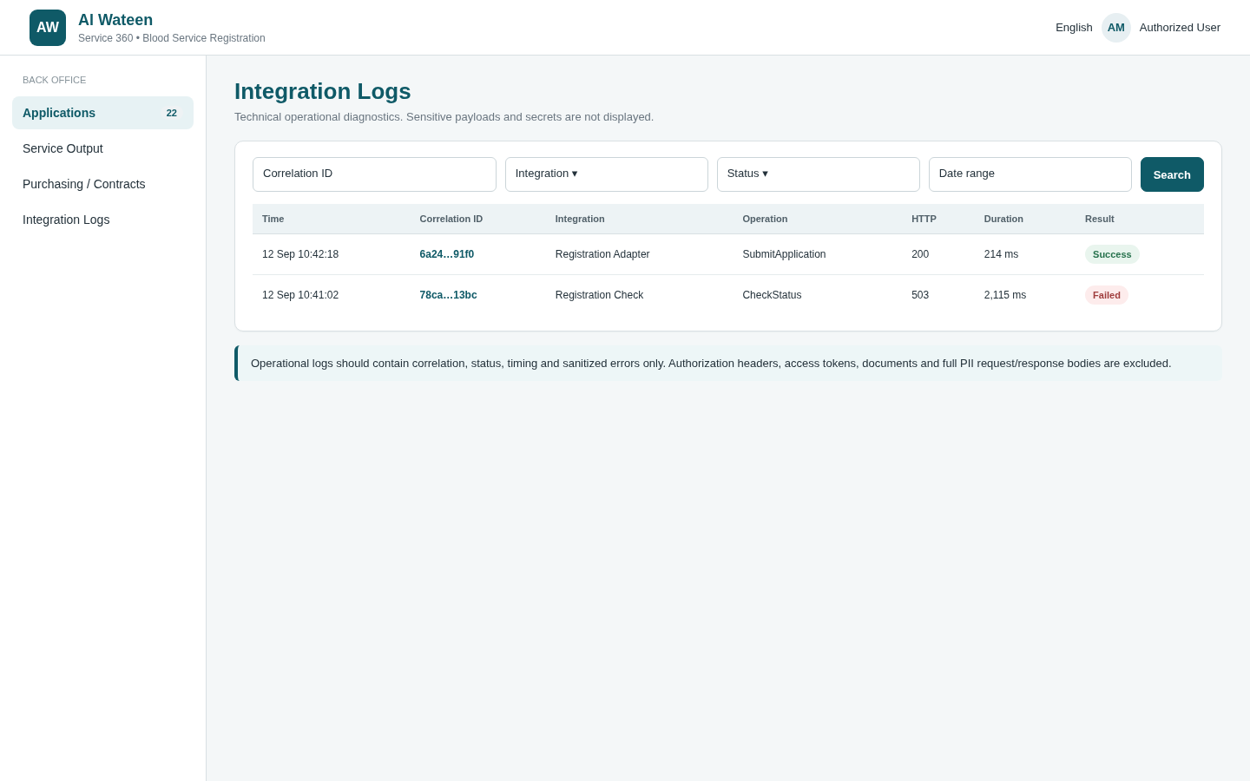
Illustrative implementation mockup - Angular - Integration Logs
Aspect | Specification
Purpose | Provide support visibility into application-related internal/external integration attempts without exposing sensitive payloads.
Data / fields | Timestamp, integration name, direction, application/reference, correlation ID, HTTP/status outcome, duration, safe error code/message.
Primary actions | Filter/search/paginate; open safe diagnostic detail if required.
Workflow / validation | This is an operational support function, not a PRD business screen. It should not be accessible to general reviewers unless approved.
Performance | Partition/archive/retain logs according to volume and policy; index timestamp, application/correlation ID and status; never run unbounded log queries.
Security | Mask personal/secrets/tokens; do not store attachment content or authentication credentials in logs; restrict to technical support/admin users.

18. State and Action Matrix
Current business state | Investor action | Back-office action | Expected next state | Source status
Start / eligibility | Start service | N/A | Check registration eligibility/status | PRD CONFIRMED
Already registered | Exit | N/A | Journey ends | PRD CONFIRMED
Eligible / not registered | Complete form + Manual Submit | N/A | Submitted | PRD CONFIRMED
Submitted | Wait / view status | Review | Decision pending | PRD CONFIRMED
Review | N/A | Request More Information | Returned to investor / information required | PRD CONFIRMED
Information required | Update allowed data/documents + Resubmit | N/A | Submitted | PRD CONFIRMED
Review | N/A | Reject | Rejected / journey ends | PRD CONFIRMED
Review | N/A | Approve | Approved / Purchasing + output | PRD CONFIRMED
Approved | Receive/view pre-approval output through IID | Generate PDF / Purchasing operational steps | IID journey ends; post-approval processing continues outside IID | PRD CONFIRMED
Internal database/API status names and their mapping to Service 360 ServiceLifecycle remain subject to the official Service 360 contract.

19. Open UI Dependencies
- Exact V1 launch/navigation behavior and whether result states are separate physical pages or one routed V1 page with stateful rendering.
- Authentication/authorization context supplied by IID / Service 360 and the immutable identifier used for resource authorization.
- Exact fields/documents that may be edited when Request More Information is returned.
- Whether approval/rejection comments are mandatory, and which text is investor-visible.
- Final pre-approval letter template/sample and the Service 360 document/output hand-off mechanism.
- Exact notification ownership/timing for email/SMS and how the returned investor workflow is activated.
- Operational user/role model for Angular review, Purchasing and technical support.

20. Client-Side Validation Specification
Client-side validation is implemented for usability and immediate feedback only. The ASP.NET Core API repeats every applicable validation and remains authoritative.
Screen / field | Client-side validation / behavior
O01 Registration - Facility Type | Required dropdown; only Government / Private options supplied by approved lookup/configuration; validation shown before submit.
O01 Registration - Facility Name | Required; trim visual whitespace; max 200; show inline error; block whitespace-only value.
O01 Registration - DHA License No. | Required; max 50; no assumed regex until licence format is confirmed.
O01 Registration - DHA License Attachment | Required; early extension/type/size feedback from environment configuration; show file name/size; replace action; never mark valid solely from browser MIME.
O01 Registration - Number of Beds | Required; integer control; no decimals; non-negative UI validation is internal design; business min/max remain TBC.
O01 Registration - Medical Specialties | Required; at least one selection; no duplicate selection; only active options displayed.
O01 Registration - Lab Medical Director License No. | Required; max 50; exact pattern TBC.
O01 Registration - Lab Director Attachment | Required; same UX checks as DHA attachment.
O01 Read-only DUL / Applicant fields | Rendered read-only; never submitted as editable user values where trusted context can be resolved server-side.
O01 Submit action | Run whole-form validation; focus first error; disable while request is in flight; prevent repeated clicks; display server validation by field when returned.
O04 More Information | Show request text clearly; mark only confirmed editable fields/documents editable; re-run complete local validation before resubmit.
O03/O05/O06 Result states | No editable business fields; output/download controls available only when corresponding server response permits them.
B01 Queue filters | Date range logical; search length capped; debounce text search; page-size from fixed choices <=100.
B02 Review | All submitted data read-only by default; decision buttons disabled during pending request; refresh/concurrency conflict handled explicitly.
B03 More Information dialog | Request text required; max 2000; whitespace-only rejected; selected-fields option only if policy is confirmed.
B04 Approve dialog | Explicit confirmation required; comment optional unless business later confirms mandatory.
B05 Reject dialog | Explicit confirmation required; reason may be captured, but do not label mandatory until business confirms.
B06 Service Output | Generate available only in server-confirmed approved state; prevent double generation click; show generation/share status.
B07 Contract | Contract number required max 100; start/end required; end >= start; signed document required; same configurable file checks.
B08 Integration Logs | Filters only; no raw request/response payload display; errors truncated/sanitized; technical data copy actions exclude tokens/secrets.

20.1 Common Client Validation Behavior
- Validation messages appear next to the field and in an accessible summary when submission fails.
- Required validation occurs on blur and again on submit; do not show all errors on initial page load.
- Server validation errors are mapped back to the relevant field where possible; business-rule errors use a page-level alert.
- All buttons that create state changes enter a loading/disabled state while the request is pending.
- Never hide a server error behind a generic success state. Correlation/reference ID is shown for unexpected failures where available.
- Do not store tokens, secrets, attachment content or sensitive application payloads in browser localStorage/sessionStorage unless the final security architecture explicitly requires and approves it.
- Output encode all displayed free text, filenames and comments. Do not render server text as raw HTML.
- Use accessible labels, keyboard focus handling, clear required indicators and error descriptions for OutSystems and Angular forms.

