DUBAI HEALTH
Internal Technical Reference | Architecture Proposal

Error Management Hub
Unified Support Workspace — Architecture Proposal Package

Version: 1.0 | Status: Pending Solution Architect Approval
Audience: Solution Architect, Technical Management
Classification: Confidential — Internal Use Only

1. Executive Summary
The Error Management Hub (EMH) is a centralized support workspace designed to solve a critical operational problem: support team at Dubai Health must currently access the db or call apis and navigate multiple disconnected systems/places to investigate and resolve support tickets. This fragmentation causes slow ticket resolution.

The EMH replaces this fragmented landscape with a single App. The system dynamically presents application cards and navigation menus based on each user's roles and permissions — all controlled by the backend. Four initial applications/modules are in scope for Phase 1:
- User Management — Internal and external users’ details
- Clinical Attachment — Training application error investigation
- Premarital — Status Details and payment verification support
- Patient Services — Health card, sick leave, and medical report support
The architecture is a Modular Monolith following Vertical Slice Architecture (VSA), using MediatR for request handling, EF Core (Database First) with SQL Server. Authentication in Phase 1 uses simple local login (bcrypt + JWT). The authentication layer is abstracted behind an interface, making the system SSO-ready without implementing SSO in Phase 1.
IDAM / SSO Deferral: All identity integration (SSO , OpenID Connect IDAM) is explicitly deferred to Future Scope. Phase 1 uses local login only. The architecture is designed to be SSO-ready — swapping in SSO requires only replacing the auth provider, not restructuring the application.

2. Phase 1 Scope vs. Future Scope
Phase 1 — In Scope
- Simple local login (username/password, bcrypt hashing, JWT + refresh tokens, account lockout)
- RBAC + Permission-based model with admin management UI for Users, Roles, Permissions
- Applications Hub — Dynamic application cards returned from backend based on user roles
- Dynamic Sidebar Navigation — Per-application menu tree from backend, permission-filtered
- Page-Level Access Control — Route guards (UX) + backend API 403 enforcement(Forbidden)
- Action-Level Access Control — View, Create, Edit, Delete, Assign, Approve, Close, Export
- Global Authorization Default— all endpoints require authentication; [AllowAnonymous] is explicit opt-out only
- User Management, Clinical Attachment, Premarital, Patient Services modules
- External Integration Layer — all external data via owned REST APIs
- Centralized Audit Logs — All user actions logged with IP, action category, timestamp, entity, old/new value
- Admin Management — User, role, permission, application, menu management UI
- EF Core Database First + SQL Server — Models generated from DB, mapped to DTOs via explicit mapping
- Secure REST APIs (HTTPS TLS 1.3 + Input Validation + security Headers + CORS, Rate Limiting)
- Angular SPA with Route Guards standalone components, Zoneless, lazy-loaded routes, Signals, functional DI (instead of constructor inhection)
- Environment configuration — environment.ts (dev), environment.staging.ts (staging), and environment.prod.ts (prod)
- Structured Logging — Serilog with Seq sink (dev/staging) and file/Azure Monitor sink (prod). Correlation ID on every log entry. Stack traces never returned to client.
- Health Check Endpoints — /health (full), /health/live (liveness), /health/ready (readiness). Dashboard: Seq UI (dev/staging), Azure Monitor (prod). Go-live blocker.

Future Scope — Deferred
- IDAM Integration (identity provider, provisioning, lifecycle management)
- Multi-Factor Authentication (SMS OTP)
- Monitoring & Alerts — Advanced alerting rules and PagerDuty/OpsGenie integration
3. Applications Analysis Matrix
All modules integrate with external systems via REST API. EMH never reads from external databases directly. The "API Exists" column indicates whether the API exists or needs to be imlemented

Integration Rule: All external data flows through owned API clients only. Direct database readings from any external system are not allowed. Timeout: 15 seconds per call. Unavailable external services return "Service Unavailable" message — other modules remain functional.

3.1 User Managment
Internal and External user management. Support in investigating usrs(access/login) errors, user status issues.
Primary Search Keys: Email . Username . EID
View Attributes: Full User Details
Backend Owner: Imtias | Frontend Owner: AboBakar
Module / Feature | Search Parameters | Returned Attributes | API Exists
Internal User Search | Username, Email, Emirates ID | loginId, email, username, firstName, lastName, nationality, employeeType, mobile, fullName, middleName, emiratesId, hcNumber, uaePassUserUuid, uaePassUserType, countryCode, dhaReferenceNumber, myChartLinked, accountStatus, channel, dob, gender, emiratesExpiryDate, eServiceApplication, userVerifiedStatus, userLockedStatus, facebookId, googleId, passportNumber | ✓ Yes
External User Search | Username, Email, Emirates ID, UAE Pass UUID, Sheryan Unique ID, Google ID, Facebook ID, HC Number, DHA Reference No | Same attributes as Internal User Search | ✓ Yes
Get User Roles | Username, Email, Mobile Number | User role assignments (roles per system) | API does not exist in IDAM — must be built

3.2 Clinical Attachment
Training applications management. Support in investigating users’ errors, status issues, and payment problems for clinical/medical staff seeking attachment at Dubai Health facilities.
Primary Search Keys: Application No · EID · Mobile No · Email
Backend Owner: Shabeer | Frontend Owner: Safaa
Module / Feature | Search Parameters | Actions / View Attributes | API Exists
Check User Applications | EID, Application No, Mobile, Email | View application list and summary | ✓ Yes
Checking Application Details & Payment | From applications result | Full application details including payment status | ✓ Yes
Check User ICP Data | EID | Applicant ICP data | ✓ Yes
Get Facilities & Specialities | Facility name, Speciality name | Mapped facilities and specialities list | ✓ Yes
Check Application Responsibility | Reference No | Who is currently responsible for the application | ✗ No
3.3 Premarital
Mandatory health screening certificates for marriage in Dubai. Support team investigate application status, payment issues, and application problems(missing data).
Primary Search Keys: MRN · EID . Email
View Attributes: Application Status, Payment Status, Name, EID, Nationality, MRN
Backend Owner: Shabeer | Frontend Owner: Safaa

Module / Feature | Search Parameters | Actions / View Attributes | API Exists
Application Lookup | MRN, EID, Email | Application status, payment status, Name, EID, Nationality, MRN | ?
Payment Validation | From application result | Payment details and current status | ?

3.4 Patient Services
The core operational hub (Dubai Health Portal). Manages health card coverage, sick leave certificates, and medical report requests. The patient is the primary search entity.
Backend Owner: Eng Mind | Frontend Owner: Abobakar

Sub-Module | Search Parameters | View Attributes | API Exists
Health Card | MRN, EID, SPTRN, TransactionId, Mobile Number | MRN, Patient Name, EID, Start/End Date, Patient Status, Nationality, Coverage Name, Digital Card, Online Renewal Eligibility, Payment Status, TransactionId, SPTRN, Amount | ✓ Yes
Sick Leave | MRN, Certificate No, TransactionId, SPTRN, EID, Mobile Number | MRN, Patient Name, Certificate No, EID, Nationality, Leave Start/End Date, Doctor Name, Facility Name, Sick Leave Status, TransactionId, SPTRN, Created/Modified Date | ✓ Yes
Medical Report | RefNumber, MRN, TransactionId, Specialty, EID, Mobile, SPTRN | RefNumber, MRN, Patient Name, EID, Nationality, Facility Name, Specialty, Report Status, Doctor Name, FilenetVSID, Visit Date, Created Date, TransactionId, Request Date | ✓ Yes

4. User Roles & Permission Model (Management Hub)
4.1 Proposed User Roles
Role | Description | Scope
Super Admin | Full access to all applications, modules, pages, and actions. Manages users, roles, permissions, applications, and menu structure. | All Applications
Application Admin | Full access within assigned applications. Can manage users within their scope, view details, and perform all operational actions. | Per-Application
Viewer / Read-Only | View-only access to permitted applications and pages. Cannot create, edit, delete, assign, or export. | Read Only
4.2 Permission Level Hierarchy
Permissions are applied at four levels, from broadest to most granular:
- Level 1 — Application: Can the user see and access this application at all?
- Level 2 — Module: Can the user access this module or sub-application?
- Level 3 — Page: Can the user open this page or menu item?
- Level 4 — Action: Can the user perform this specific action (View / Create / Edit / Delete / Assign / Approve / Close / Export)?
4.3 Permission Naming Convention
Format: [application_code].[module].[page].[action]
Example: ca.applications.detail.view

4.4 Role × Permission Matrix
Permission / Feature | Super Admin | App Admin | Viewer
View Applications Hub | All | Assigned | Assigned
View Module Pages
Create Error Case |  |  | —
Edit / Update Case |  |  | —
Manage Users |  | Scoped | —
Manage Roles & Permissions |  | — | —
View Audit Logs |  |  | —

5. High-Level Architecture & Pattern
5.1 Recommended Pattern: Modular Monolith + Vertical Slice Architecture
Recommended: Modular Monolith with Vertical Slice Architecture (VSA) using MediatR. Each feature is self-contained in its own folder (Command/Query + Handler + Validator + Response). Cross-cutting concerns (Permission, Audit, Logging, Validation) are enforced once via MediatR Pipeline Behaviors — applying to every request including HTTP, internal, and background jobs. Microservices are NOT recommended for this application — the complexity overhead (network calls, service discovery, distributed tracing, separate deployments) outweighs any benefit for an internal tool at this scale.
Reasoning:
- Internal simple tool — no need for independent scaling of individual services
- Modules are logically separated within the monolith — can be extracted to microservices in future if truly required
- Vertical Slice ensures each feature is independently understandable, testable, and deletable — a developer touches one folder to implement, change, or remove a feature. Handlers call EMHDbContext directly — no Repository abstraction layer, which adds zero value over EF Core’s built-in testability.
5.2 Architecture Layer Overview
Layer | Technology | Responsibility
Presentation | Angular SPA | ApplicationsHub, Sidebar, Feature Modules, Admin Panel, Audit Logs
API | ASP.NET Core REST | Controllers, [RequirePermission], Rate Limiting, Auth/Audit/Exception Middleware
Application | MediatR Handlers / Pipeline Behaviors | Features (Command/Query + Handler + Validator + Response), Pipeline Behaviors (Permission, Audit, Logging, Validation), IAuthService, IPermissionService
Domain | C# Entities | Shared models and interfaces (ICurrentUser, IPermissionService, EMHDbContext, BaseResponse) — no separate domain isolation layer
Infrastructure | EF Core + SQL Server + Polly | EMHDbContext (used directly by Handlers), LocalAuthProvider, External API Clients with Polly (Retry + Circuit Breaker). No Repository layer.
Data | SQL Server | Auth, Navigation, Audit schemas — EMH-owned tables only
External | REST APIs | Clinical Attachment, Premarital, Patient Services, IDAM — HTTP only, never direct DB

6. Backend Architecture Proposal
6.1 Solution Structure
Proposed solution structure following Modular Monolith + Vertical Slice Architecture:
- ErrorHub.Api — Entry point. Minimal Controllers (route only — no logic), MediatR pipeline registration, middleware (Exception, CorrelationId, RateLimiter), Program.cs. [RequirePermission] enforced via PermissionBehavior in Pipeline, not Controller attributes.
- ErrorHub.Features — All Vertical Slices live here, organized by module: Auth/, Clinical/, Patient/, Premarital/, Audit/, Admin/. Each feature folder contains: Command or Query, Handler (calls EMHDbContext or API Client directly), Validator (FluentValidation), Response DTO. IAuthService and IPermissionService interfaces defined here.
- ErrorHub.Domain — Domain entities, enums, constants. User, Role, Permission, ErrorCase. Business rules that don't depend on infrastructure.
- ErrorHub.Infrastructure — EF Core DbContext + scaffolded models (Generated/ — never hand-edited), LocalAuthProvider (bcrypt + JWT), External API Clients (IDAMApiClient, ClinicalAttachmentApiClient, PatientServicesApiClient, PremaritalApiClient) with Polly Retry + Circuit Breaker. No Repository classes — Handlers use DbContext directly.
- ErrorHub.Tests — Unit tests (permission service, auth service, application services) and integration tests (API endpoints including 403 validation).
Figure 1: Backend Architecture — Modular Monolith + Vertical Slice Architecture
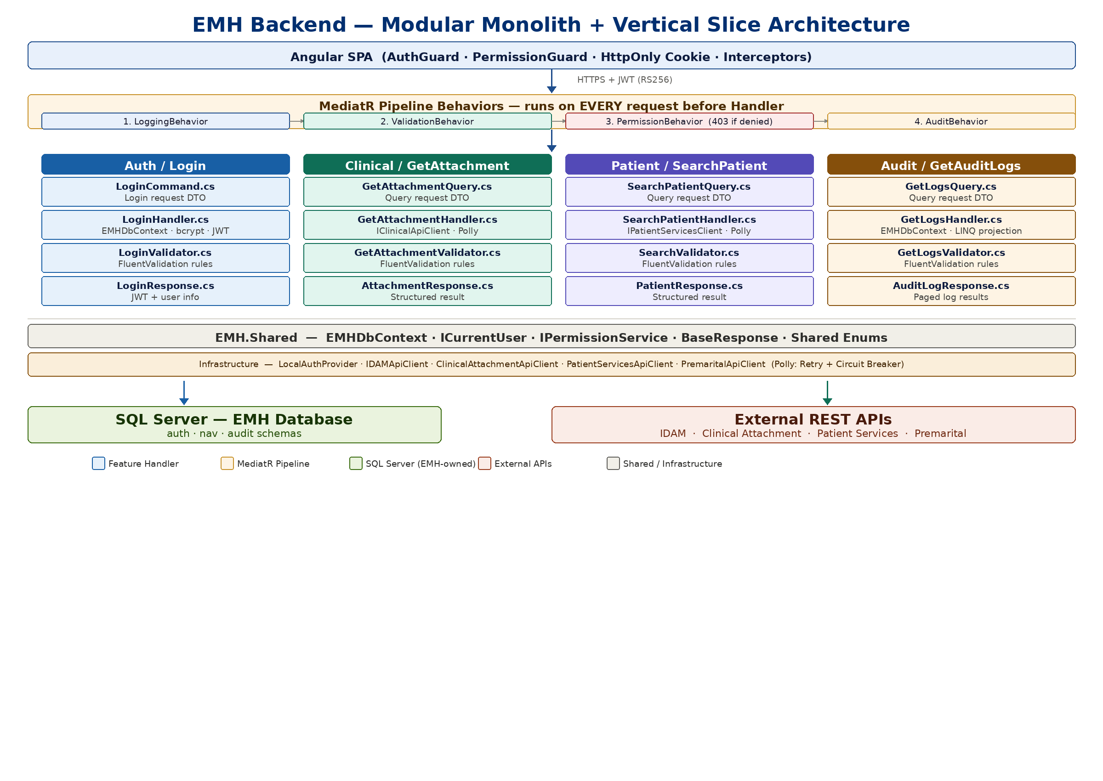
6.2 Global Authorization Default
Rule | Implementation | Applies To
Require authentication by default | AddAuthorization() with RequireAuthenticatedUser() as default policy in Program.cs | All endpoints
Explicit opt-out only | [AllowAnonymous] applied manually — login and refresh only | POST /api/v1/auth/login, POST /api/v1/auth/refresh
Granular permission check | [RequirePermission("permission.key")] on every feature endpoint | All feature endpoints

6.3 EF Core Database First — Key Rules
- All schema changes happen at the database level first, then scaffolded into EF models
- Generated EF models live in Infrastructure/Data/Generated/ — never edit these files manually
- Use partial classes to extend generated models without losing changes on re-scaffold
- EMHDbContext is injected directly into Feature Handlers — no Repository abstraction. This is a deliberate architectural decision: EF Core’s InMemory provider handles test isolation without a Repository layer. Handlers in ErrorHub.Features reference EMHDbContext from ErrorHub.Shared.

6.4 SSO Readiness via Auth Abstraction
Phase | Implementation | What Changes
Phase 1 (now) | LocalAuthProvider implements IAuthService — bcrypt + JWT generation | Nothing outside LocalAuthProvider
Future (SSO) | SsoAuthProvider implements IAuthService — OIDC integration | Only swap the registered DI implementation

6.5 Input Validation Strategy
Decision | Choice | Rationale
Library | FluentValidation | Separates validation rules from DTO classes. Each validator is a standalone class co-located with its use case.
Location | Application layer only | Controllers do not validate — they deserialize and call the service. Validation in controllers couples it to the delivery mechanism.
Registration | AddValidatorsFromAssembly(typeof(ApplicationAssemblyMarker).Assembly) | Auto-discovers all AbstractValidator<T> classes. No manual registration per validator.
400 Response shape | {"type":"validation_error","errors":[{"field":"username","message":"..."}]} | Consistent across all endpoints. Matches api-response.model.ts in Angular.

6.6 API Versioning
All API routes use the /api/v1/ prefix. This enables non-breaking Phase 2 changes.
- POST /api/v1/auth/login — Login
- POST /api/v1/auth/refresh — Refresh token
- GET /api/v1/me/applications — Application cards
- GET /api/v1/me/navigation — Sidebar navigation
- All feature endpoints: /api/v1/{module}/{resource}

6.7 External Integration Layer
Each external system is accessed through an interface defined in the Application layer and implemented in the infrastructure layer — the same pattern as IAuthService.

Application Layer Interface | Infrastructure Implementation | External System | API Status
IUserManagementClient | IDAMApiClient | IDAM REST API | ✓ Confirmed (Get Roles: missing — must be built)
IClinicalAttachmentClient | ClinicalAttachmentApiClient | Clinical Attachment REST API | ✓ 4 of 5 endpoints confirmed
IPremaritalClient | PremaritalApiClient | Premarital REST API | ? Unconfirmed
IPatientServicesClient | PatientServicesApiClient | Patient Services REST API | ✓ All 3 sub-modules confirmed

Integration Requirement | Specification
Timeout | 10 seconds per external call (configurable per environment)
Retry | 1 retry with 2-second delay for 5xx. No retry on 4xx.
Circuit breaker | Open after 5 consecutive failures. Half-open after 30 seconds.
Credentials | API keys in Azure Key Vault or environment variables — NEVER in appsettings.json
Failure UX | Graceful "Service Unavailable" per module. Other modules remain functional.
Error logging | All external failures logged to ErrorLogs: ModuleCode, Endpoint, StatusCode, ExceptionType
Prohibited | Direct database reads from any external system. All data via owned API clients only.
7. Security Architecture
Frontend authorization is for UX ONLY. Every backend endpoint MUST validate JWT AND check permissions server-side. This is the real security boundary.
7.1 Authentication (Phase 1)
- Username + password login via /api/auth/login
- bcrypt password hashing (cost factor 12+)
- JWT access token — RS256 signing algorithm (asymmetric, RSA 2048-bit key pair). Short-lived (15–60 minutes, configurable). Private key in Azure Key Vault — never in appsettings.json.
- Account lockout after 5 failed login attempts
- Lockout duration configurable (30 minutes)
- Token revocation on logout
- Secure token storage — HttpOnly cookie, SameSite=Strict — prevents CSRF. Tokens are NOT stored in localStorage.
- Username enumeration defense — POST /api/v1/auth/login must return identical response body, HTTP status (401), and processing time for both “user not found” and “wrong password” cases. Use constant-time comparison (CryptographicOperations.FixedTimeEquals) to prevent timing-based enumeration.
- Rate limit 429 response — return Retry-After header only. Response body must NOT state the limit value, window size, or remaining count. Exposing exact limits enables attackers to calibrate requests just below the threshold.
7.2 Authorization
Rule | Implementation
Default policy | RequireAuthenticatedUser() — all endpoints require valid JWT by default
Explicit opt-out | [AllowAnonymous] on login and refresh endpoints only
Granular control | [RequirePermission("key")] on every feature endpoint
Permission resolution | Role permissions → UserPermissions override → deny by default
403 response | Returned for valid JWT with insufficient permissions
401 response | Returned for missing, invalid, or expired JWT
Audit | Unauthorized access attempts logged to AuditLogs with UserId, IP, endpoint
Least privilege | No permissions granted by default. All permissions explicitly assigned.
7.3 Password Policy (Recommended — Pending SA Confirmation)
- Minimum 10 characters must include uppercase, lowercase, number, special character
- No reuse of last 5 passwords
- 90-day password expiry (configurable)
- Account lockout after 5 failed attempts, 30-minute lockout
7.4 Direct URL Access Security Flow
Step | Actor | Action
1 | Angular AuthGuard | Checks JWT presence in HttpOnly cookie. Redirects to login if missing
2 | Angular PermissionGuard | Reads cached permission set — NO network call. Redirects to 403 page if permission absent
3 | Angular | Page loads and calls backend API
4 | ASP.NET Core Middleware | Validates JWT signature and expiry. Returns 401 if invalid
5 | [RequirePermission] attribute | Checks user actual permissions server-side. Returns 403 if insufficient
6 | Backend | Returns 200 OK with data or 403 Forbidden
7 | AuditLoggingMiddleware | Logs unauthorized access attempts
8 | Angular Interceptor | Shows Not Authorized page on 403 responses
7.5 Rate Limiting
Endpoint / Scope | Policy | Limit | Response on Exceed
POST /api/v1/auth/login | Fixed window per IP | 5 req / minute | 429 Too Many Requests
POST /api/v1/auth/refresh | Fixed window per IP | 10 req / minute | 429 Too Many Requests
All authenticated endpoints | Sliding window per userId | 20 req / minute | 429 Too Many Requests
Implementation: AddRateLimiter() in Program.cs. Login uses FixedWindowRateLimiterOptions keyed by IP. Global policy uses SlidingWindowRateLimiterOptions keyed by authenticated userId. 429 responses include Retry-After header only — response body must NOT state the limit value or window size.

7.6 MFA
Deferred to Future Scope. The IAuthService abstraction supports adding MFA as a second step without structural changes to the application.

7.7 CORS Policy
Setting | Value
Allowed origins | Angular app origin only — configurable per environment
Allowed methods | GET, POST, PUT, DELETE, OPTIONS
Allowed headers | Authorization, Content-Type, X-Request-ID
Credentials | Allowed (required for HttpOnly cookie token storage)
Preflight cache (Max-Age) | 600 seconds //10 minutes this cache improve performance (decrease network round trips,latency,server processing,unnecessary traffic)  // Sets the Access-Control-Max-Age header to 600 seconds  .SetPreflightMaxAge(TimeSpan.FromSeconds(600));

7.8 HTTPS / TLS
Requirement | Specification
TLS version | TLS 1.3 preferred
HTTP redirect | UseHttpsRedirection() middleware — all HTTP redirected to HTTPS
HSTS | Enforced via Strict-Transport-Security header

7.9 Exception Middleware
Exception Type | HTTP Status | Logged to ErrorLogs | Client Message
ValidationException | 400 Bad Request | No | Structured field errors
UnauthorizedException | 401 Unauthorized | No | "Authentication required"
ForbiddenException | 403 Forbidden | Yes — UserId, endpoint | "Access denied"
NotFoundException | 404 Not Found | No | "Resource not found"
ExternalServiceException | 503 Service Unavailable | Yes — ModuleCode, endpoint, status | "Service temporarily unavailable"
Unhandled Exception | 500 Internal Server Error | Yes | "Unexpected error”
** Save the Full stack traces as StackTraceHash in ErrorLogs — never returned to the client.

7.10 Audit Logging
Requirement | Specification
What is logged | Who(user),what(action),action category(read/write/delete/auth),when(timestamp),target(what was affected),result(success/failure)
Retention | To be confirmed with compliance team/ SA ???

7.11 Least Privilege — Page / Action Permissions
- No permission is granted by default. All permissions must be explicitly assigned.
7.12 HTTP Security Headers
All headers are set at the reverse proxy level. Exception: Cache-Control is set in ASP.NET Core middleware for /api/ routes only.

Header | Value | Purpose
Strict-Transport-Security | max-age=31536000; includeSubDomains | Forces HTTPS. Prevents protocol downgrade attacks
X-Content-Type-Options | nosniff | Prevents MIME-sniffing. Blocks certain XSS vectors.
X-Frame-Options | DENY | EMH is never in iframes. Blocks clickjacking.
Referrer-Policy | strict-origin-when-cross-origin | Prevents leaking internal URLs to external systems.
Content-Security-Policy | ex: Content-Security-Policy: default-src 'self'; script-src 'self';  style-src 'self' 'unsafe-inline';  img-src 'self' data:; font-src 'self';  connect-src https://api.example.com;  frame-ancestors 'none';  object-src 'none';  base-uri 'self'; | Primary XSS defense.
Permissions-Policy | geolocation=(), camera=(), microphone=() | Disables unused browser features.
Cache-Control | no-store | Prevents patient data caching by browsers/proxies.

CSP Finalization: Content-Security-Policy cannot be finalized until Angular production build is tested. Minimum requirements: default-src 'self'; connect-src [API origin]; frame-ancestors 'none'. Owner: Frontend lead confirms CSP does not break Angular build. Deadline: Before production deployment.
7.13 JWT Signing Key Management
Requirement | Specification
Key storage | Azure Key Vault — RSA 2048-bit private key (signing) and public key (verification). Algorithm: RS256 (NEVER store in appsettings.json or source control)
Key rotation | Supported via IAuthService abstraction. Rotation procedure defined by infrastructure team/SA(30 min)
7.14 Observability — Structured Logging & Health Checks
Structured Logging — Serilog
Requirement | Specification
Library | Serilog — UseSerilog() in Program.cs. Structured JSON output, not plain text
Sinks | Dev/Staging: Serilog.Sinks.Seq (Seq UI at http://localhost:5341)  Prod: Serilog.Sinks.File (rolling daily) + Azure Monitor / Application Insights sink  *** Avoid saving Passwords, JWT tokens, raw stack traces, EID/Emirates ID values, full patient records. Sanitize all sensitive fields before logging
Health Check Endpoints
Endpoint | Type | Checks / Notes
GET /health | Full health | SQL Server connectivity, external API reachability (per module). Returns 200 Healthy or 503 Unhealthy with per-check detail.
GET /health/live | Liveness | Process alive check only. Fast (no DB call). Load balancer / container probe target.
GET /health/ready | Readiness | SQL Server reachable + EF Core migrations applied. Returns 503 until ready — prevents routing traffic before startup completes.
8. Performance Practices
8.1 Backend **
Practice | Where applied | Implementation
Server-side pagination | All list endpoints | page and pageSize query params; never return all records; max pageSize = 30
DTO projection | All EF queries | Select() to DTO in LINQ — never load full entity graph, never use Include() unless the navigation is needed
Async everywhere | All controllers and services | Task<T> and CancellationToken on every method that does I/O
Permission cache | Navigation JSON | PermissionService caches navigation per userId for 10 minutes in IMemoryCache
No N+1 queries | All repositories | Joins in single LINQ query rather than looping and calling FindById per item
Response compression | Program.cs | AddResponseCompression() with Brotli and GZip — significant reduction for JSON responses
8.2 Frontend
Practice | Implementation
Lazy loading | All feature routes use loadComponent() or loadChildren(). Initial bundle: login + shell only.
OnPush everywhere | No component re-renders unless its signal inputs change.
Server-side pagination | All list endpoints: page, pageSize query params. Never load all records.
Sidebar cache | PermissionsService caches sidebar JSON per projectCode. One API call per project per browser session. (** for 10 minutes only)
Track in @for | Always: @for (item of list(); track item.id). Prevents full DOM re-creation on list refresh.
toSignal() for streams | eliminates manual subscribe/unsubscribe boilerplate
Debounced search | Search inputs use debounceTime(300) + distinctUntilChanged() before triggering API call.
Environment config | environment.ts (dev) + environment.stg.ts (stg) + environment.prod.ts (prod) for API URL
Figure 2: Frontend Architecture — Angular SPA (Standalone · Zoneless · Signals)
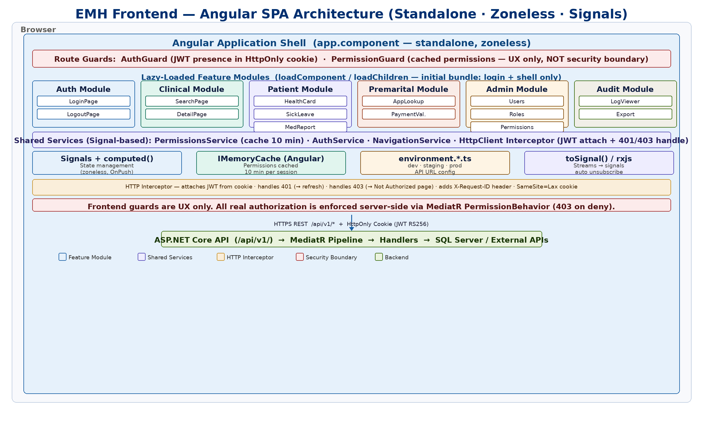
8.3 Database (** to ensure proper peformance from DB side it’s depending on the application owner)
Practice
Add Relationships( for the consistency)
Add indexes
Use Correct data types
Add soft delete (if needed)
8.4 Database Index Specification (EMH-Owned Tables Only)
Table | Index Columns | Index Type | Query Served
Users | Username | Unique | Login lookup — every authentication
Users | Email | Unique | Account lookup
RefreshTokens | TokenHash | Unique | Token validation — called on every refresh request
RefreshTokens | UserId | Non-clustered | Bulk revocation per user
AuditLogs | (UserId, CreatedAt) | Non-clustered composite | Audit viewer: user + date range search
AuditLogs | (EntityName, EntityId) | Non-clustered composite | Entity history: all actions on a specific record
LoginHistory | (UserId, CreatedAt) | Non-clustered composite | Login history per user
MenuItems | AppId | Non-clustered | Sidebar build — called on every session start

External systems: EMH does not own or manage indexes on Clinical Attachment, Premarital, Patient Services, or IDAM databases. Their performance is the responsibility of each application's backend owner. EMH enforces 15-second timeout + circuit breaker on all external API calls.

9. Database Conceptual Model
9.1 Core Tables Overview
Table | Schema | Key Columns | Notes
Users | auth | UserId (PK), Username (unique), PasswordHash, Email (unique), IsActive, IsDeleted, DeletedAt, FailedLoginCount, LockedUntil, CreatedAt, UpdatedAt | Soft delete: IsDeleted + DeletedAt. UpdatedAt set by EF Core SaveChanges interceptor on every write.
Roles | auth | RoleId (PK), RoleName (unique), Description, IsActive, IsDeleted, DeletedAt, CreatedAt, UpdatedAt | Soft delete supported. UpdatedAt auto-maintained via EF Core interceptor.
UserRoles | auth | UserId (FK), RoleId (FK), AssignedAt, AssignedBy | Composite PK (UserId, RoleId)
Permissions | auth | PermissionId (PK), PermissionKey (unique), ApplicationCode, Module, Page, Action, IsActive, CreatedAt, UpdatedAt | Key format: app.module.page.action
RolePermissions | auth | RoleId (FK), PermissionId (FK) | Composite PK
UserPermissions | auth | UserId (FK), PermissionId (FK), IsGrant (TINYINT: 1=Grant / 0=Deny), AssignedBy, AssignedAt | Per-user override. IsGrant: 1 = Grant, 0 = Deny (TINYINT — no Inherit state; absence of row means no override, role-level permission applies). See §4.4 precedence rule.
RefreshTokens | auth | TokenId (PK), UserId (FK), TokenHash (unique), ExpiresAt, RevokedAt, IsRevoked, CreatedAt, CreatedByIp (NVARCHAR 45), RevokedByIp (NVARCHAR 45), ReplacedByTokenId (FK self) | TokenHash = SHA-256 of raw token. Never store plaintext token.
Applications | nav | AppId (PK), AppCode (unique), AppName, RoutePrefix, DisplayOrder, IsActive | Database-driven app cards
MenuItems | nav | MenuItemId (PK), AppId (FK), ParentMenuItemId (FK self), Label, Route, RequiredPermission, DisplayOrder, IsActive | Self-referencing tree. Max depth enforced in app layer.
PageActions | nav | ActionId (PK), AppId (FK), MenuItemId (FK), PageCode, ActionKey, RequiredPermission | FK to MenuItems prevents orphaned actions
AuditLogs | audit | AuditId (PK), UserId (FK nullable), Action, EntityName, EntityId, OldValue (NVARCHAR MAX), NewValue (NVARCHAR MAX), IPAddress, UserAgent, CreatedAt, RetentionDate | Non-transactional write. RetentionDate for archiving. OldValue/NewValue are NVARCHAR(MAX) — no truncation. Index strategy: avoid indexing MAX columns; query via EntityName + EntityId composite index.
LoginHistory | audit | HistoryId (PK), UserId (FK), EventType, IPAddress, UserAgent, Success, FailReason, CreatedAt | Login, logout, lockout events
ErrorLogs | audit | ErrorLogId (PK), UserId (FK nullable), ModuleCode, Endpoint, HttpMethod, StatusCode, ExceptionType, SanitizedMessage, StackTraceHash, CreatedAt | StackTraceHash deduplicates errors. Raw stack trace never stored.

9.2 ERD
Figure 3: Entity Relationship Diagram — EMH-Owned Tables (auth · nav · audit schemas)
