DUBAI HEALTH
Architecture Design Document
Error Management Hub (EMH)
Mendix Enterprise Solution
Version: 1.0
Status: Draft for Architecture Review
Classification: Confidential - Internal Use Only

Document Control
Table 1: Document Control
Field | Value
Document Name | Architecture Design Document
Project | Error Management Hub (EMH)
Organization | Dubai Health
Platform | Mendix Low-Code Platform
Deployment Model | On-Premises
Version | 1.0
Status | Draft for Architecture Review
Classification | Confidential - Internal Use Only
Audience | Architecture Review Board, Solution Architecture, Information Security, Infrastructure, Operations, Data Governance, Project Management, Development Team

Version History
Table 2: Version History
Version | Date | Author / Owner | Description
0.1 | TBD | Architecture Team | Initial Mendix architecture baseline
0.5 | TBD | Architecture Team | Chapters 1-6 drafted and diagrams reviewed
1.0 | TBD | Architecture Team | Draft for Architecture Review Board submission

Review & Approval
Table 3: Review and Approval
Reviewer / Approver | Role | Status | Date
TBD | Business Owner | Pending | TBD
TBD | Enterprise Architecture | Pending | TBD
TBD | Information Security | Pending | TBD
TBD | Infrastructure Operations | Pending | TBD
TBD | Data Governance | Pending | TBD

Distribution List
Table 4: Distribution List
Group / Role | Purpose
Business Sponsor / Business Owner | Business review and confirmation of functional scope
Enterprise Architecture | Architecture governance and approval
Solution Architecture | Solution design validation
Information Security | Security, privacy, and compliance review
Infrastructure Operations | Deployment, monitoring, availability, and operations review
Data Governance | Data ownership, classification, and privacy review
Development Team | Implementation guidance
Project Management | Delivery governance and planning

Table of Contents
This document uses standard Word heading styles. After combining or editing the document, update the Table of Contents, List of Figures, and List of Tables using Microsoft Word references functionality.
- Executive Summary
- 1. Solution Overview
- 2. Data Architecture
- 3. Application Architecture
- 4. Technical Architecture
- 5. Information Security Architecture
- 6. Implementation & Migration Approach
- Appendix A - Glossary
- Appendix B - Acronyms
- Appendix C - References
- Appendix D - Architecture Decision Records
- Appendix E - Architecture Assumptions

Executive Summary
The Error Management Hub (EMH) is a centralized enterprise support application developed to streamline operational investigations across multiple Dubai Health enterprise systems. The solution consolidates support activities into a single secure Mendix-based interface while preserving each connected application as the authoritative System of Record.
EMH is designed as an internal, read-only investigation portal. It enables authorized support officers to search and view information from systems such as IDAM, Clinical Attachment, Premarital, Patient Services, UAE Pass, and ICP through approved REST APIs. External business data is displayed using non-persistent Mendix entities and is not stored by EMH.
The application shall be deployed on-premises within an approved Dubai Health environment. Authentication shall be delegated to enterprise IDAM through SAML Single Sign-On. Authorization shall be enforced using Mendix security capabilities, including user roles, module roles, page access, microflow access, entity access rules, and permission mapping. Microsoft SQL Server shall be used for EMH-owned persistent data, including users, roles, permissions, audit logs, exception logs, and configuration. AppDynamics shall provide monitoring and observability.
Table 5: Executive Architecture Summary
Area | Architecture Position
Business Purpose | Centralized support investigation platform for Dubai Health support officers.
Platform | Mendix Low-Code Platform.
Deployment | On-premises in an approved Dubai Health environment.
Authentication | Enterprise IDAM using SAML SSO.
Integration | REST APIs / JSON only; no direct database integration.
Data Strategy | External business data is display-only and non-persistent.
Persistence | Only EMH-owned users, roles, permissions, audit logs, exception logs, and configuration.
Monitoring | AppDynamics and Mendix runtime logging capabilities.
Security Classification | Confidential and Highly Confidential information handling.

Table 6: Key Architecture Decisions
ADR ID | Decision
ADR-001 | Adopt Mendix as the application platform.
ADR-002 | Deploy EMH on-premises.
ADR-003 | Use Enterprise IDAM with SAML SSO for authentication.
ADR-004 | Use REST APIs for all integrations.
ADR-005 | Do not persist external operational business data.
ADR-006 | Use non-persistent entities for external search results.
ADR-007 | Persist only EMH-owned operational and governance data.
ADR-008 | Use AppDynamics for monitoring and observability.

Table 7: Expected Benefits
Benefit | Description
Centralized Support | Support officers access a single investigation portal instead of multiple systems.
Reduced Investigation Time | Consolidated search and display reduce context switching and manual correlation.
Security and Governance | Access is controlled, audited, and aligned with least-privilege principles.
Data Ownership Preservation | External systems remain Systems of Record.
Maintainability | Modular Mendix architecture supports future enhancements and additional modules.
Operational Visibility | AppDynamics and audit logs support monitoring, troubleshooting, and compliance.

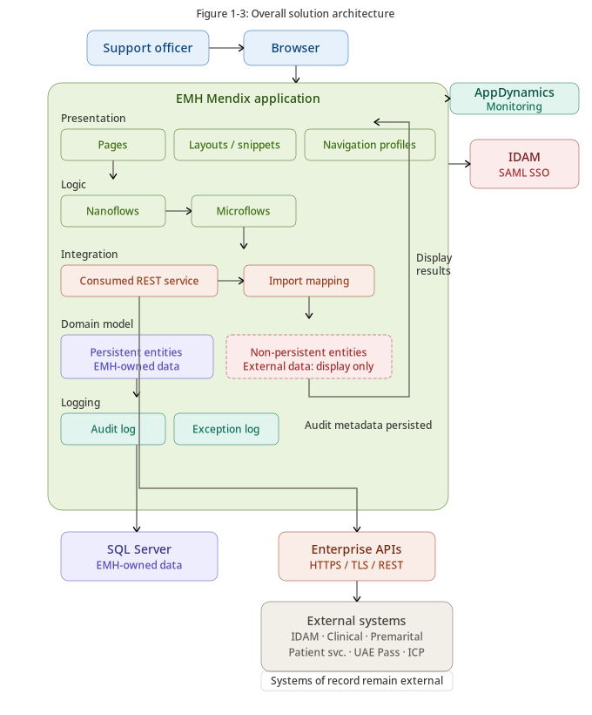
Figure 1-3 - Overall Solution Architecture
Presents the end-to-end EMH architecture, showing the flow from browser access through Mendix pages, microflows, REST services, import mappings, non-persistent entities, persistence, and monitoring.

1. Solution Overview
This chapter provides the architectural foundation for the Error Management Hub (EMH), including its business purpose, solution summary, architecture decisions, RAID log, architecture gaps, references, principles, and stakeholder concerns.

1.1 Business Purpose
EMH provides Dubai Health support officers with a governed, centralized workspace for investigating operational issues across multiple enterprise systems. The solution reduces operational complexity by replacing fragmented investigation approaches with a consistent, secure, and auditable support portal.
Table 8: Business Drivers
Business Driver | Description
Centralized Support Operations | Provide a unified support workspace that reduces the need to access multiple systems independently.
Reduced Resolution Time | Improve investigation efficiency through consolidated access to relevant information.
Security and Auditability | Enforce controlled access and maintain an audit trail for support actions.
Operational Efficiency | Reduce reliance on technical teams for routine support investigations.
Enterprise Integration | Standardize access through approved REST APIs rather than direct database access.
Future Scalability | Enable future onboarding of additional support modules.

1.2 Solution Summary
EMH shall be implemented using the Mendix Low-Code Platform and deployed on-premises. It shall authenticate users through enterprise IDAM using SAML SSO, enforce EMH-specific authorization through Mendix security capabilities, consume external data through REST APIs, display external data using non-persistent entities, and persist only EMH-owned data.
Table 9: Solution Characteristics
Characteristic | Description
Application Platform | Mendix Low-Code Platform.
Deployment Model | On-premises.
Authentication | Enterprise IDAM using SAML SSO.
Authorization | Role-based authorization using Mendix security and EMH permission mappings.
Integration | REST APIs / JSON only.
Data Ownership | External systems remain Systems of Record.
Persistence | Users, roles, permissions, mappings, audit logs, exception logs, and configuration only.
Monitoring | AppDynamics and Mendix runtime logs.

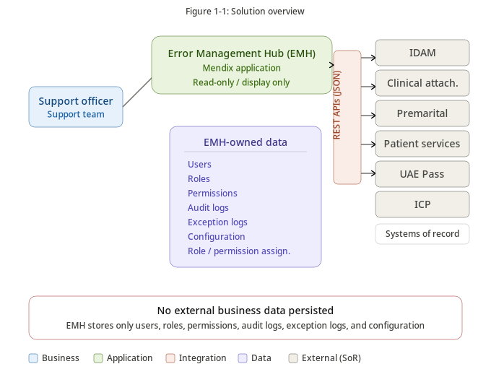
Figure 1-1 - Solution Overview
Illustrates how EMH centralizes support investigations through a Mendix application while external enterprise systems remain Systems of Record and EMH persists only application-owned data.

1.3 Key Architecture Decisions
The following architecture decisions establish the baseline direction for the EMH solution. Detailed decision records are included in Appendix D.
Table 10: Architecture Decision Register Summary
ADR ID | Decision | Status | Rationale
ADR-001 | Adopt Mendix as the application platform | Approved | Mendix enables rapid delivery, modularity, governance, and maintainability.
ADR-002 | Deploy on-premises | Approved | Supports current project direction and data residency expectations.
ADR-003 | Use SAML SSO through enterprise IDAM | Approved | Centralizes authentication and avoids local password management.
ADR-004 | Use REST APIs for all integrations | Approved | Preserves loose coupling and enterprise integration governance.
ADR-005 | Prohibit direct database access to external systems | Approved | Protects source-system ownership and reduces coupling.
ADR-006 | Use non-persistent entities for external business data | Approved | Avoids persistence of sensitive external data in EMH.
ADR-007 | Persist only EMH-owned data | Approved | Limits privacy risk and simplifies governance.
ADR-008 | Use AppDynamics for monitoring | Approved | Provides enterprise observability and runtime monitoring.
ADR-009 | Use Microsoft SQL Server for EMH persistence | Approved | Aligns to relational persistence needs for application-owned data.
ADR-010 | Restrict custom Java actions to approved exceptions | Approved | Preserves Mendix-native maintainability and secure development.

1.3.x Architecture Principles Applied
Table 11: Architecture Principles Applied
Principle | Application in EMH
API First | All integrations use enterprise-approved REST APIs.
Secure by Design | Authentication, authorization, logging, and privacy controls are embedded throughout the architecture.
Least Privilege | Access is managed using roles, permissions, module roles, and entity access.
Data Minimization | External business data is displayed only and not persisted.
Separation of Concerns | Presentation, business logic, integration, security, persistence, and monitoring are logically separated.
Observability | AppDynamics and audit/exception logs support operational monitoring and investigation.

1.4 RAID Log
Table 12: RAID Register
ID | Category | Description | Impact | Mitigation / Action | Owner | Status
RAID-001 | Risk | Premarital APIs have not yet been confirmed by the owning application team. | High | Confirm API availability and interface specifications before implementation. | Project Manager / Application Owner | Open
RAID-002 | Risk | External system unavailability may impact support investigations. | High | Implement timeouts, graceful error handling, monitoring, and service-availability messages. | Solution Architect | Open
RAID-003 | Risk | External API contract changes may affect EMH functionality. | Medium | Establish API governance, versioning, and change notification procedures. | Integration Architect | Open
RAID-004 | Assumption | IDAM will provide SAML-based authentication services. | Medium | Validate with Enterprise IAM Team. | Enterprise IAM Team | Open
RAID-005 | Assumption | EMH consumes operational data through approved REST APIs only. | Low | Validate with application owners during interface design. | Enterprise Architecture | Open
RAID-006 | Issue | Marketplace module approval process requires confirmation. | Medium | Obtain guidance from Enterprise Architecture and Information Security. | Enterprise Architecture | Open
RAID-007 | Dependency | Production and non-production infrastructure environments are required. | High | Coordinate provisioning with Infrastructure Operations. | Infrastructure Team | Open
RAID-008 | Dependency | AppDynamics onboarding is required before go-live. | Medium | Complete monitoring configuration prior to production deployment. | Operations Team | Open

1.5 Architecture Gaps
Table 13: Architecture Gap Register
Gap ID | Architecture Domain | Gap Description | Recommended Action | Priority | Status
AG-001 | Business / Integration | Premarital API availability requires confirmation. | Finalize API contracts with application owner. | High | Open
AG-002 | Data Architecture | Final data classification per data element requires governance validation. | Complete classification assessment. | High | Open
AG-003 | Technical Architecture | DR strategy requires validation against target RTO/RPO. | Validate during infrastructure readiness review. | High | Open
AG-004 | Security Architecture | Marketplace governance process requires confirmation. | Obtain EA and Information Security approval process. | Medium | Open
AG-005 | Operations | Operational support model requires finalization. | Define support ownership and escalation model. | Medium | Open
AG-006 | Monitoring | AppDynamics dashboard and alerting scope requires definition. | Finalize monitoring design before go-live. | Medium | Open

1.6 References
Table 14: Reference Documents
Reference | Purpose
Dubai Health Enterprise Architecture Standards | Enterprise architecture governance and design alignment.
Dubai Health Information Security Policies | Security, privacy, and operational security requirements.
UAE Personal Data Protection Law (PDPL) | Privacy and personal data protection context.
UAE Information Assurance Regulation | Government information assurance and security control context.
Mendix Documentation | Mendix platform capabilities, security, deployment, and runtime guidance.
OWASP ASVS and OWASP Top 10 | Application security verification and threat guidance.
NIST Cybersecurity Framework | Security governance and risk management reference.
Original EMH Architecture Proposal | Baseline business and functional requirements for EMH.

1.6.1 Principles & Guidelines
Table 15: Architecture Principles
Principle ID | Principle | Description
AP-001 | Business Alignment | Architecture decisions shall support EMH business objectives.
AP-002 | API First | All integrations shall use approved APIs.
AP-003 | Single Source of Truth | External systems remain authoritative for their business data.
AP-004 | Secure by Design | Security controls shall be embedded across the architecture.
AP-005 | Least Privilege | Users shall receive only required access.
AP-006 | Privacy by Design | Personal and sensitive data shall be minimized and protected.
AP-007 | Modular Architecture | Business capabilities shall be organized into Mendix modules.
AP-008 | Observability | The solution shall provide monitoring, logging, and auditability.

1.7 Stakeholders & Concerns

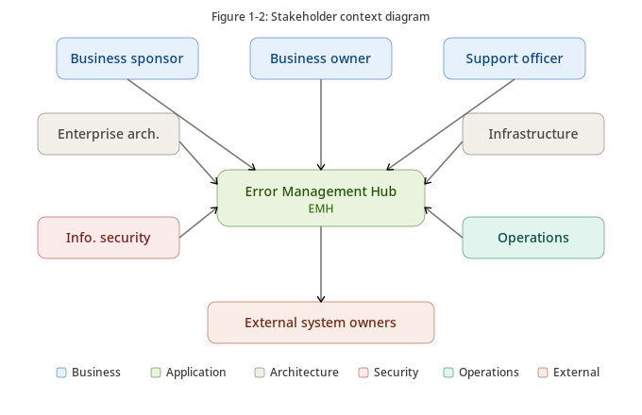
Figure 1-2 - Stakeholder Context
Identifies the key business, architecture, security, infrastructure, operations, and external system stakeholders interacting with or governing EMH.

Table 16: Stakeholders and Concerns
Stakeholder | Role / Responsibility | Primary Concerns
Business Sponsor | Project sponsorship and prioritization | Business value, delivery timeline, and operational adoption.
Business Owner | EMH business process ownership | Centralized support capability and accurate investigation results.
Support Officer | Primary operational user | Fast search, intuitive navigation, and reliable data visibility.
Enterprise Architecture | Architecture governance | Standards alignment, maintainability, and integration strategy.
Information Security | Security governance | Authentication, authorization, encryption, auditability, and privacy.
Infrastructure Operations | Hosting and operations | Availability, backup, monitoring, DR, and supportability.
Data Governance | Data ownership and privacy | Data classification, retention, privacy, and mastership.
External Application Owners | Owners of source systems | API stability, source-system performance, and ownership preservation.

2. Data Architecture
This chapter defines the data architecture for EMH, including scope, glossary, conceptual model, logical model, data mastership, data management, data quality, retention, privacy, and migration considerations. EMH follows a minimal-persistence model and does not become a repository for external business data.

2.1 Data Scope, Glossary & Reference
EMH persists only application-owned data required for access control, authorization, auditability, exception handling, and configuration. External operational data is retrieved at runtime through approved APIs and displayed to authorized support officers using non-persistent entities.
Table 17: EMH Data Scope
Data Category | Stored in EMH | Purpose | System of Record
EMH Users | Yes | Authorized access to EMH | EMH / IDAM reference
Roles | Yes | Access grouping | EMH
Permissions | Yes | Application, module, page, and action authorization | EMH
Role Assignments | Yes | User-role association | EMH
Permission Assignments | Yes | Role-to-permission association | EMH
Audit Logs | Yes | Governance and traceability | EMH
Exception Logs | Yes | Operational troubleshooting | EMH
System Configuration | Yes | Application runtime configuration | EMH
Clinical Attachment Data | No | Display-only investigation | Clinical Attachment
Premarital Data | No | Display-only investigation | Premarital
Patient Services Data | No | Display-only investigation | Patient Services
UAE Pass / ICP Data | No | Display-only identity investigation | UAE Pass / ICP

2.1.1 Conceptual Data Model

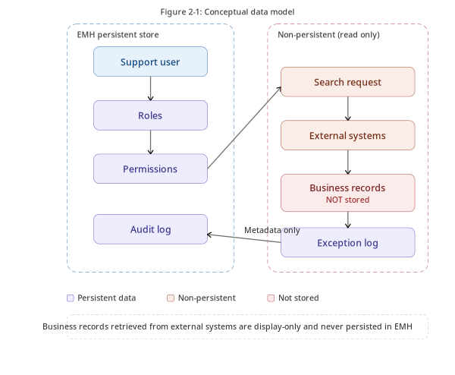
Figure 2-1 - Conceptual Data Model
Shows the high-level business entities and relationships relevant to EMH, emphasizing access, search, external Systems of Record, auditability, and exception logging.

The conceptual data model separates the support investigation context from source-system ownership. EMH governs access, search, audit, and error logging while external systems remain authoritative for their business records.

2.1.2 Logical Data Model

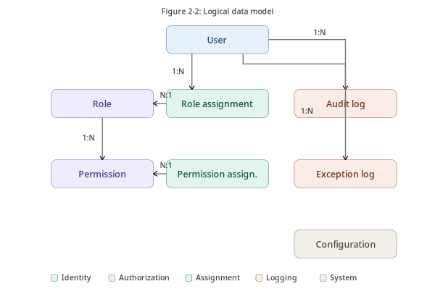
Figure 2-2 - Logical Data Model
Shows the logical EMH-owned data entities including users, roles, permissions, mappings, audit logs, exception logs, and configuration entities.

Table 18: Logical Data Model
Entity | Key Attributes | Description
EMH User | User ID, Username, Full Name, Email, Status, Last Login Date | Authorized internal user mapped to enterprise identity.
Role | Role ID, Role Name, Description, Status | Business access grouping within EMH.
Permission | Permission ID, Permission Code, Application, Module, Action | Granular authorization rule.
Role Assignment | User ID, Role ID, Assigned Date, Assigned By | Association between users and roles.
Permission Assignment | Role ID, Permission ID, Granted Date | Association between roles and permissions.
Audit Log | Audit ID, User ID, Action, Module, Result, Timestamp, Correlation ID | Traceable record of user and administrative actions.
Exception Log | Exception ID, Type, Module, Source System, Sanitized Message, Timestamp | Record of runtime and integration failures.
System Configuration | Configuration Key, Value, Description, Last Updated | Controlled application runtime configuration.

2.1.3 Data Glossary
Table 19: Data Glossary
Entity / Data Concept | Description | Data Ownership
EMH User | Authorized internal user who accesses EMH through SSO. | EMH / IDAM reference
Role | Logical access grouping assigned to EMH users. | EMH
Permission | Granular rule controlling access to applications, modules, pages, and actions. | EMH
Audit Log | Record of searches, views, access denials, and administrative actions. | EMH
Exception Log | Record of application and integration exceptions. | EMH
IDAM User Profile | User identity and account information retrieved for investigation. | IDAM
UAE Pass Identity | National digital identity data exposed through approved identity flows. | UAE Pass
ICP Information | Identity/applicant verification data exposed through approved services. | ICP
Clinical Attachment Application | Clinical attachment support record displayed for investigation. | Clinical Attachment
Premarital Application | Premarital application support record displayed for investigation. | Premarital
Patient Services Record | Health card, sick leave, or medical report support data. | Patient Services

2.2 Data Mastership

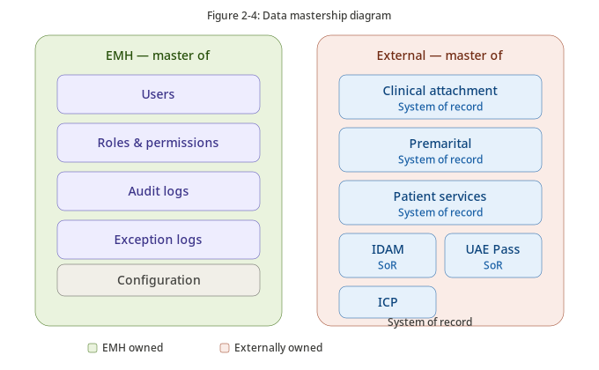
Figure 2-4 - Data Mastership
Clarifies data ownership boundaries by identifying EMH-owned data and external Systems of Record such as IDAM, Clinical Attachment, Premarital, Patient Services, UAE Pass, and ICP.

Table 20: Data Mastership Matrix
Data Entity | EMH | IDAM | UAE Pass | ICP | Clinical Attachment | Premarital | Patient Services
EMH User | M | P
Role | M
Permission | M
Audit Log | M
Exception Log | M
System Configuration | M
User Identity | S | M | P
UAE Pass Identity | S | P | M
ICP Applicant Information | S |  |  | M | P | P
Clinical Attachment Application | S |  |  |  | M
Premarital Application | S |  |  |  |  | M
Patient Profile / Services | S |  |  |  |  |  | M

Legend: M = Master / System of Record, P = Provider, S = Subscriber / Consumer, A = Associated, O = Originator.

2.3 Data Management
The EMH data management approach focuses on minimal persistence, secure access, auditability, and runtime retrieval of external information. Business records remain governed by their source applications.

2.3.1 Data Profile
Table 21: Data Profile
Data Category | Classification | Source | Persistence | Usage
User Administration | Confidential | EMH / IDAM | Persistent | User administration and authorization.
Roles & Permissions | Confidential | EMH | Persistent | Access control.
Audit Logs | Confidential | EMH | Persistent | Governance and compliance.
Exception Logs | Confidential | EMH | Persistent | Troubleshooting.
Identity Information | Highly Confidential | IDAM / UAE Pass / ICP | Non-Persistent | Support investigation.
Clinical Attachment Information | Highly Confidential | Clinical Attachment | Non-Persistent | Support investigation.
Premarital Information | Highly Confidential | Premarital | Non-Persistent | Support investigation.
Patient Services Information | Highly Confidential | Patient Services | Non-Persistent | Support investigation.

2.3.2 Data Quality & Reconciliation Checks
Table 22: Data Quality Controls
Control | Description
API Response Validation | Validate mandatory response fields before presentation.
Null Value Handling | Handle incomplete or unavailable data gracefully.
Data Type Validation | Validate expected response formats and values.
Correlation IDs | Maintain request identifiers for troubleshooting.
Authorization Validation | Validate permissions before retrieving data.
Timeout Handling | Detect and report unavailable services.

No batch reconciliation is required for external business data because EMH does not synchronize or persist source-system records.

2.3.3 Data Volume & Sizing
Table 23: Estimated Data Volumes
Data Category | Estimated Growth | Notes
Users | Low | Limited to authorized support personnel.
Roles | Very Low | Stable reference data.
Permissions | Very Low | Stable authorization catalogue.
Audit Logs | High | Continuous growth based on search and access activity.
Exception Logs | Medium | Dependent on application and integration failures.
Configuration | Very Low | Administrative data only.

2.3.4 Data Retention & Archival Plan
Table 24: Data Retention Policy
Data Type | Retention | Archive Strategy
Users | Active lifecycle | Retained while authorized access is required.
Roles & Permissions | Active lifecycle | Maintained as current security configuration.
Audit Logs | 1 Year | Archive or purge according to approved retention policy.
Exception Logs | 1 Year | Archive or purge according to approved retention policy.
Configuration | Current version with change history where applicable | Maintained according to operational need.
External Business Data | Not retained | Retrieved on demand only.

2.3.5 Data Privacy Compliance & Decisions

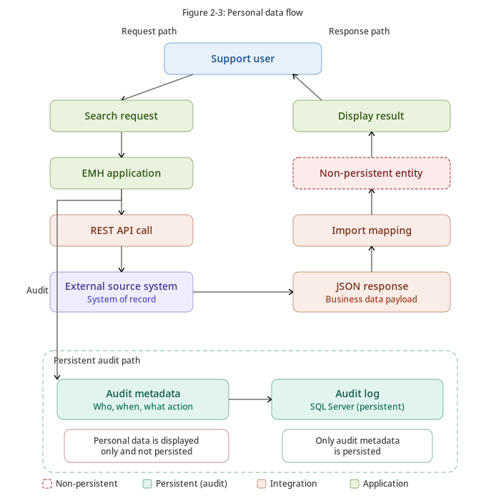
Figure 2-3 - Personal Data Flow
Illustrates the personal-data request and response flow. External personal data is displayed using non-persistent entities, while only audit metadata is persisted.

Table 25: Privacy Design Decisions
Decision | Rationale
External business data is not persisted | Reduces privacy exposure and duplicate storage of sensitive information.
Authentication delegated to IDAM | Avoids local credential management.
Access controlled through RBAC and Mendix security | Supports least privilege and accountability.
Audit logging enabled | Supports investigation and governance.
Sensitive payloads excluded from logs | Reduces accidental disclosure risk.

2.3.6 Data Conversion & Data Migration Approach
Table 26: Data Migration Scope
Data Category | Migration Required | Remarks
Users | Yes, if applicable | Initial provisioning or controlled mapping with IDAM.
Roles | Yes | Initial application setup.
Permissions | Yes | Initial application setup.
Role Assignments | Yes | Initial configuration.
System Configuration | Yes | Application initialization.
Audit Logs | No | Audit history starts at go-live unless otherwise required.
External Business Data | No | Retrieved in real time from source systems.

3. Application Architecture
This chapter describes the logical application architecture of EMH, including application context, component design, interface design, API catalogue, event catalogue, and application environments. The application architecture is Mendix-native and aligned to the data ownership boundaries defined in Chapter 2.

3.1 Application Interface View

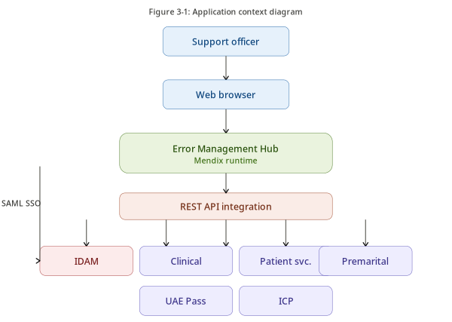
Figure 3-1 - Application Context
Shows EMH within the application landscape and its interaction with support officers and enterprise systems through controlled REST-based interfaces.

EMH is an internal enterprise web application that provides authorized support officers with a unified investigation interface. The application is read-only with respect to external business systems and retrieves data through approved REST APIs.
Table 27: Application Responsibilities
Capability | Responsibility
Authentication | Delegate authentication to enterprise IDAM via SAML SSO.
Authorization | Enforce application, module, page, microflow, and entity-level access.
Search | Provide centralized search across supported domains.
Information Retrieval | Consume enterprise APIs and map responses into non-persistent entities.
Presentation | Display consolidated results to authorized support officers.
Audit | Record user activities and administrative changes.
Exception Logging | Record application and integration failures.

3.2 Component Description
Table 28: Application Component Catalogue
Component | Description | Mendix Implementation
User Interface | Dashboards, search pages, result views, and admin pages. | Pages, Layouts, Snippets, Navigation Profiles, Atlas UI.
Authentication | Delegates authentication to IDAM. | SAML SSO integration.
Authorization | Controls access to modules, pages, microflows, and entities. | App Security, User Roles, Module Roles, Entity Access, XPath constraints.
Search & Investigation | Validates search criteria and coordinates API calls. | Microflows, Non-Persistent Entities.
Integration Services | Communicates with external systems. | Consumed REST Services, Import Mappings.
Audit Service | Records user activities and administrative events. | Audit Microflows and Persistent Audit Entities.
Exception Management | Captures application and integration exceptions. | Exception Logging Microflows and Runtime Log Nodes.
Configuration Management | Maintains runtime configuration. | Constants, Configuration Entities, Admin Pages.

Table 29: Mendix Module Structure
Mendix Module | Responsibility
Security | Users, roles, permissions, authentication mapping, access checks.
Administration | Application configuration and administration pages.
Audit | Audit logging and activity history.
Exception Management | Application and integration exception handling.
Integration | Consumed REST services, import mappings, and API wrappers.
User Management | IDAM and user-related investigations.
Clinical Attachment | Clinical Attachment investigation capability.
Premarital | Premarital investigation capability.
Patient Services | Patient Services investigation capability.
Common | Shared constants, enumerations, helper microflows, reusable components.

3.3 Interface Description
EMH exchanges information with enterprise applications using approved REST APIs. It does not directly read from or write to external databases. Interface interactions are synchronous request-response integrations unless explicitly approved otherwise.

3.3.1 Interface Design

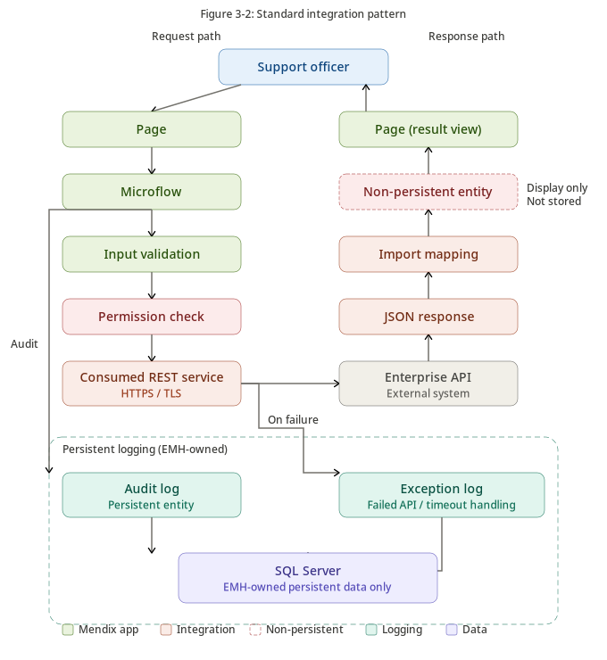
Figure 3-2 - Standard Integration Pattern
Shows the Mendix-native integration pattern: page, microflow, permission check, consumed REST service, import mapping, non-persistent entity, result display, and audit persistence.

Table 30: Integration Design Principles
Principle | Description
API First | All integrations shall use approved enterprise REST APIs.
Loose Coupling | EMH shall not depend on implementation details of source systems.
No Direct Database Access | External databases shall not be accessed directly.
Read-Only Operations | EMH retrieves and displays data without modifying source records.
Secure Communication | All interfaces shall use HTTPS/TLS.
Traceability | Interface requests shall support correlation identifiers where available.
Timeout Protection | Unavailable services shall fail gracefully.

3.3.2 API List
Table 31: API Catalogue
API | Purpose | Consumer | Provider | Operation
IDAM User API | Retrieve user identity and account information. | EMH | IDAM | Read
IDAM Role API | Retrieve enterprise role information where applicable. | EMH | IDAM | Read
UAE Pass Identity API | Retrieve identity verification information where applicable. | EMH | UAE Pass | Read
ICP Information API | Retrieve applicant identity information. | EMH | ICP | Read
Clinical Attachment API | Retrieve clinical attachment application details. | EMH | Clinical Attachment | Read
Clinical Attachment Payment API | Retrieve payment status. | EMH | Clinical Attachment | Read
Premarital API | Retrieve premarital application details. | EMH | Premarital | Read
Premarital Payment API | Retrieve payment status. | EMH | Premarital | Read
Patient Profile API | Retrieve patient profile information. | EMH | Patient Services | Read
Health Card API | Retrieve health card information. | EMH | Patient Services | Read
Sick Leave API | Retrieve sick leave certificate details. | EMH | Patient Services | Read
Medical Report API | Retrieve medical report request details. | EMH | Patient Services | Read

3.3.3 Event List
Table 32: Application Event Catalogue
Event | Trigger | Description | Persisted
User Authenticated | Successful SAML login | Records successful authentication and session creation. | Yes
User Logout | Session termination | Records logout or session termination. | Yes
Search Executed | User initiates search | Records search metadata and execution result. | Yes
External API Invoked | Outbound request initiated | Records API request metadata. | Yes
Access Denied | Authorization failure | Records unauthorized access attempts. | Yes
Configuration Updated | Admin changes configuration | Records administrative changes. | Yes
Role Assignment Changed | Role assignment modification | Records access changes. | Yes
Application Exception | Runtime error | Records sanitized application error details. | Yes
Integration Failure | API timeout or failure | Records external integration failure metadata. | Yes

3.4 Application Environments
EMH shall follow a controlled multi-environment application lifecycle supporting development, integration testing, user acceptance testing, production readiness, production operation, and support.

3.4.1 Environment Mapping

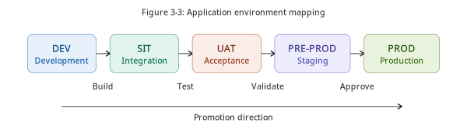
Figure 3-3 - Application Environment Mapping
Shows the application promotion lifecycle across Development, SIT, UAT, Pre-Production where applicable, Production, and DR/hypercare stages.

Table 33: Application Environment Mapping
Environment | Purpose | Users | External Integrations | Data
Development | Application development and unit testing | Developers | Mock services or development APIs | Synthetic/Test
SIT | Integration testing with enterprise systems | Development and QA | Test APIs | Test
UAT | Business validation and acceptance | Business users | UAT APIs | Masked/Test
Pre-Production | Final deployment rehearsal where applicable | Operations and technical teams | Production-like APIs | Approved/Masked
Production | Live operational environment | Authorized support officers | Production APIs | Live source-system data displayed only

4. Technical Architecture
This chapter describes the technical architecture of EMH, including deployment, technology landscape, technical services, implementation details, availability, backup, disaster recovery, logging, monitoring, DevSecOps, and performance efficiency.

4.1 Implementation & Deployment View

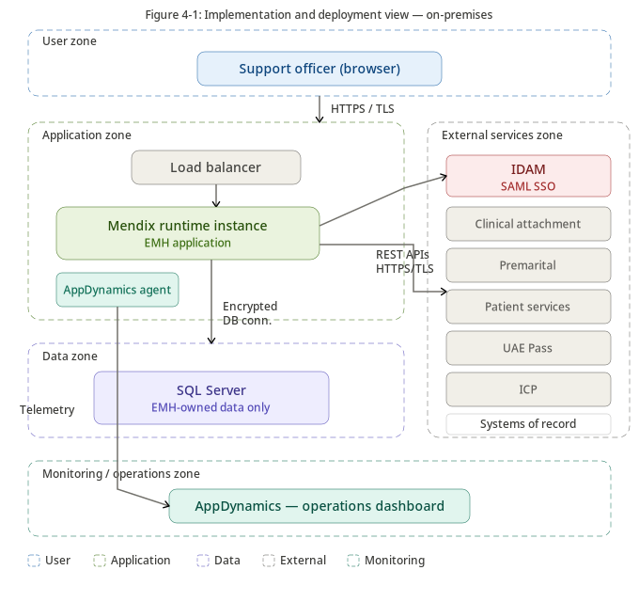
Figure 4-1 - Implementation and Deployment View
Shows the on-premises deployment architecture, including user, application, data, enterprise services, and monitoring zones.

EMH shall be deployed as an on-premises enterprise Mendix application. The logical deployment separates user access, application runtime, persistence, enterprise services, and monitoring concerns.
Table 34: Deployment Characteristics
Component | Description
Client Access | Internal web browser access over HTTPS/TLS.
Application Runtime | Mendix Runtime hosting EMH.
Database | Microsoft SQL Server for EMH-owned data.
Authentication | Enterprise IDAM with SAML SSO.
Monitoring | AppDynamics agent and monitoring platform.
Integration | REST APIs / JSON.

4.1.1 On-Premises Deployment View

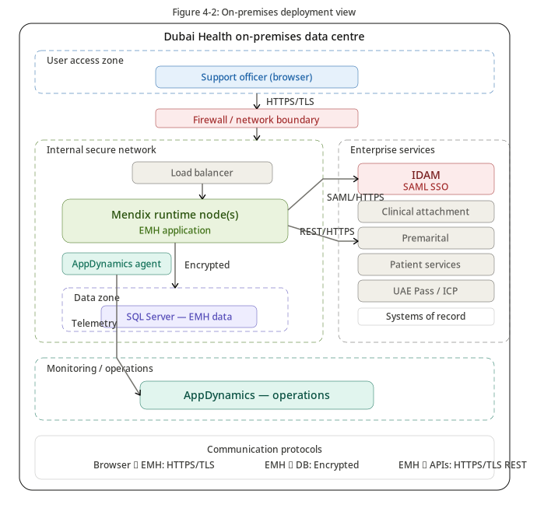
Figure 4-2 - On-Premises Deployment View
Illustrates the on-premises data-centre architecture, including internal network boundaries, load balancing, Mendix runtime, SQL Server, AppDynamics, and enterprise integrations.

Table 35: Infrastructure Components
Infrastructure Component | Responsibility
Load Balancer (if applicable) | Distribute user requests across runtime instances.
Mendix Runtime Instance | Execute EMH application logic.
Microsoft SQL Server | Persist EMH-owned data.
AppDynamics Agent | Collect runtime metrics and dependency telemetry.
Enterprise Backup Solution | Protect database, configuration, and deployment artifacts.
Enterprise Network | Secure connectivity between EMH and enterprise systems.

4.2 Technology Landscape

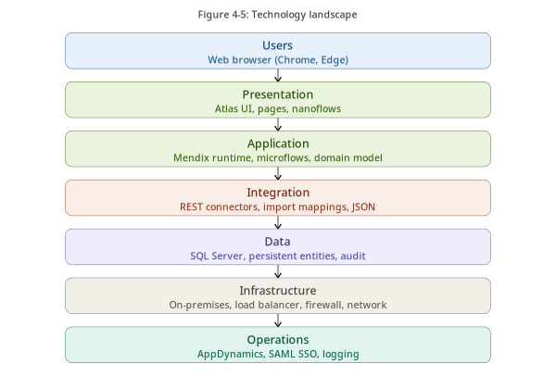
Figure 4-5 - Technology Landscape
Shows the technology layers supporting EMH, including users, presentation, application, integration, data, infrastructure, and operations technologies.

Table 36: Technology Landscape
Technology Domain | Selected Technology | Purpose
Application Platform | Mendix Low-Code Platform | Application development and runtime platform.
Runtime Engine | Mendix Runtime | Executes application logic.
Database | Microsoft SQL Server | Persistent storage for EMH-owned data.
Web Client | HTML5/CSS/JavaScript generated by Mendix | Browser-based user interface.
Authentication | Enterprise IDAM / SAML 2.0 | Single Sign-On.
Integration | REST APIs / JSON | Enterprise system integration.
Monitoring | AppDynamics | Application performance monitoring and observability.
Logging | Mendix Runtime Log Nodes, Audit Logs, Exception Logs | Operational and governance logging.

4.3 Technical Services / Components

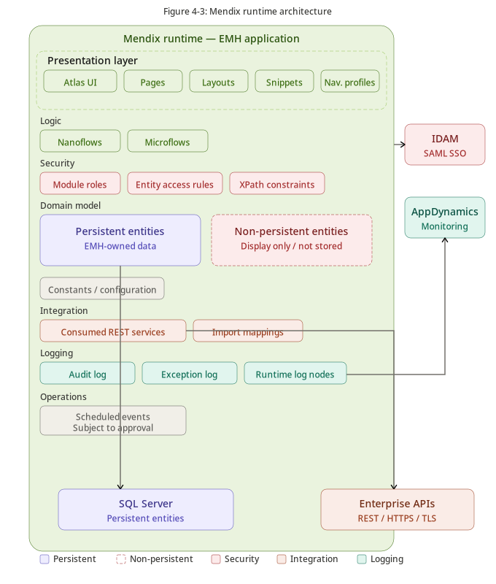
Figure 4-3 - Mendix Runtime Architecture
Illustrates the internal Mendix runtime architecture, including presentation components, microflows, nanoflows, domain model, security controls, import mappings, runtime log nodes, persistent and non-persistent entities.

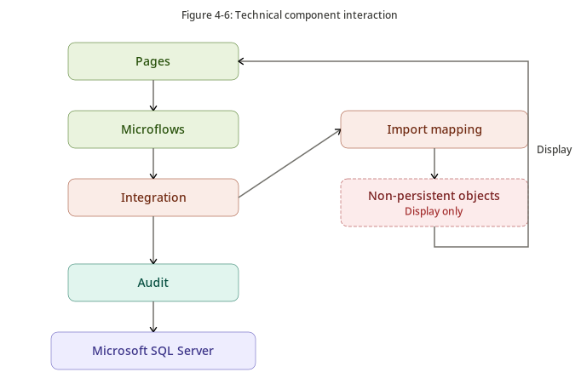
Figure 4-6 - Technical Component Interaction
Shows the interaction between Mendix pages, microflows, integration components, non-persistent objects, audit persistence, and Microsoft SQL Server.

Table 37: Technical Service Catalogue
Technical Service | Description | Technology
Authentication Service | Enterprise user authentication. | IDAM / SAML.
Authorization Service | Role and permission enforcement. | Mendix Security.
Session Management | Authenticated session lifecycle. | Mendix Runtime.
REST Integration Service | Communication with enterprise APIs. | Consumed REST Services.
JSON Mapping Service | Transform external payloads. | Import Mappings.
Data Persistence Service | Persist EMH-owned entities. | SQL Server.
Audit Service | Record user activity. | Microflows + Audit Entities.
Exception Logging Service | Capture runtime and integration failures. | Mendix Log Nodes + Exception Entities.
Monitoring Service | Application health and dependency monitoring. | AppDynamics.

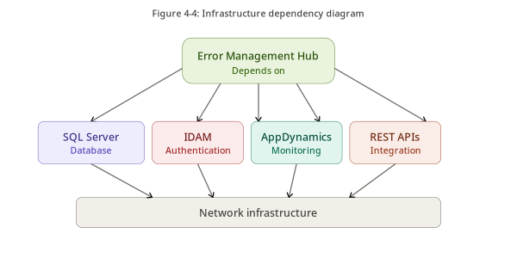
Figure 4-4 - Infrastructure Dependency
Summarizes the major infrastructure dependencies required to operate EMH, including database, identity, monitoring, network, and enterprise APIs.

4.4 Implementation Details
Implementation details focus on availability, backup, disaster recovery, logging, monitoring, and operational readiness. Low-level infrastructure specifications shall be finalized by the infrastructure and operations teams.

4.4.1 High Availability
Table 38: High Availability Design Considerations
Area | HA Consideration
Application Runtime | Mendix runtime shall be deployable in a redundant configuration where infrastructure supports it.
Load Balancing | A load balancer may distribute traffic across runtime instances.
Database | SQL Server availability shall follow enterprise database standards.
Network | Connectivity shall avoid single points of failure where practical.
Authentication | IDAM availability is critical for user access.
External APIs | External systems remain availability dependencies.
Monitoring | AppDynamics shall monitor runtime and dependency health.

4.4.2 Backup & Recovery
Table 39: Backup Scope
Data / Component | Backup Required | Notes
EMH Database | Yes | Users, roles, permissions, audit logs, exception logs, configuration.
Mendix Application Package | Yes | Required for redeployment.
Application Configuration | Yes | Environment-specific settings must be recoverable.
SAML Metadata / Certificates | Yes | Required for authentication recovery.
External Business Data | No | Remains in source systems.

4.4.3 Disaster Recovery
Table 40: Disaster Recovery Considerations
Area | Consideration
Application Package | Latest approved deployment package must be available.
Database Restore | Backup must support target RPO.
Configuration | Runtime configuration and secrets must be recoverable.
SAML | Metadata, certificates, and trust configuration must be restored.
Network | Routes and firewall rules must be available.
Monitoring | AppDynamics instrumentation must be restored.

Current target recovery objectives are RTO 1 hour and RPO 5 minutes, subject to validation through infrastructure design and recovery testing.

4.4.4 Logging & Monitoring
Table 41: Monitoring Scope
Monitoring Area | Tool | Purpose
Application Availability | AppDynamics | Detect application downtime.
Response Time | AppDynamics | Monitor performance degradation.
API Dependencies | AppDynamics | Detect external API failures or latency.
Runtime Errors | AppDynamics / Mendix Log Nodes | Identify application failures.
Database Connectivity | AppDynamics / Infrastructure Monitoring | Detect database connectivity issues.
Audit Activity | EMH Audit Logs | Support governance and compliance review.

Table 42: Logging Restrictions
Restricted Data | Requirement
Passwords / Credentials | Must not be logged.
SAML Assertions / Tokens | Must not be logged.
Full Emirates ID / MRN / Patient Records | Must not be logged in application or exception logs.
Payment Details | Must not be logged.
Full API Payloads | Must not be logged unless formally approved and protected.

4.5 DevSecOps
Table 43: DevSecOps Lifecycle
Stage | Activity
Plan | Requirements, architecture decisions, backlog refinement.
Design | Mendix domain model, microflows, UI, integrations, and security model.
Build | Mendix development and configuration.
Test | Unit, integration, security, UAT, and regression testing.
Secure | SAST, SCA, vulnerability review, and access-control validation.
Package | Generate approved Mendix deployment package.
Deploy | Promote through approved environments.
Monitor | Observe production through AppDynamics and logs.

4.6 Performance Efficiency
Table 44: Performance Design Considerations
Area | Performance Consideration
Search Execution | Validate inputs before calling external APIs.
API Calls | Avoid unnecessary calls and apply timeouts.
Import Mappings | Use efficient Mendix import mappings.
UI Rendering | Display only required fields.
Pagination | Apply pagination where results are large.
Caching | Cache only approved non-sensitive reference data.
Database Queries | Index EMH-owned tables used for authorization and audit queries.
Audit Logging | Design audit writes to avoid degrading user transactions.

5. Information Security Architecture
This chapter defines the information security architecture for EMH. It addresses information resource management, assurance, segregation, identity and access management, vulnerability management, encryption, secure connectivity, business continuity, logging, incident management, threat modeling, and privacy by design.

5.1 Information Resource Management Assessment
Table 45: Information Asset Assessment
Information Asset | Classification | Stored in EMH | Security Treatment
EMH User Records | Confidential | Yes | Restricted administrator access.
Roles and Permissions | Confidential | Yes | Controlled access and audited changes.
Audit Logs | Confidential | Yes | Restricted access and retention control.
Exception Logs | Confidential | Yes | Sanitized logging only.
IDAM Identity Information | Highly Confidential | No | Display-only and role restricted.
UAE Pass Identity Information | Highly Confidential | No | Display-only and role restricted.
ICP Information | Highly Confidential | No | Display-only and role restricted.
Clinical Attachment Data | Highly Confidential | No | Display-only and role restricted.
Premarital Data | Highly Confidential | No | Display-only and role restricted.
Patient Services Data | Highly Confidential | No | Display-only and role restricted.

5.2 Assurance
EMH is planned for on-premises deployment. Cloud or SaaS assurance is not directly applicable to the primary deployment model. If any SaaS-based services, external monitoring capabilities, or third-party components are introduced, they shall be subject to architecture, security, licensing, and data governance review before adoption.
Table 46: Assurance Applicability
Area | Applicability | Required Action
Mendix Cloud | Not Applicable | Current deployment is on-premises.
SaaS Monitoring | To Be Confirmed | Confirm AppDynamics deployment model.
Marketplace Components | Applicable if used | Security, vulnerability, license, and EA review required.
Third-Party Processing | Applicable where services process data | Review under privacy and security controls.

5.3 Segregation
Table 47: Segregation Controls
Segregation Area | Control
Environment Segregation | DEV, SIT, UAT, and PROD shall be logically separated.
User Segregation | Business users, administrators, developers, and operators shall have distinct access profiles.
Duties Segregation | Developers shall not directly deploy to production without approval.
Data Segregation | Production data shall not be used in non-production without approval and masking.
Administrative Segregation | Privileged access shall be restricted and monitored.
Integration Segregation | Non-production environments shall use non-production APIs where available.

5.4 Identity & Access Management

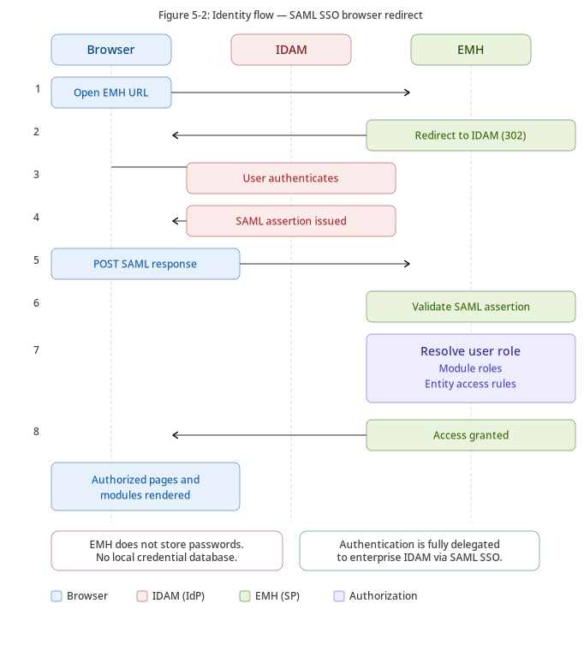
Figure 5-2 - Identity Flow
Shows the SAML browser redirect flow through enterprise IDAM, followed by EMH user role, module role, and entity access resolution.

Authentication for EMH shall be delegated to enterprise IDAM using SAML SSO. EMH shall not store or process passwords. Authorization shall be managed within EMH using Mendix app security, user roles, module roles, page access, microflow access, entity access, XPath constraints, and permission mappings.

5.4.1 Identity Management
Table 48: Identity Management Controls
Control | Description
Enterprise SSO | Users authenticate through IDAM using SAML.
No Local Passwords | EMH shall not store or validate passwords.
User Lifecycle | Joiner, mover, and leaver processes remain managed by enterprise identity governance.
User Provisioning | EMH users shall be created or enabled only for approved support users.
Authentication Logging | Authentication events shall be logged where available.

5.4.2 Access Management
Table 49: Access Management Controls
Control | Description
Role-Based Access Control | Access is granted based on assigned EMH roles.
Module Roles | Mendix module roles restrict access to functional modules.
Page Access | Mendix page access restricts unauthorized navigation.
Microflow Security | Sensitive actions are protected by microflow access.
Entity Access Rules | Persistent entities are protected through entity access and XPath constraints.
Audit of Access Changes | Role and permission changes are audited.

5.4.3 Privileged Access Management
Table 50: Privileged Access Management Controls
Control | Description
Admin Role Restriction | Administrative roles limited to authorized personnel.
Privileged Activity Logging | Privileged actions shall be logged and monitored.
Separation of Duties | Administrative access separated from development access where practical.
Break-Glass Access | Emergency access process to be defined if required.
PAM Alignment | Administrative access shall align with enterprise PAM processes where applicable.

5.5 Vulnerability Management
Table 51: Vulnerability Management Controls
Control | Description
Vulnerability Scanning | Application and infrastructure shall be scanned before production deployment.
Remediation Tracking | Findings shall be tracked to closure.
Risk Acceptance | Unresolved high-risk findings require formal acceptance.
Patch Management | Mendix runtime, database, OS, and supporting components follow enterprise patching policies.
Security Review | Information Security shall review the solution before go-live.

5.5.1 SAST
Table 52: SAST Controls
Control | Description
Mendix Model Review | Security model, entity access, and microflow access shall be reviewed.
Custom Code Review | Java actions, if used, shall be reviewed.
Static Analysis | Custom Java code shall undergo SAST where tools are available.
Remediation | Critical and high findings shall be remediated or formally accepted.

5.5.2 SCA
Table 53: SCA Controls
Control | Description
Component Inventory | Marketplace modules and third-party components shall be inventoried.
Vulnerability Review | Components shall be reviewed for known vulnerabilities.
License Review | Component licensing shall be reviewed where applicable.
Approval | Marketplace components require EA and Information Security approval before use.

5.6 Encryption

5.6.1 Encryption at Rest
Table 54: Encryption at Rest Controls
Data Store | Encryption Requirement
SQL Server Database | Database encryption shall follow Dubai Health database security standards.
Database Backups | Backups shall be encrypted where supported by enterprise backup capability.
Configuration Secrets | Secrets shall not be stored in plain text.
Logs | Logs containing sensitive metadata shall be protected by access controls and storage encryption where available.

5.6.2 Encryption in Transit
Table 55: Encryption in Transit Controls
Communication Path | Encryption Requirement
Browser to EMH | HTTPS/TLS.
EMH to External APIs | HTTPS/TLS.
EMH to SQL Server | Encrypted database connection where supported.
EMH to AppDynamics | Secure communication channel.
EMH to IDAM | SAML exchange over HTTPS.

5.7 Connectivity & Integration
Table 56: Secure Connectivity Controls
Control | Description
Approved Endpoints | Only approved APIs shall be consumed.
Firewall Rules | Network access shall be restricted to required endpoints and ports.
No Direct Database Access | Direct database integration with external systems is prohibited.
TLS | All interfaces shall use secure transport.
API Authentication | API authentication mechanisms shall be approved by Information Security.
Correlation IDs | API requests should include correlation identifiers where supported.

5.8 Business Continuity
Table 57: Business Continuity Controls
Control | Description
Backup | EMH database and configuration shall be backed up.
Recovery Testing | Recovery procedures shall be tested before go-live.
DR Plan | Disaster recovery process shall be documented.
RTO/RPO Validation | Target RTO and RPO require validation.
Manual Workaround | Support officers may use source systems directly during EMH outage subject to access permissions.

5.9 Logging & Monitoring

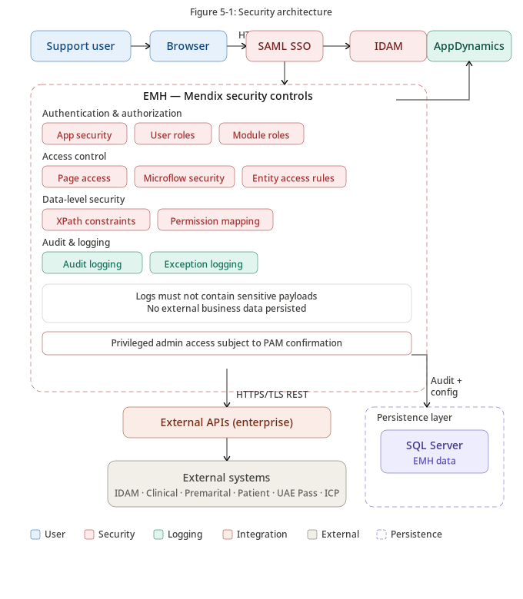
Figure 5-1 - Security Architecture
Shows the end-to-end security architecture, including SAML authentication, Mendix app security, user roles, module roles, entity access, XPath constraints, audit logging, exception logging, encryption, and monitoring.

Table 58: Logging and Monitoring Controls
Control | Description
Application Monitoring | AppDynamics shall monitor runtime performance and availability.
Audit Logging | User activity shall be logged in EMH.
Exception Logging | Application and integration failures shall be logged.
Security Logging | Access denials and privileged actions shall be logged.
Sensitive Data Protection | Logs shall not contain sensitive payloads, credentials, or SAML assertions.

5.10 Security Incident Management
Table 59: Security Incident Management Controls
Control | Description
Incident Detection | Security-relevant logs and alerts support detection.
Escalation | Incidents are escalated to Information Security.
Investigation | Audit and exception logs support investigation.
Containment | Access may be revoked or restricted if required.
Recovery | Recovery actions follow approved procedures.
Lessons Learned | Post-incident review identifies improvements.

5.11 Threat Modeling & Mitigation

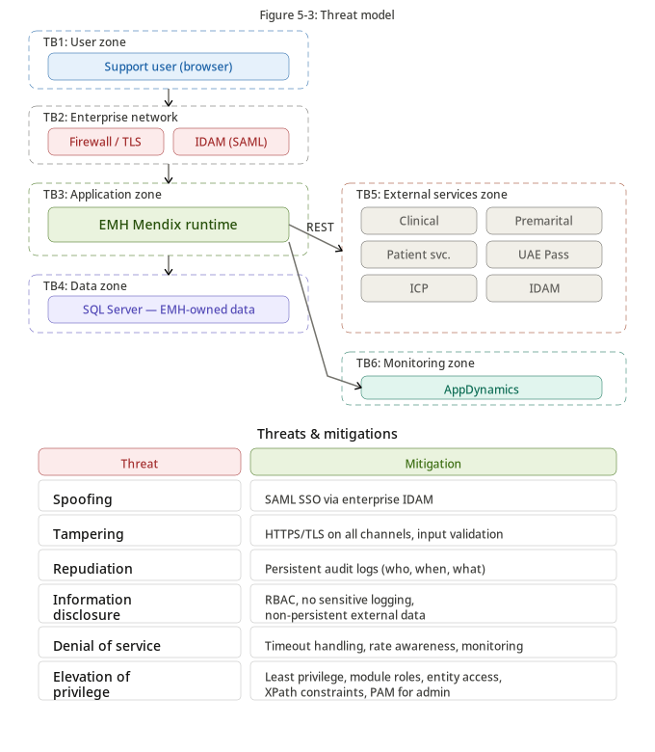
Figure 5-3 - Threat Model
Shows the trust boundaries, primary threat categories, and architectural mitigations applied across user, application, data, external services, and monitoring zones.

Table 60: Threat Model Summary
Threat | Risk | Mitigation
Spoofing | Unauthorized user impersonation. | SAML SSO through IDAM and no local credentials.
Tampering | Modification of requests or responses. | HTTPS/TLS, input validation, and controlled APIs.
Repudiation | User denies action. | Audit logging and correlation identifiers.
Information Disclosure | Sensitive data exposed. | RBAC, entity access, non-persistent data, and no sensitive logging.
Denial of Service | Service unavailability. | Timeout handling, monitoring, and graceful degradation.
Elevation of Privilege | User gains excessive access. | Least privilege, module roles, entity access, and audited admin changes.

5.12 Privacy by Design

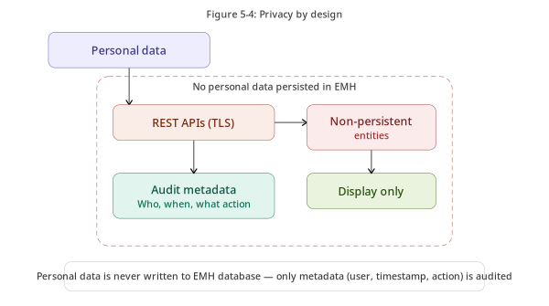
Figure 5-4 - Privacy by Design
Shows the privacy-by-design flow, emphasizing data minimization, non-persistent display of personal data, audit metadata persistence, and protected processing boundaries.

EMH incorporates privacy-by-design by minimizing storage, limiting access, avoiding external business data persistence, and persisting only audit metadata required for accountability and governance.

5.12.1 Personal Data Flow
The personal data flow is shown in Figure 2-3 and Figure 5-4. Personal data is retrieved only when an authorized support officer performs an approved search. It is displayed using non-persistent entities and is not stored as EMH business data.

5.12.2 Personal Data Usage
Table 61: Personal Data Usage
Personal Data | Purpose | Stored in EMH
Emirates ID | Search and investigation | No
MRN | Search and investigation | No
Email | User lookup and EMH user account email where applicable | Only EMH user email when required
Mobile Number | Search and investigation | No
Patient Details | Support investigation | No
Application Details | Support investigation | No
Payment Status | Support verification | No

5.12.3 Third-Party Processing
Table 62: Third-Party Processing
Processor / System | Role
IDAM | Identity provider.
UAE Pass | Identity verification provider.
ICP | Identity data provider.
Clinical Attachment | Business data provider.
Premarital | Business data provider.
Patient Services | Business data provider.
AppDynamics | Monitoring and observability.

5.12.4 Security Considerations
Table 63: Privacy Security Controls
Control | Description
Data Minimization | External data is not persisted.
Access Restriction | Access controlled by role and permission.
Auditability | Access to sensitive data is logged.
Encryption | Data protected in transit.
Logging Restriction | Sensitive payloads excluded from logs.
Environment Control | Production data restricted from non-production.

5.12.5 User Privacy Considerations
Table 64: User Privacy Considerations
Consideration | Design Response
Purpose Limitation | Data accessed only for support investigation.
Data Minimization | Only required data is retrieved and displayed.
Access Transparency | User activities are auditable.
Retention Limitation | EMH does not retain external operational data.
Accountability | Sensitive access is traceable to an authenticated user.

6. Implementation & Migration Approach
This chapter defines the implementation strategy, deployment and cut-over approach, transition architecture, and data migration approach for introducing EMH in a controlled and low-risk manner.

6.1 Implementation Roadmap

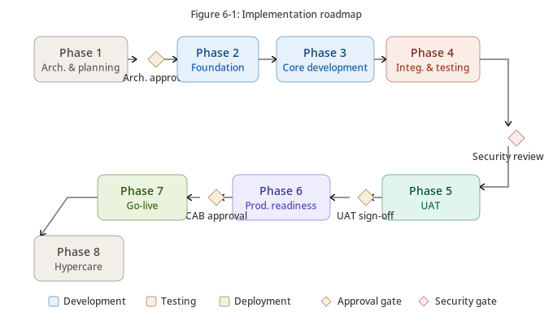
Figure 6-1 - Implementation Roadmap
Shows the phased implementation roadmap including architecture, foundation, development, integration testing, UAT, production readiness, go-live, approval gates, and hypercare.

Table 65: Implementation Roadmap
Phase | Activities | Deliverables
Phase 1 - Architecture & Planning | Finalize architecture, security review, interface agreements, infrastructure planning. | Approved ADD, project plan, interface agreements.
Phase 2 - Foundation | Configure Mendix project, security model, roles, permissions, and audit logging. | Application foundation.
Phase 3 - Core Development | Develop business modules, integrations, administration, and configuration. | Functional EMH application.
Phase 4 - Integration & Testing | SIT, security testing, performance testing, regression testing. | Tested application.
Phase 5 - Production Readiness | Operational readiness, backup validation, DR validation, deployment approval. | Go-live approval.
Phase 6 - Go-Live & Hypercare | Production deployment, monitoring, issue resolution, knowledge transfer. | Operational production system.

6.1.1 Deployment & Cut-over Strategy
The recommended deployment approach is parallel introduction. Existing support procedures remain available during the initial production period while support officers validate EMH results and gradually transition to EMH as the preferred investigation platform.
Table 66: Cut-over Activities
Activity | Responsibility
Infrastructure Preparation | Infrastructure Team
Application Deployment | Application Team
Database Initialization | Database Administrator
SAML Configuration | Identity Management Team
API Configuration | Integration Team
Monitoring Configuration | Operations Team
Smoke Testing | Project Team
Business Validation | Business Owner
Production Approval | CAB / Change Governance
Go-Live | Project Manager

Table 67: Production Readiness Checklist
Item | Status Requirement
Architecture Approved | Required
Security Assessment Completed | Required
Infrastructure Ready | Required
Backup Validated | Required
Monitoring Enabled | Required
APIs Validated | Required
Business Acceptance Signed | Required
Operational Support Established | Required
CAB Approval Obtained | Required

6.1.2 Transition Architecture

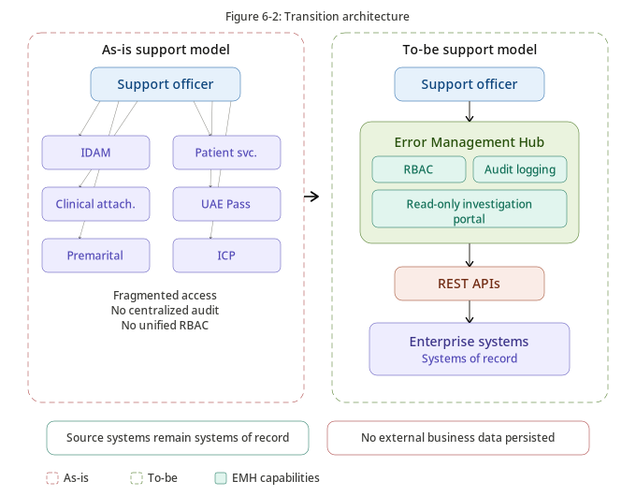
Figure 6-2 - Transition Architecture
Compares the current fragmented support model with the future EMH-enabled centralized support model using REST-based integrations and read-only investigation capabilities.

Table 68: Transition Principles
Principle | Description
No Business Disruption | Existing systems remain operational throughout implementation.
No Business Data Migration | Business data remains within source systems.
Progressive Adoption | Support officers gradually adopt EMH.
Controlled Rollout | Production release follows formal governance.
Rollback Capability | Existing investigation methods remain available if required.

6.1.3 Data Migration Approach
Table 69: Migration Scope
Data | Migration Required
Users | Initial provisioning if required.
Roles | Yes.
Permissions | Yes.
Role Assignments | Yes.
Application Configuration | Yes.
Audit Logs | No.
Exception Logs | No.
External Business Data | No.

Table 70: Migration Activities
Activity | Description
Create Roles | Configure application roles.
Configure Permissions | Configure role permissions.
Create Administrative Users | Create initial EMH administrators.
Configure SAML | Connect EMH to IDAM.
Configure REST APIs | Configure enterprise endpoints.
Configure Monitoring | Integrate with AppDynamics.
Validate Integrations | Execute end-to-end interface testing.
Verify Security | Validate role-based access.
Production Verification | Execute smoke testing after deployment.

Appendix A - Glossary
Table 71: Glossary
Term | Definition
Error Management Hub (EMH) | Centralized support investigation portal implemented using Mendix.
Support Officer | Authorized internal user who performs support investigations in EMH.
System of Record | Authoritative source system for a specific business record.
Non-Persistent Entity | Mendix object used for temporary display or processing and not stored in the database.
Persistent Entity | Mendix entity stored in the application database.
Microflow | Server-side Mendix logic used for business processing, validation, and integration orchestration.
Nanoflow | Client-side Mendix logic used for lightweight UI interactions where appropriate.
Import Mapping | Mendix mapping used to transform external response payloads into Mendix objects.
Module Role | Mendix role used to control access within application modules.
Entity Access | Mendix security rule controlling access to entity data.

Appendix B - Acronyms
Table 72: Acronyms
Acronym | Meaning
ADD | Architecture Design Document
ARB | Architecture Review Board
EMH | Error Management Hub
IDAM | Identity and Access Management
SAML | Security Assertion Markup Language
SSO | Single Sign-On
REST | Representational State Transfer
JSON | JavaScript Object Notation
RBAC | Role-Based Access Control
SAST | Static Application Security Testing
SCA | Software Composition Analysis
RTO | Recovery Time Objective
RPO | Recovery Point Objective
PAM | Privileged Access Management

Appendix C - References
Table 73: References
Reference | Purpose
Mendix Documentation | Platform architecture, security, deployment, and runtime reference.
Mendix Security Best Practices | Guidance for secure Mendix application design.
OWASP ASVS | Application security verification requirements.
OWASP Top 10 | Common web application security risks.
NIST Cybersecurity Framework | Security governance and control reference.
UAE Personal Data Protection Law | Personal data protection context.
UAE Information Assurance Regulation | Government information assurance context.
SAML 2.0 Standard | Federated authentication standard.
Original EMH Architecture Proposal | Source functional and architectural baseline.

Appendix D - Architecture Decision Records
Table 74: Architecture Decision Records
ADR ID | Decision | Status | Impact
ADR-001 | Adopt Mendix as the application platform. | Approved | Establishes Mendix as the primary implementation platform.
ADR-002 | Deploy EMH on-premises. | Approved | Aligns deployment with current government hosting direction.
ADR-003 | Use enterprise IDAM with SAML SSO. | Approved | Centralizes authentication and avoids local passwords.
ADR-004 | Use REST APIs for all integrations. | Approved | Preserves loose coupling and integration governance.
ADR-005 | Prohibit direct database access to external systems. | Approved | Protects source-system ownership.
ADR-006 | Use non-persistent entities for external business data. | Approved | Avoids storing external operational data.
ADR-007 | Persist only EMH-owned data. | Approved | Limits privacy and compliance exposure.
ADR-008 | Use AppDynamics for monitoring. | Approved | Enables observability and operational support.
ADR-009 | Use Microsoft SQL Server for persistence. | Approved | Supports EMH-owned relational data.
ADR-010 | Restrict Java Actions to approved exceptions. | Approved | Preserves maintainability and secure development.

Appendix E - Architecture Assumptions
Table 75: Architecture Assumptions
ID | Assumption
AS-001 | EMH will be deployed within a Dubai Health approved on-premises environment.
AS-002 | Enterprise IDAM provides SAML authentication services.
AS-003 | Enterprise systems expose approved REST APIs for integration.
AS-004 | Microsoft SQL Server is available for EMH persistence.
AS-005 | AppDynamics is available for application monitoring and observability.
AS-006 | Mendix Marketplace modules require Enterprise Architecture and Information Security approval before adoption.
AS-007 | SAST and SCA activities are performed as part of the secure SDLC before production deployment.
AS-008 | External business data remains owned by source systems and is not persisted by EMH.

