Dubai Health
Architecture Design Document
Error Management Hub (EMH)
Mendix Enterprise Solution | On-Premises Deployment

Document Cover Metadata
Field | Value
Version | 1.0 Comprehensive Draft
Status | Submission Draft
Classification | Confidential / Internal Use
Prepared For | Dubai Health Architecture Review Board
Prepared By | Enterprise Architecture / Solution Architecture
Date | 2026-06-15

Document Control
Table 0-1 – Document Control
Field | Value
Document Name | Architecture Design Document
Project | Error Management Hub (EMH)
Platform | Mendix Low-Code Platform
Deployment Model | On-Premises
Authentication | Enterprise IDAM using SAML Single Sign-On
Monitoring | AppDynamics
Persistent Data Store | Microsoft SQL Server
Data Classification | Confidential / Highly Confidential
Document Purpose | Define the target application, data, technical, security, and migration architecture for EMH.

Version History
Table 0-2 – Version History
Version | Date | Author / Owner | Description
0.1 | TBD | Solution Architecture | Initial draft based on EMH proposal and target Mendix architecture.
0.5 | TBD | Enterprise Architecture | ARB-ready structure, decisions, diagrams, and security sections added.
1.0 | 2026-06-15 | Enterprise Architecture | Comprehensive version regenerated without intentionally omitting agreed sections.

Review & Approval
Table 0-3 – Review and Approval
Name | Role | Review Area | Status | Date
TBD | Business Owner | Business scope and operational needs | Pending | TBD
TBD | Enterprise Architect | Architecture alignment | Pending | TBD
TBD | Information Security | Security architecture | Pending | TBD
TBD | Infrastructure Lead | On-premises hosting readiness | Pending | TBD
TBD | Application Owner | Application design and support model | Pending | TBD

Distribution List
Table 0-4 – Distribution List
Audience | Purpose
Architecture Review Board | Formal architecture review and approval.
Enterprise Architecture | Architecture governance and standards alignment.
Information Security | Security review and risk assessment.
Infrastructure & Operations | Deployment, monitoring, backup, and support readiness.
Business Owner / Support Team | Scope validation and UAT readiness.
Development Team | Implementation guidance and technical baseline.

Table of Contents
This document uses Word heading styles. After opening the document in Microsoft Word, right-click the Table of Contents area and select Update Field to generate page numbers automatically.

List of Figures
The figure list is intentionally represented through figure captions in the document body. It can be generated automatically in Word from caption styles if required.

List of Tables
The table list is intentionally represented through table captions in the document body. It can be generated automatically in Word from caption styles if required.

Executive Summary
The Error Management Hub (EMH) is a centralized enterprise support application intended to streamline operational investigation activities across multiple Dubai Health systems. The solution provides support officers with a unified investigation interface while preserving each connected application as the authoritative System of Record.
EMH is implemented using the Mendix Low-Code Platform and deployed within an approved on-premises environment. The target architecture integrates with enterprise systems through secure REST APIs, authenticates users through Enterprise IDAM using SAML Single Sign-On, persists only EMH-owned operational data, and presents external business data using Mendix Non-Persistent Entities.
The architecture intentionally avoids direct database access to source systems. External operational data is retrieved at runtime, displayed to authorized support officers, and discarded after the request lifecycle. Audit metadata, configuration, roles, permissions, exception logs, and EMH user administration records are stored in Microsoft SQL Server.
This document defines the complete application architecture baseline for EMH across solution, data, application, technical, information security, and implementation domains. It is intended to support Architecture Review Board assessment and implementation governance.
Table ES-1 – Executive Architecture Baseline
Architecture Area | Decision / Baseline
Platform | Mendix Low-Code Platform.
Deployment | On-premises deployment in an approved Dubai Health environment.
Authentication | Enterprise IDAM using SAML Single Sign-On.
Authorization | Mendix role-based access control, module roles, page access, microflow security, entity access, and XPath constraints where applicable.
Integration | REST APIs using JSON payloads and Mendix Consumed REST Services.
Data persistence | Only EMH-owned operational and configuration data is persisted.
External business data | Displayed using Non-Persistent Entities and not persisted by EMH.
Monitoring | AppDynamics with runtime logging, audit logging, and exception logging.

Table ES-2 – Expected Solution Benefits
Benefit | Description
Centralized Support | Support officers use a single investigation portal instead of navigating multiple applications.
Reduced Risk | No direct database access is required for support investigations.
Better Governance | Audit logs and access controls provide traceability and accountability.
Improved Maintainability | Mendix modular design supports controlled enhancement and faster delivery.
Data Protection | External business records remain in their source systems and are not replicated into EMH.
Operational Visibility | AppDynamics and structured exception logging support monitoring and troubleshooting.

1. Solution Overview
This chapter defines the business purpose, solution summary, architecture decisions, RAID log, architecture gaps, references, principles, and stakeholder concerns for the Error Management Hub.

1.1 Business Purpose
EMH addresses the operational need for a centralized, controlled, and auditable support investigation workspace. Support officers currently need to use multiple systems or request technical assistance to diagnose user issues. This increases investigation time, introduces operational dependency, and may create unnecessary exposure to backend systems.
The solution enables support officers to search and view relevant records from Clinical Attachment, Premarital, Patient Services, UAE Pass, ICP, and identity-related systems through controlled APIs. EMH does not replace these source applications and does not become the System of Record for their business data.
The project objective is to provide a secure investigation portal with consistent access control, auditability, operational visibility, and standardized interaction patterns across supported modules.
Table 1-1 – Business Problem to Architecture Response
Business Problem | Architecture Response
Multiple applications are required for support investigations. | Provide a unified Mendix support portal.
Support staff may require technical teams to inspect data. | Expose approved read-only search and retrieval functions through EMH.
Direct backend/database inspection creates risk. | Use only enterprise-approved APIs; prohibit direct DB access.
Auditability is inconsistent across investigation activities. | Persist structured audit events and correlate integration calls.
External data ownership must remain with source systems. | Use runtime retrieval and Non-Persistent Entities for external data.

1.2 Solution Summary
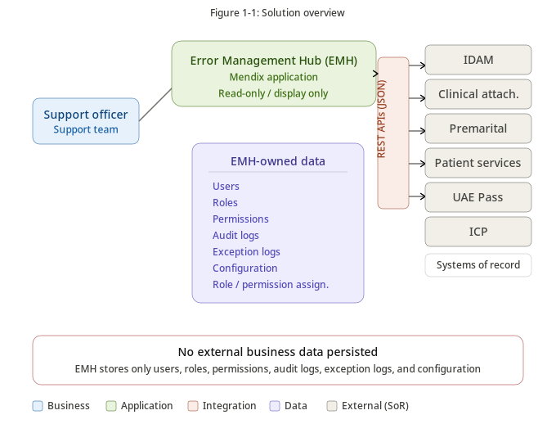
Figure 1-1 – Solution Overview
Illustrates the high-level EMH solution context, showing support officers accessing the Mendix application, integrating with enterprise services through REST APIs, persisting only EMH-owned data, and monitoring operations through AppDynamics.
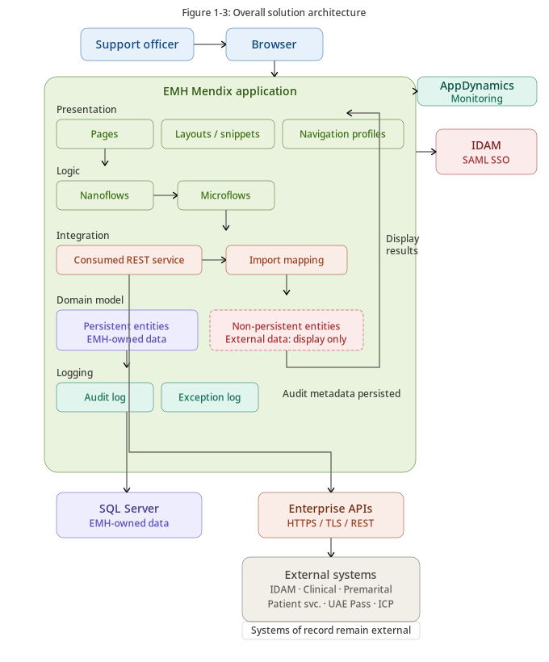
Figure 1-2 – Overall Solution Architecture
Shows the overall target architecture for EMH across user access, Mendix runtime, integration services, enterprise systems, SQL Server persistence, and monitoring components.
Table 1-2 – Solution Summary by Architecture Layer
Layer | Description | EMH Design Treatment
User Access | Browser-based access for support officers and administrators. | Access is authenticated through Enterprise IDAM and authorized through Mendix security.
Presentation | Mendix pages, layouts, snippets, forms, and search result views. | Pages expose read-only investigation functions and administrative functions based on role.
Application Logic | Microflows, nanoflows where applicable, validation logic, and orchestration. | Microflows implement search validation, authorization checks, API calls, response mapping, audit, and exception handling.
Integration | Consumed REST Services, import mappings, and integration microflows. | All external data access is through REST APIs. No direct database integration is allowed.
Persistence | SQL Server database for EMH-owned data. | Only users, roles, permissions, configuration, audit logs, and exception logs are persisted.
Operations | AppDynamics, runtime logs, audit logs, exception logs. | Operational monitoring and support troubleshooting are enabled without logging sensitive payloads.

1.3 Key Architecture Decisions
Table 1-3 – Key Architecture Decisions
Decision ID | Decision | Rationale | Status
ADR-001 | Adopt Mendix Low-Code Platform | EMH shall be implemented using Mendix to accelerate delivery while maintaining enterprise governance, modularity, and maintainability. | Approved
ADR-002 | Deploy On-Premises | EMH shall be deployed within an approved on-premises environment to support data sovereignty, integration control, and government hosting expectations. | Approved
ADR-003 | Use REST APIs for Integration | All external business data access shall be performed through enterprise-approved REST APIs. | Approved
ADR-004 | Prohibit Direct Database Integration | EMH shall not connect directly to external system databases. | Approved
ADR-005 | Use Non-Persistent Entities for External Data | External business data shall be mapped into Mendix Non-Persistent Entities and displayed without persistence. | Approved
ADR-006 | Persist Only EMH-Owned Data | EMH shall persist users, roles, permissions, audit logs, exception logs, and configuration only. | Approved
ADR-007 | Authenticate through Enterprise IDAM | Authentication shall be delegated to Enterprise IDAM using SAML Single Sign-On. | Approved
ADR-008 | Implement RBAC through Mendix Security | Access control shall use Mendix module roles, user roles, page access, microflow security, entity access, and XPath constraints. | Approved
ADR-009 | Use AppDynamics for Monitoring | Application performance and runtime health shall be monitored using AppDynamics. | Approved
ADR-010 | Use Microsoft SQL Server for Persistence | EMH-owned persistent data shall be stored in Microsoft SQL Server. | Approved
ADR-011 | Control Marketplace Modules | Any Mendix Marketplace module shall undergo architecture, security, licensing, and vulnerability review before adoption. | Approved
ADR-012 | Restrict Java Actions | Custom Java Actions shall be used only by exception and shall be subject to secure coding review and approval. | Approved
ADR-013 | Use Mendix Constants for Runtime Configuration | Environment-specific endpoints and configurable values shall be externalized through approved runtime configuration mechanisms. | Approved
ADR-014 | Audit Security-Relevant Activities | User searches, access denied events, configuration changes, role/permission changes, and integration failures shall be audited. | Approved

1.3.1 Architecture Principles Applied
Table 1-4 – Architecture Principles Applied
Principle | Application in EMH
API First | All integrations with Clinical Attachment, Premarital, Patient Services, IDAM, UAE Pass, ICP, and payment-related services use enterprise-approved REST APIs.
Secure by Design | Authentication, authorization, encryption, audit logging, vulnerability management, and privacy controls are embedded into the design.
Least Privilege | Support officers receive only the minimum module, page, microflow, and entity access required for their role.
Data Minimization | External business data is displayed only at runtime and not persisted in EMH.
Separation of Concerns | Presentation, domain logic, integration, persistence, and monitoring responsibilities are separated through Mendix modules and architecture layers.
Reuse Before Build | Enterprise IDAM, existing source system APIs, AppDynamics, and SQL Server are reused instead of duplicating capabilities.
Observability | Runtime behavior, integration failures, security events, and audit metadata are logged and monitored.
Maintainability | Mendix modules, reusable microflows, constants, and standardized integration patterns support maintainability.

1.4 RAID Logs
Table 1-5 – RAID Log
ID | Type | Description | Mitigation / Treatment | Owner
RAID-001 | Risk | External APIs for all target modules may not be available or finalized before implementation. | Confirm API contracts early; maintain API readiness tracker. | Application Owners
RAID-002 | Risk | External system unavailability may prevent support officers from retrieving records. | Display clear error messages and log integration failures with correlation IDs. | Operations / App Owners
RAID-003 | Risk | RTO/RPO targets may not be achievable if disaster recovery relies only on redeploy-on-disaster. | Validate DR strategy with infrastructure and database teams. | Infrastructure
RAID-004 | Assumption | EMH is read-only for external business data. | Confirm with business owner and application owners. | Business Owner
RAID-005 | Assumption | Enterprise IDAM supports SAML integration for EMH. | Confirm metadata exchange, attributes, and group/role mapping. | IAM Team
RAID-006 | Issue | Marketplace module governance may not yet be finalized. | Require EA and Security approval before module adoption. | EA / InfoSec
RAID-007 | Dependency | AppDynamics onboarding is required before production. | Define application health dashboards and alert routing. | Operations
RAID-008 | Dependency | Infrastructure environments must be provisioned for development, SIT, UAT, and production. | Track environment readiness through project plan. | Infrastructure
RAID-009 | Risk | Scope may expand into full case management or workflow automation. | Treat workflow/case management as separate phase or change request. | Project Sponsor
RAID-010 | Risk | Sensitive payloads may accidentally be captured in logs. | Implement logging standards and payload redaction rules. | Development / InfoSec

1.5 Architecture Gaps
Table 1-6 – Architecture Gaps
Gap ID | Architecture Domain | Gap | Recommended Treatment
AG-001 | Application | Final API contracts for each source application require confirmation. | Complete API design review before detailed build. / Define stubs for early development.
AG-002 | Security | PAM integration model is not confirmed. | Align privileged administration with enterprise PAM approach where available.
AG-003 | Security | SAST, SCA, and DAST toolchain requires confirmation. | Define secure SDLC gates and responsible teams.
AG-004 | Operations | AppDynamics deployment model and alert thresholds require confirmation. | Confirm monitoring integration pattern and operational runbooks.
AG-005 | Technical | Final production topology and HA pattern are infrastructure-owned. | Document application requirements and receive infrastructure design confirmation.
AG-006 | Data | Audit retention is assumed as one year subject to governance confirmation. | Confirm retention with compliance and records management.
AG-007 | Integration | Payment status availability depends on source system/payment-related APIs. | Confirm source of truth for payment status and available endpoint fields.
AG-008 | Governance | Marketplace and Java Action approval process must be confirmed. | Include governance controls in DevSecOps and implementation plan.

1.6 References
Table 1-7 – References
Reference | Purpose
Original EMH Architecture Proposal | Source functional and technical context for the original Angular/.NET proposal.
Dubai Health Enterprise Architecture Standards | Architecture governance, review, and alignment expectations.
Dubai Health Information Security Policies | Security controls, risk acceptance, incident, and data protection requirements.
Mendix Platform Documentation | Mendix runtime, domain model, security, integration, and deployment guidance.
OWASP Top 10 | Application security risk awareness.
OWASP ASVS | Application security verification controls.
SAML 2.0 Specification | Enterprise Single Sign-On authentication standard.
UAE Personal Data Protection Law | Privacy and personal data governance consideration.
NIST Cybersecurity Framework | Security risk management and control alignment.

1.6.1 Principles & Guidelines
Table 1-8 – Principles and Guidelines
Guideline | EMH Application
No direct access to external databases | All external access shall use APIs.
Data minimization | External data shall not be persisted unless explicitly approved.
Role-based access | Access shall be granted through defined roles and permissions.
Auditability | Security-relevant and investigation-relevant activities shall be auditable.
Configuration over hardcoding | Endpoints, timeout values, and configurable parameters shall be externalized.
Defense in depth | Authentication, authorization, transport security, logging, and monitoring shall be layered.

1.7 Stakeholders & Concerns
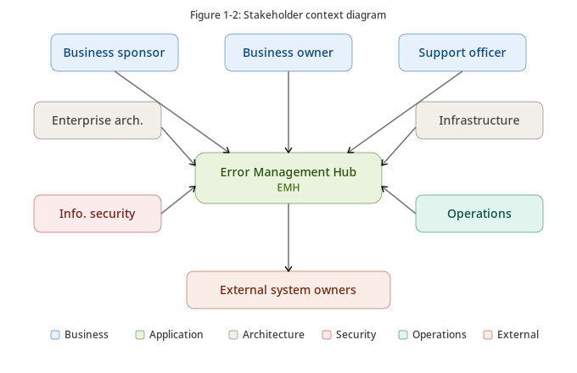
Figure 1-3 – Stakeholder Context
Shows the key stakeholder groups and their primary concerns across business, architecture, security, infrastructure, operations, development, and application ownership.
Table 1-9 – Stakeholders and Concerns
Stakeholder | Concern | Architecture Response
Business Sponsor | Operational efficiency and faster investigations. | Unified support interface with standardized search capabilities.
Support Officer | Simple, secure, searchable access to investigation data. | Role-based pages and read-only result views.
Enterprise Architecture | Alignment with enterprise standards and future extensibility. | Modular Mendix architecture and API-first integration.
Information Security | Protection of confidential and highly confidential data. | SAML, RBAC, encryption, audit, no external data persistence.
Infrastructure | Deployability and operational supportability. | On-premises runtime, SQL Server, AppDynamics integration, documented dependencies.
Application Owners | Source system ownership and stability. | External systems remain Systems of Record; EMH consumes APIs only.
Operations | Monitoring, supportability, and incident response. | AppDynamics, structured exception logs, audit events, and support runbooks.
Data Governance | Data ownership, retention, and privacy. | Data mastership and retention model defined in Chapter 2.

2. Data Architecture
This chapter defines data scope, glossary, data mastership, data management, retention, privacy, and migration approach. It is central to the EMH design because the solution intentionally separates EMH-owned data from external business data owned by source systems.

2.1 Data Scope, Glossary & Reference
EMH stores only application-owned operational data. External business data from Clinical Attachment, Premarital, Patient Services, UAE Pass, ICP, payment-related sources, and IDAM is retrieved at runtime and displayed to authorized users. It is not persisted in EMH unless explicitly reclassified and approved through architecture and security governance.
Table 2-1 – Data Scope
Data Object | Persistent in EMH | Classification | System of Record | Usage in EMH
EMH User | Yes | Confidential | EMH / IDAM reference | Administration, authorization, audit attribution.
Role | Yes | Confidential | EMH | Role-based access management.
Permission | Yes | Confidential | EMH | Page, function, module, and action authorization.
User Role Assignment | Yes | Confidential | EMH | Maps support users to roles.
Role Permission Mapping | Yes | Confidential | EMH | Defines access coverage for each role.
Audit Log | Yes | Confidential | EMH | Records user activity and security-relevant events.
Exception Log | Yes | Confidential | EMH | Records sanitized technical and integration failures.
Application Configuration | Yes | Internal / Confidential | EMH | Stores runtime configuration and controlled parameters.
IDAM User Profile | No | Confidential | IDAM | Authentication and user identity reference.
UAE Pass Identity | No | Highly Confidential | UAE Pass | External identity profile display where applicable.
ICP Applicant Information | No | Highly Confidential | ICP | External applicant/person reference display.
Clinical Attachment Application | No | Highly Confidential | Clinical Attachment | Read-only investigation result.
Clinical Attachment Payment | No | Confidential | Clinical Attachment / Payment Source | Payment status display only.
Premarital Application | No | Highly Confidential | Premarital | Read-only investigation result.
Premarital Payment | No | Confidential | Premarital / Payment Source | Payment status display only.
Patient Profile | No | Highly Confidential | Patient Services | Read-only investigation result.
Health Card | No | Highly Confidential | Patient Services | Read-only investigation result.
Sick Leave Certificate | No | Highly Confidential | Patient Services | Read-only investigation result.
Medical Report Request | No | Highly Confidential | Patient Services | Read-only investigation result.

2.1.1 Conceptual Data Model
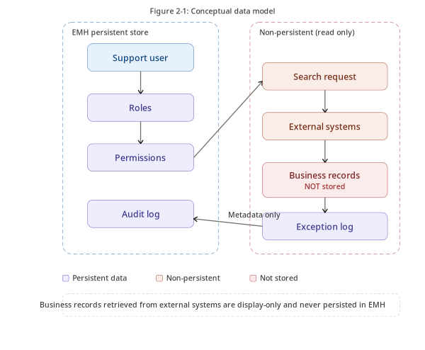
Figure 2-1 – Conceptual Data Model
Illustrates the conceptual relationship between support users, EMH roles and permissions, search activity, external systems, non-persistent results, audit logs, and exception logs.
The conceptual model establishes that EMH owns access management, audit, exception, and configuration entities. Business records remain mastered externally. The application consumes external records during support investigations but does not replicate or re-master them.

2.1.2 Logical Data Model
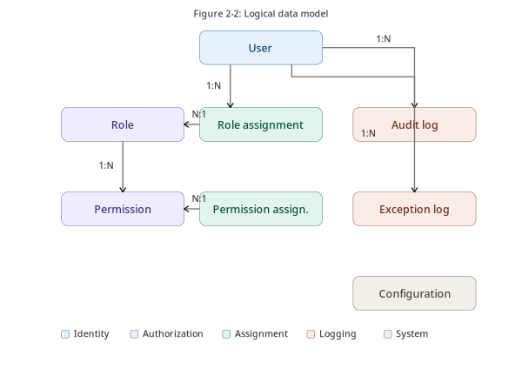
Figure 2-2 – Logical Data Model
Shows the logical data structures used by EMH, separating persistent administrative and audit data from non-persistent external business views.
Table 2-2 – Logical Entity Catalogue
Entity | Persistence | Key Attributes | Description
EMH_User | Persistent | UserId, Username, FullName, Email, Status, LastLoginDate, CreatedDate, ModifiedDate | Represents an authorized EMH user profile used for administration and audit attribution.
Role | Persistent | RoleId, RoleName, Description, Status, CreatedDate, ModifiedDate | Represents a functional access role in EMH.
Permission | Persistent | PermissionId, PermissionCode, PermissionName, Application, Module, Description | Represents an authorized capability, page, action, or investigation function.
UserRole | Persistent | UserRoleId, UserId, RoleId, AssignedBy, AssignedDate, Status | Maps users to roles.
RolePermission | Persistent | RolePermissionId, RoleId, PermissionId, GrantedBy, GrantedDate, Status | Maps roles to permissions.
UserPermissionOverride | Persistent / Optional | OverrideId, UserId, PermissionId, EffectiveFrom, EffectiveTo, Reason | Supports exceptional access where approved.
ApplicationConfiguration | Persistent | ConfigurationId, Key, Value, Environment, Description, LastUpdatedBy, LastUpdatedDate | Stores runtime configuration values.
AuditLog | Persistent | AuditId, UserId, Action, Module, Entity, Timestamp, Result, SourceIp, CorrelationId | Captures user and system activity metadata.
ExceptionLog | Persistent | ExceptionId, Type, Module, SourceSystem, SanitizedMessage, CorrelationId, Timestamp, Status | Captures sanitized exception and integration failure information.
ExternalSearchRequest | Non-Persistent | SearchType, SearchCriteria, RequestedBy, RequestTimestamp, CorrelationId | Represents runtime search input.
ClinicalAttachmentView | Non-Persistent | ApplicationNumber, ApplicantName, Status, PaymentStatus, LastUpdatedDate | Represents runtime display view from Clinical Attachment.
PremaritalView | Non-Persistent | ApplicationNumber, ApplicantName, Status, AppointmentDate, PaymentStatus | Represents runtime display view from Premarital.
PatientServicesView | Non-Persistent | MRN, PatientName, ServiceType, Status, RequestDate | Represents runtime display view from Patient Services.

2.1.3 Data Glossary
Table 2-3 – Data Glossary
Term / Entity | Definition
Persistent Entity | A Mendix entity stored in the EMH database.
Non-Persistent Entity | A Mendix entity used at runtime without database persistence.
System of Record | The authoritative source system that owns and maintains the master business data.
Audit Log | A persistent metadata record of security-relevant or business-relevant activity.
Exception Log | A persistent sanitized technical record used for troubleshooting.
Support Officer | An authorized operational user who searches and views investigation information.
Payment Status | The current payment state retrieved from the relevant source system or payment-related API.
Data Mastership | The assignment of authority for creation, maintenance, and ownership of a data object.

2.2 Data Mastership
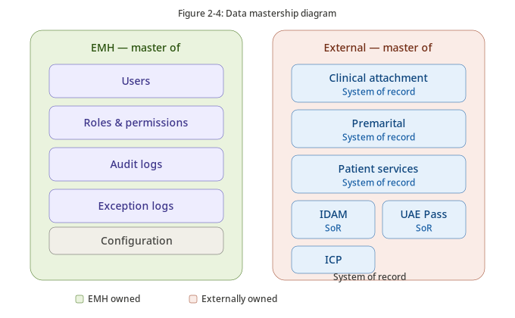
Figure 2-3 – Data Mastership
Illustrates data ownership across EMH and source systems, confirming that EMH masters only its operational data and consumes external business data as read-only information.
Table 2-4 – Data Mastership Matrix
Entity / Data Object | EMH | IDAM | UAE Pass | ICP | Clinical Attachment | Premarital | Patient Services | Notes
EMH User | M/S | P |  |  |  |  |  | EMH maintains local authorization profile; IDAM provides identity reference.
Role | M |  |  |  |  |  |  | EMH owns role definitions.
Permission | M |  |  |  |  |  |  | EMH owns permission model.
User Role Assignment | M |  |  |  |  |  |  | EMH owns authorization mappings.
Audit Log | M |  |  |  |  |  |  | EMH owns investigation and security audit metadata.
Exception Log | M |  |  |  |  |  |  | EMH owns sanitized application exception logs.
IDAM User Profile | S | M |  |  |  |  |  | IDAM is identity System of Record.
UAE Pass Identity | S | P | M |  |  |  |  | UAE Pass is identity provider/source for national identity integration.
ICP Applicant Information | S |  |  | M |  |  |  | ICP is external System of Record.
Clinical Attachment Application | S |  |  |  | M |  |  | Clinical Attachment remains System of Record.
Clinical Attachment Payment | S |  |  |  | M/P |  |  | Payment status consumed for display.
Premarital Application | S |  |  |  |  | M |  | Premarital remains System of Record.
Premarital Payment | S |  |  |  |  | M/P |  | Payment status consumed for display.
Patient Profile | S |  |  |  |  |  | M | Patient Services remains System of Record.
Health Card | S |  |  |  |  |  | M | Consumed for display only.
Sick Leave Certificate | S |  |  |  |  |  | M | Consumed for display only.
Medical Report Request | S |  |  |  |  |  | M | Consumed for display only.

Legend: M = Master; S = Subscriber/Consumer; P = Provider. Blank means no direct mastership role for the entity.

2.3 Data Management
Data management controls are designed around the principle that EMH is an investigation portal rather than a data warehouse or operational source system. This reduces privacy exposure, simplifies migration, and keeps source applications authoritative.

2.3.1 Data Profile
Table 2-5 – Data Profile
Data Category | Persistence | Volume | Classification | Management Treatment
Users / Roles / Permissions | Persistent | Low | Confidential | Administered through controlled EMH administration functions.
Audit Logs | Persistent | Medium to High | Confidential | Retained according to approved retention policy and protected from unauthorized modification.
Exception Logs | Persistent | Medium | Confidential | Sanitized and retained for support and troubleshooting.
Configuration | Persistent | Low | Internal / Confidential | Controlled changes with audit trail.
Identity Data | Non-Persistent | On-demand | Confidential / Highly Confidential | Displayed only to authorized users; not persisted.
Clinical / Premarital / Patient Services Data | Non-Persistent | On-demand | Highly Confidential | Retrieved through APIs and discarded after request lifecycle.
Payment Status | Non-Persistent | On-demand | Confidential | Displayed as source system status only.

2.3.2 Data Quality & Reconciliation
Table 2-6 – Data Quality and Reconciliation Controls
Control | Purpose | EMH Implementation
Input Validation | Prevent malformed searches. | Validate required fields, permitted formats, and role-based search eligibility.
API Response Validation | Avoid displaying invalid or incomplete data. | Validate response schema, required fields, data types, and status codes.
Source Ownership | Avoid conflicting data correction. | Route data correction to the System of Record; EMH does not modify external records.
Correlation IDs | Support traceability. | Generate or propagate correlation IDs for each integration call.
Error Handling | Improve support usability. | Display business-friendly messages while logging sanitized technical detail.
Duplicate Handling | Avoid confusing result displays. | Display source-provided identifiers and statuses; do not merge records without approved business rules.
Reconciliation | Confirm persisted EMH data integrity. | Reconcile roles, permissions, and configuration changes through audit and admin review.

2.3.3 Data Volume & Sizing
Table 2-7 – Data Volume and Sizing
Data Object | Expected Volume | Growth Driver | Sizing Consideration
Users | Low | Number of support officers and administrators. | Minimal storage; indexing on username/email.
Roles / Permissions | Low | Access model complexity. | Minimal storage; change control important.
Audit Logs | High relative to other EMH data | Search activity, access events, admin changes, integration calls. | Retention and indexing strategy required.
Exception Logs | Medium | Integration failures and application exceptions. | Retention, sanitization, and monitoring correlation required.
External Search Results | Transient | User search activity. | No database sizing required; runtime memory and payload limits considered.
Configuration | Low | Environment endpoints and application settings. | Version control and audit required.

2.3.4 Data Retention & Archival
Table 2-8 – Data Retention and Archival
Data Object | Retention Approach | Notes
Users / Roles / Permissions | Retain while active and as required for audit traceability. | Deactivation preferred over physical deletion where audit continuity is required.
Audit Logs | One year target, subject to compliance confirmation. | Retention must be confirmed with governance and records management.
Exception Logs | One year target, subject to compliance confirmation. | Sensitive payloads shall not be logged.
Configuration | Retain current and approved historical change records. | Change history supports troubleshooting and governance.
External Business Data | Not retained. | Retrieved and displayed at runtime only.
Backups | According to infrastructure and database backup policy. | Backup retention owned by infrastructure/DBA teams.

2.3.5 Data Privacy Compliance
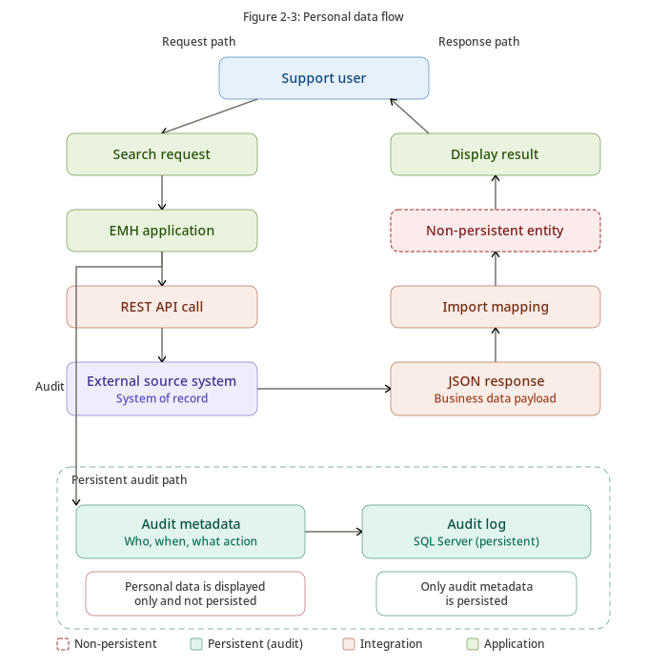
Figure 2-4 – Personal Data Flow
Shows how personal data flows from source systems to EMH at runtime, how it is displayed to authorized users, and how only audit metadata is retained.
Table 2-9 – Privacy Compliance Decisions
Privacy Principle | EMH Control
Purpose Limitation | Data is accessed only for support investigation purposes.
Data Minimization | External personal data is not persisted by EMH.
Access Limitation | Only authorized support users can access relevant search functions.
Accountability | Searches, access denied events, and administrative changes are audited.
Security | Authentication, authorization, encryption, monitoring, and logging controls are applied.
Transparency / Traceability | Investigation actions can be traced through audit metadata.
Third-Party Processing | External systems remain responsible for their own data processing and master records.

2.3.6 Data Conversion & Migration
Table 2-10 – Data Conversion and Migration
Migration Object | Migration Required | Approach
External operational business data | No | No migration into EMH. Source systems remain authoritative.
Users | Yes / Initial load | Load approved support officers and administrators or synchronize/reference IDAM as agreed.
Roles | Yes | Configure EMH role catalogue before UAT.
Permissions | Yes | Configure page, module, action, and API-related permissions.
Role Assignments | Yes | Map approved users to business roles.
Configuration | Yes | Configure endpoints, constants, environment settings, timeout values, and monitoring parameters.
Audit Logs | No historical migration | Audit logs start from EMH go-live unless explicitly required.
Exception Logs | No historical migration | Exception logs start from EMH go-live.

3. Application Architecture
Based on the data architecture defined in Chapter 2, this chapter describes how EMH orchestrates user interactions, Mendix components, enterprise APIs, environments, and application events.

3.1 Application Interface View
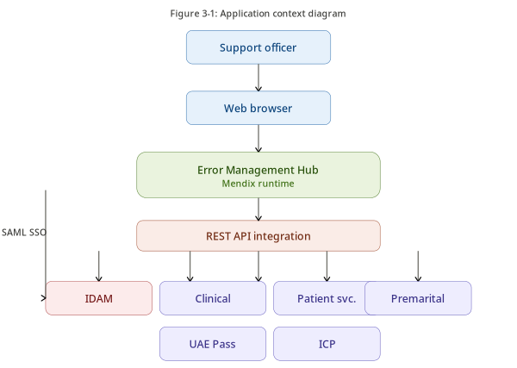
Figure 3-1 – Application Context
Shows EMH as the central Mendix web application used by support officers and administrators to interact with enterprise systems through controlled REST APIs.
Table 3-1 – Application Interface View
Interface Area | Description | Design Treatment
User Interface | Mendix pages accessed through browser. | Role-specific pages, search forms, read-only result grids, and admin pages.
Authentication Interface | SAML integration with Enterprise IDAM. | Browser redirects to IDAM; EMH consumes SAML assertion and establishes session.
Authorization Interface | Mendix security model. | Module roles, user roles, page access, microflow access, and entity access.
Business Data Interfaces | REST APIs exposed by source systems. | Consumed REST Services and import mappings.
Monitoring Interface | AppDynamics and application logging. | Runtime performance, errors, integration dependencies, and transaction health.

3.2 Component Description
Table 3-2 – Application Component Catalogue
Component | Mendix Realization | Responsibility
Presentation Components | Pages, layouts, snippets, navigation profiles, search forms, read-only views. | Expose support investigation and administration functions.
Authentication Component | SAML module/configuration and session handling. | Delegate authentication to IDAM and establish authenticated sessions.
Authorization Component | Roles, module roles, entity access, page access, microflow security. | Protect all pages, functions, and data access.
User Administration | User, role, permission, and assignment management. | Maintain EMH-owned authorization data.
Search & Investigation | Microflows and UI patterns for search execution and display. | Coordinate read-only investigations across modules.
Integration Services | Consumed REST Services, import mappings, integration microflows. | Retrieve external data through approved APIs.
Audit Service | Audit entities and audit microflows. | Record security-relevant and investigation-relevant activity.
Exception Management | Exception logging, error mapping, monitoring integration. | Capture sanitized failures and show user-safe messages.
Configuration Management | Constants, configuration entities, environment settings. | Control endpoints, timeouts, and runtime parameters.
Monitoring Integration | AppDynamics agent/integration and log nodes. | Support operational observability.

Table 3-3 – Mendix Module Structure
Mendix Module | Primary Responsibility | Key Entities / Microflows
Security | Authentication and authorization support. | UserRole, RolePermission, access validation microflows.
Administration | User and configuration administration. | User, Role, Permission, Configuration.
Audit | Audit capture and reporting. | AuditLog and reusable audit microflows.
ExceptionManagement | Error handling and troubleshooting. | ExceptionLog and error mapping microflows.
Integration | Reusable integration patterns. | Consumed REST Services, import mappings, API response handlers.
ClinicalAttachment | Module-specific search and display. | Non-persistent ClinicalAttachmentView and search microflows.
Premarital | Module-specific search and display. | Non-persistent PremaritalView and search microflows.
PatientServices | Module-specific search and display. | Non-persistent PatientServicesView and search microflows.
Common | Reusable utilities and constants. | Validation, correlation, logging, response helpers.

3.3 Interface Description
EMH uses synchronous REST request/response integrations for search and record retrieval. The application is a consumer of enterprise APIs and shall not expose external business data as a separate master source.

3.3.1 Interface Design
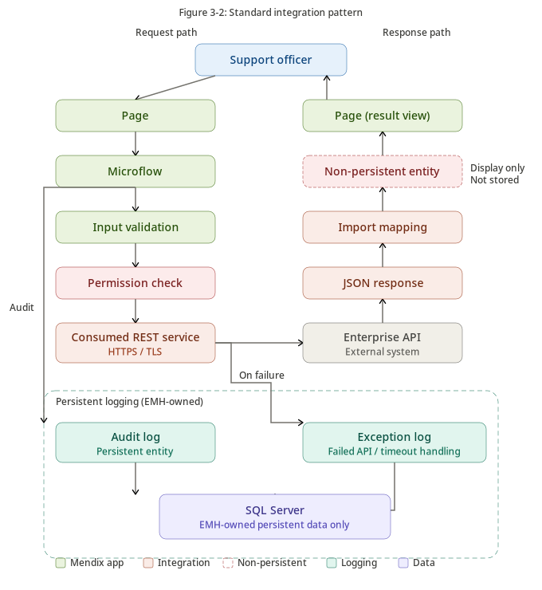
Figure 3-2 – Standard Integration Pattern
Illustrates the standard EMH request-processing pattern: page interaction, validation, authorization, consumed REST service, response mapping, non-persistent display, audit logging, and exception handling.
Table 3-4 – Interface Design Rules
Design Rule | Description
REST and JSON | All integrations shall use REST APIs with JSON payloads unless an approved exception exists.
Consumed REST Services | Mendix Consumed REST Services shall be used for source system API calls.
Import Mappings | Responses shall be mapped to Mendix entities through import mappings.
Non-Persistent Results | External business results shall be mapped into Non-Persistent Entities.
Timeout Handling | Timeouts shall be configurable and handled with user-safe messages.
No Sensitive Payload Logging | Request and response payloads containing sensitive data shall not be logged.
Correlation | Each request shall be traceable through correlation ID or equivalent metadata.
Authorization Before Call | Microflows shall validate user permission before invoking external APIs.

3.3.2 API List
Table 3-5 – API Catalogue
API ID | Interface | Provider | Purpose | Mode | Classification
API-001 | IDAM User Profile API | IDAM | Retrieve authenticated user attributes / user reference. | Read | Confidential
API-002 | UAE Pass Identity API | UAE Pass | Retrieve identity reference information where applicable. | Read | Highly Confidential
API-003 | ICP Person / Applicant API | ICP | Retrieve applicant/person data for support investigation. | Read | Highly Confidential
API-004 | Clinical Attachment Search API | Clinical Attachment | Search clinical attachment applications. | Read | Highly Confidential
API-005 | Clinical Attachment Detail API | Clinical Attachment | Retrieve clinical attachment application details. | Read | Highly Confidential
API-006 | Clinical Attachment Payment Status API | Clinical Attachment / Payment Source | Retrieve payment status. | Read | Confidential
API-007 | Premarital Search API | Premarital | Search premarital applications. | Read | Highly Confidential
API-008 | Premarital Detail API | Premarital | Retrieve premarital application details. | Read | Highly Confidential
API-009 | Premarital Payment Status API | Premarital / Payment Source | Retrieve payment status. | Read | Confidential
API-010 | Patient Profile API | Patient Services | Retrieve patient profile details. | Read | Highly Confidential
API-011 | Health Card API | Patient Services | Retrieve health card status/details. | Read | Highly Confidential
API-012 | Sick Leave API | Patient Services | Retrieve sick leave certificate/request details. | Read | Highly Confidential
API-013 | Medical Report API | Patient Services | Retrieve medical report request details. | Read | Highly Confidential

Table 3-6 – API Specification Template
API Design Area | Required Specification
Endpoint and Method | To be provided by source application owner during interface design.
Authentication / Authorization | To follow enterprise-approved service authentication pattern.
Request Schema | Search criteria, mandatory fields, validation rules, and correlation metadata.
Response Schema | Business fields required for support investigation, status fields, identifiers, and timestamps.
Error Model | HTTP status, source error code, safe message, correlation ID, and retry guidance.
Timeout | Configurable per API based on source SLA and user experience requirements.
Audit Metadata | API name, operation, user, timestamp, result, and correlation ID.

3.3.3 Event List
Table 3-7 – Event Catalogue
Event ID | Event | Trigger | Persisted | Purpose
EVT-001 | User Authenticated | Successful SAML login | Yes / Audit | Trace access to EMH.
EVT-002 | User Logout | User session termination | Optional / Audit | Trace session lifecycle.
EVT-003 | Search Executed | Support officer performs search | Yes / Audit | Trace investigation activity.
EVT-004 | External API Invoked | Integration microflow calls API | Yes / Metadata | Trace integration usage.
EVT-005 | Access Denied | User attempts unauthorized action | Yes / Security Audit | Support security monitoring.
EVT-006 | Role Assignment Changed | Admin modifies role assignment | Yes / Audit | Govern access changes.
EVT-007 | Permission Updated | Admin modifies permission mapping | Yes / Audit | Govern access changes.
EVT-008 | Configuration Updated | Admin modifies configuration | Yes / Audit | Trace operational changes.
EVT-009 | Integration Failure | API error/timeout | Yes / Exception | Support troubleshooting.
EVT-010 | Application Exception | Unhandled or handled exception | Yes / Exception | Support incident analysis.

3.4 Application Environments
EMH shall follow controlled environment progression. Each environment shall have defined configuration, data restrictions, access controls, and deployment governance.

3.4.1 Environment Mapping
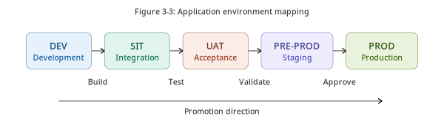
Figure 3-3 – Environment Mapping
Shows the intended environment progression for EMH from development through test, UAT, pre-production where applicable, and production.
Table 3-8 – Environment Mapping
Environment | Purpose | Data Use | Access | Controls
Development | Build and unit testing. | Synthetic or non-sensitive test data. | Development team. | Basic logging, local configuration, no production data.
SIT | System integration testing. | Approved test data and integration test endpoints. | Development, QA, integration teams. | Integration logs, API validation, security baseline.
UAT | Business validation. | Masked or approved test data only. | Business testers and support representatives. | Role-based access, audit enabled, UAT evidence.
Pre-Production | Production readiness and dress rehearsal where applicable. | Production-like but controlled data as approved. | Restricted project and operations team. | Monitoring, backup validation, release rehearsal.
Production | Live support investigation service. | Live data displayed from source systems at runtime. | Authorized support officers and administrators. | SAML, RBAC, audit, monitoring, backup, incident process.

4. Technical Architecture
This chapter defines the implementation and deployment architecture, technology landscape, technical components, availability, backup, disaster recovery, logging, monitoring, DevSecOps, and performance efficiency considerations for EMH.

4.1 Implementation & Deployment View
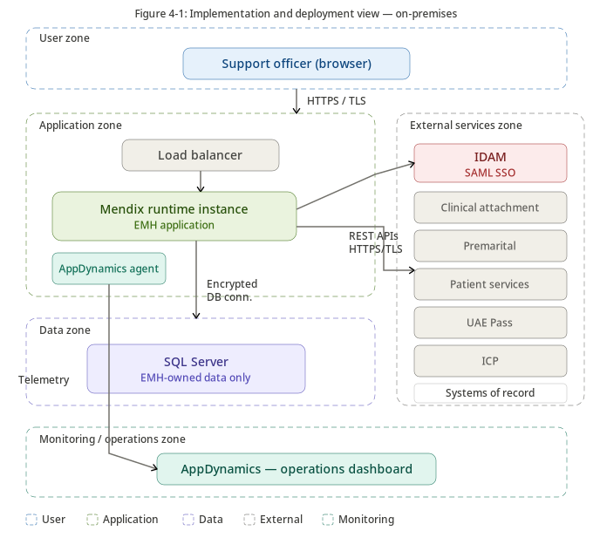
Figure 4-1 – Implementation and Deployment View
Illustrates the logical deployment of EMH across user access, Mendix runtime, SQL Server persistence, enterprise integrations, identity services, and monitoring services.
Table 4-1 – Deployment Elements
Deployment Element | Description | Ownership / Notes
Client Browser | User access channel for support officers and administrators. | User device and enterprise endpoint controls apply.
Load Balancer / Reverse Proxy | Optional or required depending on final HA topology. | Infrastructure-owned. Mentioned as a capability, not a product decision.
Mendix Runtime Instance(s) | Runs the EMH application package. | Application runtime hosted on approved on-premises infrastructure.
Microsoft SQL Server | Stores EMH-owned persistent entities. | Database platform and HA managed by DBA/infrastructure.
Enterprise IDAM | Provides SAML authentication. | IAM team-owned.
External Enterprise APIs | Provide read-only business data. | Source application teams own APIs and data.
AppDynamics | Monitors application performance and runtime health. | Operations-owned monitoring platform.
Backup Platform | Protects database and application configuration. | Infrastructure/DBA-owned.

4.1.1 On-Premises Deployment View
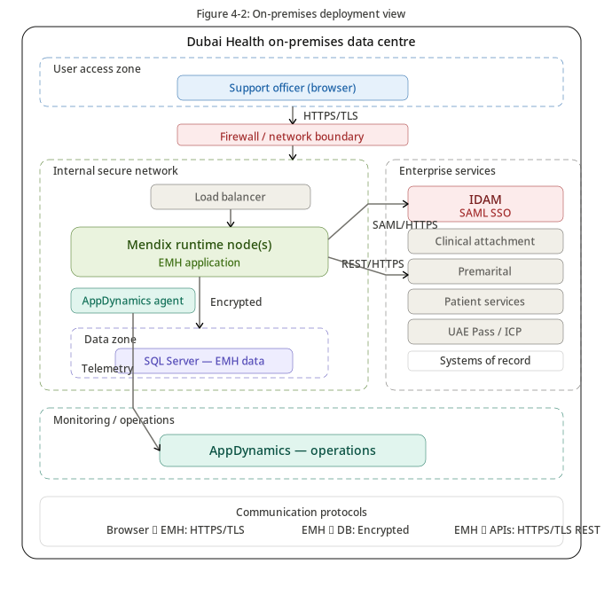
Figure 4-2 – On-Premises Deployment View
Shows the on-premises deployment boundary for EMH, including network zones, runtime, database, identity, integrations, and monitoring dependencies.
Although the Dubai Health template refers to cloud deployment, the EMH target architecture is explicitly on-premises. This section therefore preserves the template numbering while describing the on-premises deployment view.

4.2 Technology Landscape
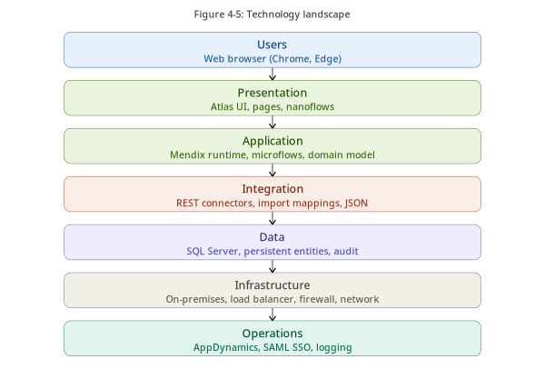
Figure 4-3 – Technology Landscape
Summarizes the primary technologies and platform capabilities used by EMH, including Mendix, SQL Server, REST/JSON, SAML, AppDynamics, and enterprise systems.
Table 4-2 – Technology Landscape
Technology / Capability | Use in EMH | Rationale
Mendix Low-Code Platform | Primary application development and runtime platform. | Accelerates delivery and supports modular enterprise application design.
Mendix Runtime | Executes EMH application logic, pages, microflows, and integrations. | Standard Mendix runtime capability.
Microsoft SQL Server | Persistent storage for EMH-owned entities. | Enterprise database platform aligned with EMH persistence needs.
REST / JSON | Integration style for external systems. | Standard API-first integration pattern.
SAML 2.0 | Single Sign-On with Enterprise IDAM. | Enterprise authentication standard.
AppDynamics | Application performance monitoring and observability. | Operational monitoring and troubleshooting.
Mendix Domain Model | Persistent and non-persistent data modeling. | Separates EMH data from external runtime views.
Mendix Microflows | Application orchestration and server-side logic. | Implements search, authorization, mapping, logging, and integration logic.
Mendix Import Mappings | JSON response transformation. | Maps API responses to Mendix entities.
Mendix Constants / Configuration | Environment-specific runtime parameters. | Avoids hardcoded endpoints and settings.

4.3 Technical Services / Components
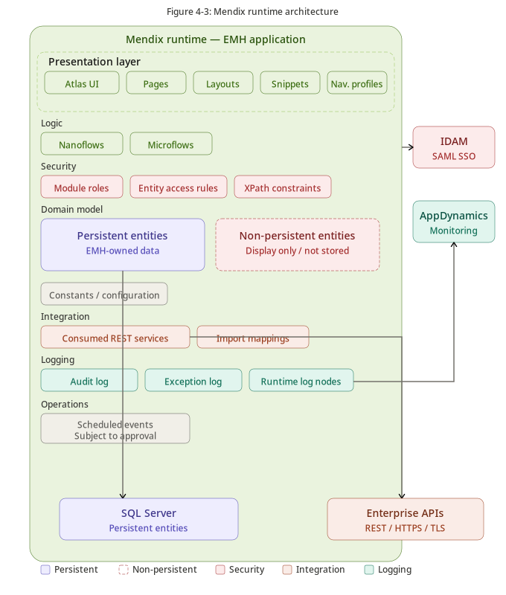
Figure 4-4 – Mendix Runtime Architecture
Illustrates the internal architecture of the EMH Mendix runtime, including presentation, domain logic, security, persistence, integration services, and monitoring hooks.
Table 4-3 – Technical Services and Components
Technical Service | Function | Implementation Notes
Authentication Service | Delegates login to IDAM. | SAML configuration and attribute mapping.
Authorization Service | Applies access control. | Mendix module roles, user roles, page access, microflow access, entity access.
Session Management | Maintains authenticated sessions. | Mendix runtime session controls and enterprise timeout policies.
Integration Service | Calls external APIs. | Consumed REST Services with import mappings.
Audit Service | Persists audit events. | Reusable microflows called from search/admin/security actions.
Exception Service | Captures sanitized failures. | Exception entity and logging microflows; no sensitive payloads.
Configuration Service | Manages runtime settings. | Constants/config entities with controlled access.
Data Persistence Service | Stores EMH-owned data. | SQL Server through Mendix persistence layer.
Monitoring Service | Exposes runtime metrics and errors. | AppDynamics integration and logging.
File Handling | Only if required by future scope. | Not part of core read-only investigation unless approved.

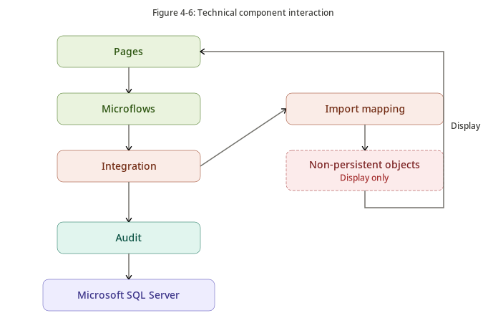
Figure 4-5 – Technical Component Interaction
Shows the interaction between user actions, Mendix UI, microflows, security validation, REST integration, non-persistent results, SQL Server persistence, and AppDynamics monitoring.

4.4 Implementation Details

4.4.1 High Availability
Table 4-4 – High Availability Considerations
Availability Area | Design Expectation | Owner / Notes
Mendix Runtime | Support redundant runtime instances where required by final topology. | Infrastructure and platform teams confirm topology.
Load Balancing | Route traffic to healthy runtime instances where HA is implemented. | Infrastructure-owned.
SQL Server | Use enterprise SQL Server HA pattern where required. | DBA/infrastructure-owned.
IDAM | Authentication availability depends on Enterprise IDAM. | IAM-owned.
External APIs | Business search availability depends on source systems. | Source application owners.
Monitoring | AppDynamics monitors runtime and dependencies. | Operations-owned.

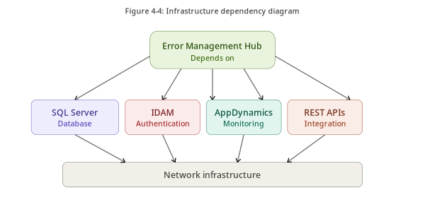
Figure 4-6 – Infrastructure Dependency View
Shows the external infrastructure and operational dependencies required for EMH deployment and runtime operation.

4.4.2 Backup & Recovery
Table 4-5 – Backup and Recovery Scope
Backup Object | Backup Required | Recovery Notes
EMH SQL Server Database | Yes | Required to recover users, roles, permissions, configuration, audit, and exception logs.
Mendix Application Package | Yes | Approved deployment package must be retained for redeployment.
Runtime Configuration | Yes | Endpoints, constants, SAML metadata, certificates, and environment-specific settings must be recoverable.
Source System Data | No | Source systems remain responsible for their own backups and recovery.
Logs | Yes / According to policy | Log backup/retention depends on operations logging platform.
AppDynamics Configuration | Yes / Platform-owned | Monitoring dashboards and alert policies should be recoverable.

4.4.3 Disaster Recovery
Table 4-6 – Disaster Recovery Approach
DR Capability | Target / Consideration | Validation Required
RTO | Target approximately one hour, subject to validation. | Infrastructure and operations must validate feasibility.
RPO | Target approximately five minutes, subject to validation. | Database backup/replication strategy must validate feasibility.
Redeploy on Disaster | Application may be redeployed from approved package. | Requires package, configuration, database restore, IDAM connectivity, API connectivity, and monitoring readiness.
Business Validation | Support officers must validate critical search paths after recovery. | Include in DR test plan.
Runbook | A recovery runbook shall be maintained. | Operations-owned with application team input.

4.4.4 Logging & Monitoring
Table 4-7 – Logging and Monitoring
Monitoring Area | Metric / Signal | Tool / Source
Application Availability | Runtime up/down, health status. | AppDynamics / runtime monitoring.
Response Time | Page load and transaction response time. | AppDynamics.
API Dependency Health | Latency, errors, timeouts by external API. | AppDynamics and exception logs.
Database Connectivity | Connection failures and DB response issues. | Runtime logs / DB monitoring.
Security Events | Login, access denied, admin changes. | Audit logs.
Application Exceptions | Unhandled and handled exceptions. | Exception logs and AppDynamics.
Audit Activity | Searches, configuration changes, role changes. | AuditLog entity.

Table 4-8 – Logging Restrictions
Do Not Log | Reason
Passwords, secrets, tokens, SAML assertions | Credential exposure risk.
Full Emirates ID / national identifier where not required | Personal data minimization.
Full patient records or clinical data payloads | Highly confidential health information.
Payment card or sensitive payment details | Compliance and security risk.
Full API request/response payloads containing sensitive data | Privacy and confidentiality risk.

4.5 DevSecOps
Table 4-9 – DevSecOps Lifecycle
Lifecycle Stage | Activities | Controls
Plan | Define scope, stories, acceptance criteria, architecture decisions. | Architecture review, security requirement review.
Design | Model domain, pages, microflows, integrations, security. | Design review, threat modeling, data privacy review.
Build | Develop Mendix modules, microflows, integrations, admin functions. | Code/model review, secure configuration, no hardcoded secrets.
Test | Unit, integration, security, regression, UAT. | SAST/SCA/DAST where applicable, test evidence.
Package | Create deployment package. | Versioning, approval, release notes.
Deploy | Promote through environments. | Change approval, rollback plan, smoke test.
Operate | Monitor, support, incident response. | AppDynamics, logs, support runbook, incident process.

4.6 Performance Efficiency
Table 4-10 – Performance Efficiency Considerations
Performance Area | Design Consideration | Control
Search Validation | Prevent inefficient or overly broad searches. | Mandatory criteria and input rules.
API Calls | External API latency affects user experience. | Timeouts, clear errors, correlation IDs, dependency monitoring.
Payload Size | Large responses can slow UI and memory usage. | Pagination, field filtering, response mapping.
Audit Writes | Audit growth can affect database performance. | Indexing, retention, archival.
Authorization Checks | Complex role checks can add overhead. | Reusable validation patterns and efficient entity access rules.
Database Indexing | EMH-owned tables require indexes. | Index key lookup fields, audit timestamps, correlation IDs.
Concurrency | Concurrent support users may execute multiple searches. | Capacity testing and infrastructure sizing.

5. Information Security Architecture
This chapter defines security architecture for EMH, including resource management, assurance, segregation, identity and access management, vulnerability management, encryption, connectivity, continuity, logging, incident management, threat modeling, and privacy by design.

5.1 Information Resource Management Assessment
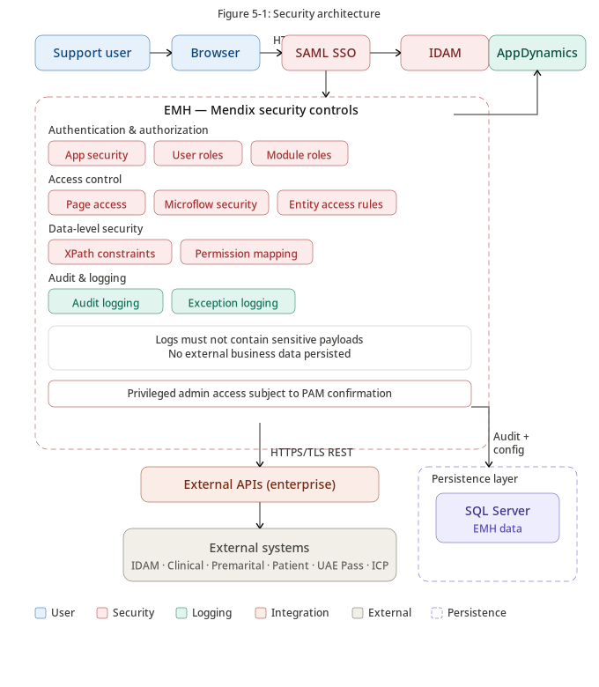
Figure 5-1 – Security Architecture
Shows the security architecture layers for EMH, including identity, access control, application security, data protection, monitoring, and integration security.
Table 5-1 – Information Resource Management Assessment
Information Resource | Classification | Stored in EMH | Security Treatment
EMH User Records | Confidential | Yes | RBAC, restricted admin access, audit changes.
Roles and Permissions | Confidential | Yes | Restricted administration, change audit.
Audit Logs | Confidential | Yes | Protected access, retention, tamper-awareness where available.
Exception Logs | Confidential | Yes | Sanitized messages, restricted access.
Application Configuration | Internal / Confidential | Yes | Restricted access, audit, no secrets in plain text.
IDAM / UAE Pass Identity Data | Confidential / Highly Confidential | No | Runtime display only, no persistence.
ICP Data | Highly Confidential | No | Runtime display only, no persistence.
Clinical / Premarital / Patient Services Data | Highly Confidential | No | Runtime display only, no persistence.
Payment Status | Confidential | No | Display only; sensitive payment details not logged.

5.2 Assurance
Table 5-2 – Assurance Assessment
Assurance Area | Applicability | Control / Decision
Cloud / SaaS Assurance | Not primary for EMH application because target is on-premises. | Any SaaS monitoring or external service component must be assessed separately.
Mendix Platform Assurance | Applicable. | Platform use shall follow approved enterprise Mendix deployment and security practices.
Marketplace Modules | Applicable if used. | EA, InfoSec, licensing, and vulnerability approval required.
Custom Java Actions | Applicable by exception. | Secure coding review and SAST/SCA coverage required.
External APIs | Applicable. | Interface security, authentication, authorization, and data classification review required.
Monitoring Platform | Applicable. | AppDynamics deployment model and data captured must align with security requirements.

5.3 Segregation
Table 5-3 – Segregation Controls
Segregation Area | Requirement | Implementation
Environment Segregation | Development, test, UAT, and production must be separated. | Separate runtime configuration and data rules per environment.
Duty Segregation | Developers should not have unrestricted production administration. | Role separation and change management.
Application Role Segregation | Support officer and administrator privileges must be separated. | Mendix roles and module roles.
Data Segregation | EMH-owned data separated from external business data. | Persistent vs non-persistent entity design.
Integration Segregation | Each source API integration should be controlled separately. | Module-specific integration microflows and configuration.
Operational Segregation | Monitoring and admin access restricted. | Operations roles and audit.

5.4 Identity & Access Management
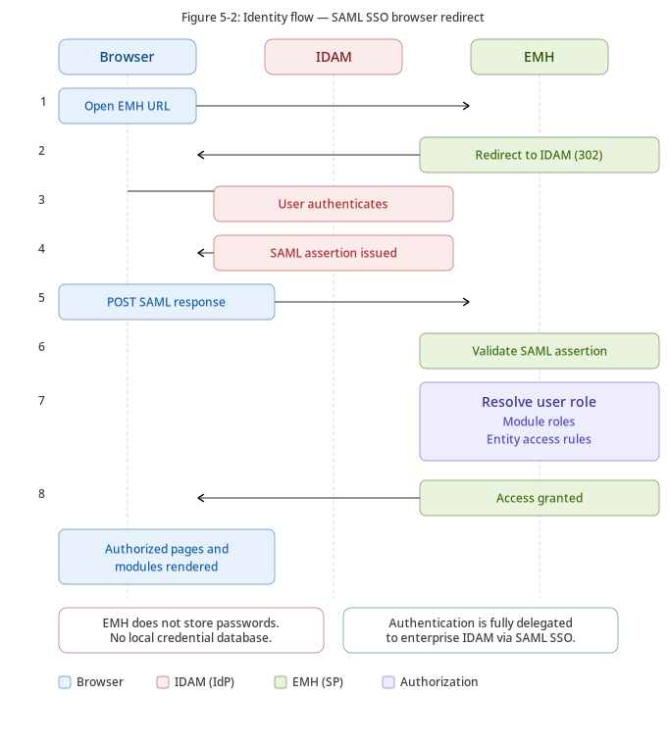
Figure 5-2 – Identity Flow
Shows the SAML authentication flow from support officer browser to Enterprise IDAM and the resolution of EMH user roles, module roles, and entity access rules.

5.4.1 Identity Management
Table 5-4 – Identity Management
Identity Control | EMH Implementation
Enterprise Authentication | EMH authentication shall be delegated to Enterprise IDAM through SAML SSO.
Local Passwords | EMH shall not manage local user passwords for enterprise users.
User Attributes | Required identity attributes shall be mapped from IDAM to EMH user context.
User Lifecycle | Joiner/mover/leaver governance remains aligned with enterprise IAM processes.
Session Establishment | Mendix runtime establishes session after successful SAML assertion validation.
Authentication Failure | Failed authentication is handled by IDAM and/or logged according to approved security process.

5.4.2 Access Management
Table 5-5 – Access Management
Access Control Layer | Purpose | Implementation
User Role | High-level business role assignment. | EMH roles such as Support Officer, Module Support Officer, Administrator.
Module Role | Controls module-level Mendix capabilities. | Mapped to Mendix module security.
Page Access | Restricts page visibility and navigation. | Defined in Mendix security settings.
Microflow Access | Restricts execution of server-side logic. | Only allowed roles can execute sensitive microflows.
Entity Access | Restricts entity read/write permissions. | Mendix entity access rules.
XPath Constraints | Applies row-level filtering where applicable. | Used where entity access requires contextual filtering.
Administrative Access | Restricts user/role/permission management. | Admin-only pages and audited changes.

5.4.3 Privileged Access Management
Table 5-6 – Privileged Access Management
PAM Area | Requirement / Treatment
Privileged Users | Administrative roles shall be limited to approved personnel.
Break-Glass Access | If required, emergency access shall follow enterprise approval and audit rules.
PAM Tooling | Where enterprise PAM exists, EMH administrative access should align with it.
Audit | Privileged activities shall be audited, including role changes, permission changes, and configuration changes.
Segregation | Privileged administrative functions should be separated from regular support investigation functions.

5.5 Vulnerability Management
Table 5-7 – Vulnerability Management
Area | Control
Secure SDLC | Security activities shall be embedded into design, build, test, release, and operate phases.
Vulnerability Register | Findings shall be recorded, owned, prioritized, and tracked to closure.
Risk Acceptance | Unresolved high-risk findings require formal risk acceptance before production.
Patch Management | Runtime, dependencies, modules, and infrastructure components shall follow approved patch process.
Security Testing | SAST, SCA, DAST, and configuration reviews shall be performed based on applicability.

5.5.1 SAST
Table 5-8 – Static Application Security Testing
SAST Area | EMH Requirement
Mendix Model Review | Security settings, access rules, microflow access, and sensitive logic shall be reviewed.
Java Actions | Custom Java Actions, if any, shall undergo static code review/testing.
Critical/High Findings | Must be remediated or formally accepted before production.
Evidence | SAST results shall be retained as release evidence where applicable.

5.5.2 SCA
Table 5-9 – Software Composition Analysis
SCA Area | EMH Requirement
Marketplace Modules | All modules shall be inventoried and reviewed before adoption.
Third-Party Libraries | Java dependencies, if any, shall be tracked and reviewed.
Licensing | License compatibility shall be reviewed.
Known Vulnerabilities | Critical/high vulnerabilities shall be remediated or risk accepted.

5.5.3 DAST
Table 5-10 – Dynamic Application Security Testing
DAST Area | EMH Requirement
Authenticated Testing | Testing should include authenticated role scenarios where approved.
Unauthenticated Testing | Public/login flows should be tested for exposure and misconfiguration.
Authorization Testing | Horizontal and vertical access control attempts should be validated.
Input Testing | Search inputs, parameters, and API-facing functions should be tested.
Production Testing | DAST in production shall only occur with explicit approval and safe test conditions.

5.6 Encryption

5.6.1 Encryption at Rest
Table 5-11 – Encryption at Rest
Data / Component | Encryption Treatment
SQL Server Database | Encryption at rest shall follow enterprise SQL Server security standards.
Backups | Database and configuration backups shall be protected according to backup security policy.
Secrets and Certificates | Secrets shall not be stored in plain text in application code or documentation.
Logs | Log storage shall be protected through access control and retention rules.

5.6.2 Encryption in Transit
Table 5-12 – Encryption in Transit
Connection | Encryption Requirement
Browser to EMH | HTTPS/TLS.
EMH to IDAM | HTTPS/TLS for SAML redirection and metadata exchange.
EMH to External APIs | HTTPS/TLS.
EMH to SQL Server | Encrypted connection where supported and required by enterprise standards.
EMH to AppDynamics | Secure channel according to deployment model.

5.7 Connectivity & Integration
Table 5-13 – Connectivity and Integration Controls
Connectivity Area | Control
Firewall Rules | Only required ports/endpoints shall be opened by infrastructure through approved process.
API Endpoints | Endpoints shall be configured per environment and controlled through configuration.
No Direct DB | EMH shall not connect to external application databases.
Service Authentication | API authentication shall follow enterprise-approved mechanism.
Correlation | Integration calls shall include or propagate correlation metadata where supported.

5.8 Business Continuity
Table 5-14 – Business Continuity
Continuity Area | Approach
Application Recovery | Recover Mendix runtime from approved deployment package.
Data Recovery | Restore EMH SQL Server database according to RPO target.
External Dependencies | Source system outages are handled through clear messages and incident processes.
Manual Workaround | Existing source system support channels remain fallback until EMH is fully adopted.
Continuity Testing | Recovery and continuity procedures should be tested before production acceptance.

5.9 Logging & Monitoring
Table 5-15 – Logging and Monitoring Security
Log / Monitoring Source | Purpose | Sensitive Data Control
AuditLog | Trace user and admin actions. | Log metadata, not full business payloads.
ExceptionLog | Troubleshooting and incident support. | Sanitize messages and payloads.
AppDynamics | Performance, availability, dependency monitoring. | Ensure captured data aligns with security policy.
Runtime Logs | Technical diagnostics. | Restrict access and avoid sensitive payloads.
Security Events | Unauthorized access and suspicious activity. | Retain according to policy and incident needs.

5.10 Security Incident Management
Table 5-16 – Security Incident Management
Stage | Activity
Detect | Identify incidents through AppDynamics alerts, audit events, exception logs, and user reports.
Triage | Assess severity, affected functions, data exposure risk, and dependency impact.
Escalate | Notify Information Security, Operations, Application Owner, and Business Owner as required.
Contain | Disable affected feature, revoke access, block endpoint, or isolate runtime component where appropriate.
Investigate | Use audit logs, exception logs, correlation IDs, and monitoring evidence.
Recover | Restore service, validate security controls, and confirm business functionality.
Lessons Learned | Update controls, runbooks, test cases, and architecture decisions where required.

5.11 Threat Modeling & Mitigation
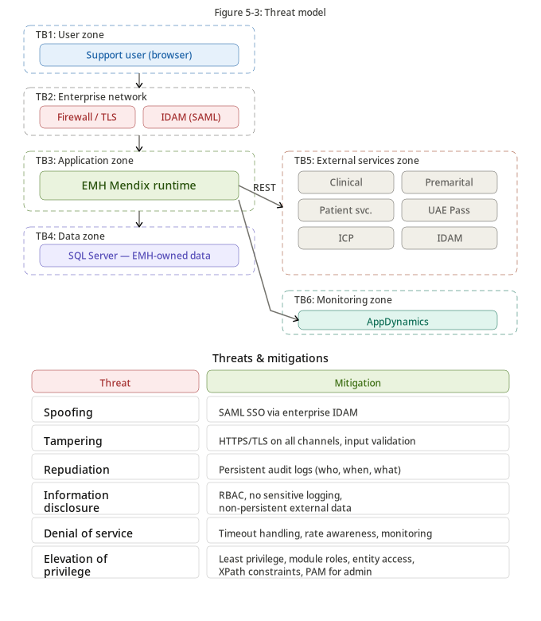
Figure 5-3 – Threat Model
Shows key threats and mitigations for EMH across identity, access control, integration, data protection, logging, monitoring, and operational resilience.
Table 5-17 – Threat Model and Mitigations
Threat | Risk | Mitigation
Unauthorized Access | User accesses module or data outside role. | SAML authentication, RBAC, module roles, page access, microflow security, entity access.
Privilege Misuse | Administrator grants excessive access. | Segregation, audit, approval workflow, periodic access review.
Data Leakage | Sensitive data persisted or logged unintentionally. | Non-persistent design, logging restrictions, sanitization, privacy review.
API Abuse | Unauthorized or excessive API calls. | Authorization before call, rate controls where available, monitoring, source API controls.
Session Hijacking | Compromised session used for access. | TLS, session timeout, secure cookies per platform configuration, IDAM controls.
Integration Failure | Source API outage prevents investigation. | Timeout handling, user-safe messages, exception logs, AppDynamics monitoring.
Configuration Exposure | Endpoint/secrets exposed. | Restricted configuration access, secret handling, audit.
Vulnerable Dependency | Marketplace module or Java dependency vulnerability. | SCA, approval process, patching.

5.12 Privacy by Design
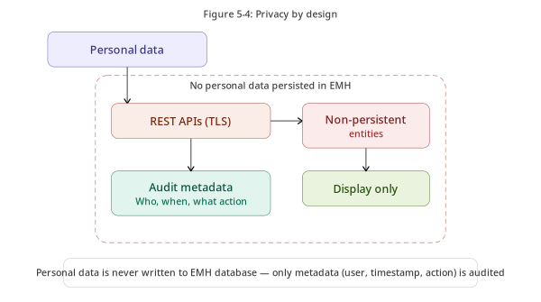
Figure 5-4 – Privacy by Design
Shows the privacy-by-design controls applied to EMH, including minimization, access control, auditability, retention, and external data ownership.

5.12.1 Personal Data Flow
Personal data is retrieved from external Systems of Record only when an authorized support officer performs a permitted search. The data is mapped into Non-Persistent Entities and displayed in EMH. EMH persists only audit metadata and sanitized exception details.

5.12.2 Personal Data Usage
Table 5-18 – Personal Data Usage
Personal Data Type | Usage | Persisted in EMH
User name / email | EMH user administration and audit attribution. | Yes, for EMH user records.
National identity / EID reference | Search and identity verification where approved. | No, unless included only as masked metadata by approved design.
Patient identifiers / MRN | Patient Services search and result display. | No.
Applicant details | Clinical Attachment / Premarital investigation display. | No.
Payment status | Support investigation display. | No.
Audit metadata | Traceability of searches and access events. | Yes.

5.12.3 Third-Party Processing
Table 5-19 – Third-Party Processing
Party / System | Role | Data Handling
Enterprise IDAM | Identity Provider | Authenticates users and provides identity attributes.
UAE Pass | Identity source/provider | Provides identity-related data where applicable.
ICP | External System of Record | Provides applicant/person information.
Clinical Attachment | External System of Record | Provides clinical attachment application and payment status data.
Premarital | External System of Record | Provides premarital application and payment status data.
Patient Services | External System of Record | Provides patient-related service data.
AppDynamics | Monitoring platform | Processes application performance and runtime telemetry according to deployment model.

5.12.4 Security Considerations
- External data persistence is intentionally avoided.
- Access is restricted by authenticated identity and assigned role.
- Search actions are audited for accountability.
- Sensitive payloads shall not be written to logs.
- Encryption applies at rest and in transit according to enterprise standards.
- Integration failures are logged with sanitized technical detail only.

5.12.5 User Privacy Considerations
- Users shall only access data for legitimate support investigation purposes.
- Result screens should display only fields required for investigation.
- Screens should avoid unnecessary exposure of highly confidential data.
- Role design should separate general support access from sensitive module-specific access.
- Audit evidence should support investigation of misuse without unnecessarily storing personal payloads.

6. Implementation & Migration Approach
This chapter defines implementation roadmap, deployment and cut-over strategy, transition architecture, and data migration approach. The strategy is designed to introduce EMH without replacing existing source systems.

6.1 Implementation Roadmap
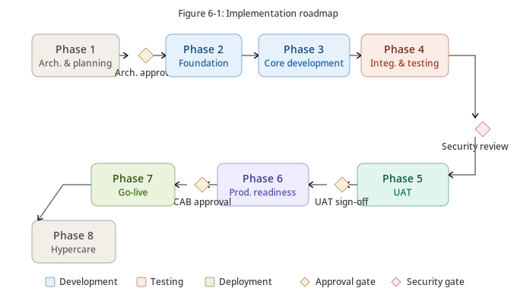
Figure 6-1 – Implementation Roadmap
Shows the phased roadmap for EMH from architecture planning through foundation, core development, integration testing, UAT, production readiness, go-live, and hypercare.
Table 6-1 – Implementation Roadmap
Phase | Description | Key Outputs
Phase 1 – Architecture & Planning | Confirm scope, architecture baseline, risks, assumptions, and delivery approach. | Approved ADD, decision register, high-level backlog, API readiness plan.
Phase 2 – Foundation | Set up Mendix app, security baseline, environments, configuration, and module structure. | Runtime baseline, modules, roles, initial admin functions.
Phase 3 – Core Development | Build user administration, role/permission model, audit, exception, and common components. | Core EMH platform capabilities.
Phase 4 – Module Development | Build Clinical Attachment, Premarital, and Patient Services search/display functions. | Module-specific pages, microflows, entities, and integration flows.
Phase 5 – Integration & Testing | Validate REST APIs, import mappings, error handling, and audit behavior. | Integration test evidence and defect resolution.
Phase 6 – UAT | Business validation with support officers. | UAT sign-off and operational feedback.
Phase 7 – Production Readiness | Security review, monitoring, backup, DR validation, CAB. | Production readiness approval.
Phase 8 – Go-Live & Hypercare | Deploy, validate, monitor, and support early operations. | Go-live confirmation and hypercare closure.

6.1.1 Deployment & Cut-over Strategy
Table 6-2 – Deployment and Cut-over Strategy
Cut-over Activity | Description | Owner
Final Deployment Package | Build and approve production Mendix deployment package. | Development / Release Manager
Environment Configuration | Configure endpoints, constants, SAML metadata, certificates, and monitoring. | Application / Infrastructure / IAM
Database Initialization | Create EMH database schema and seed configuration/roles/permissions. | DBA / Application Team
Security Validation | Confirm SAML, RBAC, entity access, and admin restrictions. | InfoSec / Application Team
Integration Smoke Test | Validate all critical source API connectivity. | Application / Source App Owners
Monitoring Activation | Confirm AppDynamics dashboards and alerts. | Operations
Business Validation | Support officers validate critical search journeys. | Business Owner / UAT Users
Go-Live Approval | CAB/ARB/project approval to go live. | Project Governance
Hypercare | Monitor production behavior and resolve issues. | Application / Operations / Vendors

6.1.2 Transition Architecture
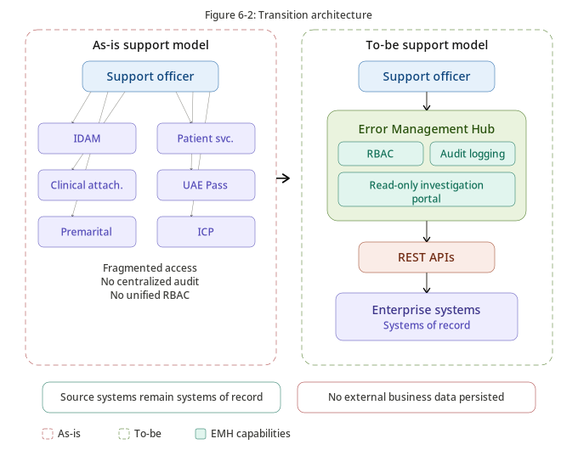
Figure 6-2 – Transition Architecture
Shows the transition from current multi-system support investigation to the target EMH read-only investigation portal while preserving source systems as Systems of Record.
Table 6-3 – Transition Architecture States
State | Description
Current State | Support officers investigate issues using multiple systems, manual coordination, or technical assistance.
Transition State | EMH introduced for selected modules while existing support methods remain available as fallback.
Target State | Support officers use EMH as the preferred unified investigation portal for covered modules.
Future State | Additional modules may be onboarded through the same API-first, non-persistent, read-only pattern subject to scope approval.

6.1.3 Data Migration Approach
Table 6-4 – Data Migration Approach
Migration Area | Approach
Business Data | No migration. External systems remain authoritative.
User Setup | Initial approved support users/admins configured or referenced from IDAM.
Role Setup | Roles configured according to approved business access model.
Permission Setup | Permissions configured for pages, modules, actions, and APIs.
Configuration Setup | Endpoints, constants, timeout values, and monitoring settings configured per environment.
Audit / Exception History | No historical migration unless explicitly required. EMH logs start from go-live.
Validation | Post-migration validation confirms login, access control, search, audit, and exception handling.

Appendix A – Glossary
Table A-1 – Glossary
Term | Definition
Architecture Design Document | Formal document defining the target architecture for a solution.
EMH | Error Management Hub, the Mendix support investigation application.
Mendix | Low-code application development and runtime platform used to implement EMH.
Support Officer | Authorized user who performs support investigations in EMH.
System of Record | Authoritative source system for a data object.
Non-Persistent Entity | Mendix entity used at runtime without persistence.
Persistent Entity | Mendix entity stored in the application database.
Microflow | Mendix server-side logic flow.
Nanoflow | Mendix client-side logic flow where applicable.
Consumed REST Service | Mendix capability to consume REST API endpoints.
Import Mapping | Mendix mapping used to transform JSON/XML response into entities.
SAML | Security Assertion Markup Language used for Single Sign-On.
RBAC | Role-Based Access Control.
AppDynamics | Application performance monitoring platform.

Appendix B – Acronyms
Table B-1 – Acronyms
Acronym | Meaning
ADD | Architecture Design Document
ADR | Architecture Decision Record
API | Application Programming Interface
ARB | Architecture Review Board
BCP | Business Continuity Plan
DAST | Dynamic Application Security Testing
DR | Disaster Recovery
EA | Enterprise Architecture
EMH | Error Management Hub
HA | High Availability
IAM | Identity and Access Management
IDAM | Identity and Access Management
ICP | Federal Authority for Identity, Citizenship, Customs and Port Security
JSON | JavaScript Object Notation
PAM | Privileged Access Management
RBAC | Role-Based Access Control
REST | Representational State Transfer
RPO | Recovery Point Objective
RTO | Recovery Time Objective
SAML | Security Assertion Markup Language
SAST | Static Application Security Testing
SCA | Software Composition Analysis
SDLC | Software Development Life Cycle
SIEM | Security Information and Event Management
SSO | Single Sign-On
TLS | Transport Layer Security
UAT | User Acceptance Testing

Appendix C – References
Table C-1 – References
Reference | Relevance
Dubai Health Enterprise Architecture Standards | Architecture governance and compliance.
Dubai Health Information Security Policies | Security controls and incident management.
Mendix Platform Documentation | Mendix design, runtime, security, integration, and deployment.
OWASP Top 10 | Common web application security risks.
OWASP ASVS | Application security verification standard.
SAML 2.0 Specification | Single Sign-On and identity federation.
REST Architectural Style | API design and integration approach.
JSON Specification | Data interchange format.
NIST Cybersecurity Framework | Cybersecurity control framework.
UAE Personal Data Protection Law | Privacy and personal data governance.

Appendix D – Architecture Decision Records
Table D-1 – Architecture Decision Register
ADR | Decision | Description | Status
ADR-001 | Adopt Mendix Low-Code Platform | EMH shall be implemented using Mendix to accelerate delivery while maintaining enterprise governance, modularity, and maintainability. | Approved
ADR-002 | Deploy On-Premises | EMH shall be deployed within an approved on-premises environment to support data sovereignty, integration control, and government hosting expectations. | Approved
ADR-003 | Use REST APIs for Integration | All external business data access shall be performed through enterprise-approved REST APIs. | Approved
ADR-004 | Prohibit Direct Database Integration | EMH shall not connect directly to external system databases. | Approved
ADR-005 | Use Non-Persistent Entities for External Data | External business data shall be mapped into Mendix Non-Persistent Entities and displayed without persistence. | Approved
ADR-006 | Persist Only EMH-Owned Data | EMH shall persist users, roles, permissions, audit logs, exception logs, and configuration only. | Approved
ADR-007 | Authenticate through Enterprise IDAM | Authentication shall be delegated to Enterprise IDAM using SAML Single Sign-On. | Approved
ADR-008 | Implement RBAC through Mendix Security | Access control shall use Mendix module roles, user roles, page access, microflow security, entity access, and XPath constraints. | Approved
ADR-009 | Use AppDynamics for Monitoring | Application performance and runtime health shall be monitored using AppDynamics. | Approved
ADR-010 | Use Microsoft SQL Server for Persistence | EMH-owned persistent data shall be stored in Microsoft SQL Server. | Approved
ADR-011 | Control Marketplace Modules | Any Mendix Marketplace module shall undergo architecture, security, licensing, and vulnerability review before adoption. | Approved
ADR-012 | Restrict Java Actions | Custom Java Actions shall be used only by exception and shall be subject to secure coding review and approval. | Approved
ADR-013 | Use Mendix Constants for Runtime Configuration | Environment-specific endpoints and configurable values shall be externalized through approved runtime configuration mechanisms. | Approved
ADR-014 | Audit Security-Relevant Activities | User searches, access denied events, configuration changes, role/permission changes, and integration failures shall be audited. | Approved

Appendix E – Architecture Assumptions
Table E-1 – Architecture Assumptions Register
Assumption ID | Assumption | Impact if Invalid
AS-001 | EMH will be deployed within a Dubai Health approved on-premises environment. | Deployment architecture and security controls require revision.
AS-002 | Enterprise IDAM provides SAML authentication services. | Authentication design must be revised.
AS-003 | Enterprise systems expose approved REST APIs for integration. | Integration scope, timeline, or design must be revised.
AS-004 | Microsoft SQL Server is available for EMH persistence. | Persistence technology and deployment design must be revised.
AS-005 | AppDynamics is available for application monitoring and observability. | Monitoring section must be updated to reflect approved alternative.
AS-006 | Marketplace modules require EA and Information Security approval before use. | Governance risk increases if approval process is bypassed.
AS-007 | SAST, SCA, and DAST activities are performed as part of secure SDLC before production deployment. | Security acceptance and release readiness may be delayed.
AS-008 | External business data remains read-only and non-persistent in EMH. | Data architecture, privacy, security, and migration approach must be redesigned.
AS-009 | Audit retention target is one year subject to compliance confirmation. | Retention and storage sizing may change.
AS-010 | RTO/RPO targets require infrastructure and database validation. | DR strategy may require enhancement.

Appendix F – Solution Detailed Design
This appendix provides detailed design baseline information per major business epic. It is intended to support implementation planning and detailed backlog elaboration without changing the architecture defined in the main document.

B.1 Login Sequence
Support officer accesses EMH, is redirected to Enterprise IDAM, authenticates using enterprise credentials, receives SAML assertion, and enters EMH with roles resolved to Mendix permissions.
Table F-1 – B.1 Login Sequence Design Baseline
Design Aspect | Baseline
Actor | Support Officer or EMH Administrator based on function.
Precondition | User is authenticated through IDAM and authorized in EMH.
Primary Flow | Open permitted page, enter search/admin criteria, validate inputs, execute microflow, apply access checks, perform action, audit result.
Data Handling | EMH-owned data may be persisted; external business data remains non-persistent and read-only.
Security | Page, microflow, and entity access controls apply.
Audit | Security-relevant and business-relevant activity is recorded.
Exception Handling | User-safe error messages shown; sanitized technical details logged.

B.2 User Management
Administrators manage EMH user records, role assignments, permission mappings, activation status, and access-related audit evidence.
Table F-2 – B.2 User Management Design Baseline
Design Aspect | Baseline
Actor | Support Officer or EMH Administrator based on function.
Precondition | User is authenticated through IDAM and authorized in EMH.
Primary Flow | Open permitted page, enter search/admin criteria, validate inputs, execute microflow, apply access checks, perform action, audit result.
Data Handling | EMH-owned data may be persisted; external business data remains non-persistent and read-only.
Security | Page, microflow, and entity access controls apply.
Audit | Security-relevant and business-relevant activity is recorded.
Exception Handling | User-safe error messages shown; sanitized technical details logged.

B.3 Clinical Attachment Investigation
Support officer searches clinical attachment application records through approved REST APIs and views non-persistent results without modifying source records.
Table F-3 – B.3 Clinical Attachment Investigation Design Baseline
Design Aspect | Baseline
Actor | Support Officer or EMH Administrator based on function.
Precondition | User is authenticated through IDAM and authorized in EMH.
Primary Flow | Open permitted page, enter search/admin criteria, validate inputs, execute microflow, apply access checks, perform action, audit result.
Data Handling | EMH-owned data may be persisted; external business data remains non-persistent and read-only.
Security | Page, microflow, and entity access controls apply.
Audit | Security-relevant and business-relevant activity is recorded.
Exception Handling | User-safe error messages shown; sanitized technical details logged.

B.4 Premarital Investigation
Support officer searches premarital application records, appointment/status information, and payment status through source APIs.
Table F-4 – B.4 Premarital Investigation Design Baseline
Design Aspect | Baseline
Actor | Support Officer or EMH Administrator based on function.
Precondition | User is authenticated through IDAM and authorized in EMH.
Primary Flow | Open permitted page, enter search/admin criteria, validate inputs, execute microflow, apply access checks, perform action, audit result.
Data Handling | EMH-owned data may be persisted; external business data remains non-persistent and read-only.
Security | Page, microflow, and entity access controls apply.
Audit | Security-relevant and business-relevant activity is recorded.
Exception Handling | User-safe error messages shown; sanitized technical details logged.

B.5 Patient Services Investigation
Support officer searches patient services records such as patient profile, health card, sick leave, and medical report requests through approved APIs.
Table F-5 – B.5 Patient Services Investigation Design Baseline
Design Aspect | Baseline
Actor | Support Officer or EMH Administrator based on function.
Precondition | User is authenticated through IDAM and authorized in EMH.
Primary Flow | Open permitted page, enter search/admin criteria, validate inputs, execute microflow, apply access checks, perform action, audit result.
Data Handling | EMH-owned data may be persisted; external business data remains non-persistent and read-only.
Security | Page, microflow, and entity access controls apply.
Audit | Security-relevant and business-relevant activity is recorded.
Exception Handling | User-safe error messages shown; sanitized technical details logged.

B.6 Audit and Exception Management
EMH records search, access, administration, integration, and exception events in persistent EMH-owned entities.
Table F-6 – B.6 Audit and Exception Management Design Baseline
Design Aspect | Baseline
Actor | Support Officer or EMH Administrator based on function.
Precondition | User is authenticated through IDAM and authorized in EMH.
Primary Flow | Open permitted page, enter search/admin criteria, validate inputs, execute microflow, apply access checks, perform action, audit result.
Data Handling | EMH-owned data may be persisted; external business data remains non-persistent and read-only.
Security | Page, microflow, and entity access controls apply.
Audit | Security-relevant and business-relevant activity is recorded.
Exception Handling | User-safe error messages shown; sanitized technical details logged.

Appendix G – Architecture Plan
Table G-1 – Architecture Plan
Architecture Activity | Purpose | Output
Architecture Baseline | Confirm project context and architecture scope. | Approved baseline and assumptions.
Data Architecture Review | Validate data ownership, persistence, privacy, and retention. | Data architecture approval.
Application Architecture Review | Validate Mendix modules, interfaces, APIs, and environment mapping. | Application architecture approval.
Technical Architecture Review | Validate deployment, runtime, SQL Server, monitoring, backup, and DR dependencies. | Technical architecture approval.
Security Architecture Review | Validate IAM, RBAC, encryption, vulnerability, logging, threat model, and privacy. | Security architecture approval.
ARB Submission | Submit complete ADD for governance approval. | ARB decision and actions.

Appendix H – Architecture Proofs of Concept
Table H-1 – Architecture PoC Register
PoC | Objective | Success Criteria
SAML Authentication PoC | Validate IDAM SAML integration with Mendix. | User can authenticate and role mapping is established.
REST Integration PoC | Validate consumed REST service and import mapping pattern. | API response mapped to Non-Persistent Entity and displayed.
Audit Logging PoC | Validate reusable audit microflow and audit persistence. | Search/admin events stored with required metadata.
Exception Handling PoC | Validate integration timeout/error handling. | User-safe message displayed and sanitized exception logged.
AppDynamics Monitoring PoC | Validate runtime monitoring and dependency visibility. | AppDynamics shows runtime health and integration behavior.
Security Access PoC | Validate module roles, page access, microflow security, entity access. | Unauthorized users cannot access restricted functions.

Appendix I – Requirements Traceability Matrix
Table I-1 – Requirements Traceability Matrix
Requirement / Concern | Architecture Coverage | Evidence / Section
Centralized support investigation | Business purpose, solution summary, application architecture | 1.1, 1.2, 3.1
On-premises deployment | Deployment and technical architecture | 4.1, 4.1.1
Mendix implementation | Technology landscape and runtime architecture | 4.2, 4.3
SAML authentication | Identity flow and IAM | 5.4.1
Role-based access | Access management | 5.4.2
Read-only external data | Data scope and interface design | 2.1, 3.3.1
No direct database access | ADRs and interface design | 1.3, 3.3.1
Non-persistent external data | Data architecture and privacy | 2.1, 5.12
Audit logging | Audit service, logging, security | 3.2, 5.9
Exception logging | Exception service and monitoring | 3.2, 4.4.4
AppDynamics monitoring | Technical architecture and logging | 4.4.4, 5.9
SQL Server persistence | Data and technology architecture | 2.1, 4.2
Privacy by design | Privacy sections and data flow | 5.12
DR expectations | Disaster recovery | 4.4.3
Migration approach | Implementation and migration | 6.1.3

Appendix J – Detailed API Design Catalogue
This appendix expands the high-level API catalogue into detailed interface design baselines. Final endpoint URLs, authentication mechanism, request schemas, and response schemas shall be confirmed with source application owners during detailed interface design. The purpose of this appendix is to ensure that no API design aspect is omitted from the architecture baseline.

J.1 API-001 – IDAM User Profile API
API-001 is part of the EMH read-only integration landscape. It shall be consumed by EMH through Mendix Consumed REST Services. The response shall be mapped into Non-Persistent Entities unless explicitly approved otherwise. EMH shall audit invocation metadata and shall not persist sensitive business payloads.
Table J-1 – API-001 Detailed Design Baseline
Design Area | Baseline Requirement
Provider | IDAM User Profile API
Business Purpose | IDAM
Operation Mode | Synchronous REST request/response.
Data Classification | Confidential
Consumer | Error Management Hub (EMH) Mendix application.
Persistence Rule | Business response data shall not be persisted in EMH.
Authentication / Authorization | Service authentication shall follow enterprise-approved API security pattern. User authorization shall be validated by EMH before invocation.
Request Validation | Mandatory search fields, format validation, length validation, and role eligibility shall be checked before API call.
Response Mapping | Mendix Import Mapping shall map response fields to Non-Persistent Entities for runtime display.
Error Handling | HTTP errors, source error codes, timeout, null response, and schema mismatch shall be handled using standard exception microflows.
Audit Requirement | User, API ID, operation, timestamp, result, source system, and correlation ID shall be recorded.
Logging Restriction | Request and response payloads containing personal, clinical, identity, payment, or highly confidential data shall not be logged.
Performance Consideration | Timeouts and pagination/limits shall be configured according to agreed source API behavior.
Open Design Items | Endpoint URL, method, request schema, response schema, authentication details, timeout, SLA, and owner contacts to be confirmed during detailed interface design.

Expected processing sequence: validate user role; validate search criteria; create/propagate correlation ID; invoke consumed REST service; evaluate HTTP status and source status; import response to Non-Persistent Entity; display authorized fields; write audit metadata; write sanitized exception record if failure occurs.

J.2 API-002 – UAE Pass Identity API
API-002 is part of the EMH read-only integration landscape. It shall be consumed by EMH through Mendix Consumed REST Services. The response shall be mapped into Non-Persistent Entities unless explicitly approved otherwise. EMH shall audit invocation metadata and shall not persist sensitive business payloads.
Table J-2 – API-002 Detailed Design Baseline
Design Area | Baseline Requirement
Provider | UAE Pass Identity API
Business Purpose | UAE Pass
Operation Mode | Synchronous REST request/response.
Data Classification | Highly Confidential
Consumer | Error Management Hub (EMH) Mendix application.
Persistence Rule | Business response data shall not be persisted in EMH.
Authentication / Authorization | Service authentication shall follow enterprise-approved API security pattern. User authorization shall be validated by EMH before invocation.
Request Validation | Mandatory search fields, format validation, length validation, and role eligibility shall be checked before API call.
Response Mapping | Mendix Import Mapping shall map response fields to Non-Persistent Entities for runtime display.
Error Handling | HTTP errors, source error codes, timeout, null response, and schema mismatch shall be handled using standard exception microflows.
Audit Requirement | User, API ID, operation, timestamp, result, source system, and correlation ID shall be recorded.
Logging Restriction | Request and response payloads containing personal, clinical, identity, payment, or highly confidential data shall not be logged.
Performance Consideration | Timeouts and pagination/limits shall be configured according to agreed source API behavior.
Open Design Items | Endpoint URL, method, request schema, response schema, authentication details, timeout, SLA, and owner contacts to be confirmed during detailed interface design.

Expected processing sequence: validate user role; validate search criteria; create/propagate correlation ID; invoke consumed REST service; evaluate HTTP status and source status; import response to Non-Persistent Entity; display authorized fields; write audit metadata; write sanitized exception record if failure occurs.

J.3 API-003 – ICP Person / Applicant API
API-003 is part of the EMH read-only integration landscape. It shall be consumed by EMH through Mendix Consumed REST Services. The response shall be mapped into Non-Persistent Entities unless explicitly approved otherwise. EMH shall audit invocation metadata and shall not persist sensitive business payloads.
Table J-3 – API-003 Detailed Design Baseline
Design Area | Baseline Requirement
Provider | ICP Person / Applicant API
Business Purpose | ICP
Operation Mode | Synchronous REST request/response.
Data Classification | Highly Confidential
Consumer | Error Management Hub (EMH) Mendix application.
Persistence Rule | Business response data shall not be persisted in EMH.
Authentication / Authorization | Service authentication shall follow enterprise-approved API security pattern. User authorization shall be validated by EMH before invocation.
Request Validation | Mandatory search fields, format validation, length validation, and role eligibility shall be checked before API call.
Response Mapping | Mendix Import Mapping shall map response fields to Non-Persistent Entities for runtime display.
Error Handling | HTTP errors, source error codes, timeout, null response, and schema mismatch shall be handled using standard exception microflows.
Audit Requirement | User, API ID, operation, timestamp, result, source system, and correlation ID shall be recorded.
Logging Restriction | Request and response payloads containing personal, clinical, identity, payment, or highly confidential data shall not be logged.
Performance Consideration | Timeouts and pagination/limits shall be configured according to agreed source API behavior.
Open Design Items | Endpoint URL, method, request schema, response schema, authentication details, timeout, SLA, and owner contacts to be confirmed during detailed interface design.

Expected processing sequence: validate user role; validate search criteria; create/propagate correlation ID; invoke consumed REST service; evaluate HTTP status and source status; import response to Non-Persistent Entity; display authorized fields; write audit metadata; write sanitized exception record if failure occurs.

J.4 API-004 – Clinical Attachment Search API
API-004 is part of the EMH read-only integration landscape. It shall be consumed by EMH through Mendix Consumed REST Services. The response shall be mapped into Non-Persistent Entities unless explicitly approved otherwise. EMH shall audit invocation metadata and shall not persist sensitive business payloads.
Table J-4 – API-004 Detailed Design Baseline
Design Area | Baseline Requirement
Provider | Clinical Attachment Search API
Business Purpose | Clinical Attachment
Operation Mode | Synchronous REST request/response.
Data Classification | Highly Confidential
Consumer | Error Management Hub (EMH) Mendix application.
Persistence Rule | Business response data shall not be persisted in EMH.
Authentication / Authorization | Service authentication shall follow enterprise-approved API security pattern. User authorization shall be validated by EMH before invocation.
Request Validation | Mandatory search fields, format validation, length validation, and role eligibility shall be checked before API call.
Response Mapping | Mendix Import Mapping shall map response fields to Non-Persistent Entities for runtime display.
Error Handling | HTTP errors, source error codes, timeout, null response, and schema mismatch shall be handled using standard exception microflows.
Audit Requirement | User, API ID, operation, timestamp, result, source system, and correlation ID shall be recorded.
Logging Restriction | Request and response payloads containing personal, clinical, identity, payment, or highly confidential data shall not be logged.
Performance Consideration | Timeouts and pagination/limits shall be configured according to agreed source API behavior.
Open Design Items | Endpoint URL, method, request schema, response schema, authentication details, timeout, SLA, and owner contacts to be confirmed during detailed interface design.

Expected processing sequence: validate user role; validate search criteria; create/propagate correlation ID; invoke consumed REST service; evaluate HTTP status and source status; import response to Non-Persistent Entity; display authorized fields; write audit metadata; write sanitized exception record if failure occurs.

J.5 API-005 – Clinical Attachment Detail API
API-005 is part of the EMH read-only integration landscape. It shall be consumed by EMH through Mendix Consumed REST Services. The response shall be mapped into Non-Persistent Entities unless explicitly approved otherwise. EMH shall audit invocation metadata and shall not persist sensitive business payloads.
Table J-5 – API-005 Detailed Design Baseline
Design Area | Baseline Requirement
Provider | Clinical Attachment Detail API
Business Purpose | Clinical Attachment
Operation Mode | Synchronous REST request/response.
Data Classification | Highly Confidential
Consumer | Error Management Hub (EMH) Mendix application.
Persistence Rule | Business response data shall not be persisted in EMH.
Authentication / Authorization | Service authentication shall follow enterprise-approved API security pattern. User authorization shall be validated by EMH before invocation.
Request Validation | Mandatory search fields, format validation, length validation, and role eligibility shall be checked before API call.
Response Mapping | Mendix Import Mapping shall map response fields to Non-Persistent Entities for runtime display.
Error Handling | HTTP errors, source error codes, timeout, null response, and schema mismatch shall be handled using standard exception microflows.
Audit Requirement | User, API ID, operation, timestamp, result, source system, and correlation ID shall be recorded.
Logging Restriction | Request and response payloads containing personal, clinical, identity, payment, or highly confidential data shall not be logged.
Performance Consideration | Timeouts and pagination/limits shall be configured according to agreed source API behavior.
Open Design Items | Endpoint URL, method, request schema, response schema, authentication details, timeout, SLA, and owner contacts to be confirmed during detailed interface design.

Expected processing sequence: validate user role; validate search criteria; create/propagate correlation ID; invoke consumed REST service; evaluate HTTP status and source status; import response to Non-Persistent Entity; display authorized fields; write audit metadata; write sanitized exception record if failure occurs.

J.6 API-006 – Clinical Attachment Payment Status API
API-006 is part of the EMH read-only integration landscape. It shall be consumed by EMH through Mendix Consumed REST Services. The response shall be mapped into Non-Persistent Entities unless explicitly approved otherwise. EMH shall audit invocation metadata and shall not persist sensitive business payloads.
Table J-6 – API-006 Detailed Design Baseline
Design Area | Baseline Requirement
Provider | Clinical Attachment Payment Status API
Business Purpose | Clinical Attachment / Payment Source
Operation Mode | Synchronous REST request/response.
Data Classification | Confidential
Consumer | Error Management Hub (EMH) Mendix application.
Persistence Rule | Business response data shall not be persisted in EMH.
Authentication / Authorization | Service authentication shall follow enterprise-approved API security pattern. User authorization shall be validated by EMH before invocation.
Request Validation | Mandatory search fields, format validation, length validation, and role eligibility shall be checked before API call.
Response Mapping | Mendix Import Mapping shall map response fields to Non-Persistent Entities for runtime display.
Error Handling | HTTP errors, source error codes, timeout, null response, and schema mismatch shall be handled using standard exception microflows.
Audit Requirement | User, API ID, operation, timestamp, result, source system, and correlation ID shall be recorded.
Logging Restriction | Request and response payloads containing personal, clinical, identity, payment, or highly confidential data shall not be logged.
Performance Consideration | Timeouts and pagination/limits shall be configured according to agreed source API behavior.
Open Design Items | Endpoint URL, method, request schema, response schema, authentication details, timeout, SLA, and owner contacts to be confirmed during detailed interface design.

Expected processing sequence: validate user role; validate search criteria; create/propagate correlation ID; invoke consumed REST service; evaluate HTTP status and source status; import response to Non-Persistent Entity; display authorized fields; write audit metadata; write sanitized exception record if failure occurs.

J.7 API-007 – Premarital Search API
API-007 is part of the EMH read-only integration landscape. It shall be consumed by EMH through Mendix Consumed REST Services. The response shall be mapped into Non-Persistent Entities unless explicitly approved otherwise. EMH shall audit invocation metadata and shall not persist sensitive business payloads.
Table J-7 – API-007 Detailed Design Baseline
Design Area | Baseline Requirement
Provider | Premarital Search API
Business Purpose | Premarital
Operation Mode | Synchronous REST request/response.
Data Classification | Highly Confidential
Consumer | Error Management Hub (EMH) Mendix application.
Persistence Rule | Business response data shall not be persisted in EMH.
Authentication / Authorization | Service authentication shall follow enterprise-approved API security pattern. User authorization shall be validated by EMH before invocation.
Request Validation | Mandatory search fields, format validation, length validation, and role eligibility shall be checked before API call.
Response Mapping | Mendix Import Mapping shall map response fields to Non-Persistent Entities for runtime display.
Error Handling | HTTP errors, source error codes, timeout, null response, and schema mismatch shall be handled using standard exception microflows.
Audit Requirement | User, API ID, operation, timestamp, result, source system, and correlation ID shall be recorded.
Logging Restriction | Request and response payloads containing personal, clinical, identity, payment, or highly confidential data shall not be logged.
Performance Consideration | Timeouts and pagination/limits shall be configured according to agreed source API behavior.
Open Design Items | Endpoint URL, method, request schema, response schema, authentication details, timeout, SLA, and owner contacts to be confirmed during detailed interface design.

Expected processing sequence: validate user role; validate search criteria; create/propagate correlation ID; invoke consumed REST service; evaluate HTTP status and source status; import response to Non-Persistent Entity; display authorized fields; write audit metadata; write sanitized exception record if failure occurs.

J.8 API-008 – Premarital Detail API
API-008 is part of the EMH read-only integration landscape. It shall be consumed by EMH through Mendix Consumed REST Services. The response shall be mapped into Non-Persistent Entities unless explicitly approved otherwise. EMH shall audit invocation metadata and shall not persist sensitive business payloads.
Table J-8 – API-008 Detailed Design Baseline
Design Area | Baseline Requirement
Provider | Premarital Detail API
Business Purpose | Premarital
Operation Mode | Synchronous REST request/response.
Data Classification | Highly Confidential
Consumer | Error Management Hub (EMH) Mendix application.
Persistence Rule | Business response data shall not be persisted in EMH.
Authentication / Authorization | Service authentication shall follow enterprise-approved API security pattern. User authorization shall be validated by EMH before invocation.
Request Validation | Mandatory search fields, format validation, length validation, and role eligibility shall be checked before API call.
Response Mapping | Mendix Import Mapping shall map response fields to Non-Persistent Entities for runtime display.
Error Handling | HTTP errors, source error codes, timeout, null response, and schema mismatch shall be handled using standard exception microflows.
Audit Requirement | User, API ID, operation, timestamp, result, source system, and correlation ID shall be recorded.
Logging Restriction | Request and response payloads containing personal, clinical, identity, payment, or highly confidential data shall not be logged.
Performance Consideration | Timeouts and pagination/limits shall be configured according to agreed source API behavior.
Open Design Items | Endpoint URL, method, request schema, response schema, authentication details, timeout, SLA, and owner contacts to be confirmed during detailed interface design.

Expected processing sequence: validate user role; validate search criteria; create/propagate correlation ID; invoke consumed REST service; evaluate HTTP status and source status; import response to Non-Persistent Entity; display authorized fields; write audit metadata; write sanitized exception record if failure occurs.

J.9 API-009 – Premarital Payment Status API
API-009 is part of the EMH read-only integration landscape. It shall be consumed by EMH through Mendix Consumed REST Services. The response shall be mapped into Non-Persistent Entities unless explicitly approved otherwise. EMH shall audit invocation metadata and shall not persist sensitive business payloads.
Table J-9 – API-009 Detailed Design Baseline
Design Area | Baseline Requirement
Provider | Premarital Payment Status API
Business Purpose | Premarital / Payment Source
Operation Mode | Synchronous REST request/response.
Data Classification | Confidential
Consumer | Error Management Hub (EMH) Mendix application.
Persistence Rule | Business response data shall not be persisted in EMH.
Authentication / Authorization | Service authentication shall follow enterprise-approved API security pattern. User authorization shall be validated by EMH before invocation.
Request Validation | Mandatory search fields, format validation, length validation, and role eligibility shall be checked before API call.
Response Mapping | Mendix Import Mapping shall map response fields to Non-Persistent Entities for runtime display.
Error Handling | HTTP errors, source error codes, timeout, null response, and schema mismatch shall be handled using standard exception microflows.
Audit Requirement | User, API ID, operation, timestamp, result, source system, and correlation ID shall be recorded.
Logging Restriction | Request and response payloads containing personal, clinical, identity, payment, or highly confidential data shall not be logged.
Performance Consideration | Timeouts and pagination/limits shall be configured according to agreed source API behavior.
Open Design Items | Endpoint URL, method, request schema, response schema, authentication details, timeout, SLA, and owner contacts to be confirmed during detailed interface design.

Expected processing sequence: validate user role; validate search criteria; create/propagate correlation ID; invoke consumed REST service; evaluate HTTP status and source status; import response to Non-Persistent Entity; display authorized fields; write audit metadata; write sanitized exception record if failure occurs.

J.10 API-010 – Patient Profile API
API-010 is part of the EMH read-only integration landscape. It shall be consumed by EMH through Mendix Consumed REST Services. The response shall be mapped into Non-Persistent Entities unless explicitly approved otherwise. EMH shall audit invocation metadata and shall not persist sensitive business payloads.
Table J-10 – API-010 Detailed Design Baseline
Design Area | Baseline Requirement
Provider | Patient Profile API
Business Purpose | Patient Services
Operation Mode | Synchronous REST request/response.
Data Classification | Highly Confidential
Consumer | Error Management Hub (EMH) Mendix application.
Persistence Rule | Business response data shall not be persisted in EMH.
Authentication / Authorization | Service authentication shall follow enterprise-approved API security pattern. User authorization shall be validated by EMH before invocation.
Request Validation | Mandatory search fields, format validation, length validation, and role eligibility shall be checked before API call.
Response Mapping | Mendix Import Mapping shall map response fields to Non-Persistent Entities for runtime display.
Error Handling | HTTP errors, source error codes, timeout, null response, and schema mismatch shall be handled using standard exception microflows.
Audit Requirement | User, API ID, operation, timestamp, result, source system, and correlation ID shall be recorded.
Logging Restriction | Request and response payloads containing personal, clinical, identity, payment, or highly confidential data shall not be logged.
Performance Consideration | Timeouts and pagination/limits shall be configured according to agreed source API behavior.
Open Design Items | Endpoint URL, method, request schema, response schema, authentication details, timeout, SLA, and owner contacts to be confirmed during detailed interface design.

Expected processing sequence: validate user role; validate search criteria; create/propagate correlation ID; invoke consumed REST service; evaluate HTTP status and source status; import response to Non-Persistent Entity; display authorized fields; write audit metadata; write sanitized exception record if failure occurs.

J.11 API-011 – Health Card API
API-011 is part of the EMH read-only integration landscape. It shall be consumed by EMH through Mendix Consumed REST Services. The response shall be mapped into Non-Persistent Entities unless explicitly approved otherwise. EMH shall audit invocation metadata and shall not persist sensitive business payloads.
Table J-11 – API-011 Detailed Design Baseline
Design Area | Baseline Requirement
Provider | Health Card API
Business Purpose | Patient Services
Operation Mode | Synchronous REST request/response.
Data Classification | Highly Confidential
Consumer | Error Management Hub (EMH) Mendix application.
Persistence Rule | Business response data shall not be persisted in EMH.
Authentication / Authorization | Service authentication shall follow enterprise-approved API security pattern. User authorization shall be validated by EMH before invocation.
Request Validation | Mandatory search fields, format validation, length validation, and role eligibility shall be checked before API call.
Response Mapping | Mendix Import Mapping shall map response fields to Non-Persistent Entities for runtime display.
Error Handling | HTTP errors, source error codes, timeout, null response, and schema mismatch shall be handled using standard exception microflows.
Audit Requirement | User, API ID, operation, timestamp, result, source system, and correlation ID shall be recorded.
Logging Restriction | Request and response payloads containing personal, clinical, identity, payment, or highly confidential data shall not be logged.
Performance Consideration | Timeouts and pagination/limits shall be configured according to agreed source API behavior.
Open Design Items | Endpoint URL, method, request schema, response schema, authentication details, timeout, SLA, and owner contacts to be confirmed during detailed interface design.

Expected processing sequence: validate user role; validate search criteria; create/propagate correlation ID; invoke consumed REST service; evaluate HTTP status and source status; import response to Non-Persistent Entity; display authorized fields; write audit metadata; write sanitized exception record if failure occurs.

J.12 API-012 – Sick Leave API
API-012 is part of the EMH read-only integration landscape. It shall be consumed by EMH through Mendix Consumed REST Services. The response shall be mapped into Non-Persistent Entities unless explicitly approved otherwise. EMH shall audit invocation metadata and shall not persist sensitive business payloads.
Table J-12 – API-012 Detailed Design Baseline
Design Area | Baseline Requirement
Provider | Sick Leave API
Business Purpose | Patient Services
Operation Mode | Synchronous REST request/response.
Data Classification | Highly Confidential
Consumer | Error Management Hub (EMH) Mendix application.
Persistence Rule | Business response data shall not be persisted in EMH.
Authentication / Authorization | Service authentication shall follow enterprise-approved API security pattern. User authorization shall be validated by EMH before invocation.
Request Validation | Mandatory search fields, format validation, length validation, and role eligibility shall be checked before API call.
Response Mapping | Mendix Import Mapping shall map response fields to Non-Persistent Entities for runtime display.
Error Handling | HTTP errors, source error codes, timeout, null response, and schema mismatch shall be handled using standard exception microflows.
Audit Requirement | User, API ID, operation, timestamp, result, source system, and correlation ID shall be recorded.
Logging Restriction | Request and response payloads containing personal, clinical, identity, payment, or highly confidential data shall not be logged.
Performance Consideration | Timeouts and pagination/limits shall be configured according to agreed source API behavior.
Open Design Items | Endpoint URL, method, request schema, response schema, authentication details, timeout, SLA, and owner contacts to be confirmed during detailed interface design.

Expected processing sequence: validate user role; validate search criteria; create/propagate correlation ID; invoke consumed REST service; evaluate HTTP status and source status; import response to Non-Persistent Entity; display authorized fields; write audit metadata; write sanitized exception record if failure occurs.

J.13 API-013 – Medical Report API
API-013 is part of the EMH read-only integration landscape. It shall be consumed by EMH through Mendix Consumed REST Services. The response shall be mapped into Non-Persistent Entities unless explicitly approved otherwise. EMH shall audit invocation metadata and shall not persist sensitive business payloads.
Table J-13 – API-013 Detailed Design Baseline
Design Area | Baseline Requirement
Provider | Medical Report API
Business Purpose | Patient Services
Operation Mode | Synchronous REST request/response.
Data Classification | Highly Confidential
Consumer | Error Management Hub (EMH) Mendix application.
Persistence Rule | Business response data shall not be persisted in EMH.
Authentication / Authorization | Service authentication shall follow enterprise-approved API security pattern. User authorization shall be validated by EMH before invocation.
Request Validation | Mandatory search fields, format validation, length validation, and role eligibility shall be checked before API call.
Response Mapping | Mendix Import Mapping shall map response fields to Non-Persistent Entities for runtime display.
Error Handling | HTTP errors, source error codes, timeout, null response, and schema mismatch shall be handled using standard exception microflows.
Audit Requirement | User, API ID, operation, timestamp, result, source system, and correlation ID shall be recorded.
Logging Restriction | Request and response payloads containing personal, clinical, identity, payment, or highly confidential data shall not be logged.
Performance Consideration | Timeouts and pagination/limits shall be configured according to agreed source API behavior.
Open Design Items | Endpoint URL, method, request schema, response schema, authentication details, timeout, SLA, and owner contacts to be confirmed during detailed interface design.

Expected processing sequence: validate user role; validate search criteria; create/propagate correlation ID; invoke consumed REST service; evaluate HTTP status and source status; import response to Non-Persistent Entity; display authorized fields; write audit metadata; write sanitized exception record if failure occurs.

Appendix K – Mendix Microflow and Nanoflow Design Catalogue
This appendix defines the reusable Mendix flow catalogue expected for EMH. Names are indicative and should be aligned to the final project naming convention during implementation.
Table K-1 – Microflow and Nanoflow Catalogue
Module | Flow Name | Purpose | Type | Design Notes
Common | COM_MF_01 | Validate input | Microflow | Server-side logic with audit/error handling where applicable.
Common | COM_MF_02 | Authorize user | Microflow | Server-side logic with audit/error handling where applicable.
Common | COM_MF_03 | Call service | Microflow | Server-side logic with audit/error handling where applicable.
Common | COM_MF_04 | Map response | Microflow | Server-side logic with audit/error handling where applicable.
Common | COM_MF_05 | Audit result | Microflow | Server-side logic with audit/error handling where applicable.
Security | SEC_MF_01 | Validate input | Microflow | Server-side logic with audit/error handling where applicable.
Security | SEC_MF_02 | Authorize user | Microflow | Server-side logic with audit/error handling where applicable.
Security | SEC_MF_03 | Call service | Microflow | Server-side logic with audit/error handling where applicable.
Security | SEC_MF_04 | Map response | Microflow | Server-side logic with audit/error handling where applicable.
Security | SEC_MF_05 | Audit result | Microflow | Server-side logic with audit/error handling where applicable.
Administration | ADM_MF_01 | Validate input | Microflow | Server-side logic with audit/error handling where applicable.
Administration | ADM_MF_02 | Authorize user | Microflow | Server-side logic with audit/error handling where applicable.
Administration | ADM_MF_03 | Call service | Microflow | Server-side logic with audit/error handling where applicable.
Administration | ADM_MF_04 | Map response | Microflow | Server-side logic with audit/error handling where applicable.
Administration | ADM_MF_05 | Audit result | Microflow | Server-side logic with audit/error handling where applicable.
Audit | AUD_MF_01 | Validate input | Microflow | Server-side logic with audit/error handling where applicable.
Audit | AUD_MF_02 | Authorize user | Microflow | Server-side logic with audit/error handling where applicable.
Audit | AUD_MF_03 | Call service | Microflow | Server-side logic with audit/error handling where applicable.
Audit | AUD_MF_04 | Map response | Microflow | Server-side logic with audit/error handling where applicable.
Audit | AUD_MF_05 | Audit result | Microflow | Server-side logic with audit/error handling where applicable.
ExceptionManagement | EXC_MF_01 | Validate input | Microflow | Server-side logic with audit/error handling where applicable.
ExceptionManagement | EXC_MF_02 | Authorize user | Microflow | Server-side logic with audit/error handling where applicable.
ExceptionManagement | EXC_MF_03 | Call service | Microflow | Server-side logic with audit/error handling where applicable.
ExceptionManagement | EXC_MF_04 | Map response | Microflow | Server-side logic with audit/error handling where applicable.
ExceptionManagement | EXC_MF_05 | Audit result | Microflow | Server-side logic with audit/error handling where applicable.
Integration | INT_MF_01 | Validate input | Microflow | Server-side logic with audit/error handling where applicable.
Integration | INT_MF_02 | Authorize user | Microflow | Server-side logic with audit/error handling where applicable.
Integration | INT_MF_03 | Call service | Microflow | Server-side logic with audit/error handling where applicable.
Integration | INT_MF_04 | Map response | Microflow | Server-side logic with audit/error handling where applicable.
Integration | INT_MF_05 | Audit result | Microflow | Server-side logic with audit/error handling where applicable.
ClinicalAttachment | CLI_MF_01 | Validate input | Microflow | Server-side logic with audit/error handling where applicable.
ClinicalAttachment | CLI_MF_02 | Authorize user | Microflow | Server-side logic with audit/error handling where applicable.
ClinicalAttachment | CLI_MF_03 | Call service | Microflow | Server-side logic with audit/error handling where applicable.
ClinicalAttachment | CLI_MF_04 | Map response | Microflow | Server-side logic with audit/error handling where applicable.
ClinicalAttachment | CLI_MF_05 | Audit result | Microflow | Server-side logic with audit/error handling where applicable.
Premarital | PRE_MF_01 | Validate input | Microflow | Server-side logic with audit/error handling where applicable.
Premarital | PRE_MF_02 | Authorize user | Microflow | Server-side logic with audit/error handling where applicable.
Premarital | PRE_MF_03 | Call service | Microflow | Server-side logic with audit/error handling where applicable.
Premarital | PRE_MF_04 | Map response | Microflow | Server-side logic with audit/error handling where applicable.
Premarital | PRE_MF_05 | Audit result | Microflow | Server-side logic with audit/error handling where applicable.
PatientServices | PAT_MF_01 | Validate input | Microflow | Server-side logic with audit/error handling where applicable.
PatientServices | PAT_MF_02 | Authorize user | Microflow | Server-side logic with audit/error handling where applicable.
PatientServices | PAT_MF_03 | Call service | Microflow | Server-side logic with audit/error handling where applicable.
PatientServices | PAT_MF_04 | Map response | Microflow | Server-side logic with audit/error handling where applicable.
PatientServices | PAT_MF_05 | Audit result | Microflow | Server-side logic with audit/error handling where applicable.

Table K-2 – Standard Microflow Patterns
Flow Pattern | Mandatory Steps
Search Execution Microflow | Receive search criteria; validate input; validate role; generate correlation ID; call integration microflow; map non-persistent result; audit success/failure; return result or safe error.
Administration Change Microflow | Validate administrator role; validate submitted change; apply change to EMH-owned entity; write audit log; return confirmation.
Integration Microflow | Resolve endpoint/configuration; prepare request; call Consumed REST Service; handle HTTP/source error; import response; return non-persistent object/list.
Audit Microflow | Receive event metadata; sanitize values; persist AuditLog; avoid business payloads.
Exception Microflow | Receive exception context; sanitize message; persist ExceptionLog; notify/return safe message as appropriate.
Authorization Validation Microflow | Validate user role, module permission, function permission, and optional entity constraints before allowing execution.

Appendix L – Mendix Security Matrix
Table L-1 – Functional Access Matrix
Function / Role | EMH Administrator | Support Officer | Clinical Attachment Support | Premarital Support | Patient Services Support | Audit Viewer | Operations Viewer
Login | Yes | Yes | Yes | Yes | Yes | Yes | No
View dashboard | Yes | Yes | Yes | Yes | Yes | Yes | No
Manage users | Yes | No | No | No | No | No | No
Manage roles | Yes | No | No | No | No | No | No
Manage permissions | Yes | No | No | No | No | No | No
Search Clinical Attachment | Yes | Yes | Yes | No | No | No | No
View Clinical Attachment Details | Yes | Yes | Yes | No | No | No | No
Search Premarital | Yes | Yes | No | Yes | No | No | No
View Premarital Details | Yes | Yes | No | Yes | No | No | No
Search Patient Services | Yes | Yes | No | No | Yes | No | No
View Patient Services Details | Yes | Yes | No | No | Yes | No | No
View audit logs | Yes | No | No | No | No | Yes | No
View exception logs | Yes | No | No | No | No | Read | Read
Update configuration | Yes | No | No | No | No | No | No

Table L-2 – Mendix Security Configuration Checklist
Mendix Security Control | Required Configuration
Project Security Level | Production security shall be enabled before production deployment.
Module Roles | Each module shall define minimum module roles required for page, microflow, and entity access.
User Roles | User roles shall be mapped to module roles according to approved access matrix.
Page Access | Pages shall be accessible only to authorized roles.
Microflow Access | All sensitive microflows shall require explicit allowed roles.
Entity Access | Persistent and non-persistent entities shall have entity access rules defined according to data sensitivity.
XPath Constraints | XPath constraints shall be applied where row-level or context-specific restrictions are required.
Anonymous Users | Anonymous access shall not be enabled for EMH business/admin functions.
Administrator Accounts | Administrator access shall be restricted and audited.
Access Review | Periodic access review shall validate assigned users, roles, and exceptions.

Appendix M – Detailed Operational Runbook Baseline
This appendix provides a baseline operational runbook. It does not replace the formal operations manual, but ensures that architecture-level operational responsibilities are not omitted.
Table M-1 – Operational Runbook Baseline
Operational Scenario | Detection | Initial Response | Escalation
EMH unavailable | AppDynamics availability alert or user report. | Check runtime health, web tier, DB connectivity, and IDAM reachability. | Operations, Infrastructure, Application Support.
Login failure | User report or authentication error. | Check IDAM status, SAML configuration, user status, and role mapping. | IAM Team, Application Support.
External API timeout | ExceptionLog and AppDynamics dependency alert. | Identify source system/API, correlation ID, timestamp, and affected module. | Source Application Owner, Operations.
High response time | AppDynamics transaction latency. | Review API latency, DB performance, payload size, and concurrent usage. | Operations, DBA, Application Team.
Access denied complaint | User report and audit log. | Validate user role, module role, page access, and permission mapping. | EMH Administrator, Business Owner.
Unexpected data mismatch | Business user report. | Confirm source system response; EMH does not correct source data. | Source Application Owner, Data Governance.
Audit log growth | DB monitoring or capacity alert. | Review retention, indexing, archival, and audit volume drivers. | DBA, Application Owner.
Security incident | Security alert, suspicious audit, unauthorized access attempt. | Contain, preserve logs, notify InfoSec, investigate with correlation IDs. | InfoSec, Operations, Application Owner.

Table M-2 – Monitoring Signal Baseline
Monitoring Signal | Suggested Threshold / Trigger | Action
Runtime availability | Runtime unavailable or health check failed. | Raise incident and verify infrastructure/runtime.
API error rate | Repeated failures for a source API within monitoring window. | Notify source application owner and capture correlation details.
API latency | Latency exceeds agreed user experience threshold. | Investigate dependency performance and timeout settings.
Database connectivity | Connection failure or sustained slow DB responses. | Engage DBA and infrastructure support.
Exception volume | Spike in exception records. | Review recent deployments, API changes, configuration changes.
Access denied volume | Spike in access denied events. | Review possible misuse, role mapping issue, or configuration error.
Audit write failures | Audit persistence errors. | Treat as high severity because traceability is impacted.

Appendix N – Test Strategy and Acceptance Evidence
Table N-1 – Test Strategy and Acceptance Evidence
Test Area | Scope | Evidence Required
Unit Testing | Microflows, validation logic, reusable utilities. | Unit test evidence and review notes.
Integration Testing | REST APIs, import mappings, timeout/error scenarios. | API test results, sample sanitized evidence, defects.
Security Testing | SAML, RBAC, page/microflow/entity access, unauthorized attempts. | Security test cases and results.
SAST | Mendix model review and Java Actions if used. | SAST reports/findings.
SCA | Marketplace modules and third-party dependencies. | SCA inventory and vulnerability report.
DAST | Runtime dynamic security testing. | DAST report and remediation evidence.
Performance Testing | Search flows, concurrent users, API latency, audit growth. | Performance report and tuning actions.
UAT | Business support investigation scenarios. | Signed UAT results.
DR / Recovery Test | Restore and redeploy validation. | DR test evidence.
Monitoring Test | AppDynamics visibility and alert routing. | Monitoring validation evidence.

N.Login and Identity Test Scenarios
Table N-Login and Identity – Login and Identity Test Scenarios
Scenario | Expected Result
Valid Login and Identity scenario | Function completes successfully and required audit/monitoring evidence is created.
Unauthorized Login and Identity scenario | Access is denied and access-denied audit event is created where applicable.
Invalid input in Login and Identity | Validation prevents execution and displays user-safe message.
Error path in Login and Identity | Exception is sanitized, logged, and visible to support/operations without sensitive payload.
Performance path in Login and Identity | Function responds within agreed operational expectation or raises monitored dependency concern.

N.User Administration Test Scenarios
Table N-User Administration – User Administration Test Scenarios
Scenario | Expected Result
Valid User Administration scenario | Function completes successfully and required audit/monitoring evidence is created.
Unauthorized User Administration scenario | Access is denied and access-denied audit event is created where applicable.
Invalid input in User Administration | Validation prevents execution and displays user-safe message.
Error path in User Administration | Exception is sanitized, logged, and visible to support/operations without sensitive payload.
Performance path in User Administration | Function responds within agreed operational expectation or raises monitored dependency concern.

N.Role and Permission Management Test Scenarios
Table N-Role and Permission Management – Role and Permission Management Test Scenarios
Scenario | Expected Result
Valid Role and Permission Management scenario | Function completes successfully and required audit/monitoring evidence is created.
Unauthorized Role and Permission Management scenario | Access is denied and access-denied audit event is created where applicable.
Invalid input in Role and Permission Management | Validation prevents execution and displays user-safe message.
Error path in Role and Permission Management | Exception is sanitized, logged, and visible to support/operations without sensitive payload.
Performance path in Role and Permission Management | Function responds within agreed operational expectation or raises monitored dependency concern.

N.Clinical Attachment Search Test Scenarios
Table N-Clinical Attachment Search – Clinical Attachment Search Test Scenarios
Scenario | Expected Result
Valid Clinical Attachment Search scenario | Function completes successfully and required audit/monitoring evidence is created.
Unauthorized Clinical Attachment Search scenario | Access is denied and access-denied audit event is created where applicable.
Invalid input in Clinical Attachment Search | Validation prevents execution and displays user-safe message.
Error path in Clinical Attachment Search | Exception is sanitized, logged, and visible to support/operations without sensitive payload.
Performance path in Clinical Attachment Search | Function responds within agreed operational expectation or raises monitored dependency concern.

N.Premarital Search Test Scenarios
Table N-Premarital Search – Premarital Search Test Scenarios
Scenario | Expected Result
Valid Premarital Search scenario | Function completes successfully and required audit/monitoring evidence is created.
Unauthorized Premarital Search scenario | Access is denied and access-denied audit event is created where applicable.
Invalid input in Premarital Search | Validation prevents execution and displays user-safe message.
Error path in Premarital Search | Exception is sanitized, logged, and visible to support/operations without sensitive payload.
Performance path in Premarital Search | Function responds within agreed operational expectation or raises monitored dependency concern.

N.Patient Services Search Test Scenarios
Table N-Patient Services Search – Patient Services Search Test Scenarios
Scenario | Expected Result
Valid Patient Services Search scenario | Function completes successfully and required audit/monitoring evidence is created.
Unauthorized Patient Services Search scenario | Access is denied and access-denied audit event is created where applicable.
Invalid input in Patient Services Search | Validation prevents execution and displays user-safe message.
Error path in Patient Services Search | Exception is sanitized, logged, and visible to support/operations without sensitive payload.
Performance path in Patient Services Search | Function responds within agreed operational expectation or raises monitored dependency concern.

N.Audit Logging Test Scenarios
Table N-Audit Logging – Audit Logging Test Scenarios
Scenario | Expected Result
Valid Audit Logging scenario | Function completes successfully and required audit/monitoring evidence is created.
Unauthorized Audit Logging scenario | Access is denied and access-denied audit event is created where applicable.
Invalid input in Audit Logging | Validation prevents execution and displays user-safe message.
Error path in Audit Logging | Exception is sanitized, logged, and visible to support/operations without sensitive payload.
Performance path in Audit Logging | Function responds within agreed operational expectation or raises monitored dependency concern.

N.Exception Handling Test Scenarios
Table N-Exception Handling – Exception Handling Test Scenarios
Scenario | Expected Result
Valid Exception Handling scenario | Function completes successfully and required audit/monitoring evidence is created.
Unauthorized Exception Handling scenario | Access is denied and access-denied audit event is created where applicable.
Invalid input in Exception Handling | Validation prevents execution and displays user-safe message.
Error path in Exception Handling | Exception is sanitized, logged, and visible to support/operations without sensitive payload.
Performance path in Exception Handling | Function responds within agreed operational expectation or raises monitored dependency concern.

N.Monitoring Test Scenarios
Table N-Monitoring – Monitoring Test Scenarios
Scenario | Expected Result
Valid Monitoring scenario | Function completes successfully and required audit/monitoring evidence is created.
Unauthorized Monitoring scenario | Access is denied and access-denied audit event is created where applicable.
Invalid input in Monitoring | Validation prevents execution and displays user-safe message.
Error path in Monitoring | Exception is sanitized, logged, and visible to support/operations without sensitive payload.
Performance path in Monitoring | Function responds within agreed operational expectation or raises monitored dependency concern.

N.Privacy and Logging Restrictions Test Scenarios
Table N-Privacy and Logging Restrictions – Privacy and Logging Restrictions Test Scenarios
Scenario | Expected Result
Valid Privacy and Logging Restrictions scenario | Function completes successfully and required audit/monitoring evidence is created.
Unauthorized Privacy and Logging Restrictions scenario | Access is denied and access-denied audit event is created where applicable.
Invalid input in Privacy and Logging Restrictions | Validation prevents execution and displays user-safe message.
Error path in Privacy and Logging Restrictions | Exception is sanitized, logged, and visible to support/operations without sensitive payload.
Performance path in Privacy and Logging Restrictions | Function responds within agreed operational expectation or raises monitored dependency concern.

Appendix O – Configuration and Environment Parameter Catalogue
Table O-1 – Configuration and Environment Parameter Catalogue
Parameter | Purpose | Environment Scope | Access | Notes
IDAM SAML Metadata URL | Environment-specific configuration | Dev/SIT/UAT/Prod | Restricted Administrator | Change audited; no secrets in plain text.
IDAM Entity ID | Environment-specific configuration | Dev/SIT/UAT/Prod | Restricted Administrator | Change audited; no secrets in plain text.
EMH Entity ID | Environment-specific configuration | Dev/SIT/UAT/Prod | Restricted Administrator | Change audited; no secrets in plain text.
Clinical Attachment API Base URL | Environment-specific configuration | Dev/SIT/UAT/Prod | Restricted Administrator | Change audited; no secrets in plain text.
Premarital API Base URL | Environment-specific configuration | Dev/SIT/UAT/Prod | Restricted Administrator | Change audited; no secrets in plain text.
Patient Services API Base URL | Environment-specific configuration | Dev/SIT/UAT/Prod | Restricted Administrator | Change audited; no secrets in plain text.
ICP API Base URL | Environment-specific configuration | Dev/SIT/UAT/Prod | Restricted Administrator | Change audited; no secrets in plain text.
UAE Pass API Base URL | Environment-specific configuration | Dev/SIT/UAT/Prod | Restricted Administrator | Change audited; no secrets in plain text.
Default API Timeout | Environment-specific configuration | Dev/SIT/UAT/Prod | Restricted Administrator | Change audited; no secrets in plain text.
Audit Retention Period | Environment-specific configuration | Dev/SIT/UAT/Prod | Restricted Administrator | Change audited; no secrets in plain text.
Exception Retention Period | Environment-specific configuration | Dev/SIT/UAT/Prod | Restricted Administrator | Change audited; no secrets in plain text.
AppDynamics Application Name | Environment-specific configuration | Dev/SIT/UAT/Prod | Restricted Administrator | Change audited; no secrets in plain text.
AppDynamics Tier Name | Environment-specific configuration | Dev/SIT/UAT/Prod | Restricted Administrator | Change audited; no secrets in plain text.
Feature Toggle: Clinical Attachment | Environment-specific configuration | Dev/SIT/UAT/Prod | Restricted Administrator | Change audited; no secrets in plain text.
Feature Toggle: Premarital | Environment-specific configuration | Dev/SIT/UAT/Prod | Restricted Administrator | Change audited; no secrets in plain text.
Feature Toggle: Patient Services | Environment-specific configuration | Dev/SIT/UAT/Prod | Restricted Administrator | Change audited; no secrets in plain text.

Appendix P – Data Privacy Field Handling Matrix
Table P-1 – Data Privacy Field Handling Matrix
Data Field | Classification | Display in EMH | Persist in EMH | Log Handling | Privacy Treatment
Username | Confidential | Yes | Yes | No, unless masked/approved | Display only to authorized roles and avoid unnecessary exposure.
Email | Confidential | Yes | Yes | No, unless masked/approved | Display only to authorized roles and avoid unnecessary exposure.
Full Name | Confidential | Yes | Yes | No, unless masked/approved | Display only to authorized roles and avoid unnecessary exposure.
Emirates ID / National ID | Highly Confidential | Yes | No | No, unless masked/approved | Display only to authorized roles and avoid unnecessary exposure.
MRN | Highly Confidential | Yes | No | No, unless masked/approved | Display only to authorized roles and avoid unnecessary exposure.
Patient Name | Highly Confidential | Yes | No | No, unless masked/approved | Display only to authorized roles and avoid unnecessary exposure.
Applicant Name | Highly Confidential | Yes | No | No, unless masked/approved | Display only to authorized roles and avoid unnecessary exposure.
Mobile Number | Confidential | Yes | No | No, unless masked/approved | Display only to authorized roles and avoid unnecessary exposure.
Application Number | Confidential | Yes | No | Metadata only | Display only to authorized roles and avoid unnecessary exposure.
Payment Status | Confidential | Yes | No | Metadata only | Display only to authorized roles and avoid unnecessary exposure.
Clinical Details | Highly Confidential | Yes | No | No, unless masked/approved | Display only to authorized roles and avoid unnecessary exposure.
Appointment Details | Confidential | Yes | No | No, unless masked/approved | Display only to authorized roles and avoid unnecessary exposure.
Medical Report Request Details | Highly Confidential | Yes | No | No, unless masked/approved | Display only to authorized roles and avoid unnecessary exposure.
Sick Leave Details | Highly Confidential | Yes | No | No, unless masked/approved | Display only to authorized roles and avoid unnecessary exposure.

Appendix Q – Expanded RAID Register
Table Q-1 – Expanded RAID Register
ID | Type | Description | Treatment | Owner
RAID-EX-001 | Assumption | Expanded governance item 1 covering API readiness, security validation, environment readiness, testing evidence, operational support, or data privacy control. | Track through project governance; assign owner; update before ARB submission and production readiness. | Project / Architecture / Owner TBD
RAID-EX-002 | Issue | Expanded governance item 2 covering API readiness, security validation, environment readiness, testing evidence, operational support, or data privacy control. | Track through project governance; assign owner; update before ARB submission and production readiness. | Project / Architecture / Owner TBD
RAID-EX-003 | Dependency | Expanded governance item 3 covering API readiness, security validation, environment readiness, testing evidence, operational support, or data privacy control. | Track through project governance; assign owner; update before ARB submission and production readiness. | Project / Architecture / Owner TBD
RAID-EX-004 | Risk | Expanded governance item 4 covering API readiness, security validation, environment readiness, testing evidence, operational support, or data privacy control. | Track through project governance; assign owner; update before ARB submission and production readiness. | Project / Architecture / Owner TBD
RAID-EX-005 | Assumption | Expanded governance item 5 covering API readiness, security validation, environment readiness, testing evidence, operational support, or data privacy control. | Track through project governance; assign owner; update before ARB submission and production readiness. | Project / Architecture / Owner TBD
RAID-EX-006 | Issue | Expanded governance item 6 covering API readiness, security validation, environment readiness, testing evidence, operational support, or data privacy control. | Track through project governance; assign owner; update before ARB submission and production readiness. | Project / Architecture / Owner TBD
RAID-EX-007 | Dependency | Expanded governance item 7 covering API readiness, security validation, environment readiness, testing evidence, operational support, or data privacy control. | Track through project governance; assign owner; update before ARB submission and production readiness. | Project / Architecture / Owner TBD
RAID-EX-008 | Risk | Expanded governance item 8 covering API readiness, security validation, environment readiness, testing evidence, operational support, or data privacy control. | Track through project governance; assign owner; update before ARB submission and production readiness. | Project / Architecture / Owner TBD
RAID-EX-009 | Assumption | Expanded governance item 9 covering API readiness, security validation, environment readiness, testing evidence, operational support, or data privacy control. | Track through project governance; assign owner; update before ARB submission and production readiness. | Project / Architecture / Owner TBD
RAID-EX-010 | Issue | Expanded governance item 10 covering API readiness, security validation, environment readiness, testing evidence, operational support, or data privacy control. | Track through project governance; assign owner; update before ARB submission and production readiness. | Project / Architecture / Owner TBD
RAID-EX-011 | Dependency | Expanded governance item 11 covering API readiness, security validation, environment readiness, testing evidence, operational support, or data privacy control. | Track through project governance; assign owner; update before ARB submission and production readiness. | Project / Architecture / Owner TBD
RAID-EX-012 | Risk | Expanded governance item 12 covering API readiness, security validation, environment readiness, testing evidence, operational support, or data privacy control. | Track through project governance; assign owner; update before ARB submission and production readiness. | Project / Architecture / Owner TBD
RAID-EX-013 | Assumption | Expanded governance item 13 covering API readiness, security validation, environment readiness, testing evidence, operational support, or data privacy control. | Track through project governance; assign owner; update before ARB submission and production readiness. | Project / Architecture / Owner TBD
RAID-EX-014 | Issue | Expanded governance item 14 covering API readiness, security validation, environment readiness, testing evidence, operational support, or data privacy control. | Track through project governance; assign owner; update before ARB submission and production readiness. | Project / Architecture / Owner TBD
RAID-EX-015 | Dependency | Expanded governance item 15 covering API readiness, security validation, environment readiness, testing evidence, operational support, or data privacy control. | Track through project governance; assign owner; update before ARB submission and production readiness. | Project / Architecture / Owner TBD
RAID-EX-016 | Risk | Expanded governance item 16 covering API readiness, security validation, environment readiness, testing evidence, operational support, or data privacy control. | Track through project governance; assign owner; update before ARB submission and production readiness. | Project / Architecture / Owner TBD
RAID-EX-017 | Assumption | Expanded governance item 17 covering API readiness, security validation, environment readiness, testing evidence, operational support, or data privacy control. | Track through project governance; assign owner; update before ARB submission and production readiness. | Project / Architecture / Owner TBD
RAID-EX-018 | Issue | Expanded governance item 18 covering API readiness, security validation, environment readiness, testing evidence, operational support, or data privacy control. | Track through project governance; assign owner; update before ARB submission and production readiness. | Project / Architecture / Owner TBD
RAID-EX-019 | Dependency | Expanded governance item 19 covering API readiness, security validation, environment readiness, testing evidence, operational support, or data privacy control. | Track through project governance; assign owner; update before ARB submission and production readiness. | Project / Architecture / Owner TBD
RAID-EX-020 | Risk | Expanded governance item 20 covering API readiness, security validation, environment readiness, testing evidence, operational support, or data privacy control. | Track through project governance; assign owner; update before ARB submission and production readiness. | Project / Architecture / Owner TBD
RAID-EX-021 | Assumption | Expanded governance item 21 covering API readiness, security validation, environment readiness, testing evidence, operational support, or data privacy control. | Track through project governance; assign owner; update before ARB submission and production readiness. | Project / Architecture / Owner TBD
RAID-EX-022 | Issue | Expanded governance item 22 covering API readiness, security validation, environment readiness, testing evidence, operational support, or data privacy control. | Track through project governance; assign owner; update before ARB submission and production readiness. | Project / Architecture / Owner TBD
RAID-EX-023 | Dependency | Expanded governance item 23 covering API readiness, security validation, environment readiness, testing evidence, operational support, or data privacy control. | Track through project governance; assign owner; update before ARB submission and production readiness. | Project / Architecture / Owner TBD
RAID-EX-024 | Risk | Expanded governance item 24 covering API readiness, security validation, environment readiness, testing evidence, operational support, or data privacy control. | Track through project governance; assign owner; update before ARB submission and production readiness. | Project / Architecture / Owner TBD
RAID-EX-025 | Assumption | Expanded governance item 25 covering API readiness, security validation, environment readiness, testing evidence, operational support, or data privacy control. | Track through project governance; assign owner; update before ARB submission and production readiness. | Project / Architecture / Owner TBD
RAID-EX-026 | Issue | Expanded governance item 26 covering API readiness, security validation, environment readiness, testing evidence, operational support, or data privacy control. | Track through project governance; assign owner; update before ARB submission and production readiness. | Project / Architecture / Owner TBD
RAID-EX-027 | Dependency | Expanded governance item 27 covering API readiness, security validation, environment readiness, testing evidence, operational support, or data privacy control. | Track through project governance; assign owner; update before ARB submission and production readiness. | Project / Architecture / Owner TBD
RAID-EX-028 | Risk | Expanded governance item 28 covering API readiness, security validation, environment readiness, testing evidence, operational support, or data privacy control. | Track through project governance; assign owner; update before ARB submission and production readiness. | Project / Architecture / Owner TBD
RAID-EX-029 | Assumption | Expanded governance item 29 covering API readiness, security validation, environment readiness, testing evidence, operational support, or data privacy control. | Track through project governance; assign owner; update before ARB submission and production readiness. | Project / Architecture / Owner TBD
RAID-EX-030 | Issue | Expanded governance item 30 covering API readiness, security validation, environment readiness, testing evidence, operational support, or data privacy control. | Track through project governance; assign owner; update before ARB submission and production readiness. | Project / Architecture / Owner TBD

Appendix R – Chapter-by-Chapter Consistency Checklist
Table R-1 – Consistency Checklist
Consistency Item | Expected Alignment
Mendix terminology | All chapters refer to Mendix Pages, Microflows, Domain Model, Module Roles, Entity Access, Consumed REST Services, Import Mappings, and Non-Persistent Entities.
Deployment model | All chapters consistently state on-premises deployment.
Authentication | All chapters consistently state Enterprise IDAM with SAML SSO.
Authorization | All chapters consistently state RBAC through Mendix security.
Data ownership | All chapters consistently state external systems remain Systems of Record.
Persistence | All chapters consistently state EMH persists only EMH-owned data.
Integration | All chapters consistently state REST APIs and no direct DB integration.
Monitoring | All chapters consistently state AppDynamics and structured logs.
Privacy | All chapters consistently state data minimization and no sensitive payload logging.
Migration | All chapters consistently state no migration of external business data.

