###### 2018-2019 FALL SEMESTER

###### LABORATORY MANUAL

###### Experiment 6

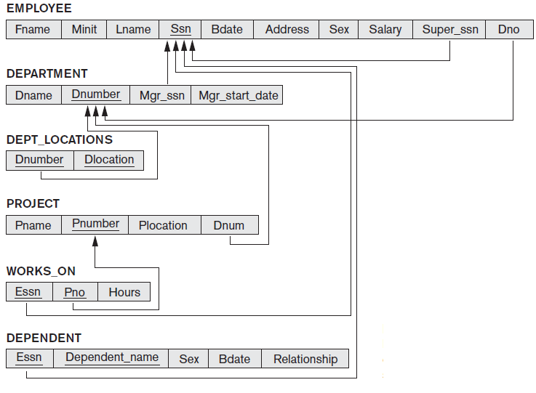

1. Create the tables that given below and insert at least 3 records inside the tables.

2. Write SQL codes for following questions according to tables above.

1. Select the birthdate and address of the employee whose name is ‘Zeynep H Sezgin’
2. Select the names of employees who have no dependents.(Hint: Exist)
3. Select the all employees whose address is in Erzurum, Turkey
4. Select for the each department that has more than 4 employees, retrieve the department number and the number of its employees who are making more than 5082 TL.