IOT Algorithms: Preventing Animal Extinction and challenges

Safal Lamichhane

Department of Computer Science, Southeast Missouri State University

CS 503: Fundamentals of Computing

Instructor’s name: Dr. Wei Dai

November 25, 2021

Contents

Introduction 4

Literature Review 6

The ICS algorithm 7

Routing Algorithm 8

A* search algorithm 8

Efficient Location Privacy Algorithms 10

DLS Algorithm 10

ADLS Algorithm 11

DLP Algorithm 12

Heuristic Algorithm 13

Markov-Prediction Model Algorithm 14

PRISEC Symmetric Key Algorithms 14

Big Data Clustering Algorithm 15

Wild Animal Tracking and Health Monitoring System 20

Challenges 21

Discussion 23

Conclusion 24

References 25

***Abstract-* While we think that IOT is used to make our life luxurious and typically limited to Smart homes, industry, connected cars, there have been new areas that are not so obvious and general. Such areas include Agriculture, Animal Farming, and many more. One of the areas is also wildlife conservation as there are many endangered species in the world in the present context. Some have already been extinct, and some are to be if no further steps are taken. Though some steps are being taken, today the major percentage of wildlife is vulnerable. The major cause is forest destruction for farming and replacing the natural habitat with cities to fulfill our need for settlement land (Kulkarni et al., 2019). Many wild animals are killed by vehicles passing through the wildlife-protected area. Fortunately, IOT has shown some potential to address this issue. Monitoring endangered species problem has been solved with the help of IOT to implement wireless sensor networks (generally in remote and hard to reach areas). There are many technologies like GPS tracking, but they are expensive in comparison to IOT to track and monitor that wildlife. So, this research paper focuses on implementing animal monitoring with the help of IOT along with the technical challenges while implementing systems that monitor animal tracking.**

***Keywords:* Internet of Things, wireless sensor networks, challenges while animal conservation, tracking animals, temperature sensor.**

# Introduction

For the past few years, the utilization of the Internet of Things (IoT) has grown steadily. Wildlife monitoring is one of the trending applications of IoT technologies, where several heterogeneous sensors are deployed to monitor the activities of wild animals dwelling in a remote and geographically large habitat (Choudhary, 2020). Instead of using any physical fences, with the help of IOT we can achieve virtual fences and monitor wildlife.

We can see that the wild animals are on the side of the road. The reason is due to the vehicle passing in speed through the wildlife-protected areas. Even though we say the animals are not hunted down by the poachers there is still danger to the wild animals especially, larger mammals. The system that is included in this research paper is not in a laboratory research prototype but a real-world working system that has been working for years (Choudhary, 2020). The system which we are discussing in this research can monitor the behavior of the wildlife in a much more effective way from using a traditional approach. Not only animals but valuable trees are also being smuggled from the forest which is less available in the market and is expensive. IOT can help prevent smuggling and save wildlife with the help of sensors. We can place PIR (Passive Infrared Sensors) sensors on the areas and monitor the motion which detects motion and send the notification and, SMS alert.

Currently, various IOT technology is being used for monitoring wildlife. IOT has been able to access the real and natural environment of animals. The animals are put into a digital identity card. These cards help to analyze the behavior of animals at the same time to know more about the animals without the presence of any human being. Due to these technologies, researchers can find out the cause of the extinction of other animals by comparing the present animals to the extinct ones. To prevent the extinction of endangered species we can also find out the physical and mental status of such animals through the help of various sensors.

The sensors like accelerometer and gyroscope could be used either as collars or could also be buried under the ground to monitor activities (Ayele et al., 2018). This sensor can work in a remote area with a minimum source of energy. We need proper WMS (Wildlife monitoring Systems) designs that have high energy, good reliability, and low latency. The technologies have been evolved from time to time to make monitoring more efficient, but all have the same motive of saving the wildlife.

# Literature Review

Nowadays, manufacturers want to collect the data of their sold-products to the cloud to conduct analysis and improve the operation, services, and maintenance of the product (Hu et al., 2018). Storing data of sold products in the cloud so that the manufacturers can find the self-contained solutions to data transmissions as the products will be sold on mass and it is not possible to negotiate each building to use the same networks. The solution given by the ISPs will be more costly. So, using a particular algorithm we can reduce the cost five times and eight times for the two cases. The IOT Communication Sharing model(ICS) is a three-tier network.

*Fig 1: ICS model*

## The ICS algorithm

It is unrealistic while finding a globally optimal solution within a polynomial (NP complete).

**Algorithm Minimize Communication Cost, MCC(S, N , S, u, C)** (Hu et al., 2018)

1: Initialize v ← 0,f ← 0, c` ← 0, d ← 0, v~ ← 0

2: v ← init-Upload(S, N , S, u)

3: repeat

4: v~ ← v

5: [c` , d] ← best-Plan(C, v)

6: v ← best-Upload(S, N , S, u, c` , d)

7: until v~ == v

8: f ← compute-Indicator(d)

9: return c, d,f, v

The overall algorithm is an iterative algorithm where,

Purchasing strategy 🡪 c` and d values

Data- upload scheme 🡪 v from which we develop the two different sub-functions which are **best-Upload()** and **best-Plan()**.

The algorithm first calls init-Upload() to initialize Vij € V then it calls best_Plan(): purchasing strategy c and d. Such c and d are then passed to best_Upload() which will adjust the data upload scheme v according to the purchasing strategy. The v will be returned to the best_Plan(). If there is no change in the data upload scheme then the code will be terminated. The algorithm now calls compute_Indicator() to find the values of installed/vacant N- nodes according to d. (if dj>0 then n fj = 1. Otherwise fj = 0)

## Routing Algorithm

Based on ZigBee Technology is another type of algorithm used in IOT (Gang, 2018). The case study is related to the intelligent parking system which is based on the ZigBee wireless network. There are functions of online viewing, parking reservation online, online path planning which helps in urban areas where there are limited parking areas.

## A* search algorithm

It is used in the parking system to find out the shortest path from a specified point to another point in a 2-D grid. This algorithm minimizes the following function:

**f(n)=g(n) + h(n)** where,

**n** is the last node

**g(n)** cost from start node to n node

**h(n)** heuristic function

The implementation of the A* algorithm has two lists. They are OPEN and CLOSED

OPEN- which hasn’t been visited but already been evaluated by the heuristic function

CLOSED- nodes that are already visited

Steps:

1. Start
2. Define a list OPEN
3. If list== empty, Return failure and EXIT
4. Remove node n Where

N is smallest value of OPEN and move it to CLOSED

If node n == goal state Return success and EXIT

1. Expand node n
2. If ( any successor to n is goal node) Return success and trace path from goal node to S

else GOTO step 7

1. For each successor node

Apply f to the node

If node is not in OPEN or CLOSED, add to OPEN

1. GOTO step 3

The Intelligent parking system is also used for the reservation of parking areas and preventing other vehicles to enter into booked parking space. For that preventive measure, Arduino is used to coordinating each hardware work and intime response to any requests.

*Fig 2:Structure diagram of parking lot system using Routing Algorithm and Arduino*

The parking nodes are controlled by a set of vehicle location modules along with detection and control. Whenever there is a change in the status of any vehicle the data will be transmitted to the ZigBee network through the Arduino Controller. The data will be later sent to the serial port of the host computer. When information comes in a host computer, it will broadcast the data to all the vehicle nodes through the ZigBee network. The data will be read by the Arduino controller in the parking lot and judge if it is the target node of information or not. If not discard the information else read control information and control the buzzer(sensor) working there.

As we know that location-based services have been able to help IOT to grow more but there have been some issues related to privacy and the information that is used in the systems can track the users in various ways.

## Efficient Location Privacy Algorithms

The Efficient location privacy algorithms has been divided into three parts (Sun et al., 2017):

* DLS(Dummy Location Selection)
* ADLS(Attack Dummy location Selection)
* DLP( Dummy Location Privacy Preserving)

## DLS Algorithm

The DLS algorithm is used to generate dummy locations for the location privacy of users. If there is a k level of privacy that is required then the algorithm needs to have k-1 locations. DLS works by:

1. determine the degree of anonymity k.
2. read all of the obtained query probabilities and sort the query probabilities of all locations in ascending order.
3. From the list, the algorithm chooses 2k candidate locations, where query probabilities are similar to the real location of the user. In 2k locations, the algorithm randomly selects k-1 locations. Then derives m sets where one location is a real location and others are k-1 selected randomly from 2k locations
4. Finally, the algorithm has to determine an optimal location set with the biggest entropy to effectively achieve k-anonymity for the user.

The computational cost of the DLS algorithm will increase if there is a greater value of randomly selecting the algorithm. We assume that the user is at a particular location say i, and the probabilities of the dummy locations are the same as the user locations, then the LBS server cannot know the user's location. It is due to the equal probability of other dummy locations as the user's real location.

## ADLS Algorithm

In this algorithm, we need to introduce the attack model at first. In the attack model, the dummy location generation algorithm is used to generate dummy locations. So, there will be both users location and dummy location. The goal of this algorithm is to find out the real location of the user. Since there can be a risk of compromisation of the LBS server.

INPUT

**P 🡪** historical query probabilities of all the locations

**R 🡪**  users location information

OUTPUT: The real location of user

Algorithm**[3]:**

1: Sort P and R in ascending order;

2: k ← user’s anonymity degree

3: for (i=1; i ≤ k; i++) do

4: Set Ci ←read one location L from R which isn’t read before;

5: Choose k-1 locations left before and k-1 locations right after location L in the sorted list as candidate location set Di ;

6: for (j=1; j ≤ k; j++) do

7: pmax←max(Ci);

8: pmin ←min(Ci);

9: Find one location from set Di, which is the maximum of the probability set being less than pmin in set Di, denoted as pmin-max ;

10: Find one location from set Di, which is the minimum of the probability set being greater than pmax in set Di, denoted as pmax-min;

11: if H(Ci , pmax-min) > H(Ci , pmin-max ) then

12: Ci ←Ci∪{pmax-min}, Di ← Di \{pmax-min};

13: else

14: Ci ← Ci ∪{pmin-max}, Di← Di \{pmin-max};

15: end

16: end for

17: Sort the elements in Ci in ascending order;

18: return arg min Si

## DLP Algorithm

This algorithm selects the optimal dummy locations considering that there might be some side of exploitation of information through adversary and making choices different for different users. This algorithm is greedy in comparison to the other two. For having k anonymity, we select k-1 locations from all the locations in a map and make sure that the current entropy used is the biggest.

While comparing DLP and DLS in terms of running time and privacy level. The running time of DLS rapidly increases with the increase in the value of K but in DLP there will be little variation in proportion to the increase in value K. The DLP and DLS has the same entropy level. In conclusion, in terms of better performance on the probability of query recognition DLP algorithm is better than DLS

## Heuristic Algorithm

Resource allocation(RA) and optimization deal with mapping between available resources and gateways as IOT infrastructure have multiple resources and gateways (Sangaiah, et al., 2020). The old method to solve this problem is deterministic algorithms and using the heuristic algorithm is another way of solving the RA problem. The heuristic algorithm finds out the best solution to the problem without searching and studying the whole solution.

The main objective of RA is to reduce the communication cost and balancing load. Reducing communication cost leads to less latency and by balancing load, we can eliminate any possible bottleneck problem from the network. Due to the elimination of the bottleneck problem, we are also able to increase the performance of any network. The heuristic algorithm is WOA that is used to solve the RA problem in cloud computing. It is the whale algorithm to find out about the collective hunting of Humpback whales. To reinforce this algorithm they have used the graph clustering method. This method provides an initial solution with better quality enhancing optimization process. From the result of using the graph clustering method and without using that we can see that the graph clustering will have a greater effect whenever there is a larger problem size and vice-versa.

Nowadays, the term location service has been one of the primary services in an automated system of IOT. For that, a localization approach is proposed that uses other relative neighbor signal strengths (Lin et al., 2016). For providing higher accuracy while achieving localization, we can use the Markov-chain model.

## Markov-Prediction Model Algorithm

These systems usually take fingerprints as ARSS values. There will be some challenges while using ARSS like vulnerability to environmental dynamics and limitation to accuracy to radio map. To overcome this issue NR-RSS(Neighbor relative RSS) is built. The Markov-prediction model algorithm is developed in this system to consume less energy and time (Lin, 2016). However, there might be the problem of having accumulator error so NR-RSS match localization needs to be executed to verify the accuracy of this algorithm.

## PRISEC Symmetric Key Algorithms

The symmetric key algorithm discusses strong cryptographic solutions in the growing heterogeneous IOT devices. In the present context, due to the rise of IOT, the number of devices that are connected to a single network has been increasing day by day. The increase of users creates security and privacy issues day by day. There is no proper standard set while using the network.

There is a protocol CoAP that is used for IOT[1]. As we know that the resources in the environment are limited and we must use that resources properly. CoAP is used for that purpose. There are many risks while using remote control execution and attacks on the hardware. So, for that, an outsourced calculation tool is proposed based on the Cloud that helps the users to store and manage their data in a secure manner. A distributed key procedure is proposed to make communication secure in a medical network. For verifying the source of an encrypted message, algorithms were used. The algorithm allows self-adaptive access control which can be used in any condition. There is also another solution by using middleware just like a middleman between two people to make it more secure. The middle is the interface between applications and the devices. The DES algorithm which has a 64bit block size can be called prone to a collision attack. The algorithm performance can be measured in various terms like time, memory, and resource. The result was obtained using the RC6 algorithm but was used in ECB mode to prevent leaking of plaintext.

## Big Data Clustering Algorithm

Clustering algorithms are used to group the data in the same cluster based on similarity. The clustering algorithms are evolving rapidly to meet the Big Data difficulties[2]. There are certain parallel clustering algorithms but they are also not suitable for all the scenarios. By analyzing the clusters we can find a new structure according to the properties of data and classify them. There are many types of clustering algorithms like hierarchical, density-based, centroid-based, grid-based, and so on.

The clustering algorithms can be classified according to the types:

|  |  |
| --- | --- |
| Algorithms | Categories |
| PAM, CLARA | Centroid-based Clustering |
| SCAN, DBSCAN | Density-Based Clustering |
| CURE | Hierarchical Algorithm |
| STING | Grid-based Algorithm |

Table 1: Clustering Algorithms

There are each of the pros and cons of each algorithm while talking in Big Data. The density-based algorithm helps in finding out the different sizes and shapes from the big dataset. Every cluster will be represented according to the set of connected objects. The set of objects are divided according to the boundary, connectivity, and mostly by the density of that particular region. Center-based clustering algorithms find the center part in a cluster that is shown. It helps in reducing the comparisons between objects and medoids in the cluster. Similarly there is grid-based, hierarchical and co-clustering.

Nobrega et al.’s (2018) work display how sheep can be allowed in the cultivated areas without harming them. As we know that to keep the sheep in the vineyard, additional effort is needed. The effort can be monitoring and conditioning the animal location to a fixed area to maintain their feeding. According to that paper, the animal behavior monitoring system works with the help of an IOT device and cloud platform. The system receives the data received from the sensors of the animal, allowing managers to access that data and trigger the alarms when there is some problem (attack from predators, animal panic attack, and so on). There is also the use of machine learning algorithms, and they were tested to show animal posture monitoring use cases. This SheepIT project helps to monitor, controlling, managing herds. According to this system, there are some distinct blocks with has their role. For instance, one block role can be gathering the data and another block role can be processing those gathered data. The environment is connected through wide-band connections (3G, 4G, LTE) to the cloud platform.

While transmission of data, the energy is being consumed at that time. So, opportunistic radio IOT network architecture for WMS (wildlife monitoring system) is important (Ayele et al., 2018). The processed data consumes less energy to transmit than raw data. Various sensors with conventional routing algorithms were used from time to time to increase efficiency. BLE (Bluetooth low energy) is a lightweight and low-power version of Bluetooth technology. LoRa is a low power wide area network modulation technique. Generally, the WMS system uses BLE for the short-range conversation whereas long-range LoRa radio link that to the gateway. So, the WMS is a mixed network that helps to provide the local pre-processing and data sharing among the nodes. The source node is used to generate the data in the BLE network and the sink node to translate and attach the data in the LoRa gateway. With the help of WMS, we don't need to check on animals and systems from time to time.

|  |  |  |  |
| --- | --- | --- | --- |
|  | BLE | LoRa | Proposed WMS  (BLE+ LoRa) |
|  |  | Star of Star | Star of Mesh |
| Topology | Mesh/Star | (LP-WAN) | (LP-WAN) |
| No of nodes | Unlimited | 100000s | Unlimited |
| Max Payload | 30 | 256 | 30(mesh),256 (Lora) |
| Throughput | High(250Kbps) | Low (5.4 kbps) | High |
| Coverage area | Short(<=200m)  (Large with mesh) | Large(<=15km) | Large |
| Network Lifetime | High | Low | High |
|  |  |  |  |

Table 2: Wildlife Monitoring System Guidelines (Ayele et al., 2018)

The device which is placed on the animals and the fields can work for months and years without being attended by any human intervention like maintaining and powering the device due to the lower power consumption. Overall, from the test, we can say that WMS can provide a cheap and promising solution for monitoring and tracking wildlife.

Till now some type of tracking device has been designed. There is no proper solution to the animals which cannot be tracked with wireless networks due to weight restrictions placed on the tracking collar (Kulkarni et al., 2019). This paper proposes to introduce a single wireless network that can track any animals where the factor size will not be any problem. The virtual fencing can be achieved with the help of an RF module. This module will send the alert whenever the animals will try to cross the range of the transmitter.

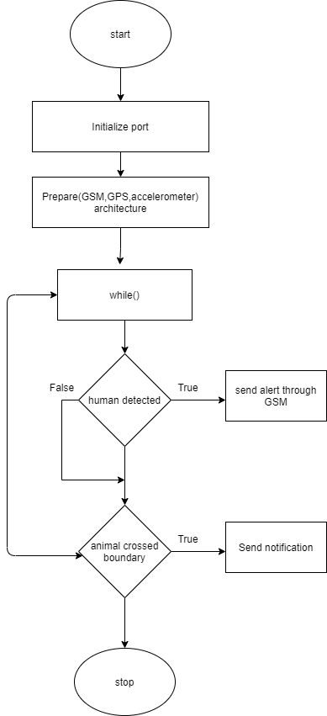

*Fig 3: Flowchart RF module (Animal Health Monitoring & Tracking System)*

In the above figure, the system has two sensors. They are motion and accelerometer sensors. According to this system module, the sensors values will be transferred with the help of GPRS and to the amazon cloud. The main problem of this system is that the GPS works only when there is some movement in the model.

Husain et al. (2019) have proposed a system that uses sensors. The sensors create the data which is constantly monitored. The data is real-time and sends data like humidity, temperature to the computer where it is being monitored. The data which is collected from the sensors will be compared to the basic forest resource data to check any abnormalities. For the temperature sensor, a water pump is activated. RF transmitters are used in the animal body to track and identify. They are the output devices that are activated through a relay switch to sensors. There are 3 types of sensors that are proposed in his system.

1. Tilt sensors (to monitor the trees if they are being cut down)
2. Temperature sensors (to detect forest fire)
3. Sound sensor (to detect the sound of illegal cutting trees as the sound of an axe being used on the tree)

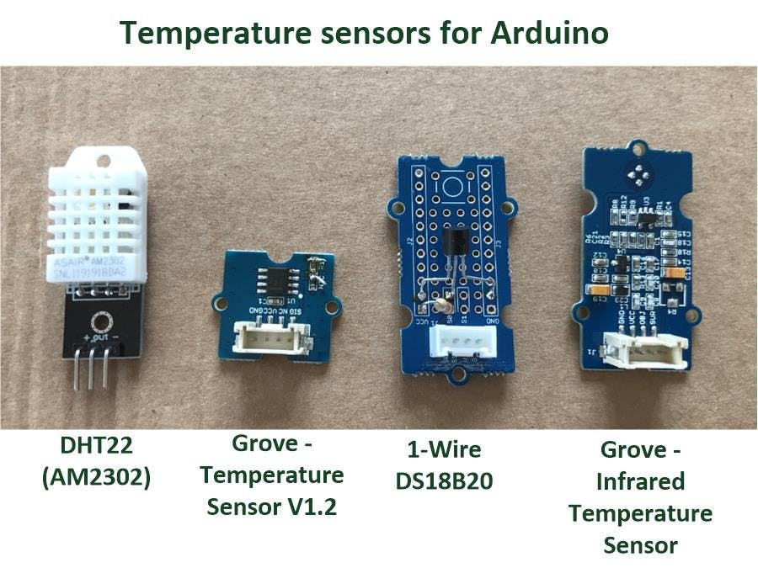

*Fig 4: Temperature Sensors (source:* *shorturl.at/iIOT3)*

# Wild Animal Tracking and Health Monitoring System

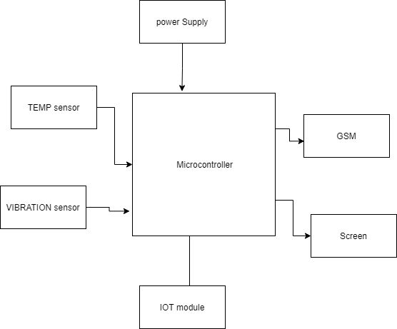

*Fig 5: Block diagram of Sensor nodes (In progress)*

# Challenges

It is not easy to implement the IOT in Wildlife. The environment and the access to those areas make it hard even for implementing something as a technology. The challenges while implementing IOT for wildlife conservation can be discussed into two segments. They are sensing infrastructure and Data Science. This challenge was faced in the Kinabatangan Wildlife Sanctuary (Perera et al., 2019).

|  |  |  |
| --- | --- | --- |
| Sensing Infrastructure |  | Data Science |
|  |  |  |
| Trap Activation Detection |  | Automated camera Trap Image Annotation |
| Poacher Tracking |  | Semantic Data Integration for wildlife |
| Poacher Detection  Data Communication in Terrains  Remote Camera Trap Battery Monitoring |  |  |
|  |  |  |

Table 3: Segments while implementing IOT

As many of the animals are tracked with the help of microchips. On one hand, its demand is getting high in the market but on the other, there is difficulty in getting the hand of them. The manufacturers should create this tracker not too bulky and large but something easy to use too and portable. The tracking technology used in animal collars should be portable too but it should not compromise the tracking accuracy over a long distance. If the collar is huge then it will be impractical to implement them on small animals. The tracker can have health issues and some sort of discomfortable for the small animals. The tracking device should also be durable. As animals' normal lifestyle will be rough and those trackers should withstand such harsh scenarios. The tracker should not also affect the lifestyle of animals.

The tracking software and hardware that these devices use must be fast, reliable, long-lasting. There might be a situation when the animal is lost, and we need to track it within minutes. The location should be accurate at that time too and the tracking location should be within yards not more than that. The precise location has always been a problem while using tracking collars. Also, the animal tracking IOT must have durable battery life. The wildlife is harsh, and it is difficult for someone to go locate and replace the battery of trackers from the animals. The animals don't want to be disturbed too. So, it would be great if the tracker or device battery could be made to last longer without compromising its working principle. Overall, animal monitoring has many challenges while the environment is unpredictable nature and wildlife which is large scale in an area with the uncertainty of animal movement patterns.

# Discussion

The way of using the internet has been changed from what it was back and what it is now. The lost cost of using digital and analog VLSI components in a system makes them easy to use for the IOT. There is always a challenge of maintaining power consumption. There is also the challenge of maintaining the security of any system over the network as it could be misutilized in the context of IOT.

The SVM algorithm is used whenever there is a need for data processing. Clustering algorithms are used to discover the structure of unclassified data. This is achieved by using large data set and finding out similar features and keeping them in one place. Neural networks are also really helpful to solve any data-related problems as there are many hidden layers and the activities are performed through a knowledge base.

Security while transferring data over the internet is cryptography. It is achieved using encryption and decryption. Some will think that AES encryption is better for a certain context whereas others can prefer some lightweight encryption. RC6 can be a good choice for that. There is also the advantage of using machine learning with IOT which has given many advantages in this field. Machine Learning helps in performing better, reducing costs in the long run, and also improving the security of any system by studying previous breaches. In our tracking system, we can use a vibration sensor that can detect the vibration behavior of the machine. There are many types of Vibration sensors that are available, but accelerometer offers more advantages than other sensors. The accelerometer is a sensor that produces the electronic signal directly dependent on the acceleration of the vibrating component where the sensor is attached.

We can utilize modems like GSM and GPS. The purpose of the modems is to receive SMS to the tracker with latitude and longitude which can help to find if the animal is in or out of the boundary. GPS is a satellite-based navigation system to locate the positions anywhere around the earth. GPS receivers will be taking the information from the satellite and triangulation is used to calculate animals’ exact location.

Temperature sensors can also be used in this monitoring system. A wild animal has a core body temperature (CBT) which can indicate its body temperature. We can check any deviation from their normal temperature. The health can be monitored accordingly. The LM35 temperature sensor will be implemented in the research.

# Conclusion

Many of the animals have been gone to extinction, mostly due to human interference with their environment. Some are also on the verge of extinction due to illegal hunting and exploiting the resources of humans. The use of IOT can help prevent more extinction and effective monitoring of the wildlife. We can find that IOT technology has been changing from time to time to help achieve effective monitoring of wild animals and different types of systems are being implemented according to the place and their scenarios.

The system can be able to track the animal's location within a range. It can also detect animal movement. The system can measure the temperature of the animal. The proposed system ensures to provide safety to animals by constant monitoring. The overall motive of this system is to stop the illegal hunting and capturing of wild animals. This system will also help to divert the animals while entering human areas. The work of humans can be minimized. This system can also be implemented in wildlife sanctuaries and Zoos. It can also be used as a tracking system for household pets. While developing and implementing the new IOT system, we should keep in mind the various factors that will be affecting it. For instance, if you are testing the tracking system then we should consider the factors like testing the system in the Wildlife only rather than testing with some prototype in city areas.

We conducted a survey and read a paper on various algorithms that are being implemented in different sectors of IOT. The new technologies will change life in the future. By using AI and automation systems IOT has progressed a lot but there is still a huge milestone to achieve. There are many challenges while achieving something that will help us. Most IOT devices are not used for general purposes but are designed to solve a specific problem. The complexity is increasing due to which many of them are moving beyond a simple computer with programming models.

# References

Ayele E.D., Meratnia, N., & Havinga, P.J.M. (2018). Towards a New Opportunistic IoT Network Architecture for Wildlife Monitoring System, *9th IFIP International Conference on New Technologies, Mobility and Security (NTMS),* 1-5, doi: 10.1109/NTMS.2018.8328721.

Choudhary, R. K. (2020). Internet of Things: Wildlife Conservation and its Challenges. *Asian Journal of Computer Science and Technology, 9*(1), 8–13. https://doi.org/10.51983/ajcst-2020.9.1.2156

Gang, X. (2018). A Routing Algorithm Based on Zigbee Technology. *International Journal of Online Engineering (iJOE). 14*. 90-102. doi: 10.3991/ijoe.v14i11.9515.

Hu, C., Bao, W., & Wang, D. (2018) IoT Communication Sharing: Scenarios, Algorithms and Implementation. *IEEE INFOCOM 2018 - IEEE Conference on Computer Communications*, 1556-1564, doi: 10.1109/INFOCOM.2018.8486329.

Husain, S. S., Vigneshwaran, K., & Kaveya, S. (2019). Design and Implementation of Forest Monitoring System using IOT, *IJARCCE*, *8*(5). <https://doi.org/10.1a148/IJARCCE.2019.8527>

Kulkarni, S., SK, S., DN, S., Sastry, V., & AR, V. (2019). IoT – Wildlife Monitoring, Virtual Fencing with Deforestation Notifications. *IRJET, 6*(2), 1837-1840. https://www.irjet.net/archives/V6/i2/IRJET-V6I2362.pdf

Lin, K., Chen, M., Deng, J., Hassan, M. M., & Fortino, G. (2016). Enhanced Fingerprinting and Trajectory Prediction for IoT Localization in Smart Buildings, *IEEE Transactions on Automation Science and Engineering*, *13*(3), 1294-1307, doi: 10.1109/TASE.2016.2543242.

Nobrega, L., Tavares, A., Cardoso, A., & Goncalves, P. (2018). Animal monitoring based on IoT technologies, *IoT Vertical and Topical Summit on Agriculture - Tuscany (IOT Tuscany)*, 1-5, doi: 10.1109/IOT-TUSCANY.2018.8373045.

Perera, C., Rana, O., Goossens, B., & Wengel, P. O. (2019), Internet of Things for Efficient Wildlife Conservation: Challenges and Opportunities. *GCRF Facilitation Grant Report.* <https://orca.cardiff.ac.uk/134097/1/FinalReportGCRFFacilitationFund.pdf>

Sangaiah, A.K., Hosseinabadi, A.A.R., Shareh, M.B., Bozorgi Rad, S.Y., Zolfagharian, A., Chilamkurti, N. (2020). IoT Resource Allocation and Optimization Based on Heuristic Algorithm. *Sensors*. *20*(2) 539, doi: 10.3390/s20020539

Sun, G., Chang, V., Ramachandran, M., Sun, Z., Li, G., Yu, H., & Liao, D. (2017).

Efficient location privacy algorithm for Internet of Things (IoT) services and applications,

*Journal of Network and Computer Applications, 89*, 3-13. doi: 10.1016/j.jnca.2016.10.011

1. <https://pdfs.semanticscholar.org/08ce/490910737539a405005237d8b632e3fe387c.pdf?_ga=2.139503283.1687044075.1638314883-716482672.1638314883>
2. Bangui, Hind & Ge, Mouzhi & Buhnova, Barbora. (2018). Exploring Big Data Clustering Algorithms for Internet of Things Applications. 269-276. 10.5220/0006773402690276