**Set filter**

**Click on Apply a display filter to set filter**

**Fields rearrange**

**Right click on field then**

**Click on colum preferences**

**Click and add fields that you want, we added source port field**

**TCP Stream**

**Click on particular TCP packet**

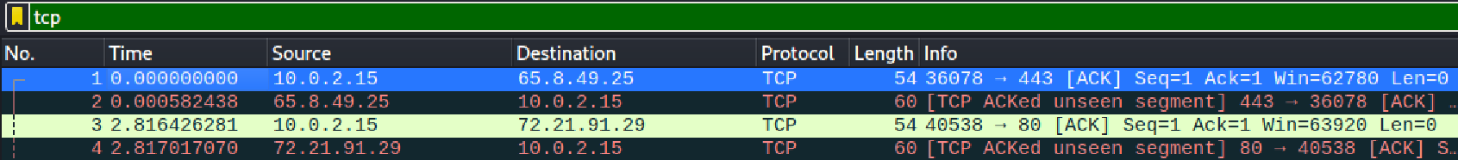

**Goto conversation filter**

**Select TCP**

**The best way is to use follow and use TCP stream**

**Decoded as**

**You can just click ctrl+shift + u or right click and select decode as**

**OR goto Analyze and then decode as**

**Analyze HTTP traffic**

**Generally we select the fourth HTTP packet which Is labelled GET but we can analyze any HTTP traffic**

**Open HTTP**

Observe the GET request, Host, Connection, User-Agent, Referrer, Accept, and Cookie fields. This information is passed to the HTTP server with the GET request.

Observe the traffic captured

Select the fifth packet, labeled **TCP ACK**. This is the server TCP acknowledgement of receiving the GET request.