Software Engineering Lab
Lab 2- Agile Model
Crop Yield Prediction
23BCE1234
Safal Goyal
Overview of the Agile Approach
The Agile model is an iterative and incremental development methodology that emphasizes continuous improvement, frequent feedback, and flexibility.
In this crop yield prediction project, Agile is used to progressively refine data understanding, machine learning models, and insights through multiple sprints rather than building the entire system in one step.

Agile Sprint Cycle
The project is divided into five iterative sprints, each focusing on a specific phase of the ML pipeline.
Sprint 1 – Data Understanding & EDA
- Analyze dataset structure and attributes
- Perform Exploratory Data Analysis (EDA)
- Identify patterns, trends, missing values, and outliers
- Understand relationships between soil, climate, and crop yield
Outcome: Clear understanding of the dataset and key influencing factors.
Sprint 2 – Data Preprocessing & Feature Engineering
- Handle missing values
- Remove outliers using IQR method
- Encode categorical variables
- Scale numerical features
- Prepare final training dataset
Outcome: Clean, structured, and model-ready dataset.
Sprint 3 – Model Building & Training
- Train multiple regression models:
  - Linear, Ridge, Lasso, ElasticNet
  - Decision Tree, Random Forest
  - Gradient Boosting, SVR, KNN
  - XGBoost
- Compare baseline and advanced models
Outcome: Trained models ready for evaluation.
Sprint 4 – Model Evaluation & Optimization
- Evaluate models using:
  - R² Score
  - MAE
  - RMSE
- Tune hyperparameters for better performance
- Compare results across models
Outcome: Identification of the most accurate and reliable model.
Sprint 5 – Model Interpretation & Insights
- Analyze feature importance
- Plot actual vs predicted yield values
- Derive agricultural insights from results
Outcome: Explainable model with actionable insights for farmers and policymakers.
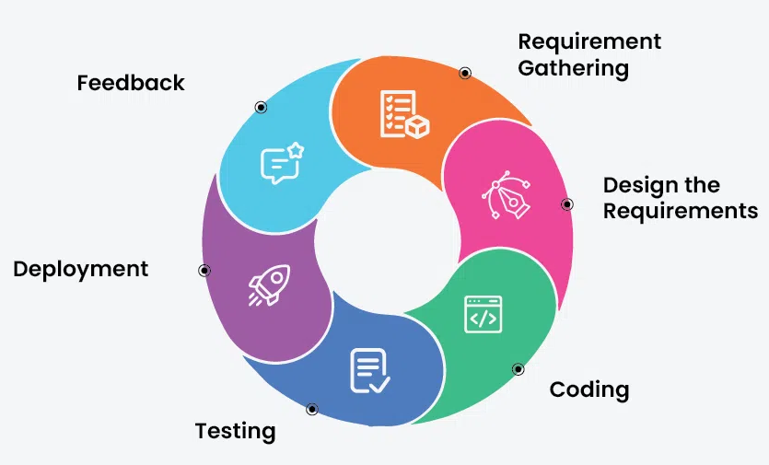

Agile Ceremonies
The Agile workflow includes standard ceremonies to maintain efficiency:
- Sprint Planning: Select tasks from the backlog for each sprint
- Daily Stand-up: Monitor progress and resolve issues
- Sprint Review: Evaluate sprint outcomes and model performance
- Sprint Retrospective: Identify improvements for the next sprint
Continuous Feedback Loop
After every Sprint Review, feedback is incorporated back into the Product Backlog.
This allows:
- Refinement of features
- Model improvements
- Adjustment of strategies based on results
This feedback loop ensures continuous learning and optimization.

Advantages of Using Agile for This ML Project
- Supports experimentation and model tuning
- Adapts easily to changing data and insights
- Improves model accuracy through iteration
- Enhances collaboration and transparency
- Produces explainable and reliable results

