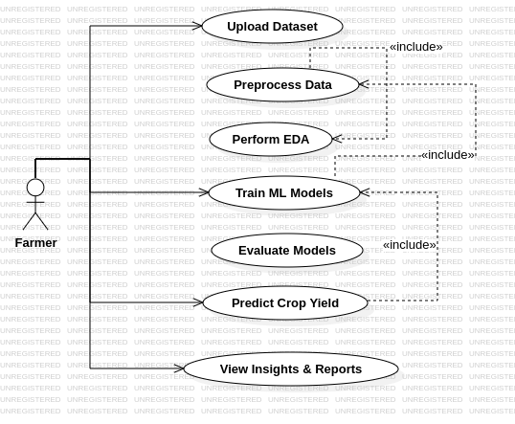
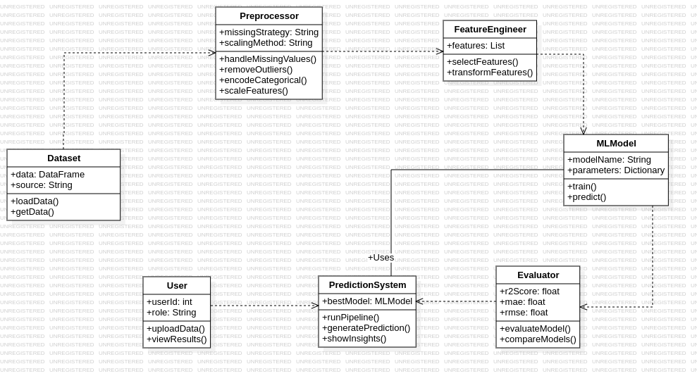
LAB-3
UML Diagram(Star UML)
23BCE1234
Safal Goyal
Use-Case Diagram:

Class Diagram:

