LAB-1
Architecture and Requirements
23BCE1234
Safal Goyal
Architecture:
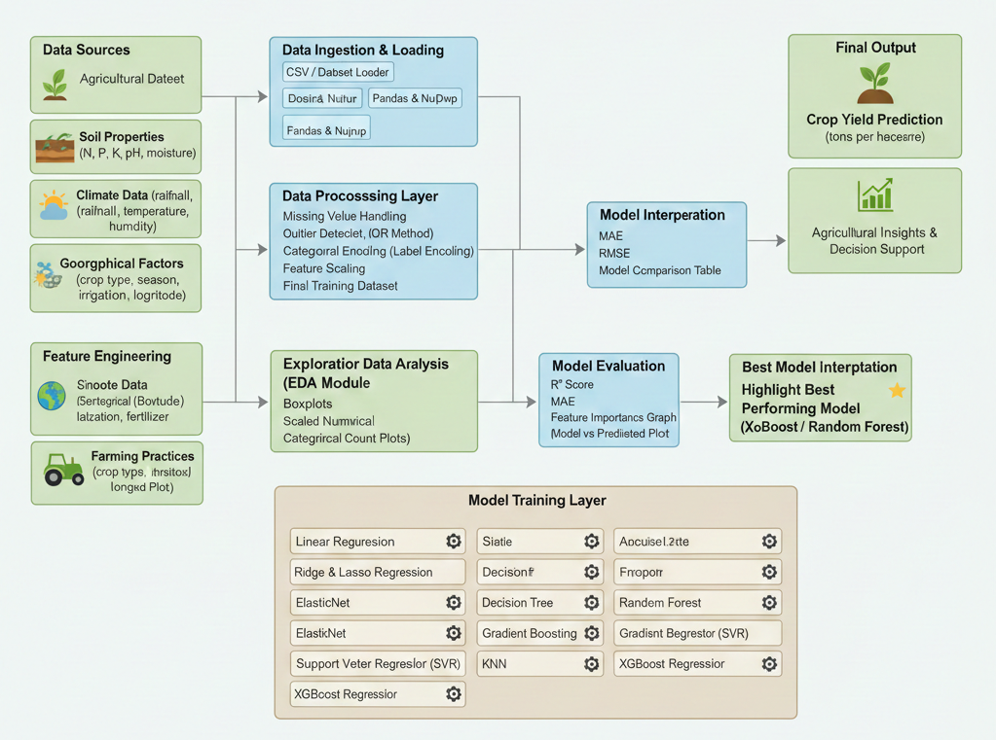

Requirements:

1.Functional Requirements

FR1: Data Loading
- The system shall load agricultural data from CSV files.
- The dataset shall include soil, climate, geographical, and farming practice features.

FR2: Data Preprocessing
- The system shall identify numerical and categorical features.
- The system shall handle missing values using statistical methods.
- The system shall detect and remove outliers using the IQR method.
- The system shall encode categorical variables using Label Encoding.
- The system shall scale numerical features using Min-Max Scaling.

FR3: Exploratory Data Analysis (EDA)
- The system shall generate histograms and KDE plots for numerical features.
- The system shall display boxplots for outlier analysis.
- The system shall generate correlation heatmaps.
- The system shall visualize categorical feature distributions.

FR4: Feature Engineering
- The system shall create encoded and scaled feature sets.
- The system shall prepare the final dataset for model training.

FR5: Model Training
- The system shall split the dataset into training and testing sets.
- The system shall train multiple regression models:
  - Linear Regression
  - Ridge Regression
  - Lasso Regression
  - ElasticNet
  - Decision Tree Regressor
  - Random Forest Regressor
  - Gradient Boosting Regressor
  - Support Vector Regressor (SVR)
  - KNN Regressor
  - XGBoost Regressor

FR6: Model Evaluation
- The system shall evaluate each model using:
  - R² Score
  - Mean Absolute Error (MAE)
  - Root Mean Squared Error (RMSE)
- The system shall compare model performances in a tabular format.

FR7: Best Model Selection
- The system shall identify the best-performing model based on evaluation metrics.

FR8: Model Interpretation
- The system shall generate feature importance plots for the best model.
- The system shall plot actual vs predicted crop yield values.

FR9: Crop Yield Prediction
- The system shall predict crop yield in tons per hectare.
- The system shall provide agricultural insights based on model results.

2.Non-Functional Requirements
These describe how well the system should perform.

NFR1: Performance
- The system shall process datasets efficiently within acceptable execution time.
- Model training and evaluation shall be optimized for moderate-sized datasets.

NFR2: Scalability
- The system shall support the addition of new agricultural features.
- The system shall allow integration of larger datasets in the future.

NFR3: Accuracy & Reliability
- The system shall provide consistent and reproducible predictions.
- The system shall minimize prediction error using advanced regression models.

NFR4: Usability
- The system shall present results through clear visualizations.
- The system shall be easy to understand for students and researchers.

NFR5: Maintainability
- The system shall be modular and easy to extend with new models.
- Code structure shall follow standard Python coding practices.

NFR6: Portability
- The system shall run on Windows, Linux, and macOS platforms.

3.Hardware Requirements
Component | Requirement
Processor | Intel i3 or above
RAM | Minimum 8 GB
Storage | 10 GB free space
GPU | Optional (for faster training)

4. Software Requirements
Software | Requirement
Operating System | Windows / Linux / macOS
Programming Language | Python 3.8+
IDE / Notebook | Jupyter Notebook / VS Code
Libraries | Pandas, NumPy, Matplotlib, Seaborn
ML Framework | Scikit-learn
Advanced ML | XGBoost
Version Control | Git (optional)

5.Dataset Requirements
- Agricultural dataset in CSV format
- Contains soil, climate, geographic, and farming features
- Includes target variable:
Crop_Yield_ton_per_hectare

6.Constraints
- Dataset size may limit

