Lab-6
Al-Powered Crop Yield Prediction and Optimization
23BCE1234
Safal Goyal
Problem Statement :-
Description :-
Develop an AI-based platform to predict crop yields using historical agricultural data, weather patterns, and soil health metrics. The system should provide actionable recommendations for farmers to optimize irrigation, fertilization, and pest control, tailored to specific crops and regional conditions.
Expected Outcome
A scalable software solution (web/mobile app) that helps small-scale farmers increase productivity by at least 10% through data-driven insights, with an interface supporting regional languages for accessibility.
Technical Feasibility
Utilizes machine learning models (e.g., regression, neural networks) trained on open-source agricultural datasets, integrated with APIs for real-time weather and soil data.

Objectives :-
The main objectives of this project are:
- To understand the dataset through statistical analysis and visualization
- To explore relationships between soil, climate, and yield
- To handle outliers, categorical variables, and feature scaling
- To build and evaluate 7-8 regression models
- To identify the best-performing model
- To analyze feature importance affecting crop yield

Approach :-
- Problem Definition
Define crop yield prediction as a supervised regression problem where the target variable is crop yield (tons per hectare).
- Data Collection
Collect agricultural dataset containing soil nutrients (N, P, K, pH), weather data (temperature, rainfall, humidity), geographical information, and farming practices.
- Data Preprocessing
Handle missing values, remove outliers using the IQR method, encode categorical variables, and apply feature scaling (Min-Max Scaling).
- Exploratory Data Analysis (EDA)
Perform statistical analysis and visualizations such as histograms, boxplots, and correlation heatmaps to understand feature relationships.
- Feature Engineering
Select relevant features and transform data to improve model performance and prepare the final training dataset.
- Train-Test Split
Split the dataset into training and testing sets (e.g., 80% training, 20% testing) to ensure unbiased evaluation.
- Model Development
Train multiple regression models including Linear Regression, Decision Tree, Random Forest, SVR, and XGBoost.
- Model Evaluation & Optimization
Evaluate models using R² Score, MAE, and RMSE. Perform hyperparameter tuning to improve accuracy.
- Prediction & Insights Generation
Select the best-performing model to predict crop yield and analyze feature importance to generate agricultural insights.
⁠Work Completed:-
Model Training and Performance Evaluation
In this phase of the project, multiple regression models were implemented and evaluated to predict the target variable accurately. The objective was to compare different machine learning algorithms and identify the best-performing model based on standard evaluation metrics.
Models Implemented
The following regression models were trained:
- Linear Regression
- Decision Tree Regressor
- Random Forest Regressor
- Gradient Boosting Regressor
Each model was trained using the same training dataset to ensure a fair comparison.
Performance Metrics Used
To evaluate the models, three key metrics were calculated:
- MAE (Mean Absolute Error)
Measures the average absolute difference between predicted and actual values.
Lower MAE indicates better performance.
- MSE (Mean Squared Error)
Measures the average squared difference between predicted and actual values.
Lower MSE indicates fewer large errors.
- R² Score (Coefficient of Determination)
Indicates how well the model explains the variance in the data.
Values closer to 1 indicate better performance.
Model Comparison Process
- All evaluation metrics were stored in a dictionary.
- The dictionary was converted into a Pandas DataFrame.
- The results were sorted in descending order based on the R² Score for better comparison.
- A summary table was generated to clearly display model performance.
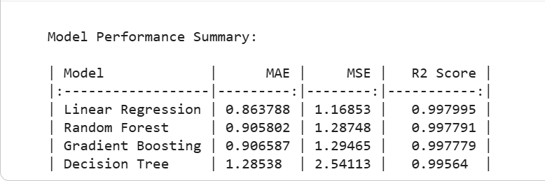

Colab Link:- https://colab.research.google.com/drive/1Z-D8z6meaJvFNHqX7VCKoSWhPCtYOWdV?usp=sharing

