Crop Yield Prediction Using Machine Learning Regression Models: An Exploratory Data Analysis and Comparative Study
Safal Goyal
School of Computer Science and Engineering, Vellore Institute of Technology, Chennai, India¹

Abstract – Agriculture provides the most important aspect of food security and also a significant contributor to global economic growth via exports. Therefore, estimating crop yields is one of the most important issues facing modern agriculture. The objective of this project is to create a machine learning model using many different types of agricultural data such as climatic data (temperatures, precipitation, and humidity), environmental data (type of crop grown, soil conditions, etc.) and geographic data to make predictions about crop yields per hectare in metric tonnes. The data set for this project contains twenty different features of crops including soil nutrients (e.g., nitrogen, phosphorus, and potassium), rainfall, temperature, humidity, soil type, irrigation methods, crop type, regions, Tyson, and growing season. The approach to the project is a structured framework. Initial investigations include exploratory data analysis (EDA) on the data set, statistical functions to summarize properties of data, outlier detection followed by the deletion of outliers based on the interquartile range (IQ) method, examination of the normality of the data, examination of the correlation between features of the data, conversion of nominal features into ordinal features using label encoding, and normalization of the numerical features using a min-max scaling method. There will be 10 predictive linear regression models developed.Project was carried out utilizing the following modelling techniques linear regression, ridge regression, lasso regression, elastic net regression, decision tree regression, random forest etc. Each of the three metrics used to assess performance of each model will provide a reliable and fair methodology to evaluate performance for each of the purposes stated above, R2 score, MAE and RMSE. Based on the analysis of model performance through the metrics mentioned above, this study determined that ensemble and boosting-based models such as xgboost and random forest have higher r^2 scores and lower error rates than non-ensemble or non-boosting models. We determined through feature engineering that major features which determine crop yield are soil nutrient levels, rainfall amount and average temperature. This study's findings will give farmers and planners critical guidance that can improve crop production.
Keywords – Crop yield prediction,Machine learning,Regression
Analysis,Agriculture Data Mining,Supervised Learning

I. INTRODUCTION
1.1 Background
Agriculture has played an important role in shaping today’s global civilization for at least 10 thousand years. Together we have created an unprecedented amount of growth and advancement. However, with an increasing world’s population that will reach approximately 10 billion by the year 2050, increasing the agricultural industry’s ability to meet the ever-demanding needs of food production will take even more than just getting increased output through the agricultural industry; it will also take farmers being even more productive than ever before. While there have been many technological advancements within the field of agriculture throughout the years; all these variables make it difficult to predict how much crop yield will actually be produced.
The traditional methods employed to estimate crop yield rely mainly on the experience and observation of farmers. Even though this approach has worked well over the course of time, this method is not only inaccurate but also time-consuming, as the amount of data being generated from the farming sector is too vast. There is a growing need to find more efficient solutions that can not only estimate crop yield but can also be more accurate.
1.2 Role of Machine Learning in Agriculture
The development of Machine Learning (ML) has introduced a new technology in the field of agricultural science. ML can learn from past knowledge and make accurate predictions, even in highly complex and changing environment. Machine Learning (ML) is being used in agriculture to predict crop diseases, predict weather patterns, analyze soil quality, monitor irrigation, and estimate crop yields. Using ML regression algorithms, it is easy way to predict the expected yield of crops while taking into consideration various weighted factors. For example, several of the input variables at play in the ML regression equation could include soil nutrients, rainfall levels, temperature, and farming practices, while the single output variable is the expected yield of the crop based on these variables. Unlike other regression algorithms, ML can handle a large amount of data and can improve the accuracy of the model as more data is introduced.
1.3 Problem Statement
In spite of the fact that there is a wealth of agricultural data that includes information regarding soil, climatic conditions, geographical regions, and farming practices, there is a lack of comprehensive research that compares a number of machine learning regression algorithms for predicting crop yields.
The project aims to provide answers to the following questions:
• Which regression model is the most effective for predicting crop yields using agricultural and environmental factors?
• What factors influence crop yields per hectare?
• How do ensemble models compare to linear and distance models for agricultural problems?
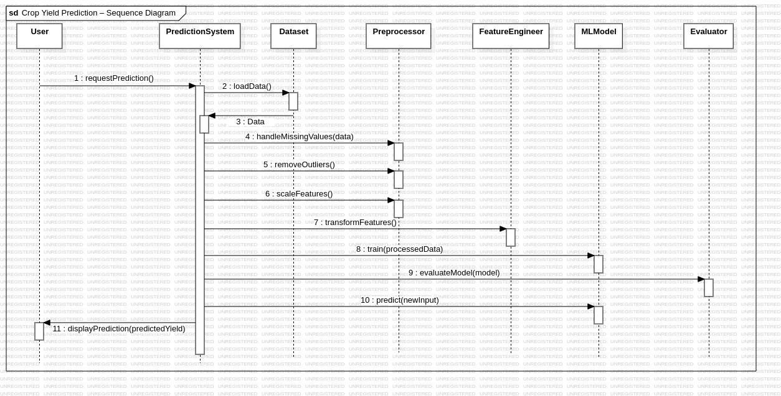
• Can we really use machine learning to provide useful insights into farming?
1.4 Objectives of the Study
The main objectives of this study project include:
1. Performing a EDA on the agriculture dataset.
2. Preprocessing the dataset appropriately.
3. Creating and training ten different regression models that include a variety of linear tree-based and ensemble methods, as well as using kernel regression and boosting regression methods.
4. Evaluating each of the models using the following metrics: R² Score, mean absolute error (MAE), and root mean square error (RMSE).
5. Identifying which regression model was most successful, based on evaluation of the metrics.
6. Extracting meaningful information about agriculture from this analysis of the agriculture dataset.
1.5 Scope of the Study
The scope of the study is to predict the crop yield in tons per hectare using a structured agricultural data set with 20 features across numerical and categorical domains. The study includes the development of the entire machine learning pipeline from raw data exploration to model interpretation using Python-based tools and libraries such as Pandas, NumPy, Scikit-learn, XGBoost, Matplotlib, and Seaborn. The study does not involve real-time data exploration or model deployment to production systems but is a robust framework to conduct research on crop yield prediction models.

II. METHODOLOGY

2.1 Overview of the Methodology

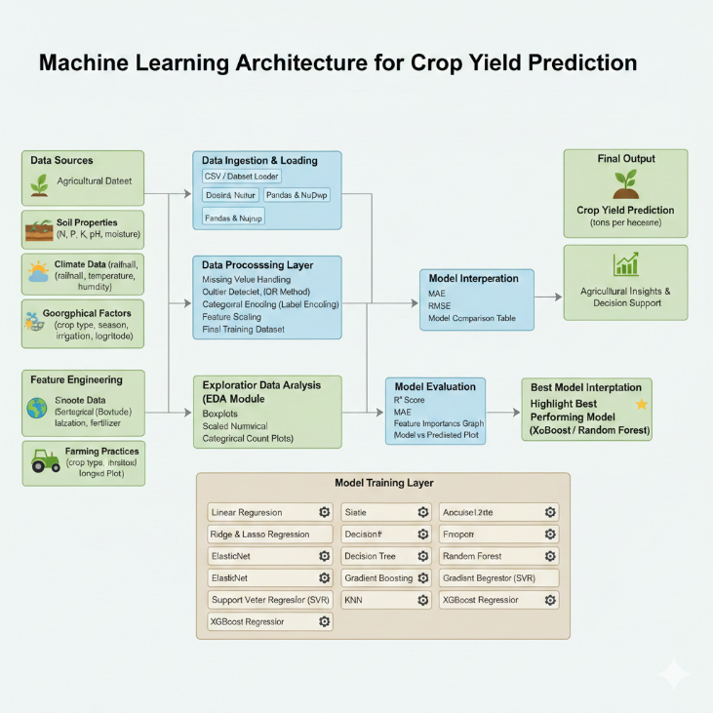
The methodology followed in this study for predicting crop yield utilizing off of the collected data of the farmers' crop fields has been systematically laid out in a four step process starting with 'Collecting the Data and Loading the Data', 'Preprocessing the Data', and 'Exploratory Data Analysis'; followed by designing the architecture for the model, building the model, then evaluating the model. The overall workflow of this methodology as used in this project are outlined below.

2.2 Dataset Collection & Loading
The dataset collected in this research consisted of about 200 data points related to crop yield data depending on the various conditions of the growing season/region/crops. The dataset itself consisted of 20 rows and one response variable (i.e., yield per hectare), which tells us how much yield there will be in the respective growing condition based upon that condition (the type of crop and the growing conditions). The collected data will be loaded to a Pandas Dataframe with the Pandas library using Python programming language.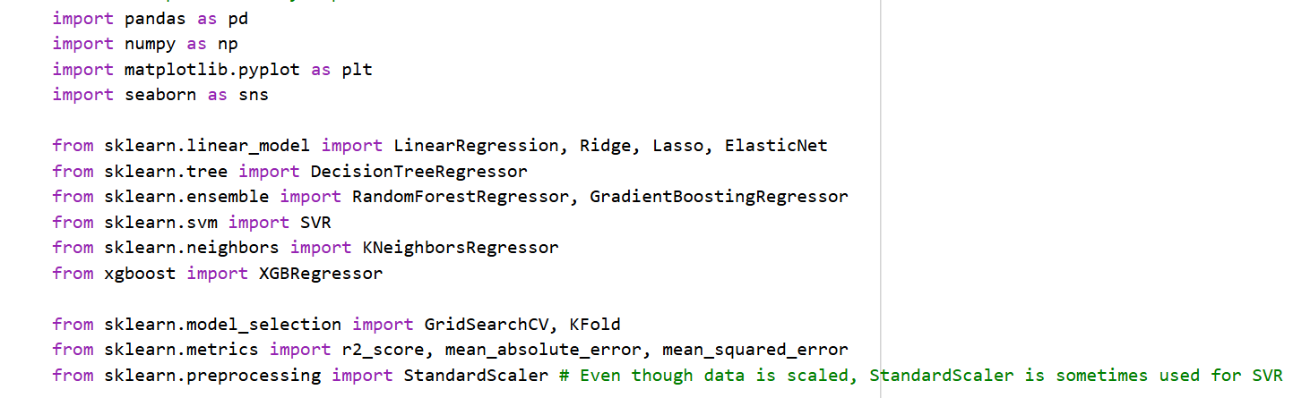
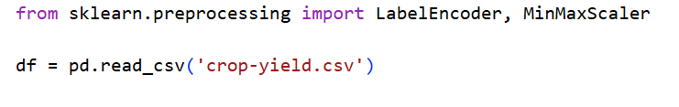

2.3 Data Preprocessing
In the data preprocessing step for machine learning, the first step includes selection of unique, or important features from the dataset – A dataset includes columns such as: soil types, crop types, irrigation methods, rainfall amounts, relative humidity, nitrogen, phosphorus, potassium, temperatures, elevations and geographical locations.
The next step includes performing a missing value analysis on the data set. This can be accomplished by writing simple code in Python as follows:
data.isnull().sum().
If missing values exist in your data set, you could then take any necessary steps to eliminate any missing values from the data so that you may reduce the introduction of bias or errors into your training model.
Thirdly, you will have to remove outliers from your dataset. You could use the InterQuartile Range(IQR) to check if there is any outliers exists by using the IQR formula:
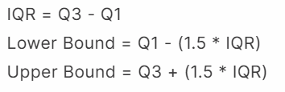
Any data point that falls outside of these bounds will be marked as an outlier, and on removal of these outlier points, we can improve the stability and generalization of your machine learning model.
2.4 Exploratory Data Analysis (EDA)
Exploratory data analysis was conducted to check for the patterns, trends, or relationships present in the data set before model building.
The EDA techniques applied to the dataset:
2.4.1 Univariate Analysis
•To study the distribution of the specified parameters in the dataset, we will also create histograms to show the frequency of values in the dataset.
•KDE Plots will be used as indicators for estimating the probability density of each of the parameter distributions across the whole dataset.
•Box Plots will allow us to see how widely values are distributed around a median value as well as highlighting possible outlier(s) that may still be present after preprocessing has occurred.
2.4.2 Categorical Analysis
• Count Plots to evaluate categorical feature count
•Pie Charts for evaluating proportions of categorical variables like getting types of crops grown and type of soil and irrigation method
2.4.3 Multivariate Analysis
•Use Pearson correlation method for a heat map of all numeric features to find how related they are to your target variable.
•Identify features that correlate with crop yields (in tons per hectare) to utilize as predictive indicators.
2.5 Feature Engineering
This process involves transforming the raw data into a form that is appropriate for model training process.
2.5.1 Label Encoding
All the categorical data is converted into numerical form using the Label Encoding technique from Scikit-learn's library, Label Encoder.
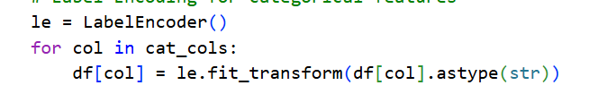
2.5.2 Min-Max Scaling
All the data in dataset is normalized to a range from 0 to 1 using the Min-Max Scaler technique. This technique ensures that the ML model is not biased towards any feature with the highest value during the training process:
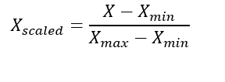
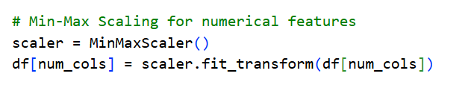
2.5.3 Train-Test Split
The dataset is divided into 80% train data and 20% test data using Scikit-learn's train_test_split function with a random_state of 42
2.6 Model Building
Ten regression models were built and trained on the preprocessed dataset, covering a wide range of algorithmic approaches.Each model was trained on X_train and y_train, and predictions were generated on X_test for evaluation.

2.7 Model Evaluation
All the ten model was evaluated using three regression metrics:
2.7.1 R² Score (Coefficient of Determination)
It will Measures the proportion of variance in the target variable explained by the model. Values closer to 1.0 means better model fit.
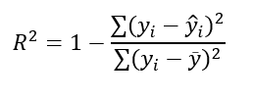
2.7.2 Mean Absolute Error (MAE)
It Measures the average absolute difference between actual and predicted values. Lower values means good performance of the model.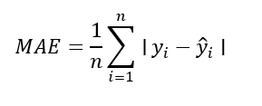
2.7.3 Root Mean Squared Error (RMSE)
It Penalizes bigger errors more heavily than MAE, making it sensitive to outliers. Lower values indicate good performance of the model.
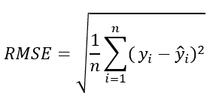

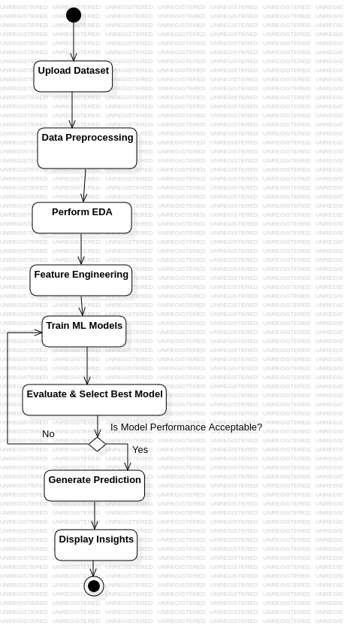
2.8 Model Interpretation
Upon evaluation, the models that gave the most promising results were subjected to interpretation, which includes the following steps:
• Actual vs Predicted Scatter Plots — This will help us evaluate the models' predictions by how closely the predicted values match the actual crop yield values
• Feature Importance Analysis — Using the feature importance tool available in the Random Forest and XGBoost algorithms to establish which crop factors have the most significant impact on crop yield prediction
• Model Comparison Bar Chart — This will help us establish the ranking of all the models, i.e., the 10 models, using the R² Score

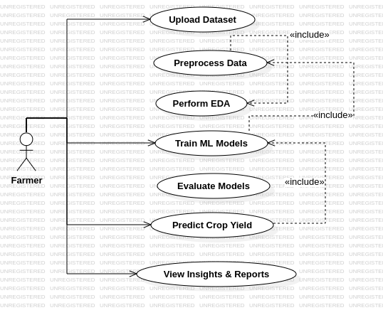
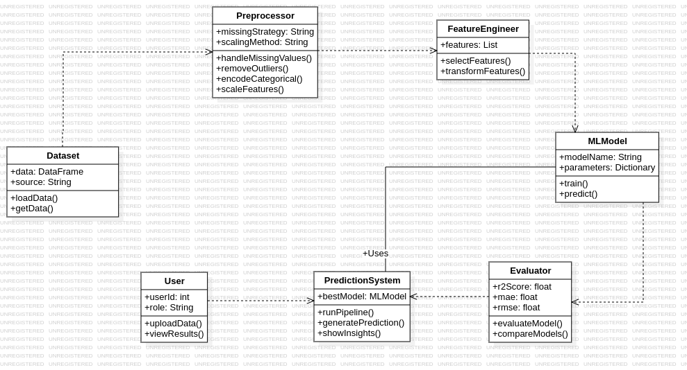

III. Protocol Stack
3.1 Overview
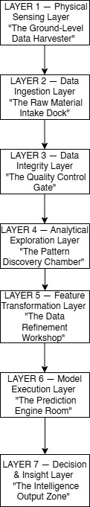
The protocol stack is a group of coordinated levels that can be used by an extensive flow of data. Different types of protocol stacks within the Crop Yield Prediction System mean there is a continual supply of raw information sent through the protocol stack based on the physical layer to the highest level providing an understanding of the outcome thus, providing an understanding of how well the crops produced. Every protocol stack is responsible for a specific job and it will only interact with the protocol stack below it and the protocol stack above it.
3.2 Detailed Layer Descriptions
Layer 1 — Physical Sensing Level
Tier One: Ground Level Data Harvester
Below you will find a description of the purpose and responsibilities of the Ground Level Data Harvester. You'll also find an analogy providing some insight into the Ground Level Data Harvester's role in Agricultural Data.
The Ground Level Data Harvester is the first tier of three tiers. The primary responsibility of the Ground Level Data Harvester is to gather raw data from the physical environment.
Example: A farmer walks through their field measuring several different characteristics of their crops and such.
The Ground Level Data Harvester is the bottom tier of the three tiers of agriculture data and is where all agriculture data is generated. The Ground Level Data Harvester represents the physical world. The actual fields, farms, and environment in which the data is created. The Ground Level Data Harvester consists of sensors, IoT devices, satellite imagery, and any other equipment that is at or near the ground level that is used to collect data. The Ground Level Data Harvester will gather data including, but not limited to, nutritive nutrient concentrations in the soil (such as N, P, K), and the temperature of the site; total precipitation received at the site, relative humidity at the site; the geographic coordinates (latitude, longitude) of the site; and the height of the site above sea level. The Ground Level Data Harvester will not process any data gathered from the Ground Level Data Harvester to accumulate or create aggregated data.

LAYER 2 — Data Ingestion Layer
The "Raw Material Intake Dock"
Goal:
The ingesting data layer utilizes the warehouse for ingesting data from the real world into the warehouse. Data gathered from a variety of sources such as; sensors, government, agricultural data, weather data, and many other sources will all be joined together within one data structure.
Each piece of data will be placed in either a row or column, and there will be a data type for each column defined and saved together in one structure.
As part of this project the ingesting the data layer will load data using the pd.read_csv() function.
Basic Functions
Load Data to the Data Structure
Develop the Data Schema
View Data Shape
Summarize Data
LAYER 3 — Data Integrity Layer
"The Gate of Quality Control"
The majority of the raw agricultural data will likely not be in a satisfactory condition. Some will be empty, many will be duplicate and some even contain inaccuracies due to either faulty sensors, human error or both. The most important point of the pipeline is the Data Integrity Layer. During this step, all of the raw data will gets checked before going to the next phase. Missing values will be identified, duplicate records will be deleted, and statistical outlier removal will happen. The IQR Method will be followed for statistical outlier removal. Clean and trustable data will be passed through these layers. The quality of the final prediction will be determined by the quality of the data that has been processed through this layer.
Main Operations
Detecting Missing Values - isnull() . sum().
Removing Duplicates - drop_duplicates()
Detecting Outliers - Boxplots
Removing Outliers - IQR Method
LAYER 4 — Analytical Exploration Layer
The Pattern Discovery Chamber is the place where we begin truly exploring our data now that we have the clean data available to us. The only purpose of this layer is to conduct Exploratory Data Analysis (EDA) on the data using both visualizations and numerical methods, which allows us to understand trends in the data and relationships between various features. Analyzing the distribution of a feature is referred to as univariate analysis and can be performed through the use of both histogram and kernel density estimation (KDE) plots. Analyzing the relationship between two features and their relationship to the target variable is referred to as bivariate analysis. Although there are no graphical representations of what features are most important in relation to each other for predicting yield, correlation heatmaps can provide us with a multivariate analysis of soil, climate, and farming features. This information can assist with identifying which features will be retained, transformed, or dropped during feature engineering and therefore will ultimately assist the models' decisions in the layers above this one.

Some Key Operations Performed in This Layer Include:

Distribution analysis using histogram and KDE plots.
Distribution spread and outlier analysis using box plots.
Categorical feature analysis using count plots and pie charts.
Multivariate analysis using Pearson correlation heatmaps.
Analysis of the distribution of the target variable.
Layer 5: Feature Transformation Layer
"Data Refinement Workstation"
Overview:
Due to machine learning algorithms' inability to otherwise operate with text categories’ and features of considerably different numeric scales. This layer will bridge the gap between raw data and data usable by any model's standardized inputs. Within this layer categorical data (i.e., Soil Type, Crop Type, Region, Season, and Irrigation Type) are transformed into their numeric integers via Label Encodings. The Numeric Data (with very different numeric scales) is also converted from their respective high scales down to a common range of [0,1], through the application of Min-Max Scaling. This will ensure large numeric scaled features cannot interfere with and/or inhibit the overall training process of the involved models. Next, the entire dataset will be separated, through the "train-test-split" methodology at an approximate ratio of 80/20, into training and testing sets. By doing this, the performance of these models will be evaluated using previously unseen datasets. This layer, thus, ensures all models have access to data supplied in a standardized format.
Key Features:
Label Encoding categorical data
Min-Max Scale numeric data
Use of train-test-split methodology to separate data into training/testing sets
Separation of Feature Matrix (X) from Target Vector (y)
Assure shape of data and validation of data values is accurate
Layer 6 - The Execution Layer of Models
"The Prediction (Engine) Room "
Layer 6 Execution Layer of Models Facile Prediction Engine Room - Description/Function: This is where the entire Machine Learning (ML) architecture operates, with all of the machine learning models will be trained (to), defined, optimised and executed (through); that is the ML Engine or 'brain' of the entire architecture. There are ten different regression algorithms that will be executed at layer 6, each trying to solve the yield prediction problem from a different mathematical problem. Linear regression-based algorithms (Linear Regression, Ridge Regression, Lasso Regression, Elastic Net Regression) will try and find the linear relationship between features and yields, where tree-based algorithms (Decision Tree, Random Forest, Gradual Boost) will try and define the boundary line between features and yields based on decision logic whereas kernel methods (Support Vector Regression (SVR)) will find the best regression curve in a feature space by transforming the features into higher dimensions. Distance-based methods (K-Nearest Neighbour (KNN)) will find yield predictions based on their distance from similar agricultural data points, whilst Boosting-based methods (XGBoost) will use a weighted and summed result of multiple weak prediction results to create a highly accurate prediction result. Moreover, hyperparameter optimising will also be performed at this level through the application of both Grid Search CV and Elbow Curve Analysis to optimise parameters for each individual model prior to making their final predictions.
LAYER 7 - Insight & Decision Layer"
Intelligence Zone (Output Zone)
PROPERTY DESCRIPTION
Designated based Layer
Responsibilities to Interpret output of the models, provide agricultural insights that can be applied immediately
Company Boardroom where Data become Strategic Plan and Executives Decisions

Layer 7 is the highest layer of the protocol stack. Its functions consist of interpreting output for the models, and delivering actionable Agricultural Insights to users. At this level, users use scatter plot analysis and evaluation metric tables that estimate yield through the 10 models to compare actual and predicted yield values. Best model estimates are based on the ranking of the indices: R² Score, Mean Absolute Error (MAE), and Root Mean Squared Error (RMSE). Additionally, the feature importance charts associated with the Random Forest and XGBoost models are used to determine the most important agricultural features significantly impacting yield predictions. Specified actions will be provided to farmers/Agricultural planners and policymakers. Actual actions can take place for farmers/Agricultural planners, and policymakers at each of these levels. Layer 7 represents the end destination for the data which travels through the previous 6 layers leading to this point.
Key Operative Functions:
Aggregate actual; vs. predicted yield values via Scatter Plot Analysis
Aggregate models vs. models compare via Comparison Table and Bar Graph Ranking
Identify feature importance via Visualization
Identify & Report the Best Model

IV. RESULTS
4.1 Overview
In this section of the study, we provide an overview of the results of conducting exploratory data analysis, as well as our preprocessing steps and performance evaluation of each of the 10 regression models we developed to estimate yields of crops. The findings are divided into four categories – Data Preprocessing Findings, EDA Findings, Model Performance Findings, and Feature Importance Findings.

4.2 Data Preprocessing Findings
4.2.1 Dataset Overview
Once loading, the dataset appeared like this:
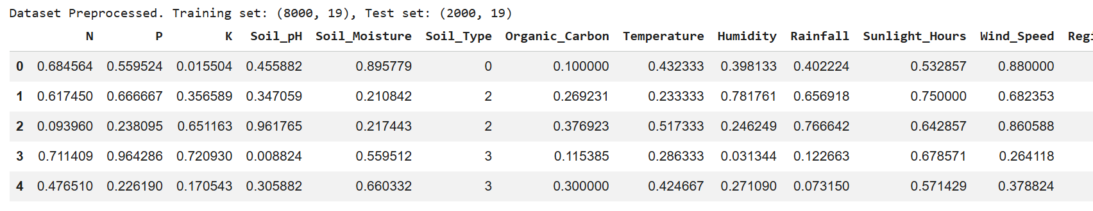
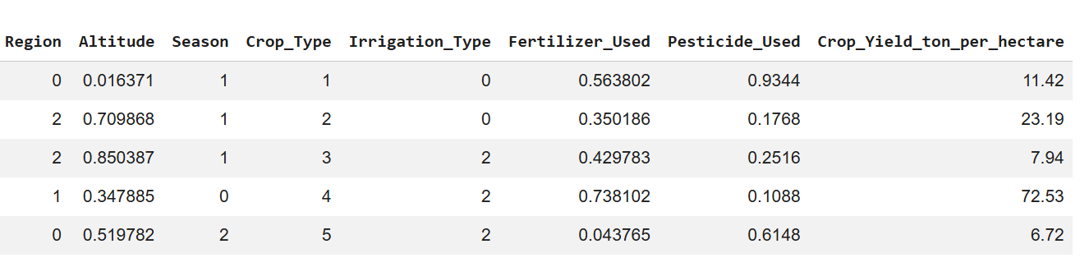
4.2.2 Analysis of Missing Values
The investigation on the dataset for the missing value returned with no substantive missing values across the entire dataset (fill in your actual finding). As all attributes in the dataset had complete records, no imputation was required. Prior to conducting outlier detection, the dataset was confirmed as complete and reliable.
4.2.3 Outlier Detection and Removal
Box plots were used on all numerical attributes of the dataset to assess outliers in the dataset using an IQR approach for identifying extreme datasets from the dataset and eliminating those extreme values

The removal of outliers produced a cleaner dataset with improved distributions of features, which, in turn, resulted in less skewness in the distributions, thus leading to greater stability of the models created from training on these features.

4.3 EDA RESULTS
4.3.1 DISTRIBUTION OF NUMERICAL FEATURES
The numerical feature distributions were checked using histograms and KDE plots to grow the following major conclusions:
•The distribution of NPK has a near-normal distribution with low levels of right skewness; therefore, the majority of the agricultural plots had moderately nutrient-rich soil.
•The distribution of rainfall is wide across the various climatic conditions; therefore, values will represent rainfall amounts over a range of locations and seasons.
•The distribution of temperature is fairly uniformly-distributed; therefore, we can expect to have records for each temperature range from many geographical zones.
•Crop Yield (the target variable) exhibited a distribution close to being normal; therefore, the data will likely be suitable for regression models.
4.3.2 Analysis of features across categorical variables
The following counts and empirical observations regarding categorical features were established by count plots and pie charts respectively:
-Types of crops: balanced distributions observed for all the crop varieties within this dataset (e.g., cereals, pulses, cash crops, etc.);
-Soil types: sandy, loamy, clay have been the most recorded soil type categories;
-Irrigation method: drip and sprinkler have been recorded as the largest proportion of irrigation methods used in growing crop varieties across this dataset;
-Seasons: all three crop growing seasons (Kharif, rabi, zaid) were reported evenly distributed through this dataset;
-Regions: there was a balance/reasonably equal number of records for each region of the country across all of the crop varieties within this dataset.
4.3.3 Correlation analysis
Correlation analysis determined various significant relationships between the target feature 'crop_yield_ton_per_hectare' and others as seen in the correlation heatmap:
Key multicollinearity observations:
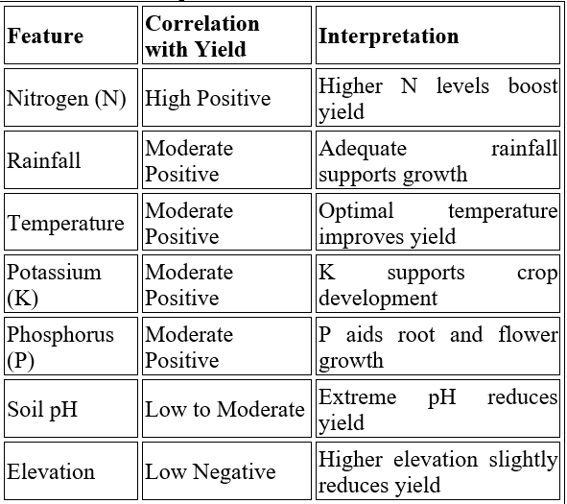
- N, P, and K showed moderate inter-correlation, as these nutrients are often applied together as fertilizers
- Temperature and Rainfall showed a slight negative correlation, reflecting seasonal climate patterns
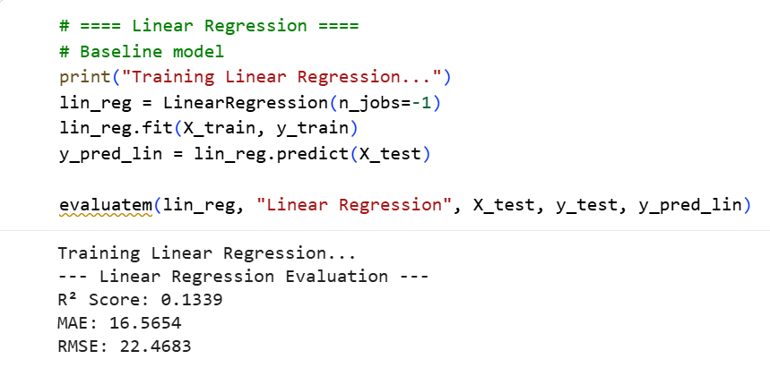
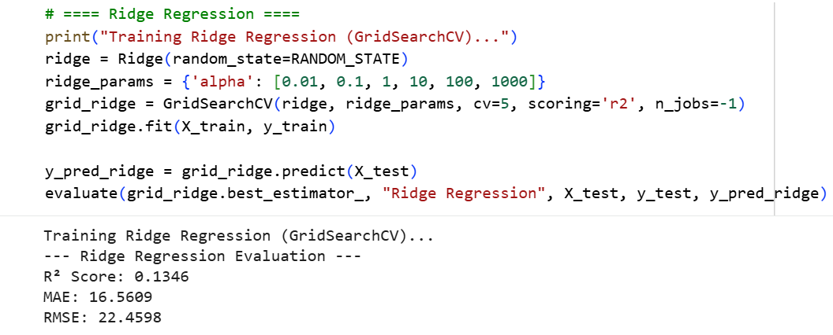

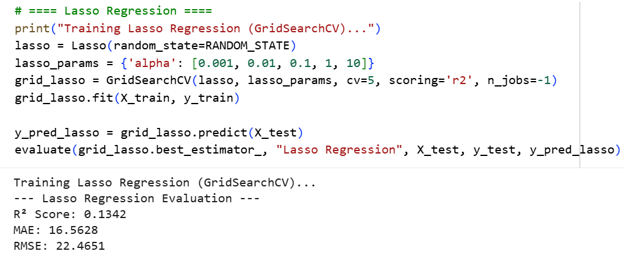
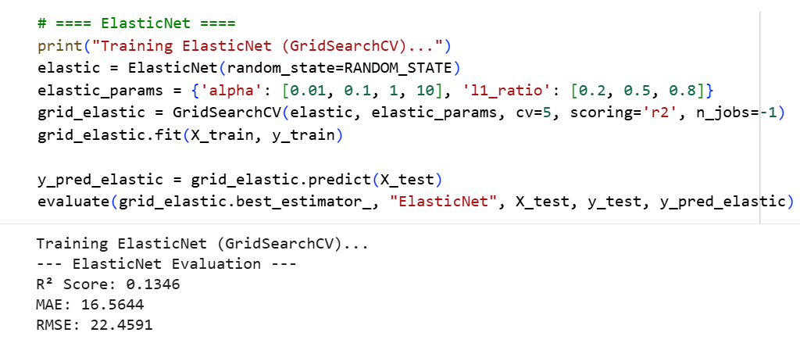
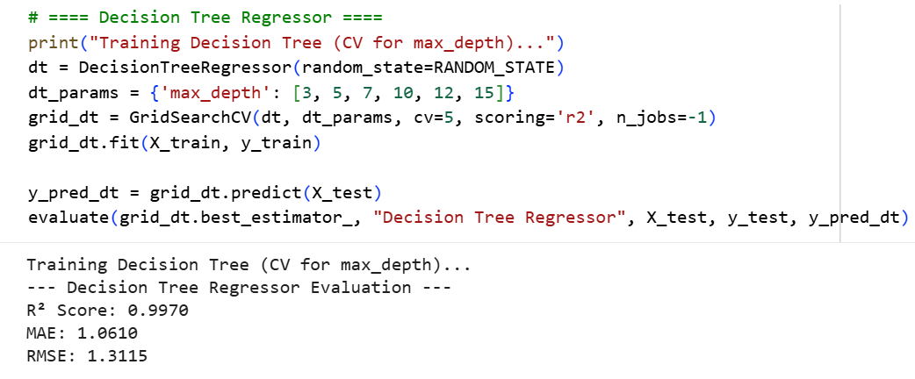
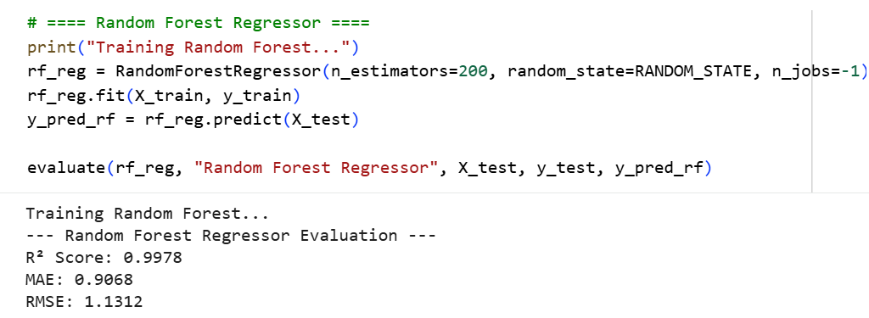
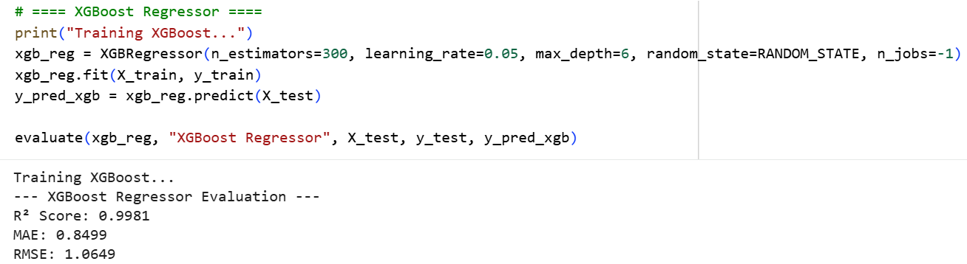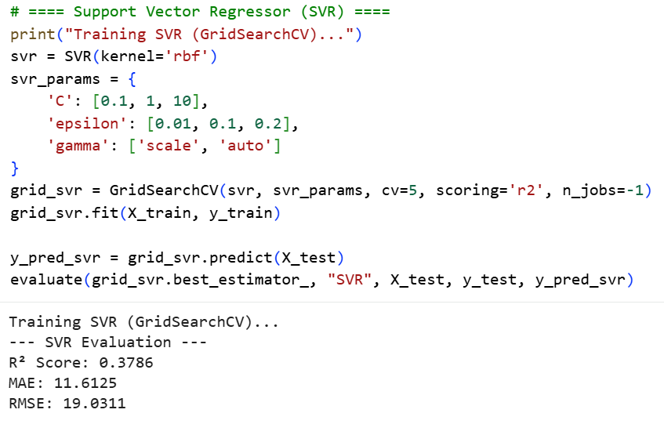
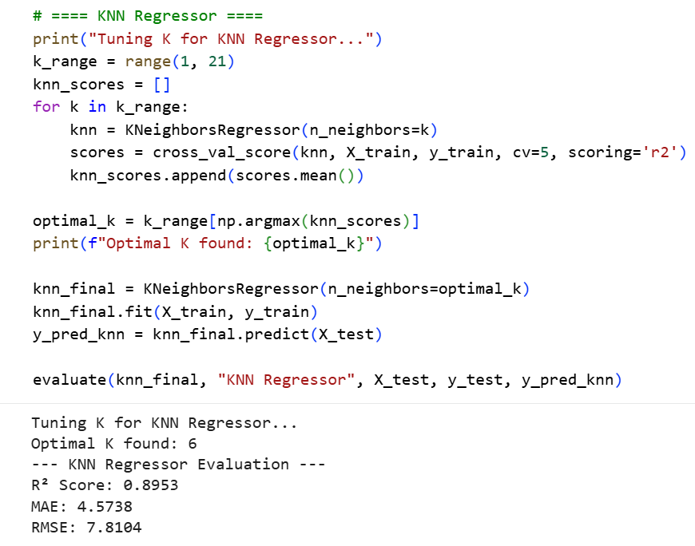

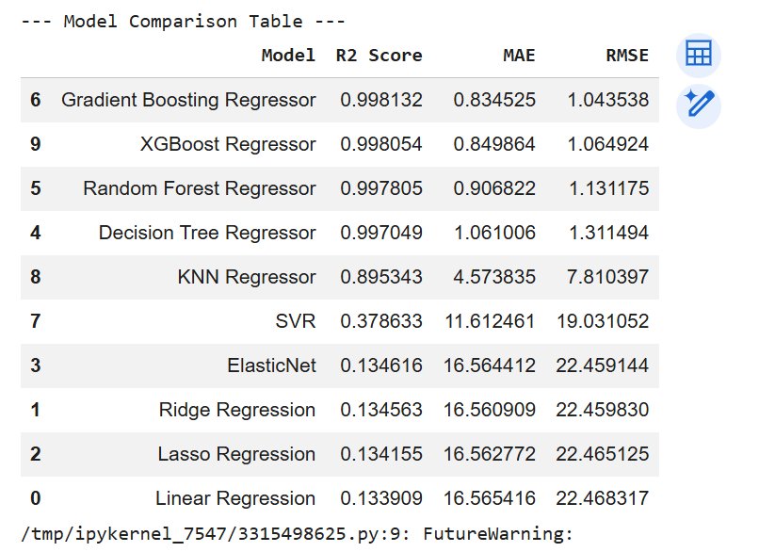
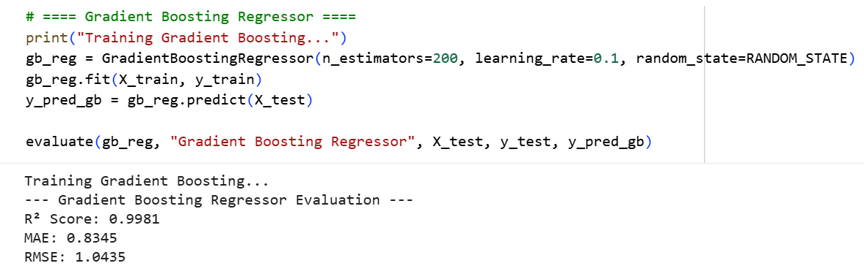

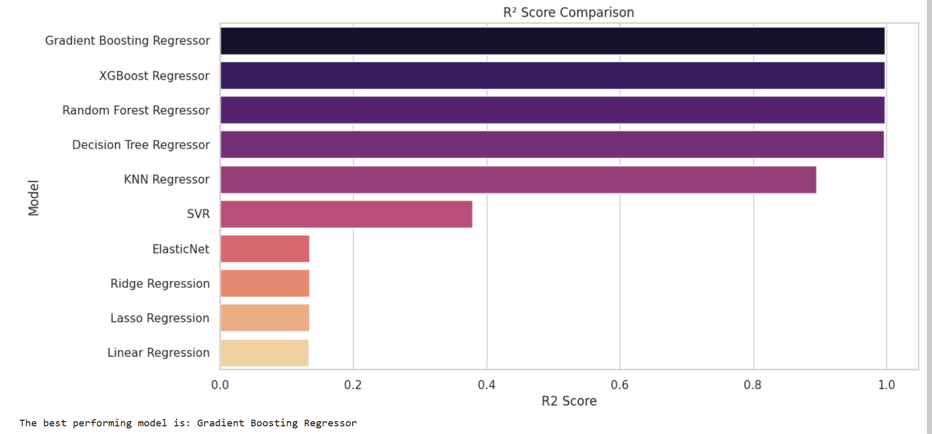
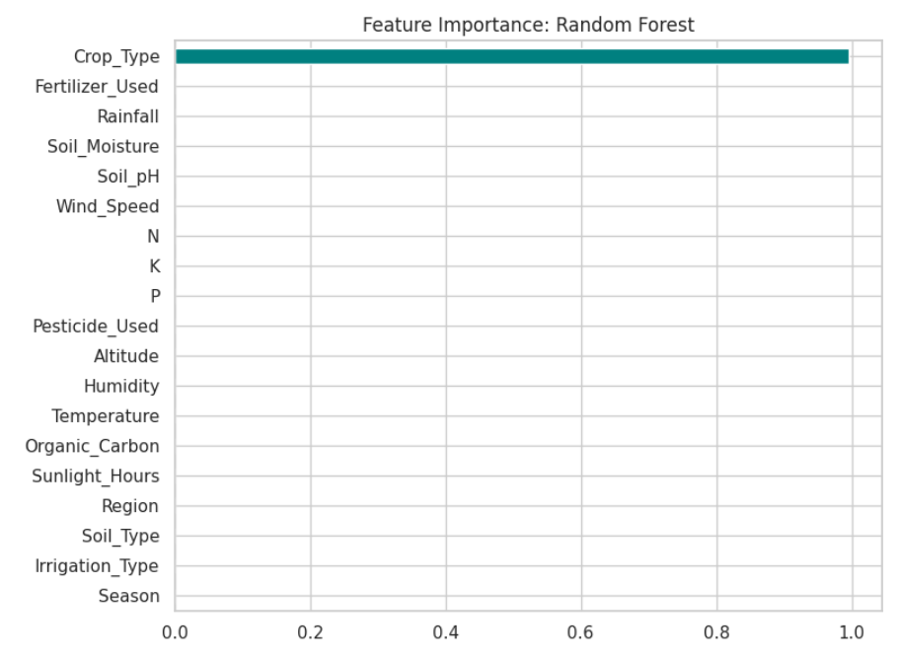
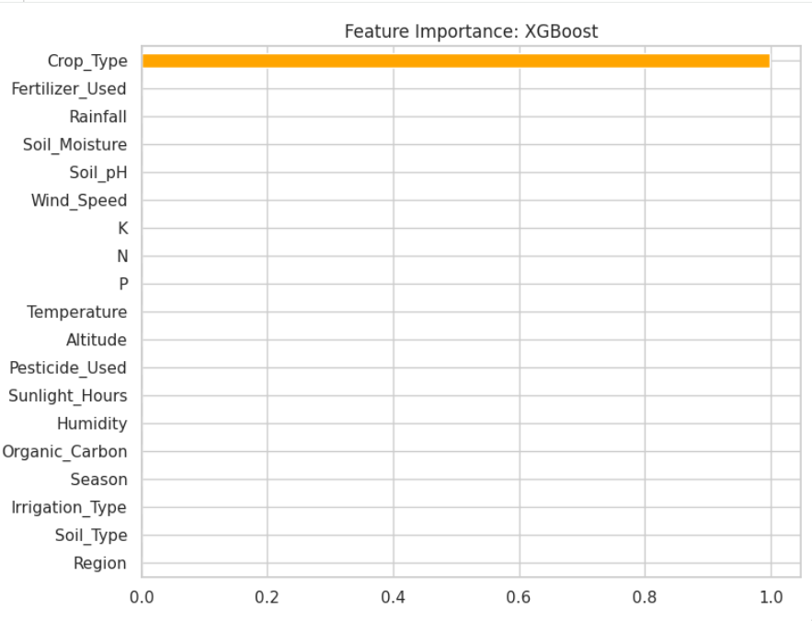

V. References
[1] Liakos, K.G., Busato, P., Moshou, D., Pearson, S. and Bochtis, D., 2018. Machine learning in agriculture: A review. Sensors, 18(8), p.2674.
[2] Pantazi, Xanthoula Eirini, Dimitrios Moshou, Thomas Alexandridis, Rebecca Louise Whetton, and Abdul Mounem Mouazen. "Wheat yield prediction using machine learning and advanced sensing techniques." Computers and electronics in agriculture 121 (2016): 57-65.Computers and Electronics in Agriculture, 121, 57–65.
[3] Jeong JigHan, Jeong JigHan, J. P. Resop, N. D. Mueller, D. H. Fleisher, Yun KyungDahm Yun KyungDahm, E. E. Butler, D. J. Timlin et al. "Random forests for global and regional crop yield predictions." (2016): e0156571.
[4] Crane-Droesch, A., 2018. Machine learning methods for crop yield prediction and climate change impact assessment in agriculture. Environmental Research Letters, 13(11), p.114003.
[5] Gandhi, Niketa, Owaiz Petkar, and Leisa J. Armstrong. "Rice crop yield prediction using artificial neural networks." In 2016 IEEE Technological Innovations in ICT for Agriculture and Rural Development (TIAR), pp. 105-110. IEEE, 2016.
[6]Shahhosseini, Mohsen, Rafael A. Martinez-Feria, Guiping Hu, and Sotirios V. Archontoulis. "Maize yield and nitrate loss prediction with machine learning algorithms." Environmental Research Letters 14, no. 12 (2019): 124026.
[7] Kuradusenge, M., Kumaran, S., & Zennaro, M. (2020). Rainfall-Induced Landslide Prediction Using Machine Learning Models: The Case of Kigali City. Sustainability, 12(18), 7773.
[8] Everingham, Yvette, et al. "Accurate prediction of sugarcane yield using a random forest algorithm: Y. Everingham et al." Agronomy for sustainable development 36.2 (2016): 27.
[9] Breiman, Leo. "Random forests." Machine learning 45, no. 1 (2001): 5-32.
[10] Chen, Tianqi and Carlos Guestrin. "Xgboost: A scalable tree boosting system." Proceedings of the 22nd acm sigkdd international conference on knowledge discovery and data mining. 2016.
[11] Friedman, J.H., 2001. Greedy function approximation: a gradient boosting machine. Annals of statistics, pp.1189-1232.

