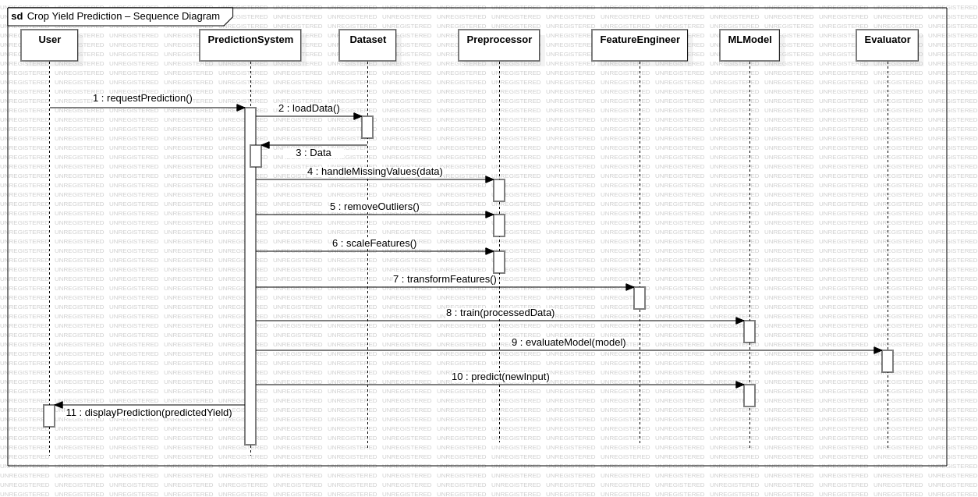
LAB-4
UML Diagram(Star UML)
23BCE1234
Safal Goyal

Sequence Diagram:-

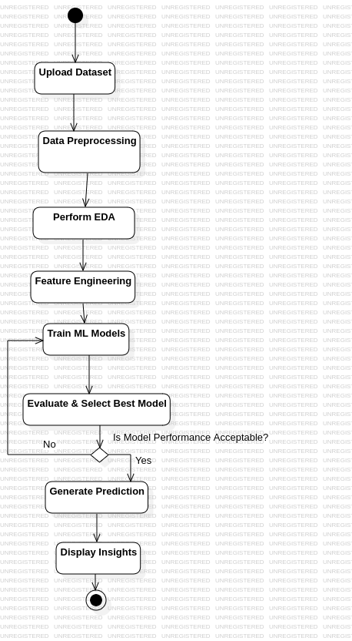

Activity Diagram:-

