Apache Camel in a Real Insurance Company
The complete story — from problem to architecture

1. The Company and Its Systems
Imagine "SecureLife Insurance". Like every real insurance company, it does not run one application. It runs many:
System | What it does
Mobile App / Web Portal | Customers buy policies and file claims
Policy Service | Creates and manages policies
Claims Service | Registers and tracks claims
Fraud Detection Service | Scores every claim for fraud risk
Payment Service | Pays approved claims
Document Service | Stores photos, PDFs, reports
Notification Service | Sends email / SMS / push
CRM (e.g. Salesforce) | Customer history for agents
Core System (legacy) | 30-year-old mainframe; talks SOAP and files
Partner Systems | Hospitals, garages, other insurers
Regulator | Monthly reports in a fixed file format

KEY POINT 1 In real companies these are separate microservices and external systems. Different teams, different languages, different data formats, different speeds.
KEY POINT 2 None of them is useful alone. The business value is in the connections: a claim is only “processed” when six or seven of these systems have done their part.

2. The Problem Without an Integration Framework
Connect 10 systems point-to-point and you get up to 10 × 9 = 90 possible connections. Each connection hand-written means:
- HTTP clients, retries, timeouts — written 90 times
- JSON ↔ XML ↔ CSV mapping — written 90 times
- Error handling and logging — written 90 times, all slightly different
- A change in one system breaks unknown others
This is called spaghetti integration. Every old company has it. It is why “add one field to the claim form” takes three months.
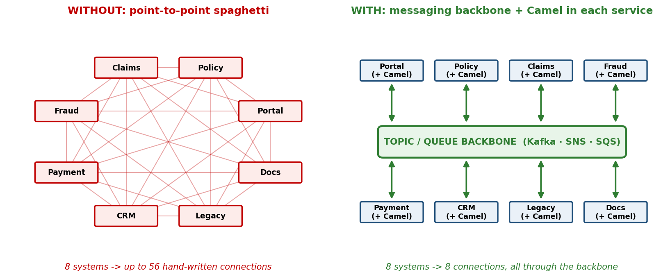
Figure 1 — Point-to-point spaghetti vs. a messaging backbone with Camel in every service

The fix has two parts
- A messaging backbone (queues/topics: Kafka, SQS, JMS) so systems talk indirectly and survive each other's downtime.
- An integration framework (Apache Camel) inside each service, so the connect-transform-route code is not hand-written.
CAMEL'S JOB IN ONE SENTENCE “Receive from anywhere, transform anything, send to anywhere — with retries, error handling and monitoring built in.”

3. The Story — One Claim, End to End
Ravi has a car accident. He opens the mobile app, fills the claim form, attaches 4 photos, presses SUBMIT. One tap. Watch how many services work now:
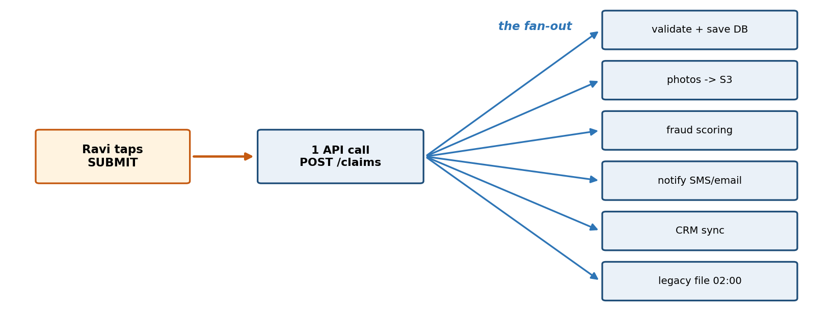
Figure 2 — One customer tap fans out into many independent service calls and events
Step | What happens | Who does it
1 | App sends POST /claims (JSON) | Claims Service (Camel REST DSL)
2 | Validate: policy active? fields ok? | Camel route: choice() validation
3 | Photos uploaded to object storage | Camel → aws2-s3
4 | Claim saved to database | Camel → jpa / jdbc
5 | Event CLAIM_REGISTERED published to a topic | Camel → Kafka / SNS
 | THE FAN-OUT: one event, many independent subscribers | (this is why topics exist)
6 | Fraud service consumes the event, calls the scoring model, writes the score | Camel ← topic, Camel → http
7 | Notification service consumes it, sends “claim received” SMS + email | Camel ← topic, Camel → mail / sms
8 | CRM sync consumes it, updates the customer record in Salesforce | Camel ← topic, Camel → salesforce
9 | Core system cannot do events. A Camel route writes it a fixed-width file at 02:00 (it only reads files) | Camel file / sftp + data format
10 | Adjuster approves in the back office | Claims Service
11 | Event CLAIM_APPROVED published | Camel → topic
12 | Payment service consumes, pays via bank API, retries on timeout | Camel ← topic, Camel → http + retry
13 | Notification: “money is on the way” | Camel ← topic
14 | Monthly: regulator report built from all claims, uploaded via SFTP | Camel quartz timer + aggregate + sftp

Count: one customer tap touched ~9 services, 3 protocols (HTTP, messaging, files) and 4 data formats (JSON, database rows, fixed-width text, XML for the regulator).
KEY POINT 3 No single “super application” did this. Each service did one step and passed a message on. Camel routes are the in/out doors of every service.
KEY POINT 4 (say this in the session) “In real systems one call rarely stays one call. It fans out into many service calls and events. Integration is not an edge case — it IS the system.”

4. The Architecture
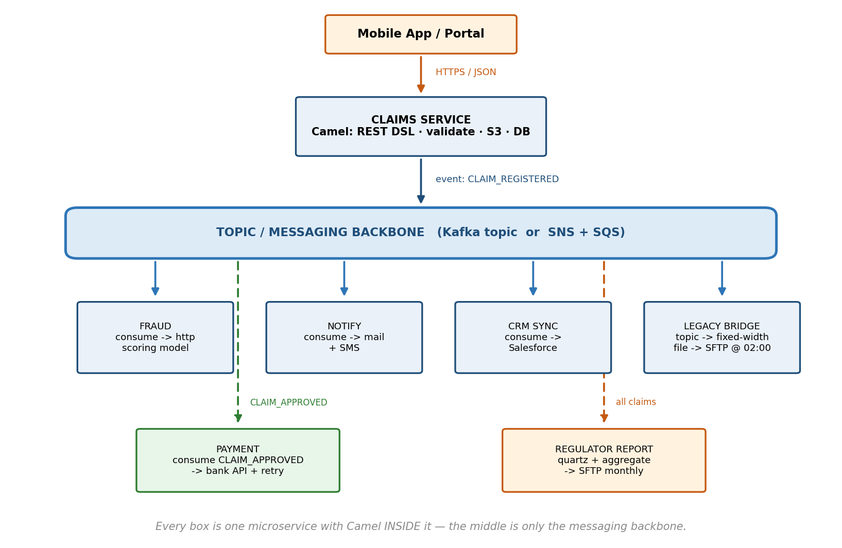
Figure 3 — The claim-processing architecture: Camel embedded in every service, a topic in the middle

How to read it
- Every box = one microservice with Camel inside it
- Camel is NOT a central server in the middle (that was the ESB model — OSB). Camel is a library embedded in each service. The middle is just the messaging backbone.
- Arrows into a box = Camel from(...) consumers
- Arrows out of a box = Camel to(...) producers
OSB BRIDGE (one line) OSB = one central bus doing all mediation. Camel = the same mediation skills, distributed into every service. Same patterns, modern deployment.

5. Which Camel Piece Does Which Job
Job in the story | Camel feature | We did it in
Receive the claim (REST) | REST DSL | Module 6
Validate / branch | choice / when / otherwise | Module 5
Store photos | aws2-s3 component | Module 10
Save to DB | jpa / jdbc / aws2-ddb | Module 13
Publish the event | kafka / aws2-sns | Module 12
Consume events | kafka / aws2-sqs | Module 11
JSON ↔ object | marshal / unmarshal | Module 4
Batch of claims → report | splitter / aggregator | Module 5
Audit copy of everything | wireTap | Module 5
Bank API timeout | onException + retry | Module 7
Poison messages | dead letter queue | Module 11
Legacy file at 02:00 | file / sftp + quartz | Module 3
Send email / SMS | mail / sms components | (concept)

KEY POINT 5 Everything in the big story is a pattern you already taught in the small labs. Scale changes; patterns do not.

6. The Connectors (Components) That Matter
Camel has 300+ components. In an insurance stack, these carry almost all the traffic:
Component | Connects to | Typical insurance use
platform-http / REST DSL | REST APIs (in) | Claim submission API
http | REST APIs (out) | Fraud scoring, bank API
kafka | Kafka topics | Event backbone
aws2-sqs / aws2-sns | AWS queues / topics | Event backbone (AWS)
jms | ActiveMQ / IBM MQ | Older middleware
file | Local folders | Legacy imports / exports
ftp / sftp | Partner file transfer | Hospitals, regulator
aws2-s3 | Object storage | Claim photos, documents
jpa / jdbc / aws2-ddb | Databases | Policies, claims
cxf / soap | SOAP web services | Core mainframe wrapper
mail (smtp) | Email | Customer notifications
quartz / timer | Schedules | Nightly jobs, reports
salesforce | Salesforce CRM | Agent view sync
bean / direct | Java beans / other routes | Internal wiring

WHY CONNECTORS ARE THE SELLING POINT Each component solves protocol + connection + retry + headers for you. The route stays 5 lines whether it talks to a folder or to Salesforce. Replacing an endpoint = changing a URI, not rewriting the flow. (LocalStack → real AWS proved exactly this.)

7. Why Camel Helps — The Argument List
# | Argument | Because
1 | 300+ ready connectors | No hand-written clients
2 | EIPs built in | Routing / splitting / aggregating are one-liners with standard names
3 | Error handling built in | Retries, backoff, dead letters — policy, not boilerplate
4 | One skill, every system | File today, Kafka tomorrow, S3 next week — same DSL
5 | Routes read like diagrams | The code IS the documentation
6 | Testable | Routes are Java: unit tests, mocks
7 | Portable | Same route in Spring Boot, Quarkus, Kubernetes, standalone
8 | Open source, huge community | No license cost, 17+ years mature, backed by Red Hat / IBM
9 | Gradual migration | Wrap the legacy system with a Camel bridge; retire it slowly
10 | Monitoring included | Health checks, metrics, JMX, Hawtio console

8. Cheatsheet — Key Points to Remember

Vocabulary (7 words)
Term | Meaning
CamelContext | The running engine (one per app)
Route | One flow: from → steps → to
Endpoint | Address as URI: component:path?options
Component | The connector that understands the URI scheme
Exchange | The envelope travelling through the route
Message | Body + headers, inside the exchange
Processor | Your own Java step

Route anatomy
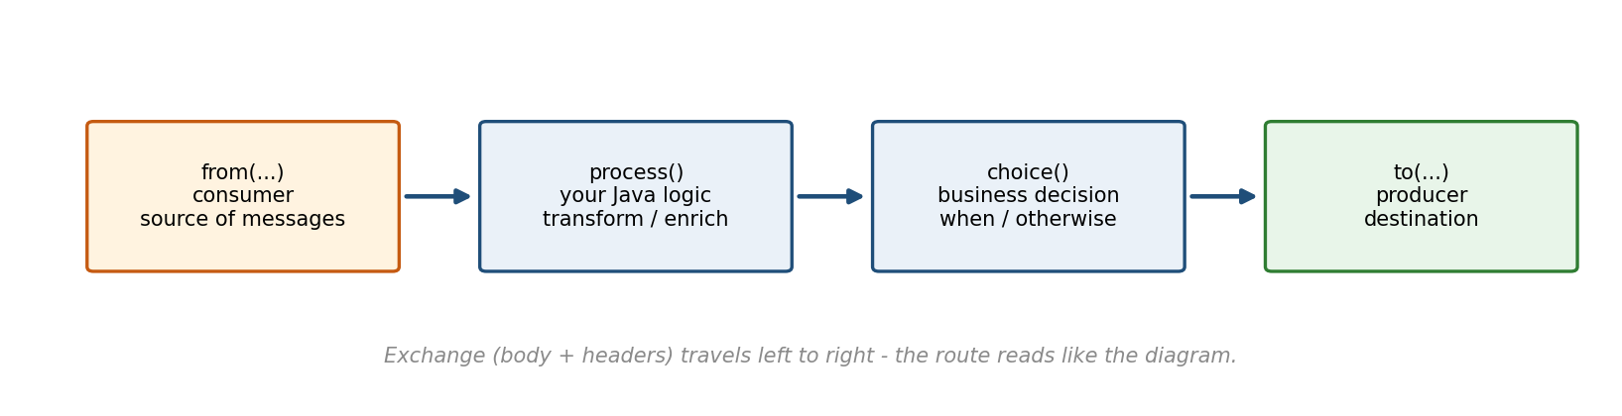
Figure 4 — A route reads left to right: consumer, logic, decision, producer
from("file:data/input?move=../processed") // source + options
.routeId("my-route") // name it, always
.log("${header.CamelFileName}") // see what happens
.process(e -> { ... }) // own logic
.choice() // decision
.when(predicate) ...
.otherwise() ...
.end()
.to("kafka:claims"); // destination

EIP quick table
Need | Use
if / else on content | choice / when / otherwise
Drop unwanted messages | filter
One big message → many small | split
Many small → one big | aggregate
Copy aside without disturbing the flow | wireTap
Same message to several endpoints | multicast
Call a service, merge the answer | enrich
Protect against duplicates | idempotentConsumer

Error handling minimum
onException(SomeException.class)
.maximumRedeliveries(3)
.redeliveryDelay(1000)
.handled(true)
.to("file:data/error"); // or a DLQ queue
- maximumRedeliveries(3) = 4 total attempts
- handled(true) = caller gets the error-branch result, not the exception

Data format minimum
.unmarshal().json(...) // text -> Java (Map or POJO)
.marshal().json(...) // Java -> text
- CSV values are always Strings; types are your job

Five sentences that answer most questions
- “The component does the protocol; the route does the logic.”
- “Body and headers travel together in the exchange; stash values in headers before you transform the body.”
- “Every message must end somewhere you can look at — output, queue, or error folder. Never nowhere.”
- “One call fans out into many — topics decouple the many.”
- “Change the URI, keep the route: that is portability.”

9. How to Tell This Story in a Session (10 minutes)
Minute | Do this
0–1 | Name the systems of SecureLife (Part 1 table)
1–3 | Draw the spaghetti problem: 10 systems, 90 connections
3–6 | Tell Ravi's claim story, count the services touched
6–8 | Draw the architecture (Part 4); stress: Camel lives INSIDE each service, the middle is only a topic
8–9 | Show the Part 5 mapping: “you already built all of this in the labs, just smaller”
9–10 | Close with the five sentences (Part 8)

THE CONFIDENCE TRICK You are never claiming Camel does magic. You are showing that a huge realistic flow decomposes into the exact small patterns the participants already ran on their own laptops.

