Spring Cloud Config
It is more like externalizing properties/resource file out of project codebase to an external service altogether so that any changes to any given property does not necessitate the re-deployment of service which is using that property. All such property changes will be reflected without redeploying the microservice.

Create a Git Repository
Create a folder D:\\config-repo
Run CMD
Git init
Create the cloud-config-client.properties. This file name must match the Micro service name
server.port=3333
welcome=Ram Welcomes You

spring.datasource.driver-class-name=oracle.jdbc.driver.OracleDriver
spring.datasource.url=jdbc:oracle:thin:@localhost:1521:XE
spring.datasource.username=xe
spring.datasource.password=govind

git add .
git config user.name “govind”
git config user.email “govind”
git commit -m “message”

Create a Cloud Config Server
- Create the Spring boot starter project
- Add the dependency Cloud-Config-Server and WEB
- Add the properties in application.properties
  - server.port=8888
  - spring.cloud.config.server.git.uri=d:\\config-repo
@EnableConfigServer
Spring Cloud Config Server provides an HTTP resource-based API for external configuration (name-value pairs or equivalent YAML content).
This annotation creates the embeddable Spring cloud config server.
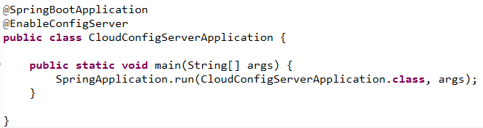

Create the Cloud Config Client
- Create the Spring boot starter project
- Add the dependency Cloud-Config-Client , actuator and WEB
- Add the properties in application.properties
  - spring.application.name=cloud-config-client
  - spring.cloud.config.uri=http://localhost:8888
  - management.endpoints.web.exposure.include=*

How to define the Cloud Config Server?
- spring.cloud.config.uri is the property to mention the config server url.

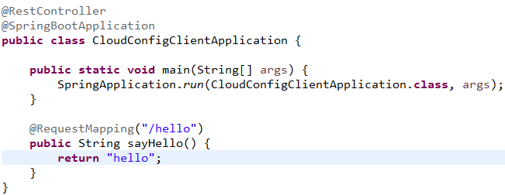
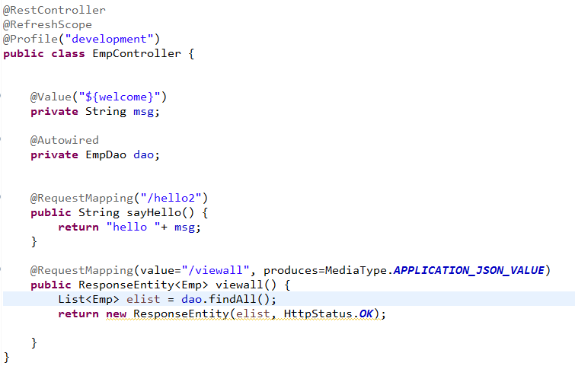
Do some change, in the value of the msg property in the config-server-client-development.properties and check-in in the local git, then hit the http://localhost:3333/hello2 again in the browser, You will the old value only.
To reflect the new value, we need to refresh the configuration by hitting http://localhost:3333/actuator/refresh endpoint using POST method from any of the REST client.
Once you have successfully refreshed the config client service, the new value should be reflected in the service response. This is because @RefreshScope annotation the Rest Controller that we have exposed.

