Feign Client
- Feign is a declarative web service client. It makes writing web service clients easier. To use Feign create an interface and annotate it.
- Spring Cloud integrates Ribbon and Eureka to provide a load balanced http client when using Feign.
- Spring cloud integrates Hystrix to provide Circuit Breaker or fall back implemenation
How a microservice consumes another Micro service?
- Using RestTemplate
- Instead of Using RestTemplate to consume micro service, use Feign Client
Who creates the FeignClient Implementation
Feign is a declarative web service client. It dynamically creates the implementation for the interface annotated @FeignClient and Annotated with JAX-RS or Spring MVC
@EnableFeignClient
It allows specifying the path to scan our clients. The interface that is annotated @FeignClient
How to create the Feign Client
- Create the interface and annotate @FeignClient
- Define the method and Map the webservice URL using @RequestMapping annotation
How Feign Works
- Feign Uses Discovery server and Obtain MicroService that matches the micro service name defined in @FeignClient and hit the micro service
- Uses Load balanced using Ribbon
- Uses Circuit Breaker using Hystrix
Create a Eureka Serer
- Create a Spring starter Project
- Add the following dependency in POM.XML
Eureka server
- Application.properties
  - server.port=8761
  - spring.application.name=eureka-server
  - eureka.client.register-with-eureka=false
  - eureka.client.fetch-registry=false
- Create an Eureka server
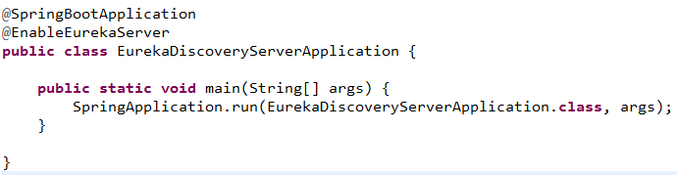
- Run the Micro Service
- Type URl in the browser http://localhost:8761
Create a Micro Service
- Create a Spring starter Project
- Add the following dependency in POM.XML
Eureka server
- Application.properties
  - spring.application.name=feign-dependency-service
  - eureka.client.service-url.default-zone=http://localhost:8761/eureka
  - server.port=3333

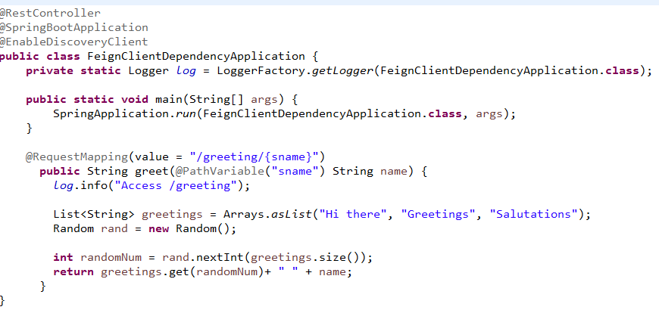

Create Feign Client
- Create a Spring starter Project
- Add the following dependency in POM.XML
Eureka server, Open Feign, Hystrix, Lombak
- Application.properties
  - server.port=9999
  - spring.application.name=myfeign-client
  - eureka.client.service-url.default-zone=http://localhost:8761/eureka
  - feign.hystrix.enabled=true
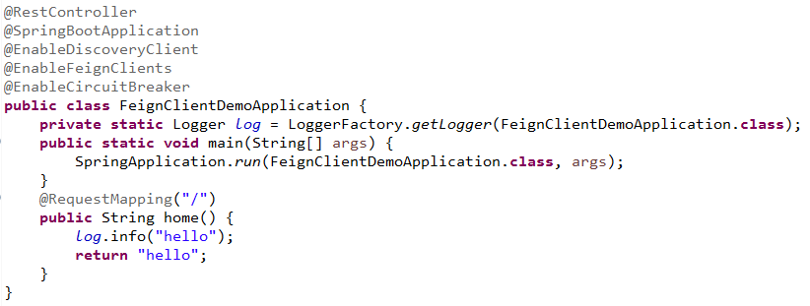
Create an interface and annotate FeignClient
@FeignClient
- Represents the Feign Client
- Value attribute matches the Micro service name registred in Eureka(Discovery service)
- Fallback attribute represents the Fallback implementation if Micro service not found in Discovery Service
- The Url defined in this interface using @RequestMappimg/@GetMaping/@PostMapping annotation or JAX-Rs annotation are the webservice producer URL that to be consumed in current project.
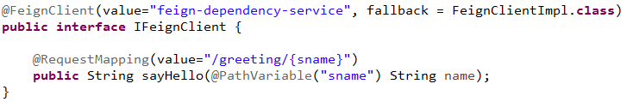
Implement the fall back implementation
- Create the fall back implementation
  - Implement the interface that annotated @FeignClient
- Specify the fall back implementation class using fallback attribute in @Feignclient
  - @FeignClient(value="feign-dependency-service", fallback = FeignClientImpl.class)
- In application .properties
  - feign.hystrix.enabled=true
- Annotate @EnableCircuitBreaker in Spring Boot Main application
- If Micro service is not discovered in Discovery Server(Eureka) then it invokes the method in fall back implementation class
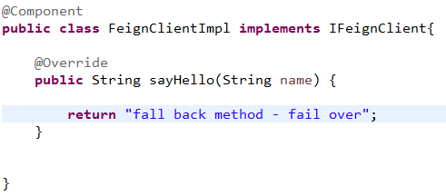
Write the Micro Service that access another Micro service
- Inject the Feign Client
- Access the methods defined in the interface annotated with @FeignClient
- Feign obtain the webservice using service discovery and make the web service call
