Microservice
Each functionality is developed as a component and exposed as the restful webservice.This leads to high scalability and faster to develop
Disadvantages of Monolothic Application
- If there is a change in one component , after changing you have to deploy the entire application
- Presentation layer is tightly coupled
- The team have to undergo only one technology. This leads the situation where resources may not be available for that specific technology.
- Since all the components are in single application there will be the network traffic iand this leads to poor scalability
- If there is an issue in the service then the entire application fails
Advantages of Micro services
- Each Module can have its own architecture, technology and Db
- If there is a change in one component , then that component is changed and deployed.
- Presentaion layers are loosely coupled
- Each component is developed as a separate service and exposed as a webservice in a server that leads to good scalability
- Identifying resources and skillset of various technologies and makes more flexible to use
- All the components are developed at a time Independently and they are small. This follows the agile process and leads faster development
- One Webservice can be dependent on other webservice in loosely coupled manner
- If there is an issue in the service then oly that service fails but other services still works fine
Monolothiic | Microservices
Tightly coupled modules bundled as a single unit. | Loosely coupled independent services
The presentation, business layer and integration layer are combined as one unit. | Each functionality is a separate service
Deployed as a single war file | Each service is deployed as a set of service instances

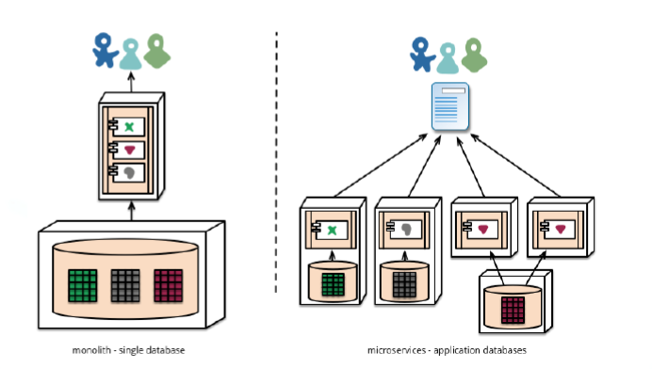

How Micoservices developed
- Identify the requirements , resources and skillset
- Break the requirements in to functionalities
- Based on the resources and skillset available say 4 java developers, 5 c# developers and 4 nodejs developers then one module can be developed in java, the other module in c# and other module using nodejs
- Each module have its own architecture , design and DB and deployed in different server
- If there is a change in design/implementation then only that module have to be changed.
- UI layer is developed in a different tier and this leads the layers loosely coupled, Say you can develop Admin functionalities in UI Layer in C#, Customer functionalities UI layer in Angular
Each Module developed in different technology and DB
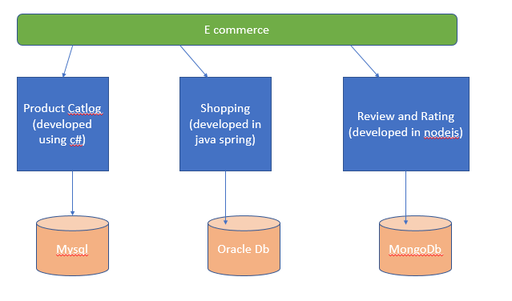
Services Interact each other
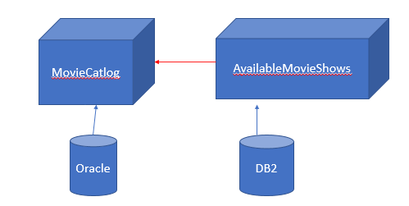
Service Registration and Discovery server
- It is a server which contains the available RESTful webservices UP running.
- Restful webservice is registered in the Service registration server to discover it.
- Eureka is the Service registration server provided by Netfix.
- If any client need to know the services running and its url to consume its services then they can discover using Service Registration.
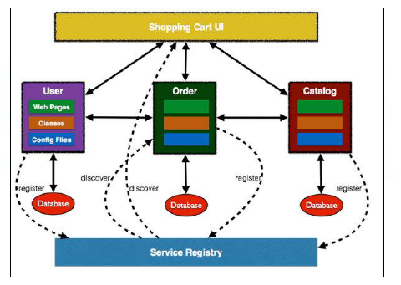
To create the Eureka ServiceRegistration Server
- Create the spring boot starter project
- Add the dependency Eureka Server
- Goto SpringBoot Application Main code and annotate @EnableEurekaserver
@EnableEurekaServer
- It launches the eureka Service registration server and it is ready to register any webservices to discover
- The default port no is 8761
Create Spring boot starter project
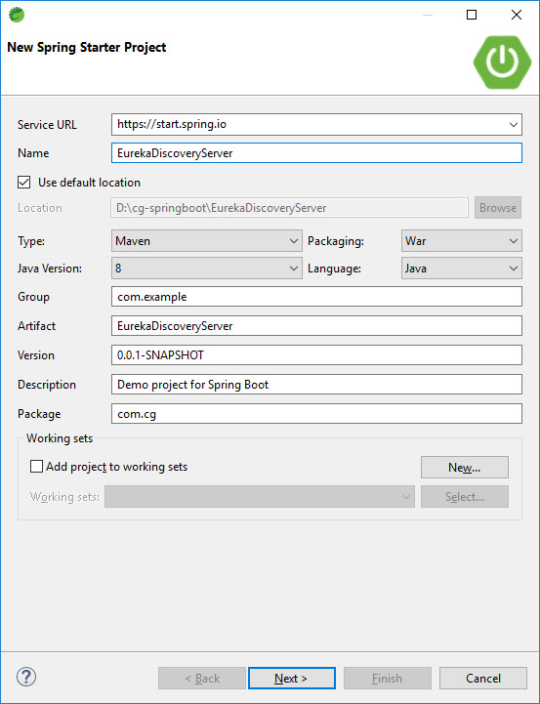
- Choose the dependency EurekaServer
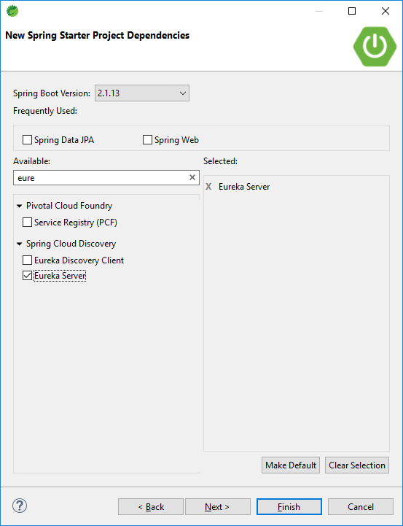

Application.properties
server.port=8761
spring.application.name=eureka-server
eureka.client.register-with-eureka=false
eureka.client.fetch-registry=false

- Annotate @EnableEurekaServer to Spring boot main code

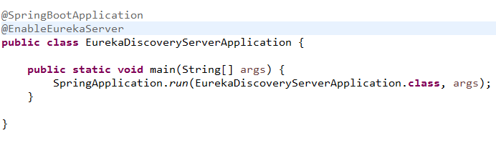

- Type the url http://localhost:8761 in the browser

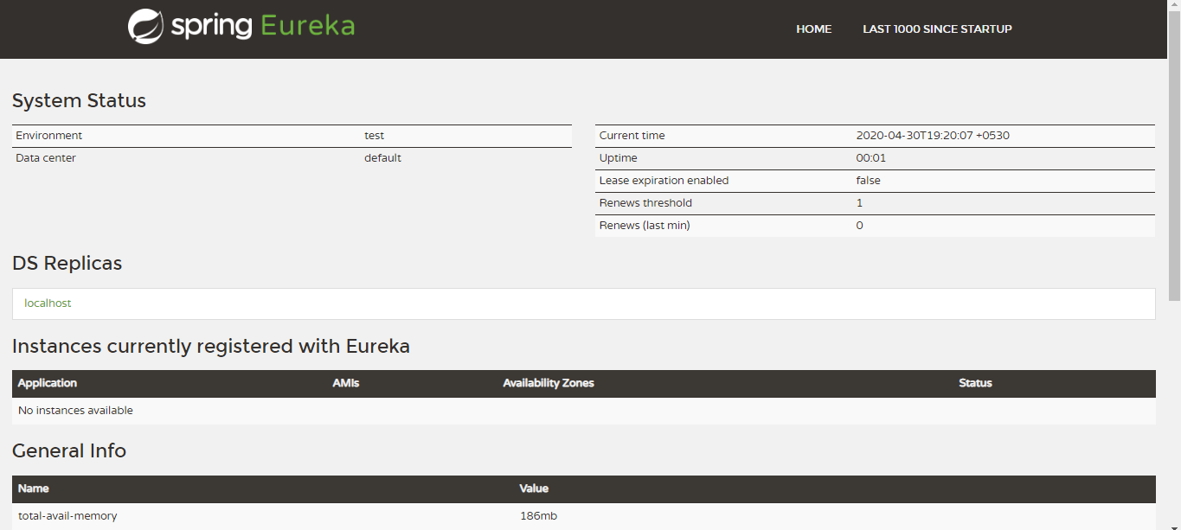
Register the webservices in Eureka service registration
- Create a new Spring boot starter project where micro services available
- Add the following dependency in your Webservice project
- Annoatate @EnableDiscoveryClient
@EnableDiscoveryClient
- This annotation registers the microservices in Eureka Service Registration.
- To register the micro service in service Registration, provide the eureka server URL in application.properties
  - eureka.client.service-url.default-zone =http://localhost:8761/eureka
How will you come to know all the microservices of your application are running?
- Discovery in Eureka Service Registartion server
<properties>
<java.version>1.8</java.version>
<spring-cloud.version>Greenwich.SR5</spring-cloud.version>
</properties>
<dependencies>
<dependency>
<groupId>org.springframework.cloud</groupId>
<artifactId>spring-cloud-starter-netflix-eureka-server</artifactId>
</dependency>
</dependencies>

<dependencyManagement>
<dependencies>
<dependency>
<groupId>org.springframework.cloud</groupId>
<artifactId>spring-cloud-dependencies</artifactId>
<version>${spring-cloud.version}</version>
<type>pom</type>
<scope>import</scope>
</dependency>
</dependencies>
</dependencyManagement>

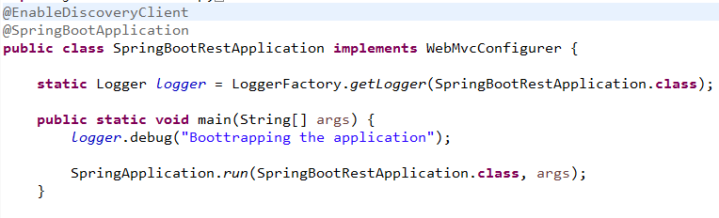

Application.properties
spring.application.name=emp-mgmt
eureka.client.service-url.default-zone=http://localhost:8761/eureka

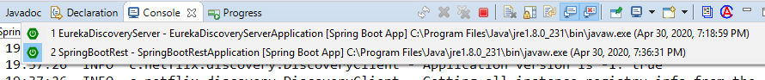

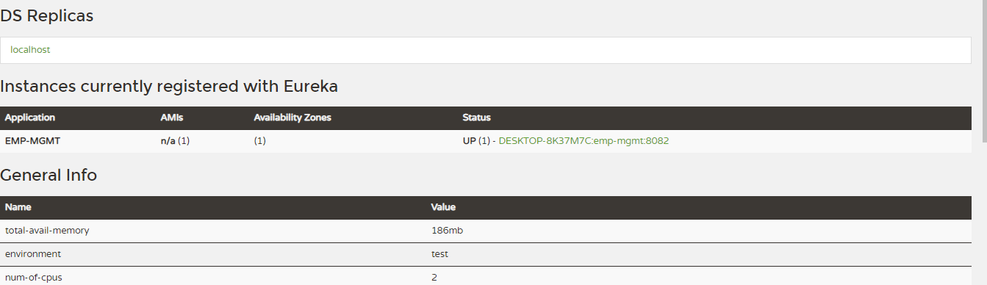

Registration of Second Micro service
Add the following dependency in your Webservice project
<properties>
<java.version>1.8</java.version>
<spring-cloud.version>Greenwich.SR5</spring-cloud.version>
</properties>
<dependencies>
<dependency>
<groupId>org.springframework.cloud</groupId>
<artifactId>spring-cloud-starter-netflix-eureka-server</artifactId>
</dependency>
</dependencies>

<dependencyManagement>
<dependencies>
<dependency>
<groupId>org.springframework.cloud</groupId>
<artifactId>spring-cloud-dependencies</artifactId>
<version>${spring-cloud.version}</version>
<type>pom</type>
<scope>import</scope>
</dependency>
</dependencies>
</dependencyManagement>
Application.properties
server.port=9082
spring.application.name=online-exam
eureka.client.service-url.default-zone=http://localhost:8761/eureka

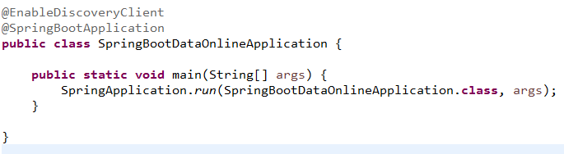
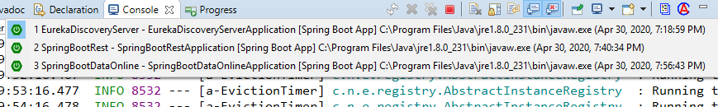

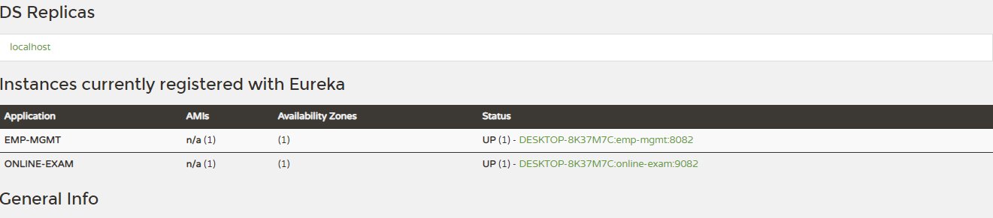

Hysrtix
- Latency and fault tolerance library
- Also called as Circuit breaker
- Stops cascading failure
- Component of Netfix
Why Hystrix?
- If Service A is depenedent on Service B, If service B is down then it uses fallback tolerance logic instead of failing it.

Hystrix DAshBoard
<dependency>
<groupId>org.springframework.cloud</groupId>
<artifactId>spring-cloud-starter-netflix-hystrix</artifactId>
</dependency>
<dependency>
<groupId>org.springframework.cloud</groupId>
<artifactId>spring-cloud-starter-netflix-hystrix-dashboard</artifactId>

First Service of Project A running in Port 8082
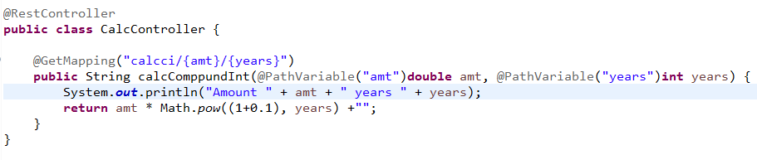

Second Service of Project A running in Port 9082
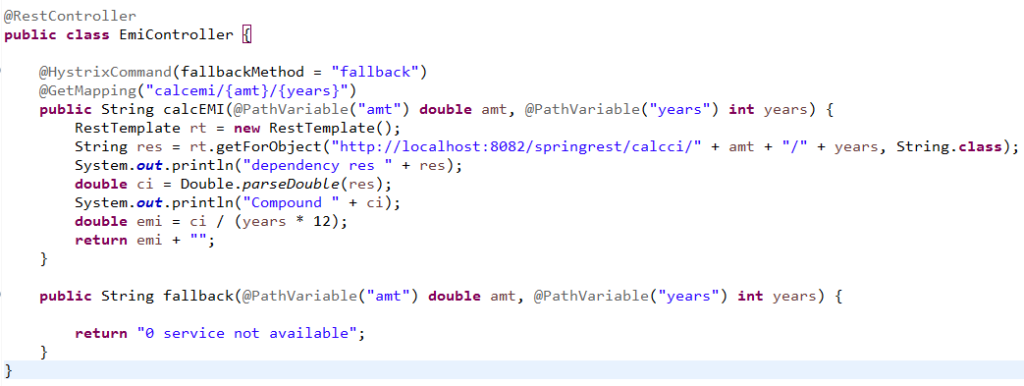
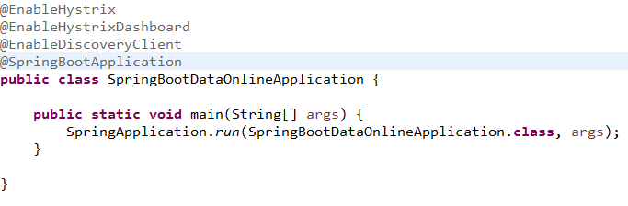
@EnableHystrix
- It provides the fault tolerance logic if dependency not available
@EnableHystrixDashBoard
- It provides the dashboard to monitor the Hystrix metrics in real time
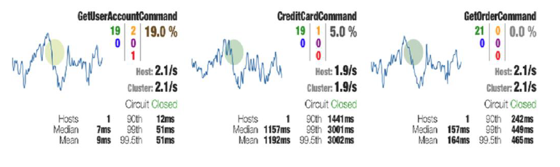
Fallback method must have same return type and method parameters
When Fallback() method is run?
- If the dependent micro service is failed
How a Micro service interact with another Micro service?
- Using rest template

